D17111GC30

Edition 3.0

January 2009

D57873



**Oracle Database 10*g*: SQL**

**Fundamentals II**

**Student Guide • Volume 1**

|  |
| --- |
| Oracle Internal & Oracle Academy Use Only |

**Authors**

Salome Clement Chaitanya Koratamaddi Priya Vennapusa

**Technical Contributors and Reviewers**

Claire Bennett

Brian Boxx

Zarko Cesljas

Laurent Dereac

Nancy Greenberg

Yash Jain

Angelika Krupp

Malika Marghadi

Priya Nathan

Narayanan Radhakrishnan

Bryan Roberts

Lata Shivaprasad

Naoko Susuki

**Editors**

Nita Pavitran

Atanu Raychaudhuri

**Graphic Designer** Sanjeev Sharma

**Publishers**

Jobi Varghese

Giri Venugopal

**Copyright © 2009, Oracle. All rights reserved.**

**Disclaimer**

This document contains proprietary information and is protected by copyright and other intellectual property laws. You may copy and print this document solely for your own use in an Oracle training course. The document may not be modified or altered in any way. Except where your use constitutes "fair use" under copyright law, you may not use, share, download, upload, copy, print, display, perform, reproduce, publish, license, post, transmit, or distribute this document in whole or in part without the express authorization of Oracle.

The information contained in this document is subject to change without notice. If you find any problems in the document, please report them in writing to: Oracle University, 500 Oracle Parkway, Redwood Shores, California 94065 USA. This document is not warranted to be error-free.

**Restricted Rights Notice**

If this documentation is delivered to the United States Government or anyone using the documentation on behalf of the United States Government, the following notice is applicable:

U.S. GOVERNMENT RIGHTS

The U.S. Government’s rights to use, modify, reproduce, release, perform, display, or disclose these training materials are restricted by the terms of the applicable Oracle license agreement and/or the applicable U.S. Government contract.

**Trademark Notice**

Oracle is a registered trademark of Oracle Corporation and/or its affiliates. Other names may be trademarks of their respective owners.

|  |
| --- |
| Oracle Internal & Oracle Academy Use Only |

**Contents**

**Preface**

1. **Introduction** Objectives I-2 Course Objectives I-3 Course Overview I-4 Course Application I-5 Summary I-6
2. **Controlling User Access** Objectives 1-2 Controlling User Access 1-3 Privileges 1-4

System Privileges 1-5 Creating Users 1-6

User System Privileges 1-7

Granting System Privileges 1-8

What Is a Role? 1-9

Creating and Granting Privileges to a Role 1-10

|  |  |
| --- | --- |
| Changing Your Password | 1-11 |
| Object Privileges 1-12 |  |
| Granting Object Privileges | 1-14 |
| Passing On Your Privileges | 1-15 |
| Confirming Privileges Granted 1-16 | |
| Revoking Object Privileges | 1-17 |
| Summary 1-19 |  |
| Practice 1: Overview 1-20 |  |

1. **Managing Schema Objects** Objectives 2-2

ALTER TABLE Statement 2-3

Adding a Column 2-5 Modifying a Column 2-6 Dropping a Column 2-7

SET UNUSED Option 2-8

**iii**

|  |
| --- |
| Oracle Internal & Oracle Academy Use Only |

|  |  |  |
| --- | --- | --- |
| Adding a Constraint Syntax 2-10 | | |
| Adding a Constraint 2-11 | |  |
| ON DELETE CASCADE | 2-12 | |
| Deferring Constraints | 2-13 | |
| Dropping a Constraint | 2-14 | |
| Disabling Constraints | 2-15 | |
| Enabling Constraints | 2-16 | |
| Cascading Constraints 2-18 | | |
| Overview of Indexes | 2-20 | |
| CREATE INDEX with the CREATE TABLE Statement 2-21 | | |
| Function-Based Indexes | | 2-23 |
| Removing an Index 2-24 | |  |
| DROP TABLE … PURGE | | 2-25 |

|  |  |
| --- | --- |
| FLASHBACK TABLE Statement 2-26 | |
| External Tables 2-28 |  |
| Creating a Directory for the External Table 2-30 | |
| Creating an External Table | 2-32 |
| Creating an External Table by Using ORACLE_LOADER 2-34 | |
| Querying External Tables | 2-36 |
| Summary 2-37 |  |
| Practice 2: Overview 2-38 |  |

**3** **Manipulating Large Data Sets**

Objectives 3-2

Using Subqueries to Manipulate Data 3-3

Copying Rows from Another Table 3-4

Inserting Using a Subquery as a Target 3-5

Retrieving Data with a Subquery as Source 3-7

|  |  |
| --- | --- |
| Updating Two Columns with a Subquery | 3-8 |
| Updating Rows Based on Another Table | 3-9 |
| Deleting Rows Based on Another Table | 3-10 |

Using the WITH CHECK OPTION Keyword on DML Statements 3-11

|  |  |
| --- | --- |
| Overview of the Explicit Default Feature | 3-12 |
| Using Explicit Default Values 3-13 |  |
| Overview of Multitable INSERT Statements 3-14 | |
| Types of Multitable INSERT Statements | 3-16 |

Multitable INSERT Statements 3-17

Unconditional INSERT ALL 3-19

Conditional INSERT ALL 3-20

Conditional INSERT FIRST 3-22

**iv**

|  |
| --- |
| Oracle Internal & Oracle Academy Use Only |

Pivoting INSERT 3-24

MERGE Statement 3-27

MERGE Statement Syntax 3-28

Merging Rows 3-29

Tracking Changes in Data 3-31

Example of the Flashback Version Query 3-32

VERSIONS BETWEEN Clause 3-34

Summary 3-35

Practice 3: Overview 3-36

1. **Generating Reports by Grouping Related Data** Objectives 4-2

Review of Group Functions 4-3 Review of the GROUP BY Clause 4-4 Review of the HAVING Clause 4-5

GROUP BY with ROLLUP and CUBE Operators 4-6

|  |  |
| --- | --- |
| ROLLUP Operator 4-7 |  |
| ROLLUP Operator: Example | 4-8 |
| CUBE Operator 4-9 |  |
| CUBE Operator: Example 4-10 | |
| GROUPING Function 4-11 |  |
| GROUPING Function: Example | 4-12 |
| GROUPING SETS 4-13 |  |
| GROUPING SETS: Example | 4-15 |

Composite Columns 4-17

Composite Columns: Example 4-19

Concatenated Groupings 4-21

Concatenated Groupings: Example 4-22

Summary 4-23

Practice 4: Overview 4-24

1. **Managing Data in Different Time Zones** Objectives 5-2

Time Zones 5-3

TIME_ZONE Session Parameter 5-4

CURRENT_DATE, CURRENT_TIMESTAMP, and LOCALTIMESTAMP 5-5 CURRENT_DATE 5-6

CURRENT_TIMESTAMP 5-7

LOCALTIMESTAMP 5-8

**v**

|  |
| --- |
| Oracle Internal & Oracle Academy Use Only |

DBTIMEZONE and SESSIONTIMEZONE 5-9

TIMESTAMP Data Type 5-10

TIMESTAMP Data Types 5-11

TIMESTAMP Fields 5-12

Difference Between DATE and TIMESTAMP 5-13

TIMESTAMP WITH TIME ZONE Data Type 5-14

TIMESTAMP WITH TIMEZONE: Example 5-15

TIMESTAMP WITH LOCAL TIMEZONE 5-16

TIMESTAMP WITH LOCAL TIMEZONE: Example 5-17

INTERVAL Data Types 5-18

INTERVAL Fields 5-20

INTERVAL YEAR TO MONTH Data Type 5-21

INTERVAL YEAR TO MONTH: Example 5-22

INTERVAL DAY TO SECOND Data Type 5-23

INTERVAL DAY TO SECOND Data Type: Example 5-24

EXTRACT 5-25

TZ_OFFSET 5-26

TIMESTAMP Conversion Using FROM_TZ 5-28

Converting to TIMESTAMP Using TO_TIMESTAMP and TO_TIMESTAMP_TZ 5-29 Time Interval Conversion with TO_YMINTERVAL 5-30 Using TO_DSINTERVAL: Example 5-31

Daylight Saving Time 5-32

Summary 5-34

Practice 5: Overview 5-35

1. **Retrieving Data Using Subqueries** Objectives 6-2 Multiple-Column Subqueries 6-3 Column Comparisons 6-4 Pairwise Comparison Subquery 6-5 Nonpairwise Comparison Subquery 6-6 Scalar Subquery Expressions 6-7 Scalar Subqueries: Examples 6-8 Correlated Subqueries 6-10

Using Correlated Subqueries 6-12 Using the EXISTS Operator 6-14

Find Employees Who Have At Least One Person Reporting to Them 6-15 Find All Departments That Do Not Have Any Employees 6-16 Correlated UPDATE 6-17

**vi**

|  |
| --- |
| Oracle Internal & Oracle Academy Use Only |

|  |  |
| --- | --- |
| Using Correlated UPDATE | 6-18 |
| Correlated DELETE 6-20 |  |
| Using Correlated DELETE | 6-21 |
| WITH Clause 6-22 |  |

WITH Clause: Example 6-23

Summary 6-25

Practice 6: Overview 6-27

1. **Hierarchical Retrieval** Objectives 7-2

Sample Data from the EMPLOYEES Table 7-3

Natural Tree Structure 7-4

Hierarchical Queries 7-5

Walking the Tree 7-6

Walking the Tree: From the Bottom Up 7-8

Walking the Tree: From the Top Down 7-9

Ranking Rows with the LEVEL Pseudocolumn 7-10

Formatting Hierarchical Reports Using LEVEL and LPAD 7-11

Pruning Branches 7-13

Summary 7-14

Practice 7: Overview 7-15

1. **Regular Expression Support** Objectives 8-2

Regular Expression: Overview 8-3 Meta Characters 8-4

Using Meta Characters 8-5 Regular Expression Functions 8-7 REGEXP Function Syntax 8-8

Performing Basic Searches 8-9

Checking the Presence of a Pattern 8-10

Example of Extracting Substrings 8-11

Replacing Patterns 8-12

Regular Expressions and Check Constraints 8-13

Summary 8-14

Practice 8: Overview 8-15

**Appendix A: Practice Solutions**

**Appendix B: Table Descriptions and Data**

**vii**

|  |
| --- |
| Oracle Internal & Oracle Academy Use Only |

**Appendix C: Writing Advanced Scripts**

Objectives C-2

Using SQL to Generate SQL C-3

Creating a Basic Script C-4

Controlling the Environment C-5

The Complete Picture C-6

Dumping the Contents of a Table to a File C-7

Generating a Dynamic Predicate C-9

Summary C-11

**Appendix D: Oracle Architectural Components**

Objectives D-2

Oracle Database Architecture: Overview D-3

Database Physical Architecture D-4

Control Files D-5

Redo Log Files D-6

Tablespaces and Data Files D-7

Segments, Extents, and Blocks D-8

Oracle Instance Management D-9

Oracle Memory Structures D-10

Oracle Processes D-12

Other Key Physical Structures D-13

Processing a SQL Statement D-14

Connecting to an Instance D-15

Processing a Query D-17

Shared Pool D-18

Database Buffer Cache D-20

Program Global Area (PGA) D-21

Processing a DML Statement D-22

Redo Log Buffer D-24

Rollback Segment D-25

COMMIT Processing D-26

Summary D-28

**Appendix E: Using SQL Developer**

Objectives E-2

What Is Oracle SQL Developer? E-3

Key Features E-4

Installing SQL Developer E-5

Menus for SQL Developer E-6

Creating a Database Connection E-7

**viii**

|  |
| --- |
| Oracle Internal & Oracle Academy Use Only |

Browsing Database Objects E-9

Creating a Schema Object E-10

Creating a New Table: Example E-11

Using SQL Worksheet E-12

Executing SQL Statements E-14

Viewing the Execution Plan E-15

Formatting the SQL Code E-16

Using Snippets E-17

Using Snippets: Example E-18

Using SQL*Plus E-19

Database Reporting E-20

Creating a User Defined Report E-21

Summary E-22

**Index**

**Additional Practices**

**Additional Practice Solutions**

**ix**

|  |
| --- |
| Oracle Internal & Oracle Academy Use Only |

|  |
| --- |
| **x** |

Oracle Internal & Oracle Academy Use Only



|  |
| --- |
| **Preface** |

Oracle Internal & Oracle Academy Use Only

Oracle Internal & Oracle Academy Use Only

**Profile**

**Before You Begin This Course**

Before you begin this course, you should have working experience with SQL.

**Prerequisites**

1. *Oracle Database 10g: SQL Fundamentals I*

**How This Course Is Organized**

*Oracle Database 10g: SQL Fundamentals II* is an instructor-led course featuringlectures and hands-on exercises. Online demonstrations and written practice sessions reinforce the concepts and skills that are introduced.

|  |
| --- |
| Oracle Internal & Oracle Academy Use Only |

**Preface - 3**

|  |  |
| --- | --- |
| **Related Publications** |  |
| **Oracle Publications** |  |
| **Title** | **Part Number** |
| *Oracle® Database Reference 10g Release 2 (10.2)* | B14237-02 |
| *Oracle® Database SQL Reference 10g Release 2 (10.2)* | B14200-02 |
| Oracle® Database Concepts 10*g* Release *2 (10.2)* | B14220-02 |
| *Oracle® Database Application Developer's Guide -* |  |
| *Fundamentals 10g Release 2 (10.2)* | B14251-01 |
| *SQL*Plus® User's Guide and Reference* | B14357-01 |

**Additional Publications**

1. System release bulletins
2. Installation and user’s guides
3. *read.me* files
4. International Oracle User’s Group (IOUG) articles
5. *Oracle Magazine*

|  |
| --- |
| Oracle Internal & Oracle Academy Use Only |

**Preface - 4**

**Typographic Conventions**

The following two lists explain Oracle University typographical conventions for words that appear within regular text or within code samples.

**1. Typographic Conventions for Words Within Regular Text**

|  |  |  |
| --- | --- | --- |
| **Convention** | **Object or Term** | **Example** |
| Courier New | User input; | Use the SELECT command to view |
|  | commands; | information stored in the LAST_NAME |
|  | column, table, and | column of the EMPLOYEES table. |
|  | schema names; |  |
|  | functions; | Enter 300. |
|  | PL/SQL objects; |  |
|  | paths | Log in as scott |
| Initial cap | Triggers; | Assign a When-Validate-Item trigger to |
|  | user interface object | the ORD block. |
|  | names, such as |  |
|  | button names | Click the Cancel button. |
| Italic | Titles of | For more information on the subject see |
|  | courses and | *Oracle SQL Reference* |
|  | manuals; | *Manual* |
|  | emphasized | Do *not* save changes to the database. |
|  | words or phrases; |
|  | placeholders or |  |
|  | variables | Enter *hostname*, where |
|  |  | *hostname* is the host on which the |
|  |  | password is to be changed. |
| Quotation marks | Lesson or module | This subject is covered in Lesson 3, |
|  | titles referenced | “Working with Objects.” |
|  | within a course |  |

|  |
| --- |
| Oracle Internal & Oracle Academy Use Only |

**Preface - 5**

**Typographic Conventions (continued)**

**2. Typographic Conventions for Words Within Code Samples**

|  |  |  |  |
| --- | --- | --- | --- |
| **Convention** | **Object or Term** | **Example** | |
| Uppercase | Commands, | SELECT employee_id | |
|  | functions | FROM | employees; |
| Lowercase, | Syntax variables | CREATE ROLE *role*; | |
| italic |  |  |  |
| Initial cap | Forms triggers | Form module: ORD | |
|  |  | Trigger level: S _ITEM.QUANTITY | |
|  |  | item |  |
|  |  | Trigger name: When-Validate-Item | |
|  |  | . . . |  |
| Lowercase | Column names, | . . . |  |
|  | table names, | OG_ACTIVATE_LAYER | |
|  | filenames, | (OG_GET_LAYER ('prod_pie_layer')) | |
|  | PL/SQL objects | . . . |  |
|  |  | SELECT last_name | |
|  |  | FROM | employees; |
| Bold | Text that must | CREATE USER **scott** | |
|  | be entered by a | IDENTIFIED BY **tiger**; | |
|  | user |  |  |

|  |
| --- |
| Oracle Internal & Oracle Academy Use Only |

**Preface - 6**



**Introduction**

Copyright © 2009, Oracle. All rights reserved.

|  |
| --- |
| Oracle Internal & Oracle Academy Use Only |

**Objectives**

After completing this lesson, you should be able to do the following:

1. List the course objectives
2. Describe the sample tables used in the course

Copyright © 2009, Oracle. All rights reserved.

|  |
| --- |
| Oracle Internal & Oracle Academy Use Only |

**Oracle Database 10*g*: SQL Fundamentals II I - 2**

**Course Objectives**

After completing this course, you should be able to do the following:

1. Use advanced SQL data retrieval techniques to retrieve data from database tables
2. Apply advanced techniques in a practice that simulates real life

Copyright © 2009, Oracle. All rights reserved.

|  |
| --- |
| Oracle Internal & Oracle Academy Use Only |

**Oracle Database 10*g*: SQL Fundamentals II I - 3**

**Course Overview**

In this course, you use advanced SQL data retrieval techniques such as:

1. Datetime functions
2. ROLLUP, CUBE operators, and GROUPING SETS
3. Hierarchical queries
4. Correlated subqueries
5. Multitable inserts
6. Merge operation
7. External tables
8. Regular expression usage

Copyright © 2009, Oracle. All rights reserved.

|  |
| --- |
| Oracle Internal & Oracle Academy Use Only |

**Oracle Database 10*g*: SQL Fundamentals II I - 4**

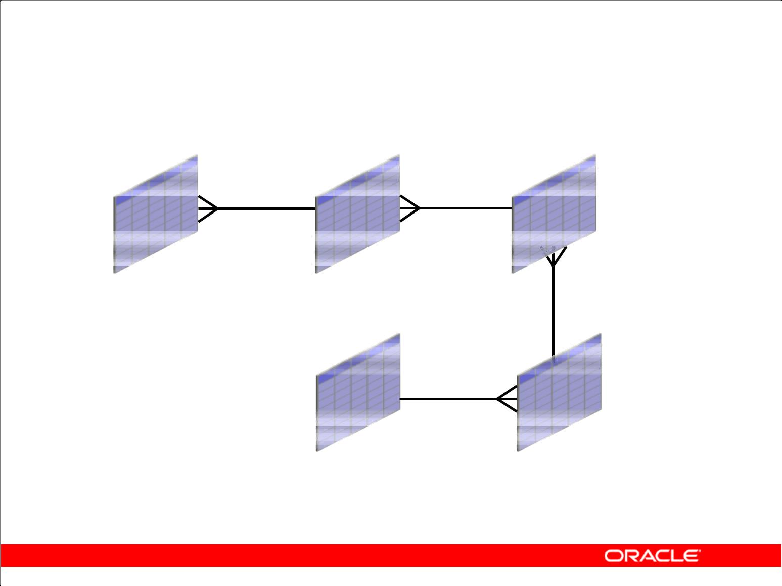**Course Application**

**EMPLOYEES** **DEPARTMENTS** **LOCATIONS**

**REGIONS** **COUNTRIES**

Copyright © 2009, Oracle. All rights reserved.

**Tables Used in the Course**

The following tables are used in this course:

1. **EMPLOYEES:** TheEMPLOYEEStable contains information about all the employees such astheir first and last names, job IDs, salaries, hire dates, department IDs, and manager IDs. This table is a child of the DEPARTMENTS table.
2. **DEPARTMENTS:** TheDEPARTMENTStable contains information such as the department ID,department name, manager ID, and location ID. This table is the primary key table to the

EMPLOYEES table.

1. **LOCATIONS:** This table contains department location information. It contains location ID,street address, city, state province, postal code, and country ID information. It is the primary key table to the DEPARTMENTS table and is a child of the COUNTRIES table.
2. **COUNTRIES:** This table contains the country names, country IDs, and region IDs. It is a childof the REGIONS table. This table is the primary key table to the LOCATIONS table.
3. **REGIONS:** This table contains region IDs and region names of the various countries. It is aprimary key table to the COUNTRIES table.

|  |
| --- |
| Oracle Internal & Oracle Academy Use Only |

**Oracle Database 10*g*: SQL Fundamentals II I - 5**

**Summary**

In this lesson, you should have learned the following:

1. The course objectives
2. The sample tables used in the course

Copyright © 2009, Oracle. All rights reserved.

|  |
| --- |
| Oracle Internal & Oracle Academy Use Only |

**Oracle Database 10*g*: SQL Fundamentals II I - 6**



**Controlling User Access**

Copyright © 2009, Oracle. All rights reserved.

|  |
| --- |
| Oracle Internal & Oracle Academy Use Only |

**Objectives**

After completing this lesson, you should be able to do the following:

1. Differentiate system privileges from object privileges
2. Grant privileges on tables
3. View privileges in the data dictionary
4. Grant roles
5. Distinguish between privileges and roles

Copyright © 2009, Oracle. All rights reserved.

**Objectives**

In this lesson, you learn how to control database access to specific objects and add new users with different levels of access privileges.

|  |
| --- |
| Oracle Internal & Oracle Academy Use Only |

**Oracle Database 10*g*: SQL Fundamentals II 1 - 2**

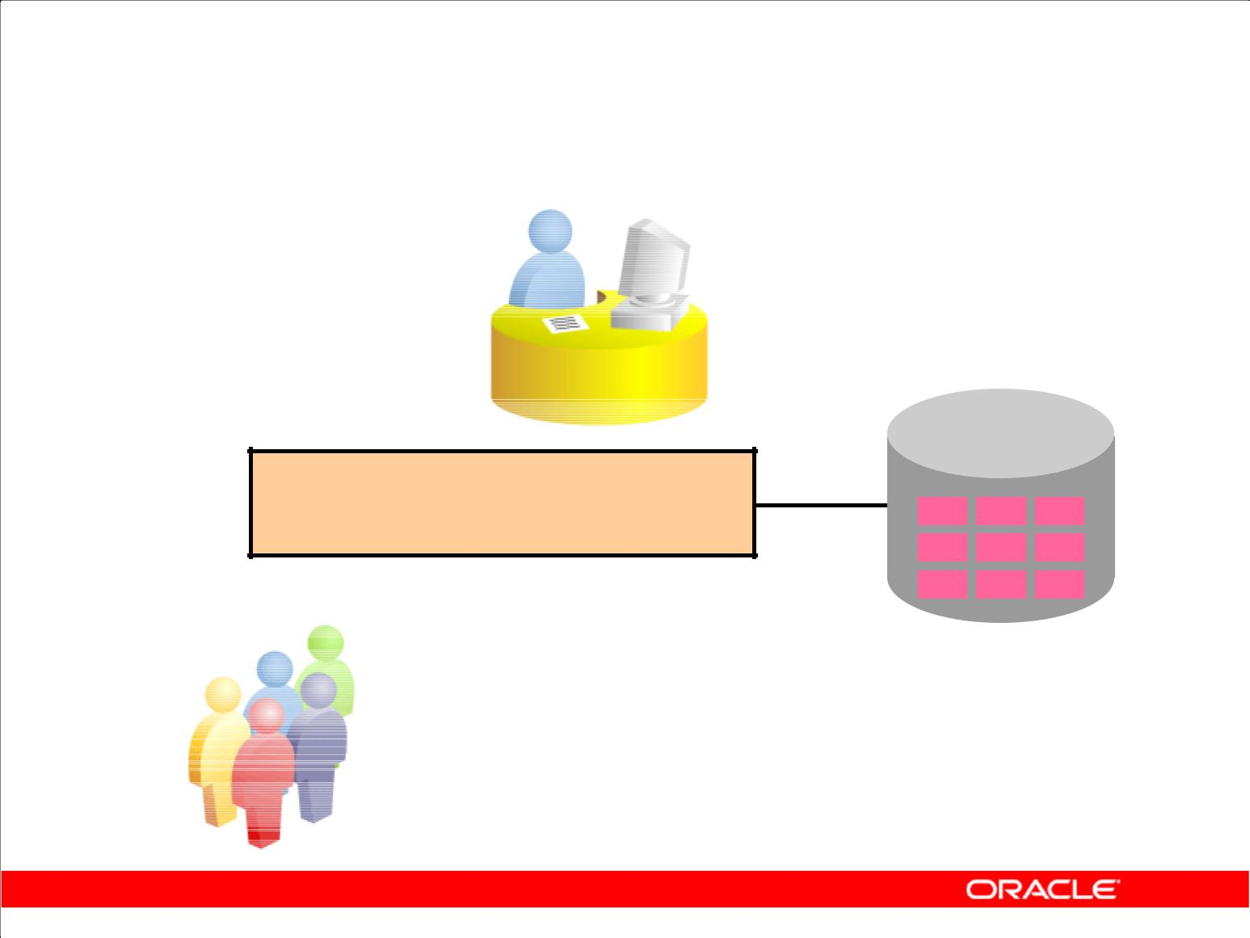**Controlling User Access**

**Database**

**administrator**

**Username and password**

**Privileges**

**Users**

Copyright © 2009, Oracle. All rights reserved.

**Controlling User Access**

In a multiple-user environment, you want to maintain security of the database access and use. With Oracle server database security, you can do the following:

1. Control database access.
2. Give access to specific objects in the database.
3. Confirm given and received privileges with the Oracle data dictionary.
4. Create synonyms for database objects.

Database security can be classified into two categories: system security and data security. System security covers access and use of the database at the system level such as the username and password, the disk space allocated to users, and the system operations that users can perform. Database security covers access and use of the database objects and the actions that those users can have on the objects.

|  |
| --- |
| Oracle Internal & Oracle Academy Use Only |

**Oracle Database 10*g*: SQL Fundamentals II 1 - 3**

**Privileges**

1. Database security:

– System security

– Data security

1. System privileges: Gaining access to the database
2. Object privileges: Manipulating the content of the database objects
3. Schemas: Collection of objects such as tables, views, and sequences

Copyright © 2009, Oracle. All rights reserved.

**Privileges**

Privileges are the right to execute particular SQL statements. The database administrator (DBA) is a high-level user with the ability to create users and grant users access to the database and its objects. Users require *system privileges* to gain access to the database and *object privileges* to manipulate the content of the objects in the database. Users can also be given the privilege to grant additional privileges to other users or to *roles*, which are named groups of related privileges.

**Schemas**

A *schema* is a collection of objects such as tables, views, and sequences. The schema is owned by a database user and has the same name as that user.

For more information, see the *Oracle Database10g Application Developer’s Guide–Fundamentals* reference manual.

|  |
| --- |
| Oracle Internal & Oracle Academy Use Only |

**Oracle Database 10*g*: SQL Fundamentals II 1 - 4**

**System Privileges**

1. More than 100 privileges are available.
2. The database administrator has high-level system privileges for tasks such as:

– Creating new users

– Removing users

– Removing tables

– Backing up tables

Copyright © 2009, Oracle. All rights reserved.

**System Privileges**

More than 100 distinct system privileges are available for users and roles. System privileges typically are provided by the database administrator.

**Typical DBA Privileges**

|  |  |
| --- | --- |
| **System Privilege** | **Operations Authorized** |
|  |  |
| CREATE USER | Grantee can create other Oracle users. |
|  |  |
| DROP USER | Grantee can drop another user. |
|  |  |
| DROP ANY TABLE | Grantee can drop a table in any schema. |
|  |  |
| BACKUP ANY TABLE | Grantee can back up any table in any schema with the export |
|  | utility. |
|  |  |
| SELECT ANY TABLE | Grantee can query tables, views, or materialized views in any |
|  | schema. |
|  |  |
| CREATE ANY TABLE | Grantee can create tables in any schema. |
|  |  |

|  |
| --- |
| Oracle Internal & Oracle Academy Use Only |

**Oracle Database 10*g*: SQL Fundamentals II 1 - 5**

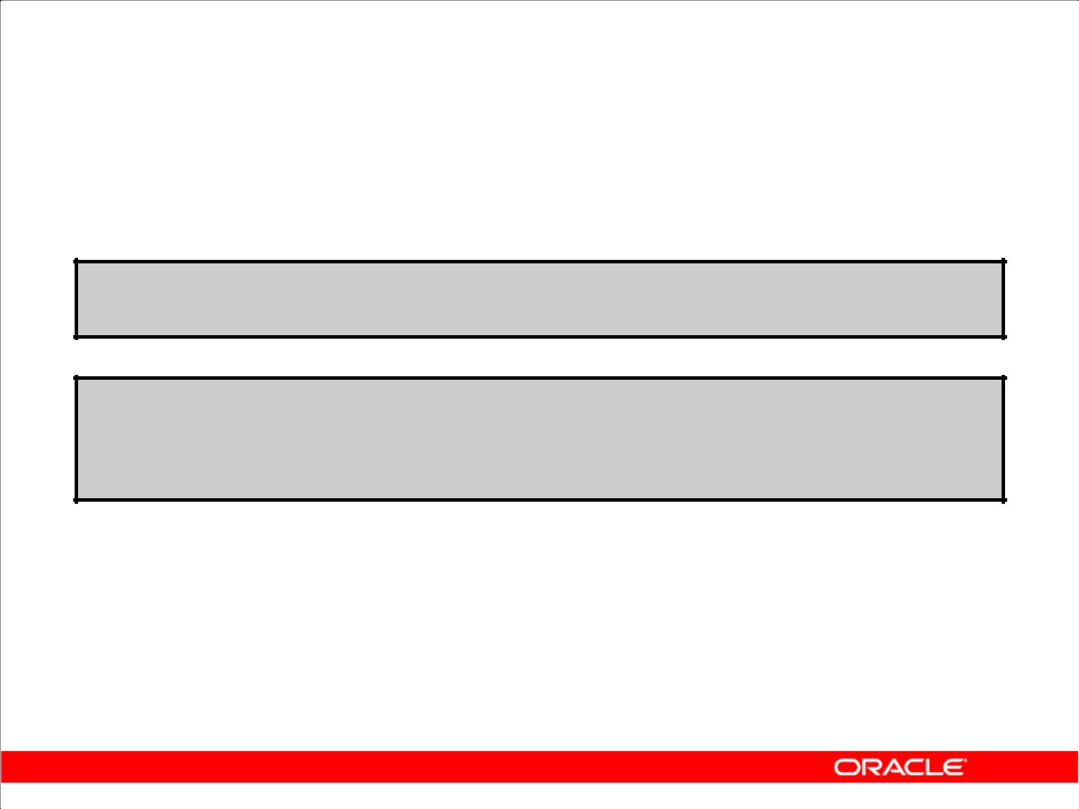**Creating Users**

The DBA creates users with the CREATE USER statement.

**CREATE USER *user***

**IDENTIFIED BY** ***password*;**

**CREATE USER** **USER1**

**IDENTIFIED BY** **USER1;**

**CREATE USER succeeded.**

Copyright © 2009, Oracle. All rights reserved.

**Creating a User**

The DBA creates a user by executing the CREATE USER statement. The user does not have any privileges at this point. The DBA can then grant privileges to that user. These privileges determine what the user can do at the database level.

The slide gives the abridged syntax for creating a user.

|  |  |
| --- | --- |
| In the syntax: | Is the name of the user to be created |
| *user* |
| *Password* | Specifies that the user must log in with this password |

For more information, see *Oracle Database10g SQL Reference*.

|  |
| --- |
| Oracle Internal & Oracle Academy Use Only |

**Oracle Database 10*g*: SQL Fundamentals II 1 - 6**

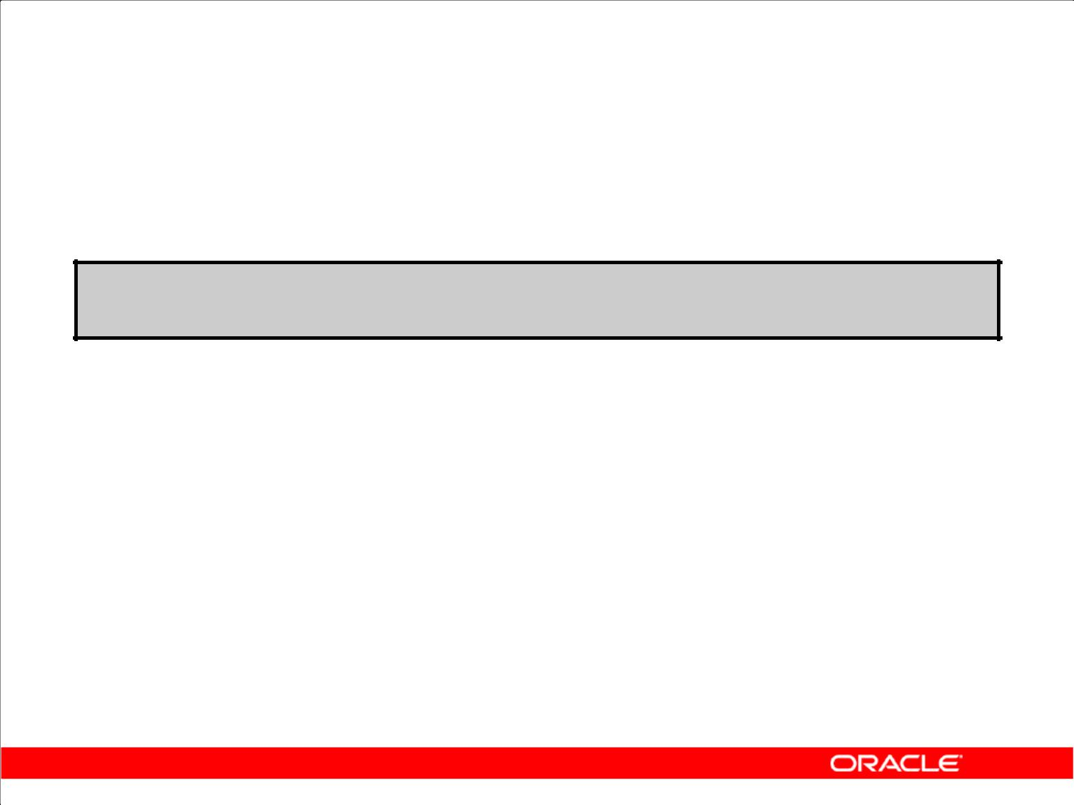**User System Privileges**

1. After a user is created, the DBA can grant specific system privileges to that user.

**GRANT *privilege* [, *privilege*...] TO *user* [, *user| role, PUBLIC*...];**

1. An application developer, for example, may have the following system privileges:

– CREATE SESSION

– CREATE TABLE

– CREATE SEQUENCE

– CREATE VIEW

– CREATE PROCEDURE

Copyright © 2009, Oracle. All rights reserved.

**Typical User Privileges**

After the DBA creates a user, the DBA can assign privileges to that user.

|  |  |
| --- | --- |
| **System Privilege** | **Operations Authorized** |
|  |  |
| CREATE SESSION | Connect to the database. |
|  |  |
| CREATE TABLE | Create tables in the user’s schema. |
|  |  |
| CREATE SEQUENCE | Create a sequence in the user’s schema. |
|  |  |
| CREATE VIEW | Create a view in the user’s schema. |
|  |  |
| CREATE PROCEDURE | Create a stored procedure, function, or package in the user’s |
|  | schema. |
|  |  |

|  |  |  |
| --- | --- | --- |
| In the syntax: | | Is the system privilege to be granted |
| *privilege* | |
| *user* | |role|PUBLIC | Is the name of the user, the name of the role, or PUBLIC |
|  | designates that every user is granted the privilege | |

**Note:** Current system privileges can be found in theSESSION_PRIVSdictionary view.

|  |
| --- |
| Oracle Internal & Oracle Academy Use Only |

**Oracle Database 10*g*: SQL Fundamentals II 1 - 7**

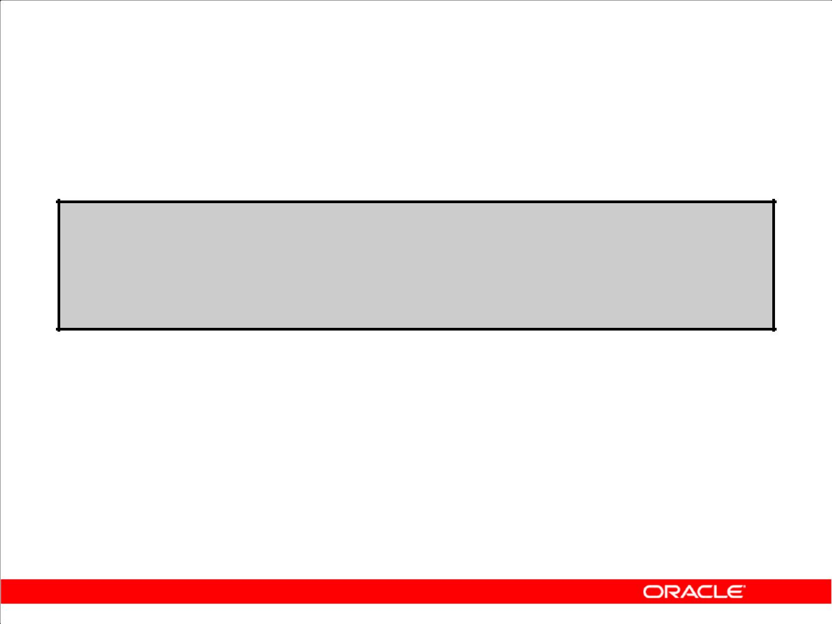**Granting System Privileges**

The DBA can grant specific system privileges to a user.

**GRANT create session, create table, create sequence, create view**

**TO** **scott;**

**GRANT CREATE succeeded.**

Copyright © 2009, Oracle. All rights reserved.

**Granting System Privileges**

The DBA uses the GRANT statement to allocate system privileges to the user. After the user has been granted the privileges, the user can immediately use those privileges.

In the example in the slide, user Scott has been assigned the privileges to create sessions, tables, sequences, and views.

|  |
| --- |
| Oracle Internal & Oracle Academy Use Only |

**Oracle Database 10*g*: SQL Fundamentals II 1 - 8**

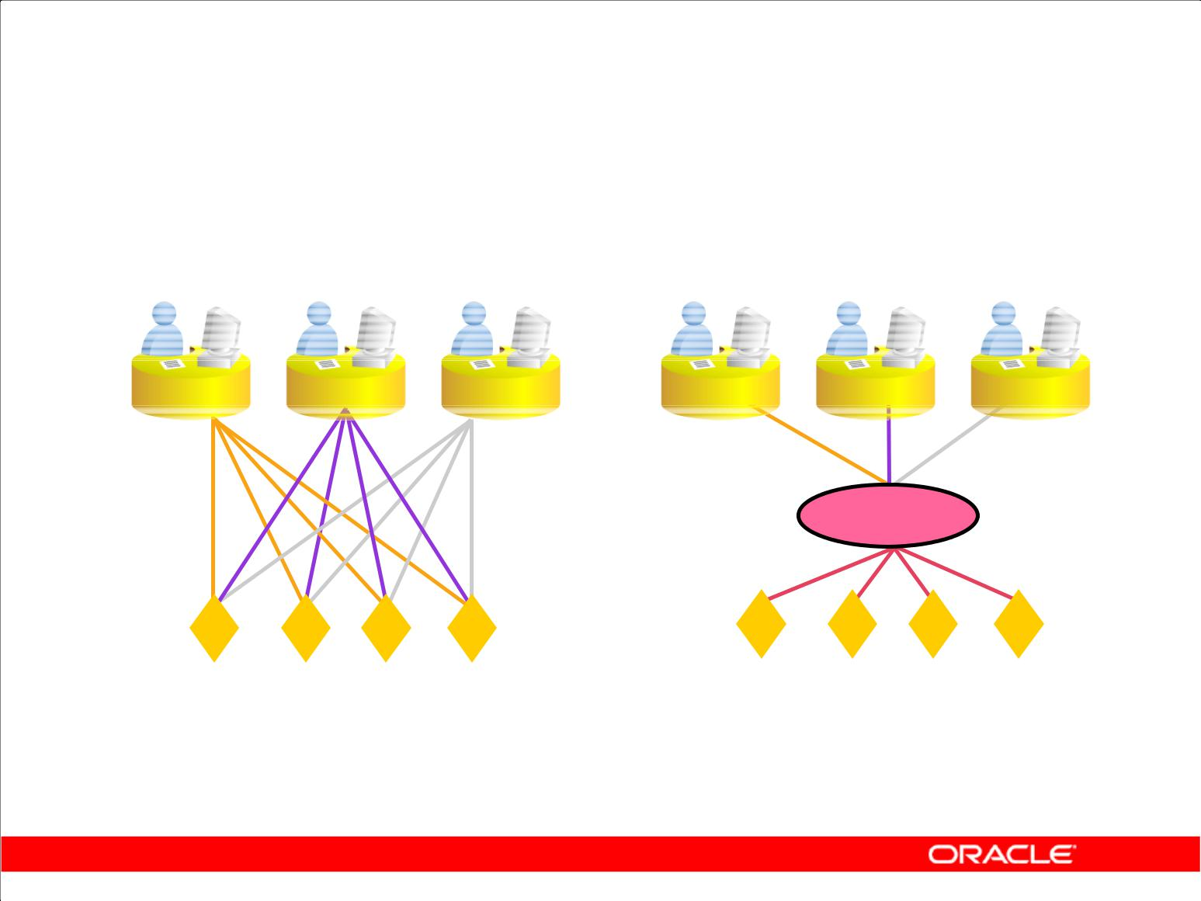**What Is a Role?**

**Users**

**Manager**

**Privileges**

**Allocating privileges** **Allocating privileges**

**without a role** **with a role**

Copyright © 2009, Oracle. All rights reserved.

**What Is a Role?**

A role is a named group of related privileges that can be granted to the user. This method makes it easier to revoke and maintain privileges.

A user can have access to several roles, and several users can be assigned the same role. Roles are typically created for a database application.

**Creating and Assigning a Role**

First, the DBA must create the role. Then the DBA can assign privileges to the role and assign the role to users.

**Syntax**

CREATE ROLE *role*;

In the syntax:

*role* Is the name of the role to be created

After the role is created, the DBA can use the GRANT statement to assign the role to users as well as assign privileges to the role.

|  |
| --- |
| Oracle Internal & Oracle Academy Use Only |

**Oracle Database 10*g*: SQL Fundamentals II 1 - 9**

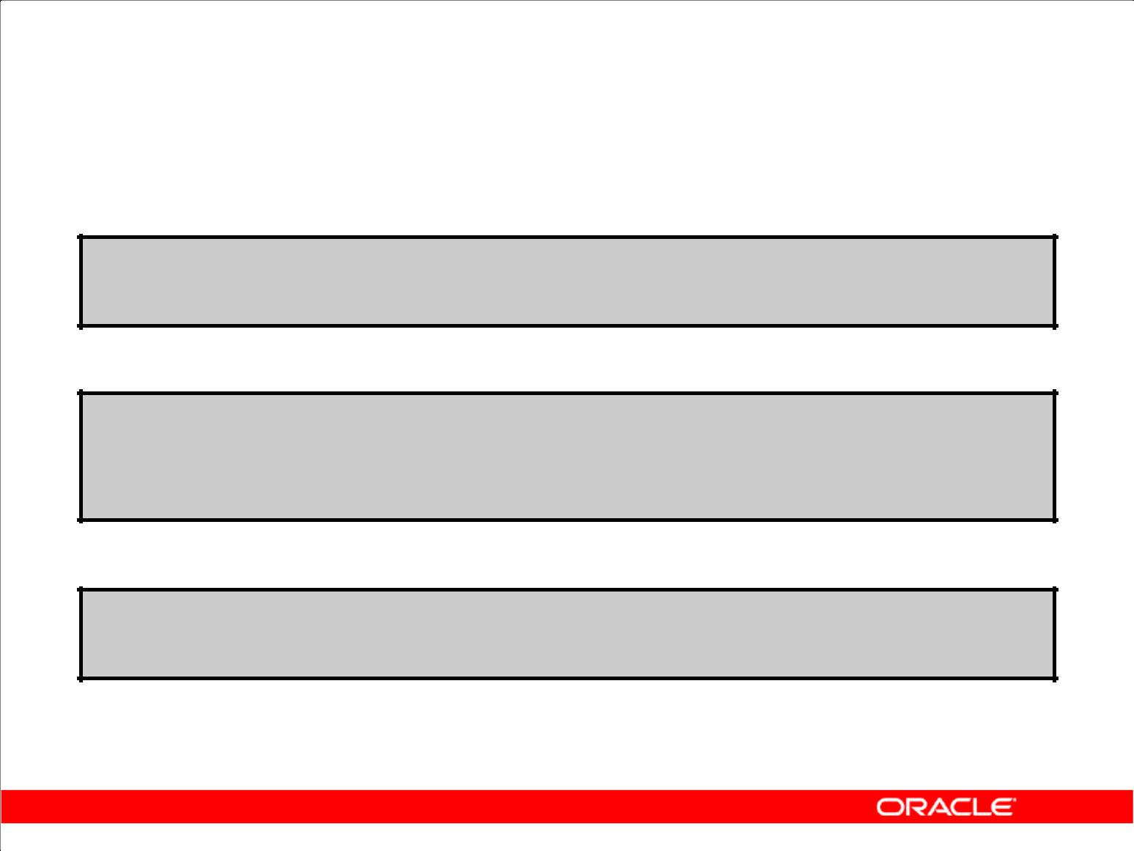**Creating and Granting Privileges to a Role**

1. Create a role:

**CREATE ROLE manager;**

**CREATE ROLE succeeded.**

1. Grant privileges to a role:

**GRANT create table, create view TO manager;**

**GRANT succeeded.**

1. Grant a role to users:

**GRANT manager TO BELL, KOCHHAR;**

**GRANT succeeded.**

Copyright © 2009, Oracle. All rights reserved.

**Creating a Role**

The example in the slide creates a manager role and then enables managers to create tables and views. It then grants Bell and Kochhar the role of managers. Now Bell and Kochhar can create tables and views.

If users have multiple roles granted to them, they receive all the privileges associated with all the roles.

|  |
| --- |
| Oracle Internal & Oracle Academy Use Only |

**Oracle Database 10*g*: SQL Fundamentals II 1 - 10**

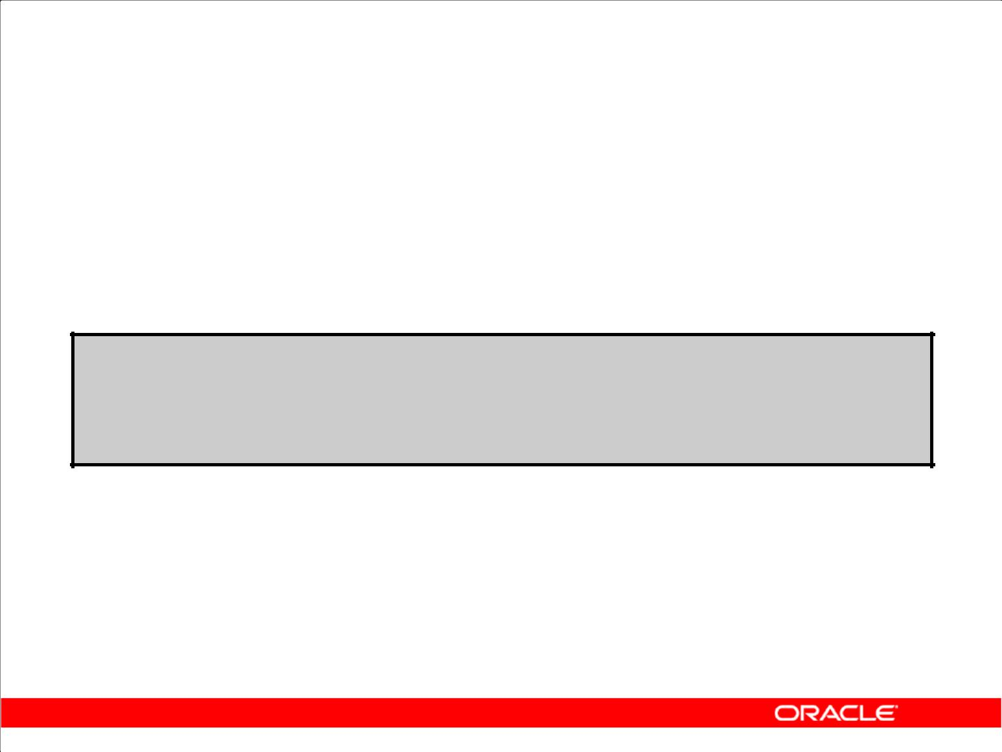**Changing Your Password**

1. The DBA creates your user account and initializes your password.
2. You can change your password by using the ALTER USER statement.

**ALTER USER HR**

**IDENTIFIED BY employ;**

**ALTER USER HR succeeded.**

Copyright © 2009, Oracle. All rights reserved.

**Changing Your Password**

The DBA creates an account and initializes a password for every user. You can change your password by using the ALTER USER statement.

**Syntax**

ALTER USER user IDENTIFIED BY password;

|  |  |
| --- | --- |
| In the syntax: | Is the name of the user |
| *user* |
| *password* | Specifies the new password |

Although this statement can be used to change your password, there are many other options. You must have the ALTER USER privilege to change any other option.

For more information, see the *Oracle Database10g SQL Reference* manual*.*

**Note:** SQL*Plus has aPASSWORDcommand (PASSW) that can be used to change the password of auser when the user is logged in. This command is not available in SQL Developer.

|  |
| --- |
| Oracle Internal & Oracle Academy Use Only |

**Oracle Database 10*g*: SQL Fundamentals II 1 - 11**

**Object Privileges**

|  |  |  |  |  |
| --- | --- | --- | --- | --- |
| **Object** |  |  |  |  |
| **Privilege** | **Table** | **View** | **Sequence** | **Procedure** |
|  |  |  |  |  |
| **ALTER** | **√** |  | **√** |  |
| **DELETE** | **√** | **√** |  |  |
| **EXECUTE** |  |  |  | **√** |
|  |  |  |  |  |
| **INDEX** | **√** |  |  |  |
| **INSERT** | **√** | **√** |  |  |
| **REFERENCES** | **√** |  |  |  |
| **SELECT** | **√** | **√** | **√** |  |
| **UPDATE** | **√** | **√** |  |  |

Copyright © 2009, Oracle. All rights reserved.

**Object Privileges**

An *object privilege* is a privilege or right to perform a particular action on a specific table, view, sequence, or procedure. Each object has a particular set of grantable privileges. The table in the slide lists the privileges for various objects. Note that the only privileges that apply to a sequence are SELECT and ALTER. UPDATE, REFERENCES, and INSERT can be restricted by specifying a subset of updatable columns. A SELECT privilege can be restricted by creating a view with a subset of columns and granting the SELECT privilege only on the view. A privilege granted on a synonym is converted to a privilege on the base table referenced by the synonym.

|  |
| --- |
| Oracle Internal & Oracle Academy Use Only |

**Oracle Database 10*g*: SQL Fundamentals II 1 - 12**

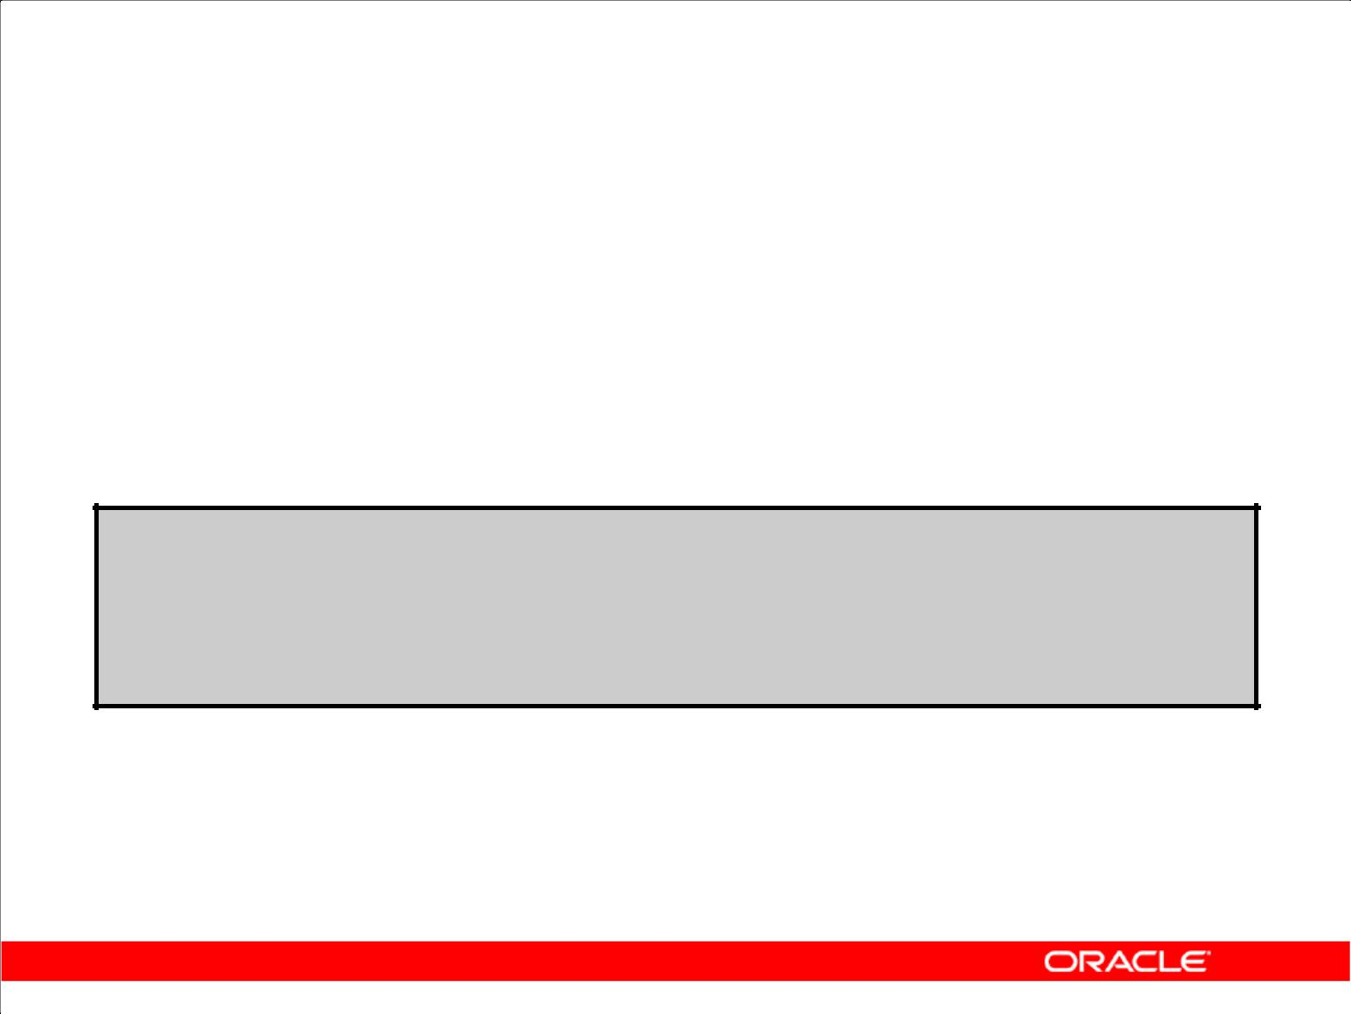**Object Privileges**

1. Object privileges vary from object to object.
2. An owner has all the privileges on the object.
3. An owner can give specific privileges on that owner’s object.

**GRANT** ***object_priv* [(*columns*)]**

**ON** ***object***

**TO** **{*user*|*role*|PUBLIC}**

**[WITH GRANT OPTION];**

Copyright © 2009, Oracle. All rights reserved.

**Granting Object Privileges**

Different object privileges are available for different types of schema objects. A user automatically has all object privileges for schema objects contained in the user’s schema. A user can grant any object privilege on any schema object that the user owns to any other user or role. If the grant includes WITH GRANT OPTION, then the grantee can further grant the object privilege to other users; otherwise, the grantee can use the privilege but cannot grant it to other users.

|  |  |
| --- | --- |
| In the syntax: | Is an object privilege to be granted |
| *object_priv* |
| ALL | Specifies all object privileges |
| *columns* | Specifies the column from a table or view on which |
|  | privileges are granted |
| ON *object* | Is the object on which the privileges are granted |
| TO | Identifies to whom the privilege is granted |
| PUBLIC | Grants object privileges to all users |
| WITH GRANT OPTION | Enables the grantee to grant the object privileges to other |
|  | users and roles |

|  |
| --- |
| Oracle Internal & Oracle Academy Use Only |

**Oracle Database 10*g*: SQL Fundamentals II 1 - 13**

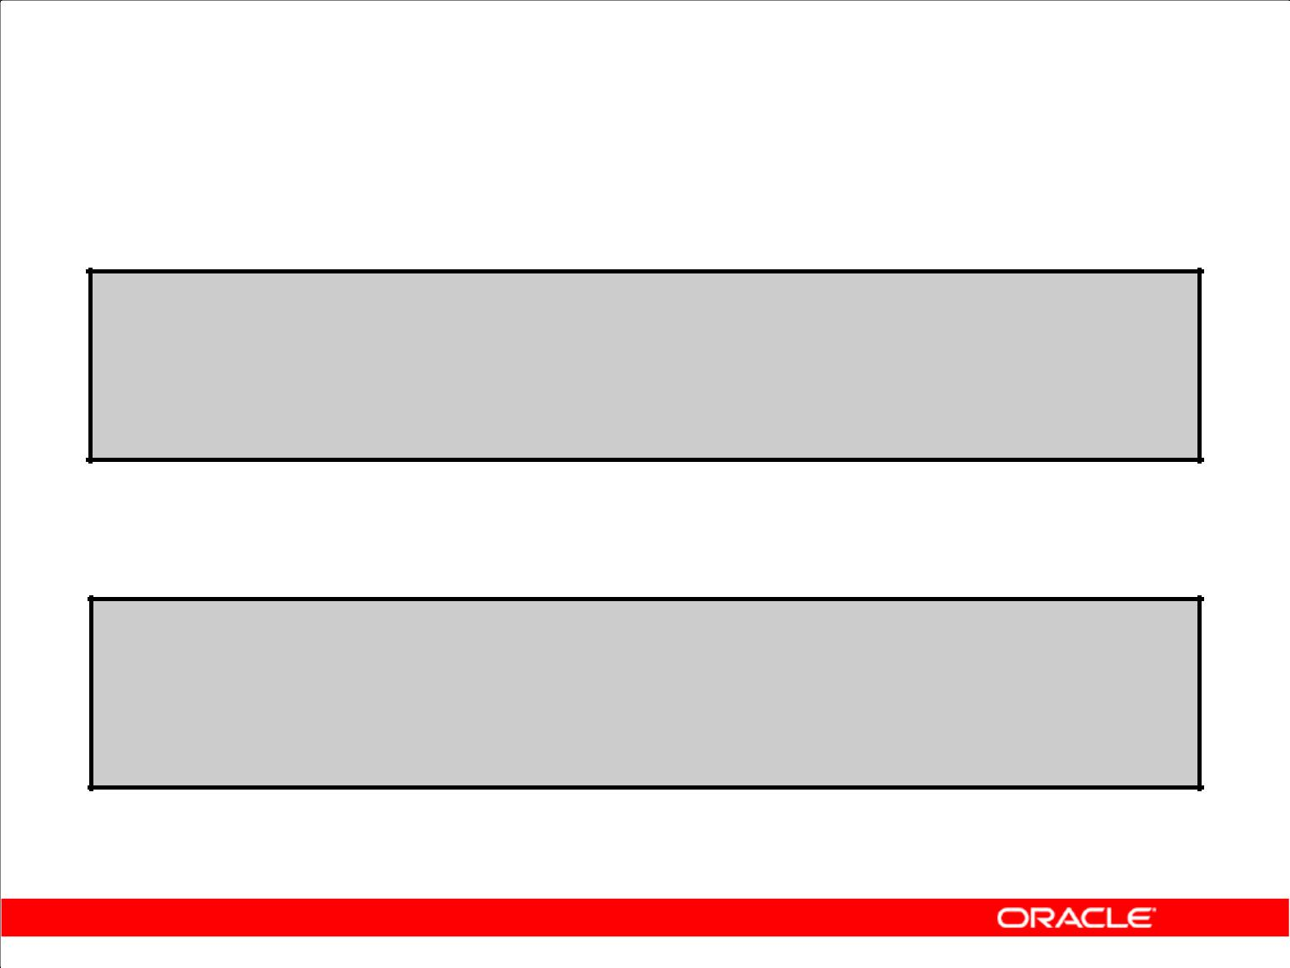**Granting Object Privileges**

1. Grant query privileges on the EMPLOYEES table:

**GRANT select**

**ON** **employees**

**TO** **sue, rich;**

**GRANT succeeded.**

1. Grant privileges to update specific columns to users and roles:

**GRANT update (department_name, location_id)**

**ON** **departments**

**TO** **scott, manager;**

**GRANT succeeded.**

Copyright © 2009, Oracle. All rights reserved.

**Guidelines**

1. To grant privileges on an object, the object must be in your own schema, or you must have been granted the object privileges WITH GRANT OPTION.
2. An object owner can grant any object privilege on the object to any other user or role of the database.
3. The owner of an object automatically acquires all object privileges on that object.

The first example in the slide grants users Sue and Rich the privilege to query your EMPLOYEES table. The second example grants UPDATE privileges on specific columns in the DEPARTMENTS table to Scott and to the manager role.

If Sue or Rich now want to use a SELECT statement to obtain data from the EMPLOYEES table, the syntax they must use is:

SELECT * FROM HR.employees;

Alternatively, they can create a synonym for the table and issue a SELECT statement from the synonym:

CREATE SYNONYM emp FOR HR.employees;

SELECT * FROM emp;

**Note:** DBAs generally allocate system privileges; any user who owns an object can grant objectprivileges.

|  |
| --- |
| Oracle Internal & Oracle Academy Use Only |

**Oracle Database 10*g*: SQL Fundamentals II 1 - 14**

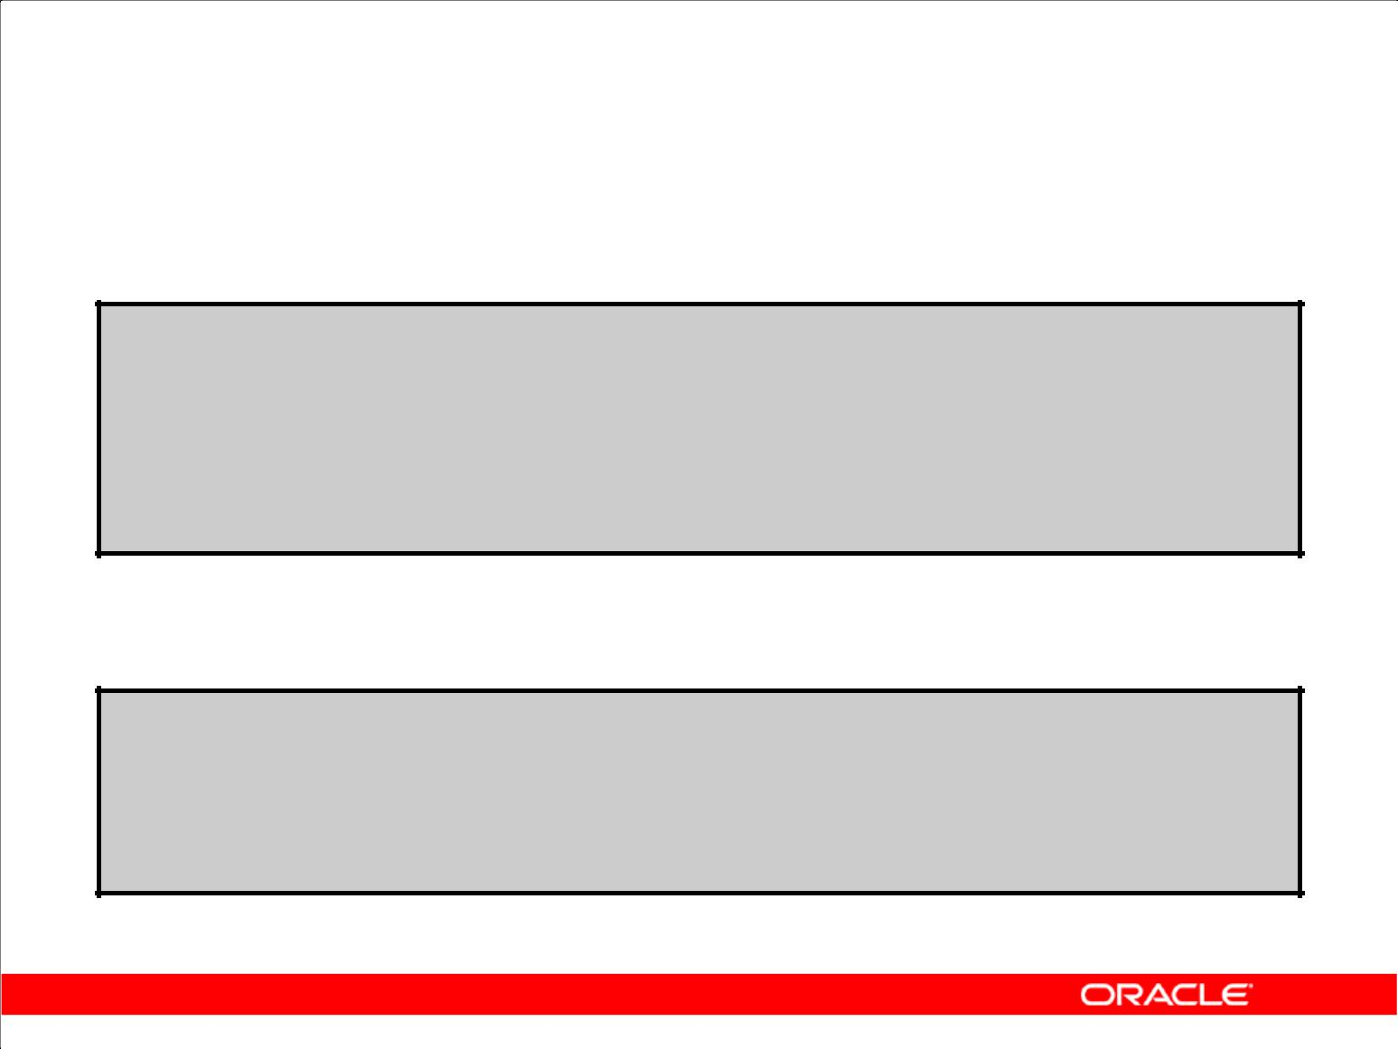**Passing On Your Privileges**

1. Give a user authority to pass along privileges:

**GRANT select, insert**

**ON** **departments**

**TO** **scott**

**WITH** **GRANT OPTION;**

**GRANT succeeded.**

1. Allow all users on the system to query data from Alice’s

DEPARTMENTS table:

**GRANT select**

**ON** **alice.departments**

**TO** **PUBLIC;**

**GRANT succeeded.**

Copyright © 2009, Oracle. All rights reserved.

**Passing On Your Privileges**

**WITH GRANT OPTION Keyword**

A privilege that is granted with the WITH GRANT OPTION clause can be passed on to other users and roles by the grantee. Object privileges granted with the WITH GRANT OPTION clause are revoked when the grantor’s privilege is revoked.

The example in the slide gives user Scott access to your DEPARTMENTS table with the privileges to query the table and add rows to the table. The example also shows that Scott can give others these privileges.

**PUBLIC Keyword**

An owner of a table can grant access to all users by using the PUBLIC keyword.

The second example allows all users on the system to query data from Alice’s DEPARTMENTS table.

|  |
| --- |
| Oracle Internal & Oracle Academy Use Only |

**Oracle Database 10*g*: SQL Fundamentals II 1 - 15**

**Confirming Privileges Granted**

|  |  |  |
| --- | --- | --- |
| **Data Dictionary View** | **Description** |  |
|  |  |  |
|  |  |  |
| ROLE_SYS_PRIVS | System privileges granted to roles |  |
|  |  |  |
| ROLE_TAB_PRIVS | Table privileges granted to roles |  |
|  |  |  |
| USER_ROLE_PRIVS | Roles accessible by the user |  |
|  |  |  |
| USER_TAB_PRIVS_MADE | Object privileges granted on the user’s | objects |
|  |  |  |
| USER_TAB_PRIVS_RECD | Object privileges granted to the user |  |
|  |  | |
| USER_COL_PRIVS_MADE | Object privileges granted on the columns of the | |
|  | user’s objects |  |
|  |  |  |
| USER_COL_PRIVS_RECD | Object privileges granted to the user on | specific |
|  | columns |  |
|  |  |  |
| USER_SYS_PRIVS | System privileges granted to the user |  |
|  |  |  |

Copyright © 2009, Oracle. All rights reserved.

**Confirming Granted Privileges**

If you attempt to perform an unauthorized operation, such as deleting a row from a table for which you do not have the DELETE privilege, the Oracle server does not permit the operation to take place.

If you receive the Oracle server error message “Table or view does not exist,” then you have done either of the following:

1. Named a table or view that does not exist
2. Attempted to perform an operation on a table or view for which you do not have the appropriate privilege

You can access the data dictionary to view the privileges that you have. The chart in the slide describes various data dictionary views.

|  |
| --- |
| Oracle Internal & Oracle Academy Use Only |

**Oracle Database 10*g*: SQL Fundamentals II 1 - 16**

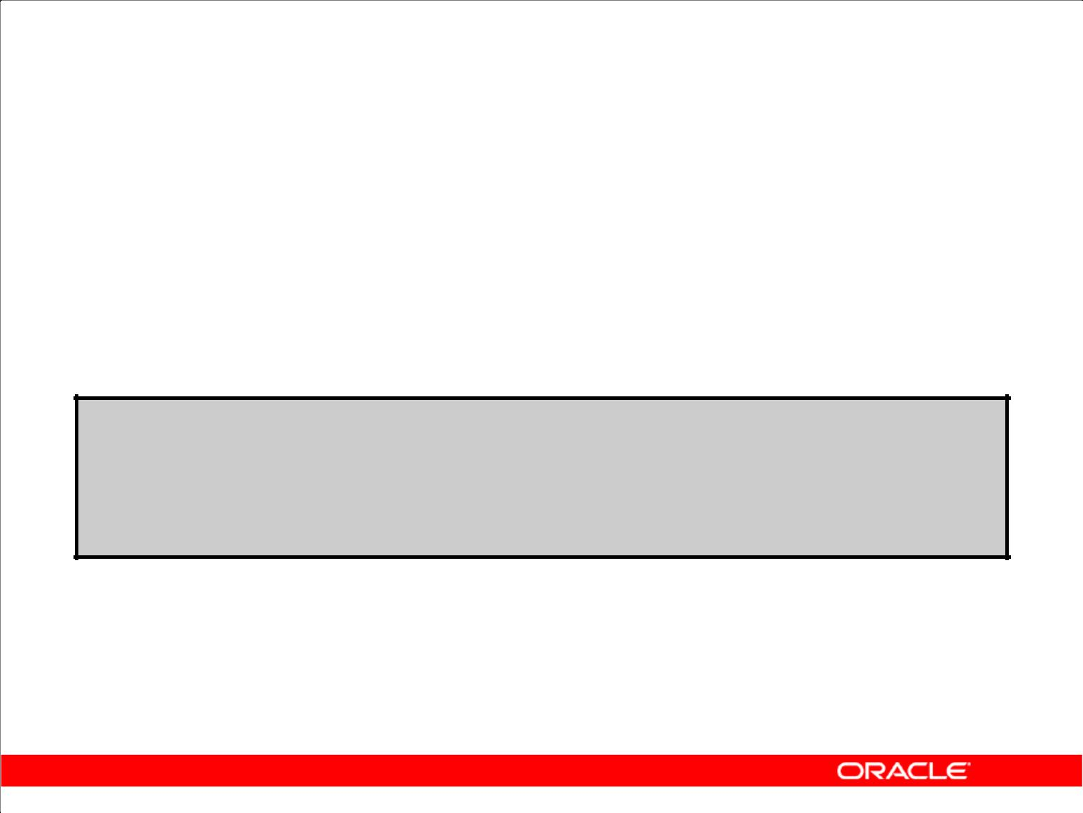**Revoking Object Privileges**

1. You use the REVOKE statement to revoke privileges granted to other users.
2. Privileges granted to others through the WITH GRANT OPTION clause are also revoked.

**REVOKE {privilege [, privilege...]|ALL}**

**ON** **object**

**FROM {user[, user...]|role|PUBLIC} [CASCADE CONSTRAINTS];**

Copyright © 2009, Oracle. All rights reserved.

**Revoking Object Privileges**

You can remove privileges granted to other users by using the REVOKE statement. When you use the REVOKE statement, the privileges that you specify are revoked from the users you name and from any other users to whom those privileges were granted by the revoked user.

In the syntax:

CASCADE is required to remove any referential integrity constraints made to the CONSTRAINTS object by means of the REFERENCES privilege

For more information, see *Oracle Database10g SQL Reference*.

**Note:** If a user were to leave the company and you revoke his privileges, you must regrant anyprivileges that this user may have granted to other users. If you drop the user account without revoking privileges from it, then the system privileges granted by this user to other users are not affected by this action.

|  |
| --- |
| Oracle Internal & Oracle Academy Use Only |

**Oracle Database 10*g*: SQL Fundamentals II 1 - 17**

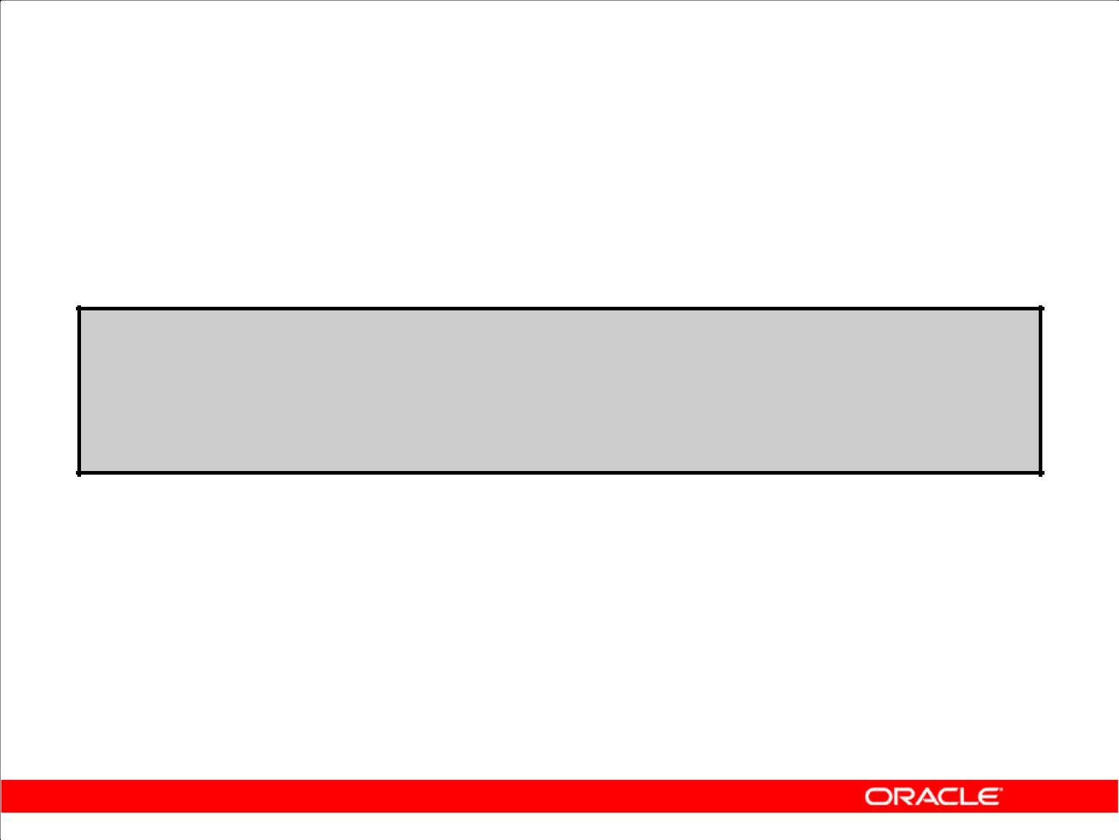**Revoking Object Privileges**

As user Alice, revoke the SELECT and INSERT privileges given to user Scott on the DEPARTMENTS table.

**REVOKE select, insert**

**ON** **departments**

**FROM** **scott;**

**REVOKE succeeded.**

Copyright © 2009, Oracle. All rights reserved.

**Revoking Object Privileges (continued)**

The example in the slide revokes SELECT and INSERT privileges given to user Scott on the DEPARTMENTS table.

**Note:** If a user is granted a privilege with theWITH GRANT OPTIONclause, that user can also grantthe privilege with the WITH GRANT OPTION clause, so that a long chain of grantees is possible, but no circular grants (granting to a grant ancestor) are permitted. If the owner revokes a privilege from a user who granted the privilege to other users, then the revoking cascades to all the privileges granted.

For example, if user A grants a SELECT privilege on a table to user B including the WITH GRANT OPTION clause, user B can grant to user C the SELECT privilege with the WITH GRANT OPTION clause as well, and user C can then grant to user D the SELECT privilege. If user A revokes privileges from user B, then the privileges granted to users C and D are also revoked.

|  |
| --- |
| Oracle Internal & Oracle Academy Use Only |

**Oracle Database 10*g*: SQL Fundamentals II 1 - 18**

**Summary**

In this lesson, you should have learned about statements that control access to the database and database objects.

|  |  |
| --- | --- |
| **Statement** | **Action** |
|  |  |
|  |  |
| CREATE USER | Creates a user (usually performed by a DBA) |
|  |  |
| GRANT | Gives other users privileges to access the objects |
|  |  |
| CREATE ROLE | Creates a collection of privileges (usually performed by |
|  | a DBA) |
|  |  |
| ALTER USER | Changes a user’s password |
|  |  |
| REVOKE | Removes privileges on an object from users |
|  |  |

Copyright © 2009, Oracle. All rights reserved.

**Summary**

DBAs establish initial database security for users by assigning privileges to the users.

1. The DBA creates users who must have a password. The DBA is also responsible for establishing the initial system privileges for a user.
2. After the user has created an object, the user can pass along any of the available object privileges to other users or to all users by using the GRANT statement.
3. A DBA can create roles by using the CREATE ROLE statement to pass along a collection of system or object privileges to multiple users. Roles make granting and revoking privileges easier to maintain.
4. Users can change their password by using the ALTER USER statement.
5. You can remove privileges from users by using the REVOKE statement.
6. With data dictionary views, users can view the privileges granted to them and those that are granted on their objects.
7. With database links, you can access data on remote databases. Privileges cannot be granted on remote objects.

|  |
| --- |
| Oracle Internal & Oracle Academy Use Only |

**Oracle Database 10*g*: SQL Fundamentals II 1 - 19**

**Practice 1: Overview**

This practice covers the following topics:

1. Granting other users privileges to your table
2. Modifying another user’s table through the privileges granted to you
3. Creating a synonym
4. Querying the data dictionary views related to privileges

Copyright © 2009, Oracle. All rights reserved.

**Practice 1: Overview**

In this exercise, you practice controlling access to the database objects. You use two accounts:

ora21 and ora22.

|  |
| --- |
| Oracle Internal & Oracle Academy Use Only |

**Oracle Database 10*g*: SQL Fundamentals II 1 - 20**

**Practice 1**

To complete question 6 and the subsequent ones, you need to connect to the database using SQL Developer. To do so, double-click the SQL Developer icon on the desktop.

To create a new database connection in the Connections Navigator, right-click Connections. Select New Connection from the shortcut menu. The New/Select Database Connection dialog box appears.

Create a database connection using the following information:

1. Connection Name: ora21
2. Username: ora21
3. Password: ora21
4. Hostname: localhost
5. Port: 1521
6. SID: ORCL
7. Ensure that you select the Save Password check box.

Create another database connection using the following information:

1. Connection Name: ora22
2. Username: ora22
3. Password: ora22
4. Hostname: localhost
5. Port: 1521
6. SID: ORCL
7. Ensure that you select the Save Password check box.
8. Which privilege should a user be given to log on to the Oracle server? Is this a system or an object privilege?

_____________________________________________________________________

1. Which privilege should a user be given to create tables?

_____________________________________________________________________

1. If you create a table, who can pass along privileges to other users on your table?

_____________________________________________________________________

1. You are the DBA. You are creating many users who require the same system privileges. What should you use to make your job easier?

_____________________________________________________________________

1. Which command would you use to change your password?

_____________________________________________________________________

|  |
| --- |
| Oracle Internal & Oracle Academy Use Only |

**Oracle Database 10*g*: SQL Fundamentals II 1 - 21**

**Practice 1 (continued)**

6. Connect as user ora21. Query all the rows in your DEPARTMENTS table.

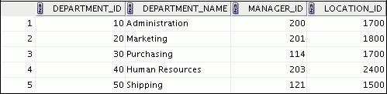

**…**



1. Add a new row to your DEPARTMENTS table. Add Education as department number 500.
2. Grant user ora22 access to your DEPARTMENTS table.
3. Connect as user ora22. Query user ora21’s DEPARTMENTS table.

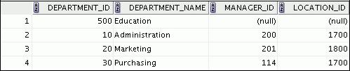

**…**



1. Create a synonym for user ora21’s DEPARTMENTS table. Query all the rows in user ora21’s DEPARTMENTS table by using your synonym.

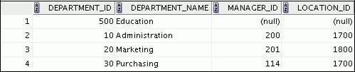

**…**



|  |
| --- |
| Oracle Internal & Oracle Academy Use Only |

**Oracle Database 10*g*: SQL Fundamentals II 1 - 22**

**Practice 1 (continued)**

1. As user ora22, query the USER_TABLES data dictionary to see information about the tables that you own.

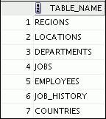

1. As user ora22, query the ALL_TABLES data dictionary view to see information about all the tables that you can access. Exclude the tables that you own.

**Note:** Your list may not exactly match the following list:

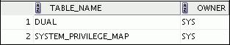

**…**

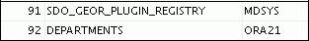

1. Connect as user ora21 and revoke the SELECT privilege from user ora22.
2. Remove the row that you inserted into the DEPARTMENTS table in step 7 and save the changes.

|  |
| --- |
| Oracle Internal & Oracle Academy Use Only |

**Oracle Database 10*g*: SQL Fundamentals II 1 - 23**

Oracle Internal & Oracle Academy Use Only



**Managing Schema Objects**

Copyright © 2009, Oracle. All rights reserved.

|  |
| --- |
| Oracle Internal & Oracle Academy Use Only |

**Objectives**

After completing this lesson, you should be able to do the following:

1. Add constraints
2. Create indexes
3. Create indexes using the CREATE TABLE statement
4. Creating function-based indexes
5. Drop columns and set column UNUSED
6. Perform FLASHBACK operations
7. Create and use external tables

Copyright © 2009, Oracle. All rights reserved.

**Objectives**

This lesson contains information about creating indexes and constraints, and altering existing objects. You also learn about external tables, and the provision to name the index at the time of creating a primary key constraint.

|  |
| --- |
| Oracle Internal & Oracle Academy Use Only |

**Oracle Database 10*g*: SQL Fundamentals II 2 - 2**

**ALTER TABLE Statement**

Use the ALTER TABLE statement to:

1. Add a new column
2. Modify an existing column
3. Define a default value for the new column
4. Drop a column

Copyright © 2009, Oracle. All rights reserved.

**ALTER TABLE Statement**

After you create a table, you may need to change the table structure because you omitted a column, your column definition needs to be changed, or you need to remove columns. You can do this by using the ALTER TABLE statement.

|  |
| --- |
| Oracle Internal & Oracle Academy Use Only |

**Oracle Database 10*g*: SQL Fundamentals II 2 - 3**

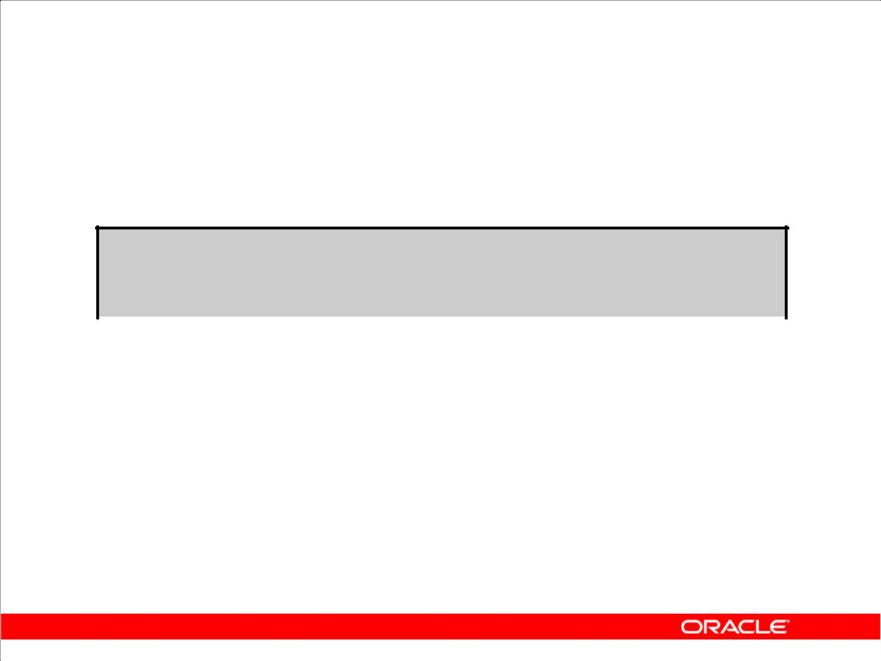**ALTER TABLE Statement**

Use the ALTER TABLE statement to add, modify, or drop columns:

**ALTER TABLE *table***

|  |  |
| --- | --- |
| **ADD** | **(*column datatype* [DEFAULT *expr*]** |
|  | **[, *column datatype* ]...);** |
|  | |
| **ALTER TABLE *table*** | |
| **MODIFY** | **(*column datatype* [DEFAULT *expr*]** |
|  | **[, *column datatype*]...);** |
|  | |
| **ALTER TABLE *table*** | |
| **DROP** | **(*column*);** |
|  |  |

Copyright © 2009, Oracle. All rights reserved.

**ALTER TABLE Statement (continued)**

You can add columns to a table, modify columns, and drop columns from a table by using the ALTER TABLE statement.

|  |  |
| --- | --- |
| In the syntax: | Is the name of the table |
| *table* |
| ADD|MODIFY|DROP | Is the type of modification |
| *column* | Is the name of the new column |
| *datatype* | Is the data type and length of the new column |
| DEFAULT *expr* | Specifies the default value for a new column |

|  |
| --- |
| Oracle Internal & Oracle Academy Use Only |

**Oracle Database 10*g*: SQL Fundamentals II 2 - 4**

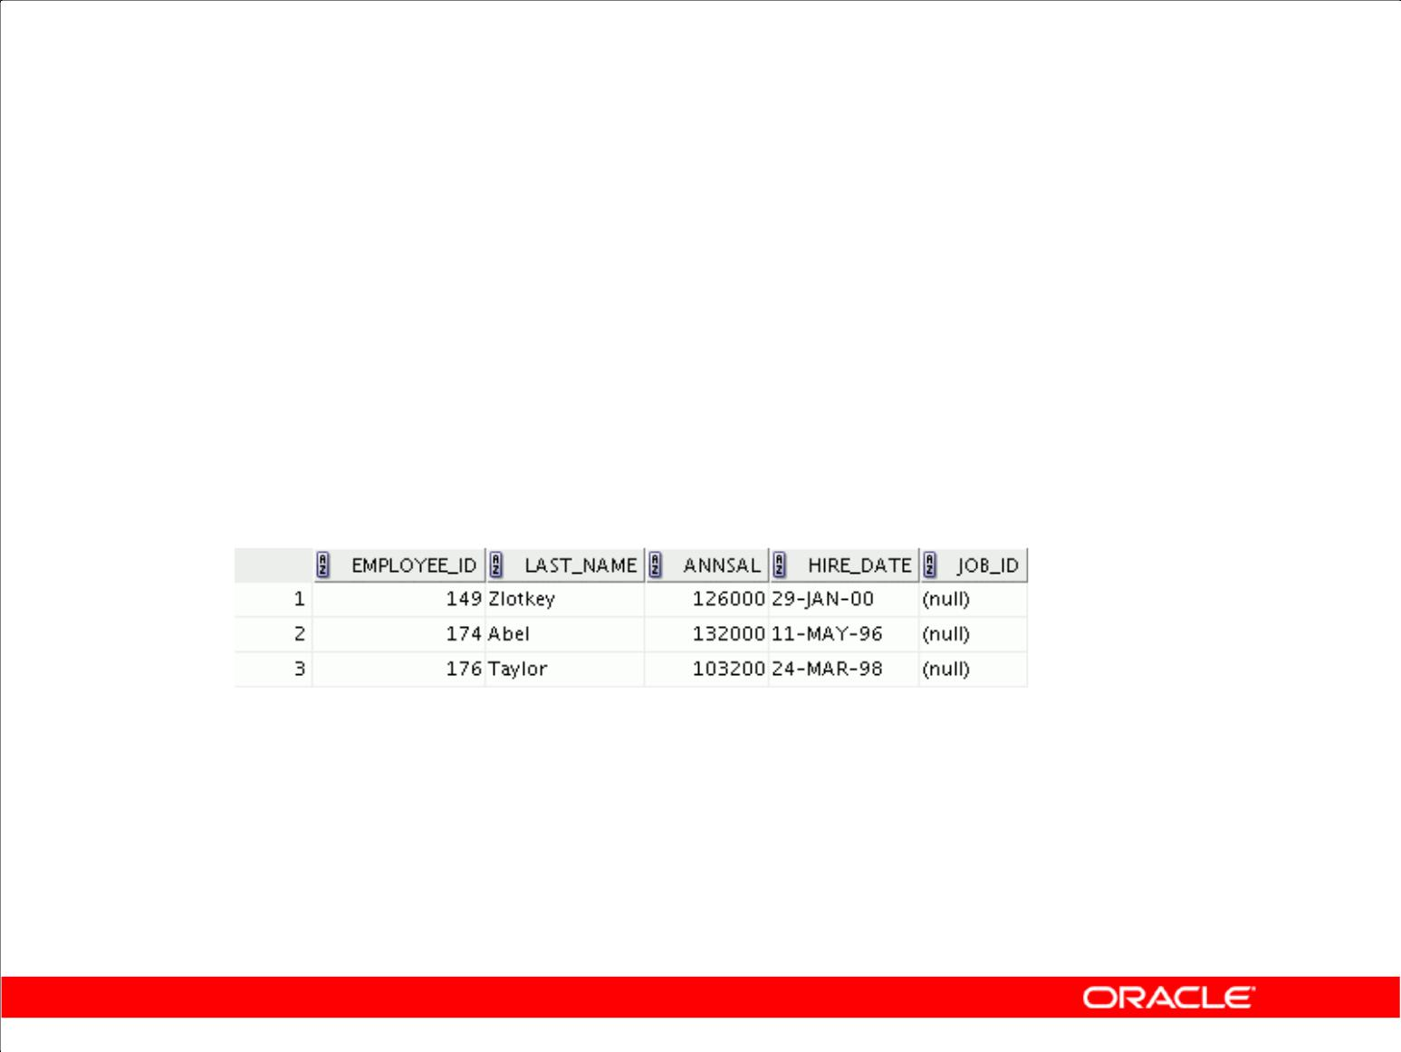**Adding a Column**

|  |  |  |  |  |  |
| --- | --- | --- | --- | --- | --- |
| • | You use the ADD clause to add columns: | | | | |
|  |  |  | |  |  |
|  | **ALTER TABLE** | | | **dept80** | |
|  | **ADD** | | **(job_id VARCHAR2(9));** | | |
|  | **ALTER TABLE** | | | **succeeded.** | |
|  |  |  | | |  |
| • | The new column becomes the last column: | | | | |
|  |  |  |  |  |  |
|  |  |  |  |  |  |

Copyright © 2009, Oracle. All rights reserved.

**Guidelines for Adding a Column**

1. You can add or modify columns.
2. You cannot specify where the column is to appear. The new column becomes the last column.

The example in the slide adds a column named JOB_ID to the DEPT80 table. The JOB_ID column becomes the last column in the table.

**Note:** If a table already contains rows when a column is added, then the new column is initially nullfor all the rows. You cannot add a mandatory NOT NULL column to a table that contains data in the other columns. You can only add a NOT NULL column to an empty table.

|  |
| --- |
| Oracle Internal & Oracle Academy Use Only |

**Oracle Database 10*g*: SQL Fundamentals II 2 - 5**

**Modifying a Column**

• You can change a column’s data type, size, and default value.

|  |  |  |
| --- | --- | --- |
| **ALTER** | **TABLE dept80** | |
| **MODIFY** | | **(last_name VARCHAR2(30));** |
| **ALTER** | **TABLE succeeded.** | |
|  |  |  |

• A change to the default value affects only subsequent insertions to the table.

Copyright © 2009, Oracle. All rights reserved.

**Modifying a Column**

You can modify a column definition by using the ALTER TABLE statement with the MODIFY clause.

Column modification can include changes to a column’s data type, size, and default value.

**Guidelines**

1. You can increase the width or precision of a numeric column.
2. You can increase the width of numeric or character columns.
3. You can decrease the width of a column if:
   1. The column contains only null values
   2. The table has no rows
   3. The decrease in column width is not less than the existing values in that column
4. You can change the data type if the column contains only null values. The exception to this is CHAR-to-VARCHAR2 conversions, which can be done with data in the columns.
5. You can convert a CHAR column to the VARCHAR2 data type or convert a VARCHAR2 column to the CHAR data type only if the column contains null values or if you do not change the size.
6. A change to the default value of a column affects only subsequent insertions to the table.

|  |
| --- |
| Oracle Internal & Oracle Academy Use Only |

**Oracle Database 10*g*: SQL Fundamentals II 2 - 6**

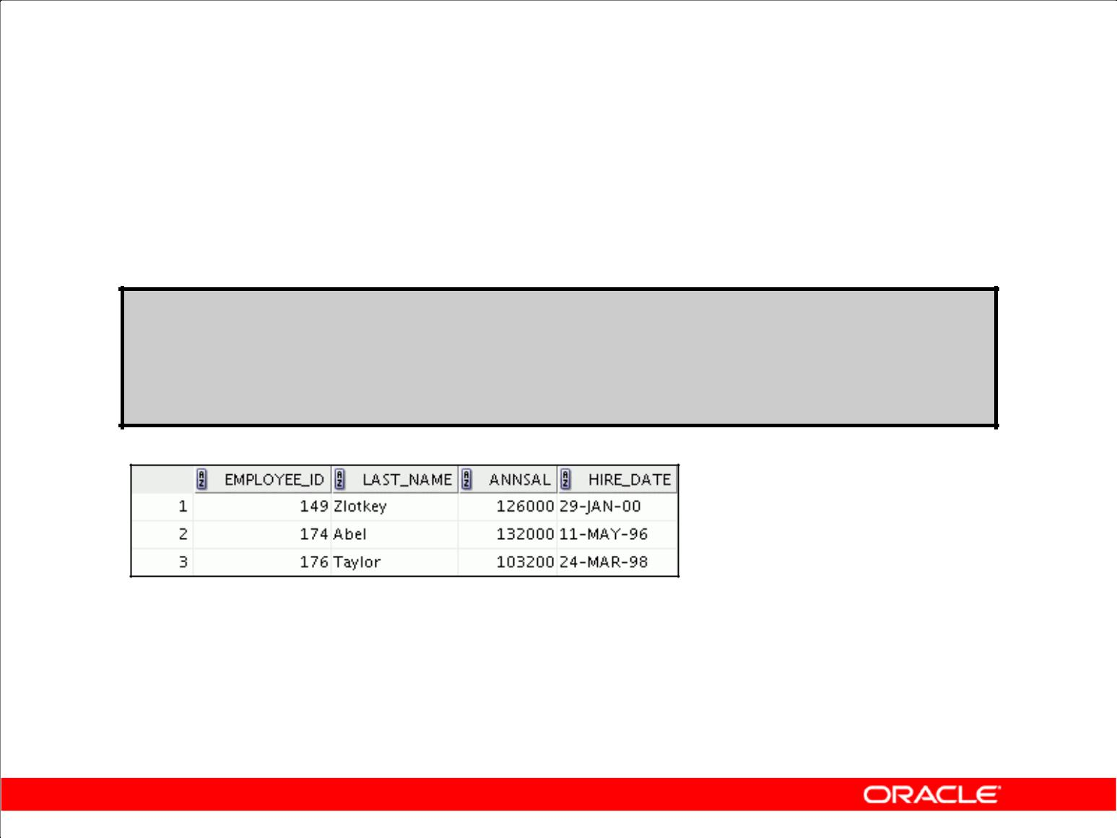**Dropping a Column**

Use the DROP COLUMN clause to drop columns you no longer need from the table:

**ALTER TABLE** **dept80**

**DROP COLUMN** **job_id;**

**ALTER TABLE succeeded.**

Copyright © 2009, Oracle. All rights reserved.

**Dropping a Column**

You can drop a column from a table by using the ALTER TABLE statement with the DROP COLUMN clause.

**Guidelines**

1. The column may or may not contain data.
2. Using the ALTER TABLE statement, only one column can be dropped at a time.
3. The table must have at least one column remaining in it after it is altered.
4. After a column is dropped, it cannot be recovered.
5. A column cannot be dropped if it is part of a constraint or part of an index key unless the cascade option is added.
6. Dropping a column can take a while if the column has a large number of values. In this case, it may be better to set it to be unused and drop it when there are fewer users on the system to avoid extended locks.

**Note:** Certain columns can never be dropped such as columns that form part of the partitioning keyof a partitioned table or columns that form part of the primary key of an index-organized table.

|  |
| --- |
| Oracle Internal & Oracle Academy Use Only |

**Oracle Database 10*g*: SQL Fundamentals II 2 - 7**

**SET UNUSED Option**

1. You use the SET UNUSED option to mark one or more columns as unused.
2. You use the DROP UNUSED COLUMNS option to remove the columns that are marked as unused.

|  |  |  |  |
| --- | --- | --- | --- |
|  | **ALTER** | **TABLE** | **<*table_name>*** |
|  | **SET** | **UNUSED(<** | ***column_name>*);** |
|  | **OR** |  |  |
|  | **ALTER** | **TABLE** | ***<table_name>*** |
|  | **SET** | **UNUSED** | **COLUMN *<column_name>;*** |
|  |  |  |  |
|  |  |  | |
|  | **ALTER** | **TABLE <*table_name>*** | |
|  | **DROP** | **UNUSED** | **COLUMNS;** |
|  |  |  |  |

Copyright © 2009, Oracle. All rights reserved.

**SET UNUSED Option**

The SET UNUSED option marks one or more columns as unused so that they can be dropped when the demand on system resources is lower. Specifying this clause does not actually remove the target columns from each row in the table (that is, it does not restore the disk space used by these columns). Therefore, the response time is faster than if you executed the DROP clause. Unused columns are

treated as if they were dropped, even though their column data remains in the table’s rows. After a column has been marked as unused, you have no access to that column. A SELECT * query will not

retrieve data from unused columns. In addition, the names and types of columns marked unused will not be displayed during a DESCRIBE statement, and you can add to the table a new column with the same name as an unused column. SET UNUSED information is stored in the

USER_UNUSED_COL_TABS dictionary view.

**Note:** The guidelines for setting a column to beUNUSEDare similar to those of dropping a column.

|  |
| --- |
| Oracle Internal & Oracle Academy Use Only |

**Oracle Database 10*g*: SQL Fundamentals II 2 - 8**

**DROP UNUSED COLUMNS Option**

DROP UNUSED COLUMNS removes from the table all columns currently marked as unused. You can use this statement when you want to reclaim the extra disk space from unused columns in the table. If the table contains no unused columns, the statement returns with no errors.

|  |  |  |
| --- | --- | --- |
| ALTER | TABLE | dept80 |
| SET | UNUSED | (last_name); |
| ALTER | TABLE succeeded. | |
| ALTER | TABLE | dept80 |
| DROP | UNUSED | COLUMNS; |
| ALTER | TABLE succeeded. | |

|  |
| --- |
| Oracle Internal & Oracle Academy Use Only |

**Oracle Database 10*g*: SQL Fundamentals II 2 - 9**

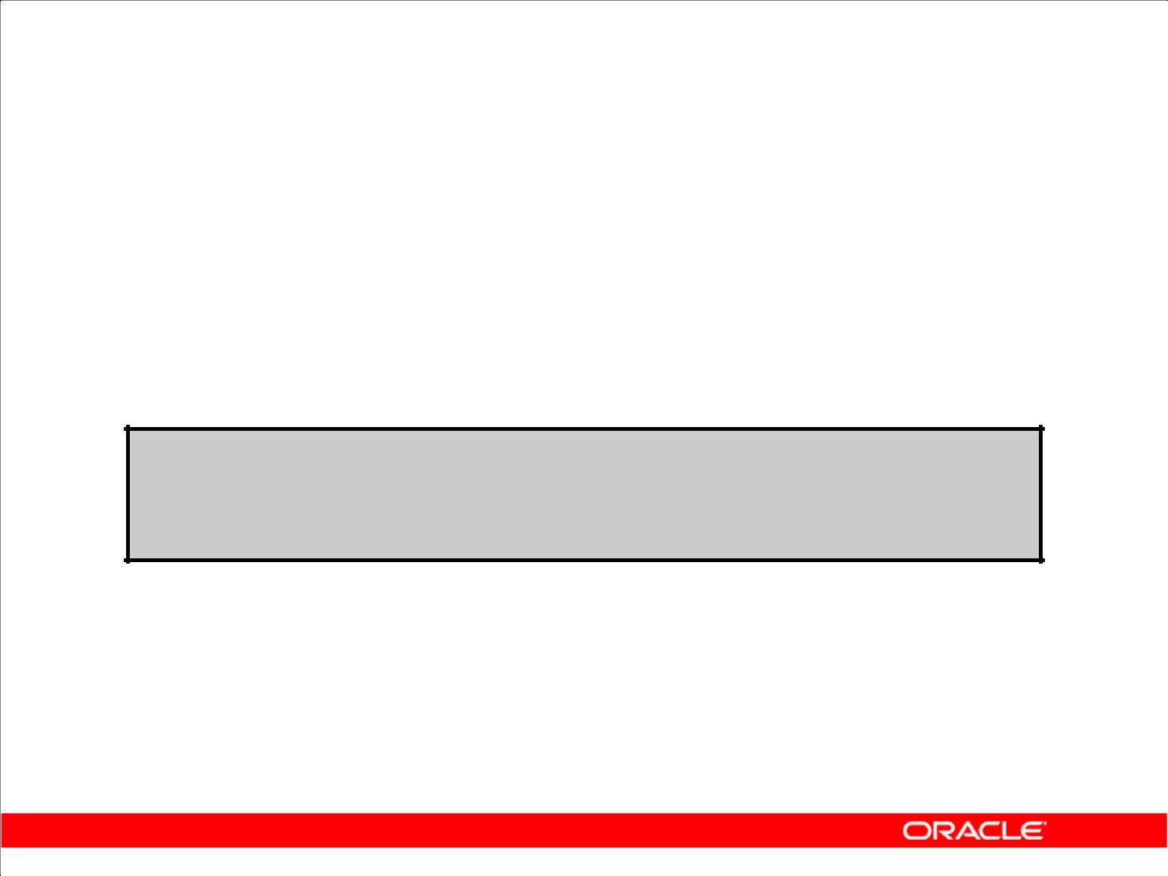**Adding a Constraint Syntax**

Use the ALTER TABLE statement to:

1. Add or drop a constraint, but not modify its structure
2. Enable or disable constraints
3. Add a NOT NULL constraint by using the MODIFY clause

**ALTER TABLE** **<*table_name>***

**ADD [CONSTRAINT <*constraint_name>*]**

***type* (<*column_name>*);**

Copyright © 2009, Oracle. All rights reserved.

**Adding a Constraint**

You can add a constraint for existing tables by using the ALTER TABLE statement with the ADD clause.

|  |  |
| --- | --- |
| In the syntax: | Is the name of the table |
| *table* |
| *constraint* | Is the name of the constraint |
| *type* | Is the constraint type |
| *column* | Is the name of the column affected by the constraint |

The constraint name syntax is optional, although recommended. If you do not name your constraints, the system generates constraint names.

**Guidelines**

1. You can add, drop, enable, or disable a constraint, but you cannot modify its structure.
2. You can add a NOT NULL constraint to an existing column by using the MODIFY clause of the

ALTER TABLE statement.

**Note:** You can define aNOT NULLcolumn only if the table is empty or if the column has a value forevery row.

|  |
| --- |
| Oracle Internal & Oracle Academy Use Only |

**Oracle Database 10*g*: SQL Fundamentals II 2 - 10**

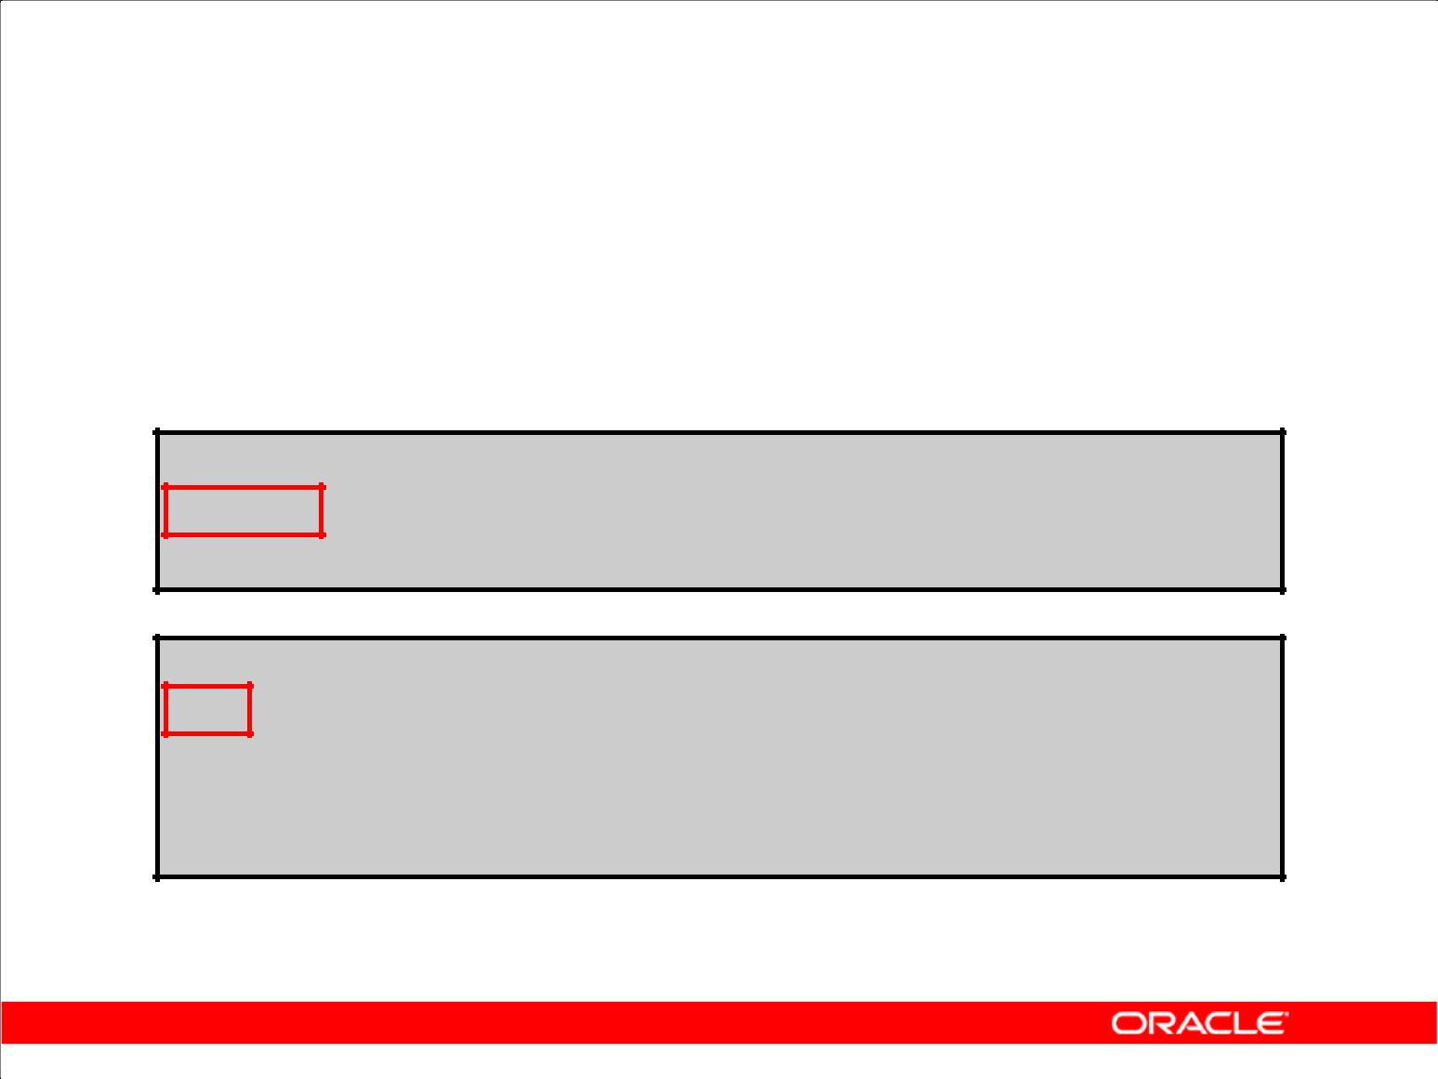**Adding a Constraint**

Add a FOREIGN KEY constraint to the EMP2 table indicating that a manager must already exist as a valid employee in the EMP2 table.

**ALTER TABLE emp2**

**modify employee_id Primary Key; ALTER TABLE succeeded.**

**ALTER TABLE emp2**

**ADD CONSTRAINT emp_mgr_fk**

**FOREIGN KEY(manager_id)**

**REFERENCES emp2(employee_id);**

**ALTER TABLE succeeded.**

Copyright © 2009, Oracle. All rights reserved.

**Adding a Constraint (continued)**

The first example in the slide modifies the EMP2 table to add a PRIMARY KEY constraint on the EMPLOYEE_ID column. Note that because no constraint name is provided, the constraint is automatically named by the Oracle server. The second example in the slide creates a FOREIGN KEY constraint on the EMP2 table. The constraint ensures that a manager exists as a valid employee in the EMP2 table.

|  |
| --- |
| Oracle Internal & Oracle Academy Use Only |

**Oracle Database 10*g*: SQL Fundamentals II 2 - 11**

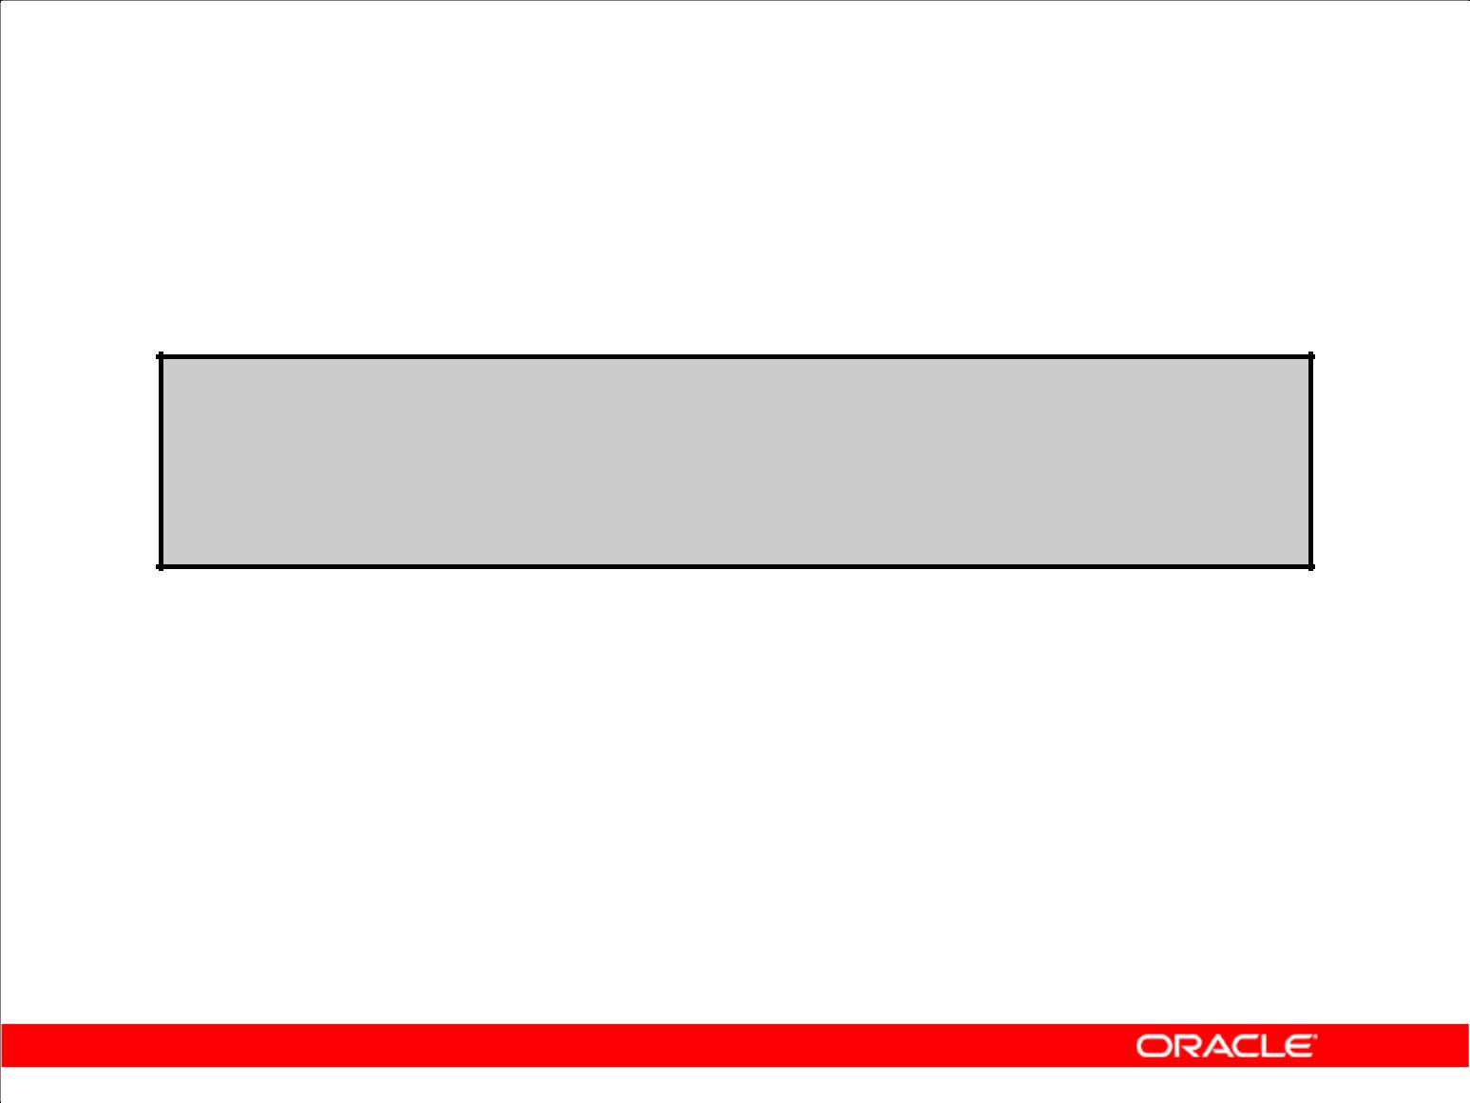**ON DELETE CASCADE**

Delete child rows when a parent key is deleted:

**ALTER TABLE Emp2 ADD CONSTRAINT emp_dt_fk**

**FOREIGN KEY (Department_id)**

**REFERENCES departments ON DELETE CASCADE);**

**ALTER TABLE succeeded.**

Copyright © 2009, Oracle. All rights reserved.

**ON DELETE CASCADE**

The ON DELETE CASCADE action allows parent key data that is referenced from the child table to be deleted, but not updated. When data in the parent key is deleted, all rows in the child table that depend on the deleted parent key values are also deleted. To specify this referential action, include the ON DELETE CASCADE option in the definition of the FOREIGN KEY constraint.

|  |
| --- |
| Oracle Internal & Oracle Academy Use Only |

**Oracle Database 10*g*: SQL Fundamentals II 2 - 12**

**Deferring Constraints**

Constraints can have the following attributes:

1. DEFERRABLE or NOT DEFERRABLE
2. INITIALLY DEFERRED or INITIALLY IMMEDIATE

|  |  |  |  |  |  |  |  |  |  |
| --- | --- | --- | --- | --- | --- | --- | --- | --- | --- |
|  |  |  |  |  |  |  |  |  |  |
|  | **ALTER TABLE dept2** | | | |  | **Deferring constraint on** | | | |
|  | **ADD CONSTRAINT dept2_id_pk** | | | |  | **creation** | | |  |
|  |  |  |  |  |  |
|  | **PRIMARY KEY (department_id)** | | | |  |  |  |  |  |
|  | **DEFERRABLE INITIALLY DEFERRED** | | | |  |  |  |  |  |
|  |  |  |  |  |  |  |  |  |  |
|  |  |  |  |  |  |  |  |  |  |
|  |  |  |  |  |  |  |  |  | **Changing a specific** |
|  | **SET CONSTRAINTS dept2_id_pk** | | | **IMMEDIATE** | | |  |  |
|  |  |  | **constraint attribute** |
|  |  |  |  |  |  |  |  |  |  |
|  | **ALTER SESSION** | | | |  | **Changing all constraints for a** | | | |
|  | **SET CONSTRAINTS=** | **IMMEDIATE** |  |  |  | **session** | | |  |
|  |  |  |  |  |  |  |  |  |  |

Copyright © 2009, Oracle. All rights reserved.

**Deferring Constraints**

You can defer checking constraints for validity until the end of the transaction. A constraint is deferred if the system checks that it is satisfied only on commit. If a deferred constraint is violated, then commit causes the transaction to roll back. If a constraint is immediate (not deferred), then it is checked at the end of each statement. If it is violated, the statement is rolled back immediately. If a constraint causes an action (for example, DELETE CASCADE), that action is always taken as part of the statement that caused it, whether the constraint is deferred or immediate. Use the SET CONSTRAINTS statement to specify, for a particular transaction, whether a deferrable constraint is checked following each DML statement or when the transaction is committed. To create deferrable constraints, you must create a nonunique index for that constraint.

You can define constraints as either deferrable or not deferrable, and either initially deferred or initially immediate. These attributes can be different for each constraint.

**Usage scenario:** Company policy dictates that department number 40 should be changed to 45.Changing the DEPARTMENT_ID column affects employees assigned to this department. Therefore,

you make the primary key and foreign keys deferrable and initially deferred. You update both department and employee information, and at the time of commit, all rows are validated.

|  |
| --- |
| Oracle Internal & Oracle Academy Use Only |

**Oracle Database 10*g*: SQL Fundamentals II 2 - 13**

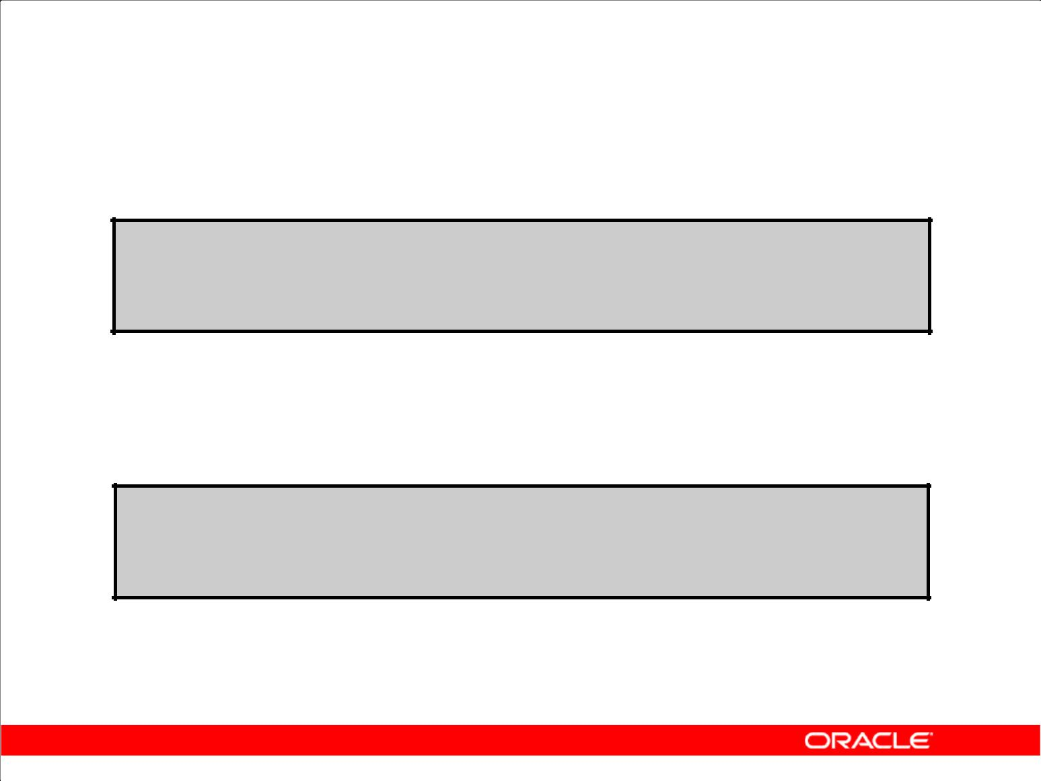**Dropping a Constraint**

1. Remove the manager constraint from the EMP2 table:

**ALTER TABLE emp2**

**DROP CONSTRAINT emp_mgr_fk;**

**ALTER TABLE succeeded.**

1. Remove the PRIMARY KEY constraint on the DEPT2 table and drop the associated FOREIGN KEY constraint on the

EMP2.DEPARTMENT_ID column:

**ALTER TABLE dept2**

**DROP PRIMARY KEY CASCADE;**

**ALTER TABLE succeeded.**

Copyright © 2009, Oracle. All rights reserved.

**Dropping a Constraint**

To drop a constraint, you can identify the constraint name from the USER_CONSTRAINTS and USER_CONS_COLUMNS data dictionary views. Then use the ALTER TABLE statement with the DROP clause. The CASCADE option of the DROP clause causes any dependent constraints also to be dropped.

**Syntax**

ALTER TABLE *table*

DROP PRIMARY KEY | UNIQUE (*column*) |

|  |  |
| --- | --- |
| CONSTRAINT | *constraint* [CASCADE]; |
| In the syntax: | Is the name of the table |
| *table* |
| *column* | Is the name of the column affected by the constraint |
| *constraint* | Is the name of the constraint |

When you drop an integrity constraint, that constraint is no longer enforced by the Oracle server and is no longer available in the data dictionary.

|  |
| --- |
| Oracle Internal & Oracle Academy Use Only |

**Oracle Database 10*g*: SQL Fundamentals II 2 - 14**

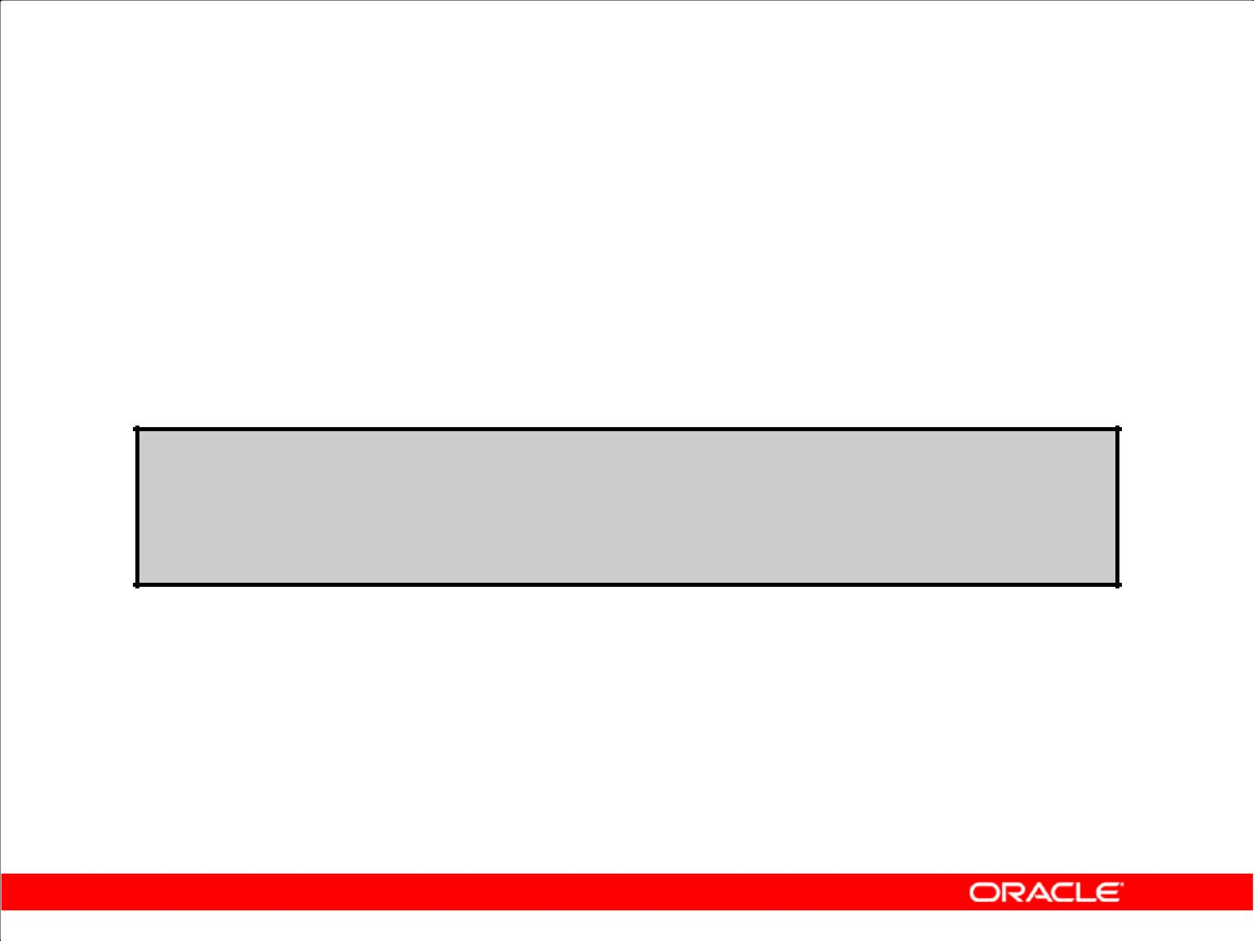**Disabling Constraints**

1. Execute the DISABLE clause of the ALTER TABLE statement to deactivate an integrity constraint.
2. Apply the CASCADE option to disable dependent integrity constraints.

**ALTER TABLE emp2**

**DISABLE CONSTRAINT emp_dt_fk;**

**ALTER TABLE succeeded.**

Copyright © 2009, Oracle. All rights reserved.

**Disabling a Constraint**

You can disable a constraint without dropping it or re-creating it by using the ALTER TABLE statement with the DISABLE clause.

**Syntax**

ALTER TABLE *table*

DISABLE CONSTRAINT *constraint* [CASCADE];

|  |  |
| --- | --- |
| In the syntax: | Is the name of the table |
| *table* |

*constraint* Is the name of the constraint

**Guidelines**

1. You can use the DISABLE clause in both the CREATE TABLE statement and the ALTER TABLE statement.
2. The CASCADE clause disables dependent integrity constraints.
3. Disabling a unique or primary key constraint removes the unique index.

|  |
| --- |
| Oracle Internal & Oracle Academy Use Only |

**Oracle Database 10*g*: SQL Fundamentals II 2 - 15**

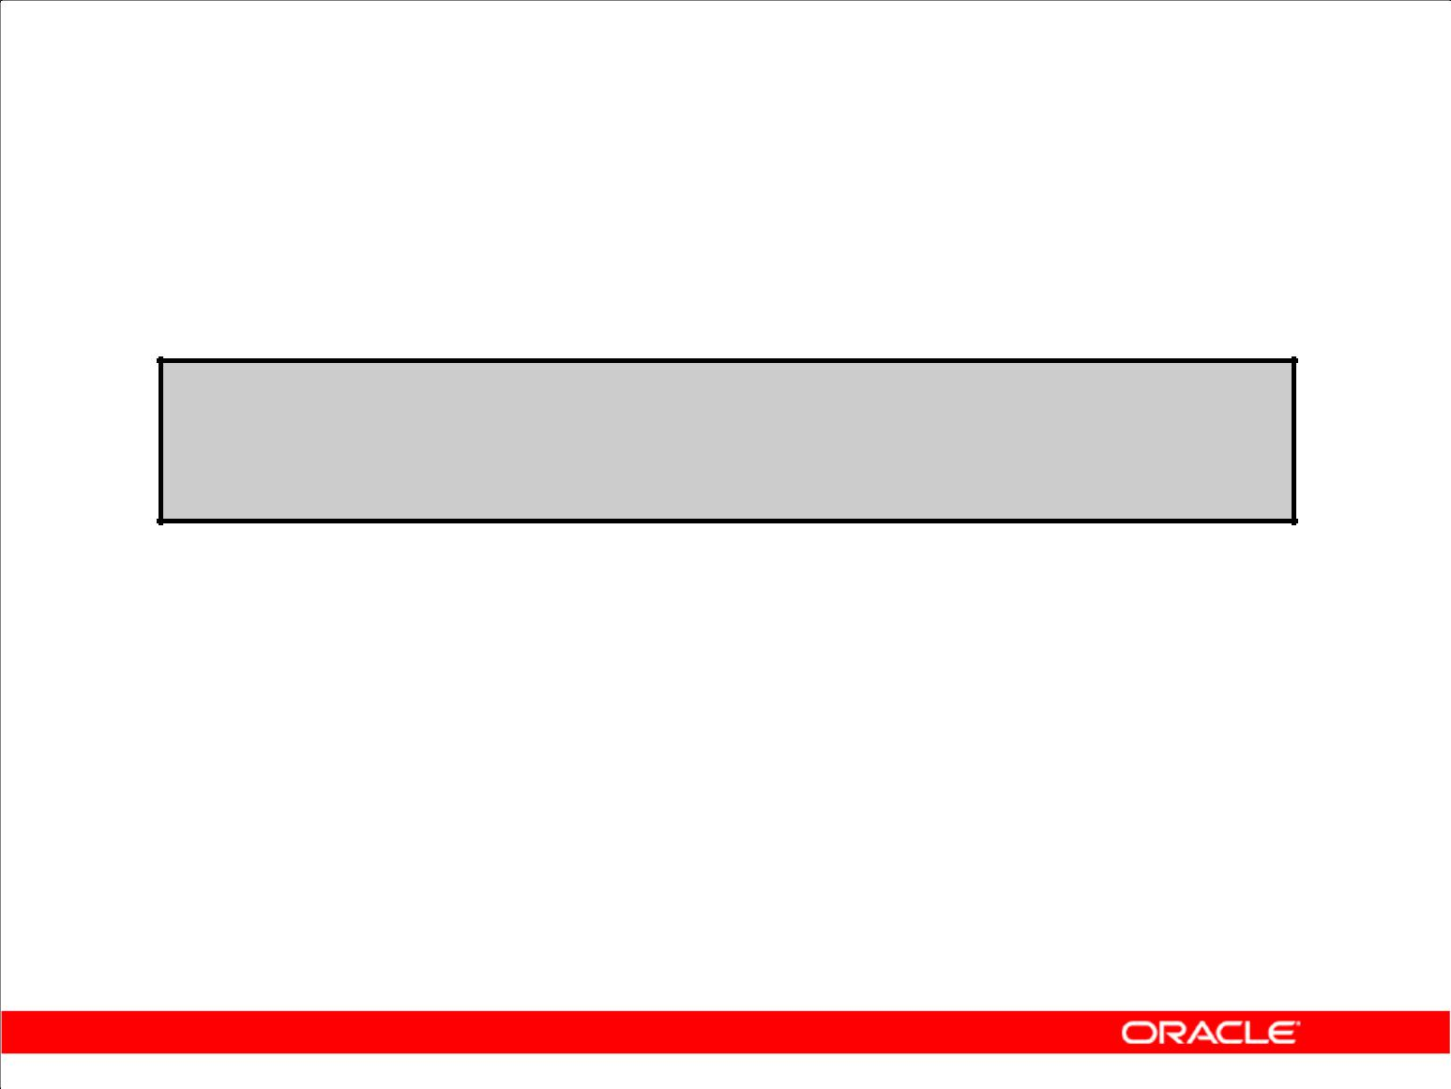**Enabling Constraints**

1. Activate an integrity constraint currently disabled in the table definition by using the ENABLE clause.

**ALTER TABLE** **emp2**

**ENABLE CONSTRAINT emp_dt_fk;**

**ALTER TABLE succeeded.**

1. A UNIQUE index is automatically created if you enable a UNIQUE key or a PRIMARY KEY constraint.

Copyright © 2009, Oracle. All rights reserved.

**Enabling a Constraint**

You can enable a constraint without dropping it or re-creating it by using the ALTER TABLE statement with the ENABLE clause.

|  |  |  |
| --- | --- | --- |
| **Syntax** |  |  |
| ALTER | TABLE | table |
| ENABLE | CONSTRAINT constraint; | |
| In the syntax: | Is the name of the table | |
| *table* |

*constraint* Is the name of the constraint

**Guidelines**

1. If you enable a constraint, that constraint applies to all the data in the table. All the data in the table must comply with the constraint.
2. If you enable a UNIQUE key or a PRIMARY KEY constraint, a UNIQUE or PRIMARY KEY index is created automatically. If an index already exists, then it can be used by these keys.
3. You can use the ENABLE clause in both the CREATE TABLE statement and the ALTER TABLE statement.

|  |
| --- |
| Oracle Internal & Oracle Academy Use Only |

**Oracle Database 10*g*: SQL Fundamentals II 2 - 16**

**Enabling a Constraint (continued)**

**Guidelines (continued)**

1. Enabling a primary key constraint that was disabled with the CASCADE option does not enable any foreign keys that are dependent on the primary key.
2. To enable a UNIQUE or PRIMARY KEY constraint, you must have the privileges necessary to create an index on the table.

|  |
| --- |
| Oracle Internal & Oracle Academy Use Only |

**Oracle Database 10*g*: SQL Fundamentals II 2 - 17**

**Cascading Constraints**

1. The CASCADE CONSTRAINTS clause is used along with the DROP COLUMN clause.
2. The CASCADE CONSTRAINTS clause drops all referential integrity constraints that refer to the primary and unique keys defined on the dropped columns.
3. The CASCADE CONSTRAINTS clause also drops all multicolumn constraints defined on the dropped columns.

Copyright © 2009, Oracle. All rights reserved.

**Cascading Constraints**

This statement illustrates the usage of the CASCADE CONSTRAINTS clause. Assume that the

TEST1 table is created as follows:

CREATE TABLE test1 (

pk NUMBER PRIMARY KEY,

fk NUMBER,

col1 NUMBER,

col2 NUMBER,

CONSTRAINT fk_constraint FOREIGN KEY (fk) REFERENCES test1,

CONSTRAINT ck1 CHECK (pk > 0 and col1 > 0),

CONSTRAINT ck2 CHECK (col2 > 0));

An error is returned for the following statements:

ALTER TABLE test1 DROP (pk); —pk is a parent key.

ALTER TABLE test1 DROP (col1); —col1 is referenced by the multicolumn constraint, ck1.

|  |
| --- |
| Oracle Internal & Oracle Academy Use Only |

**Oracle Database 10*g*: SQL Fundamentals II 2 - 18**

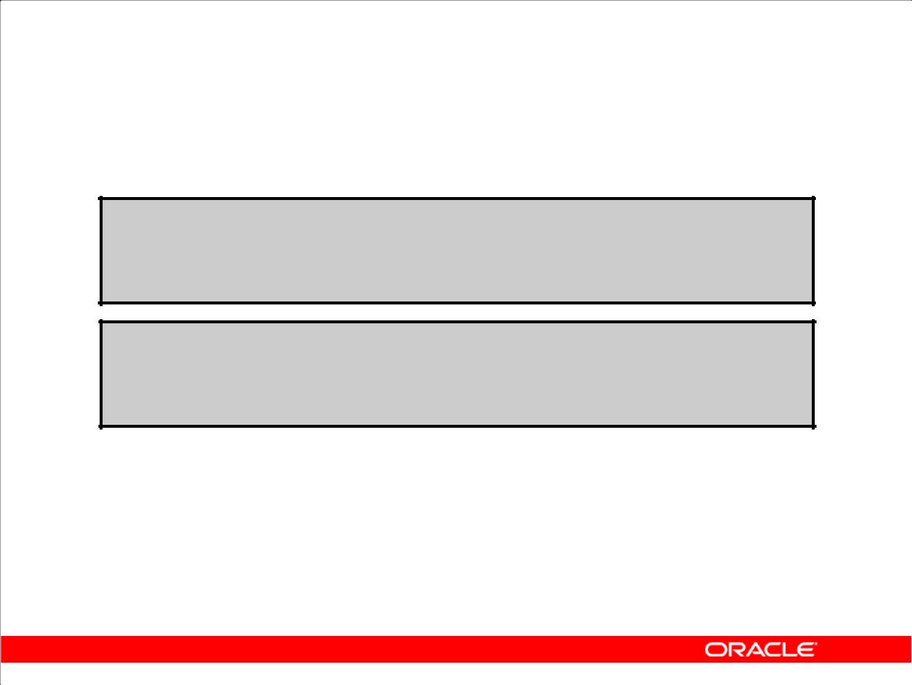**Cascading Constraints**

Example:

**ALTER TABLE emp2**

**DROP COLUMN employee_id CASCADE CONSTRAINTS; ALTER TABLE succeeded.**

**ALTER TABLE test1**

**DROP (pk, fk, col1);**

**ALTER TABLE succeeded.**

Copyright © 2009, Oracle. All rights reserved.

**Cascading Constraints (continued)**

Submitting the following statement drops the EMPLOYEE_ID column, the primary key constraint, and any foreign key constraints referencing the primary key constraint for the EMP2 table:

ALTER TABLE emp2 DROP COLUMN employee_id CASCADE CONSTRAINTS;

If all columns referenced by the constraints defined on the dropped columns are also dropped, then CASCADE CONSTRAINTS is not required. For example, assuming that no other referential constraints from other tables refer to the PK column, it is valid to submit the following statement without the CASCADE CONSTRAINTS clause for the TEST1 table created on the previous page:

ALTER TABLE test1 DROP (pk, fk, col1);

|  |
| --- |
| Oracle Internal & Oracle Academy Use Only |

**Oracle Database 10*g*: SQL Fundamentals II 2 - 19**

**Overview of Indexes**

Indexes are created:

1. Automatically

– PRIMARY KEY creation

– UNIQUE KEY creation

1. Manually

– CREATE INDEX statement

– CREATE TABLE statement

Copyright © 2009, Oracle. All rights reserved.

**Overview of Indexes**

Two types of indexes can be created. One type is a unique index. The Oracle server automatically creates a unique index when you define a column or group of columns in a table to have a PRIMARY KEY or a UNIQUE key constraint. The name of the index is the name given to the constraint.

The other type of index is a nonunique index, which a user can create. For example, you can create an index for a FOREIGN KEY column to be used in joins to improve retrieval speed.

You can create an index on one or more columns by issuing the CREATE INDEX statement.

For more information, see *Oracle Database 10g SQL Reference*.

**Note:** You can manually create a unique index, but it is recommended that you create a uniqueconstraint, which implicitly creates a unique index.

|  |
| --- |
| Oracle Internal & Oracle Academy Use Only |

**Oracle Database 10*g*: SQL Fundamentals II 2 - 20**

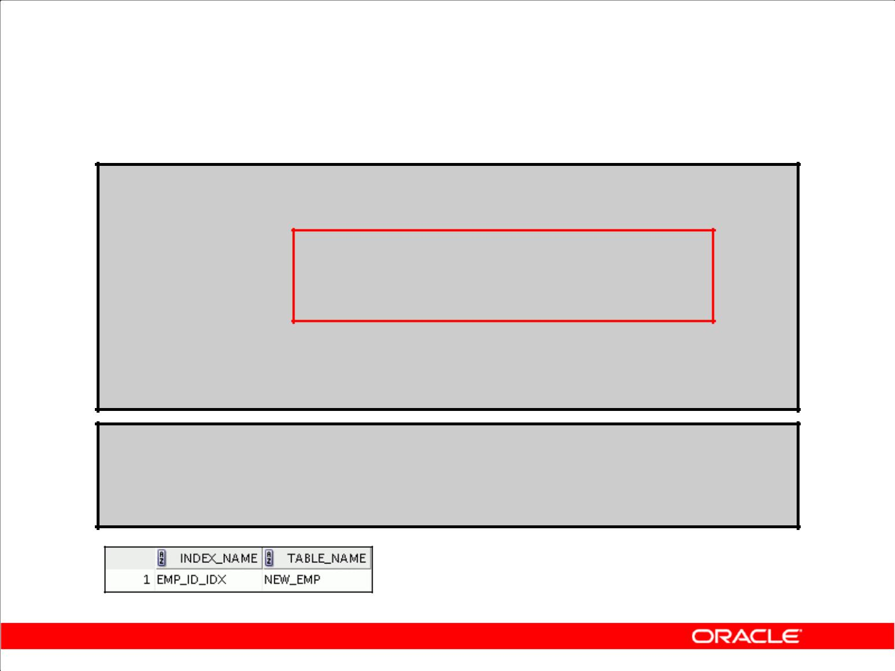**CREATE INDEX with the CREATE TABLE Statement**

**CREATE TABLE NEW_EMP**

**(employee_id NUMBER(6)**

**PRIMARY KEY USING INDEX**

**(CREATE INDEX emp_id_idx ON**

**NEW_EMP(employee _id)),**

**first_name** **VARCHAR2(20),**

**last_name** **VARCHAR2(25));**

**CREATE TABLE succeeded.**

**SELECT INDEX_NAME, TABLE_NAME**

**FROM USER_INDEXES**

**WHERE TABLE_NAME = 'NEW_EMP';**

Copyright © 2009, Oracle. All rights reserved.

**CREATE INDEX with the CREATE TABLE Statement**

In the example in the slide, the CREATE INDEX clause is used with the CREATE TABLE statement

to create a primary key index explicitly. You can name your indexes at the time of primary key creation to be different from the name of the PRIMARY KEY constraint. The following example

illustrates the database behavior if the index is not explicitly named:

CREATE TABLE EMP_UNNAMED_INDEX (employee_id NUMBER(6) PRIMARY KEY , first_name VARCHAR2(20), last_name VARCHAR2(25));

CREATE TABLE succeeded.

SELECT INDEX_NAME, TABLE_NAME

FROM USER_INDEXES

WHERE TABLE_NAME = 'EMP_UNNAMED_INDEX';

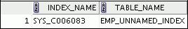

|  |
| --- |
| Oracle Internal & Oracle Academy Use Only |

**Oracle Database 10*g*: SQL Fundamentals II 2 - 21**

**CREATE INDEX with the CREATE TABLE Statement (continued)**

Observe that the Oracle server gives a generic name to the index that is created for the PRIMARY KEY column.

You can also use an existing index for your PRIMARY KEY column—for example, when you are expecting a large data load and want to speed up the operation. You may want to disable the constraints while performing the load and then enable them, in which case having a unique index on the primary key will still cause the data to be verified during the load. So you can first create a nonunique index on the column designated as PRIMARY KEY, and then create the PRIMARY KEY

column and specify that it should use the existing index. The following examples illustrate this process:

**Step 1: Create the table:**

CREATE TABLE NEW_EMP2

(employee_id NUMBER(6)

first_name VARCHAR2(20),

last_name VARCHAR2(25)

);

**Step 2: Create the index:**

CREATE INDEX emp_id_idx2 ON

new_emp2(employee_id);

**Step 3: Create the Primary Key:**

ALTER TABLE new_emp2 ADD PRIMARY KEY (employee_id) USING INDEX

emp_id_idx2;

|  |
| --- |
| Oracle Internal & Oracle Academy Use Only |

**Oracle Database 10*g*: SQL Fundamentals II 2 - 22**

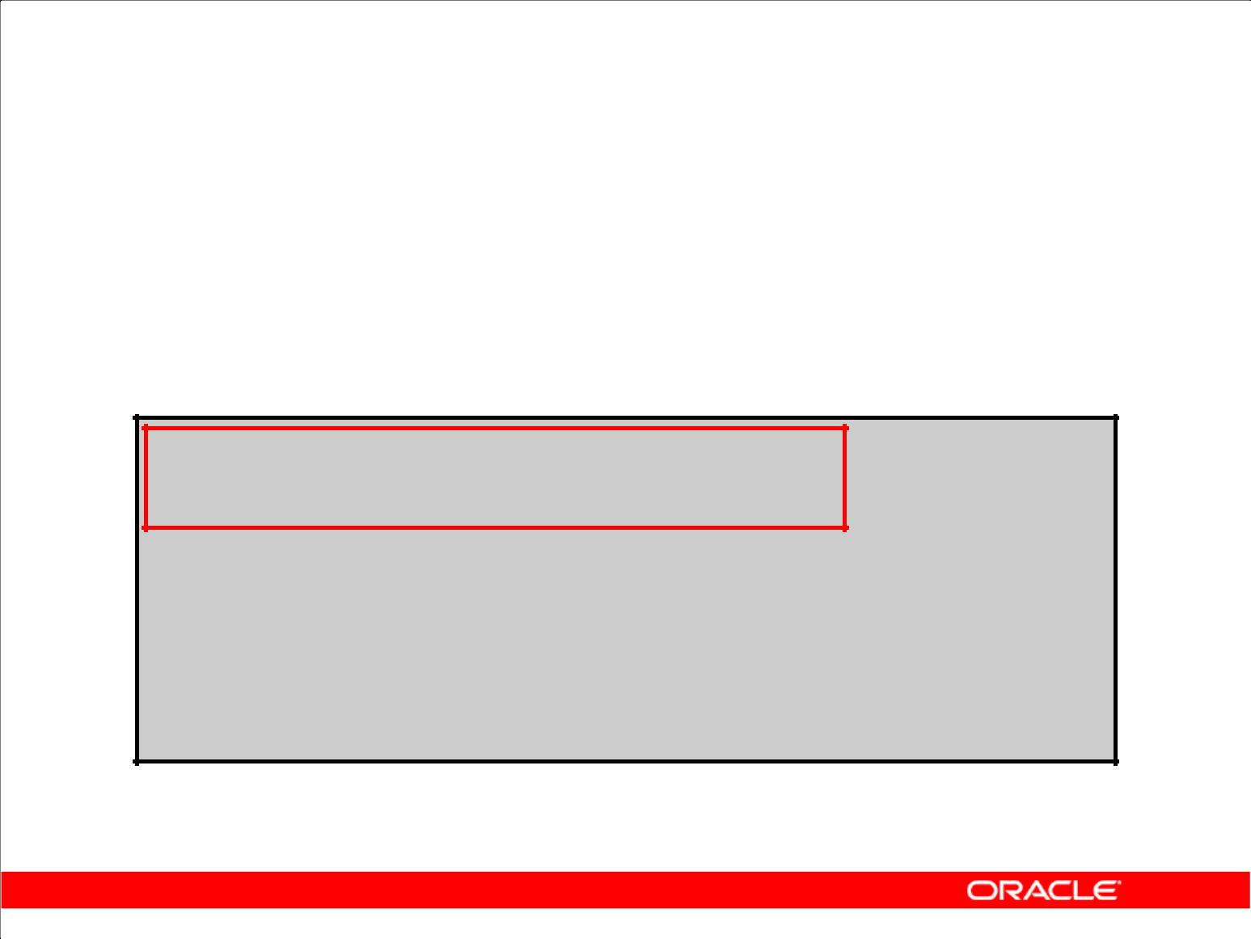**Function-Based Indexes**

1. A function-based index is based on expressions.
2. The index expression is built from table columns, constants, SQL functions, and user-defined functions.

**CREATE INDEX upper_dept_name_ idx ON dept2(UPPER(department_name));**

**CREATE INDEX succeeded.**

**SELECT \***

**FROM dept2**

**WHERE UPPER(department_name) = 'SALES';**

Copyright © 2009, Oracle. All rights reserved.

**Function-Based Indexes**

Function-based indexes defined with the UPPER(*column_name*) or LOWER(*column_name*)

keywords allow non-case-sensitive searches. For example, the following index:

CREATE INDEX upper_last_name_idx ON emp2 (UPPER(last_name)); facilitates processing queries such as:

SELECT * FROM emp2 WHERE UPPER(last_name) = 'KING';

The Oracle server uses the index only when that particular function is used in a query. For example, the following statement may use the index, but without the WHERE clause, the Oracle server may

perform a full table scan:

SELECT *

FROM employees

WHERE UPPER (last_name) IS NOT NULL

ORDER BY UPPER (last_name);

**Note:** TheQUERY_REWRITE_ENABLEDinitialization parameter must be set toTRUEfor afunction-based index to be used.

The Oracle server treats indexes with columns marked DESC as function-based indexes. The columns marked DESC are sorted in descending order.

|  |
| --- |
| Oracle Internal & Oracle Academy Use Only |

**Oracle Database 10*g*: SQL Fundamentals II 2 - 23**

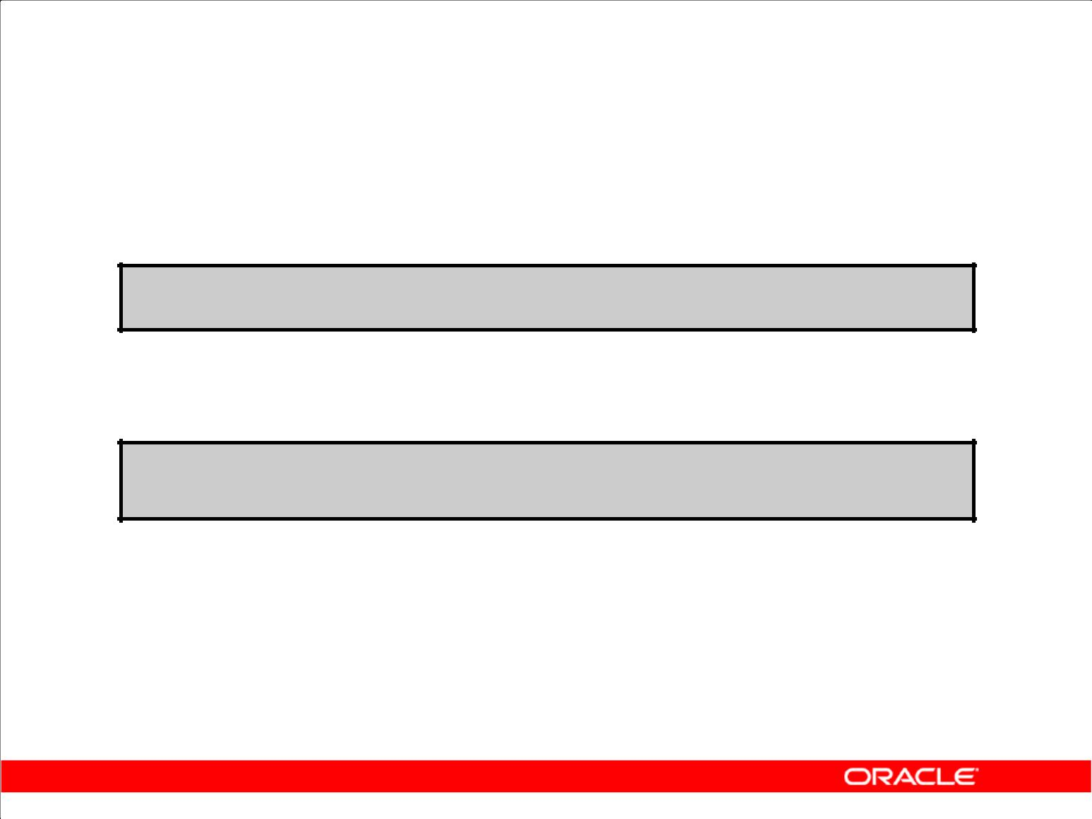**Removing an Index**

1. Remove an index from the data dictionary by using the

DROP INDEX command:

**DROP INDEX *index*;**

1. Remove the UPPER_DEPT_NAME_ IDX index from the data dictionary:

**DROP INDEX upper_dept_name_idx;**

**DROP INDEX succeeded.**

1. To drop an index, you must be the owner of the index or have the DROP ANY INDEX privilege:

Copyright © 2009, Oracle. All rights reserved.

**Removing an Index**

You cannot modify indexes. To change an index, you must drop it and then re-create it. Remove an index definition from the data dictionary by issuing the DROP INDEX statement. To drop an index, you must be the owner of the index or have the DROP ANY INDEX privilege.

In the syntax:

*index* Is the name of the index

**Note:** If you drop a table, indexes and constraints are automatically dropped, but views andsequences remain.

|  |
| --- |
| Oracle Internal & Oracle Academy Use Only |

**Oracle Database 10*g*: SQL Fundamentals II 2 - 24**

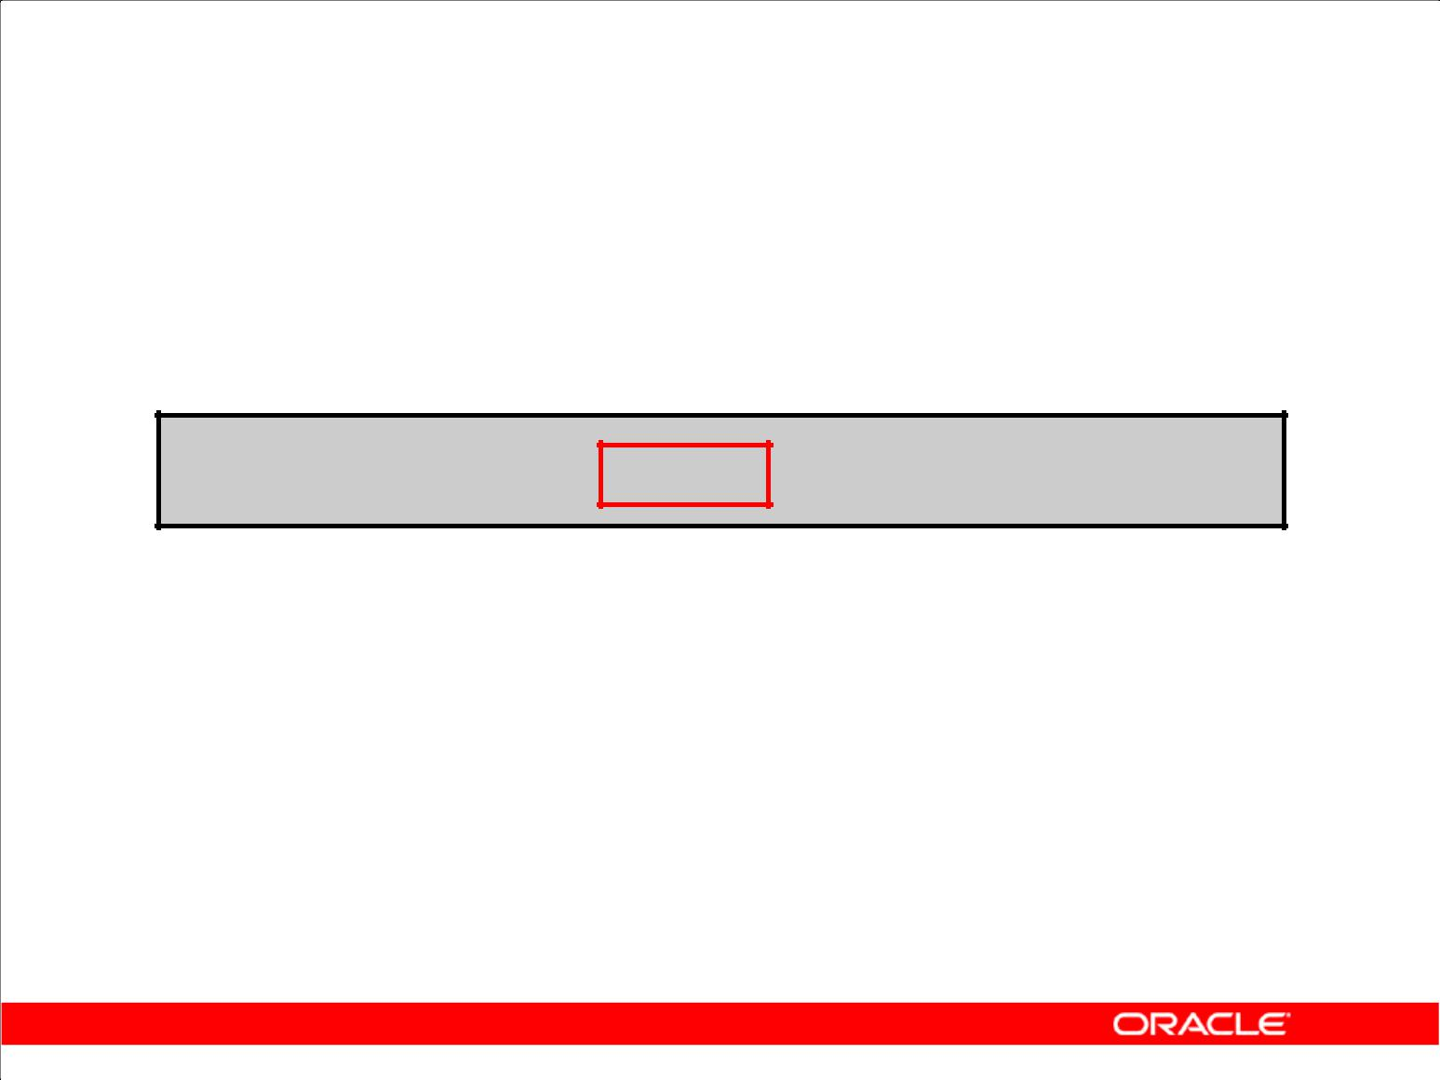**DROP TABLE … PURGE**

**DROP TABLE dept80 PURGE;**

Copyright © 2009, Oracle. All rights reserved.

**DROP TABLE … PURGE**

Oracle Database 10*g* introduces a new feature for dropping tables. When you drop a table, the database does not immediately release the space associated with the table. Rather, the database renames the table and places it in a recycle bin, where it can later be recovered with the FLASHBACK TABLE statement if you find that you dropped the table in error. If you want to immediately release the space associated with the table at the time you issue the DROP TABLE statement, then include the PURGE clause as shown in the statement in the slide.

Specify PURGE only if you want to drop the table and release the space associated with it in a single step. If you specify PURGE, then the database does not place the table and its dependent objects into the recycle bin.

Using this clause is equivalent to first dropping the table and then purging it from the recycle bin. This clause saves you one step in the process. It also provides enhanced security if you want to prevent sensitive material from appearing in the recycle bin.

**Note:** You cannot roll back aDROP TABLEstatement with thePURGEclause, and you cannotrecover the table if you drop it with the PURGE clause. This feature was not available in earlier releases.

|  |
| --- |
| Oracle Internal & Oracle Academy Use Only |

**Oracle Database 10*g*: SQL Fundamentals II 2 - 25**

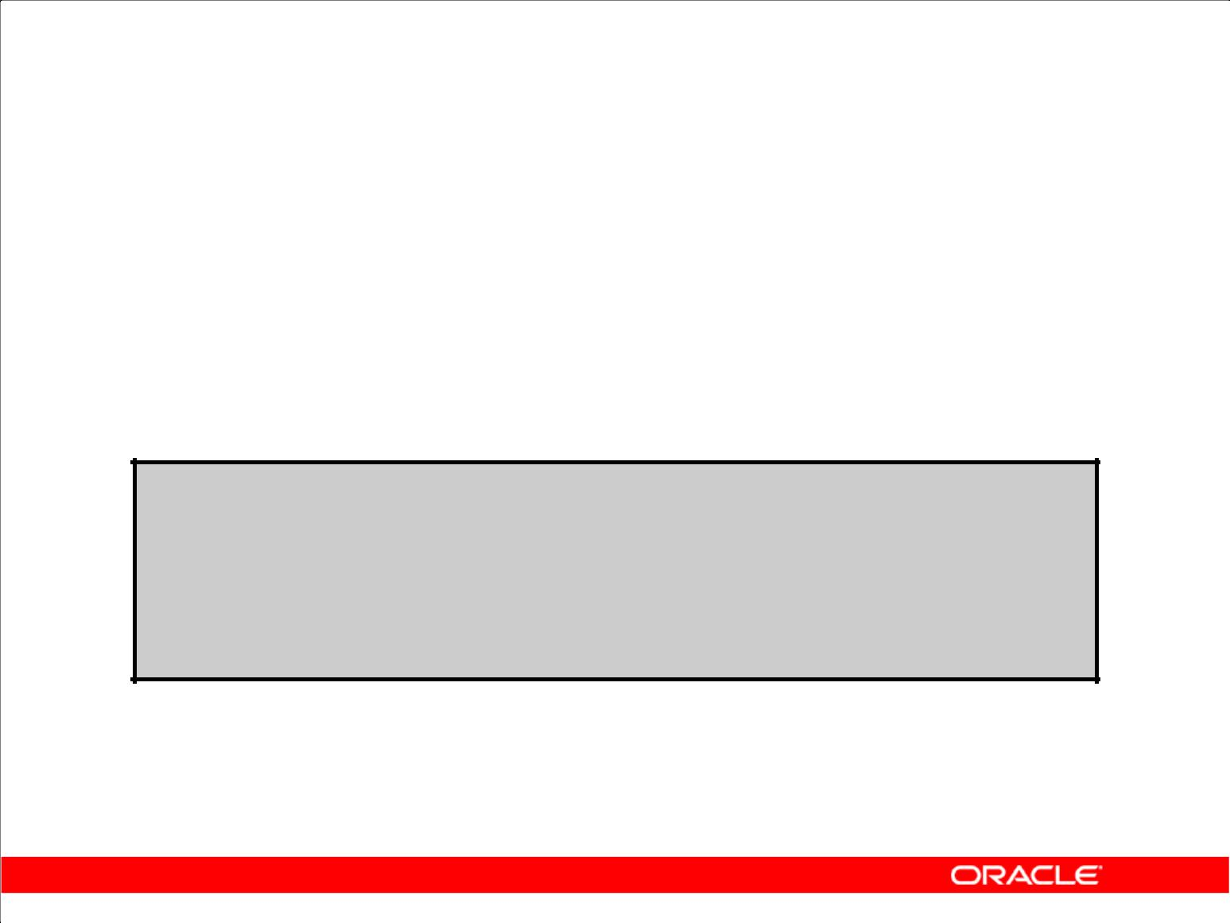**FLASHBACK TABLE Statement**

1. Repair tool for accidental table modifications

– Restores a table to an earlier point in time

– Benefits: Ease of use, availability, fast execution

– Performed in place

1. Syntax:

**FLASHBACK TABLE[schema.]table[, [ schema.]table ]...**

**TO { TIMESTAMP | SCN } expr**

**[ { ENABLE | DISABLE } TRIGGERS ];**

Copyright © 2009, Oracle. All rights reserved.

**FLASHBACK TABLE Statement**

**Self-Service Repair Facility**

Oracle Database 10*g* provides a new SQL DDL command, FLASHBACK TABLE, to restore the state of a table to an earlier point in time in case it is inadvertently deleted or modified. The FLASHBACK TABLE command is a self-service repair tool to restore data in a table along with associated attributes such as indexes or views. This is done while the database is online by rolling back only the subsequent changes to the given table. Compared to traditional recovery mechanisms, this feature offers significant benefits such as ease of use, availability, and faster restoration. It also takes the burden off the DBA to find and restore application-specific properties. The flashback table feature does not address physical corruption caused because of a bad disk.

**Syntax**

You can invoke a FLASHBACK TABLE operation on one or more tables, even on tables in different schemas. You specify the point in time to which you want to revert by providing a valid time stamp. By default, database triggers are disabled for all tables involved. You can override this default behavior by specifying the ENABLE TRIGGERS clause.

**Note:** For more information about recycle bin and flashback semantics, refer to*Oracle Database**Administrator’s Guide 10g Release 2 (10.2)*.

|  |
| --- |
| Oracle Internal & Oracle Academy Use Only |

**Oracle Database 10*g*: SQL Fundamentals II 2 - 26**

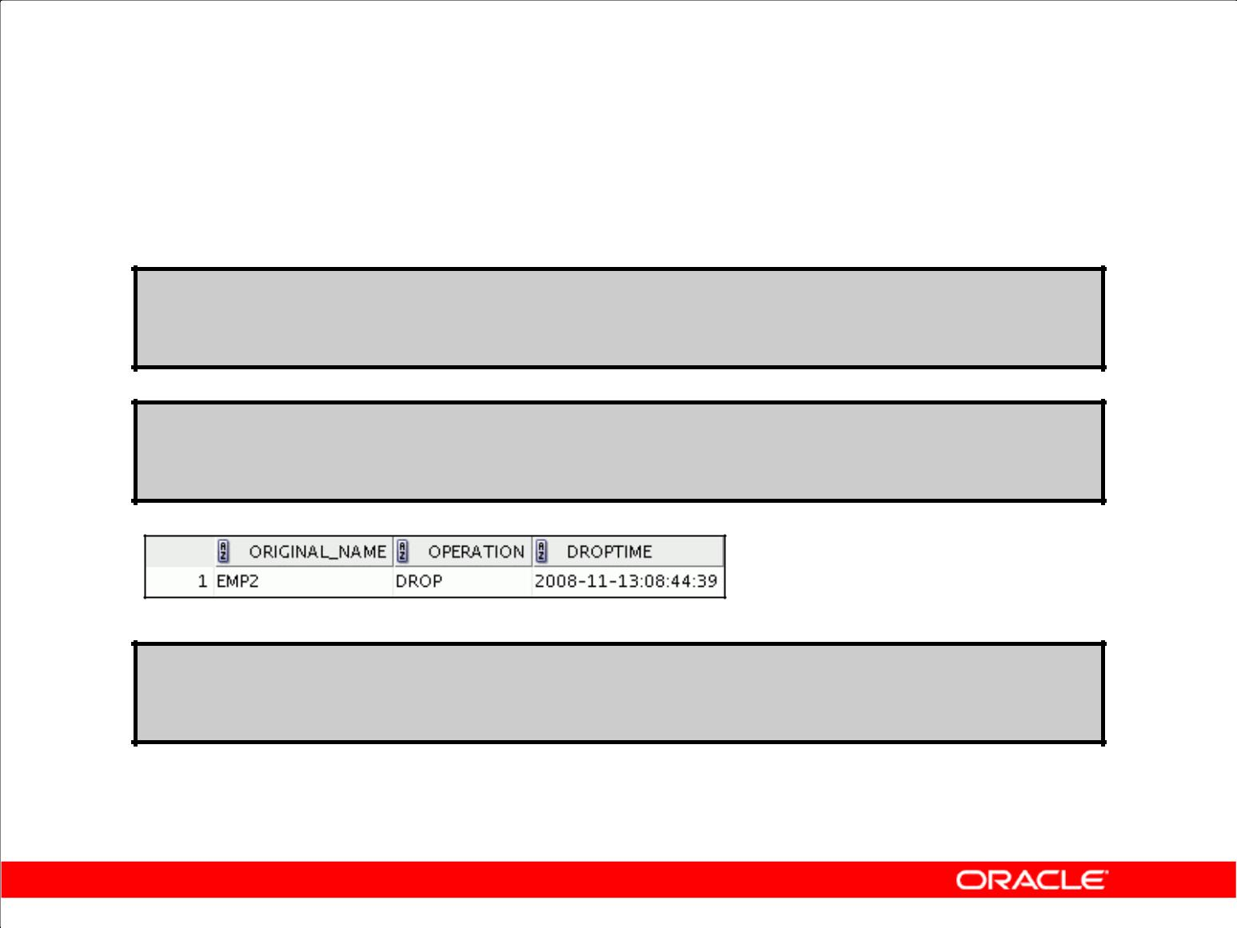**FLASHBACK TABLE Statement**

**DROP TABLE emp2;**

**DROP TABLE succeeded.**

**SELECT original_name, operation, droptime FROM recyclebin;**

**FLASHBACK TABLE emp2 TO BEFORE DROP;**

**FLASHBACK TABLE succeeded.**

Copyright © 2009, Oracle. All rights reserved.

**FLASHBACK TABLE Statement (continued)**

**Syntax and Examples**

The example restores the EMP2 table to a state before a DROP statement.

The recycle bin is actually a data dictionary table containing information about dropped objects. Dropped tables and any associated objects, such as indexes, constraints, nested tables, and so on, are not removed and still occupy space. They continue to count against user space quotas, until specifically purged from the recycle bin or the unlikely situation where they must be purged by the database because of tablespace space constraints.

Each user can be thought of as an owner of a recycle bin because, unless a user has the SYSDBA privilege, the only objects that the user has access to in the recycle bin are those that the user owns. A user can view his or her objects in the recycle bin by using the following statement:

SELECT * FROM RECYCLEBIN;

When you drop a user, any objects belonging to that user are not placed in the recycle bin and any objects in the recycle bin are purged.

You can purge the recycle bin with the following statement:

PURGE RECYCLEBIN;

|  |
| --- |
| Oracle Internal & Oracle Academy Use Only |

**Oracle Database 10*g*: SQL Fundamentals II 2 - 27**

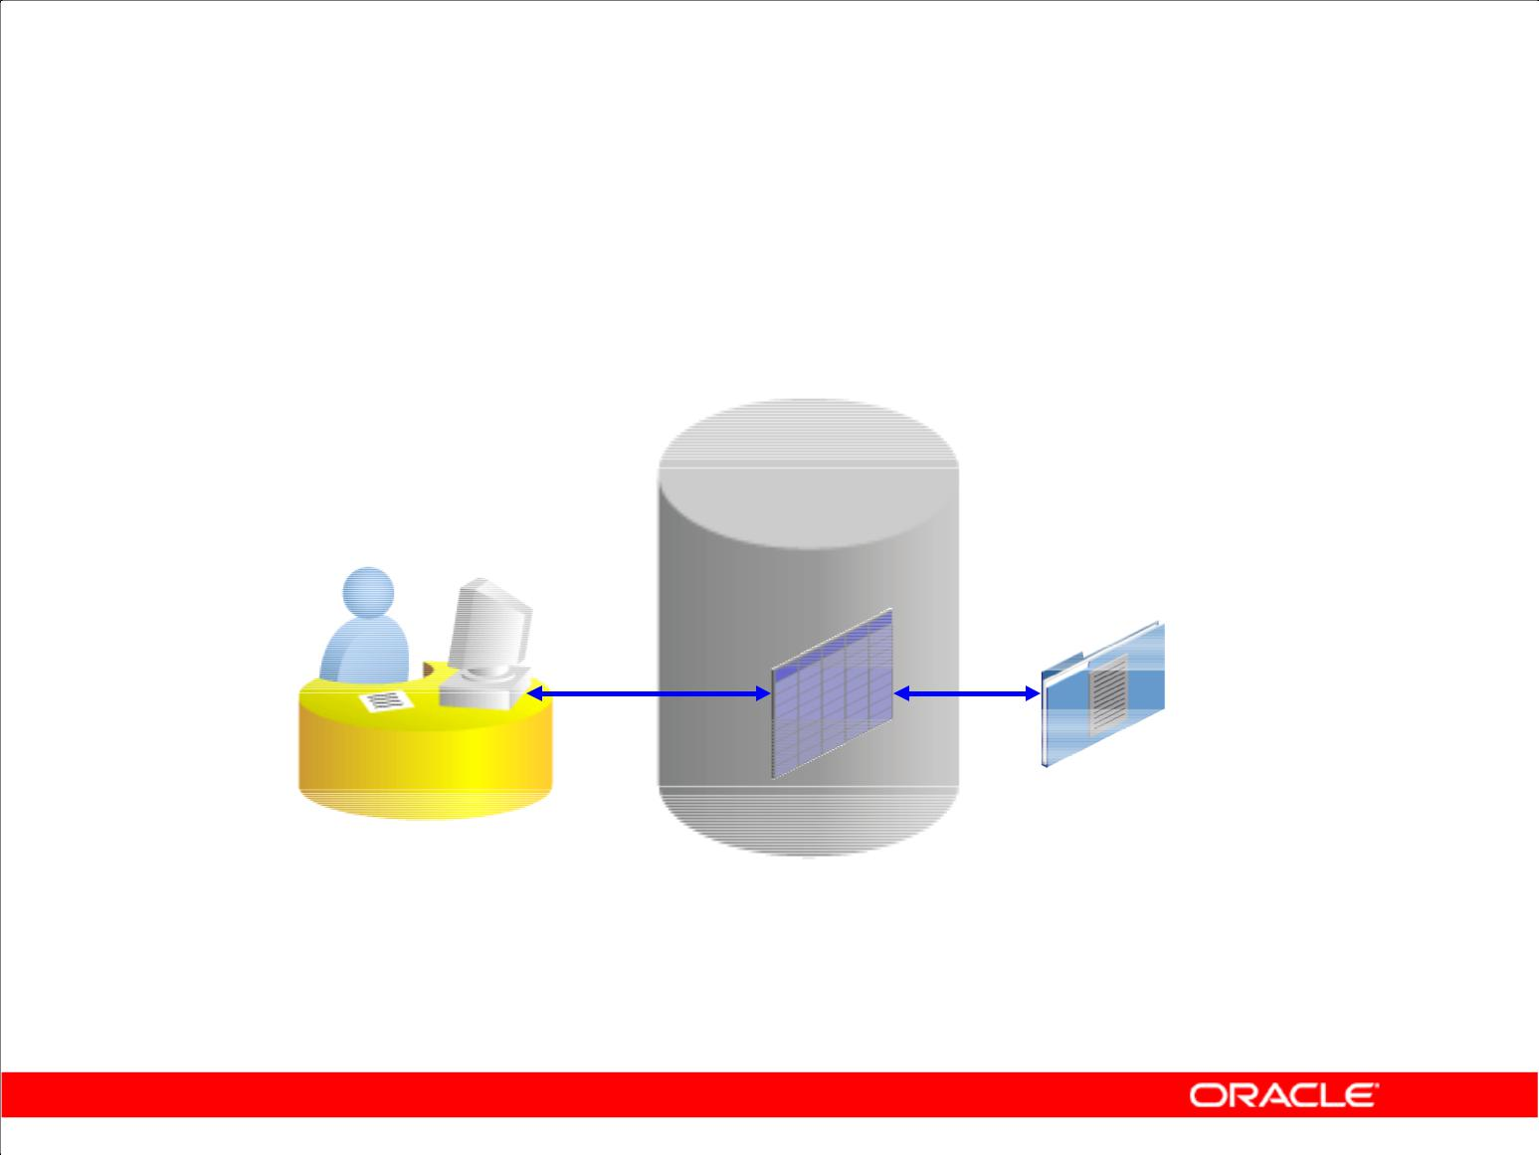**External Tables**

Copyright © 2009, Oracle. All rights reserved.

**External Tables**

An external table is a read-only table whose metadata is stored in the database but whose data is stored outside the database. This external table definition can be thought of as a view that is used for running any SQL query against external data without requiring that the external data first be loaded into the database. The external table data can be queried and joined directly and in parallel without requiring that the external data first be loaded in the database. You can use SQL, PL/SQL, and Java to query the data in an external table.

The main difference between external tables and regular tables is that externally organized tables are read-only. No data manipulation language (DML) operations are possible, and no indexes can be created on them. However, you can create an external table, and thus unload data, by using the CREATE TABLE AS SELECT command.

The Oracle server provides two major access drivers for external tables. One, the loader access driver (or ORACLE_LOADER), is used for reading of data from external files whose format can be

interpreted by the SQL*Loader utility. Note that not all SQL*Loader functionality is supported with external tables.

|  |
| --- |
| Oracle Internal & Oracle Academy Use Only |

**Oracle Database 10*g*: SQL Fundamentals II 2 - 28**

**External Tables (continued)**

The ORACLE_DATAPUMP access driver can be used to both import and export data using a platform-independent format. The ORACLE_DATAPUMP access driver writes rows from a SELECT statement to be loaded into an external table as part of a CREATE TABLE ...ORGANIZATION EXTERNAL...AS SELECT statement. You can then use SELECT to read data out of that data file. You can also create an external table definition on another system and use that data file. This allows data to be moved between Oracle databases.

|  |
| --- |
| Oracle Internal & Oracle Academy Use Only |

**Oracle Database 10*g*: SQL Fundamentals II 2 - 29**

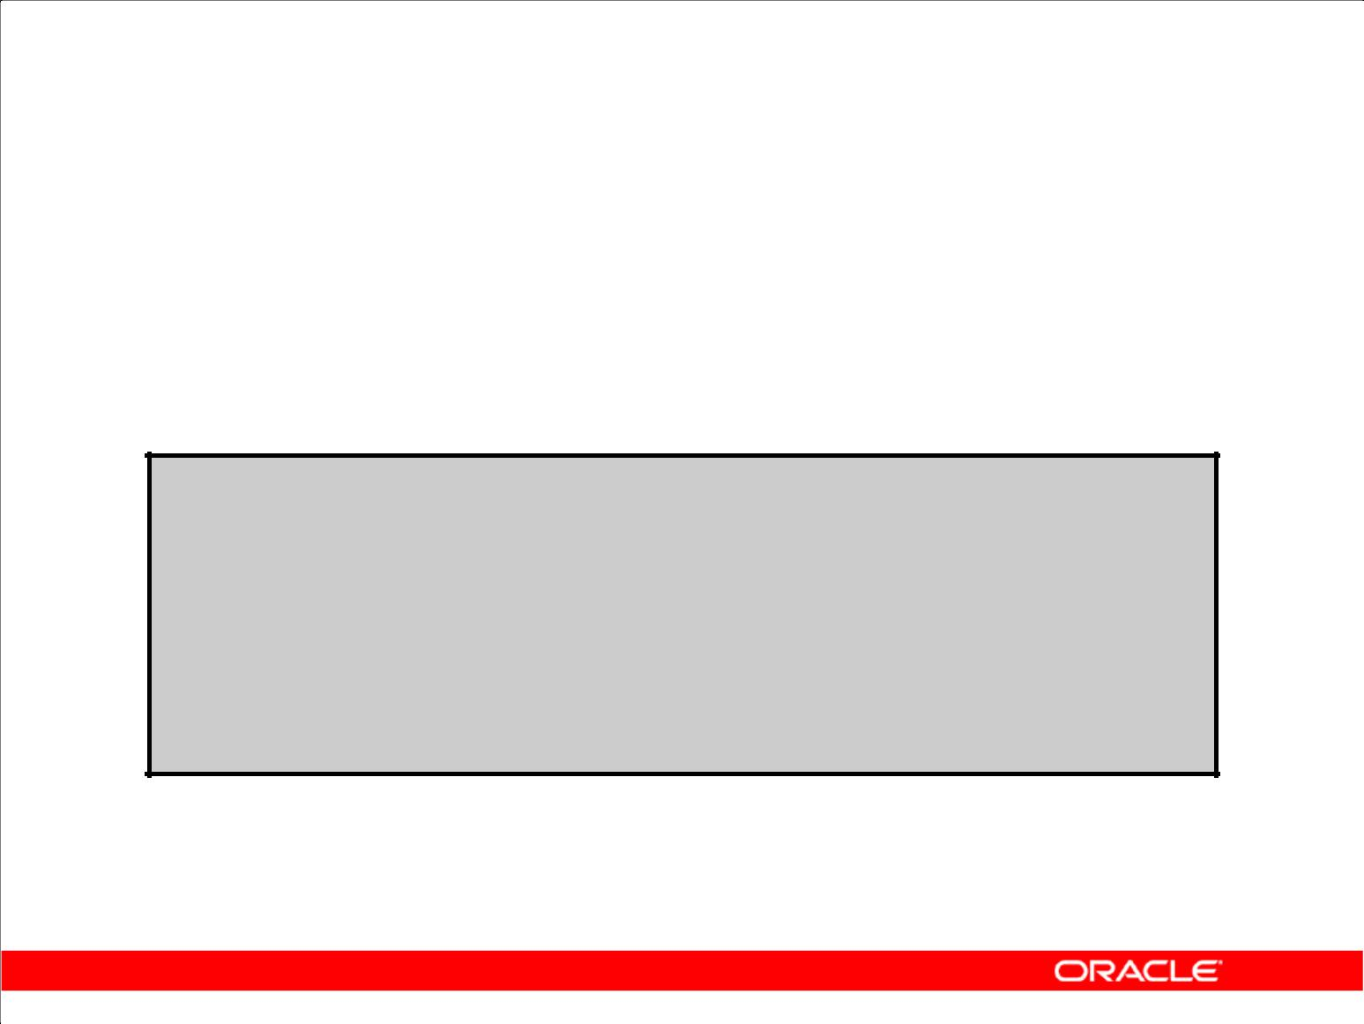**Creating a Directory for the External Table**

Create a DIRECTORY object that corresponds to the directory on the file system where the external data source resides.

**CREATE OR REPLACE DIRECTORY emp_dir AS '/…/emp_dir';**

**GRANT READ ON DIRECTORY emp_dir TO hr;**

Copyright © 2009, Oracle. All rights reserved.

**Example of Creating an External Table**

Use the CREATE DIRECTORY statement to create a directory object. A directory object specifies an alias for a directory on the server’s file system where an external data source resides. You can use directory names when referring to an external data source, rather than hard code the operating system path name, for greater file management flexibility.

You must have CREATE ANY DIRECTORY system privileges to create directories. When you create a directory, you are automatically granted the READ and WRITE object privileges and can grant READ and WRITE privileges to other users and roles. The DBA can also grant these privileges to other users and roles.

A user needs READ privileges for all directories used in external tables to be accessed and WRITE privileges for the log, bad, and discard file locations being used.

In addition, a WRITE privilege is necessary when the external table framework is being used to unload data.

Oracle also provides the ORACLE_DATAPUMP type, with which you can unload data (that is, read data from a table in the database and insert it into an external table) and then reload it into an Oracle Database. This is a one-time operation that can be done when the table is created. After the creation and initial population is done, you cannot update, insert, or delete any rows.

|  |
| --- |
| Oracle Internal & Oracle Academy Use Only |

**Oracle Database 10*g*: SQL Fundamentals II 2 - 30**

**Example of Creating an External Table (continued)**

**Syntax**

CREATE [OR REPLACE] DIRECTORY AS 'path_name';

In the syntax:

OR REPLACE Specify OR REPLACE to re-create the directory database

object if it already exists. You can use this clause to change the definition

of an existing directory without dropping, re- creating, and regranting

database object privileges previously granted on the directory. Users who were

previously granted privileges on a redefined directory can continue to access the

directory without requiring that the privileges be regranted.

directory Specify the name of the directory object to be created. The

maximum length of the directory name is 30 bytes. You cannot

qualify a directory object with a schema name.

'path_name' Specify the full path name of the operating system directory to be accessed. The path name is case sensitive.

The syntax for using the ORACLE_DATAPUMP access driver is as follows:

CREATE TABLE extract_emps

ORGANIZATION EXTERNAL (TYPE ORACLE_DATAPUMP

DEFAULT DIRECTORY …

ACCESS PARAMETERS (… )

LOCATION (…)

PARALLEL 4

REJECT LIMIT UNLIMITED

AS

SELECT * FROM …;

|  |
| --- |
| Oracle Internal & Oracle Academy Use Only |

**Oracle Database 10*g*: SQL Fundamentals II 2 - 31**

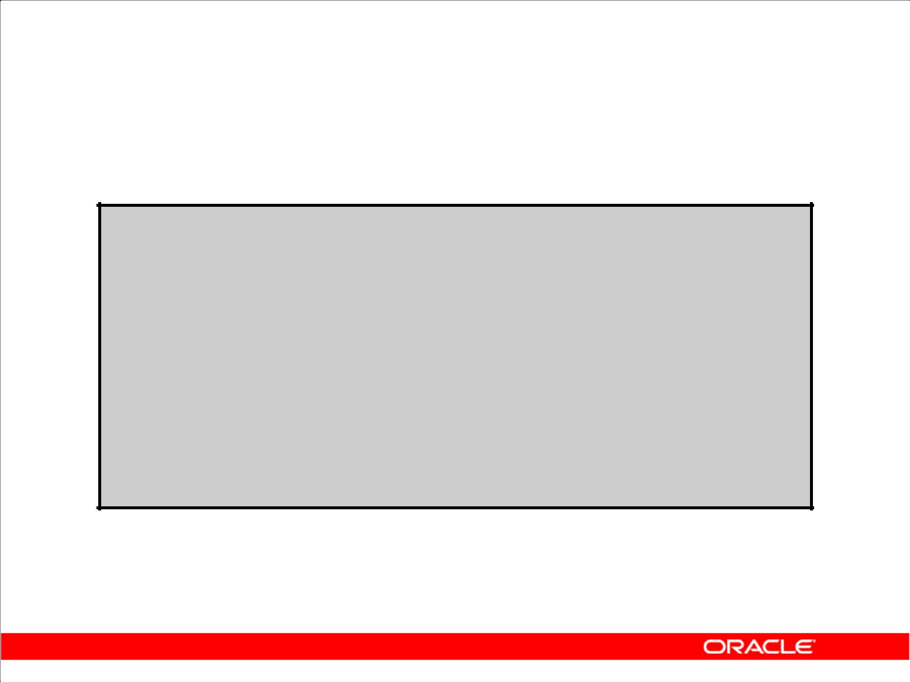**Creating an External Table**

**CREATE TABLE <table_name>**

**( <col_name> <datatype>, … )**

**ORGANIZATION EXTERNAL**

**(TYPE <access_driver_type>**

**DEFAULT DIRECTORY <directory_name>**

**ACCESS PARAMETERS**

**(… ) )**

**LOCATION ('<location_specifier>') )**

**REJECT LIMIT [0 | <number> | UNLIMITED];**

Copyright © 2009, Oracle. All rights reserved.

**Creating an External Table**

You create external tables using the ORGANIZATION EXTERNAL clause of the CREATE TABLE

statement. You are not, in fact, creating a table. Rather, you are creating metadata in the data dictionary that you can use to access external data. You use the ORGANIZATION clause to specify the order in which the data rows of the table are stored. By specifying EXTERNAL in the ORGANIZATION clause, you indicate that the table is a read-only table located outside the database. Note that the external files must already exist outside the database.

TYPE <*access_driver_type*> indicates the access driver of the external table. The access driver is the API that interprets the external data for the database. If you do not specify TYPE, Oracle uses the default access driver, ORACLE_LOADER. The other option is ORACLE_DATAPUMP.

You use the DEFAULT DIRECTORY clause to specify one or more Oracle Database directory objects that correspond to directories on the file system where the external data sources may reside.

The optional ACCESS PARAMETERS clause enables you to assign values to the parameters of the specific access driver for this external table.

|  |
| --- |
| Oracle Internal & Oracle Academy Use Only |

**Oracle Database 10*g*: SQL Fundamentals II 2 - 32**

**Creating an External Table (continued)**

Use the LOCATION clause to specify one external locator for each external data source. Usually, the <*location_specifier*> is a file, but it need not be.

The REJECT LIMIT clause enables you to specify how many conversion errors can occur during a

query of the external data before an Oracle error is returned and the query is aborted. The default value is 0.

|  |
| --- |
| Oracle Internal & Oracle Academy Use Only |

**Oracle Database 10*g*: SQL Fundamentals II 2 - 33**

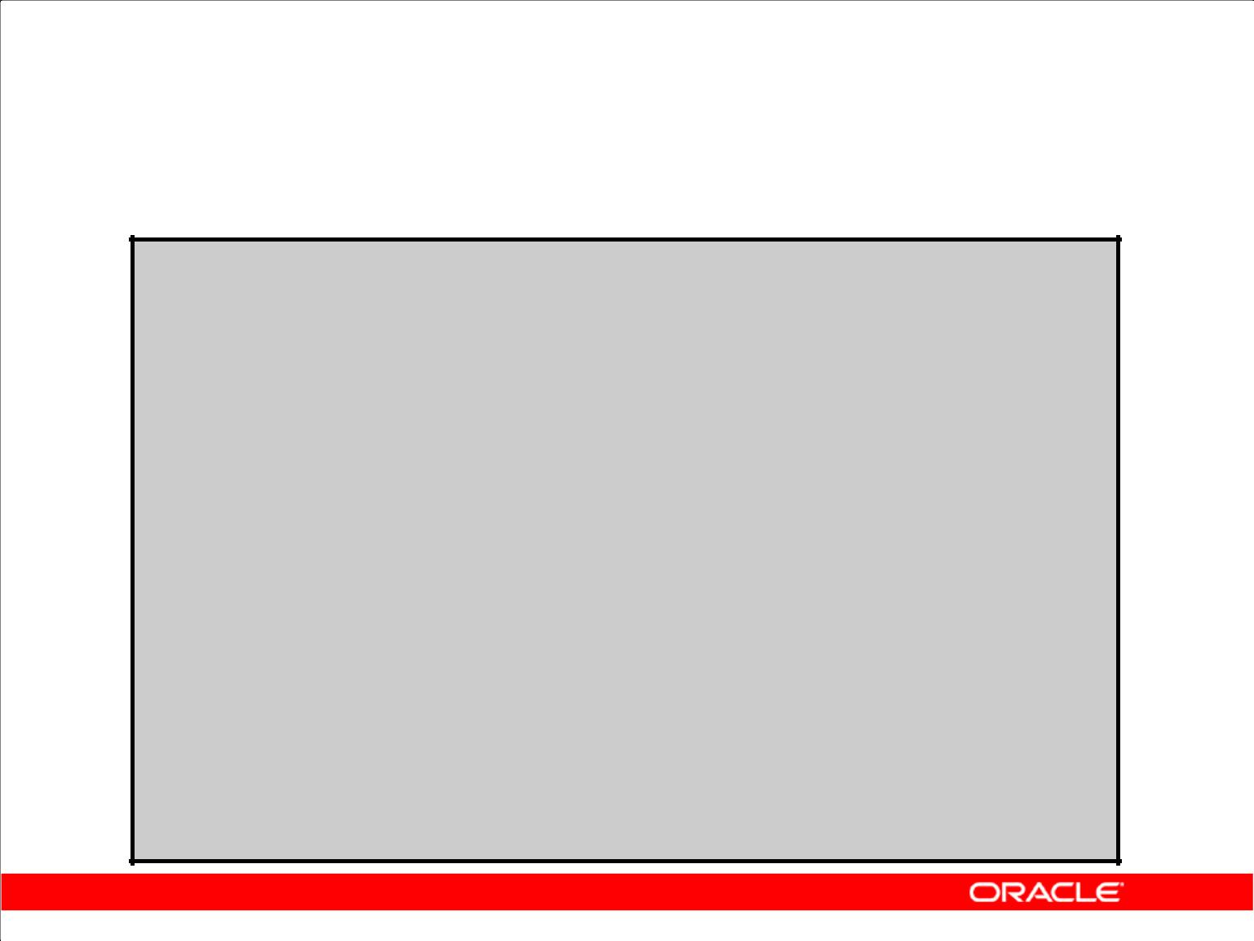**Creating an External Table by Using**

**ORACLE_LOADER**

**CREATE TABLE oldemp (**

**fname char(25), lname CHAR(25))**

**ORGANIZATION EXTERNAL**

**(TYPE ORACLE_LOADER**

**DEFAULT DIRECTORY emp_dir**

**ACCESS PARAMETERS**

**(RECORDS DELIMITED BY NEWLINE**

**NOBADFILE**

**NOLOGFILE**

**FIELDS TERMINATED BY ','**

**(fname POSITION ( 1:20) CHAR,**

**lname POSITION (22:41) CHAR))**

**LOCATION ('emp.dat'))**

**PARALLEL 5**

**REJECT LIMIT 200;**

**CREATE TABLE succeeded.**

Copyright © 2009, Oracle. All rights reserved.

**Example of Creating an External Table by Using the ORACLE_LOADER Access Driver**

Assume that there is a flat file that has records in the following format:

10,jones,11-Dec-1934

20,smith,12-Jun-1972

Records are delimited by new lines, and the fields are all terminated by a comma ( , ). The name of the file is /emp_dir/emp.dat.

To convert this file as the data source for an external table, whose metadata will reside in the database, you must perform the following steps:

1. Create a directory object, emp_dir, as follows:

CREATE DIRECTORY emp_dir AS '/emp_dir' ;

1. Run the CREATE TABLE command shown in the slide.

The example in the slide illustrates the table specification to create an external table for the file:

/emp_dir/emp.dat

|  |
| --- |
| Oracle Internal & Oracle Academy Use Only |

**Oracle Database 10*g*: SQL Fundamentals II 2 - 34**

**Example of Creating an External Table by Using the ORACLE_LOADER Access Driver (continued)**

In the example, the TYPE specification is given only to illustrate its use. ORACLE_LOADER is the default access driver if not specified. The ACCESS PARAMETERS option provides values to parameters of the specific access driver, which are interpreted by the access driver, not by the Oracle server.

The PARALLEL clause enables five parallel execution servers to simultaneously scan the external data sources (files) when executing the INSERT INTO TABLE statement. For example, if PARALLEL=5 were specified, then more than one parallel execution server can be working on a data

source. Because external tables can be very large, for performance reasons, it is advisable to specify the PARALLEL clause, or a parallel hint for the query.

The REJECT LIMIT clause specifies that if more than 200 conversion errors occur during a query of the external data, then the query be aborted and an error be returned. These conversion errors can arise when the access driver tries to transform the data in the data file to match the external table definition.

After the CREATE TABLE command executes successfully, the OLDEMP external table can be described and queried like a relational table.

|  |
| --- |
| Oracle Internal & Oracle Academy Use Only |

**Oracle Database 10*g*: SQL Fundamentals II 2 - 35**

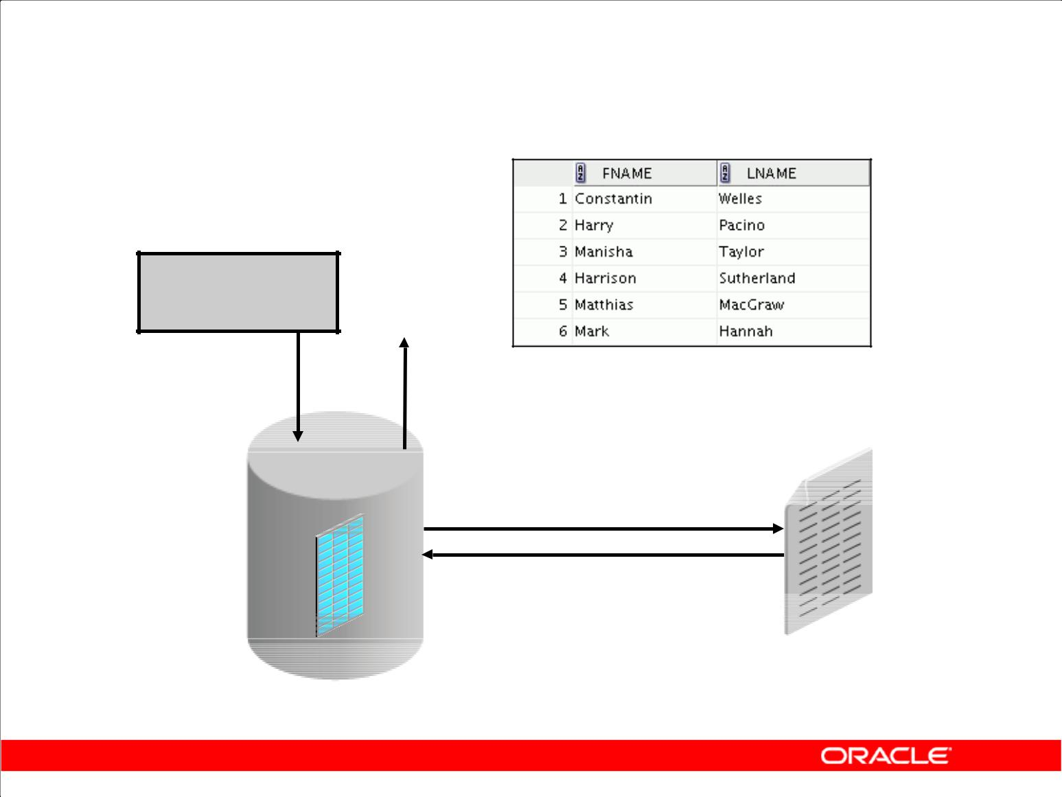**Querying External Tables**

**SELECT \***

**FROM oldemp**

**…**

**OLDEMP**

**emp.dat**

Copyright © 2009, Oracle. All rights reserved.

**Querying External Tables**

An external table does not describe any data that is stored in the database. It does not describe how data is stored in the external source. Instead, it describes how the external table layer must present the data to the server. It is the responsibility of the access driver and the external table layer to do the necessary transformations required on the data in the data file so that it matches the external table definition.

When the database server accesses data in an external source, it calls the appropriate access driver to get the data from an external source in a form that the database server expects.

It is important to remember that the description of the data in the data source is separate from the definition of the external table. The source file can contain more or fewer fields than there are columns in the table. Also, the data types for fields in the data source can be different from the columns in the table. The access driver takes care of ensuring that the data from the data source is processed so that it matches the definition of the external table.

|  |
| --- |
| Oracle Internal & Oracle Academy Use Only |

**Oracle Database 10*g*: SQL Fundamentals II 2 - 36**

**Summary**

In this lesson, you should have learned how to:

1. Add constraints
2. Create indexes
3. Create a primary key constraint using an index
4. Create indexes using the CREATE TABLE statement
5. Create function-based indexes
6. Drop columns and set column UNUSED
7. Perform FLASHBACK operations
8. Create and use external tables

Copyright © 2009, Oracle. All rights reserved.

**Summary**

Alter tables to add or modify columns or constraints. Create indexes and function-based indexes using the CREATE INDEX statement. Drop unused columns. Use FLASHBACK mechanics to restore tables. Use the external_table clause to create an external table, which is a read-only table

whose metadata is stored in the database but whose data is stored outside the database. Use external tables to query data without first loading it into the database. Name your PRIMARY KEY column indexes as you create the table with the CREATE TABLE statement.

|  |
| --- |
| Oracle Internal & Oracle Academy Use Only |

**Oracle Database 10*g*: SQL Fundamentals II 2 - 37**

**Practice 2: Overview**

This practice covers the following topics:

1. Altering tables
2. Adding columns
3. Dropping columns
4. Creating indexes
5. Creating external tables

Copyright © 2009, Oracle. All rights reserved.

**Practice 2: Overview**

In this practice, you use the ALTER TABLE command to modify columns and add constraints. You use the CREATE INDEX command to create indexes when creating a table, along with the CREATE TABLE command. You create external tables. You drop columns and use the FLASHBACK operation.

|  |
| --- |
| Oracle Internal & Oracle Academy Use Only |

**Oracle Database 10*g*: SQL Fundamentals II 2 - 38**

**Practice 2**

1. Create the DEPT2 table based on the following table instance chart. Place the syntax in a script called lab_02_01.sql, and then execute the statement in the script to create the table. Confirm that the table is created.

|  |  |  |  |
| --- | --- | --- | --- |
| **Column Name** | ID | NAME | |
|  |  |  |  |
| **Key Type** |  |  |  |
|  |  |  |  |
| **Nulls/Unique** |  |  |  |
|  |  |  |  |
| **FK Table** |  |  |  |
|  |  |  |  |
| **FK Column** |  |  |  |
|  |  |  |  |
| **Data type** | NUMBER | VARCHAR2 | |
|  |  |  |  |
| **Length** | 7 | 25 | |
|  |  |  |  |
|  |  |  |  |
|  |  |  |  |

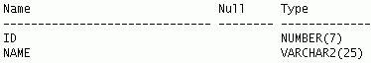

1. Populate the DEPT2 table with data from the DEPARTMENTS table. Include only the columns that you need.
2. Create the EMP2 table based on the following table instance chart. Place the syntax in a script called lab_02_03.sql, and then execute the statement in the script to create the table. Confirm that the table is created.

|  |  |  |  |  |  |  |
| --- | --- | --- | --- | --- | --- | --- |
|  | **Column Name** | ID | LAST_NAME | FIRST_NAME | | DEPT_ID |
|  |  |  |  |  |  |  |
|  | **Key Type** |  |  |  |  |  |
|  |  |  |  |  |  |  |
|  | **Nulls/Unique** |  |  |  |  |  |
|  |  |  |  |  |  |  |
|  | **FK Table** |  |  |  |  |  |
|  |  |  |  |  |  |  |
|  | **FK Column** |  |  |  |  |  |
|  |  |  |  |  |  |  |
|  | **Data type** | NUMBER | VARCHAR2 | VARCHAR2 | | NUMBER |
|  |  |  |  |  |  |  |
|  | **Length** | 7 | 25 | 25 |  | 7 |
|  |  |  |  |  |  |  |
|  |  |  |  |  |  |  |
|  |  |  |  |  |  |  |

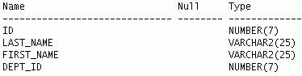

|  |
| --- |
| Oracle Internal & Oracle Academy Use Only |

**Oracle Database 10*g*: SQL Fundamentals II 2 - 39**

**Practice 2 (continued)**

1. Modify the EMP2 table to allow for longer employee last names. Confirm your modification.
2. Confirm that both the DEPT2 and EMP2 tables are stored in the data dictionary. (**Hint:** USER_TABLES)
3. Create the EMPLOYEES2 table based on the structure of the EMPLOYEES table. Include only the EMPLOYEE_ID, FIRST_NAME, LAST_NAME, SALARY, and DEPARTMENT_ID columns. Name the columns in your new table ID, FIRST_NAME, LAST_NAME, SALARY, and DEPT_ID, respectively. Confirm that the table is created.
4. Drop the EMP2 table.
5. Query the Recycle Bin to see whether the table is present.
6. Undrop the EMP2 table.
7. Drop the FIRST_NAME column from the EMPLOYEES2 table. Confirm your modification by checking the description of the table.

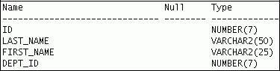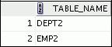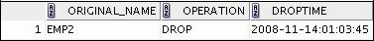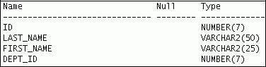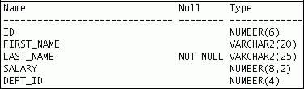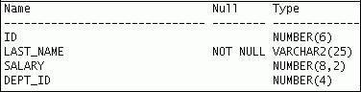

|  |
| --- |
| Oracle Internal & Oracle Academy Use Only |

**Oracle Database 10*g*: SQL Fundamentals II 2 - 40**

**Practice 2 (continued)**

1. In the EMPLOYEES2 table, mark the DEPT_ID column as UNUSED. Confirm your modification by checking the description of the table.
2. Drop all the UNUSED columns from the EMPLOYEES2 table. Confirm your modification by checking the description of the table.
3. Add a table-level PRIMARY KEY constraint to the EMP2 table on the ID column. The constraint should be named at creation. Name the constraint my_emp_id_pk.
4. Create a PRIMARY KEY constraint to the DEPT2 table using the ID column. The constraint should be named at creation. Name the constraint my_dept_id_pk.
5. Add a foreign key reference on the EMP2 table that ensures that the employee is not assigned to a nonexistent department. Name the constraint my_emp_dept_id_fk.
6. Confirm that the constraints were added by querying the USER_CONSTRAINTS view. Note the types and names of the constraints.
7. Display the object names and types from the USER_OBJECTS data dictionary view for the EMP2 and DEPT2 tables. Note that the new tables are created and a new index is created.

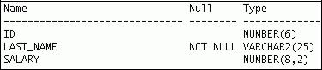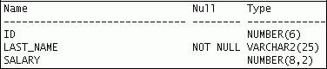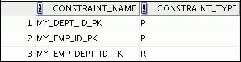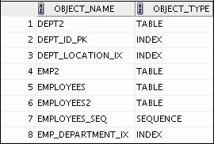

**…**

|  |
| --- |
| Oracle Internal & Oracle Academy Use Only |

**Oracle Database 10*g*: SQL Fundamentals II 2 - 41**

**Practice 2 (continued)**

If you have time, complete the following exercise:

1. Modify the EMP2 table. Add a COMMISSION column of the NUMBER data type, precision 2, scale 2. Add a constraint to the COMMISSION column that ensures that a commission value is greater than zero.
2. Drop the EMP2 and DEPT2 tables so that they cannot be restored. Check the Recycle Bin.

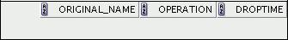

0 rows selected.

1. Create the DEPT_NAMED_INDEX table based on the following table instance chart. Name the index for the PRIMARY KEY column as DEPT_PK_IDX. Confirm that the table is created.

|  |  |  |  |  |
| --- | --- | --- | --- | --- |
|  | **Column Name** | Deptno | Dname | |
|  |  |  |  |  |
|  | **Primary Key** | Yes |  |  |
|  |  |  |  |  |
|  | **Data Type** | Number | VARCHAR2 | |
|  |  |  |  |  |
|  | **Length** | 4 | 30 |  |
|  |  |  |  |  |
|  |  |  |  |  |
|  |  |  |  |  |

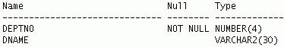

|  |
| --- |
| Oracle Internal & Oracle Academy Use Only |



**Manipulating Large Data Sets**

Copyright © 2009, Oracle. All rights reserved.

|  |
| --- |
| Oracle Internal & Oracle Academy Use Only |

**Objectives**

After completing this lesson, you should be able to do the following:

1. Manipulate data using subqueries
2. Describe the features of multitable INSERTs
3. Use the following types of multitable INSERTs

– Unconditional INSERT

– Pivoting INSERT

– Conditional ALL INSERT

– Conditional FIRST INSERT

1. Merge rows in a table
2. Track the changes to data over a period of time

Copyright © 2009, Oracle. All rights reserved.

**Objectives**

In this lesson, you learn how to manipulate data in the Oracle Database by using subqueries. You also learn about multitable insert statements, the MERGE statement, and tracking changes in the

database.

|  |
| --- |
| Oracle Internal & Oracle Academy Use Only |

**Oracle Database 10*g*: SQL Fundamentals II 3 - 2**

**Using Subqueries to Manipulate Data**

You can use subqueries in data manipulation language (DML)

statements to:

1. Copy data from one table to another
2. Retrieve data from an inline view
3. Update data in one table based on the values of another table
4. Delete rows from one table based on rows in another table

Copyright © 2009, Oracle. All rights reserved.

**Using Subqueries to Manipulate Data**

Subqueries can be used to retrieve data from a table that you can use as input to an INSERT into a

different table. In this way, you can easily copy large volumes of data from one table to another with one single SELECT statement. Similarly, you can use subqueries to do mass updates and deletes by using them in the WHERE clause of the UPDATE and DELETE statements. You can also use subqueries in the FROM clause of a SELECT statement. This is called an inline view.

|  |
| --- |
| Oracle Internal & Oracle Academy Use Only |

**Oracle Database 10*g*: SQL Fundamentals II 3 - 3**

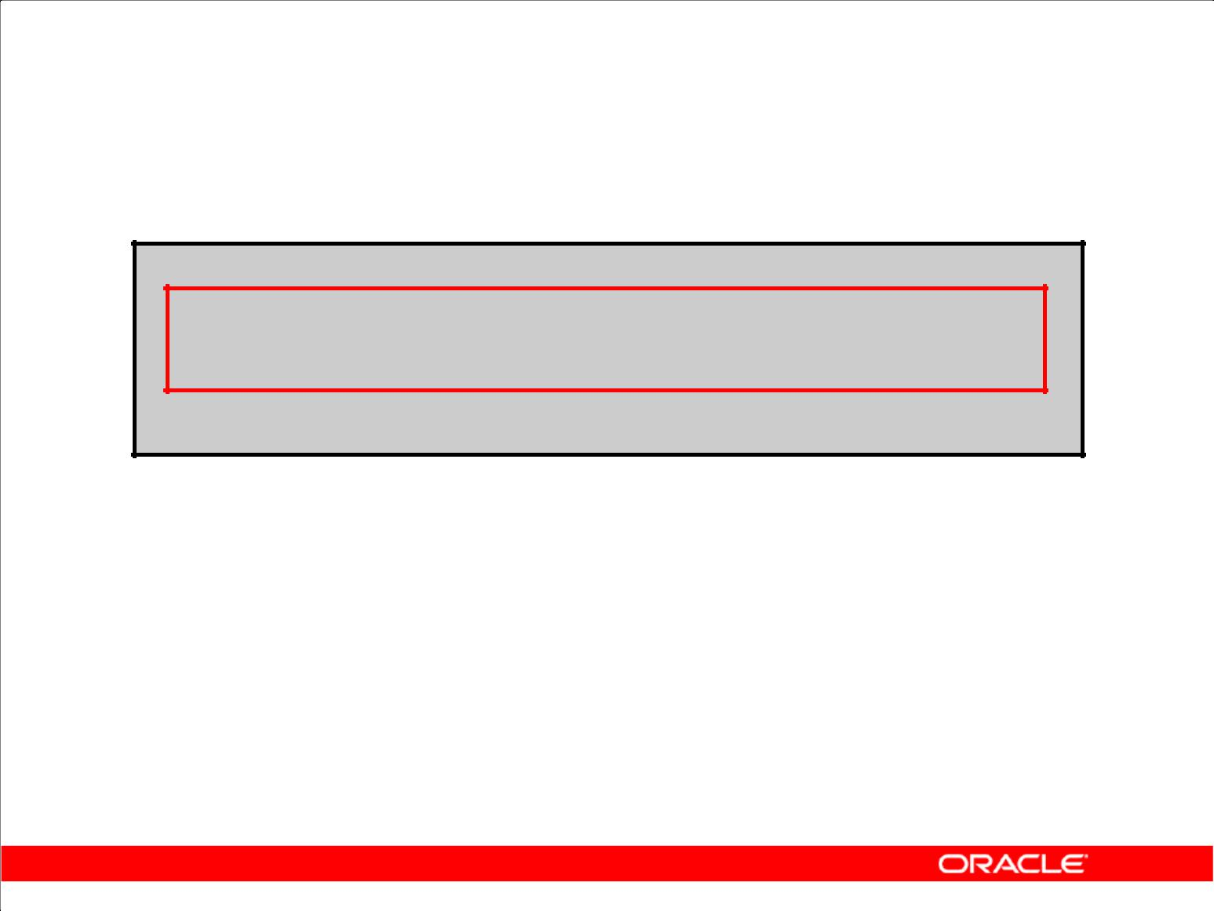**Copying Rows from Another Table**

1. Write your INSERT statement with a subquery.

**INSERT INTO sales_reps(id, name, salary, commission_pct)**

**SELECT employee_id, last_name, salary, commission_pct**

**FROM** **employees**

**WHERE job_id LIKE '%REP%';**

**33 rows inserted.**

1. Do not use the VALUES clause.
2. Match the number of columns in the INSERT clause with that in the subquery.

Copyright © 2009, Oracle. All rights reserved.

**Copying Rows from Another Table**

You can use the INSERT statement to add rows to a table where the values are derived from existing tables. In place of the VALUES clause, you use a subquery.

**Syntax**

INSERT INTO *table* [ *column* (, *column*) ] *subquery;*

|  |  |
| --- | --- |
| In the syntax: | Is the table name |
| *table* |
| *column* | Is the name of the column in the table to populate |
| *subquery* | Is the subquery that returns rows into the table |

The number of columns and their data types in the column list of the INSERT clause must match the

number of values and their data types in the subquery. To create a copy of the rows of a table, use SELECT * in the subquery.

INSERT INTO EMPL3

SELECT *

FROM employees;

For more information, see *Oracle Database 10g SQL Reference*.

|  |
| --- |
| Oracle Internal & Oracle Academy Use Only |

**Oracle Database 10*g*: SQL Fundamentals II 3 - 4**

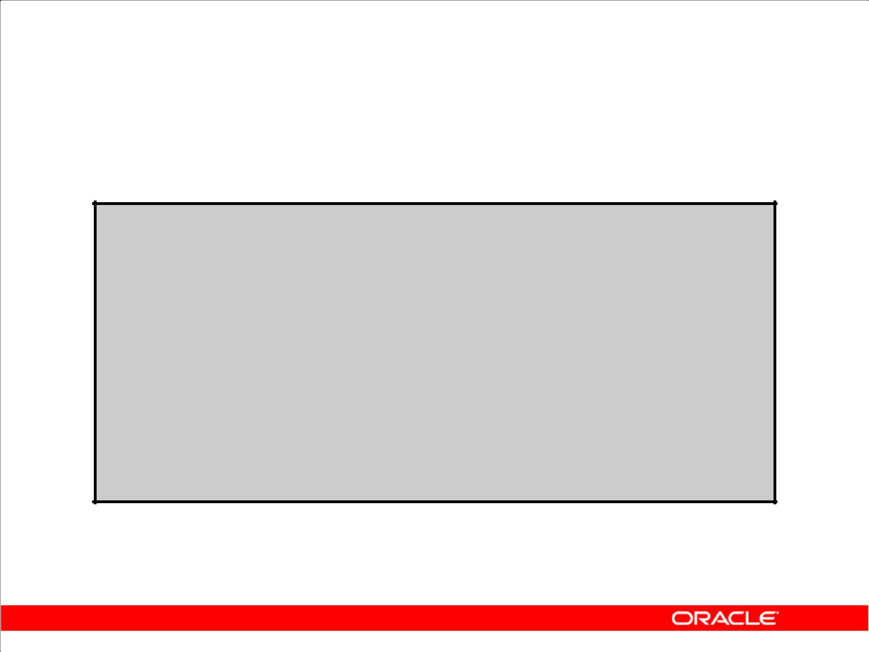**Inserting Using a Subquery as a Target**

**INSERT INTO**

**(SELECT employee_id, last_name,**

**email, hire_date, job_id, salary,**

**department_id**

**FROM empl3**

**WHERE department_id = 50) VALUES (99999, 'Taylor', 'DTAYLOR',**

**TO_DATE('07-JUN-99', 'DD-MON-RR'),**

**'ST_CLERK', 5000, 50);**

**1 row inserted.**

Copyright © 2009, Oracle. All rights reserved.

**Inserting Using a Subquery as a Target**

You can use a subquery in place of the table name in the INTO clause of the INSERT statement.

The select list of this subquery must have the same number of columns as the column list of the VALUES clause. Any rules on the columns of the base table must be followed in order for the INSERT statement to work successfully. For example, you cannot put in a duplicate employee ID or leave out a value for a mandatory NOT NULL column.

This application of subqueries helps avoid having to create a view just for performing an INSERT.

|  |
| --- |
| Oracle Internal & Oracle Academy Use Only |

**Oracle Database 10*g*: SQL Fundamentals II 3 - 5**

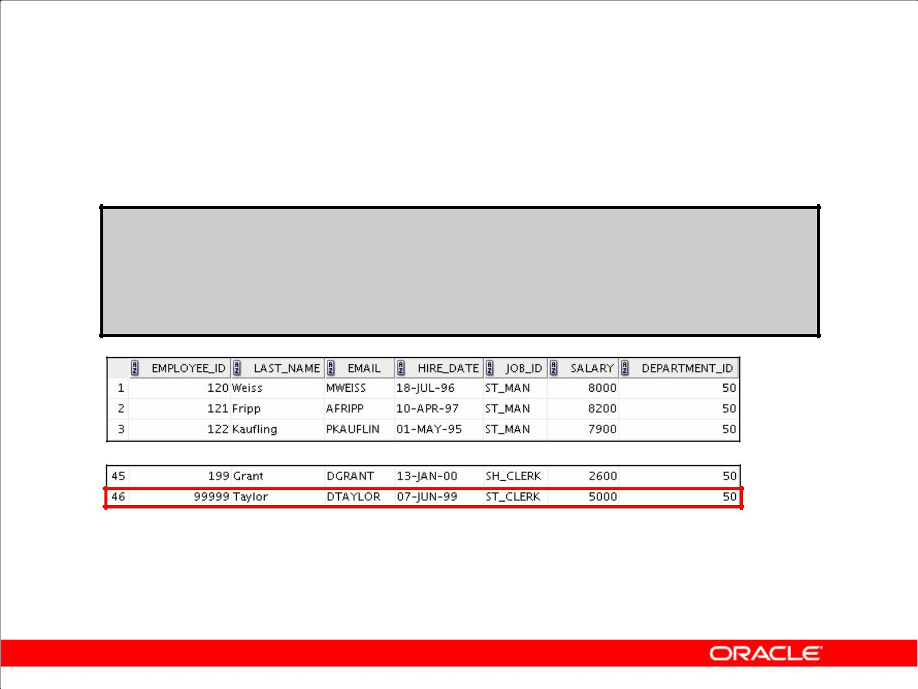**Inserting Using a Subquery as a Target**

Verify the results.

**SELECT employee_id, last_name, email, hire_date, job_id, salary, department_id**

**FROM empl3**

**WHERE department_id = 50;**

**…**

Copyright © 2009, Oracle. All rights reserved.

**Inserting Using a Subquery as a Target (continued)**

The example shows the results of the subquery that was used to identify the table for the INSERT statement.

|  |
| --- |
| Oracle Internal & Oracle Academy Use Only |

**Oracle Database 10*g*: SQL Fundamentals II 3 - 6**

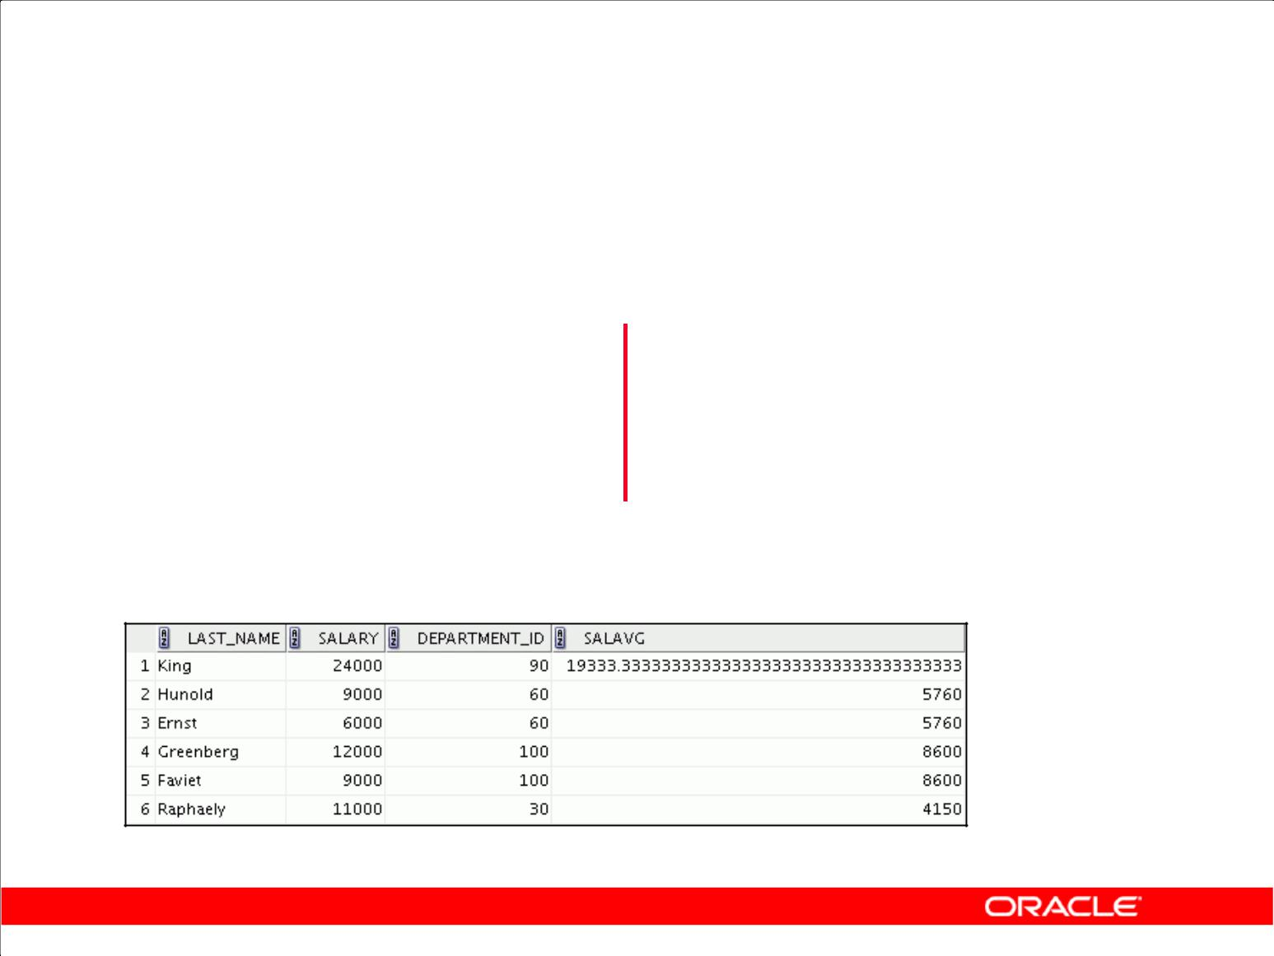**Retrieving Data with a Subquery as Source**

|  |  |  |  |
| --- | --- | --- | --- |
| **SELECT** | **a.last_name, a.salary,** | |  |
|  | **a.department_id, b.salavg** | |  |
|  |  |  |  |
| **FROM** | **employees a JOIN(SELECT** | | **department_id,** |
|  |  | **AVG(salary) salavg** | |
|  |  | **FROM** | **employees** |
|  |  | **GROUP BY department_id) b** | |
|  | |  | |
| **ON a.department_id = b.department_id** | | | |
| **AND** | **a.salary > b.salavg;** | |  |
|  |  |  |  |

**…**

Copyright © 2009, Oracle. All rights reserved.

**Retrieving Data Using a Subquery as Source**

You can use a subquery in the FROM clause of a SELECT statement, which is very similar to how views are used. A subquery in the FROM clause of a SELECT statement is also called an *inline* view. A subquery in the FROM clause of a SELECT statement defines a data source for that particular SELECT statement, and only that SELECT statement. The example in the slide displays employee

last names, salaries, department numbers, and average salaries for all the employees who earn more than the average salary in their department. The subquery in the FROM clause is named b, and the outer query references the SALAVG column using this alias.

|  |
| --- |
| Oracle Internal & Oracle Academy Use Only |

**Oracle Database 10*g*: SQL Fundamentals II 3 - 7**

**Updating Two Columns with a Subquery**

Update the job and salary of employee 114 to match the job of employee 205 and the salary of employee 168:

|  |  |  |  |  |  |  |
| --- | --- | --- | --- | --- | --- | --- |
| **UPDATE** | **empl3** |  |  |  |  |  |
| **SET** | **job_id** | **=** | **(SELECT** | | **job_id** |  |
|  |  |  |  | **FROM** | **employees** |  |
|  |  |  |  | **WHERE** | **employee_id = 205),** |  |
|  | **salary** | **=** | **(SELECT** | | **salary** |  |
|  |  |  |  | **FROM** | **employees** |  |
|  |  |  |  | **WHERE** | **employee_id = 168)** |  |
| **WHERE** | **employee_** | | **id** | **=** | **114;** |  |
| **1 rows updated.** | |  |  |  |  |  |

Copyright © 2009, Oracle. All rights reserved.

**Updating Two Columns with a Subquery**

You can update multiple columns in the SET clause of an UPDATE statement by writing multiple subqueries.

**Syntax**

UPDATE *table*

SET *column* =

(SELECT *column*

FROM *table*

WHERE *condition*)

[ ,

*column* =

(SELECT *column*

FROM *table*

WHERE *condition*)]

[WHERE *condition* ] ;

**Note:** If no rows are updated, a message “0 rows updated.” is returned.

|  |
| --- |
| Oracle Internal & Oracle Academy Use Only |

**Oracle Database 10*g*: SQL Fundamentals II 3 - 8**

**Updating Rows Based**

**on Another Table**

Use subqueries in UPDATE statements to update rows in a table based on values from another table:

|  |  |  |  |  |  |
| --- | --- | --- | --- | --- | --- |
|  |  |  |  |  |  |
| **UPDATE** | **empl3** |  |  |  |  |
| **SET** |  | **_id** | **= (SELECT department_id** | | |
| **department** |
|  |  |  | **FROM** | **employees** |  |
|  |  |  | **WHERE** |  |  |
|  |  |  | **employee_id = 100)** | |
| **WHERE** | **job_id** | | **= (SELECT job_id** | | |
|  |  |  | **FROM** | **employees** |  |
|  |  |  | **WHERE** |  |  |
|  |  |  | **employee_id = 200);** | |
| **1 rows updated.** | | |  |  |  |
|  |  |  |  |  |  |

Copyright © 2009, Oracle. All rights reserved.

**Updating Rows Based on Another Table**

You can use subqueries in UPDATE statements to update rows in a table. The example in the slide updates the EMPL3 table based on the values from the EMPLOYEES table. It changes the department number of all employees with employee 200’s job ID to employee 100’s current department number.

|  |
| --- |
| Oracle Internal & Oracle Academy Use Only |

**Oracle Database 10*g*: SQL Fundamentals II 3 - 9**

**Deleting Rows Based**

**on Another Table**

Use subqueries in DELETE statements to remove rows from a table based on values from another table:

|  |  |  |  |  |
| --- | --- | --- | --- | --- |
| **DELETE** | **FROM empl3** | |  |  |
| **WHERE** | **department_id =** | |  |  |
|  |  | **(SELECT** | **department_id** |  |
|  |  | **FROM** | **departments** |  |
|  |  | **WHERE** | **department_name** |  |
|  |  |  | **LIKE '%Public%');** |  |
| **1 rows** | **deleted.** |  |  |  |
|  |  |  |
|  |  |  |  |  |

Copyright © 2009, Oracle. All rights reserved.

**Deleting Rows Based on Another Table**

You can use subqueries to delete rows from a table based on values from another table. The example in the slide deletes all the employees who are in a department where the department name contains the string “Public.” The subquery searches the DEPARTMENTS table to find the department number

based on the department name containing the string “Public.” The subquery then feeds the department number to the main query, which deletes rows of data from the EMPLOYEES table based

on this department number.

|  |
| --- |
| Oracle Internal & Oracle Academy Use Only |

**Oracle Database 10*g*: SQL Fundamentals II 3 - 10**

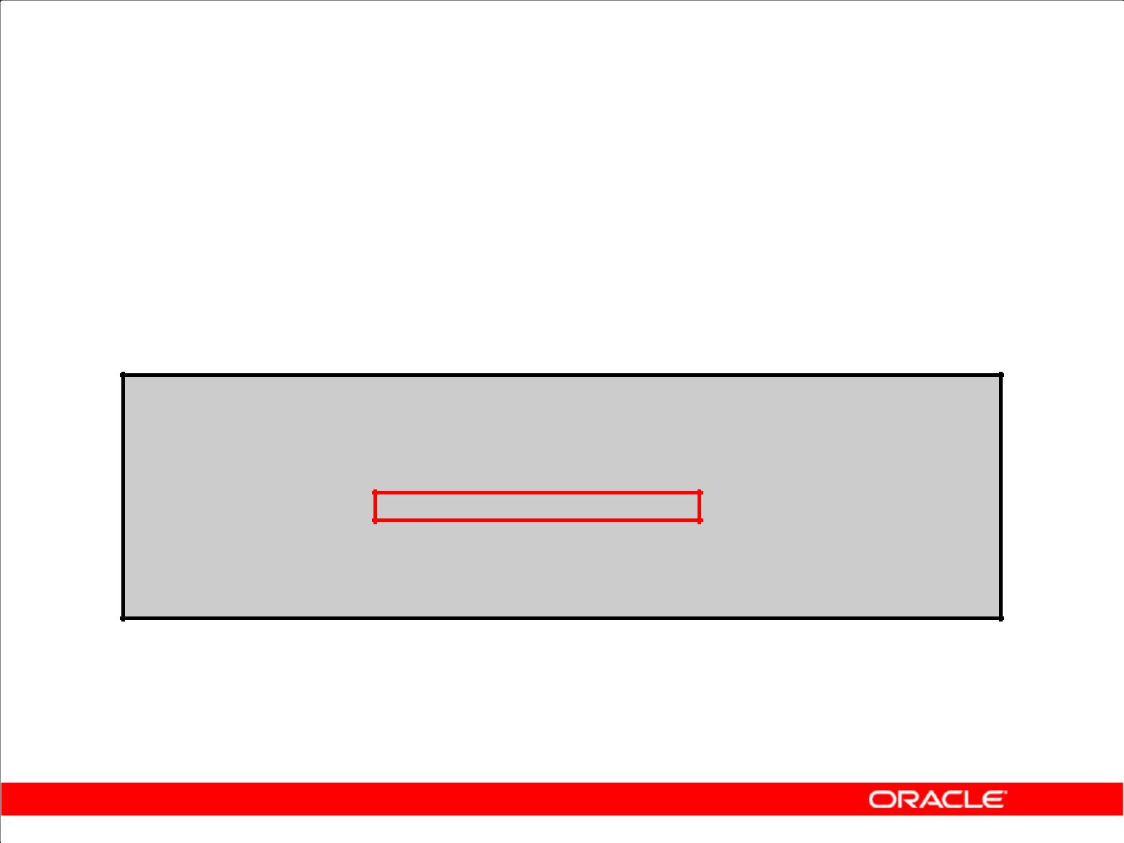**Using the WITH CHECK OPTION Keyword on DML Statements**

1. A subquery is used to identify the table and columns of the DML statement.
2. The WITH CHECK OPTION keyword prohibits you from changing rows that are not in the subquery.

**INSERT INTO (SELECT employee_id, last_name, email, hire_date, job_id, salary**

**FROM empl3**

**WHERE department_id = 50**

**WITH CHECK OPTION)**

**VALUES (99998, 'Smith', 'JSMITH',**

**TO_DATE('07-JUN-99', 'DD-MON-RR'),**

**'ST_CLERK', 5000);**

ERROR:

ORA-01402: view WITH CHECK OPTION where-clause violation

Copyright © 2009, Oracle. All rights reserved.

**WITH CHECK OPTION Keyword**

Specify WITH CHECK OPTION to indicate that, if the subquery is used in place of a table in an INSERT, UPDATE, or DELETE statement, no changes that produce rows that are not included in the subquery are permitted to that table.

In the example shown, the WITH CHECK OPTION keyword is used. The subquery identifies rows that are in department 50, but the department ID is not in the SELECT list, and a value is not provided for it in the VALUES list. Inserting this row results in a department ID of null, which is not in the subquery.

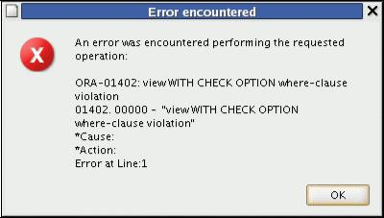

|  |
| --- |
| Oracle Internal & Oracle Academy Use Only |

**Oracle Database 10*g*: SQL Fundamentals II 3 - 11**

**Overview of the Explicit Default Feature**

1. With the explicit default feature, you can use the DEFAULT keyword as a column value where the column default is desired.
2. The addition of this feature is for compliance with the SQL:1999 standard.
3. This allows the user to control where and when the default value should be applied to data.
4. Explicit defaults can be used in INSERT and UPDATE statements.

Copyright © 2009, Oracle. All rights reserved.

**Explicit Defaults**

The DEFAULT keyword can be used in INSERT and UPDATE statements to identify a default column value. If no default value exists, a null value is used.

The DEFAULT option saves you from hard coding the default value in your programs or querying the dictionary to find it, as was done before this feature was introduced. Hard coding the default is a problem if the default changes because the code consequently needs changing. Accessing the dictionary is not usually done in an application program, so this is a very important feature.

|  |
| --- |
| Oracle Internal & Oracle Academy Use Only |

**Oracle Database 10*g*: SQL Fundamentals II 3 - 12**

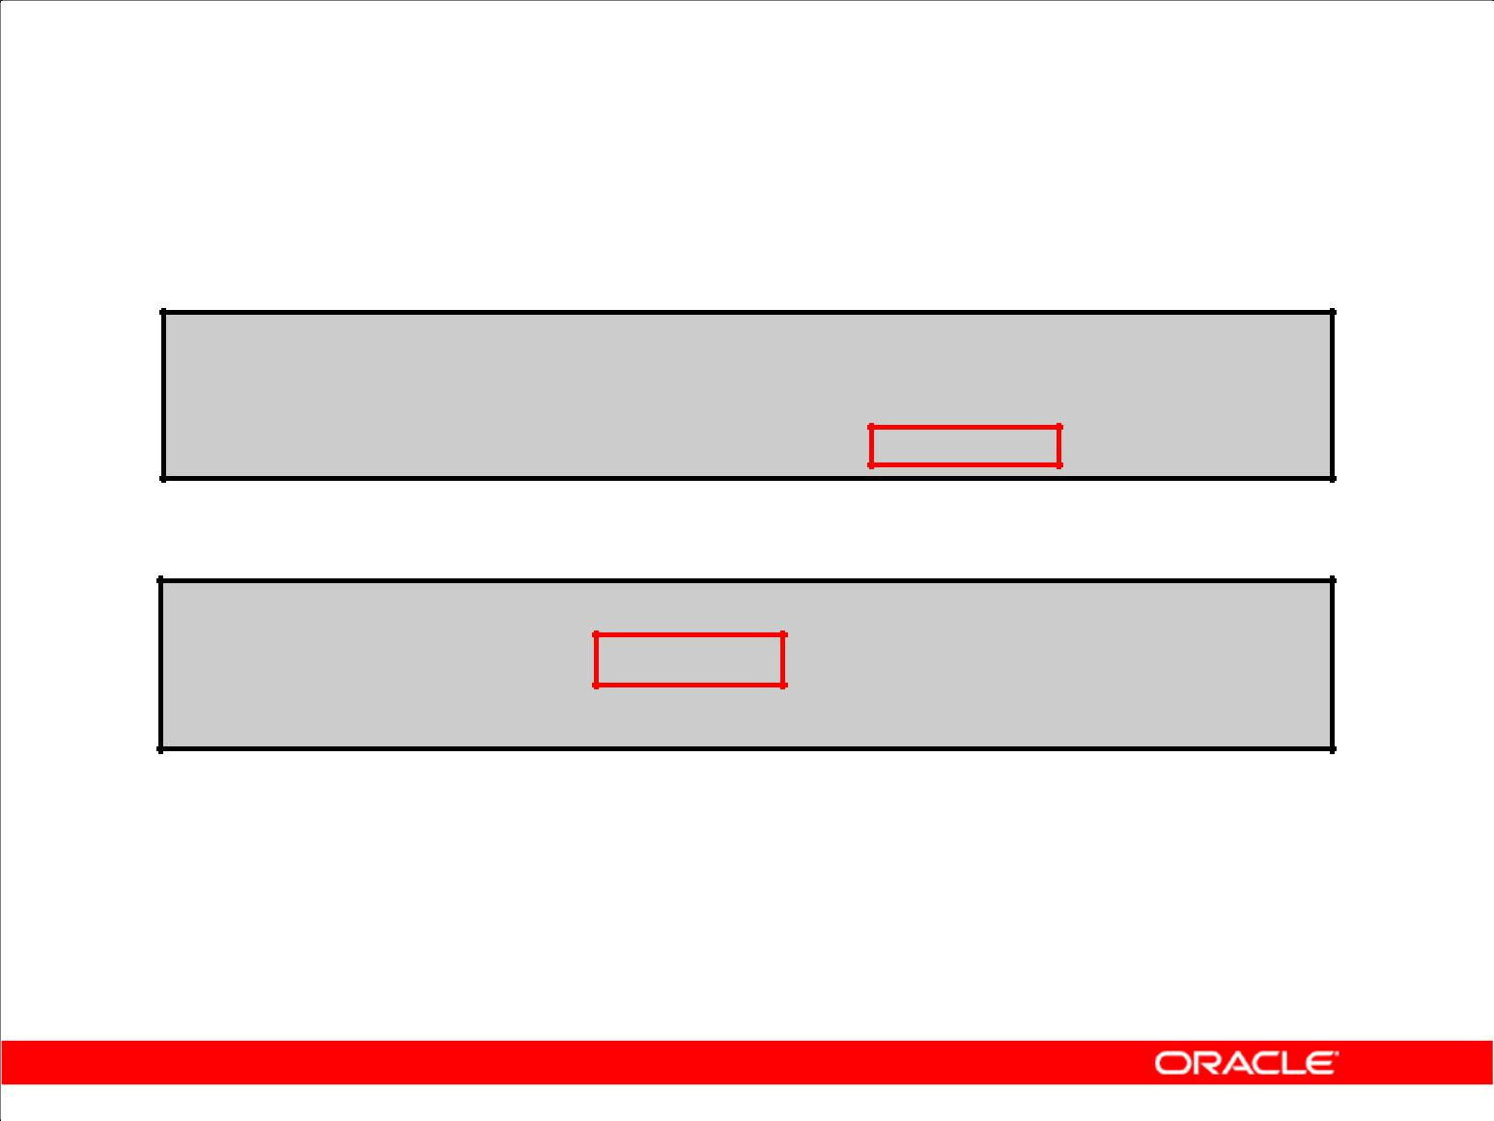**Using Explicit Default Values**

1. DEFAULT with INSERT:

**INSERT INTO deptm3**

**(department_id, department_name, manager_id)**

**VALUES (300, 'Engineering', DEFAULT);**

1. DEFAULT with UPDATE:

**UPDATE deptm3**

**SET manager_id = DEFAULT**

**WHERE department_id = 10;**

Copyright © 2009, Oracle. All rights reserved.

**Using Explicit Default Values**

Specify DEFAULT to set the column to the value previously specified as the default value for the column. If no default value for the corresponding column has been specified, then the Oracle server sets the column to null.

In the first example in the slide, the INSERT statement uses a default value for the MANAGER_ID column. If there is no default value defined for the column, a null value is inserted instead.

The second example uses the UPDATE statement to set the MANAGER_ID column to a default value for department 10. If no default value is defined for the column, then it changes the value to null.

**Note:** When creating a table, you can specify a default value for a column. This is discussed in*SQL**Fundamentals I*.

|  |
| --- |
| Oracle Internal & Oracle Academy Use Only |

**Oracle Database 10*g*: SQL Fundamentals II 3 - 13**

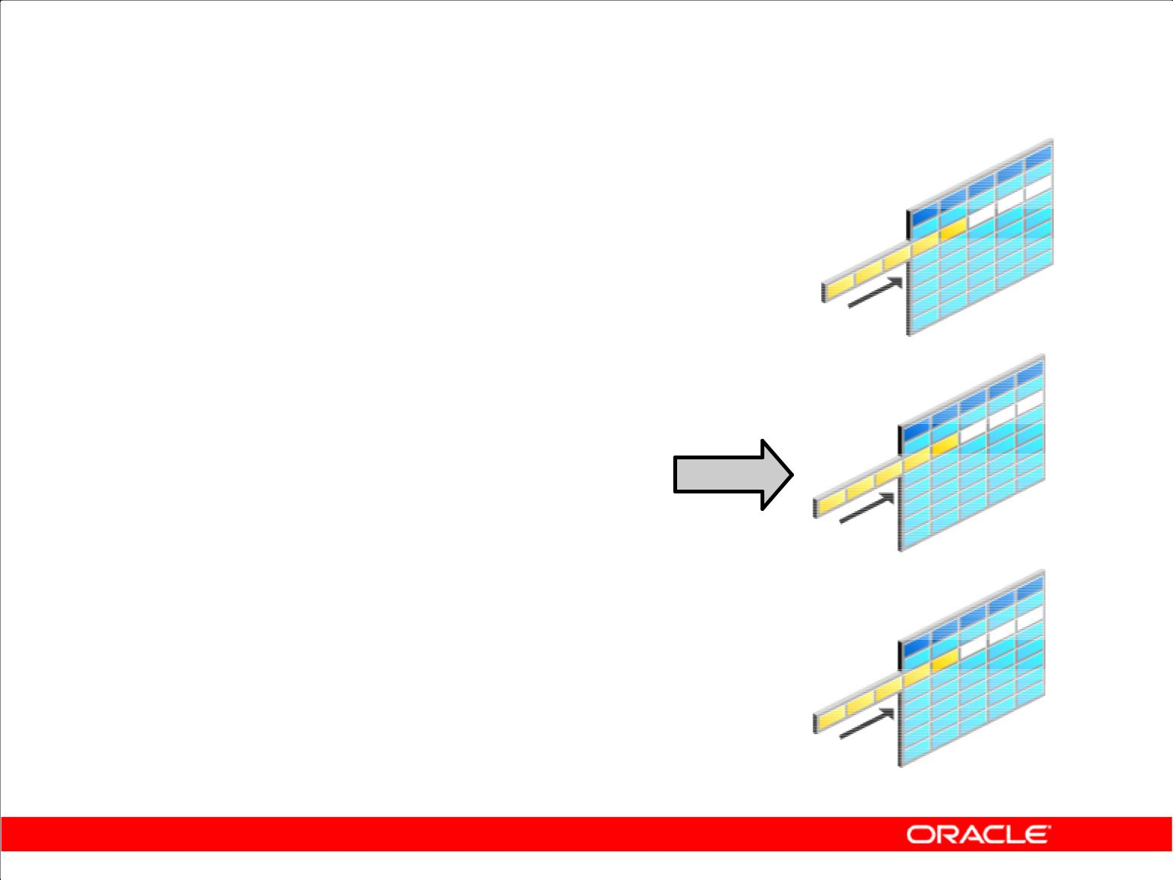**Overview of Multitable INSERT Statements**

|  |  |  |  |  |
| --- | --- | --- | --- | --- |
|  |  |  |  | **Table_a** |
| **INSERT** | | **ALL** | |
|  |
|  | **INTO table_a** | | **VALUES(…,…,…)** |  |
|  | **INTO table_b** | | **VALUES(…,…,…)** |  |
|  | **INTO table_c** | | **VALUES(…,…,…)** |  |
|  | **SELECT …** | |  |  |
|  | **FROM** | **sourcetab** | | **Table_b** |
|  | **WHERE …;** | | |
|  |  |
|  |  |  |  |  |

**Table_c**

Copyright © 2009, Oracle. All rights reserved.

**Overview of Multitable INSERT Statements**

In a multitable INSERT statement, you insert computed rows derived from the rows returned from the evaluation of a subquery into one or more tables.

Multitable INSERT statements can play a very useful role in a data warehouse scenario. You need to load your data warehouse regularly so that it can serve its purpose of facilitating business analysis. To do this, data from one or more operational systems must be extracted and copied into the warehouse. The process of extracting data from the source system and bringing it into the data warehouse is commonly called ETL, which stands for extraction, transformation, and loading.

During extraction, the desired data must be identified and extracted from many different sources, such as database systems and applications. After extraction, the data must be physically transported to the target system or an intermediate system for further processing. Depending on the chosen means of transportation, some transformations can be done during this process. For example, a SQL statement that directly accesses a remote target through a gateway can concatenate two columns as part of the SELECT statement.

After data is loaded into the Oracle Database, data transformations can be executed using SQL operations. A multitable INSERT statement is one of the techniques for implementing SQL data

transformations.

|  |
| --- |
| Oracle Internal & Oracle Academy Use Only |

**Oracle Database 10*g*: SQL Fundamentals II 3 - 14**

**Overview of Multitable INSERT Statements**

1. The INSERT…SELECT statement can be used to insert rows into multiple tables as part of a single DML statement.
2. Multitable INSERT statements can be used in data warehousing systems to transfer data from one or more operational sources to a set of target tables.
3. They provide significant performance improvement over:

– Single DML versus multiple INSERT…SELECT statements

– Single DML versus a procedure to perform multiple inserts by using the IF...THEN syntax

Copyright © 2009, Oracle. All rights reserved.

**Overview of Multitable INSERT Statements (continued)**

Multitable INSERT statements offer the benefits of the INSERT ... SELECT statement when

multiple tables are involved as targets. Using functionality before Oracle9*i* Database, you had to deal with *n* independent INSERT ... SELECT statements, thus processing the same source data *n* times

and increasing the transformation workload *n* times.

As with the existing INSERT ... SELECT statement, the new statement can be parallelized and used with the direct-load mechanism for faster performance.

Each record from any input stream, such as a nonrelational database table, can now be converted into multiple records for a more relational database table environment. To alternatively implement this functionality*,* you were required to write multiple INSERT statements.

|  |
| --- |
| Oracle Internal & Oracle Academy Use Only |

**Oracle Database 10*g*: SQL Fundamentals II 3 - 15**

**Types of Multitable INSERT Statements**

The different types of multitable INSERT statements are:

1. Unconditional INSERT
2. Conditional ALL INSERT
3. Conditional FIRST INSERT
4. Pivoting INSERT

Copyright © 2009, Oracle. All rights reserved.

**Types of Multitable INSERT Statements**

The types of multitable INSERT statements are:

1. Unconditional INSERT
2. Conditional ALL INSERT
3. Conditional FIRST INSERT
4. Pivoting INSERT

You use different clauses to indicate the type of INSERT to be executed.

|  |
| --- |
| Oracle Internal & Oracle Academy Use Only |

**Oracle Database 10*g*: SQL Fundamentals II 3 - 16**

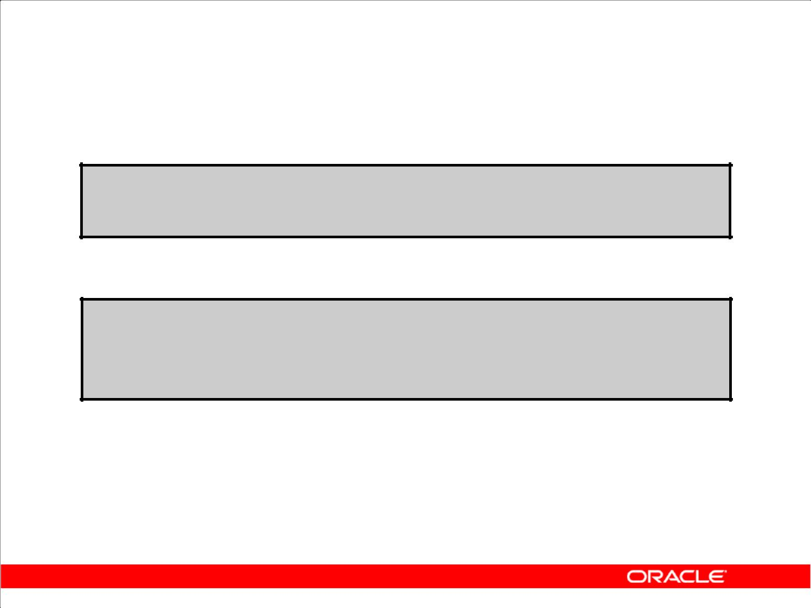**Multitable INSERT Statements**

1. Syntax:

**INSERT [ALL] [conditional_insert_clause] [insert_into_clause values_clause] (subquery)**

1. conditional_insert _clause:

**[ALL] [FIRST]**

**[WHEN condition THEN] [insert_into_clause values_clause] [ELSE] [insert_into_clause values_clause]**

Copyright © 2009, Oracle. All rights reserved.

**Multitable INSERT Statements**

The slide displays the generic format for multitable INSERT statements.

**Unconditional INSERT: ALL into_clause**

Specify ALL followed by multiple insert_into_clauses to perform an unconditional multitable INSERT. The Oracle server executes each insert_into_clause once for each row returned by the subquery.

**Conditional INSERT: conditional_insert_clause**

Specify the conditional_insert_clause to perform a conditional multitable INSERT. The Oracle server filters each insert_into_clause through the corresponding WHEN condition, which determines whether that insert_into_clause is executed. A single multitable INSERT statement can contain up to 127 WHEN clauses.

**Conditional INSERT: ALL**

If you specify ALL, the Oracle server evaluates each WHEN clause regardless of the results of the evaluation of any other WHEN clause. For each WHEN clause whose condition evaluates to true, the Oracle server executes the corresponding INTO clause list.

|  |
| --- |
| Oracle Internal & Oracle Academy Use Only |

**Oracle Database 10*g*: SQL Fundamentals II 3 - 17**

**Multitable INSERT Statements (continued)**

**Conditional INSERT: FIRST**

If you specify FIRST, the Oracle server evaluates each WHEN clause in the order in which it appears in the statement. If the first WHEN clause evaluates to true, the Oracle server executes the corresponding INTO clause and skips subsequent WHEN clauses for the given row.

**Conditional INSERT: ELSE Clause**

For a given row, if no WHEN clause evaluates to true:

1. If you have specified an ELSE clause, the Oracle server executes the INTO clause list associated with the ELSE clause
2. If you did not specify an ELSE clause, the Oracle server takes no action for that row

**Restrictions on Multitable INSERT Statements**

1. You can perform multitable INSERT statements only on tables, and not on views or materialized views.
2. You cannot perform a multitable INSERT on a remote table.
3. You cannot specify a table collection expression when performing a multitable INSERT.
4. In a multitable INSERT, all insert_into_clauses cannot combine to specify more than 999 target columns.

|  |
| --- |
| Oracle Internal & Oracle Academy Use Only |

**Oracle Database 10*g*: SQL Fundamentals II 3 - 18**

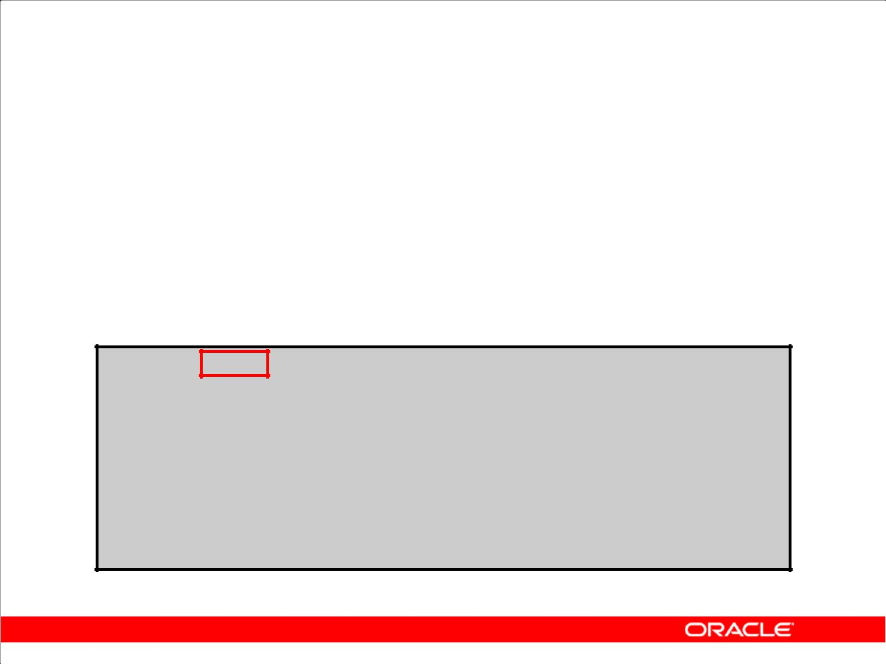**Unconditional INSERT ALL**

1. Select the EMPLOYEE_ID, HIRE_DATE, SALARY, and

MANAGER_ID values from the EMPLOYEES table for those employees whose EMPLOYEE_ID is greater than 200.

1. Insert these values into the SAL_HISTORY and MGR_HISTORY tables by using a multitable INSERT.

**INSERT** **ALL**

**INTO sal_history VALUES(EMPID,HIREDATE,SAL)**

**INTO mgr_history VALUES(EMPID,MGR,SAL)**

**SELECT employee_id EMPID, hire_date HIREDATE,**

**salary SAL, manager_id MGR**

**FROM** **employees**

**WHERE employee_id > 200;**

**12 rows inserted.**

Copyright © 2009, Oracle. All rights reserved.

**Unconditional INSERT ALL**

The example in the slide inserts rows into both the SAL_HISTORY and the MGR_HISTORY tables.

The SELECT statement retrieves the employee ID, hire date, salary, and manager ID of those employees whose employee ID is greater than 200 from the EMPLOYEES table. The employee ID, hire date, and salary are inserted into the SAL_HISTORY table. The employee ID, manager ID, and salary are inserted into the MGR_HISTORY table.

This INSERT statement is referred to as an unconditional INSERT because no further restriction is applied to the rows that are retrieved by the SELECT statement. All the rows retrieved by the SELECT statement are inserted into the two tables: SAL_HISTORY and MGR_HISTORY. The VALUES clause in the INSERT statements specifies the columns from the SELECT statement that must be inserted into each of the tables. Each row returned by the SELECT statement results in two insertions: one for the SAL_HISTORY table and one for the MGR_HISTORY table.

The feedback 12 rows created can be interpreted to mean that a total of eight insertions were performed on the base tables, SAL_HISTORY and MGR_HISTORY.

|  |
| --- |
| Oracle Internal & Oracle Academy Use Only |

**Oracle Database 10*g*: SQL Fundamentals II 3 - 19**

**Conditional INSERT ALL**

1. Select the EMPLOYEE_ID, HIRE_DATE, SALARY, and

MANAGER_ID values from the EMPLOYEES table for those employees whose EMPLOYEE_ID is greater than 200.

1. If the SALARY is greater than $10,000, insert these values into the SAL_HISTORY table using a conditional multitable INSERT statement.
2. If the MANAGER_ID is greater than 200, insert these values into the MGR_HISTORY table using a conditional multitable INSERT statement.

Copyright © 2009, Oracle. All rights reserved.

**Conditional INSERT ALL**

The problem statement for a conditional INSERT ALL statement is specified in the slide. The solution to this problem is shown on the next page.

|  |
| --- |
| Oracle Internal & Oracle Academy Use Only |

**Oracle Database 10*g*: SQL Fundamentals II 3 - 20**

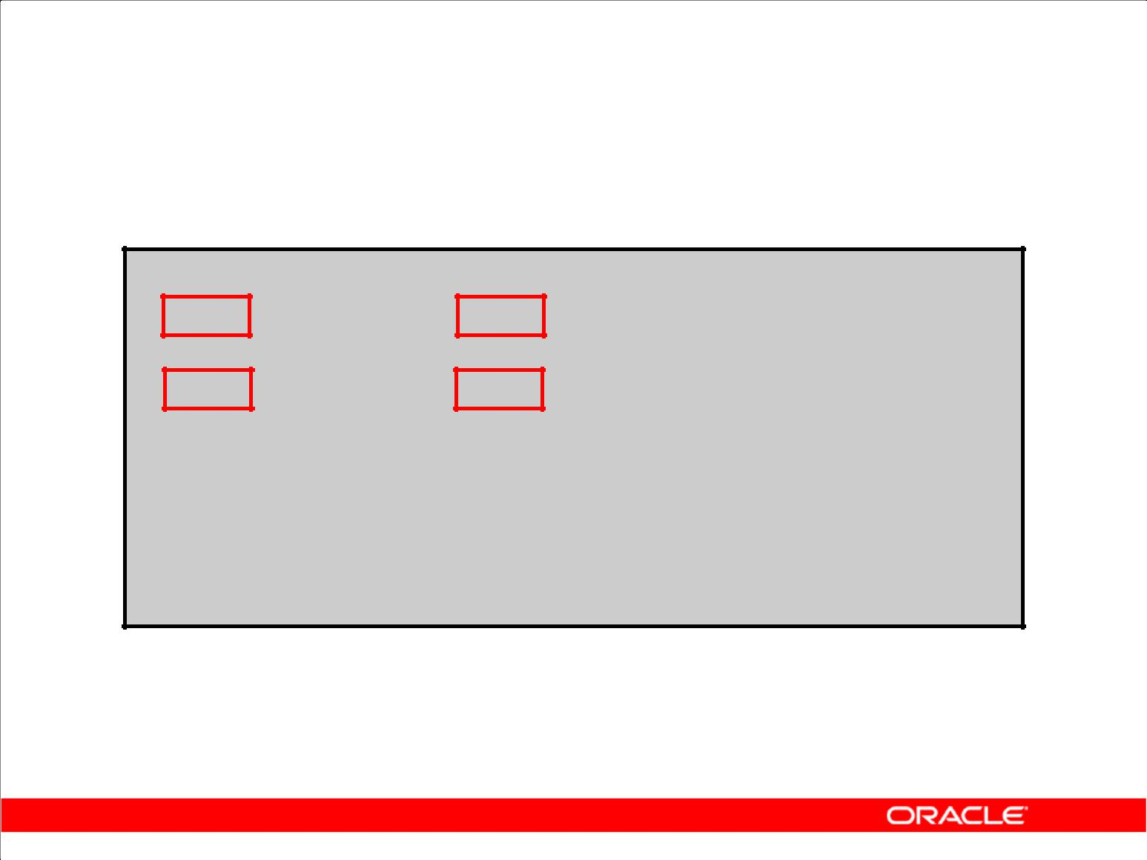**Conditional INSERT ALL**

**INSERT ALL**

**WHEN SAL > 10000 THEN**

**INTO sal_history VALUES(EMPID,HIREDATE,SAL)**

**WHEN MGR > 200** **THEN**

**INTO mgr_history VALUES(EMPID,MGR,SAL) SELECT employee_id EMPID,hire_date HIREDATE,**

**salary SAL, manager_id MGR**

**FROM employees**

**WHERE** **employee_id > 200;**

**4 rows inserted.**

Copyright © 2009, Oracle. All rights reserved.

**Conditional INSERT ALL (continued)**

The example in the slide is similar to the example in the previous slide because it inserts rows into both the SAL_HISTORY and the MGR_HISTORY tables. The SELECT statement retrieves the

employee ID, hire date, salary, and manager ID of those employees whose employee ID is greater than 200 from the EMPLOYEES table. The employee ID, hire date, and salary are inserted into the SAL_HISTORY table. The employee ID, manager ID, and salary are inserted into the MGR_HISTORY table.

This INSERT statement is referred to as a conditional ALL INSERT because a further restriction is applied to the rows that are retrieved by the SELECT statement. From the rows that are retrieved by the SELECT statement, only those rows in which the value of the SAL column is more than 10,000 are inserted in the SAL_HISTORY table, and similarly, only those rows where the value of the MGR column is more than 200 are inserted in the MGR_HISTORY table.

Observe that unlike the previous example (where eight rows were inserted into the tables), in this example, only four rows are inserted.

The feedback 4 rows created can be interpreted to mean that a total of four inserts were performed on the base tables, SAL_HISTORY and MGR_HISTORY.

|  |
| --- |
| Oracle Internal & Oracle Academy Use Only |

**Oracle Database 10*g*: SQL Fundamentals II 3 - 21**

**Conditional INSERT FIRST**

1. Select the DEPARTMENT_ID, SUM(SALARY), and MAX(HIRE_DATE)from the EMPLOYEES table.
2. If the SUM(SALARY) is greater than $25,000, insert these values into the SPECIAL_SAL by using a conditional

FIRST multitable INSERT.

1. If the first WHEN clause evaluates to true, the subsequent WHEN clauses for this row should be skipped.
2. For the rows that do not satisfy the first WHEN condition, insert into the HIREDATE_HISTORY_00, HIREDATE_HISTORY_99, or HIREDATE_HISTORY tables, based on the value in the HIRE_DATE column using a conditional multitable INSERT.

Copyright © 2009, Oracle. All rights reserved.

**Conditional INSERT FIRST**

The problem statement for a conditional FIRST INSERT statement is specified in the slide. The solution to this problem is shown on the next page.

|  |
| --- |
| Oracle Internal & Oracle Academy Use Only |

**Oracle Database 10*g*: SQL Fundamentals II 3 - 22**

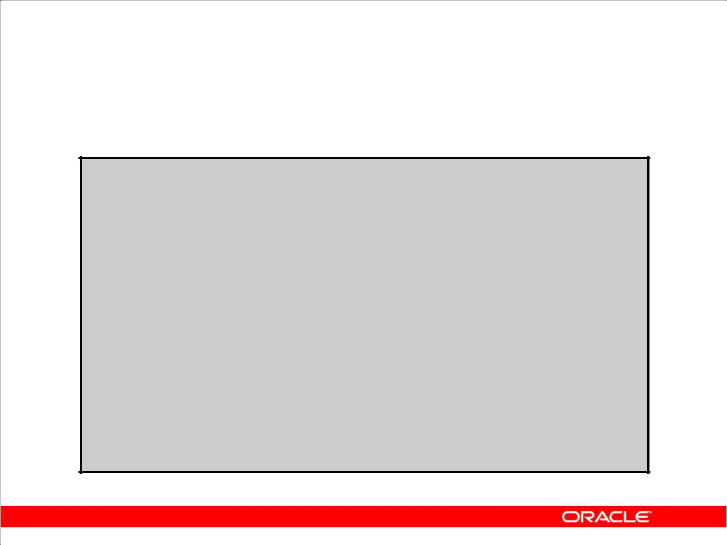**Conditional INSERT FIRST**

|  |  |  |  |
| --- | --- | --- | --- |
| **INSERT** | **FIRST** |  |  |
| **WHEN SAL > 25000** | | | **THEN** |
| **INTO special_sal** | | | **VALUES(DEPTID, SAL)** |
| **WHEN HIREDATE like** | | | **('%00%') THEN** |

**INTO hiredate_history_00 VALUES(DEPTID,HIREDATE)**

**WHEN HIREDATE like ('%99%') THEN**

**INTO hiredate_history_99 VALUES(DEPTID, HIREDATE)**

**ELSE**

**INTO hiredate_history VALUES(DEPTID, HIREDATE)**

**SELECT department_id DEPTID, SUM(salary) SAL,**

**MAX(hire_date) HIREDATE**

**FROM employees**

**GROUP BY department_id;**

**12 rows inserted.**

Copyright © 2009, Oracle. All rights reserved.

**Conditional INSERT FIRST (continued)**

The example in the slide inserts rows into more than one table using a single INSERT statement. The SELECT statement retrieves the department ID, total salary, and maximum hire date for every department in the EMPLOYEES table.

This INSERT statement is referred to as a conditional FIRST INSERT because an exception is made for the departments whose total salary is more than $25,000. The condition WHEN ALL > 25000 is evaluated first. If the total salary for a department is more than $25,000, then the record is inserted into the SPECIAL_SAL table irrespective of the hire date. If this first WHEN clause evaluates to true, the Oracle server executes the corresponding INTO clause and skips subsequent WHEN clauses for this row.

For the rows that do not satisfy the first WHEN condition (WHEN SAL > 25000), the rest of the conditions are evaluated in the same way as a conditional INSERT statement, and the records retrieved by the SELECT statement are inserted into the HIREDATE_HISTORY_00, HIREDATE_HISTORY_99, or HIREDATE_HISTORY tables, based on the value in the HIREDATE column.

The feedback 12 rows created can be interpreted to mean that a total of eight INSERT statements were performed on the base tables, SPECIAL_SAL, HIREDATE_HISTORY_00,

HIREDATE_HISTORY_99, and HIREDATE_HISTORY.

|  |
| --- |
| Oracle Internal & Oracle Academy Use Only |

**Oracle Database 10*g*: SQL Fundamentals II 3 - 23**

**Pivoting INSERT**

1. Suppose you receive a set of sales records from a nonrelational database table, SALES_SOURCE_DATA, in the following format:

– EMPLOYEE_ID, WEEK_ID, SALES_MON, SALES_TUE,

SALES_WED, SALES _THUR, SALES_FRI

1. You want to store these records in the SALES_INFO table in a more typical relational format:

– EMPLOYEE_ID, WEEK, SALES

1. Using a pivoting INSERT, convert the set of sales records from the nonrelational database table to relational format.

Copyright © 2009, Oracle. All rights reserved.

**Pivoting INSERT**

Pivoting is an operation in which you must build a transformation such that each record from any input stream, such as a nonrelational database table, must be converted into multiple records for a more relational database table environment.

To solve the problem mentioned in the slide, you must build a transformation such that each record from the original nonrelational database table, SALES_SOURCE_DATA, is converted into five records for the data warehouse’s SALES_INFO table. This operation is commonly referred to as *pivoting*.

The problem statement for a pivoting INSERT statement is specified in the slide. The solution to this problem is shown on the next page.

|  |
| --- |
| Oracle Internal & Oracle Academy Use Only |

**Oracle Database 10*g*: SQL Fundamentals II 3 - 24**

**Pivoting INSERT**

|  |  |  |
| --- | --- | --- |
| **INSERT** | **ALL** | |
| **INTO** | **sales_info** | **VALUES (employee_id,week_id,sales_MON)** |
| **INTO** | **sales_info** | **VALUES (employee_id,week_ id,sales_TUE)** |
| **INTO** | **sales_info** | **VALUES (employee_id,week_ id,sales_WED)** |
| **INTO** | **sales_info** | **VALUES (employee_id,week_id,sales_THUR)** |
| **INTO** | **sales_info** | **VALUES (employee_id,week_id, sales_FRI)** |
|  |  |  |
| **SELECT EMPLOYEE_ID, week_id, sales_MON, sales_TUE,** | | |
|  | **sales_WED, sales_THUR,sales_FRI** | |
| **FROM** | **sales_source_data;** | |
| **5 rows** | **inserted.** | |
|  |  |  |

Copyright © 2009, Oracle. All rights reserved.

**Pivoting INSERT (continued)**

In the example in the slide, the sales data is received from the nonrelational database table SALES_SOURCE_DATA, which is the details of the sales performed by a sales representative on

each day of a week, for a week with a particular week ID.

DESC SALES_SOURCE_DATA

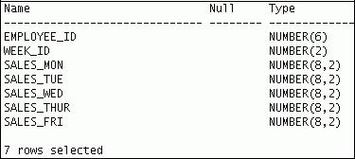

|  |
| --- |
| Oracle Internal & Oracle Academy Use Only |

**Oracle Database 10*g*: SQL Fundamentals II 3 - 25**

**Pivoting INSERT (continued)**

SELECT * FROM SALES_SOURCE_DATA;



DESC SALES_INFO

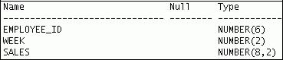

SELECT * FROM sales_info;

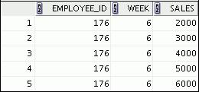

Observe in the preceding example that by using a pivoting INSERT, one row from the

SALES_SOURCE_DATA table is converted into five records for the relational table, SALES_INFO.

|  |
| --- |
| Oracle Internal & Oracle Academy Use Only |

**Oracle Database 10*g*: SQL Fundamentals II 3 - 26**

**MERGE Statement**

1. Provides the ability to conditionally update or insert data into a database table
2. Performs an UPDATE if the row exists, and an INSERT if it is a new row:

– Avoids separate updates

– Increases performance and ease of use

– Is useful in data warehousing applications

Copyright © 2009, Oracle. All rights reserved.

**MERGE Statement**

The Oracle server supports the MERGE statement for INSERT, UPDATE, and DELETE operations. Using this statement, you can update, insert, or delete a row conditionally into a table, thus avoiding multiple DML statements. The decision whether to update, insert, or delete into the target table is based on a condition in the ON clause.

You must have the INSERT and UPDATE object privileges on the target table and the SELECT

object privilege on the source table. To specify the DELETE clause of the

merge_update_clause, you must also have the DELETE object privilege on the target table.

The MERGE statement is deterministic. You cannot update the same row of the target table multiple times in the same MERGE statement.

An alternative approach is to use PL/SQL loops and multiple DML statements. The MERGE statement, however, is easy to use and more simply expressed as a single SQL statement.

The MERGE statement is suitable in a number of data warehousing applications. For example, in a data warehousing application, you may need to work with data coming from multiple sources, some of which may be duplicates. With the MERGE statement, you can conditionally add or modify rows.

|  |
| --- |
| Oracle Internal & Oracle Academy Use Only |

**Oracle Database 10*g*: SQL Fundamentals II 3 - 27**

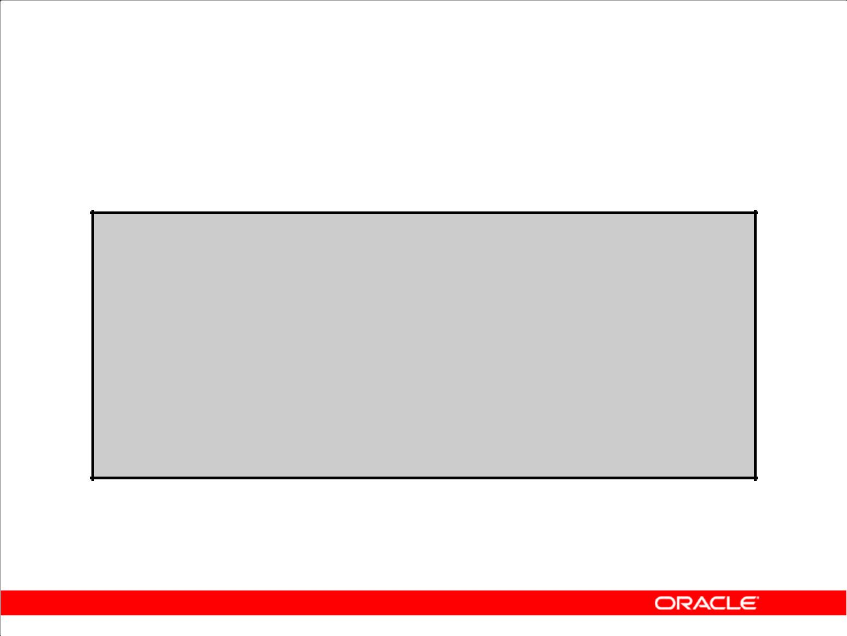**MERGE Statement Syntax**

You can conditionally insert or update rows in a table by using the MERGE statement.

**MERGE INTO *table_name table_alias***

**USING (*table|view|sub_query*) *alias***

**ON (*join condition*)**

**WHEN MATCHED THEN**

**UPDATE SET**

***col1 = col_val1,***

***col2 = col2_val***

**WHEN NOT MATCHED THEN**

**INSERT (*column_list*)**

**VALUES (*column_values*);**

Copyright © 2009, Oracle. All rights reserved.

**Merging Rows**

You can update existing rows and insert new rows conditionally by using the MERGE statement.

In the syntax:

INTO clause Specifies the target table you are updating or inserting into

USING clause Identifies the source of the data to be updated or inserted; can be

a table, view, or subquery

ON clause The condition on which the MERGE operation either updates or

inserts

WHEN MATCHED | Instructs the server how to respond to the results of the join

condition

WHEN NOT MATCHED

For more information, see *Oracle Database 10g SQL Reference*.

|  |
| --- |
| Oracle Internal & Oracle Academy Use Only |

**Oracle Database 10*g*: SQL Fundamentals II 3 - 28**

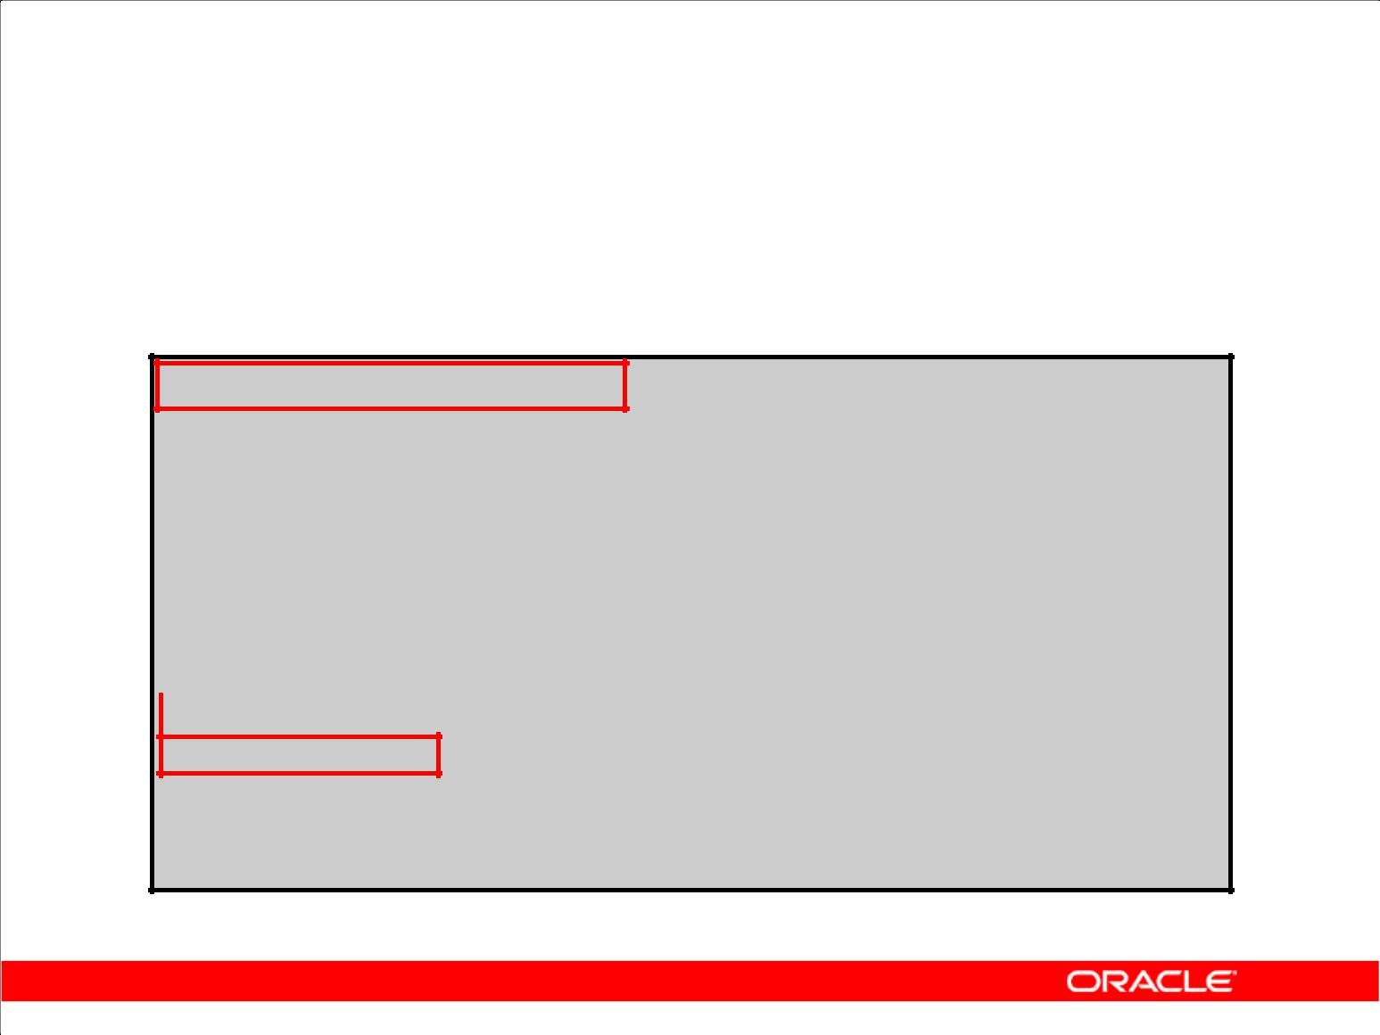**Merging Rows**

Insert or update rows in the EMPL3 table to match the EMPLOYEES table.

**MERGE INTO empl3 c**

|  |  |  |
| --- | --- | --- |
| **USING employees e** | |  |
| **ON (c.employee_id =** | | **e.employee_ id)** |
| **WHEN MATCHED THEN** |  |  |
| **UPDATE SET** |  |  |
| **c.first_name** | | **= e.first_name,** |
| **c.last_name** | | **= e.last_name,** |
| **...** |  |  |
| **c.department_id** | | **= e.department_id** |
| **WHEN NOT MATCHED THEN** | |  |

**INSERT VALUES(e.employee_id, e.first_name, e.last_name, e.email, e.phone_number, e.hire_date, e.job_id, e.salary, e.commission_pct, e.manager_id, e.department_id);**

Copyright © 2009, Oracle. All rights reserved.

**Example of Merging Rows**

MERGE INTO empl3 c

USING employees e

ON (c.employee_id = e.employee_id)

WHEN MATCHED THEN

UPDATE SET

c.first_name = e.first_name,

c.last_name = e.last_name,

c.email = e.email,

c.phone_number = e.phone_number,

c.hire_date = e.hire_date,

c.job_id = e.job_id,

c.salary = e.salary,

c.commission_pct = e.commission_pct,

c.manager_id = e.manager_id,

c.department_id = e.department_id

WHEN NOT MATCHED THEN

INSERT VALUES(e.employee_id, e.first_name, e.last_name, e.email, e.phone_number, e.hire_date, e.job_id, e.salary, e.commission_pct, e.manager_id, e.department_id);

**Oracle Database 10*g*: SQL Fundamentals II 3 - 29**

|  |
| --- |
| Oracle Internal & Oracle Academy Use Only |

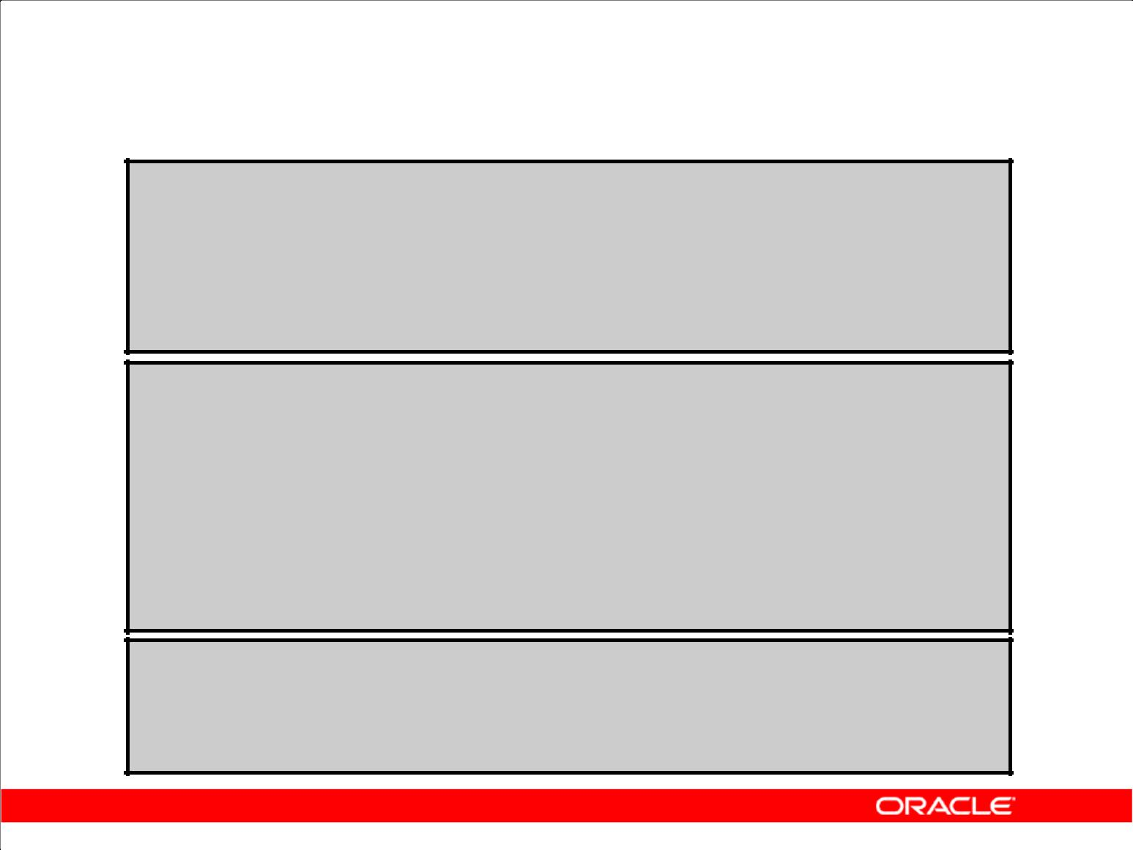**Merging Rows**

**TRUNCATE TABLE empl3;**

**SELECT \***

**FROM empl3;**

**no rows selected**

**MERGE INTO empl3 c**

**USING employees e**

**ON (c.employee_id = e.employee_id)**

**WHEN MATCHED THEN**

**UPDATE SET**

**...**

**WHEN NOT MATCHED THEN**

**INSERT VALUES...;**

**SELECT \***

**FROM empl3;**

**107 rows selected.**

Copyright © 2009, Oracle. All rights reserved.

**Example of Merging Rows (continued)**

The example in the slide matches the EMPLOYEE_ID in the EMPL3 table to the EMPLOYEE_ID in the EMPLOYEES table. If a match is found, the row in the EMPL3 table is updated to match the row in the EMPLOYEES table. If the row is not found, it is inserted into the EMPL3 table.

The condition c.employee_id = e.employee_id is evaluated. Because the EMPL3 table is empty, the condition returns false—there are no matches. The logic falls into the WHEN NOT MATCHED clause, and the MERGE command inserts the rows of the EMPLOYEES table into the EMPL3 table.

If rows existed in the EMPL3 table and employee IDs matched in both tables (the EMPL3 and EMPLOYEES tables), then the existing rows in the EMPL3 table would be updated to match the EMPLOYEES table.

|  |
| --- |
| Oracle Internal & Oracle Academy Use Only |

**Oracle Database 10*g*: SQL Fundamentals II 3 - 30**

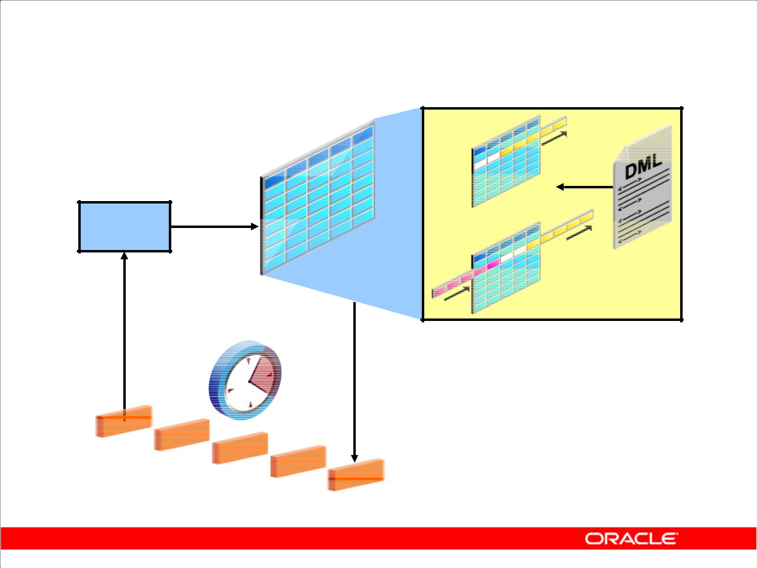**Tracking Changes in Data**

**SELECT**

**…**

**Versions of retrieved rows**

Copyright © 2009, Oracle. All rights reserved.

**Tracking Changes in Data**

You may discover that somehow data in a table has been inappropriately changed. To research this, you can use multiple flashback queries to view row data at specific points in time. More efficiently, you can use the Flashback Version Query feature to view all changes to a row over a period of time. This feature enables you to append a VERSIONS clause to a SELECT statement that specifies an SCN or time stamp range between which you want to view changes to row values. The query also can return associated metadata, such as the transaction responsible for the change.

Further, after you identify an erroneous transaction, you can then use the Flashback Transaction Query feature to identify other changes that were done by the transaction. You then have the option of using the Flashback Table feature to restore the table to a state before the changes were made.

You can use a query on a table with a VERSIONS clause to produce all the versions of all the rows that exist or ever existed between the time the query was issued and the undo_retention seconds before the current time. undo_retention is an initialization parameter, which is an autotuned parameter. A query that includes a VERSIONS clause is referred to as a version query. The results of a version query behaves as if the WHERE clause were applied to the versions of the rows. The version query returns versions of the rows only across transactions.

**System change number (SCN):** The Oracle server assigns a system change number (SCN) toidentify the redo records for each committed transaction.

|  |
| --- |
| Oracle Internal & Oracle Academy Use Only |

**Oracle Database 10*g*: SQL Fundamentals II 3 - 31**

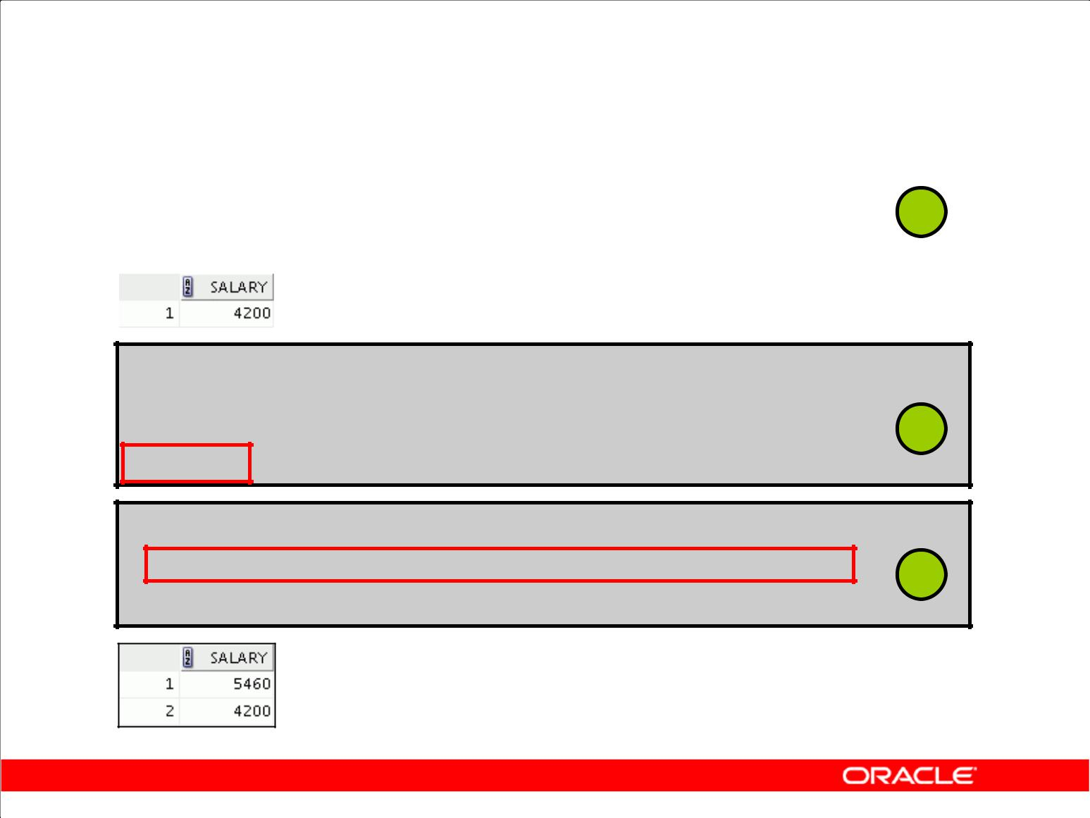**Example of the Flashback Version Query**

|  |  |  |
| --- | --- | --- |
| **SELECT salary FROM employees3** | | **1** |
| **WHERE employee_id = 107;** | |
|  |
|  |  |  |
|  |  |  |

**UPDATE employees3 SET salary = salary * 1.30 WHERE employee_id = 107;**

**2**

**COMMIT;**

**SELECT salary FROM employees3**

**VERSIONS BETWEEN SCN MINVALUE AND MAXVALUE** **3**

**WHERE** **employee_id = 107;**

Copyright © 2009, Oracle. All rights reserved.

**Example of the Flashback Version Query**

In the example in the slide, the salary for employee 107 is retrieved (1). The salary for employee 107 is increased by 30 percent and this change is committed (2). The different versions of salary are displayed (3).

The VERSIONS clause does not change the plan of the query. For example, if you run a query on a table that uses the index access method, then the same query on the same table with a VERSIONS

clause continues to use the index access method. The versions of the rows returned by the version query are versions of the rows across transactions. The VERSIONS clause has no effect on the transactional behavior of a query. This means that a query on a table with a VERSIONS clause still inherits the query environment of the ongoing transaction.

The default VERSIONS clause can be specified as VERSIONS BETWEEN {SCN|TIMESTAMP} MINVALUE AND MAXVALUE.

The VERSIONS clause is a SQL extension only for queries. You can have DML and DDL operations that use a VERSIONS clause within subqueries. The row version query retrieves all the committed versions of the selected rows. Changes made by the current active transaction are not returned. The version query retrieves all incarnations of the rows. This essentially means that versions returned include deleted and subsequent reinserted versions of the rows.

|  |
| --- |
| Oracle Internal & Oracle Academy Use Only |

**Oracle Database 10*g*: SQL Fundamentals II 3 - 32**

**Example of the Flashback Version Query (continued)**

The row access for a version query can be defined in one of the following two categories:

• **ROWID-based row access:** In case ofROWID-based access, all versions of the specifiedROWID

are returned irrespective of the row content. This essentially means that all versions of the slot in the block indicated by the ROWID are returned.

• **All other row access:** For all other row access, all versions of the rows are returned.

|  |
| --- |
| Oracle Internal & Oracle Academy Use Only |

**Oracle Database 10*g*: SQL Fundamentals II 3 - 33**

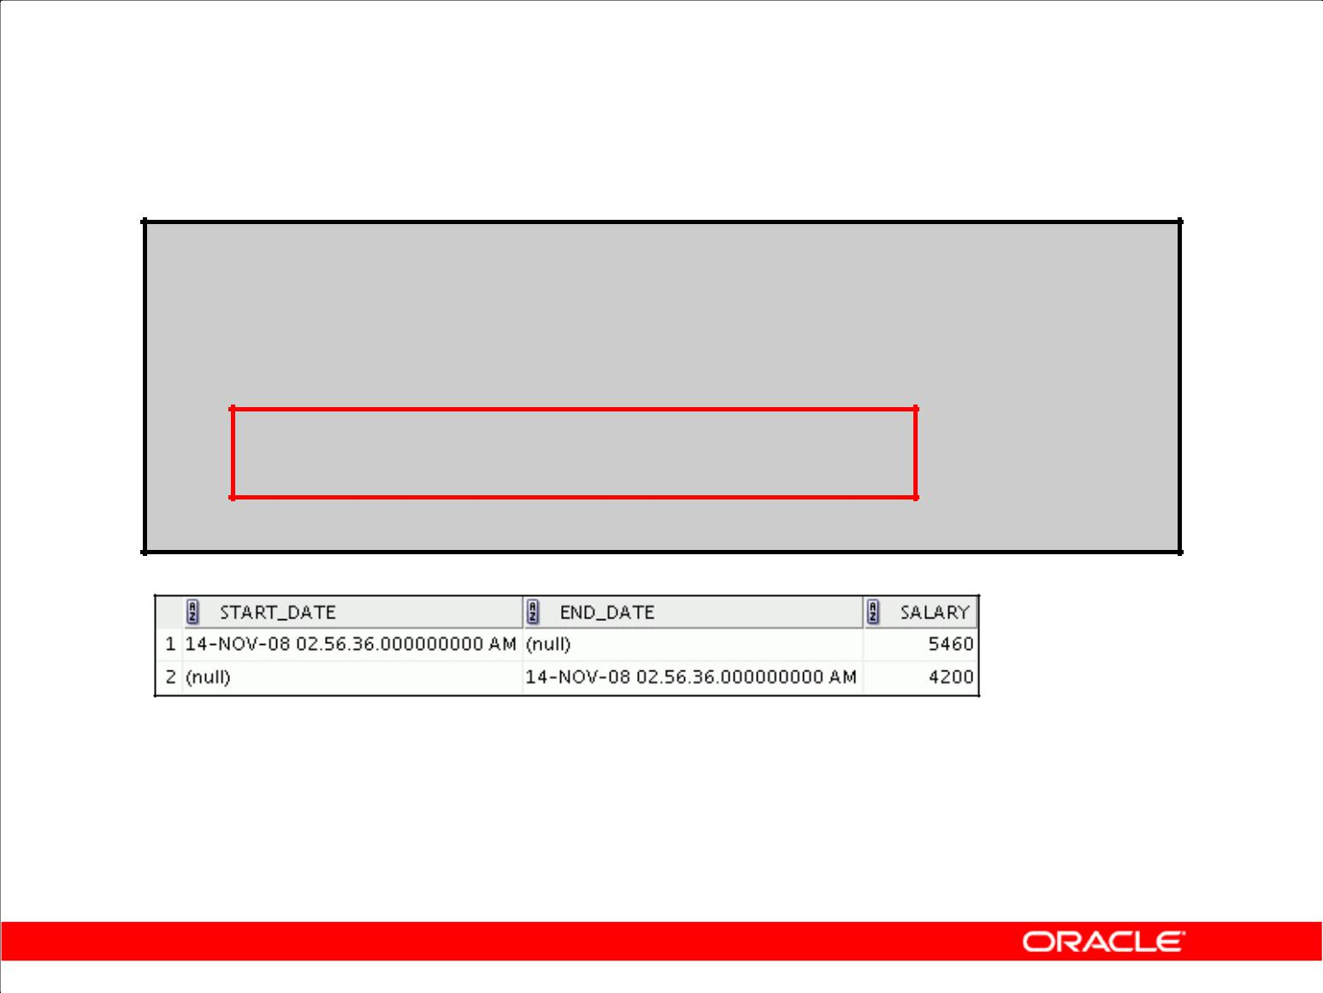**VERSIONS BETWEEN Clause**

**SELECT versions_starttime "START_DATE", versions_endtime "END_DATE", salary**

**FROM employees**

**VERSIONS BETWEEN SCN MINVALUE**

**AND MAXVALUE**

**WHERE last_name = 'Lorentz';**

Copyright © 2009, Oracle. All rights reserved.

**VERSIONS BETWEEN Clause**

You can use the VERSIONS BETWEEN clause to retrieve all the versions of the rows that exist or have ever existed between the time the query was issued and a point back in time.

If the undo retention time is less than the lower bound time/SCN of the BETWEEN clause, then the query retrieves versions up to the undo retention time only. The time interval of the BETWEEN clause can be specified as an SCN interval or a wall clock interval. This time interval is closed at both the lower and the upper bound.

In the example, Lorentz’s salary changes are retrieved. The NULL value for the END_DATE for the first version indicates that this was the existing version at the time of the query. The NULL value for the START_DATE for the last version indicates that this version was created at a time before the undo retention time.

|  |
| --- |
| Oracle Internal & Oracle Academy Use Only |

**Oracle Database 10*g*: SQL Fundamentals II 3 - 34**

**Summary**

In this lesson, you should have learned how to:

1. Use DML statements and control transactions
2. Describe the features of multitable INSERTs
3. Use the following types of multitable INSERTs:

– Unconditional INSERT

– Pivoting INSERT

– Conditional ALL INSERT

– Conditional FIRST INSERT

1. Merge rows in a table
2. Manipulate data by using subqueries
3. Track the changes to data over a period of time

Copyright © 2009, Oracle. All rights reserved.

**Summary**

In this lesson, you should have learned how to manipulate data in the Oracle Database by using subqueries. You also should have learned about multitable INSERT statements, the MERGE

statement, and tracking changes in the database.

|  |
| --- |
| Oracle Internal & Oracle Academy Use Only |

**Oracle Database 10*g*: SQL Fundamentals II 3 - 35**

**Practice 3: Overview**

This practice covers the following topics:

1. Performing multitable INSERTs
2. Performing MERGE operations
3. Tracking row versions

Copyright © 2009, Oracle. All rights reserved.

**Practice 3: Overview**

In this practice, you add rows to the emp_data table, update and delete data from the table, and track your transactions.

|  |
| --- |
| Oracle Internal & Oracle Academy Use Only |

**Oracle Database 10*g*: SQL Fundamentals II 3 - 36**

**Practice 3**

1. Run the lab_03_01.sql script in the lab folder to create the SAL_HISTORY table.
2. Display the structure of the SAL_HISTORY table.
3. Run the lab_03_03.sql script in the lab folder to create the MGR_HISTORY table.
4. Display the structure of the MGR_HISTORY table.
5. Run the lab_03_05.sql script in the lab folder to create the SPECIAL_SAL table.
6. Display the structure of the SPECIAL_SAL table.
7. a. Write a query to do the following:
   * 1. Retrieve the employee ID, hire date, salary, and manager ID of those employees whose employee ID is less than 125 from the EMPLOYEES table.
     2. If the salary is more than $20,000, insert the employee ID and salary into the

SPECIAL_SAL table.

* + 1. Insert the employee ID, hire date, and salary into the SAL_HISTORY table.
    2. Insert the employee ID, manager ID, and salary into the MGR_HISTORY table. b. Display the records from the SPECIAL_SAL table.

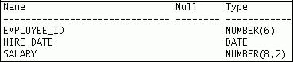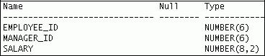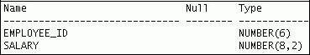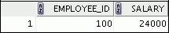

|  |
| --- |
| Oracle Internal & Oracle Academy Use Only |

**Oracle Database 10*g*: SQL Fundamentals II 3 - 37**

**Practice 3 (continued)**

1. Display the records from the SAL_HISTORY table.

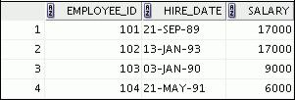

**…**



1. Display the records from the MGR_HISTORY table.

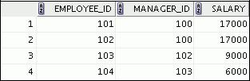

**…**



8. a. Run the lab_03_08a.sql script in the lab folder to create the SALES_SOURCE_DATA table.

1. Run the lab_03_08b.sql script in the lab folder to insert records into the

SALES_SOURCE_DATA table.

1. Display the structure of the SALES_SOURCE_DATA table.

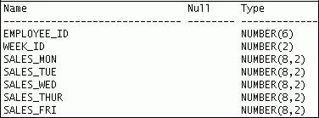

d. Display the records from the SALES_SOURCE_DATA table.



|  |
| --- |
| Oracle Internal & Oracle Academy Use Only |

**Oracle Database 10*g*: SQL Fundamentals II 3 - 38**

**Practice 3 (continued)**

1. Run the lab_03_08c.sql script in the lab folder to create the SALES_INFO table.
2. Display the structure of the SALES_INFO table.
3. Write a query to do the following:
   1. Retrieve the employee ID, week ID, sales on Monday, sales on Tuesday, sales on Wednesday, sales on Thursday, and sales on Friday from the SALES_SOURCE_DATA table.
   2. Build a transformation such that each record retrieved from the SALES_SOURCE_DATA table is converted into multiple records for the SALES_INFO table.

**Hint:** Use a pivotingINSERTstatement.

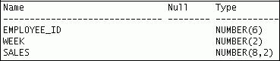

h. Display the records from the SALES_INFO table.

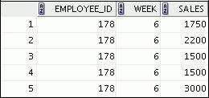

1. You have the data of past employees stored in a flat file called emp.data. You want to store the names and email IDs of all the past and present employees in a table. To do this, first create an external table called EMP_DATA using the emp.dat source file in the emp_dir directory. You can use the script in lab_03_09.sql to do this.
2. Next, run the lab_03_10.sql script to create the EMP_HIST table.
   1. Increase the size of the email column to 45.
   2. Merge the data in the EMP_DATA table that was created in step 9 with the data in the EMP_HIST table. Assume that the data in the external EMP_DATA table is the most up-to-date. If a row in the EMP_DATA table matches the EMP_HIST table, update the email column of the EMP_HIST table to match the EMP_DATA table row. If a row in the EMP_DATA table does not match, insert it into the EMP_HIST table. Rows are considered matching when the employee’s first and last names are identical.
   3. Retrieve the rows from EMP_HIST after the merge.

|  |
| --- |
| Oracle Internal & Oracle Academy Use Only |

**Oracle Database 10*g*: SQL Fundamentals II 3 - 39**

**Practice 3 (continued)**

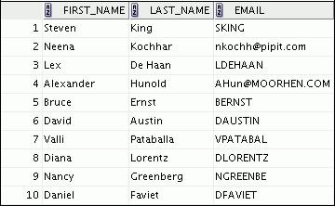

**…**

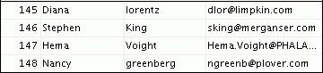

1. Create the EMP3 table by using the lab_03_11.sql script. In the EMP3 table, change the department for Kochhar to 60 and commit your change. Next, change the department for Kochhar to 50 and commit your change. Track the changes to Kochhar by using the Row Versions feature.

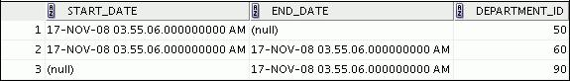

|  |
| --- |
| Oracle Internal & Oracle Academy Use Only |

**Oracle Database 10*g*: SQL Fundamentals II 3 - 40**



**Generating Reports by Grouping**

**Related Data**

Copyright © 2009, Oracle. All rights reserved.

|  |
| --- |
| Oracle Internal & Oracle Academy Use Only |

**Objectives**

After completing this lesson, you should be able to do the following:

1. Use the ROLLUP operation to produce subtotal values
2. Use the CUBE operation to produce cross- tabulation values
3. Use the GROUPING function to identify the row values created by ROLLUP or CUBE
4. Use GROUPING SETS to produce a single result set

Copyright © 2009, Oracle. All rights reserved.

**Objectives**

In this lesson, you learn how to:

1. Group data to obtain the following:
   1. Subtotal values by using the ROLLUP operator
   2. Cross-tabulation values by using the CUBE operator
2. Use the GROUPING function to identify the level of aggregation in the result set produced by a

ROLLUP or CUBE operator

1. Use GROUPING SETS to produce a single result set that is equivalent to a UNION ALL approach

|  |
| --- |
| Oracle Internal & Oracle Academy Use Only |

**Oracle Database 10*g*: SQL Fundamentals II 4 - 2**

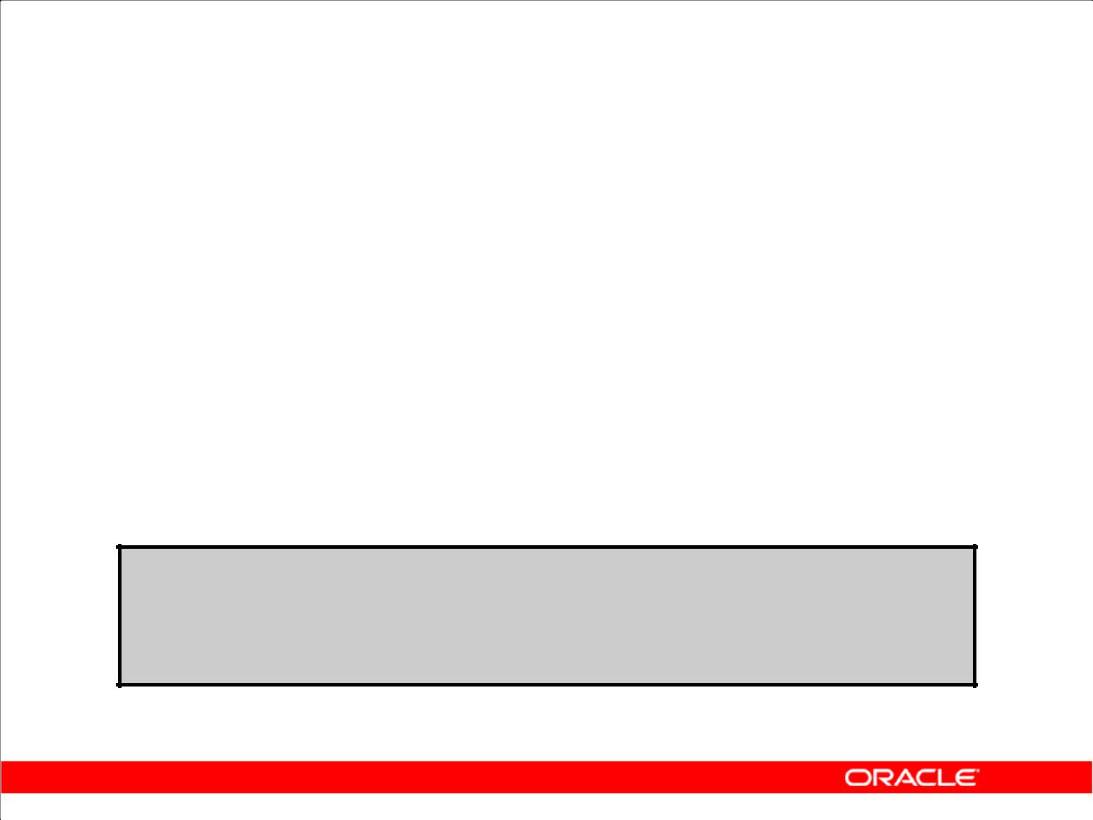**Review of Group Functions**

• Group functions operate on sets of rows to give one result per group.

|  |  |  |  |  |
| --- | --- | --- | --- | --- |
|  |  |  |  |  |
|  | **SELECT** | **[*column*,]** | ***group_function(column). . .*** | |
|  | **FROM** | ***table*** |  | |
|  | **[WHERE** | ***condition*]** | | |
|  | **[GROUP BY** | ***group_by_expression*]** | |  |
|  | **[ORDER BY** | ***column*];** | |  |
|  |  |  |  |  |

• Example:

**SELECT AVG(salary), STDDEV(salary),**

**COUNT(commission_pct),MAX(hire_date)**

**FROM employees**

**WHERE** **job_id LIKE 'SA%';**

Copyright © 2009, Oracle. All rights reserved.

**Group Functions**

You can use the GROUP BY clause to divide the rows in a table into groups. You can then use group

functions to return summary information for each group. Group functions can appear in select lists and in ORDER BY and HAVING clauses. The Oracle server applies the group functions to each group

of rows and returns a single result row for each group.

**Types of group functions:** Each of the group functions—AVG,SUM,MAX,MIN,COUNT,STDDEV,and VARIANCE—accepts one argument. The AVG, SUM, STDDEV, and VARIANCE functions operate only on numeric values. MAX and MIN can operate on numeric, character, or date data values. COUNT returns the number of non-null rows for the given expression. The example in the slide

calculates the average salary, standard deviation on the salary, number of employees earning a commission, and the maximum hire date for those employees whose JOB_ID begins with SA.

**Guidelines for Using Group Functions**

1. The data types for the arguments can be CHAR, VARCHAR2, NUMBER, or DATE.
2. All group functions except COUNT(*) ignore null values. To substitute a value for null values, use the NVL function. COUNT returns either a number or zero.
3. The Oracle server implicitly sorts the result set in ascending order of the grouping columns specified, when you use a GROUP BY clause. To override this default ordering, you can use

DESC in an ORDER BY clause.

|  |
| --- |
| Oracle Internal & Oracle Academy Use Only |

**Oracle Database 10*g*: SQL Fundamentals II 4 - 3**

**Review of the GROUP BY Clause**

• Syntax:

|  |  |
| --- | --- |
| **SELECT** | **[*column*,] *group_function(column). . .*** |
| **FROM** | ***table*** |
| **[WHERE** | ***condition*]** |
| **[GROUP BY** | ***group_by_expression*]** |
| **[ORDER BY** | ***column*];** |
|  |  |

• Example:

|  |  |  |  |
| --- | --- | --- | --- |
|  | **SELECT** | **department_id, job_id, SUM(salary),** | |
|  |  | **COUNT(employee_id)** | |
|  | **FROM** | **employees** | |
|  | **GROUP BY** | **department_id, job_id** | **;** |
|  |  |  |  |

Copyright © 2009, Oracle. All rights reserved.

**Review of the GROUP BY Clause**

The example illustrated in the slide is evaluated by the Oracle server as follows:

1. The SELECT clause specifies that the following columns be retrieved:
   1. Department ID and job ID columns from the EMPLOYEES table
   2. The sum of all the salaries and the number of employees in each group that you have specified in the GROUP BY clause
2. The GROUP BY clause specifies how the rows should be grouped in the table. The total salary and the number of employees are calculated for each job ID within each department. The rows are grouped by department ID and then grouped by job within each department.

|  |
| --- |
| Oracle Internal & Oracle Academy Use Only |

**Oracle Database 10*g*: SQL Fundamentals II 4 - 4**

**Review of the HAVING Clause**

1. Use the HAVING clause to specify which groups are to be displayed.
2. You further restrict the groups on the basis of a limiting condition.

|  |  |  |  |
| --- | --- | --- | --- |
|  | **SELECT** | **[*column*,] *group_function(column)...*** | |
|  | **FROM** | ***table*** | |
|  | **[WHERE** | ***condition*]** | |
|  | **[GROUP BY** | ***group_by_expression*]** | |
|  | **[HAVING** | ***having_expression*]** |  |
|  | **[ORDER BY** | ***column*];** |  |
|  |  |  |  |

Copyright © 2009, Oracle. All rights reserved.

**HAVING Clause**

Groups are formed and group functions are calculated before the HAVING clause is applied to the groups. The HAVING clause can precede the GROUP BY clause, but it is recommended that you place the GROUP BY clause first because it is more logical.

The Oracle server performs the following steps when you use the HAVING clause:

1. It groups rows.
2. It applies the group functions to the groups and displays the groups that match the criteria in the HAVING clause.

|  |
| --- |
| Oracle Internal & Oracle Academy Use Only |

**Oracle Database 10*g*: SQL Fundamentals II 4 - 5**

**GROUP BY with ROLLUP and**

**CUBE Operators**

1. Use ROLLUP or CUBE with GROUP BY to produce superaggregate rows by cross-referencing columns.
2. ROLLUP grouping produces a result set containing the regular grouped rows and the subtotal values.
3. CUBE grouping produces a result set containing the rows from ROLLUP and cross-tabulation rows.

Copyright © 2009, Oracle. All rights reserved.

**GROUP BY with the ROLLUP and CUBE Operators**

You specify ROLLUP and CUBE operators in the GROUP BY clause of a query. ROLLUP grouping produces a result set containing the regular grouped rows and subtotal rows. The CUBE operation in the GROUP BY clause groups the selected rows based on the values of all possible combinations of

expressions in the specification and returns a single row of summary information for each group. You can use the CUBE operator to produce cross-tabulation rows.

**Note:** When working withROLLUPandCUBE, make sure that the columns following theGROUP BYclause have meaningful, real-life relationships with each other; otherwise, the operators return irrelevant information.

|  |
| --- |
| Oracle Internal & Oracle Academy Use Only |

**Oracle Database 10*g*: SQL Fundamentals II 4 - 6**

**ROLLUP Operator**

1. ROLLUP is an extension to the GROUP BY clause.
2. Use the ROLLUP operation to produce cumulative aggregates, such as subtotals.

|  |  |  |
| --- | --- | --- |
| **SELECT** | **[*column*,] *group_function(column). . .*** | |
| **FROM** | ***table*** | |
| **[WHERE** | ***condition*]** | |
| **[GROUP BY** | **[ROLLUP]** | ***group_by_expression*]** |
| **[HAVING** | ***having_*** | ***expression*];** |
| **[ORDER BY** | ***column*];** | |
|  |  |  |

Copyright © 2009, Oracle. All rights reserved.

**ROLLUP Operator**

The ROLLUP operator delivers aggregates and superaggregates for expressions within a GROUP BY statement. The ROLLUP operator can be used by report writers to extract statistics and summary information from result sets. The cumulative aggregates can be used in reports, charts, and graphs.

The ROLLUP operator creates groupings by moving in one direction, from right to left, along the list of columns specified in the GROUP BY clause. It then applies the aggregate function to these groupings.

**Note:**

1. To produce subtotals in *n* dimensions (that is, *n* columns in the GROUP BY clause) without a ROLLUP operator, *n*+1 SELECT statements must be linked with UNION ALL. This makes the query execution inefficient because each of the SELECT statements causes table access. The ROLLUP operator gathers its results with just one table access. The ROLLUP operator is useful when there are many columns involved in producing the subtotals.
2. Subtotals and totals are produced with ROLLUP. CUBE produces totals as well but effectively rolls up in each possible direction, producing cross-tabular data.

|  |
| --- |
| Oracle Internal & Oracle Academy Use Only |

**Oracle Database 10*g*: SQL Fundamentals II 4 - 7**

|  |  |
| --- | --- |
|  | **ROLLUP Operator: Example** |
|  |  |
| **SELECT** | **department_id, job_id, SUM(salary)** |
| **FROM** | **employees** |
| **WHERE** | **department_id < 60** |

**GROUP BY ROLLUP(department_id, job_id);**

**1**

**2**

**3**

Copyright © 2009, Oracle. All rights reserved.

**Example of a ROLLUP Operator**

In the example in the slide:

1. Total salaries for every job ID within a department for those departments whose department ID is less than 60 are displayed by the GROUP BY clause
2. The ROLLUP operator displays:
   1. Total salary for each department whose department ID is less than 60
   2. Total salary for all departments whose department ID is less than 60, irrespective of the job IDs

In this example, 1 indicates a group totaled by both DEPARTMENT_ID and JOB_ID, 2 indicates a group totaled only by DEPARTMENT_ID, and 3 indicates the grand total.

The ROLLUP operator creates subtotals that roll up from the most detailed level to a grand total, following the grouping list specified in the GROUP BY clause. First, it calculates the standard aggregate values for the groups specified in the GROUP BY clause (in the example, the sum of salaries grouped on each job within a department). Then it creates progressively higher-level subtotals, moving from right to left through the list of grouping columns. (In the example, the sum of salaries for each department is calculated, followed by the sum of salaries for all departments.)

1. Given *n* expressions in the ROLLUP operator of the GROUP BY clause, the operation results in *n* + 1 (in this case, 2 + 1 = 3) groupings.
2. Rows based on the values of the first *n* expressions are called rows or regular rows and the others are called superaggregate rows.

|  |
| --- |
| Oracle Internal & Oracle Academy Use Only |

**Oracle Database 10*g*: SQL Fundamentals II 4 - 8**

**CUBE Operator**

1. CUBE is an extension to the GROUP BY clause.
2. You can use the CUBE operator to produce cross-tabulation values with a single SELECT statement.

|  |  |  |
| --- | --- | --- |
| **SELECT** | **[*column*,] *group_function(column)...*** | |
| **FROM** | ***table*** | |
| **[WHERE** | ***condition*]** | |
| **[GROUP BY** | **[CUBE]** | ***group_by_expression*]** |
| **[HAVING** | ***having_expression*]** | |
| **[ORDER BY** | ***column*];** | |
|  |  |  |

Copyright © 2009, Oracle. All rights reserved.

**CUBE Operator**

The CUBE operator is an additional switch in the GROUP BY clause in a SELECT statement. The CUBE operator can be applied to all aggregate functions, including AVG, SUM, MAX, MIN, and COUNT. It is used to produce result sets that are typically used for cross-tabular reports. Whereas ROLLUP produces only a fraction of possible subtotal combinations, CUBE produces subtotals for all possible combinations of groupings specified in the GROUP BY clause, and a grand total.

The CUBE operator is used with an aggregate function to generate additional rows in a result set. Columns included in the GROUP BY clause are cross-referenced to produce a superset of groups. The aggregate function specified in the select list is applied to these groups to produce summary values for the additional superaggregate rows. The number of extra groups in the result set is determined by the number of columns included in the GROUP BY clause.

In fact, every possible combination of the columns or expressions in the GROUP BY clause is used to produce superaggregates. If you have *n* columns or expressions in the GROUP BY clause, there will be 2*n* possible superaggregate combinations. Mathematically, these combinations form an *n*-dimensional cube, which is how the operator got its name.

By using application or programming tools, these superaggregate values can then be fed into charts and graphs that convey results and relationships visually and effectively.

|  |
| --- |
| Oracle Internal & Oracle Academy Use Only |

**Oracle Database 10*g*: SQL Fundamentals II 4 - 9**

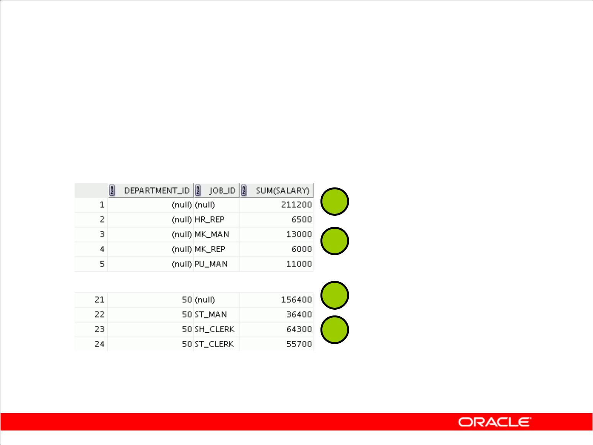**CUBE Operator: Example**

|  |  |  |  |  |  |  |
| --- | --- | --- | --- | --- | --- | --- |
|  | **SELECT** | | **department_id, job_id, SUM(salary)** | | | |
|  | **FROM** | | **employees** | | | |
|  | **WHERE** | | **department_id < 60** | | | |
|  | **GROUP BY CUBE (department_id, job_id)** | | | | | **;** |
|  |  |  |  |  | **1** |  |
|  |  |  |  |  |  |
|  |  |  |  |  |  |
|  |  |  |  |  | **2** |  |
|  |  |  |  |  | **3** |  |
|  |  |  |  | |  |
|  |  |  |  |  |  |
|  |  |  |  |  | **4** |  |
|  |  |  |  |  |  |
|  |  |  |  |  |  |  |

Copyright © 2009, Oracle. All rights reserved.

**Example of a CUBE Operator**

The output of the SELECT statement in the example can be interpreted as follows:

1. The total salary for every job within a department (for those departments whose department ID is less than 60).
2. The total salary for those departments whose department ID is less than 60
3. The total salary for every job irrespective of the department
4. The total salary for those departments whose department ID is less than 60, irrespective of the job titles

In this example, 1 indicates the grand total, 2 indicates the rows totaled by JOB_ID alone, 3 indicates some of the rows totaled by DEPARTMENT_ID alone, and 4 indicates some of the rows totaled by DEPARTMENT_ID and JOB_ID.

The CUBE operator has also performed the ROLLUP operation to display the subtotals for those

departments whose department ID is less than 60 and the total salary for those departments whose department ID is less than 60, irrespective of the job titles. Additionally, the CUBE operator displays

the total salary for every job irrespective of the department.

**Note:** Similar to theROLLUPoperator, producing subtotals in*n*dimensions (that is,*n*columns in theGROUP BY clause) without a CUBE operator requires that 2*n* SELECT statements be linked with UNION ALL. Thus, a report with three dimensions requires 23 = 8 SELECT statements to be linked with UNION ALL.

|  |
| --- |
| Oracle Internal & Oracle Academy Use Only |

**Oracle Database 10*g*: SQL Fundamentals II 4 - 10**

**GROUPING Function**

The GROUPING function:

1. Is used with either the CUBE or ROLLUP operator
2. Is used to find the groups forming the subtotal in a row
3. Is used to differentiate stored NULL values from NULL values created by ROLLUP or CUBE
4. Returns 0 or 1

|  |  |  |  |
| --- | --- | --- | --- |
| **SELECT** | **[*column*,] *group_function(column) .. ,*** | | |
|  | **GROUPING(expr)** |  |  |
| **FROM** | ***table*** |  | |
| **[WHERE** | ***condition*]** | | |
| **[GROUP BY** | **[ROLLUP][CUBE] *group_by_expression*]** | | |
| **[HAVING** | ***having_expression*]** | | |
| **[ORDER BY** | ***column*];** | | |

Copyright © 2009, Oracle. All rights reserved.

**GROUPING Function**

The GROUPING function can be used with either the CUBE or ROLLUP operator to help you understand how a summary value has been obtained.

The GROUPING function uses a single column as its argument. The *expr* in the GROUPING function must match one of the expressions in the GROUP BY clause. The function returns a value of

0 or 1.

The values returned by the GROUPING function are useful to:

1. Determine the level of aggregation of a given subtotal (that is, the group or groups on which the subtotal is based)
2. Identify whether a NULL value in the expression column of a row of the result set indicates:
   1. A NULL value from the base table (stored NULL value)
   2. A NULL value created by ROLLUP or CUBE (as a result of a group function on that expression)

A value of 0 returned by the GROUPING function based on an expression indicates one of the following:

1. The expression has been used to calculate the aggregate value.
2. The NULL value in the expression column is a stored NULL value.

A value of 1 returned by the GROUPING function based on an expression indicates one of the following:

1. The expression has not been used to calculate the aggregate value.
2. The NULL value in the expression column is created by ROLLUP or CUBE as a result of grouping.

|  |
| --- |
| Oracle Internal & Oracle Academy Use Only |

**Oracle Database 10*g*: SQL Fundamentals II 4 - 11**

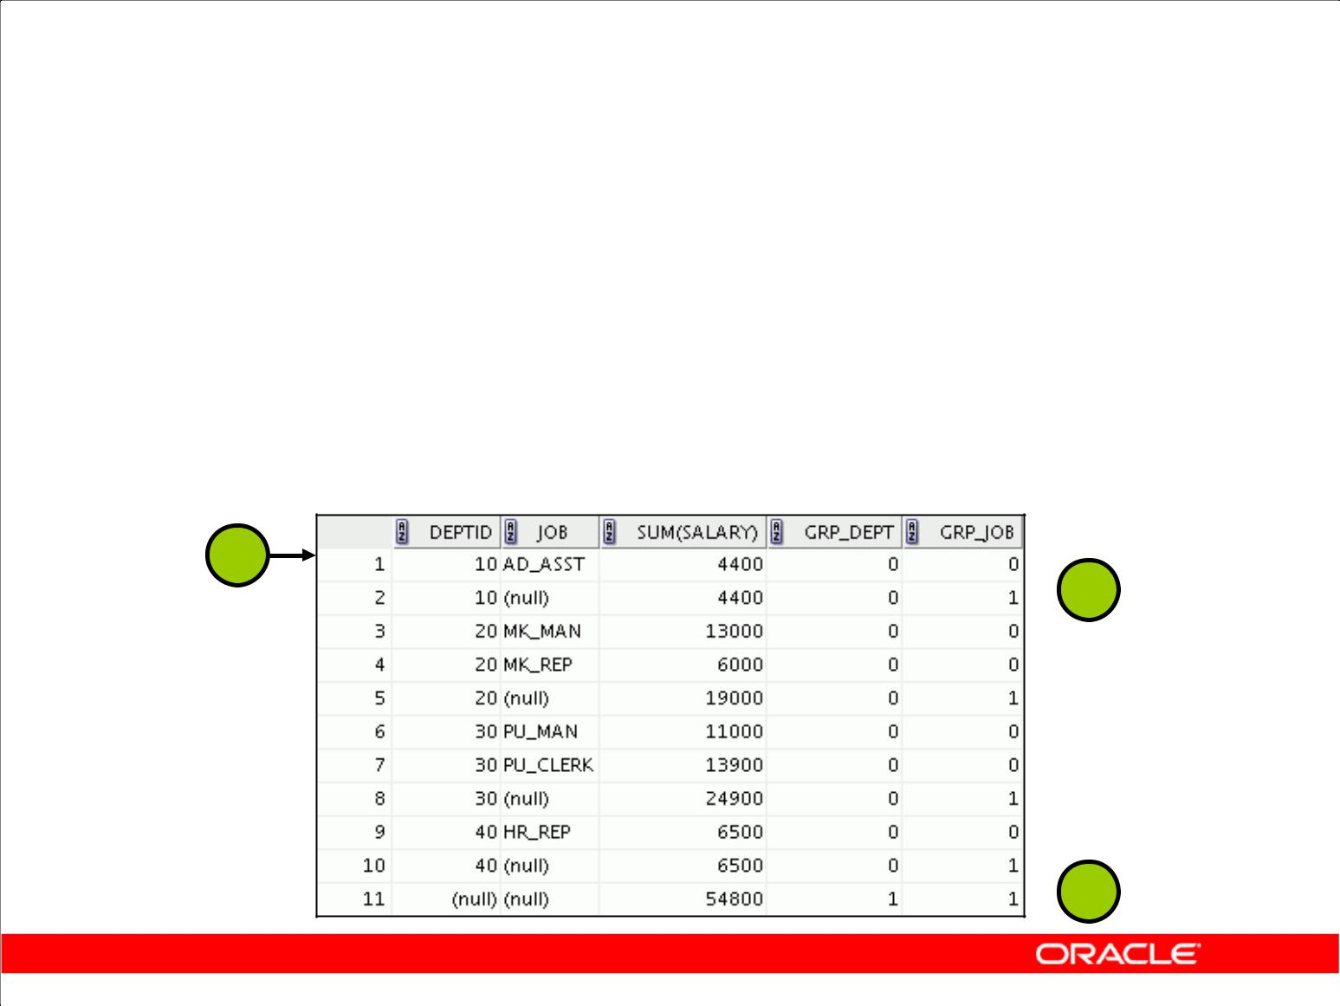**GROUPING Function: Example**

|  |  |  |
| --- | --- | --- |
| **SELECT** | **department_id DEPTID, job_id JOB,** | |
|  | **SUM(salary),** | |
|  | **GROUPING(department_id) GRP_DEPT,** |  |
|  | **GROUPING(job_id) GRP_JOB** |  |
| **FROM** | **employees** | |
| **WHERE** | **department_id < 50** | |
| **GROUP BY** | **ROLLUP(department_id, job_id);** | |
|  |  |  |

**1**

** 2**

 **3**

Copyright © 2009, Oracle. All rights reserved.

**Example of a GROUPING Function**

In the example in the slide, consider the summary value 4400 in the first row (labeled 1). This summary value is the total salary for the job ID of AD_ASST within department 10. To calculate this summary value, both the DEPARTMENT_ID and JOB_ID columns have been taken into account. Thus, a value of 0 is returned for both the GROUPING(department_id) and GROUPING(job_id)expressions.

Consider the summary value 4400 in the second row (labeled 2). This value is the total salary for department 10 and has been calculated by taking into account the DEPARTMENT_ID column; thus, a value of 0 has been returned by GROUPING(department_id). Because the JOB_ID column has not been taken into account to calculate this value, a value of 1 has been returned for GROUPING(job_id). You can observe similar output in the fifth row.

In the last row, consider the summary value 54800 (labeled 3). This is the total salary for those departments whose department ID is less than 50 and all job titles. To calculate this summary value, neither of the DEPARTMENT_ID and JOB_ID columns have been taken into account. Thus, a value of 1 is returned for both the GROUPING(department_id) and GROUPING(job_id)expressions.

|  |
| --- |
| Oracle Internal & Oracle Academy Use Only |

**Oracle Database 10*g*: SQL Fundamentals II 4 - 12**

**GROUPING SETS**

1. The GROUPING SETS syntax is used to define multiple groupings in the same query.
2. All groupings specified in the GROUPING SETS clause are computed and the results of individual groupings are combined with a UNION ALL operation.
3. Grouping set efficiency:

– Only one pass over the base table is required.

– There is no need to write complex UNION statements.

– The more elements GROUPING SETS has, the greater is the performance benefit.

Copyright © 2009, Oracle. All rights reserved.

**GROUPING SETS**

GROUPING SETS is a further extension of the GROUP BY clause that you can use to specify multiple groupings of data. Doing so facilitates efficient aggregation and, therefore, facilitates analysis of data across multiple dimensions.

A single SELECT statement can now be written using GROUPING SETS to specify various groupings (which can also include ROLLUP or CUBE operators), rather than multiple SELECT statements combined by UNION ALL operators. For example:

SELECT department_id, job_id, manager_id, AVG(salary)

FROM employees

GROUP BY

GROUPING SETS

((department_id, job_id, manager_id),

(department_id, manager_id),(job_id, manager_id));

This statement calculates aggregates over three groupings:

(department_id, job_id, manager_id), (department_id, manager_id)and (job_id, manager_id)

Without this feature, multiple queries combined together with UNION ALL are required to obtain the output of the preceding SELECT statement. A multiquery approach is inefficient because it requires multiple scans of the same data.

|  |
| --- |
| Oracle Internal & Oracle Academy Use Only |

**Oracle Database 10*g*: SQL Fundamentals II 4 - 13**

**GROUPING SETS (continued)**

Compare the previous example with the following alternative:

SELECT department_id, job_id, manager_id, AVG(salary)

FROM employees

GROUP BY CUBE(department_id, job_id, manager_id);

This statement computes all the 8 (2 *2 *2) groupings, though only the groups

(department_id, job_id, manager_id), (department_id, manager_id), and (job_id, manager_id)are of interest to you.

Another alternative is the following statement:

SELECT department_id, job_id, manager_id, AVG(salary)

FROM employees

GROUP BY department_id, job_id, manager_id

UNION ALL

SELECT department_id, NULL, manager_id, AVG(salary)

FROM employees

GROUP BY department_id, manager_id

UNION ALL

SELECT NULL, job_id, manager_id, AVG(salary)

FROM employees

GROUP BY job_id, manager_id;

This statement requires three scans of the base table, which makes it inefficient.

CUBE and ROLLUP can be thought of as grouping sets with very specific semantics. The following equivalencies show this fact:

|  |  |
| --- | --- |
| CUBE(a, b, c) | GROUPING SETS |
| is equivalent to | ((a, b, c), (a, b), (a, c), (b, c), |
|  | (a), (b), (c), ()) |
|  |  |
| ROLLUP(a, b,c) | GROUPING SETS ((a, b, c), (a, b),(a), ()) |
| is equivalent to |  |
|  |  |

|  |
| --- |
| Oracle Internal & Oracle Academy Use Only |

**Oracle Database 10*g*: SQL Fundamentals II 4 - 14**

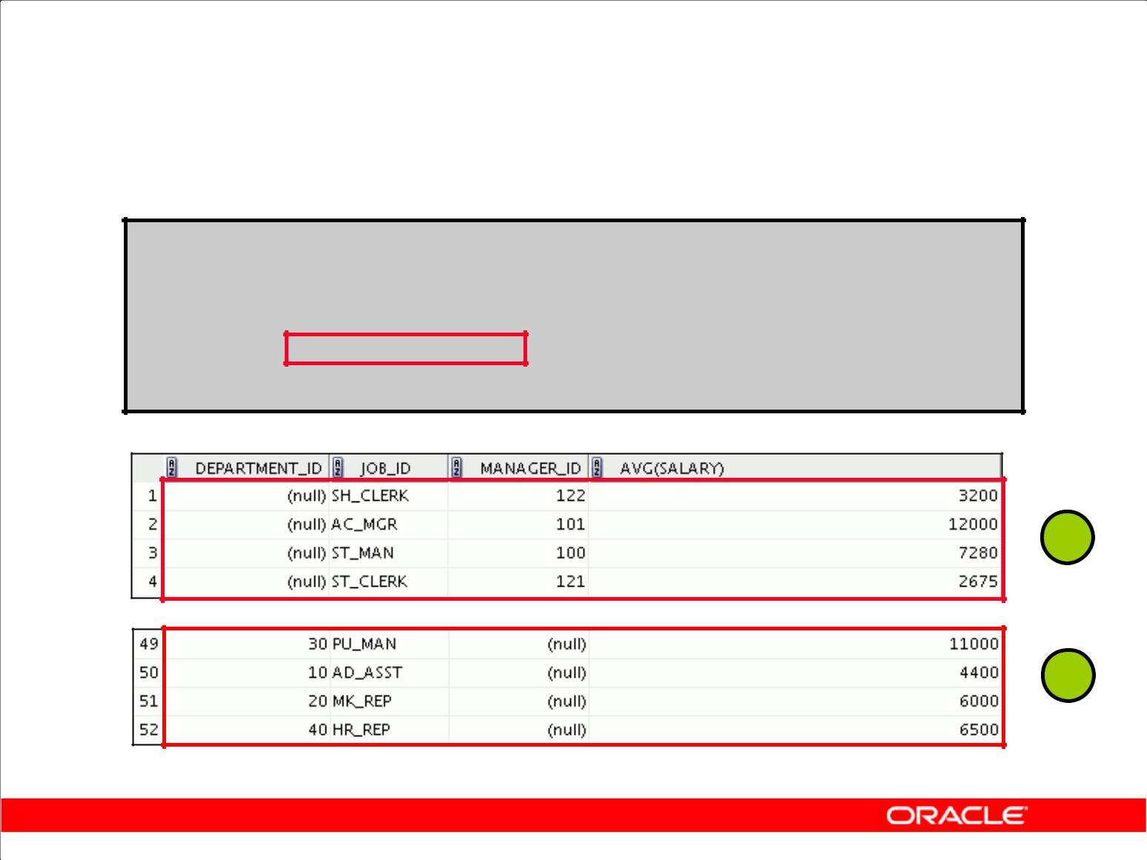**GROUPING SETS: Example**

**SELECT department_id, job_id,**

**manager_id,avg(salary)**

**FROM** **employees**

**GROUP BY GROUPING SETS**

**((department_id,job_id), (job_id,manager_id));**

 **1**

**…**

 **2**

Copyright © 2009, Oracle. All rights reserved.

**GROUPING SETS: Example**

The query in the slide calculates aggregates over two groupings. The table is divided into the following groups:

1. Job ID, Manager ID
2. Department ID, Job ID

The average salaries for each of these groups are calculated. The result set displays the average salary for each of the two groups.

In the output, the group marked as 1 can be interpreted as the following:

1. The average salary of all employees with the SH_CLERK job ID under manager 122 is 3200.
2. The average salary of all employees with the AC_MGR job ID under manager 101 is 12,000, and so on.

The group marked as 2 in the output is interpreted as the following:

1. The average salary of all employees with the PU_MAN job ID in department 30 is 11,000.
2. The average salary of all employees with the AD_ASST job ID in department 10 is 4400, and so on.

|  |
| --- |
| Oracle Internal & Oracle Academy Use Only |

**Oracle Database 10*g*: SQL Fundamentals II 4 - 15**

**GROUPING SETS: Example (continued)**

The example in the slide can also be written as:

SELECT department_id, job_id, NULL as manager_id, AVG(salary) as AVGSAL

FROM employees

GROUP BY department_id, job_id

UNION ALL

SELECT NULL, job_id, manager_id, avg(salary) as AVGSAL FROM employees

GROUP BY job_id, manager_id;

In the absence of an optimizer that looks across query blocks to generate the execution plan, the preceding query would need two scans of the base table, EMPLOYEES . This could be very inefficient. Therefore, the usage of the GROUPING SETS statement is recommended.

|  |
| --- |
| Oracle Internal & Oracle Academy Use Only |

**Oracle Database 10*g*: SQL Fundamentals II 4 - 16**

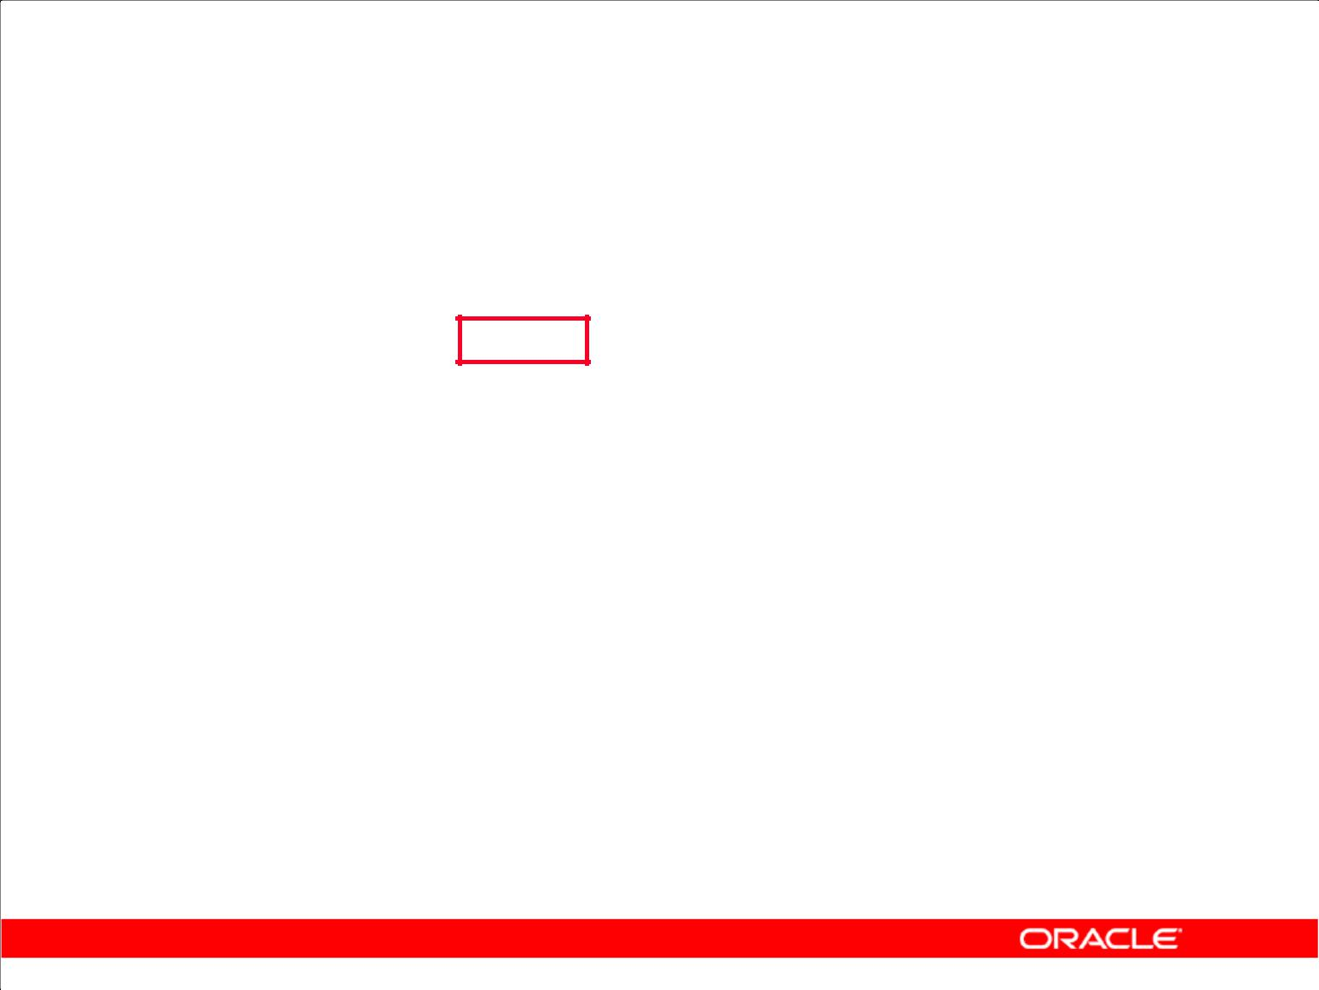**Composite Columns**

1. A composite column is a collection of columns that are treated as a unit.

– ROLLUP (a,**(b, c)**, d)

1. Use parentheses within the GROUP BY clause to group columns, so that they are treated as a unit while computing ROLLUP or CUBE operations.
2. When used with ROLLUP or CUBE, composite columns would require skipping aggregation across certain levels.

Copyright © 2009, Oracle. All rights reserved.

**Composite Columns**

A composite column is a collection of columns that are treated as a unit during the computation of groupings. You specify the columns in parentheses as in the following statement:

ROLLUP (a, (b, c), d)

Here, (b, c) forms a composite column and is treated as a unit. In general, composite columns are useful in ROLLUP, CUBE, and GROUPING SETS. For example, in CUBE or ROLLUP, composite columns would require skipping aggregation across certain levels.

That is, GROUP BY ROLLUP(a, (b, c) )is equivalent to

GROUP BY a, b, c UNION ALL

GROUP BY a UNION ALL

GROUP BY ()

Here, (b, c) is treated as a unit and ROLLUP is not applied across (b, c). It is as if you have an alias, for example, z as an alias for (b, c), and the GROUP BY expression reduces to

GROUP BY ROLLUP(a, z).

**Note:** GROUP BY( )is typically aSELECTstatement withNULLvalues for the columnsaandband only the aggregate function. This is generally used for generating grand totals.

SELECT NULL, NULL, aggregate_col

FROM <table_name>

GROUP BY ( );

**Oracle Database 10*g*: SQL Fundamentals II 4 - 17**

|  |
| --- |
| Oracle Internal & Oracle Academy Use Only |

**Composite Columns (continued)**

Compare this with the normal ROLLUP as in:

GROUP BY ROLLUP(a, b, c)

which would be:

GROUP BY a, b, c UNION ALL

GROUP BY a, b UNION ALL

GROUP BY a UNION ALL

GROUP BY ()

Similarly,

GROUP BY CUBE((a, b), c)

would be equivalent to:

GROUP BY a, b, c UNION ALL

GROUP BY a, b UNION ALL

GROUP BY c UNION ALL

GROUP By ()

The following table shows the GROUPING SETS specification and the equivalent GROUP BY specification.

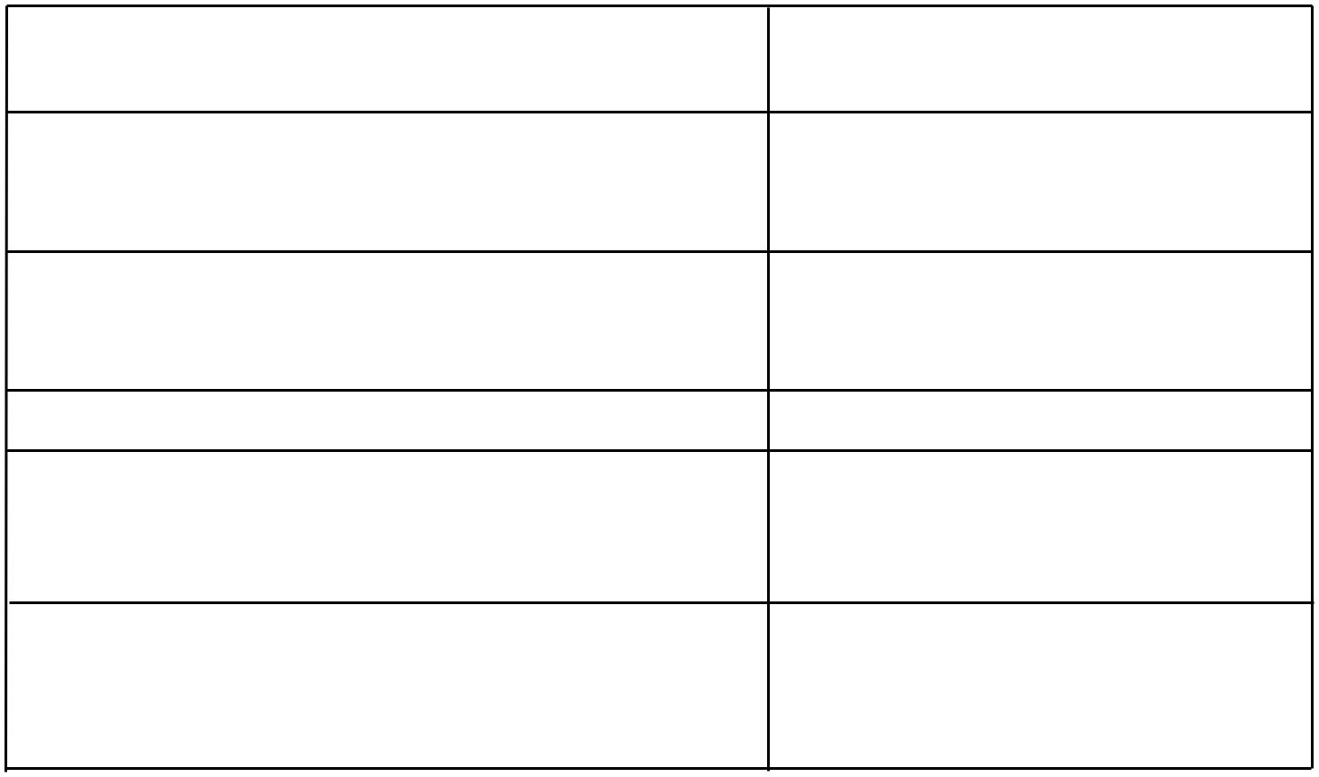

|  |
| --- |
| Use Only |

**GROUPING SETS Statements**

GROUP BY GROUPING SETS(a, b, c)

GROUP BY GROUPING SETS(a, b,(b, c)) (The GROUPING SETS expression has a composite column.)

GROUP BY GROUPING SETS((a, b, c))

GROUP BY GROUPING SETS(a, (b), ())

GROUP BY GROUPING SETS (a,ROLLUP(b, c))

(The GROUPING SETS expression has a composite column.)

**Equivalent GROUP BY Statements**

GROUP BY a UNION ALL GROUP BY b UNION ALL GROUP BY c

GROUP BY a UNION ALL GROUP BY b UNION ALL GROUP BY b, c

GROUP BY a, b, c

GROUP BY a UNION ALL GROUP BY b UNION ALL GROUP BY ()

GROUP BY a UNION ALL GROUP BY ROLLUP(b, c)

|  |
| --- |
| Oracle Internal & Oracle Academy |

**Oracle Database 10*g*: SQL Fundamentals II 4 - 18**

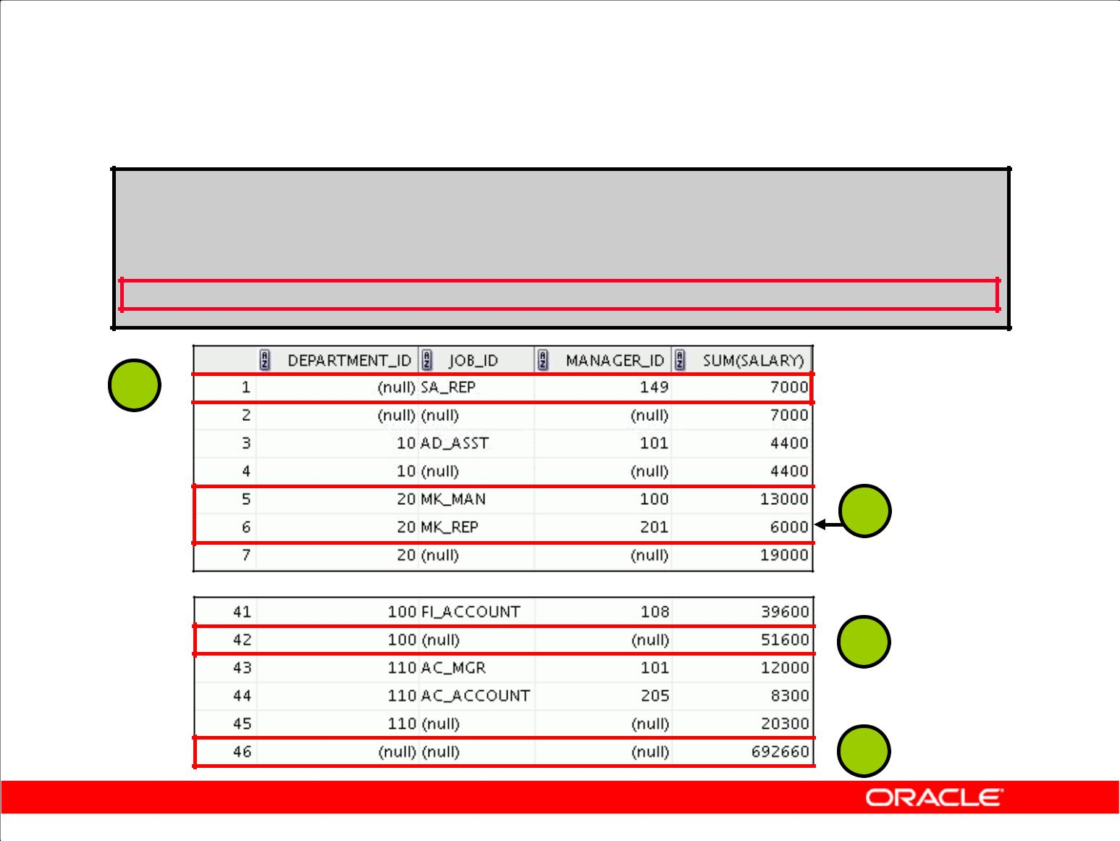**Composite Columns: Example**

**SELECT department_id, job_id, manager_id,**

**SUM(salary)**

**FROM** **employees**

**GROUP BY ROLLUP( department_id,(job_id, manager_id));**

**1**

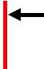 **2**

**…**

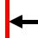 **3**

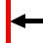 **4**

Copyright © 2009, Oracle. All rights reserved.

**Composite Columns: Example**

Consider the example:

SELECT department_id, job_id,manager_id, SUM(salary)

FROM employees

GROUP BY ROLLUP( department_id,job_id, manager_id);

This query results in the Oracle server computing the following groupings:

1. (job_id, manager_id)
2. (department_id, job_id, manager_id)
3. (department_id)
4. Grand total

If you are interested only in specific groups, you cannot limit the calculation to those groupings without using composite columns. With composite columns, this is possible by treating JOB_ID and MANAGER_ID columns as a single unit while rolling up. Columns enclosed in parentheses are treated as a unit while computing ROLLUP and CUBE. This is illustrated in the example in the slide. By enclosing the JOB_ID and MANAGER_ID columns in parentheses, you indicate to the Oracle server to treat JOB_ID and MANAGER_ID as a single unit—that is, a composite column.

|  |
| --- |
| Oracle Internal & Oracle Academy Use Only |

**Oracle Database 10*g*: SQL Fundamentals II 4 - 19**

**Composite Columns: Example (continued)**

The example in the slide computes the following groupings:

1. (department_id, job_id, manager_id)
2. (department_id)
3. ( )

The example in the slide displays the following:

1. Total salary for every job and manager (labeled 1)
2. Total salary for every department, job, and manager (labeled 2)
3. Total salary for every department (labeled 3)
4. Grand total (labeled 4)

The example in the slide can also be written as:

SELECTdepartment_id, job_id, manager_id, SUM(salary)

FROM employees

GROUP BY department_id,job_id, manager_id

UNION ALL

SELECT department_id, TO_CHAR(NULL),TO_NUMBER(NULL),

SUM(salary)

FROM employees

GROUP BY department_id

UNION ALL

SELECT TO_NUMBER(NULL), TO_CHAR(NULL),TO_NUMBER(NULL), SUM(salary)

FROM employees

GROUP BY ();

In the absence of an optimizer that looks across query blocks to generate the execution plan, the preceding query would need three scans of the base table, EMPLOYEES. This could be very

inefficient. Therefore, the use of composite columns is recommended.

|  |
| --- |
| Oracle Internal & Oracle Academy Use Only |

**Oracle Database 10*g*: SQL Fundamentals II 4 - 20**

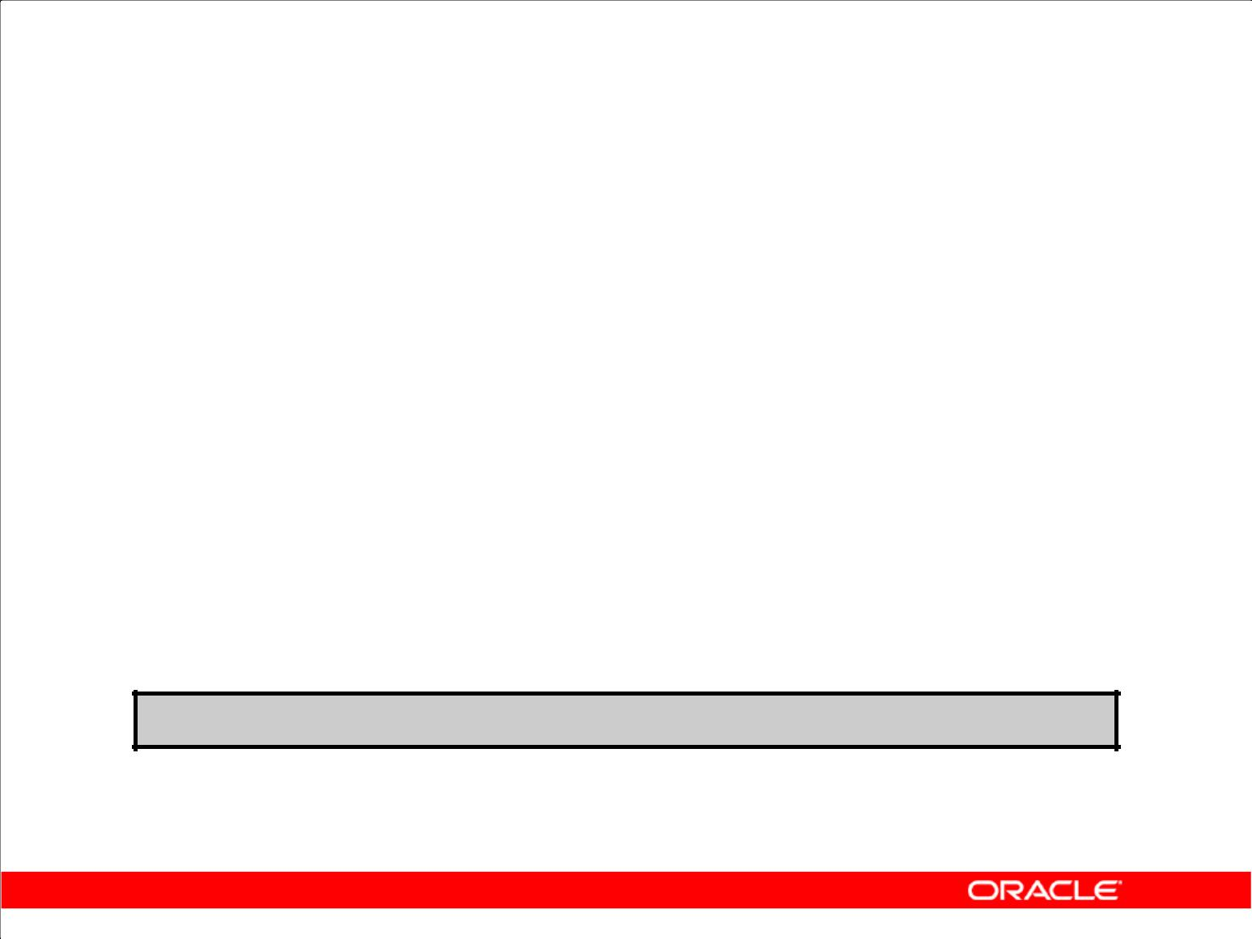**Concatenated Groupings**

1. Concatenated groupings offer a concise way to generate useful combinations of groupings.
2. To specify concatenated grouping sets, you separate multiple grouping sets, ROLLUP, and CUBE operations with commas so that the Oracle server combines them into a single GROUP BY clause.
3. The result is a cross-product of groupings from each

GROUPING SET.

**GROUP BY GROUPING SETS(a, b), GROUPING SETS(c, d)**

Copyright © 2009, Oracle. All rights reserved.

**Concatenated Columns**

Concatenated groupings offer a concise way to generate useful combinations of groupings. The concatenated groupings are specified by listing multiple grouping sets, CUBEs, and ROLLUPs, and

separating them with commas. The following is an example of concatenated grouping sets:

GROUP BY GROUPING SETS(a, b), GROUPING SETS(c, d)

This SQL example defines the following groupings:

(a, c), (a, d), (b, c), (b, d)

Concatenation of grouping sets is very helpful for these reasons:

1. **Ease of query development:** You need not manually enumerate all groupings.
2. **Use by applications:** SQL generated by online analytical processing (OLAP) applications ofteninvolves concatenation of grouping sets, with each GROUPING SET defining groupings needed for a dimension.

|  |
| --- |
| Oracle Internal & Oracle Academy Use Only |

**Oracle Database 10*g*: SQL Fundamentals II 4 - 21**

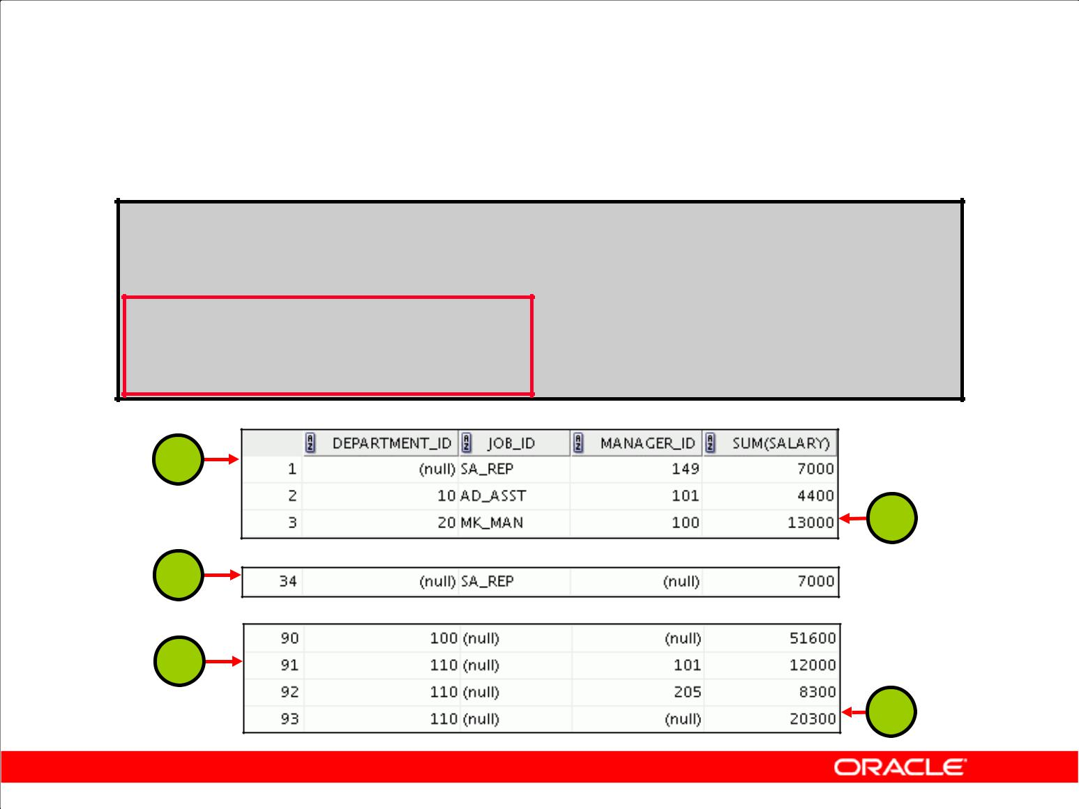**Concatenated Groupings: Example**

**SELECT department_id, job_id, manager_id, SUM(salary)**

**FROM** **employees**

**GROUP BY department_id,**

**ROLLUP(job_id),**

**CUBE(manager_id);**

**1**

**2**

**…**

**3**

**…**

**4**

**5**

Copyright © 2009, Oracle. All rights reserved.

**Concatenated Groupings: Example**

The example in the slide results in the following groupings:

1. (job_id, manager_id) (1)
2. (department_id,job_id, manager_id) (2)
3. (job_id)(3)
4. (department_id,manager_id)(4)
5. (department_id) (5)

The total salary for each of these groups is calculated.

|  |
| --- |
| Oracle Internal & Oracle Academy Use Only |

**Oracle Database 10*g*: SQL Fundamentals II 4 - 22**

**Summary**

In this lesson, you should have learned how to use the:

1. ROLLUP operation to produce subtotal values
2. CUBE operation to produce cross-tabulation values
3. GROUPING function to identify the row values created by

ROLLUP or CUBE

1. GROUPING SETS syntax to define multiple groupings in the same query
2. GROUP BY clause to combine expressions in various ways:

– Composite columns

– Concatenated grouping sets

Copyright © 2009, Oracle. All rights reserved.

**Summary**

1. ROLLUP and CUBE are extensions of the GROUP BY clause.
2. ROLLUP is used to display subtotal and grand total values.
3. CUBE is used to display cross-tabulation values.
4. The GROUPING function enables you to determine whether a row is an aggregate produced by a CUBE or ROLLUP operator.
5. With the GROUPING SETS syntax, you can define multiple groupings in the same query. GROUP BY computes all the groupings specified and combines them with UNION ALL.
6. Within the GROUP BY clause, you can combine expressions in various ways:
   1. To specify composite columns, you group columns within parentheses so that the Oracle server treats them as a unit while computing ROLLUP or CUBE operations.
   2. To specify concatenated grouping sets, you separate multiple grouping sets, ROLLUP, and CUBE operations with commas so that the Oracle server combines them into a single GROUP BY clause. The result is a cross-product of groupings from each grouping set.

|  |
| --- |
| Oracle Internal & Oracle Academy Use Only |

**Oracle Database 10*g*: SQL Fundamentals II 4 - 23**

**Practice 4: Overview**

This practice covers using the following:

1. ROLLUP operators
2. CUBE operators
3. GROUPING functions
4. GROUPING SETS

Copyright © 2009, Oracle. All rights reserved.

**Practice 4: Overview**

In this practice, you use the ROLLUP and CUBE operators as extensions of the GROUP BY clause.

You also use GROUPING SETS.

|  |
| --- |
| Oracle Internal & Oracle Academy Use Only |

**Oracle Database 10*g*: SQL Fundamentals II 4 - 24**

**Practice 4**

1. Write a query to display the following for those employees whose manager ID is less than 120:
   1. Manager ID
   2. Job ID and total salary for every job ID of employees who report to the same manager
   3. Total salary of those managers
   4. Total salary of those managers, irrespective of the job IDs

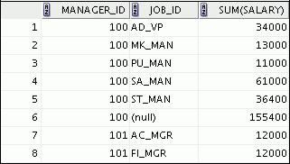

**…**

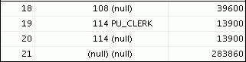

1. Observe the output from question 1. Write a query using the GROUPING function to determine whether the NULL values in the columns corresponding to the GROUP BY expressions are caused by the ROLLUP operation.

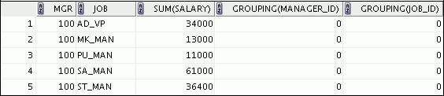

**…**

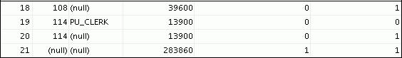

|  |
| --- |
| Oracle Internal & Oracle Academy Use Only |

**Oracle Database 10*g*: SQL Fundamentals II 4 - 25**

**Practice 4 (continued)**

1. Write a query to display the following for those employees whose manager ID is less than 120:
   1. Manager ID
   2. Job and total salary for every job for employees who report to the same manager
   3. Total salary of those managers
   4. Cross-tabulation values to display the total salary for every job, irrespective of the manager
   5. Total salary irrespective of all job titles

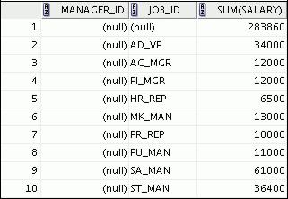

**…**

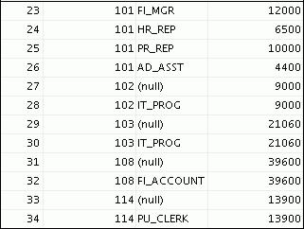

|  |
| --- |
| Oracle Internal & Oracle Academy Use Only |

**Oracle Database 10*g*: SQL Fundamentals II 4 - 26**

**Practice 4 (continued)**

1. Observe the output from question 3. Write a query using the GROUPING function to determine whether the NULL values in the columns corresponding to the GROUP BY expressions are caused by the CUBE operation.

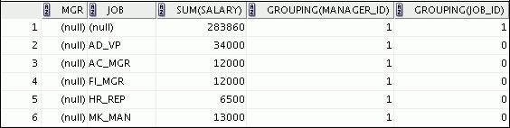

**…**

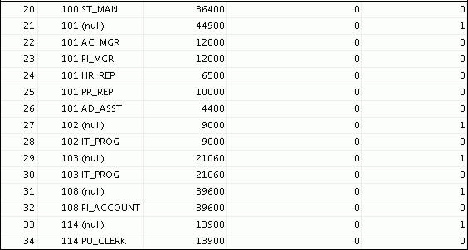

|  |
| --- |
| Oracle Internal & Oracle Academy Use Only |

**Oracle Database 10*g*: SQL Fundamentals II 4 - 27**

**Practice 4 (continued)**

1. Using GROUPING SETS, write a query to display the following groupings:
   1. department_id, manager_id, job_id
   2. department_id, job_id
   3. manager_id, job_id

The query should calculate the sum of the salaries for each of these groups.

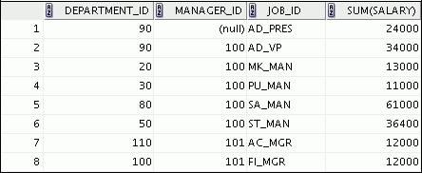

**…**

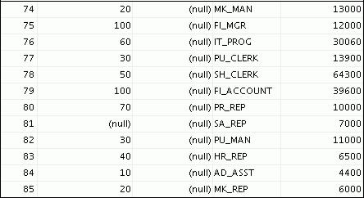

|  |
| --- |
| Oracle Internal & Oracle Academy Use Only |

**Oracle Database 10*g*: SQL Fundamentals II 4 - 28**



**Managing Data in Different Time Zones**

Copyright © 2009, Oracle. All rights reserved.

|  |
| --- |
| Oracle Internal & Oracle Academy Use Only |

**Objectives**

After completing this lesson, you should be able to use the following datetime functions:

|  |  |  |  |
| --- | --- | --- | --- |
| • | TZ_OFFSET | • | CURRENT_DATE |
| • | FROM_TZ | • | CURRENT_ TIMESTAMP |
| • | TO_TIMESTAMP | • | LOCALTIMESTAMP |
| • | TO_TIMESTAMP_TZ | • | DBTIMEZONE |
| • | TO_YMINTERVAL | • | SESSIONTIMEZONE |
| • | TO_DSINTERVAL | • | EXTRACT |

Copyright © 2009, Oracle. All rights reserved.

**Objectives**

This lesson addresses some of the datetime functions available in the Oracle Database.

|  |
| --- |
| Oracle Internal & Oracle Academy Use Only |

**Oracle Database 10*g*: SQL Fundamentals II 5 - 2**

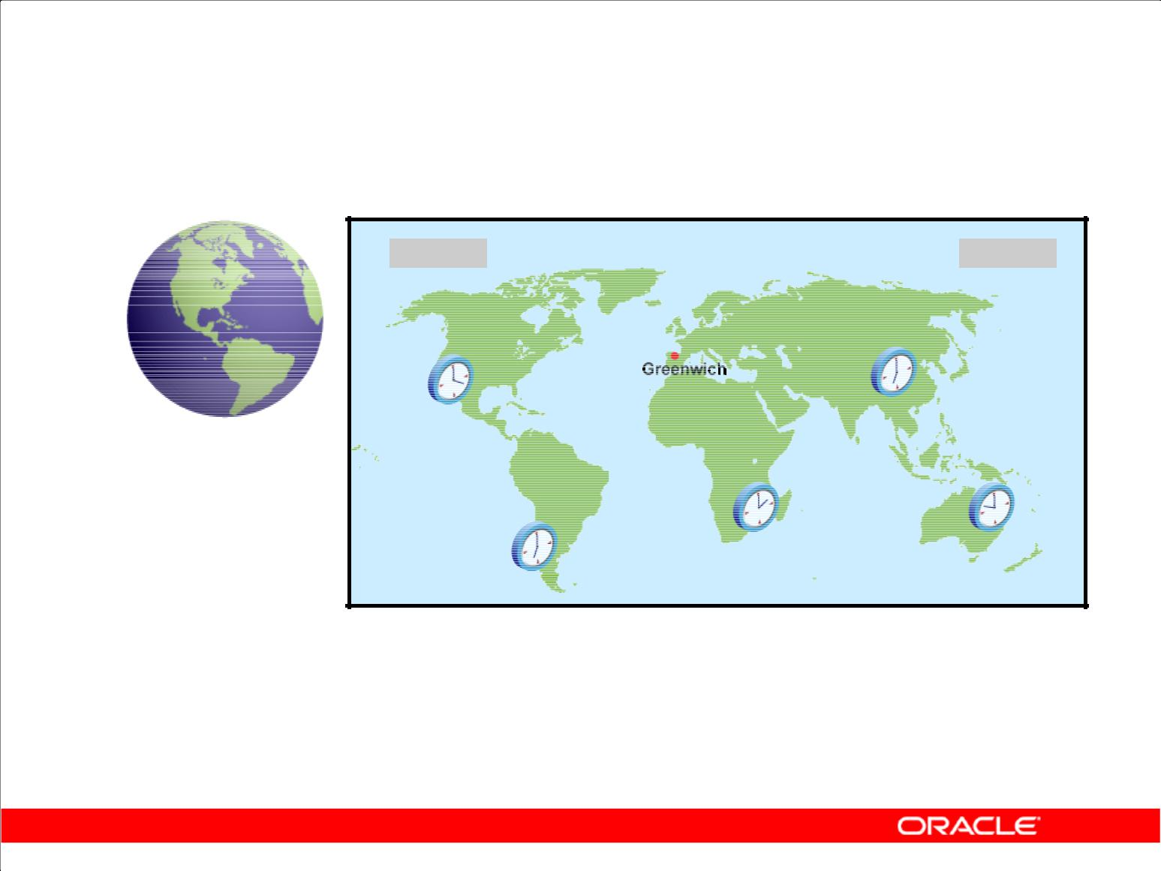**Time Zones**

**09-03-2001** **09-04-2001**

|  |  |
| --- | --- |
| **-08:00** | **+07:00** |
|  |

|  |  |
| --- | --- |
| **+02:00** | **+10:00** |
|  |

**-05:00**

**The image represents the time for each**

**time zone when Greenwich time is 12:00.**

Copyright © 2009, Oracle. All rights reserved.

**Time Zones**

The hours of the day are measured by the turning of the earth. The time of day at any particular moment depends on where you are. When it is noon in Greenwich, England, it is midnight along the International Date Line. The earth is divided into 24 time zones, one for each hour of the day. The time along the prime meridian in Greenwich, England, is known as Greenwich mean time, or GMT. GMT is the time standard against which all other time zones in the world are referenced. It is the same all year round and is not affected by summer time or daylight saving time. The meridian line is an imaginary line that runs from the North Pole to the South Pole. It is known as zero longitude and it is the line from which all other lines of longitude are measured. All time is measured relative to GMT and all places have a latitude (their distance north or south of the equator) and a longitude (their distance east or west of the Greenwich meridian).

|  |
| --- |
| Oracle Internal & Oracle Academy Use Only |

**Oracle Database 10*g*: SQL Fundamentals II 5 - 3**

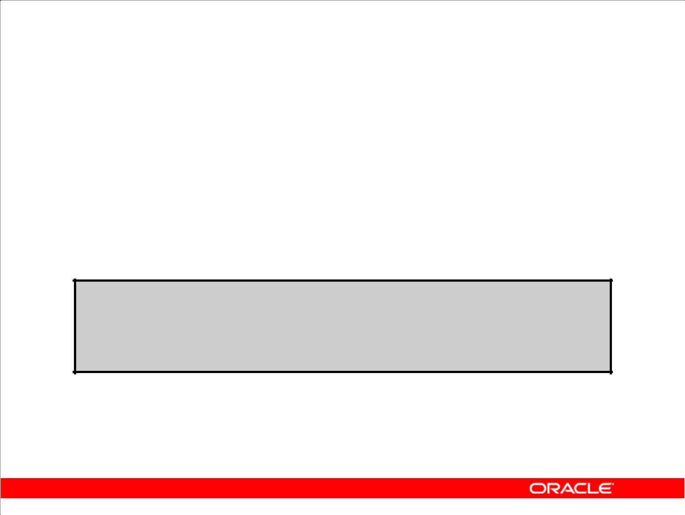**TIME_ZONE Session Parameter**

TIME_ZONE may be set to:

1. An absolute offset
2. Database time zone
3. OS local time zone
4. A named region

**ALTER SESSION SET TIME_ZONE = '-05:00';**

**ALTER SESSION SET TIME_ZONE = dbtimezone;**

**ALTER SESSION SET TIME_ZONE = local;**

**ALTER SESSION SET TIME_ZONE = 'America/New_York';**

Copyright © 2009, Oracle. All rights reserved.

**TIME_ZONE Session Parameter**

The Oracle Database supports storing the time zone in your date and time data, as well as fractional seconds. The ALTER SESSION command can be used to change time zone values in a user’s

session. The time zone values can be set to an absolute offset, a named time zone, a database time zone, or the local time zone.

|  |
| --- |
| Oracle Internal & Oracle Academy Use Only |

**Oracle Database 10*g*: SQL Fundamentals II 5 - 4**

**CURRENT_DATE, CURRENT_TIMESTAMP,**

**and LOCALTIMESTAMP**

1. CURRENT_DATE:

– Returns the current date from the system

– Has a data type of DATE

1. CURRENT_TIMESTAMP:

– Returns the current time stamp from the system

– Has a data type of TIMESTAMP WITH TIME ZONE

1. LOCALTIMESTAMP:

– Returns the current time stamp from user session

– Has a data type of TIMESTAMP

Copyright © 2009, Oracle. All rights reserved.

**CURRENT_DATE, CURRENT_TIMESTAMP, and LOCALTIMESTAMP**

The CURRENT_DATE and CURRENT_TIMESTAMP functions return the current date and current

time stamp, respectively. The data type of CURRENT_DATE is DATE. The data type of

CURRENT_TIMESTAMP is TIMESTAMP WITH TIME ZONE. The values returned display the time

zone displacement of the SQL session executing the functions. The time zone displacement is the

difference (in hours and minutes) between local time and Coordinated Universal Time (UTC). The

TIMESTAMP WITH TIME ZONE data type has the format:

TIMESTAMP [ (fractional_seconds_precision) ] WITH TIME ZONE

where fractional_seconds_precision optionally specifies the number of digits in the fractional part of the SECOND datetime field and can be a number in the range 0 through 9. The default is 6.

The LOCALTIMESTAMP function returns the current date and time in the session time zone. The difference between LOCALTIMESTAMP and CURRENT_TIMESTAMP is that LOCALTIMESTAMP returns a TIMESTAMP value, whereas CURRENT_TIMESTAMP returns a TIMESTAMP WITH TIME ZONE value.

These functions are national language support (NLS) sensitive—that is, the results will be in the current NLS calendar and datetime formats.

|  |
| --- |
| Oracle Internal & Oracle Academy Use Only |

**Oracle Database 10*g*: SQL Fundamentals II 5 - 5**

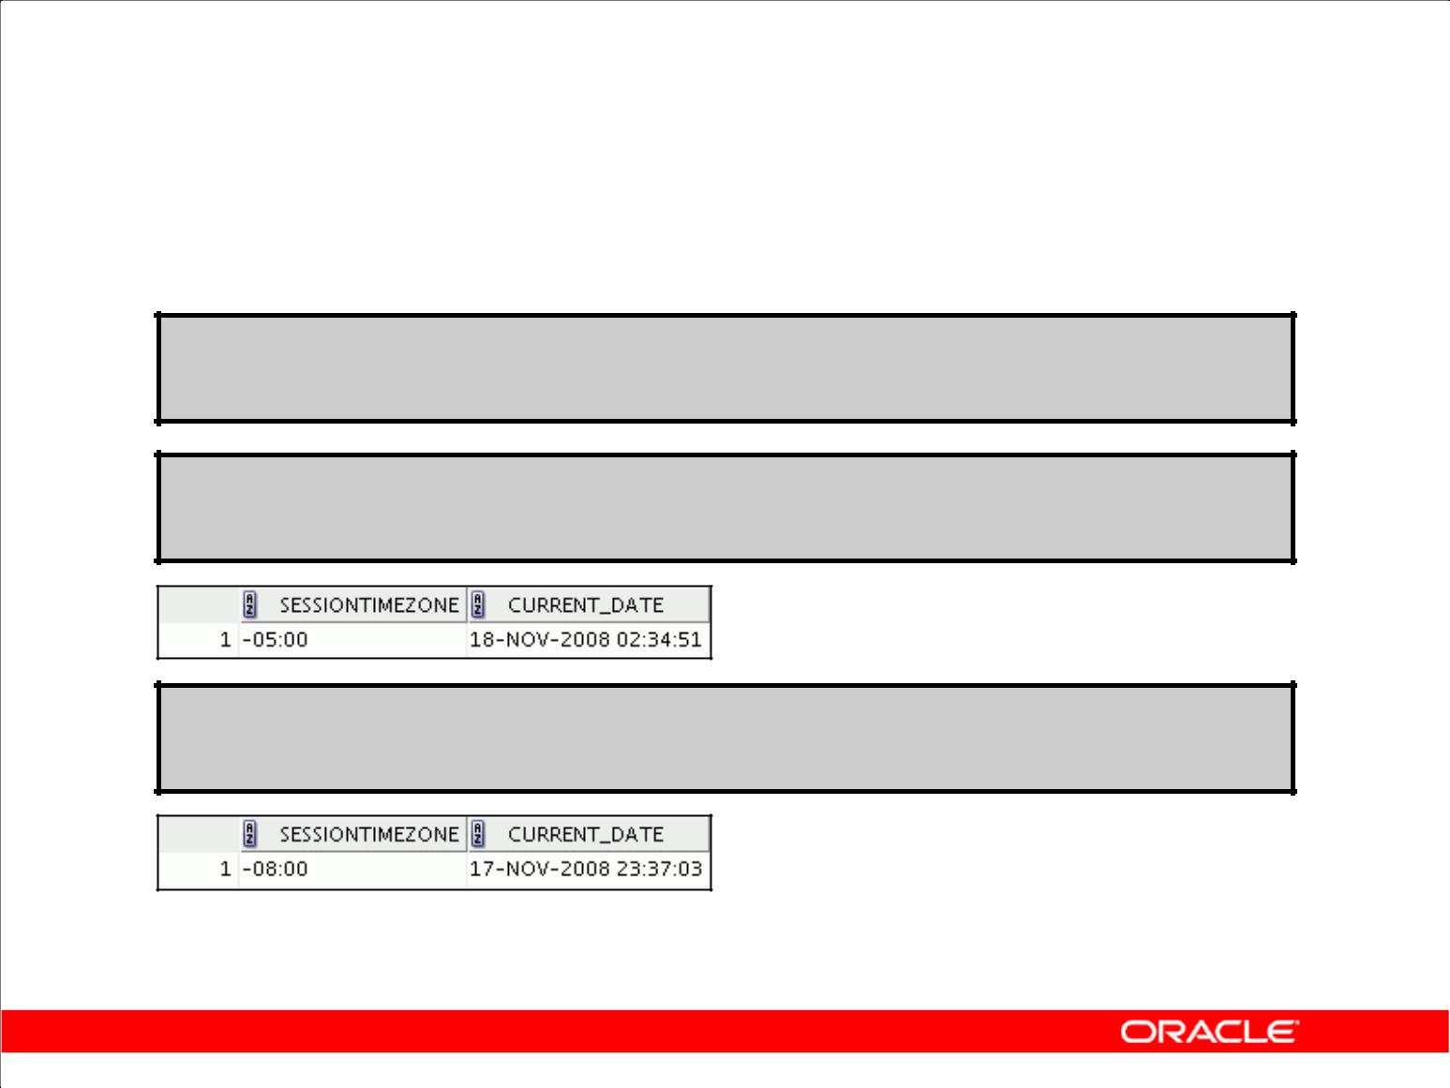**CURRENT_DATE**

Display the current date and time in the session’s time zone.

**ALTER SESSION**

**SET NLS_DATE_FORMAT = 'DD-MON-YYYY HH24:MI:SS';**

**ALTER SESSION SET TIME_ZONE = '-5:0';**

**SELECT SESSIONTIMEZONE, CURRENT_DATE FROM DUAL;**

**ALTER SESSION SET TIME_ZONE = '-8:0';**

**SELECT SESSIONTIMEZONE, CURRENT_DATE FROM DUAL;**

Copyright © 2009, Oracle. All rights reserved.

**CURRENT_DATE**

The CURRENT_DATE function returns the current date in the session’s time zone. The return value is a date in the Gregorian calendar.

The examples in the slide illustrate that CURRENT_DATE is sensitive to the session time zone. In the first example, the session is altered to set the TIME_ZONE parameter to –5:0. The TIME_ZONE

parameter specifies the default local time zone displacement for the current SQL session. TIME_ZONE is a session parameter only, not an initialization parameter. The TIME_ZONE

parameter is set as follows:

TIME_ZONE = '[+ | -] hh:mm'

The format mask ([+ | -] hh:mm) indicates the hours and minutes before or after UTC (Coordinated Universal Time, formerly known as Greenwich mean time).

Observe in the output that the value of CURRENT_DATE changes when the TIME_ZONE parameter value is changed to –8:0 in the second example.

**Note:** TheALTER SESSIONcommand sets the date format of the session to'DD-MON-YYYY HH24:MI:SS’—that is, day of month (1–31)-abbreviated name of month-4-digit year hour of day (0–23):minute (0–59):second (0–59).

|  |
| --- |
| Oracle Internal & Oracle Academy Use Only |

**Oracle Database 10*g*: SQL Fundamentals II 5 - 6**

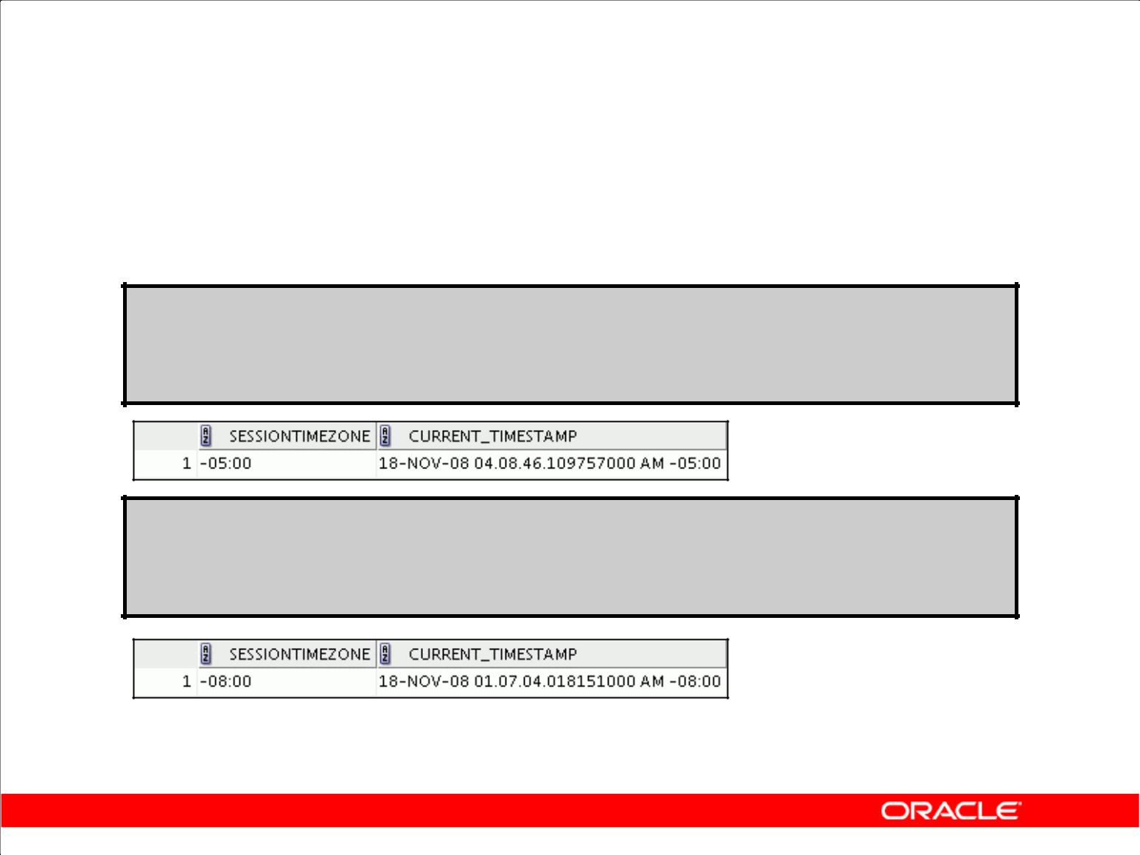**CURRENT_TIMESTAMP**

Display the current date and fractional time in the session’s time zone.

**ALTER SESSION SET TIME_ZONE = '-5:0'; SELECT SESSIONTIMEZONE, CURRENT_TIMESTAMP FROM DUAL;**

**ALTER SESSION SET TIME_ZONE = '-8:0'; SELECT SESSIONTIMEZONE, CURRENT_TIMESTAMP FROM DUAL;**

Copyright © 2009, Oracle. All rights reserved.

**CURRENT_TIMESTAMP**

The CURRENT_TIMESTAMP function returns the current date and time in the session time zone, as a value of the TIMESTAMP WITH TIME ZONE data type. The time zone displacement reflects the current local time of the SQL session. The syntax of the CURRENT_TIMESTAMP function is:

CURRENT_TIMESTAMP (*precision*)

where *precision* is an optional argument that specifies the fractional second precision of the time value returned. If you omit precision, the default is 6.

The examples in the slide illustrate that CURRENT_TIMESTAMP is sensitive to the session time zone. In the first example, the session is altered to set the TIME_ZONE parameter to –5:0. Observe in the output that the value of CURRENT_TIMESTAMP changes when the TIME_ZONE parameter value is changed to –8:0 in the second example.

|  |
| --- |
| Oracle Internal & Oracle Academy Use Only |

**Oracle Database 10*g*: SQL Fundamentals II 5 - 7**

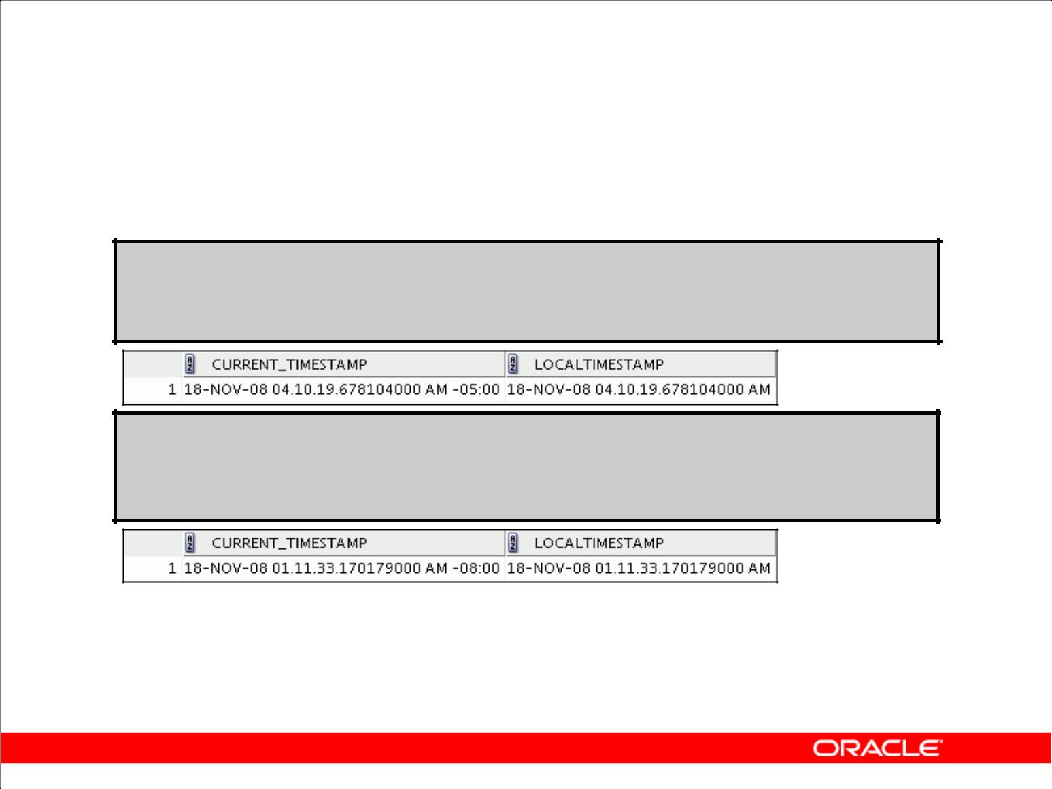**LOCALTIMESTAMP**

1. Display the current date and time in the session’s time

zone in a value of the TIMESTAMP data type.

**ALTER SESSION SET TIME_ZONE = '-5:0'; SELECT CURRENT_TIMESTAMP, LOCALTIMESTAMP FROM DUAL;**

**ALTER SESSION SET TIME_ZONE = '-8:0'; SELECT CURRENT_TIMESTAMP, LOCALTIMESTAMP FROM DUAL;**

1. LOCALTIMESTAMP returns a TIMESTAMP value, whereas CURRENT_TIMESTAMP returns a TIMESTAMP WITH TIME ZONE value.

Copyright © 2009, Oracle. All rights reserved.

**LOCALTIMESTAMP**

The LOCALTIMESTAMP function returns the current date and time in the session time zone. LOCALTIMESTAMP returns a TIMESTAMP value. The syntax of the LOCALTIMESTAMP function is:

LOCALTIMESTAMP (TIMESTAMP_precision)

where TIMESTAMP precision is an optional argument that specifies the fractional second precision of the TIMESTAMP value returned.

The examples in the slide illustrate the difference between LOCALTIMESTAMP and

CURRENT_TIMESTAMP. Observe that LOCALTIMESTAMP does not display the time zone value, whereas the CURRENT_TIMESTAMP does.

|  |
| --- |
| Oracle Internal & Oracle Academy Use Only |

**Oracle Database 10*g*: SQL Fundamentals II 5 - 8**

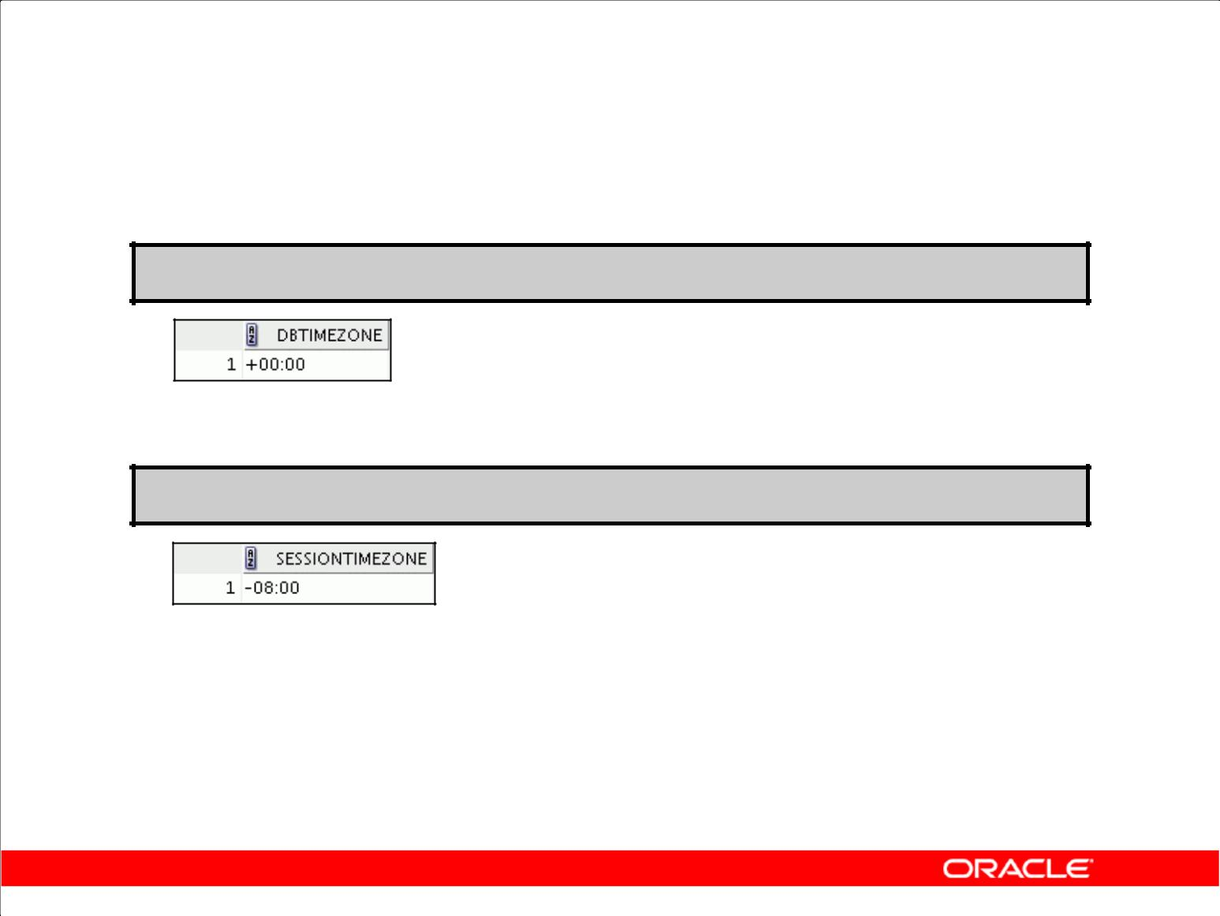**DBTIMEZONE and SESSIONTIMEZONE**

1. Display the value of the database time zone:

**SELECT DBTIMEZONE FROM DUAL;**

1. Display the value of the session’s time zone:

**SELECT SESSIONTIMEZONE FROM DUAL;**

Copyright © 2009, Oracle. All rights reserved.

**DBTIMEZONE and SESSIONTIMEZONE**

The DBA sets the database’s default time zone by specifying the SET TIME_ZONE clause of the CREATE DATABASE statement. If omitted, the default database time zone is the operating system time zone. The database time zone cannot be changed for a session with an ALTER SESSION statement.

The DBTIMEZONE function returns the value of the database time zone. The return type is a time zone offset (a character type in the format: '[+|-]TZH:TZM') or a time zone region name, depending on how the user specified the database time zone value in the most recent CREATE DATABASE or ALTER DATABASE statement. The example in the slide shows that the database time zone is set to “–05:00,” as the TIME_ZONE parameter is in the format:

TIME_ZONE = '[+ | -] hh:mm'

The SESSIONTIMEZONE function returns the value of the current session’s time zone. The return type is a time zone offset (a character type in the format '[+|-]TZH:TZM') or a time zone region name, depending on how the user specified the session time zone value in the most recent ALTER SESSION statement. The example in the slide shows that the session time zone is offset to UTC by – 8 hours. Observe that the database time zone is different from the current session’s time zone.

|  |
| --- |
| Oracle Internal & Oracle Academy Use Only |

**Oracle Database 10*g*: SQL Fundamentals II 5 - 9**

**TIMESTAMP Data Type**

1. The TIMESTAMP data type is an extension of the DATE data type.
2. It stores the year, month, and day of the DATE data type, plus hour, minute, and second values,

as well as the fractional second value.

1. Variations in TIMESTAMP are:

– TIMESTAMP [(fractional_seconds_precision)]_

– TIMESTAMP [(fractional_seconds_precision)]_

WITH TIME ZONE

– TIMESTAMP [(fractional_seconds_precision)]_

WITH LOCAL TIME ZONE

Copyright © 2009, Oracle. All rights reserved.

**Datetime Data Types**

The TIMESTAMP data type contains the datetime fields: YEAR, MONTH, DAY, HOUR, MINUTE, and SECOND and fractional seconds.

The TIMESTAMP WITH TIME ZONE data type contains the datetime fields: YEAR, MONTH, DAY, HOUR, MINUTE, SECOND, TIMEZONE_HOUR, and TIMEZONE_MINUTE and fractional seconds.

The TIMESTAMP WITH LOCAL TIME ZONE data type contains the same information as the TIMESTAMP data type, except that the data is normalized to the database time zone when stored, and adjusted to match the client’s time zone when retrieved.

**Note:** Fractional second precision specifies the number of digits in the fractional part of theSECONDdatetime field and can be a number in the range 0 through 9. The default is 6.

|  |
| --- |
| Oracle Internal & Oracle Academy Use Only |

**Oracle Database 10*g*: SQL Fundamentals II 5 - 10**

**TIMESTAMP Data Types**

|  |  |
| --- | --- |
| **Data Type** | **Fields** |
|  |  |
|  |  |
| **TIMESTAMP** | Year, Month, Day, Hour, Minute, Second |
| with fractional seconds |
|  |
|  |  |
| TIMESTAMP WITH TIME ZONE | Same as the TIMESTAMP data type; also |
|  |
|  | includes: |
|  | TIMEZONE_HOUR, and |
|  | TIMEZONE_MINUTE or |
|  | TIMEZONE_REGION |
|  |  |
| TIMESTAMP WITH LOCAL | Same as the TIMESTAMP data type; also |
| TIME ZONE | includes a time zone offset in its value |
|  |  |

Copyright © 2009, Oracle. All rights reserved.

**TIMESTAMP Data Types**

**TIMESTAMP (fractional_seconds_ precision)**

This data type contains the year, month, and day values of date, as well as hour, minute, and second values of time, where significant fractional seconds precision is the number of digits in the fractional part of the SECOND datetime field. The accepted values of significant

fractional_seconds_precision are 0 through 9. The default is 6.

**TIMESTAMP (fractional_seconds_precision) WITH TIME ZONE**

This data type contains all values of TIMESTAMP as well as time zone displacement value.

**TIMESTAMP (fractional_seconds_precision) WITH LOCAL TIME ZONE** This data type contains all values of TIMESTAMP, with the following exceptions:

1. Data is normalized to the database time zone when it is stored in the database.
2. When the data is retrieved, users see the data in the session time zone.

|  |
| --- |
| Oracle Internal & Oracle Academy Use Only |

**Oracle Database 10*g*: SQL Fundamentals II 5 - 11**

**TIMESTAMP Fields**

|  |  |
| --- | --- |
| **Datetime Field** | **Valid Values** |
|  |  |
| YEAR | –4712 to 9999 (excluding year 0) |
| MONTH | 01 to 12 |
| DAY | 01 to 31 |
| HOUR | 00 to 23 |
| MINUTE | 00 to 59 |
| SECOND | 00 to 59.9(N) where 9(N) is precision |
| TIMEZONE_HOUR | –12 to 14 |
| TIMEZONE_MINUTE | 00 to 59 |
|  |  |

Copyright © 2009, Oracle. All rights reserved.

**TIMESTAMP Fields**

Each datetime data type is composed of several of these fields. Datetimes are mutually comparable and assignable only if they have the same datetime fields.

|  |
| --- |
| Oracle Internal & Oracle Academy Use Only |

**Oracle Database 10*g*: SQL Fundamentals II 5 - 12**

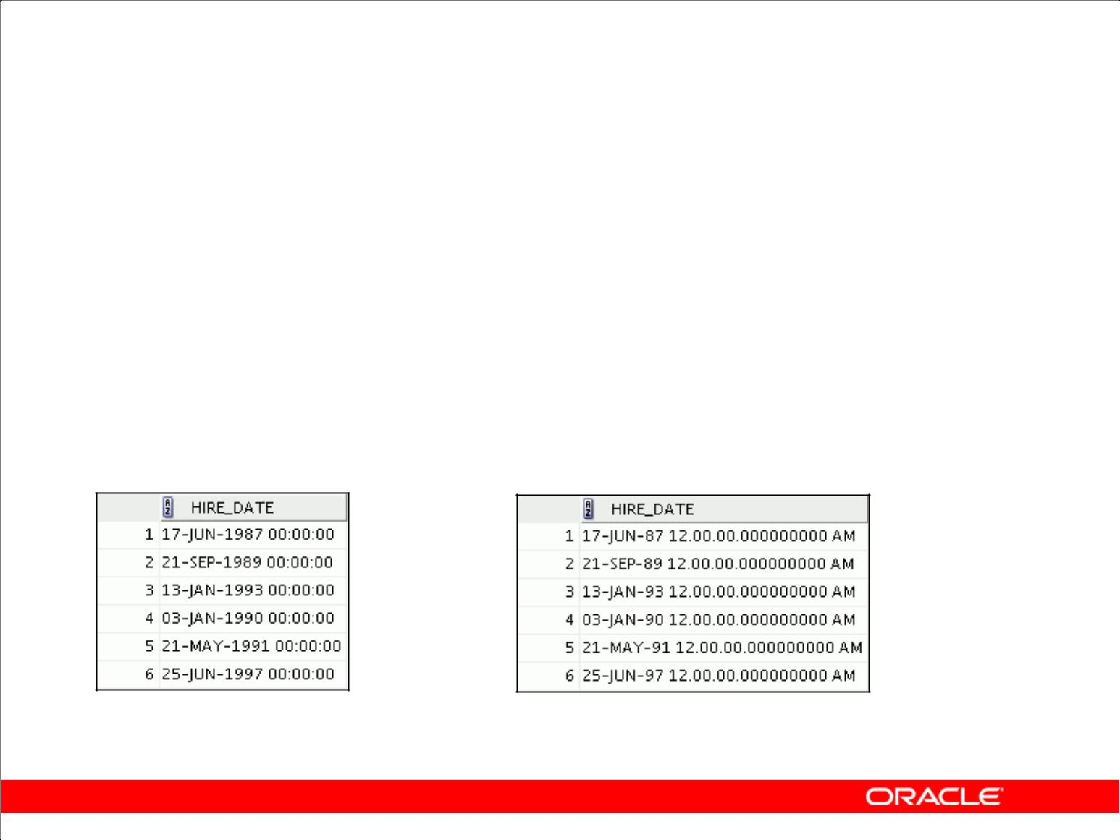**Difference Between DATE and TIMESTAMP**

|  |  |  |  |  |  |  |  |  |
| --- | --- | --- | --- | --- | --- | --- | --- | --- |
|  |  | **A** |  |  |  |  | **B** |  |
|  |  |  |  |  |  |  |  |  |
| **--** | **when hire_date is** | | |  | **ALTER TABLE emp5** | | | |
| **of** | **type DATE** | | |  | **MODIFY** | **hire_date TIMESTAMP;** | | |
| **SELECT hire_date** | | | |  | **SELECT** | **hire_date** | | |
| **FROM emp5;** | | | |  | **FROM emp5;** | | | |
|  |  |  |  |  |  |  |  |  |

**…** **…**

Copyright © 2009, Oracle. All rights reserved.

**TIMESTAMP Data Type: Example**

In the slide, example A shows the data from the hire_date column of the EMP5 table when the

data type of the column is DATE. In example B, the table is altered and the data type of the

hire_date column is made into TIMESTAMP. The output shows the differences in display. You

can convert from DATE to TIMESTAMP when the column has data, but you cannot convert from

DATE or TIMESTAMP to TIMESTAMP WITH TIME ZONE unless the column is empty.

You can specify the fractional seconds precision for time stamp. If none is specified, as in this example, then it defaults to 6.

For example, the following statement sets the fractional seconds precision as 7:

ALTER TABLE emp5

MODIFY hire_date TIMESTAMP(7);

**Note:** The Oracle date data type by default appears as shown in this example. However, the date datatype also contains additional information such as hours, minutes, seconds, a.m., and p.m. To obtain the date in this format, you can apply a format mask or a function to the date value.

|  |
| --- |
| Oracle Internal & Oracle Academy Use Only |

**Oracle Database 10*g*: SQL Fundamentals II 5 - 13**

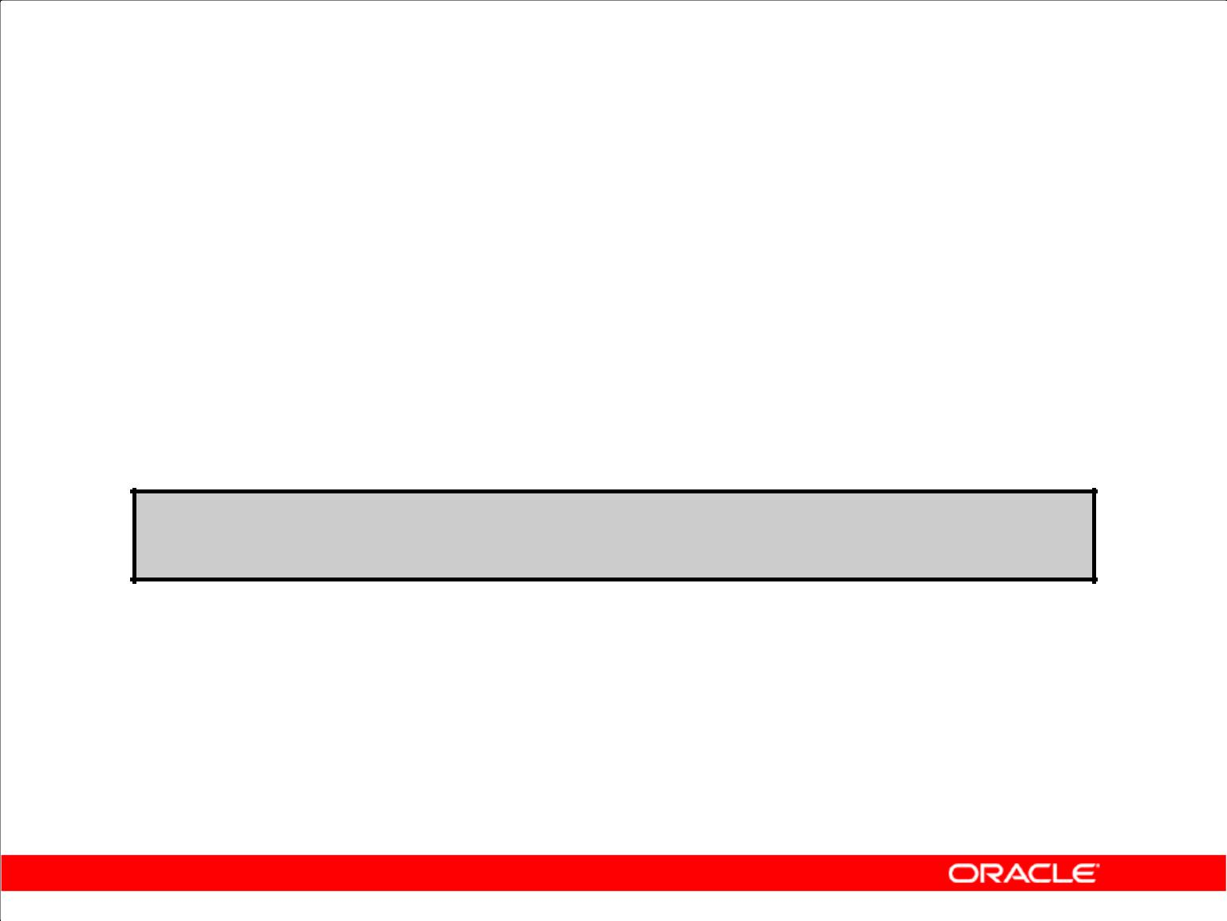**TIMESTAMP WITH TIME ZONE Data Type**

1. TIMESTAMP WITH TIME ZONE is a variant of

TIMESTAMP that includes a time zone displacement in its value.

1. The time zone displacement is the difference,

in hours and minutes, between local time and UTC.

1. It is specified as:

**TIMESTAMP[(fractional_seconds_precision)] WITH TIME ZONE**

Copyright © 2009, Oracle. All rights reserved.

**TIMESTAMP WITH TIME ZONE Data Type**

UTC stands for Coordinated Universal Time (formerly Greenwich mean time). Two TIMESTAMP WITH TIME ZONE values are considered identical if they represent the same instant in UTC, regardless of the TIME ZONE offsets stored in the data. For example:

TIMESTAMP '1999-04-15 8:00:00 -8:00'

is the same as

TIMESTAMP '1999-04-15 11:00:00 -5:00'.

That is, 8:00 a.m. Pacific Standard Time is the same as 11:00 a.m. Eastern Standard Time.

This can also be specified as:

TIMESTAMP '1999-04-15 8:00:00 US/Pacific'

|  |
| --- |
| Oracle Internal & Oracle Academy Use Only |

**Oracle Database 10*g*: SQL Fundamentals II 5 - 14**

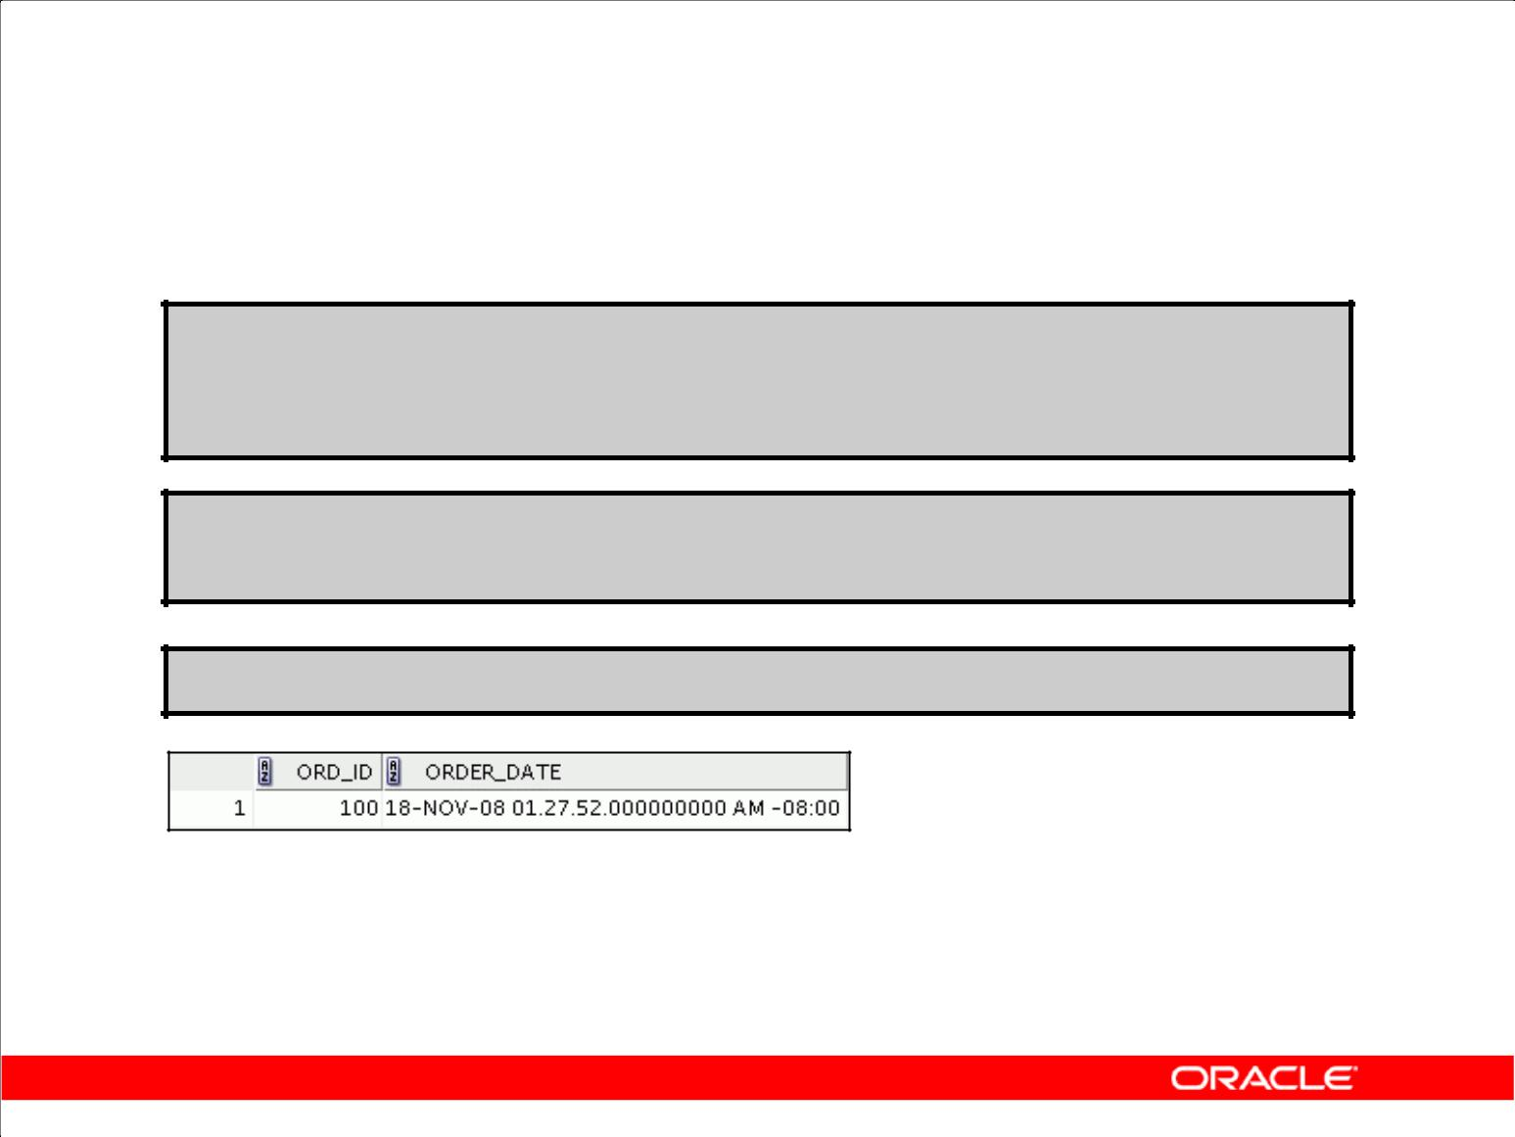**TIMESTAMP WITH TIMEZONE: Example**

**CREATE TABLE web_orders**

**(ord_id number primary key,**

**order_date TIMESTAMP WITH TIME ZONE);**

**INSERT INTO web_orders values (ord_seq.nextval, current_date);**

**SELECT * FROM web_orders;**

Copyright © 2009, Oracle. All rights reserved.

**TIMESTAMP WITH TIME ZONE: Example**

In the example in the slide, a new table web_orders is created with a column of data type TIMESTAMP WITH TIME ZONE. This table is populated whenever a web_order is placed. The time stamp and time zone for the user placing the order is inserted based on the CURRENT_DATE value. That way when a Web-based company guarantees shipping, they can estimate their delivery time based on the time zone of the person placing the order.

|  |
| --- |
| Oracle Internal & Oracle Academy Use Only |

**Oracle Database 10*g*: SQL Fundamentals II 5 - 15**

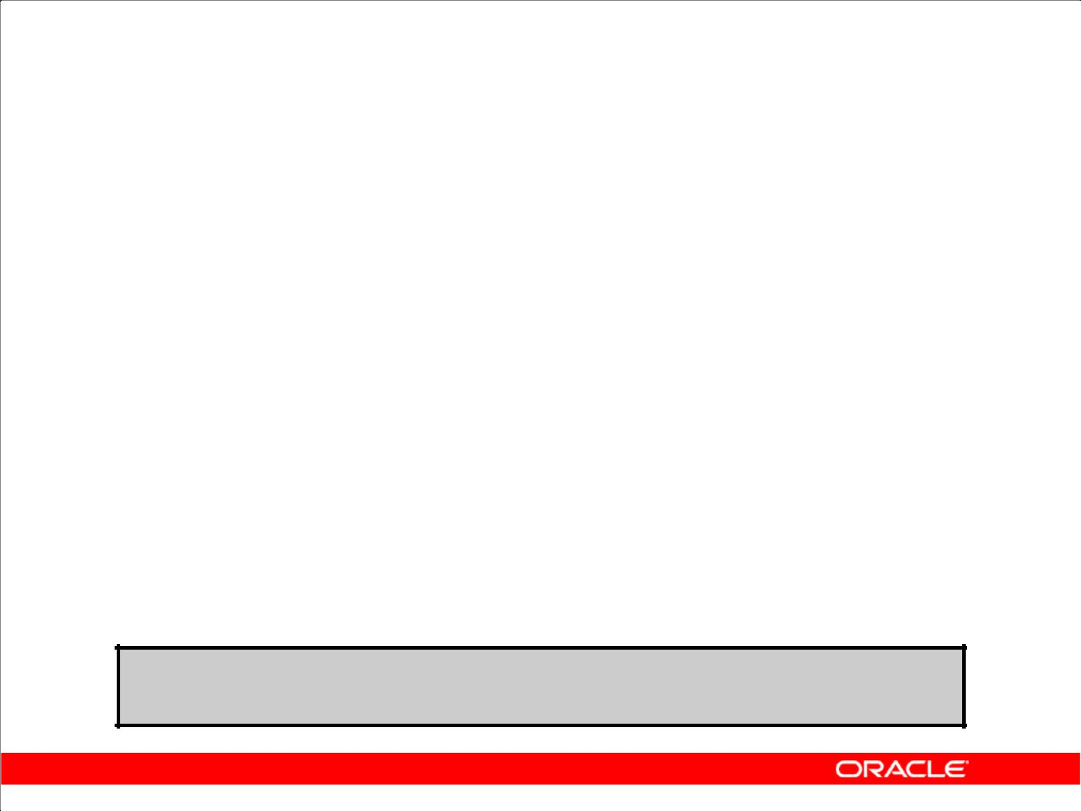**TIMESTAMP WITH LOCAL TIMEZONE**

1. TIMESTAMP WITH LOCAL TIME ZONE is another variant of TIMESTAMP that includes a time zone displacement in its value.
2. Data stored in the database is normalized to the database time zone.
3. The time zone displacement is not stored as part of the column data.
4. The Oracle Database returns the data in the user’s local session time zone.
5. The TIMESTAMP WITH LOCAL TIME ZONE data type is specified as follows:

**TIMESTAMP[(fractional_seconds_precision)] WITH LOCAL TIME ZONE**

Copyright © 2009, Oracle. All rights reserved.

**TIMESTAMP WITH LOCAL TIMEZONE**

Unlike TIMESTAMP WITH TIME ZONE, you can specify columns of the TIMESTAMP WITH LOCAL TIME ZONE type as part of a primary or unique key. The time zone displacement is the difference (in hours and minutes) between local time and UTC. There is no literal for TIMESTAMP WITH LOCAL TIME ZONE.

|  |
| --- |
| Oracle Internal & Oracle Academy Use Only |

**Oracle Database 10*g*: SQL Fundamentals II 5 - 16**

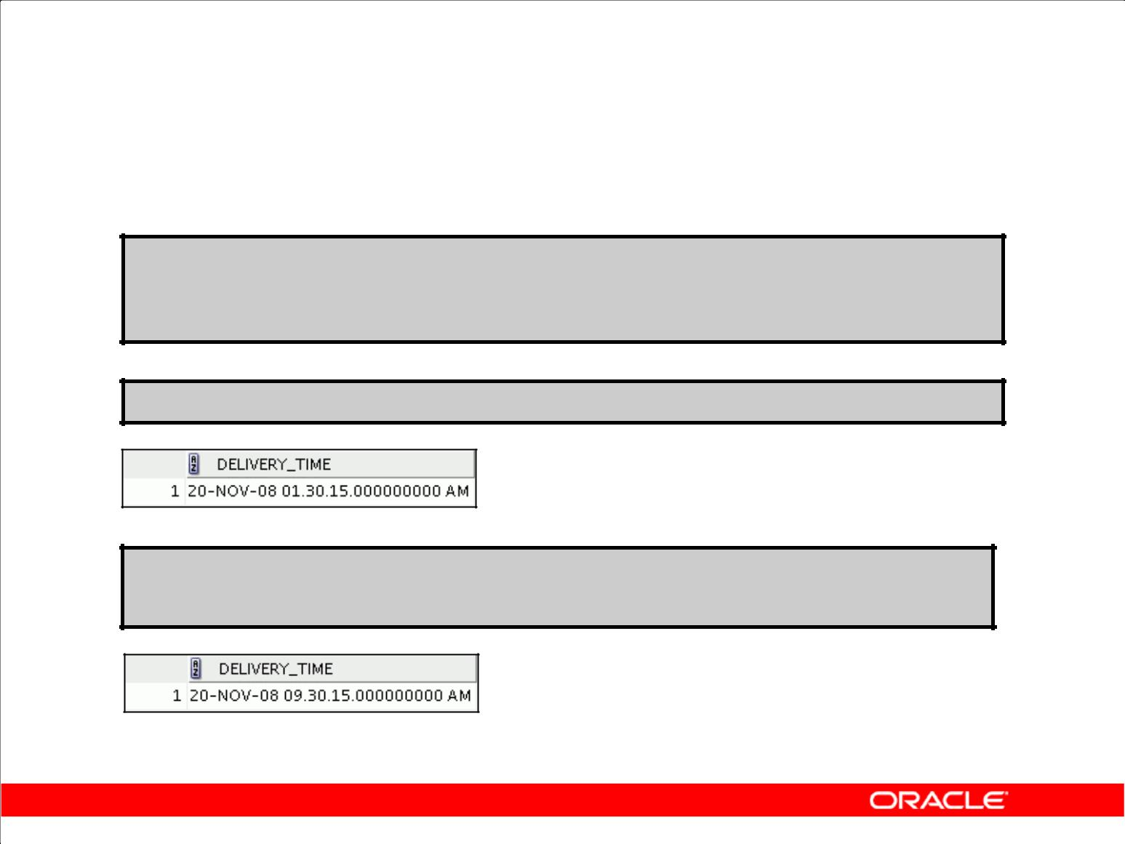**TIMESTAMP WITH LOCAL TIMEZONE: Example**

**CREATE TABLE shipping (delivery_time TIMESTAMP WITH LOCAL TIME ZONE);**

**INSERT INTO shipping VALUES(current_timestamp + 2);**

**SELECT * FROM shipping;**

**ALTER SESSION SET TIME_ZONE = 'EUROPE/LONDON'; SELECT * FROM shipping;**

Copyright © 2009, Oracle. All rights reserved.

**TIMESTAMP WITH LOCAL TIME ZONE: Example**

In the example in the slide, a new table SHIPPING is created with a column of the TIMESTAMP WITH LOCAL TIME ZONE data type. This table is populated by inserting two days from the CURRENT_TIMESTAMP value into it every time an order is placed. The output from the DATE_TAB table shows that the data is stored without the time zone offset. Then the ALTER SESSION command is issued to change the time zone to the local time zone at the place of delivery. A second query on the same table now reflects the data with the local time zone reflected in the time value, so that the customer can be notified about the expected delivery time.

|  |
| --- |
| Oracle Internal & Oracle Academy Use Only |

**Oracle Database 10*g*: SQL Fundamentals II 5 - 17**

**INTERVAL Data Types**

1. INTERVAL data types are used to store the difference between two datetime values.
2. There are two classes of intervals:

– Year-month

– Day-time

1. The precision of the interval is:

– The actual subset of fields that constitutes an interval

– Specified in the interval qualifier

|  |  |
| --- | --- |
| **Data Type** | **Fields** |
|  |  |
| **INTERVAL YEAR TO MONTH** | **Year, Month** |
| **INTERVAL DAY TO SECOND** | **Days, Hour, Minute, Second with** |
| **fractional seconds** |
|  |

Copyright © 2009, Oracle. All rights reserved.

**INTERVAL Data Types**

INTERVAL data types are used to store the difference between two datetime values. There are two

classes of intervals: year-month intervals and day-time intervals. A year-month interval is made up of a contiguous subset of fields of YEAR and MONTH, whereas a day-time interval is made up of a contiguous subset of fields consisting of DAY, HOUR, MINUTE, and SECOND. The actual subset of fields that constitute an interval is called the precision of the interval and is specified in the interval qualifier. Because the number of days in a year is calendar dependent, the year-month interval is NLS dependent, whereas day-time interval is NLS independent.

The interval qualifier may also specify the leading field precision, which is the number of digits in the leading or only field, and in case the trailing field is SECOND, it may also specify the fractional seconds precision, which is the number of digits in the fractional part of the SECOND value. If not specified, the default value for leading field precision is 2 digits, and the default value for fractional seconds precision is 6 digits.

|  |
| --- |
| Oracle Internal & Oracle Academy Use Only |

**Oracle Database 10*g*: SQL Fundamentals II 5 - 18**

**INTERVAL Data Types (continued)**

**INTERVAL YEAR (year_precision) TO MONTH**

This data type stores a period of time in years and months, where year_precision is the number of digits in the YEAR datetime field. The accepted values are 0 to 9. The default is 6.

**INTERVAL DAY (day_precision) TO SECOND (fractional_seconds_precision)**

This data type stores a period of time in days, hours, minutes, and seconds, where

day_precision is the maximum number of digits in the DAY datetime field (accepted values are

1. to 9; the default is 2), and fractional_seconds_precision is the number of digits in the fractional part of the SECOND field. The accepted values are 0 to 9. The default is 6.

|  |
| --- |
| Oracle Internal & Oracle Academy Use Only |

**Oracle Database 10*g*: SQL Fundamentals II 5 - 19**

**INTERVAL Fields**

|  |  |  |
| --- | --- | --- |
|  | **INTERVAL Field** | **Valid Values for Interval** |
|  | **YEAR** | **Any positive or negative integer** |
|  |  |  |
|  | **MONTH** | **00 to 11** |
|  |  |  |
|  | **DAY** | **Any positive or negative integer** |
|  |  |  |
|  | **HOUR** | **00 to 23** |
|  |  |  |
|  | **MINUTE** | **00 to 59** |
|  |  |  |
|  | **SECOND** | **00 to 59.9(N) where 9(N) is precision** |
|  |  |  |

Copyright © 2009, Oracle. All rights reserved.

**INTERVAL Fields**

INTERVAL YEAR TO MONTH can have fields of YEAR and MONTH.

INTERVAL DAY TO SECOND can have fields of DAY, HOUR, MINUTE, and SECOND.

The actual subset of fields that constitute an item of either type of interval is defined by an interval qualifier, and this subset is known as the precision of the item.

Year-month intervals are mutually comparable and assignable only with other year-month intervals, and day-time intervals are mutually comparable and assignable only with other day-time intervals.

|  |
| --- |
| Oracle Internal & Oracle Academy Use Only |

**Oracle Database 10*g*: SQL Fundamentals II 5 - 20**

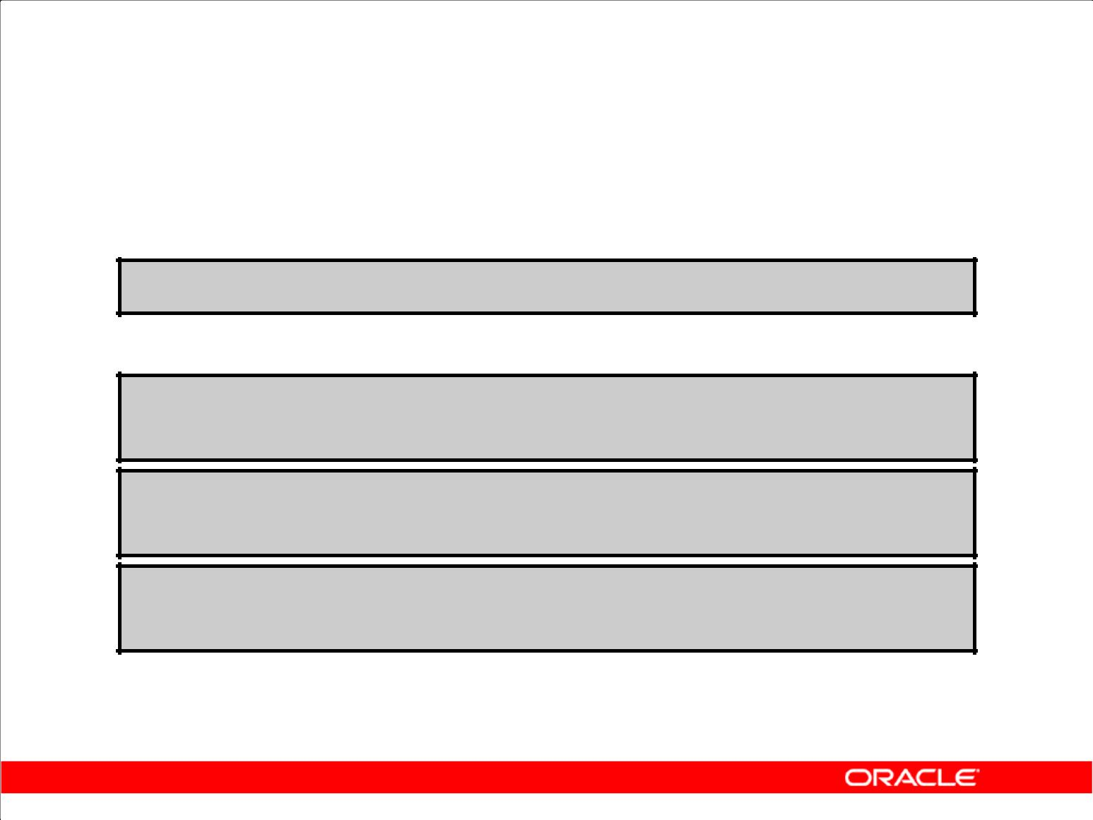**INTERVAL YEAR TO MONTH Data Type**

INTERVAL YEAR TO MONTH stores a period of time using the YEAR and MONTH datetime fields.

**INTERVAL YEAR [(year_precision)] TO MONTH**

For example:

**'312-2' assigned to INTERVAL YEAR(3) TO MONTH Indicates an interval of 312 years and 2 months**

**'312-0' assigned to INTERVAL YEAR(3) TO MONTH Indicates 312 years and 0 months**

**'0-3' assigned to INTERVAL YEAR TO MONTH Indicates an interval of 3 months**

Copyright © 2009, Oracle. All rights reserved.

**INTERVAL YEAR TO MONTH Data Type**

INTERVAL YEAR TO MONTH stores a period of time using the YEAR and MONTH datetime fields.

Specify INTERVAL YEAR TO MONTH as follows:

INTERVAL YEAR [(year_precision)] TO MONTH

where year_precision is the number of digits in the YEAR datetime field. The default value of year_precision is 2.

**Restriction:** The leading field must be more significant than the trailing field. For example,INTERVAL '0-1' MONTH TO YEAR is not valid.

The following INTERVAL YEAR TO MONTH literal indicates an interval of 123 years, 3 months:

1. INTERVAL '123-3' YEAR(3) TO MONTH

• INTERVAL '123' YEAR(3) indicates an interval of 123 years 0 months.

• INTERVAL '3' MONTH indicates an interval of 3 months.

|  |
| --- |
| Oracle Internal & Oracle Academy Use Only |

**Oracle Database 10*g*: SQL Fundamentals II 5 - 21**

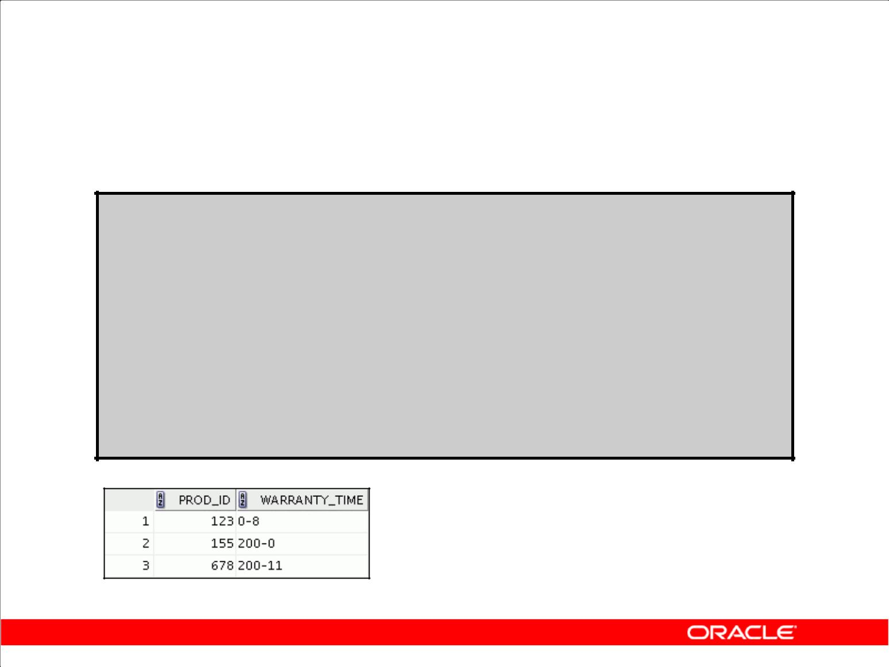**INTERVAL YEAR TO MONTH: Example**

**CREATE TABLE warranty**

**(prod_id number,** **warranty_time INTERVAL YEAR(3)**

**TO MONTH);**

**INSERT INTO warranty VALUES (123, INTERVAL '8' MONTH);**

**INSERT INTO warranty VALUES (155, INTERVAL '200' YEAR(3));**

**INSERT INTO warranty VALUES (678, '200-11'); SELECT * FROM warranty;**

Copyright © 2009, Oracle. All rights reserved.

**INTERVAL YEAR TO MONTH Data Type (continued)**

INTERVAL YEAR TO MONTH stores a period of time using the YEAR and MONTH datetime fields.

Specify INTERVAL YEAR TO MONTH as follows:

INTERVAL YEAR [(year_precision)] TO MONTH

where year_precision is the number of digits in the YEAR datetime field. The default value of year_precision is 2.

**Restriction:** The leading field must be more significant than the trailing field. For example,INTERVAL '0-1' MONTH TO YEAR is not valid.

The Oracle Database supports two interval data types: Interval Year to Month and Interval Day to Second; the column type, PL/SQL argument, variable, and return type must be one of the two. However, for interval literals, the system recognizes other American National Standards Institute

(ANSI) interval types such as INTERVAL '2' YEAR or INTERVAL '10' HOUR. In these cases, each interval is converted to one of the two supported types.

In the example in the slide, a WARRANTY table is created, which contains a warranty_time column that takes the INTERVAL YEAR(3) TO MONTH data type. Different values are inserted into it to indicate years and months for various products. When these rows are retrieved from the table, you see a year value displaced by the month value by a (-).

|  |
| --- |
| Oracle Internal & Oracle Academy Use Only |

**Oracle Database 10*g*: SQL Fundamentals II 5 - 22**

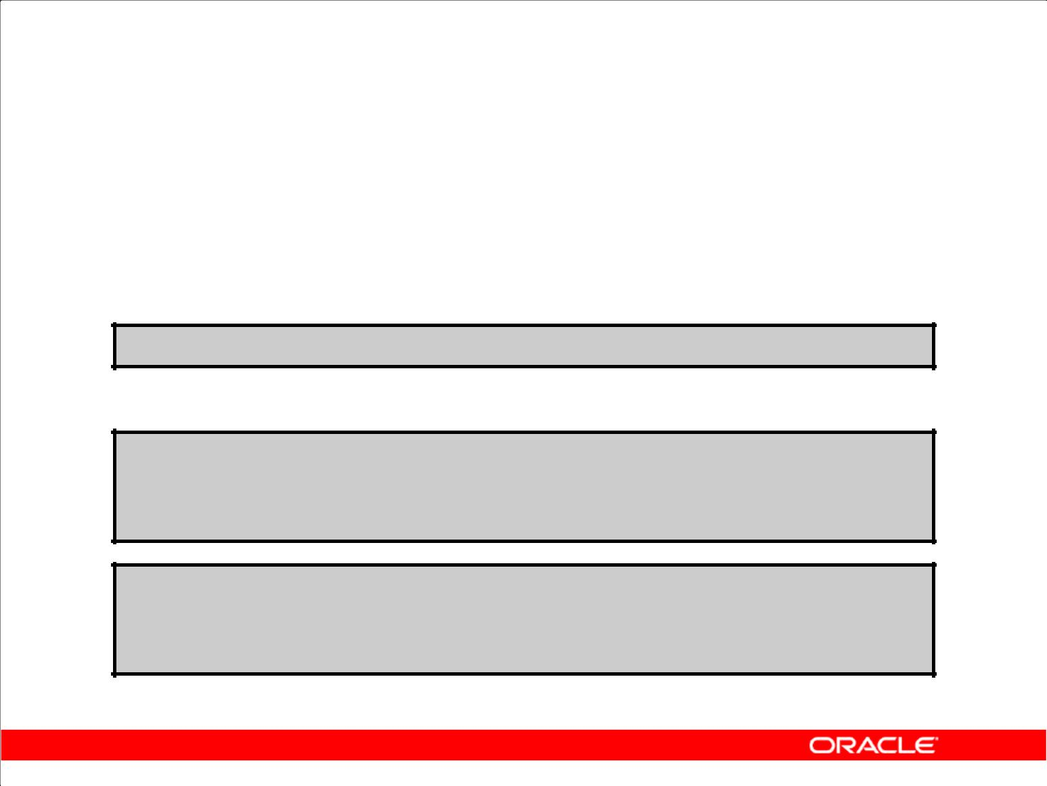**INTERVAL DAY TO SECOND Data Type**

INTERVAL DAY TO SECOND

(fractional _seconds_precision)stores a period of time in days, hours, minutes, and seconds.

**INTERVAL DAY[(day_precision)] TO Second**

**For example:**

**INTERVAL '6 03:30:16' DAY TO SECOND**

**Indicates an interval of 6 days 3 hours 30 minutes and 16 seconds**

**INTERVAL '6 00:00:00' DAY TO SECOND**

**Indicates an interval of 6 days and 0 hours, 0 minutes and 0 seconds**

Copyright © 2009, Oracle. All rights reserved.

**INTERVAL DAY TO SECOND Data Type**

INTERVAL DAY (day_precision) TO SECOND (fractional_seconds_precision) stores a period of time in days, hours, minutes, and seconds, where day_precision is the maximum number of digits in the DAY datetime field (accepted values are 0 through 9; the default is 2), and fractional_seconds_precision is the number of digits in the fractional part of the SECOND field. Accepted values are 0 through 9. The default is 6.

In the example in the slide, 6 represents the number of days, and 03:30:15 indicates the values for hours, minutes, and seconds.

|  |
| --- |
| Oracle Internal & Oracle Academy Use Only |

**Oracle Database 10*g*: SQL Fundamentals II 5 - 23**

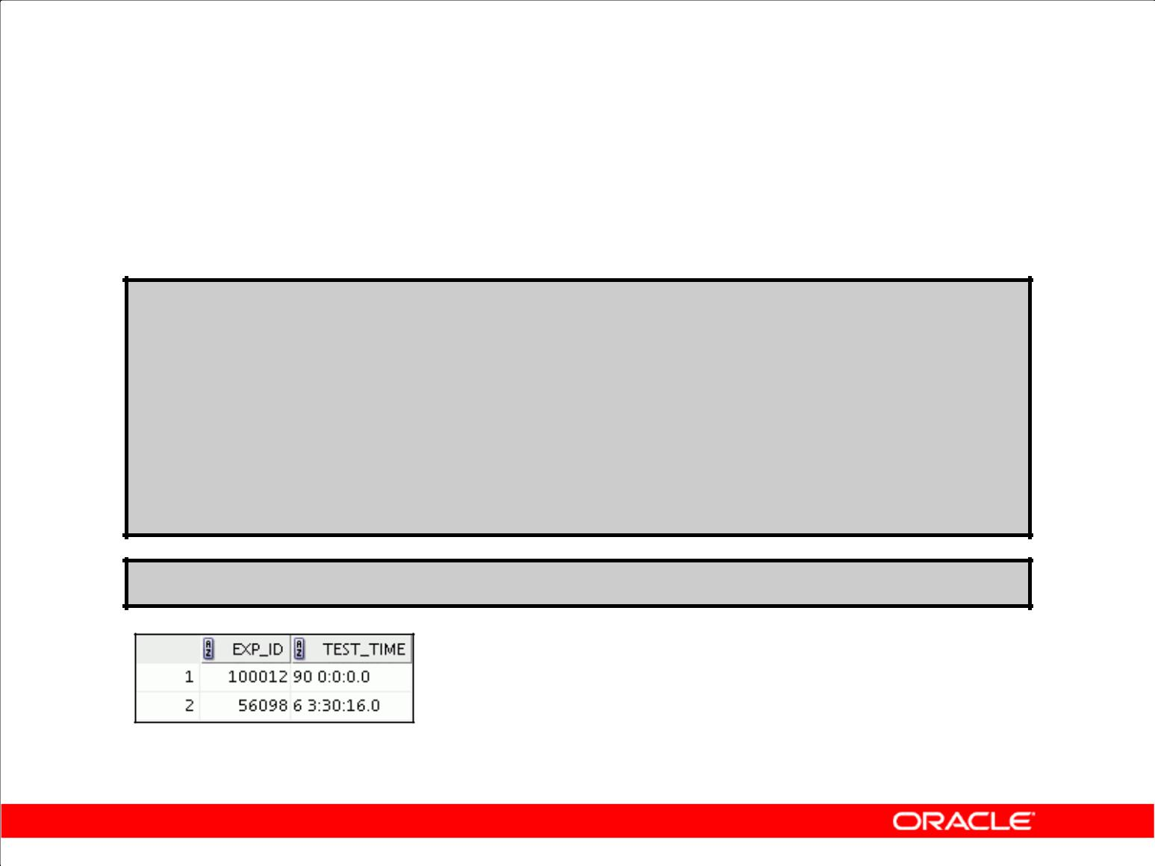**INTERVAL DAY TO SECOND**

**Data Type: Example**

**CREATE TABLE lab**

**( exp_id number, test_time INTERVAL DAY(2) TO SECOND);**

**INSERT INTO lab VALUES (100012, '90 00:00:00');**

**INSERT INTO lab VALUES (56098,**

**INTERVAL '6 03:30:16' DAY** **TO SECOND);**

**SELECT * FROM lab;**

Copyright © 2009, Oracle. All rights reserved.

**INTERVAL DAY TO SECOND Data Type: Example**

In the example in the slide, you are creating the lab table with a test_time column of the INTERVAL DAY TO SECOND data type. You then insert into it the value “90 00:00:00” to indicate 90 days and 0 hours, minutes, and seconds, and INTERVAL '6 03:30:16' DAY TO SECOND. The select statement shows how this data is displayed in the database.

|  |
| --- |
| Oracle Internal & Oracle Academy Use Only |

**Oracle Database 10*g*: SQL Fundamentals II 5 - 24**

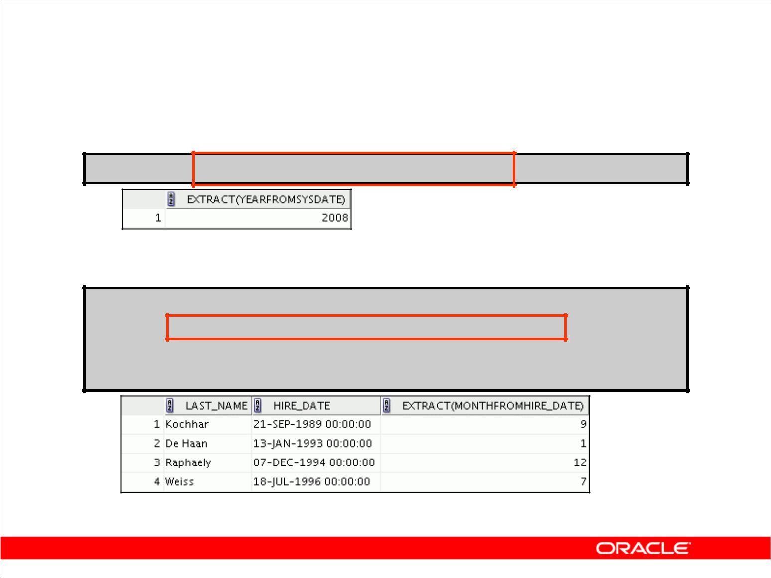**EXTRACT**

1. Display the YEAR component from the SYSDATE.

**SELECT EXTRACT (YEAR FROM SYSDATE) FROM DUAL;**

1. Display the MONTH component from the HIRE_DATE for those employees whose MANAGER _ID is 100.

**SELECT last_name, hire_date,**

**EXTRACT (MONTH FROM HIRE_DATE)**

**FROM employees**

**WHERE manager_id = 100;**

**…**

Copyright © 2009, Oracle. All rights reserved.

**EXTRACT**

The EXTRACT expression extracts and returns the value of a specified datetime field from a datetime

or interval value expression. You can extract any of the components mentioned in the following syntax using the EXTRACT function. The syntax of the EXTRACT function is:

SELECT EXTRACT ([YEAR] [MONTH][DAY] [HOUR] [MINUTE][SECOND]

[TIMEZONE_HOUR] [TIMEZONE_MINUTE]

[TIMEZONE_REGION] [TIMEZONE_ABBR]

FROM [datetime_value_expression] [interval_value_expression]);

When you extract a TIMEZONE_REGION or TIMEZONE_ABBR (abbreviation), the value returned is a string containing the appropriate time zone name or abbreviation. When you extract any of the other values, the value returned is a date in the Gregorian calendar. When extracting from a datetime with a time zone value, the value returned is in UTC.

In the first example in the slide, the EXTRACT function is used to extract the YEAR from SYSDATE. In the second example in the slide, the EXTRACT function is used to extract the MONTH from the HIRE_DATE column of the EMPLOYEES table for those employees who report to the manager whose EMPLOYEE_ID is 100.

|  |
| --- |
| Oracle Internal & Oracle Academy Use Only |

**Oracle Database 10*g*: SQL Fundamentals II 5 - 25**

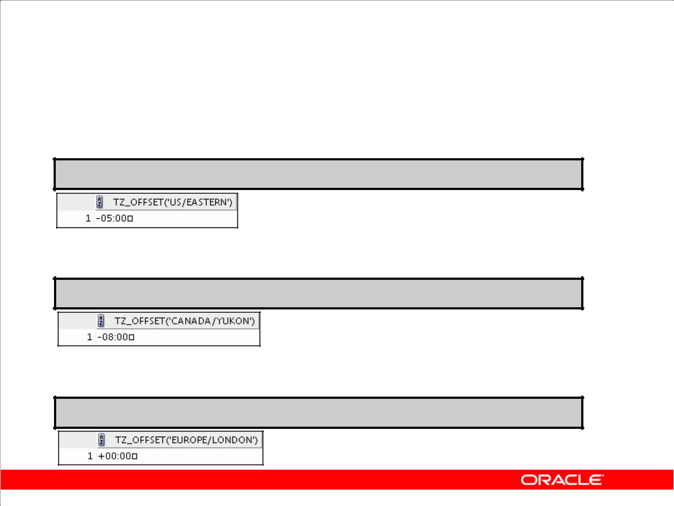**TZ_OFFSET**

1. Display the time zone offset for the 'US/Eastern' time zone:

**SELECT TZ_OFFSET('US/Eastern') FROM DUAL;**

1. Display the time zone offset for the 'Canada/Yukon' time zone:

**SELECT TZ_OFFSET('Canada/Yukon') FROM DUAL;**

1. Display the time zone offset for the 'Europe/London' time zone:

**SELECT TZ_OFFSET('Europe/London') FROM DUAL;**

Copyright © 2009, Oracle. All rights reserved.

**TZ_OFFSET**

The TZ_OFFSET function returns the time zone offset corresponding to the value entered. The

return value is dependent on the date when the statement is executed. For example, if the

TZ_OFFSET function returns a value –08:00, this value indicates that the time zone where the

command was executed is eight hours behind UTC. You can enter a valid time zone name, a time zone offset from UTC (which simply returns itself), or the keyword SESSIONTIMEZONE or DBTIMEZONE. The syntax of the TZ_OFFSET function is:

TZ_OFFSET ( ['time_zone_name'] '[+ | -] hh:mm' ]

[ SESSIONTIMEZONE] [DBTIMEZONE]

The Fold Motor Company has its headquarters in Michigan, USA, which is in the US/Eastern time zone. The company president, Mr. Fold, wants to conduct a conference call with the vice president of the Canadian operations and the vice president of European operations, who are in the Canada/Yukon and Europe/London time zones, respectively. Mr. Fold wants to find out the time in each of these places to make sure that his senior management will be available to attend the meeting. His secretary, Mr. Scott, helps by issuing the queries shown in the example and gets the following results:

1. The 'US/Eastern' time zone is five hours behind UTC.
2. The 'Canada/Yukon' time zone is eight hours behind UTC.
3. The 'Europe/London' time zone is same as UTC.

|  |
| --- |
| Oracle Internal & Oracle Academy Use Only |

**Oracle Database 10*g*: SQL Fundamentals II 5 - 26**

**TZ_OFFSET (continued)**

For a listing of valid time zone name values, you can query the V$TIMEZONE_NAMES dynamic performance view.

SELECT * FROM V$TIMEZONE_NAMES;

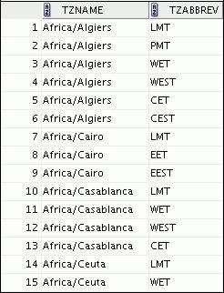

…

|  |
| --- |
| Oracle Internal & Oracle Academy Use Only |

**Oracle Database 10*g*: SQL Fundamentals II 5 - 27**

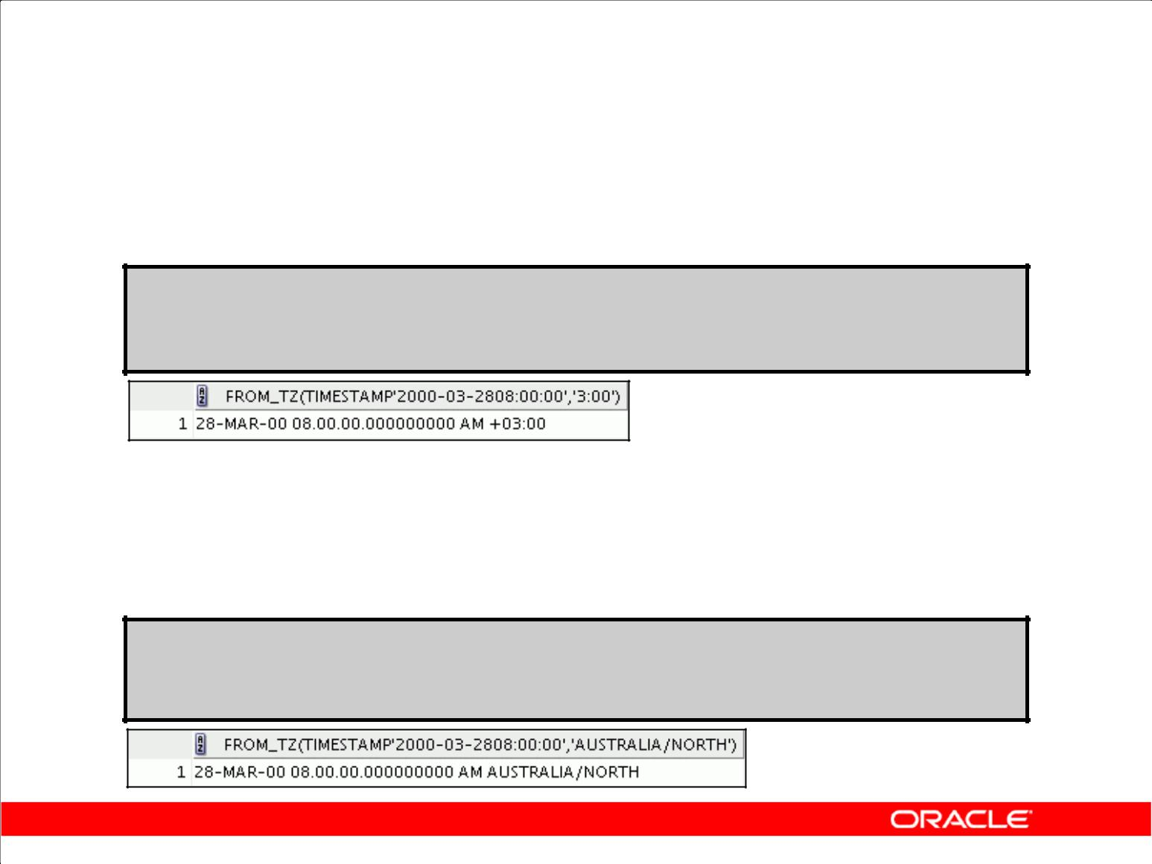**TIMESTAMP Conversion Using FROM_TZ**

1. Display the TIMESTAMP value '2000-03-28

08:00:00' as a TIMESTAMP WITH TIME ZONE value.

**SELECT FROM_TZ(TIMESTAMP '2000-03-28 08:00:00','3:00')**

**FROM DUAL;**

1. Display the TIMESTAMP value '2000-03-28

08:00:00' as a TIMESTAMP WITH TIME ZONE value for the 'Australia/North' time zone region.

**SELECT FROM_TZ(TIMESTAMP**

**'2000-03-28 08:00:00', 'Australia/North')**

**FROM DUAL;**

Copyright © 2009, Oracle. All rights reserved.

**TIMESTAMP Conversion Using FROM_TZ**

The FROM_TZ function converts a TIMESTAMP value to a TIMESTAMP WITH TIME ZONE value.

The syntax of the FROM_TZ function is as follows:

FROM_TZ(TIMESTAMP timestamp_value, time_zone_value)

where time_zone_value is a character string in the format 'TZH:TZM' or a character expression that returns a string in TZR (time zone region) with an optional TZD format. TZD is an abbreviated time zone string with daylight saving information. TZR represents the time zone region in datetime input strings. Examples are 'Australia/North', 'PST' for US/Pacific standard time, 'PDT' for US/Pacific daylight time, and so on. To see a listing of valid values for the TZR and TZD format elements, query the V$TIMEZONE_NAMES dynamic performance view.

The example in the slide converts a TIMESTAMP value to TIMESTAMP WITH TIME ZONE.

|  |
| --- |
| Oracle Internal & Oracle Academy Use Only |

**Oracle Database 10*g*: SQL Fundamentals II 5 - 28**

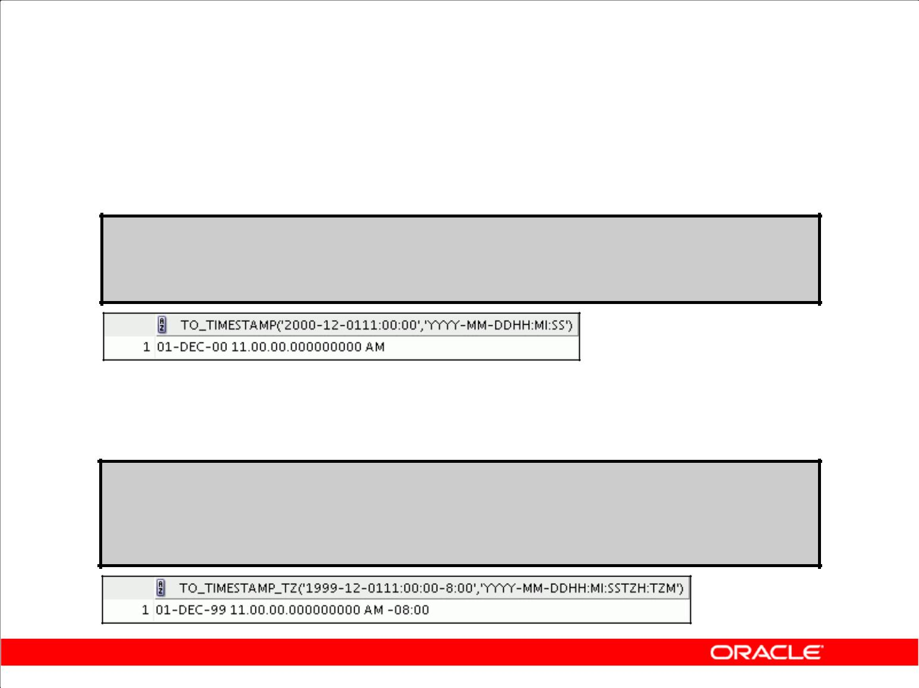**Converting to TIMESTAMP Using TO_TIMESTAMP and TO_TIMESTAMP_TZ**

1. Display the character string '2000-12-01 11:00:00'

as a TIMESTAMP value:

**SELECT TO_TIMESTAMP ('2000-12-01 11:00:00', 'YYYY-MM-DD HH:MI:SS')**

**FROM DUAL;**

1. Display the character string '1999-12-01 11:00:00 -

8:00' as a TIMESTAMP WITH TIME ZONE value:

**SELECT**

**TO_TIMESTAMP_TZ('1999-12-01 11:00:00 -8:00', 'YYYY-MM-DD HH:MI:SS TZH:TZM')**

**FROM DUAL;**

Copyright © 2009, Oracle. All rights reserved.

**Converting to TIMESTAMP Using TO_TIMESTAMP and TO_TIMESTAMP_TZ**

The TO_TIMESTAMP function converts a string of CHAR, VARCHAR2, NCHAR, or NVARCHAR2 data type to a value of the TIMESTAMP data type. The syntax of the TO_TIMESTAMP function is:

TO_TIMESTAMP (char,[fmt],['nlsparam'])

The optional fmt specifies the format of char. If you omit fmt, then the string must be in the default format of the TIMESTAMP data type. The optional nlsparam specifies the language in which month and day names, and abbreviations are returned. This argument can have this form:

'NLS_DATE_LANGUAGE = language'

If you omit nlsparams, this function uses the default date language for your session. The example in the slide converts a character string to a value of TIMESTAMP.

The TO_TIMESTAMP_TZ function converts a string of CHAR, VARCHAR2, NCHAR, or NVARCHAR2 data type to a value of the TIMESTAMP WITH TIME ZONE data type. The syntax of the TO_TIMESTAMP_TZ function is:

TO_TIMESTAMP_TZ (char,[fmt],['nlsparam'])

The optional fmt specifies the format of char. If you omit fmt, then a string must be in the default format of the TIMESTAMP WITH TIME ZONE data type. The example in the slide converts a character string to a value of TIMESTAMP WITH TIME ZONE.

|  |
| --- |
| Oracle Internal & Oracle Academy Use Only |

**Oracle Database 10*g*: SQL Fundamentals II 5 - 29**

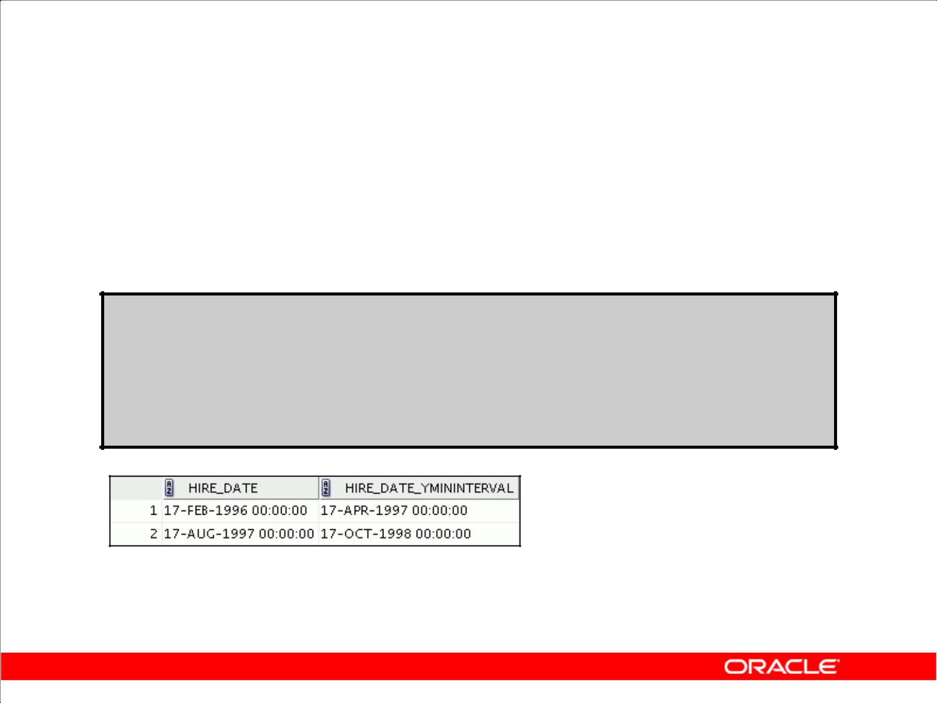**Time Interval Conversion with TO_YMINTERVAL**

Display a date that is one year and two months after the hire date for the employees working in the department with the DEPARTMENT_ID 20.

**SELECT hire_date,**

**hire_date + TO_YMINTERVAL('01-02') AS HIRE_DATE_YMININTERVAL**

**FROM employees**

**WHERE department_id = 20;**

Copyright © 2009, Oracle. All rights reserved.

**Time Interval Conversion with TO_YMINTERVAL**

The TO_YMINTERVAL function converts a character string of CHAR, VARCHAR2, NCHAR, or

NVARCHAR2 data type to an INTERVAL YEAR TO MONTH data type. The INTERVAL YEAR TO

MONTH data type stores a period of time using the YEAR and MONTH datetime fields. The format of

INTERVAL YEAR TO MONTH is as follows:

INTERVAL YEAR [(year_precision)] TO MONTH

where year_precision is the number of digits in the YEAR datetime field. The default value of

year_precision is 2.

The syntax of the TO_YMINTERVAL function is:

TO_YMINTERVAL (char)

where char is the character string to be converted.

The example in the slide calculates a date that is one year and two months after the hire date for the employees working in the department 20 of the EMPLOYEES table.

A reverse calculation can also be done using the TO_YMINTERVAL function. For example:

SELECT hire_date, hire_date + TO_YMINTERVAL('**-02-04**') AS

HIRE_DATE_YMINTERVAL

FROM EMPLOYEES WHERE department_id = 20;

Observe that the character string passed to the TO_YMINTERVAL function has a negative value. The

example returns a date that is two years and four months before the hire date for the employees working in the department 20 of the EMPLOYEES table.

|  |
| --- |
| Oracle Internal & Oracle Academy Use Only |

**Oracle Database 10*g*: SQL Fundamentals II 5 - 30**

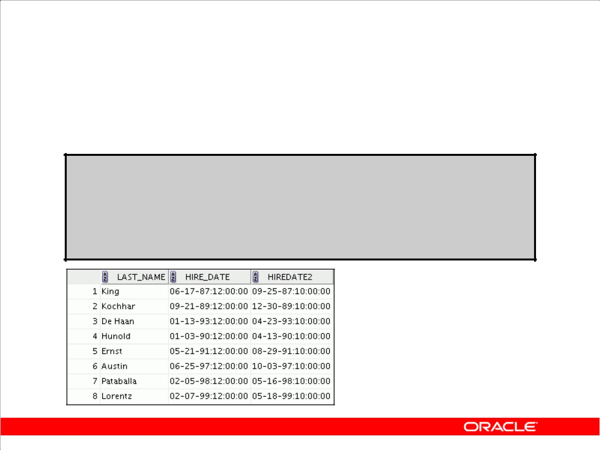**Using TO_DSINTERVAL: Example**

TO_DSINTERVAL: Converts a character string to an INTERVAL DAY TO SECOND data type

**SELECT last_name,**

**TO_CHAR(hire_date, 'mm-dd-yy:hh:mi:ss') hire_date, TO_CHAR(hire_date +**

**TO_DSINTERVAL('100 10:00:00'),**

**'mm-dd-yy:hh:mi:ss') hiredate2**

**FROM employees;**

**…**

Copyright © 2009, Oracle. All rights reserved.

**TO_DSINTERVAL**

TO_DSINTERVAL converts a character string of the CHAR, VARCHAR2, NCHAR, or NVARCHAR2 data type to an INTERVAL DAY TO SECOND type.

In the example in the slide, the date 100 days and 10 hours after the hire date is obtained.

**TO_YMINTERVAL**

The TO_YMINTERVAL function converts a character string of CHAR, VARCHAR2, NCHAR, or NVARCHAR2 data type to an INTERVAL YEAR TO MONTH type.

In the following example, the date one year and two months after the hire date is obtained.

SELECT hire_date, hire_date + TO_YMINTERVAL('01-02') ytm FROM employees;

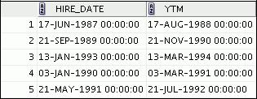

|  |
| --- |
| Oracle Internal & Oracle Academy Use Only |

…

**Oracle Database 10*g*: SQL Fundamentals II 5 - 31**

**Daylight Saving Time**

1. First Sunday in April

– Time jumps from 01:59:59 a.m. to 03:00:00 a.m.

– Values from 02:00:00 a.m. to 02:59:59 a.m. are not valid.

1. Last Sunday in October

– Time jumps from 02:00:00 a.m. to 01:00:01 a.m.

– Values from 01:00:01 a.m. to 02:00:00 a.m. are ambiguous because they are visited twice.

Copyright © 2009, Oracle. All rights reserved.

**Daylight Saving Time (DST)**

Most western nations advance the clock ahead one hour during the summer months. This period is called daylight saving time. Daylight saving time lasts from the first Sunday in April to the last Sunday in October in the most of the United States, Mexico, and Canada. The nations of the European Union observe daylight saving time, but they call it the summer time period. Europe’s summer time period begins a week earlier than its North American counterpart, but ends at the same time.

The Oracle Database automatically determines, for any given time zone region, whether daylight saving time is in effect and returns local time values accordingly. The datetime value is sufficient for the Oracle Database to determine whether daylight saving time is in effect for a given region in all cases except boundary cases. A boundary case occurs during the period when daylight saving time goes into or out of effect. For example, in the US/Eastern region, when daylight saving time goes into effect, the time changes from 01:59:59 a.m. to 03:00:00 a.m. The one-hour interval between 02:00:00 and 02:59:59 a.m. does not exist. When daylight saving time goes out of effect, the time changes from 02:00:00 a.m. back to 01:00:01 a.m., and the one-hour interval between 01:00:01 and 02:00:00 a.m. is repeated.

|  |
| --- |
| Oracle Internal & Oracle Academy Use Only |

**Oracle Database 10*g*: SQL Fundamentals II 5 - 32**

**Daylight Saving Time (DST) (continued)**

**ERROR_ON_OVERLAP_TIME**

The ERROR_ON_OVERLAP_TIME is a session parameter to notify the system to issue an error when it encounters a datetime that occurs in the overlapped period and no time zone abbreviation was specified to distinguish the period.

For example, daylight saving time ends on October 31, at 02:00:01 a.m. The overlapped periods are:

1. 10/31/2004 01:00:01 a.m. to 10/31/2004 02:00:00 a.m. (EDT)
2. 10/31/2004 01:00:01 a.m. to 10/31/2004 02:00:00 a.m. (EST)

If you input a datetime string that occurs in one of these two periods, you need to specify the time zone abbreviation (for example, EDT or EST) in the input string for the system to determine the period. Without this time zone abbreviation, the system does the following:

If the parameter ERROR_ON_OVERLAP_TIME is FALSE, then it assumes that the input time is

standard time (for example, EST). Otherwise, an error is raised. Only

|  |
| --- |
| Use |

|  |
| --- |
| Oracle Internal & Oracle Academy |

**Oracle Database 10*g*: SQL Fundamentals II 5 - 33**

**Summary**

In this lesson, you should have learned how to use the following functions:

|  |  |  |  |
| --- | --- | --- | --- |
| • | TZ_OFFSET | • | CURRENT_DATE |
| • | FROM_TZ | • | CURRENT_TIMESTAMP |
| • | TO_TIMESTAMP | • | LOCALTIMESTAMP |
| • | TO_TIMESTAMP_TZ | • | DBTIMEZONE |
| • | TO_YMINTERVAL | • | SESSIONTIMEZONE |
|  |  | • | EXTRACT |

Copyright © 2009, Oracle. All rights reserved.

**Summary**

This lesson addressed some of the datetime functions available in the Oracle Database.

|  |
| --- |
| Oracle Internal & Oracle Academy Use Only |

**Oracle Database 10*g*: SQL Fundamentals II 5 - 34**

**Practice 5: Overview**

This practice covers using the datetime functions.

Copyright © 2009, Oracle. All rights reserved.

**Practice 5: Overview**

In this practice, you display time zone offsets, CURRENT_DATE, CURRENT_TIMESTAMP, and LOCALTIMESTAMP. You also set time zones and use the EXTRACT function.

|  |
| --- |
| Oracle Internal & Oracle Academy Use Only |

**Oracle Database 10*g*: SQL Fundamentals II 5 - 35**

**Practice 5**

1. Alter the session to set the NLS_DATE_FORMAT to DD-MON-YYYY HH24:MI:SS.
2. a . Write queries to display the time zone offsets (TZ_OFFSET) for the following time zones.
   1. *US/Pacific-New*
   2. *Singapore*
   3. *Egypt*

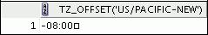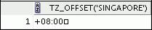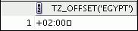

* 1. Alter the session to set the TIME_ZONE parameter value to the time zone offset of US/Pacific-New.
  2. Display the CURRENT_DATE, CURRENT_TIMESTAMP, and LOCALTIMESTAMP for this session.
  3. Alter the session to set the TIME_ZONE parameter value to the time zone offset of Singapore.
  4. Display the CURRENT_DATE, CURRENT_TIMESTAMP, and LOCALTIMESTAMP for this session.

**Note:** The output may be different based on the date when the command isexecuted.

**Note:** Observe in the preceding practice thatCURRENT_DATE,CURRENT_TIMESTAMP,and LOCALTIMESTAMP are all sensitive to the session time zone.

1. Write a query to display DBTIMEZONE and SESSIONTIMEZONE.

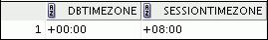

|  |
| --- |
| Oracle Internal & Oracle Academy Use Only |

**Oracle Database 10*g*: SQL Fundamentals II 5 - 36**

**Practice 5 (continued)**

1. Write a query to extract YEAR from the HIRE_DATE column of the EMPLOYEES table for those employees who work in department 80.

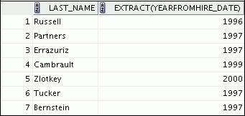

**…**

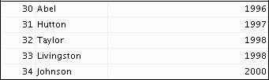

1. Alter the session to set NLS_DATE_FORMAT to DD-MON-YYYY.
2. Examine and run the lab_05_06.sql script to create the SAMPLE_DATES table and populate it.
   1. Select from the table and view the data.
   2. Change the data type of the DATE_COL column to TIMESTAMP. Select from the table to view the data.
   3. Try to change the data type of the DATE_COL column to TIMESTAMP WITH TIME ZONE. What happens?

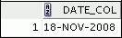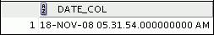

|  |
| --- |
| Oracle Internal & Oracle Academy Use Only |

**Oracle Database 10*g*: SQL Fundamentals II 5 - 37**

**Practice 5 (continued)**

1. Create a query to retrieve last names from the EMPLOYEES table and calculate the review status. If the year hired is 1998, display Needs Review for the review status; otherwise, display not this year! Name the review status column Review. Sort the results by the

HIRE_DATE column.

**Hint:** Use aCASEexpression with theEXTRACTfunction to calculate the review status.

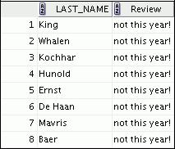

**…**

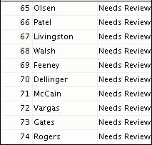

**…**

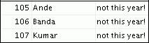

|  |
| --- |
| Oracle Internal & Oracle Academy Use Only |

**Oracle Database 10*g*: SQL Fundamentals II 5 - 38**

**Practice 5 (continued)**

1. Create a query to print the last names and number of years of service for each employee. If the employee has been employed for five or more years, print 5 years of service. If the employee has been employed for 10 or more years, print 10 years of service. If the employee has been employed for 15 or more years, print 15 years of service. If none of these conditions match, print maybe next year! Sort the results by the HIRE_DATE column. Use the EMPLOYEES table.

**Hint:** UseCASEexpressions andTO_YMINTERVAL.

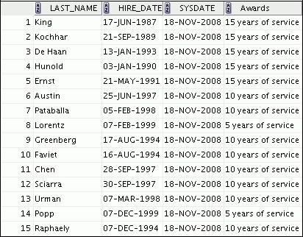

**…**

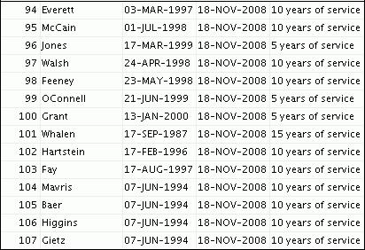

|  |
| --- |
| Oracle Internal & Oracle Academy Use Only |

**Oracle Database 10*g*: SQL Fundamentals II 5 - 39**

Oracle Internal & Oracle Academy Use Only



**Retrieving Data Using Subqueries**

Copyright © 2009, Oracle. All rights reserved.

|  |
| --- |
| Oracle Internal & Oracle Academy Use Only |

**Objectives**

After completing this lesson, you should be able to do the following:

1. Write a multiple-column subquery
2. Use scalar subqueries in SQL
3. Solve problems with correlated subqueries
4. Update and delete rows using correlated subqueries
5. Use the EXISTS and NOT EXISTS operators
6. Use the WITH clause

Copyright © 2009, Oracle. All rights reserved.

**Objectives**

In this lesson, you learn how to write multiple-column subqueries and subqueries in the FROM clause of a SELECT statement. You also learn how to solve problems by using scalar, correlated subqueries and the WITH clause.

|  |
| --- |
| Oracle Internal & Oracle Academy Use Only |

**Oracle Database 10*g*: SQL Fundamentals II 6 - 2**

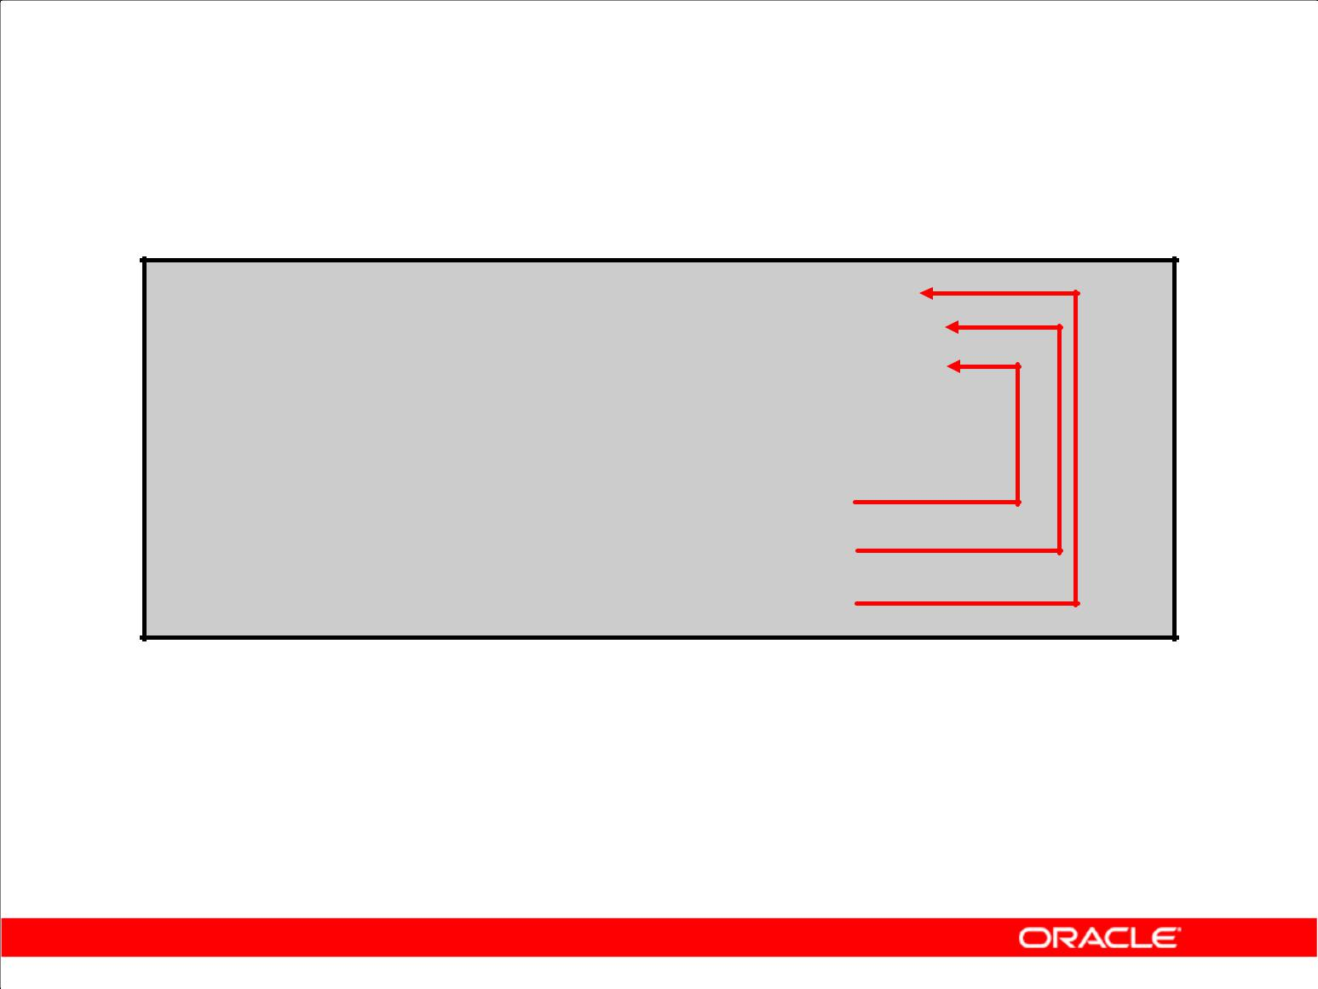**Multiple-Column Subqueries**

**Main query**

**WHERE (MANAGER_ID, DEPARTMENT_ID) IN**

**Subquery**

1. **90**
2. **60**
3. **50**

**Each row of the main query is compared to values from a multiple-row and multiple-column subquery.**

Copyright © 2009, Oracle. All rights reserved.

**Multiple-Column Subqueries**

So far, you have written single-row subqueries and multiple-row subqueries where only one column is returned by the inner SELECT statement and this is used to evaluate the expression in the parent SELECT statement. If you want to compare two or more columns, you must write a compound WHERE clause using logical operators. Using multiple-column subqueries, you can combine duplicate WHERE conditions into a single WHERE clause.

**Syntax**

SELECT *column, column*, ...

FROM *table*

WHERE (*column, column*, ...) IN

(SELECT *column, column*, ...

FROM *table*

WHERE *condition*);

The graphic in the slide illustrates that the values of MANAGER_ID and DEPARTMENT_ID from the main query are being compared with the MANAGER_ID and DEPARTMENT_ID values retrieved by the subquery. Because the number of columns that are being compared is more than one, the example qualifies as a multiple-column subquery.

|  |
| --- |
| Oracle Internal & Oracle Academy Use Only |

**Oracle Database 10*g*: SQL Fundamentals II 6 - 3**

**Column Comparisons**

Multiple-column comparisons involving subqueries can be:

1. Nonpairwise comparisons
2. Pairwise comparisons

Copyright © 2009, Oracle. All rights reserved.

**Pairwise Versus Nonpairwise Comparisons**

Multiple-column comparisons involving subqueries can be nonpairwise comparisons or pairwise comparisons. If you consider the example “Display the details of the employees who work in the same department, and have the same manager, as ‘Daniel’?”, you get the correct result with the following statement:

SELECT first_name, last_name, manager_id, department_id FROM employees

WHERE manager_id IN (SELECT manager_id FROM employees

WHERE first_name = ‘Daniel’)

AND department_id IN (SELECT department_id FROM employees

WHERE first_name = ‘Daniel’);

There is only one “Daniel” in the EMPLOYEES table (Daniel Faviet, who is managed by employee 108 and works in department 100). However, if the subqueries return more than one row, the result might not be correct. For example, if you run the same query but substitute “John” for “Daniel,” you get an incorrect result. This is because the combination of department_id and manger_id is important. To get the correct result for this query, you need a pairwise comparison.

|  |
| --- |
| Oracle Internal & Oracle Academy Use Only |

**Oracle Database 10*g*: SQL Fundamentals II 6 - 4**

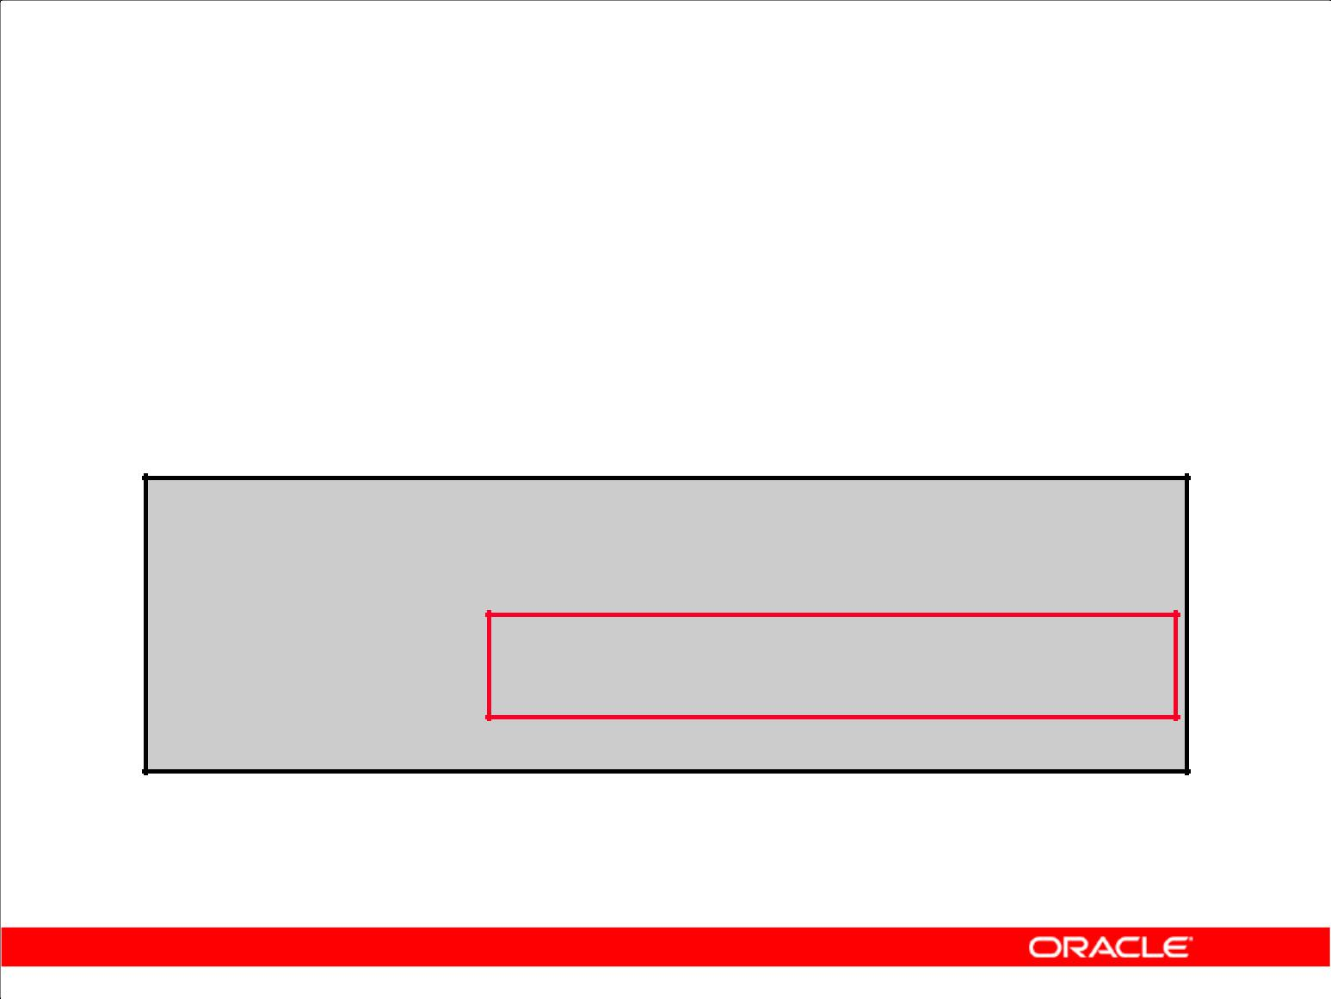**Pairwise Comparison Subquery**

Display the details of the employees who are managed by the same manager and work in the same department as employees with the first name of “John.”

**SELECT employee_id, manager_id, department_id**

**FROM** **employees**

**WHERE (manager_id, department_id) IN**

**(SELECT manager_id, department_id**

**FROM employees**

**WHERE first_name = 'John')**

**AND first_name <> 'John';**

Copyright © 2009, Oracle. All rights reserved.

**Pairwise Comparison Subquery**

The example in the slide compares the combination of values in the MANAGER_ID column and the

DEPARTMENT_ID column of each row in the EMPLOYEES table with the values in the

MANAGER_ID column and the DEPARTMENT_ID column for the employees with the

FIRST_NAME of “John.” First, the subquery to retrieve the MANAGER_ID and DEPARTMENT_ID

values for the employees with the FIRST_NAME of “John” is executed. This subquery returns the

following:

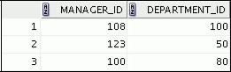

These values are compared with the MANAGER_ID column and the DEPARTMENT_ID column of each row in the EMPLOYEES table. If the combination matches, the row is displayed. In the output, the records of the employees with the FIRST_NAME of “John” will not be displayed. The following is the output of the query in the slide:

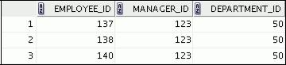

|  |
| --- |
| Oracle Internal & Oracle Academy Use Only |

**…**

**Oracle Database 10*g*: SQL Fundamentals II 6 - 5**

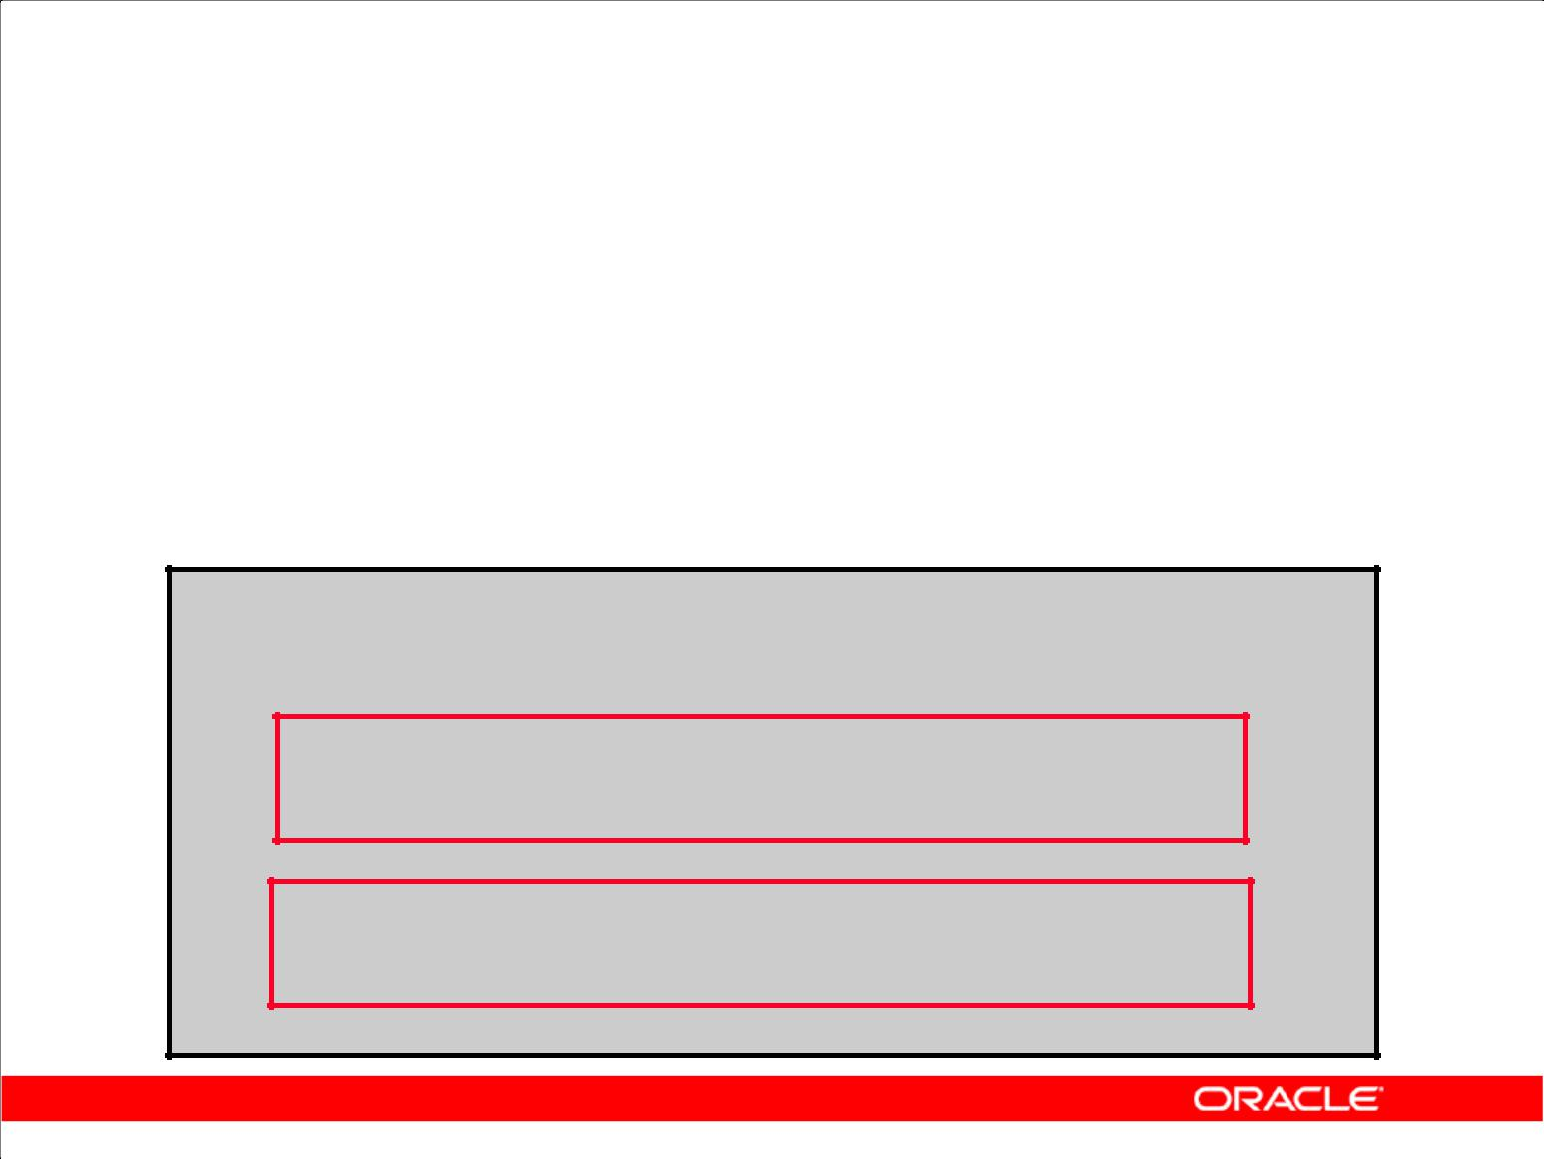**Nonpairwise Comparison Subquery**

Display the details of the employees who are managed by the same manager as the employees with the first name of “John” and work in the same department as the employees with the first name of “John.”

**SELECT employee_id, manager_id, department_id**

**FROM** **employees**

**WHERE manager_id IN**

**(SELECT manager_id**

**FROM employees**

**WHERE first_name = 'John')**

**AND department_id IN**

**(SELECT department_id**

**FROM employees**

**WHERE first_name = 'John')**

**AND first_name <> 'John';**

Copyright © 2009, Oracle. All rights reserved.

**Nonpairwise Comparison Subquery**

The example shows a nonpairwise comparison of the columns. First, the subquery to retrieve the MANAGER_ID values for the employees with the FIRST_NAME of “John” is executed. Similarly, the second subquery to retrieve the DEPARTMENT_ID values for the employees with the FIRST_NAME of “John” is executed. The retrieved values of the MANAGER_ID and DEPARTMENT_ID columns are compared with the MANAGER_ID and DEPARTMENT_ID columns for each row in the EMPLOYEES table. If the MANAGER_ID column of the row in the EMPLOYEES table matches with any of the values of MANAGER_ID retrieved by the inner subquery and if the DEPARTMENT_ID column of the row in the EMPLOYEES table matches with any of the values of DEPARTMENT_ID retrieved by the second subquery, the record is displayed. The following is the output of the query in the slide:

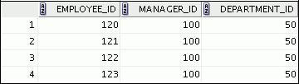

|  |
| --- |
| Oracle Internal & Oracle Academy Use Only |

**…**

This query retrieves five rows more than the pairwise comparison (those with the combination of manager_id=100 and department_id=50, although no employee named “John” has such a combination).

**Oracle Database 10*g*: SQL Fundamentals II 6 - 6**

**Scalar Subquery Expressions**

1. A scalar subquery expression is a subquery that returns exactly one column value from one row.
2. Scalar subqueries can be used in:

– Condition and expression part of DECODE and CASE

– All clauses of SELECT except GROUP BY

Copyright © 2009, Oracle. All rights reserved.

**Scalar Subqueries in SQL**

A subquery that returns exactly one column value from one row is also referred to as a scalar subquery. Multiple-column subqueries that are written to compare two or more columns, using a compound WHERE clause and logical operators, do not qualify as scalar subqueries.

The value of the scalar subquery expression is the value of the select list item of the subquery. If the subquery returns 0 rows, the value of the scalar subquery expression is NULL. If the subquery returns

more than one row, the Oracle server returns an error. The Oracle server has always supported the usage of a scalar subquery in a SELECT statement. You can use scalar subqueries in:

1. The condition and expression part of DECODE and CASE
2. All clauses of SELECT except GROUP BY
3. The SET clause and WHERE clause of an UPDATE statement

However, scalar subqueries are not valid expressions in the following places:

1. As default values for columns and hash expressions for clusters
2. In the RETURNING clause of data manipulation language (DML) statements
3. As the basis of a function-based index
4. In GROUP BY clauses, CHECK constraints, WHEN conditions
5. In CONNECT BY clauses
6. In statements that are unrelated to queries, such as CREATE PROFILE

|  |
| --- |
| Oracle Internal & Oracle Academy Use Only |

**Oracle Database 10*g*: SQL Fundamentals II 6 - 7**

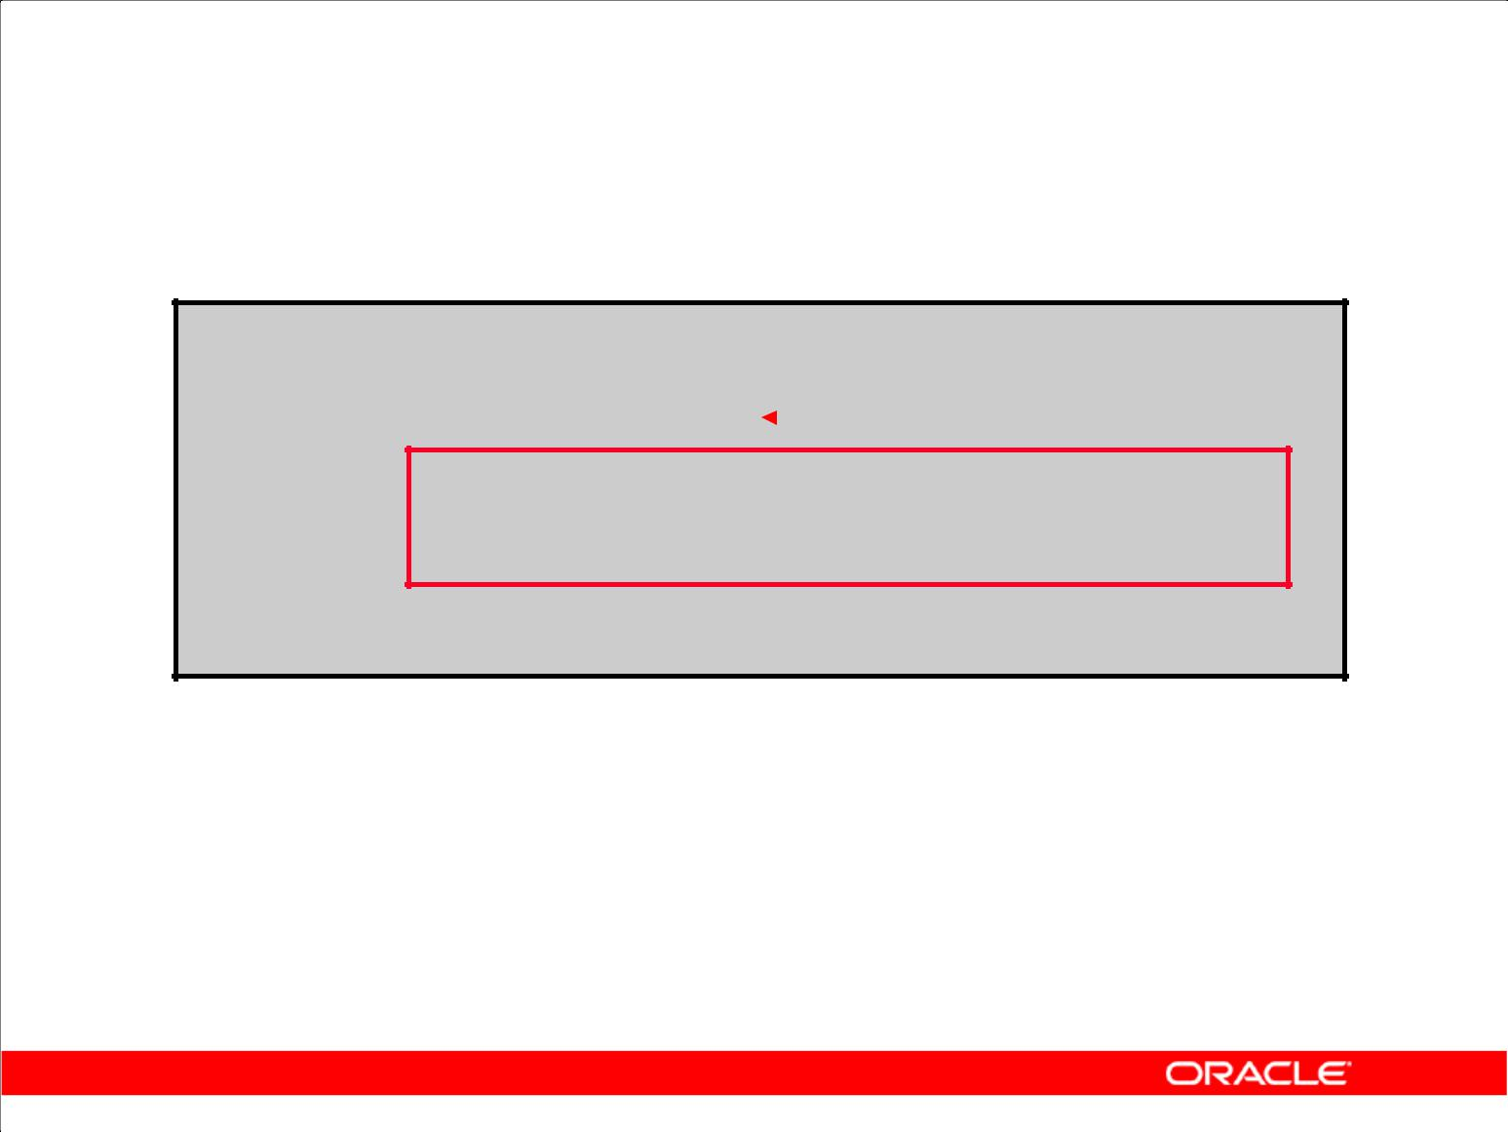**Scalar Subqueries: Examples**

1. Scalar subqueries in CASE expressions:

**SELECT employee_id, last_name,**

**(CASE**

**20**

**WHEN department_id = **

**(SELECT department _id**

**FROM departments**

**WHERE location_id = 1800)**

**THEN 'Canada' ELSE 'USA' END) location**

**FROM** **employees;**

1. Scalar subqueries in the ORDER BY clause:

|  |  |  |
| --- | --- | --- |
| **SELECT** | **employee_id, last_name** | |
| **FROM** | **employees e** | |
| **ORDER BY** | **(SELECT department_name** |  |
|  | **FROM departments d** |  |
|  | **WHERE e.department_id = d.department_id);** |  |
|  |  |  |
|  |  |  |

Copyright © 2009, Oracle. All rights reserved.

**Scalar Subqueries: Examples**

The first example in the slide demonstrates that scalar subqueries can be used in CASE expressions.

The inner query returns the value 20, which is the department ID of the department whose location ID is 1800. The CASE expression in the outer query uses the result of the inner query to display the

employee ID, last names, and a value of Canada or USA, depending on whether the department ID of the record retrieved by the outer query is 20 or not.

The following is the result of the first example in the slide:

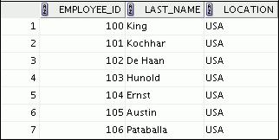

|  |
| --- |
| Oracle Internal & Oracle Academy Use Only |

**…**



**Oracle Database 10*g*: SQL Fundamentals II 6 - 8**

**Scalar Subqueries: Examples (continued)**

The second example in the slide demonstrates that scalar subqueries can be used in the ORDER BY clause. The example orders the output based on the DEPARTMENT_NAME by matching the DEPARTMENT_ID from the EMPLOYEES table with the DEPARTMENT_ID from the DEPARTMENTS table. This comparison is done in a scalar subquery in the ORDER BY clause. The following is the result of the second example:

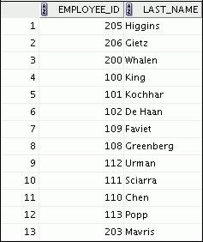

**…**

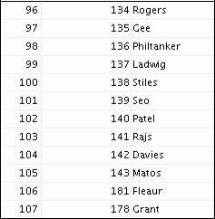

|  |
| --- |
| Oracle Internal & Oracle Academy Use Only |

The second example uses a correlated subquery. In a correlated subquery, the subquery references a column from a table referred to in the parent statement. Correlated subqueries are explained later in this lesson.

**Oracle Database 10*g*: SQL Fundamentals II 6 - 9**

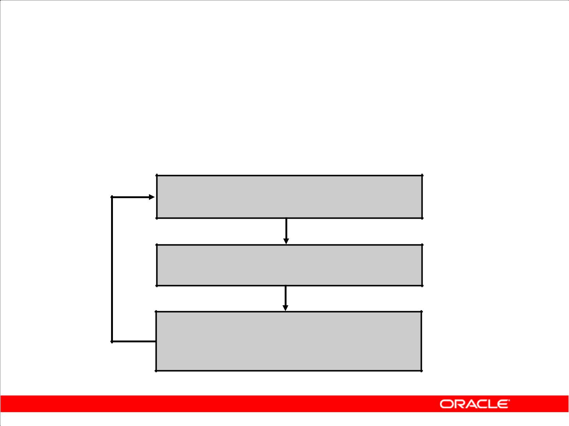**Correlated Subqueries**

Correlated subqueries are used for row-by -row processing. Each subquery is executed once for every row of the outer query.

**GET**

**candidate row from outer query**

**EXECUTE**

**inner query using candidate row value**

**USE**

**values from inner query to qualify or**

**disqualify candidate row**

Copyright © 2009, Oracle. All rights reserved.

**Correlated Subqueries**

The Oracle server performs a correlated subquery when the subquery references a column from a table referred to in the parent statement. A correlated subquery is evaluated once for each row processed by the parent statement. The parent statement can be a SELECT, UPDATE, or DELETE statement.

**Nested Subqueries Versus Correlated Subqueries**

With a normal nested subquery, the inner SELECT query runs first and executes once, returning values to be used by the main query. A correlated subquery, however, executes once for each candidate row considered by the outer query. That is, the inner query is driven by the outer query.

**Nested Subquery Execution**

1. The inner query executes first and finds a value.
2. The outer query executes once, using the value from the inner query.

**Correlated Subquery Execution**

1. Get a candidate row (fetched by the outer query).
2. Execute the inner query using the value of the candidate row.
3. Use the values resulting from the inner query to qualify or disqualify the candidate.
4. Repeat until no candidate row remains.

|  |
| --- |
| Oracle Internal & Oracle Academy Use Only |

**Oracle Database 10*g*: SQL Fundamentals II 6 - 10**

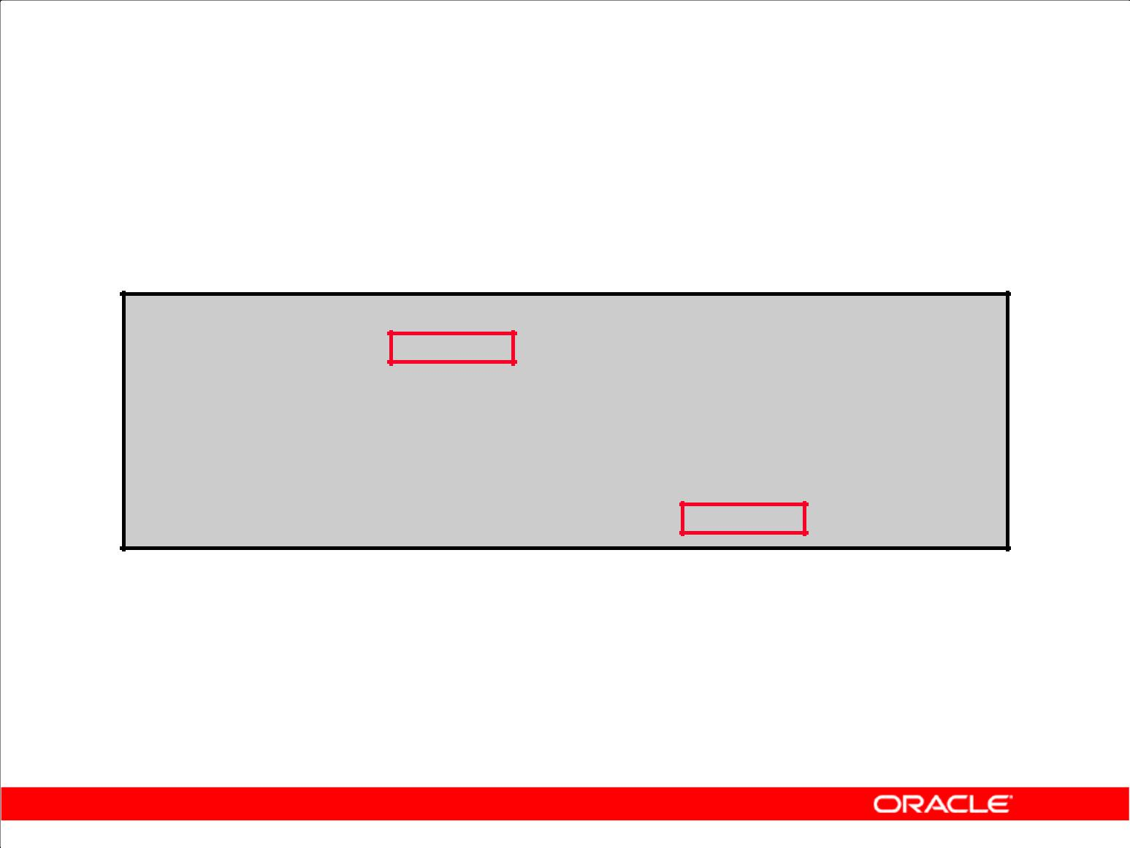**Correlated Subqueries**

The subquery references a column from a table in the parent query.

**SELECT *column1*, *column2*, ...**

**FROM** ***table1*** ***outer***

**WHERE** ***column1* operator**

**(SELECT** ***column1, column2***

**FROM** ***table2***

**WHERE** ***expr1* =**

***outer.expr2*);**

Copyright © 2009, Oracle. All rights reserved.

**Correlated Subqueries (continued)**

A correlated subquery is one way of reading every row in a table and comparing values in each row against related data. It is used whenever a subquery must return a different result or set of results for each candidate row considered by the main query. That is, you use a correlated subquery to answer a multipart question whose answer depends on the value in each row processed by the parent statement.

The Oracle server performs a correlated subquery when the subquery references a column from a table in the parent query.

**Note:** You can use theANYandALLoperators in a correlated subquery.

|  |
| --- |
| Oracle Internal & Oracle Academy Use Only |

**Oracle Database 10*g*: SQL Fundamentals II 6 - 11**

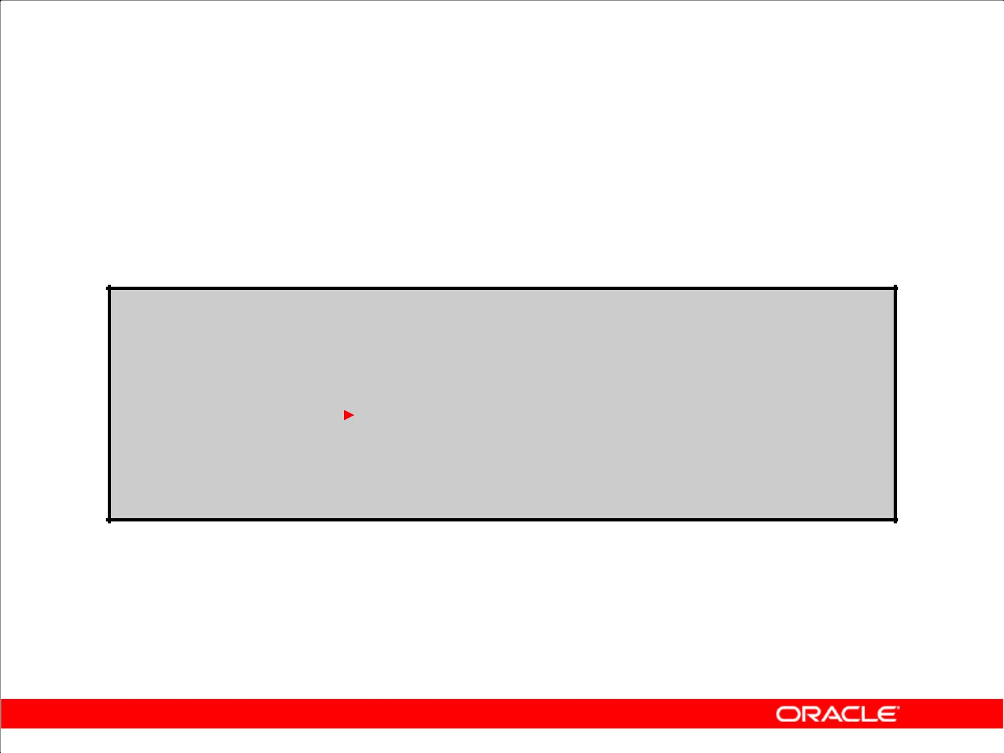**Using Correlated Subqueries**

Find all employees who earn more than the average salary in their department.

**SELECT last_name, salary, department_id**

|  |  |  |  |  |  |
| --- | --- | --- | --- | --- | --- |
| **FROM** | **employees outer** | | | |  |
| **WHERE** | **salary >** | | |  |  |
| **(SELECT AVG(salary)** | |
|  |  |  |  |
|  |  |  |
|  |  |  |  | **FROM** | **employees** |
|  |  |  |
|  |  |  |  | **WHERE** | **department_id =** |
|  |  |  |  | **outer.department_id);** | |
|  |  |  |  |  |  |

**Each time a row from**

**the outer query**

**is processed, the**

**inner query is**

**evaluated.**

Copyright © 2009, Oracle. All rights reserved.

**Using Correlated Subqueries**

The example in the slide determines which employees earn more than the average salary of their department. In this case, the correlated subquery specifically computes the average salary for each department.

Because both the outer query and inner query use the EMPLOYEES table in the FROM clause, an alias is given to EMPLOYEES in the outer SELECT statement for clarity. The alias makes the entire SELECT statement more readable. Without the alias, the query would not work properly because the inner statement would not be able to distinguish the inner table column from the outer table column.

|  |
| --- |
| Oracle Internal & Oracle Academy Use Only |

**Oracle Database 10*g*: SQL Fundamentals II 6 - 12**

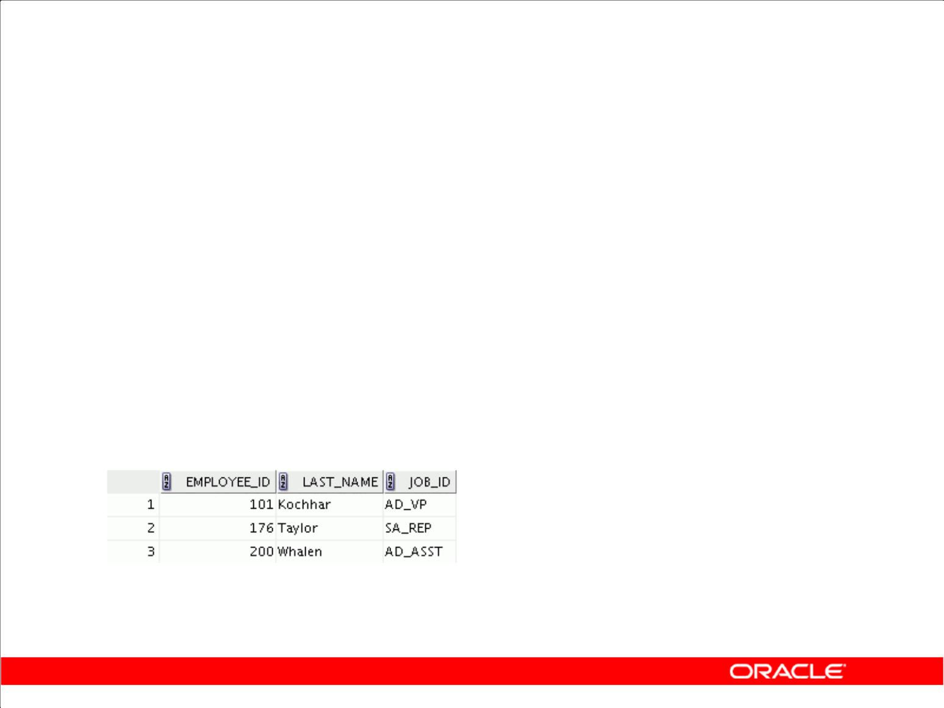**Using Correlated Subqueries**

Display details of those employees who have changed jobs at least twice.

|  |  |  |  |  |
| --- | --- | --- | --- | --- |
|  | **SELECT** | **e.employee_id, last_name,e.job_id** | | |
|  | **FROM** | **employees e** |  |  |
|  | **WHERE** | **2 <= (SELECT COUNT(*)** | | |
|  |  | **FROM** | **job_history** | |
|  |  | **WHERE** | **employee_id = e.employee_id);** | |
|  |  |  |  |  |
|  |  |  |  |  |
|  |  |  |  |  |

Copyright © 2009, Oracle. All rights reserved.

**Using Correlated Subqueries (continued)**

The example in the slide displays the details of those employees who have changed jobs at least twice. The Oracle server evaluates a correlated subquery as follows:

1. Select a row from the table specified in the outer query. This will be the current candidate row.
2. Store the value of the column referenced in the subquery from this candidate row. (In the example in the slide, the column referenced in the subquery is E.EMPLOYEE_ID.)
3. Perform the subquery with its condition referencing the value from the outer query’s candidate row. (In the example in the slide, the COUNT(*) group function is evaluated based on the value of the E.EMPLOYEE_ID column obtained in step 2.)
4. Evaluate the WHERE clause of the outer query on the basis of results of the subquery performed in step 3. This determines whether the candidate row is selected for output. (In the example, the number of times an employee has changed jobs, evaluated by the subquery, is compared with 2 in the WHERE clause of the outer query. If the condition is satisfied, that employee record is displayed.)
5. Repeat the procedure for the next candidate row of the table, and so on until all the rows in the table have been processed.

The correlation is established by using an element from the outer query in the subquery. In this example, you compare EMPLOYEE_ID from the table in the subquery with the EMPLOYEE_ID

from the table in the outer query.

|  |
| --- |
| Oracle Internal & Oracle Academy Use Only |

**Oracle Database 10*g*: SQL Fundamentals II 6 - 13**

**Using the EXISTS Operator**

1. The EXISTS operator tests for existence of rows in the results set of the subquery.
2. If a subquery row value is found:

– The search does not continue in the inner query

– The condition is flagged TRUE

1. If a subquery row value is not found:

– The condition is flagged FALSE

– The search continues in the inner query

Copyright © 2009, Oracle. All rights reserved.

**EXISTS Operator**

With nesting SELECT statements, all logical operators are valid. In addition, you can use the EXISTS operator. This operator is frequently used with correlated subqueries to test whether a value

retrieved by the outer query exists in the results set of the values retrieved by the inner query. If the subquery returns at least one row, the operator returns TRUE. If the value does not exist, it returns FALSE. Accordingly, NOT EXISTS tests whether a value retrieved by the outer query is not a part of the results set of the values retrieved by the inner query.

|  |
| --- |
| Oracle Internal & Oracle Academy Use Only |

**Oracle Database 10*g*: SQL Fundamentals II 6 - 14**

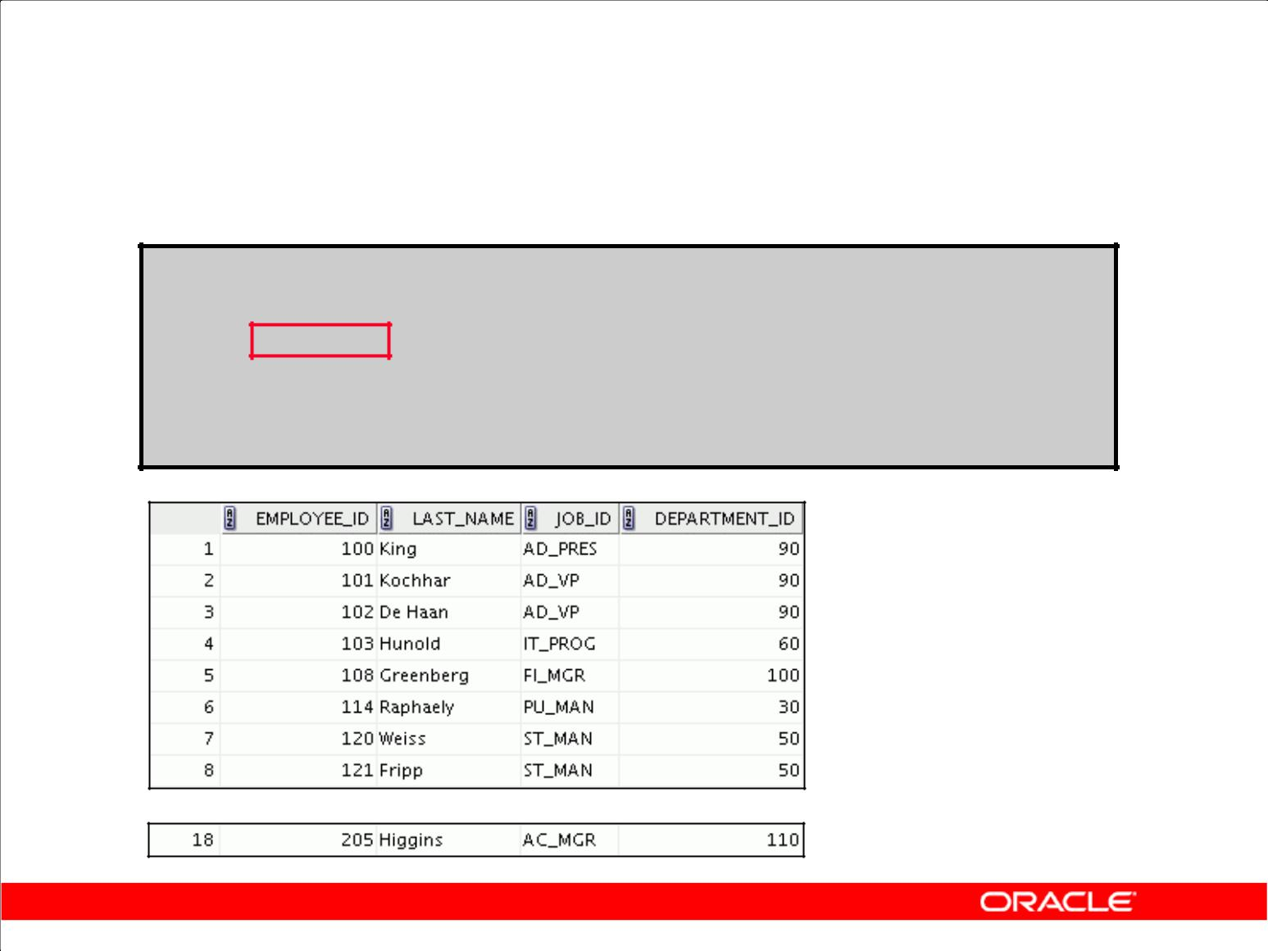**Find Employees Who Have At Least One Person Reporting to Them**

**SELECT employee_id, last_name, job_id, department_id**

**FROM** **employees outer**

**WHERE EXISTS ( SELECT 'X'**

**FROM** **employees**

**WHERE manager_id =**

**outer.employee_id);**

**…**

Copyright © 2009, Oracle. All rights reserved.

**Using the EXISTS Operator**

The EXISTS operator ensures that the search in the inner query does not continue when at least one match is found for the manager and employee number by the condition:

WHERE manager_id = outer.employee_id.

Note that the inner SELECT query does not need to return a specific value, so a constant can be selected.

|  |
| --- |
| Oracle Internal & Oracle Academy Use Only |

**Oracle Database 10*g*: SQL Fundamentals II 6 - 15**

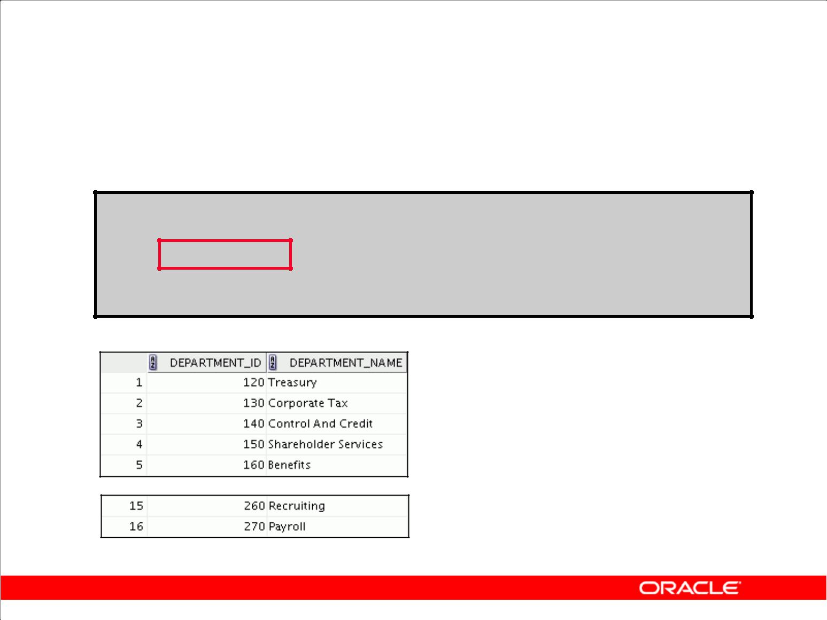**Find All Departments That Do Not Have Any**

**Employees**

**SELECT department_id, department_name**

**FROM departments d**

**WHERE NOT EXISTS (SELECT 'X'**

**FROM** **employees**

**WHERE department_id = d.department_id);**

**…**

Copyright © 2009, Oracle. All rights reserved.

**Using the NOT EXISTS Operator**

**Alternative Solution**

A NOT IN construct can be used as an alternative for a NOT EXISTS operator, as shown in the following example:

|  |  |  |
| --- | --- | --- |
| SELECT | department_id, department_name | |
| FROM | departments |  |
| WHERE | department_id NOT IN (SELECT | department_id |
|  | FROM | employees); |
| 0 rows | selected. |  |

However, NOT IN evaluates to FALSE if any member of the set is a NULL value. Therefore, your query will not return any rows even if there are rows in the departments table that satisfy the WHERE condition.

|  |
| --- |
| Oracle Internal & Oracle Academy Use Only |

**Oracle Database 10*g*: SQL Fundamentals II 6 - 16**

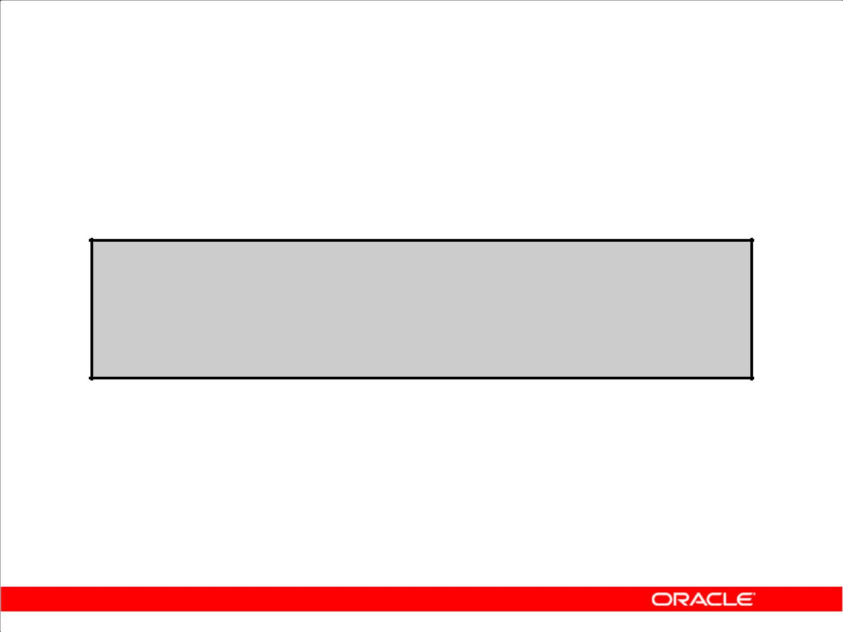**Correlated UPDATE**

Use a correlated subquery to update rows in one table based on rows from another table.

**UPDATE *table1 alias1***

**SET** **column = (SELECT *expression***

**FROM** ***table2 alias2***

**WHERE** ***alias1.column =***

***alias2.column*);**

Copyright © 2009, Oracle. All rights reserved.

**Correlated UPDATE**

In the case of the UPDATE statement, you can use a correlated subquery to update rows in one table based on rows from another table.

|  |
| --- |
| Oracle Internal & Oracle Academy Use Only |

**Oracle Database 10*g*: SQL Fundamentals II 6 - 17**

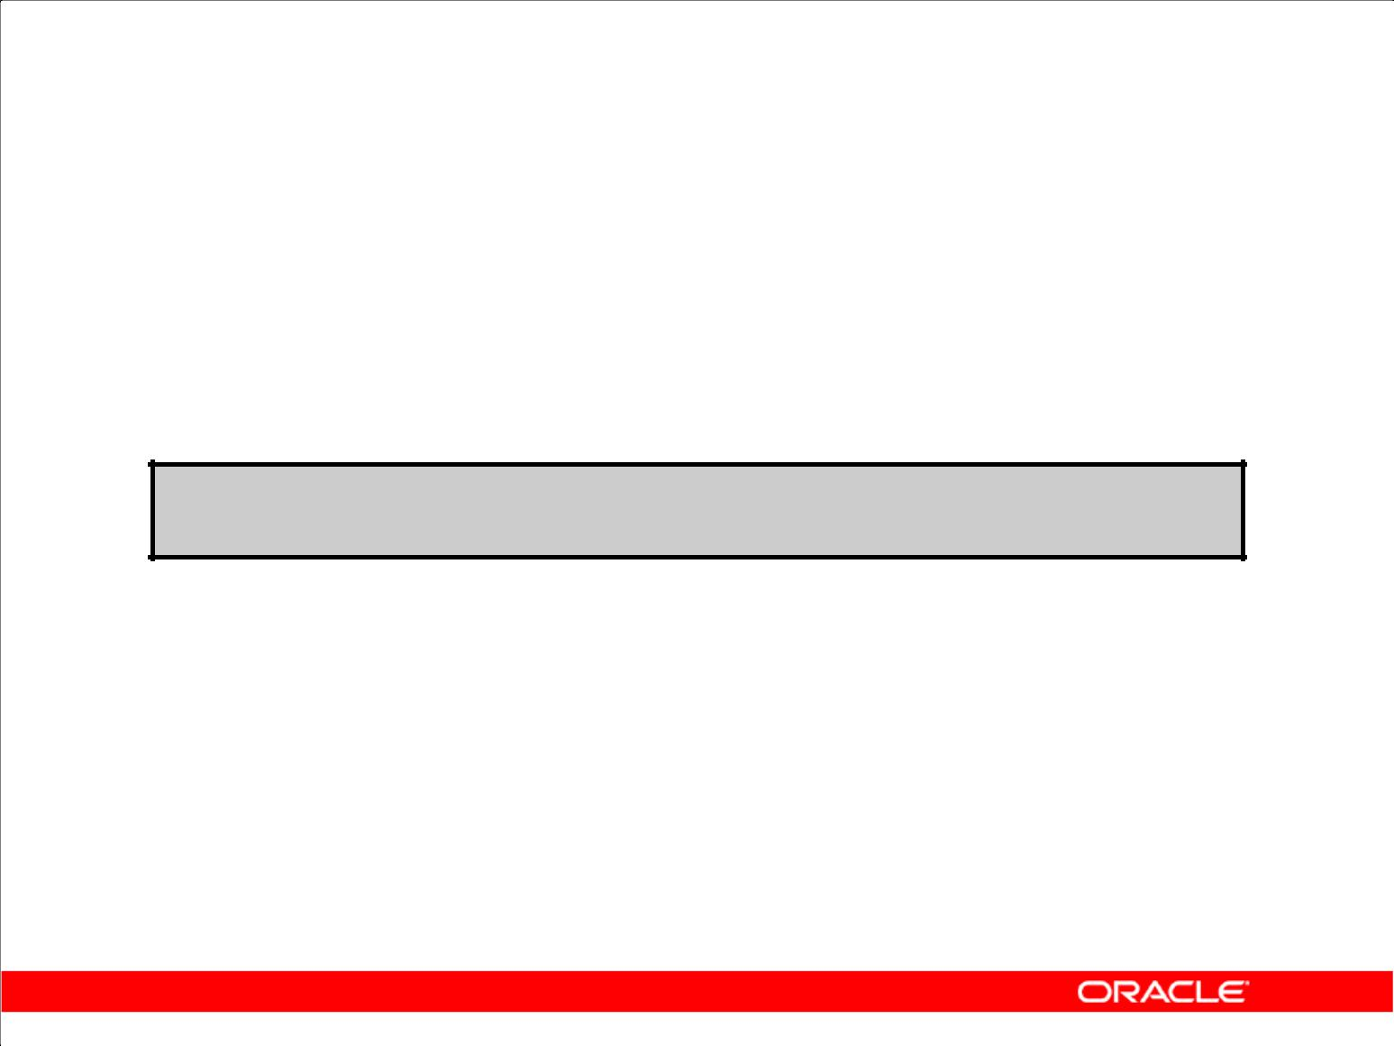**Using Correlated UPDATE**

1. Denormalize the EMPL6 table by adding a column to store the department name.
2. Populate the table by using a correlated update.

**ALTER TABLE empl6**

**ADD(department_name VARCHAR2(25));**

|  |  |  |
| --- | --- | --- |
| **UPDATE** | **empl6 e** |  |
| **SET** | **department_name =** | |
|  | **(SELECT department_name** | |
|  | **FROM** | **departments d** |
|  | **WHERE** | **e.department_id = d.department_id);** |
|  |  |  |

Copyright © 2009, Oracle. All rights reserved.

**Correlated UPDATE (continued)**

The example in the slide denormalizes the EMPL6 table by adding a column to store the department name and then populates the table by using a correlated update.

Following is another example for a correlated update.

**Problem Statement**

The REWARDS table has a list of employees who have exceeded expectations in their performance. Use a correlated subquery to update rows in the EMPL6 table based on rows from the REWARDS table:

UPDATE empl6

SET salary = (SELECT empl6.salary + rewards.pay_raise

FROM rewards

WHERE employee_id =

empl6.employee_id

AND payraise_date =

(SELECT MAX(payraise_date)

FROM rewards

WHERE employee_id = empl6.employee_id))

WHERE empl6.employee_id

IN (SELECT employee_id FROM rewards);

|  |
| --- |
| Oracle Internal & Oracle Academy Use Only |

**Oracle Database 10*g*: SQL Fundamentals II 6 - 18**

**Correlated UPDATE (continued)**

This example uses the REWARDS table. The REWARDS table has the columns EMPLOYEE_ID, PAY_RAISE, and PAYRAISE_DATE. Every time an employee gets a pay raise, a record with the

details of the employee ID, the amount of the pay raise, and the date of receipt of the pay raise is inserted into the REWARDS table. The REWARDS table can contain more than one record for an employee. The PAYRAISE _DATE column is used to identify the most recent pay raise received by an employee.

In the example, the SALARY column in the EMPL6 table is updated to reflect the latest pay raise

received by the employee. This is done by adding the current salary of the employee with the corresponding pay raise from the REWARDS table.

|  |
| --- |
| Oracle Internal & Oracle Academy Use Only |

**Oracle Database 10*g*: SQL Fundamentals II 6 - 19**

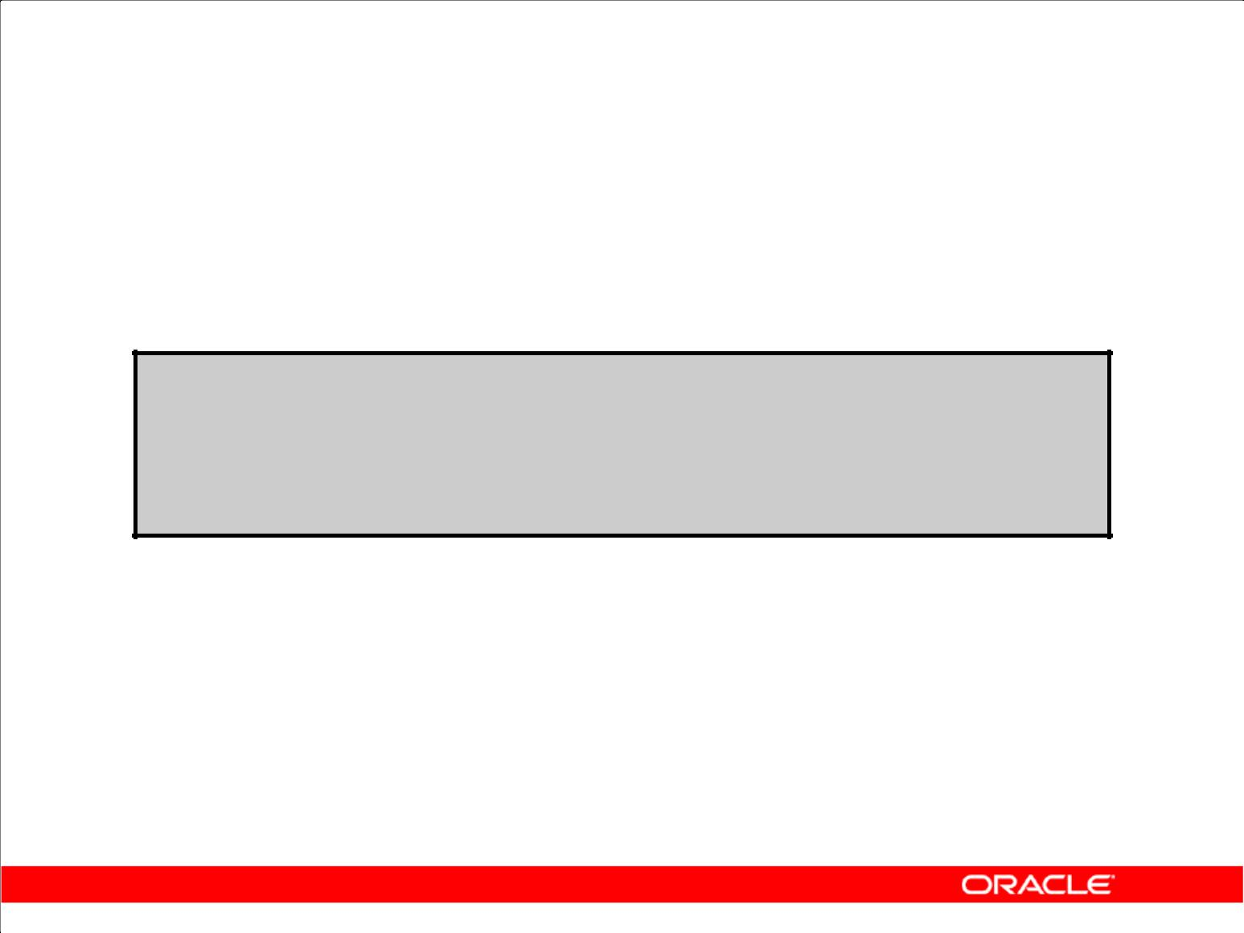**Correlated DELETE**

Use a correlated subquery to delete rows in one table based on rows from another table.

**DELETE FROM *table1 alias1***

**WHERE** ***column operator***

**(SELECT *expression***

**FROM** ***table2 alias2***

**WHERE** ***alias1.column = alias2.column);***

Copyright © 2009, Oracle. All rights reserved.

**Correlated DELETE**

In the case of a DELETE statement, you can use a correlated subquery to delete only those rows that

also exist in another table. If you decide that you will maintain only the last four job history records in the JOB_HISTORY table, then when an employee transfers to a fifth job, you delete the oldest

JOB_HISTORY row by looking up the JOB_HISTORY table for the MIN(START_DATE)for the

employee. The following code illustrates how the preceding operation can be performed using a correlated DELETE:

DELETE FROM emp_history JH

WHERE employee_id =

(SELECT employee_id

FROM employees E

WHERE JH.employee_id = E.employee_id

AND START_DATE =

(SELECT MIN(start_date)

FROM job_history JH

WHERE JH.employee_id = E.employee_id)

AND 5 > (SELECT COUNT(*)

FROM job_history JH

WHERE JH.employee_id = E.employee_id

GROUP BY EMPLOYEE_ID

HAVING COUNT(*) >= 4));

**Oracle Database 10*g*: SQL Fundamentals II 6 - 20**

|  |
| --- |
| Oracle Internal & Oracle Academy Use Only |

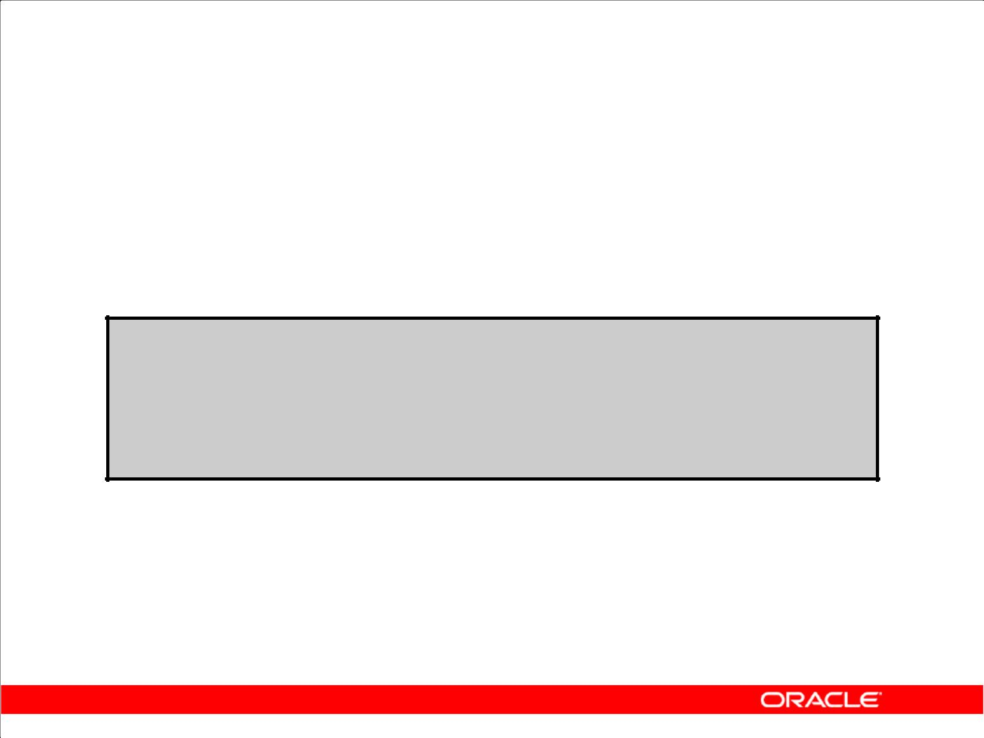**Using Correlated DELETE**

Use a correlated subquery to delete only those rows from the EMPL6 table that also exist in the EMP_HISTORY table.

**DELETE FROM empl6 E**

**WHERE employee_id =**

**(SELECT employee_id**

**FROM emp_history**

**WHERE** **employee_id = E.employee_id);**

Copyright © 2009, Oracle. All rights reserved.

**Correlated DELETE (continued)**

**Example**

Two tables are used in this example. They are:

1. The EMPL6 table, which provides details of all the current employees
2. The EMP_HISTORY table, which provides details of previous employees

EMP_HISTORY contains data regarding previous employees, so it would be erroneous if the same employee’s record existed in both the EMPL6 and EMP_HISTORY tables. You can delete such erroneous records by using the correlated subquery shown in the slide.

|  |
| --- |
| Oracle Internal & Oracle Academy Use Only |

**Oracle Database 10*g*: SQL Fundamentals II 6 - 21**

**WITH Clause**

1. Using the WITH clause, you can use the same query block in a SELECT statement when it occurs more than once within a complex query.
2. The WITH clause retrieves the results of a query block and stores it in the user’s temporary tablespace.
3. The WITH clause improves performance.

Copyright © 2009, Oracle. All rights reserved.

**WITH Clause**

Using the WITH clause, you can define a query block before using it in a query. The WITH clause (formally known as subquery_factoring_clause) enables you to reuse the same query block in a SELECT statement when it occurs more than once within a complex query. This is particularly useful when a query has many references to the same query block and there are joins and aggregations.

Using the WITH clause, you can reuse the same query when it is costly to evaluate the query block and it occurs more than once within a complex query. Using the WITH clause, the Oracle server retrieves the results of a query block and stores it in the user’s temporary tablespace. This can improve performance.

**WITH Clause Benefits**

1. Makes the query easy to read
2. Evaluates a clause only once, even if it appears multiple times in the query
3. In most cases, may improve performance for large queries

|  |
| --- |
| Oracle Internal & Oracle Academy Use Only |

**Oracle Database 10*g*: SQL Fundamentals II 6 - 22**

**WITH Clause: Example**

Using the WITH clause, write a query to display the department name and total salaries for those departments whose total salary is greater than the average salary across departments.

Copyright © 2009, Oracle. All rights reserved.

**WITH Clause: Example**

The problem in the slide would require the following intermediate calculations:

1. Calculate the total salary for every department, and store the result using a WITH clause.
2. Calculate the average salary across departments, and store the result using a WITH clause.
3. Compare the total salary calculated in the first step with the average salary calculated in the second step. If the total salary for a particular department is greater than the average salary across departments, then display the department name and the total salary for that department.

The solution for this problem is provided on the next page.

|  |
| --- |
| Oracle Internal & Oracle Academy Use Only |

**Oracle Database 10*g*: SQL Fundamentals II 6 - 23**

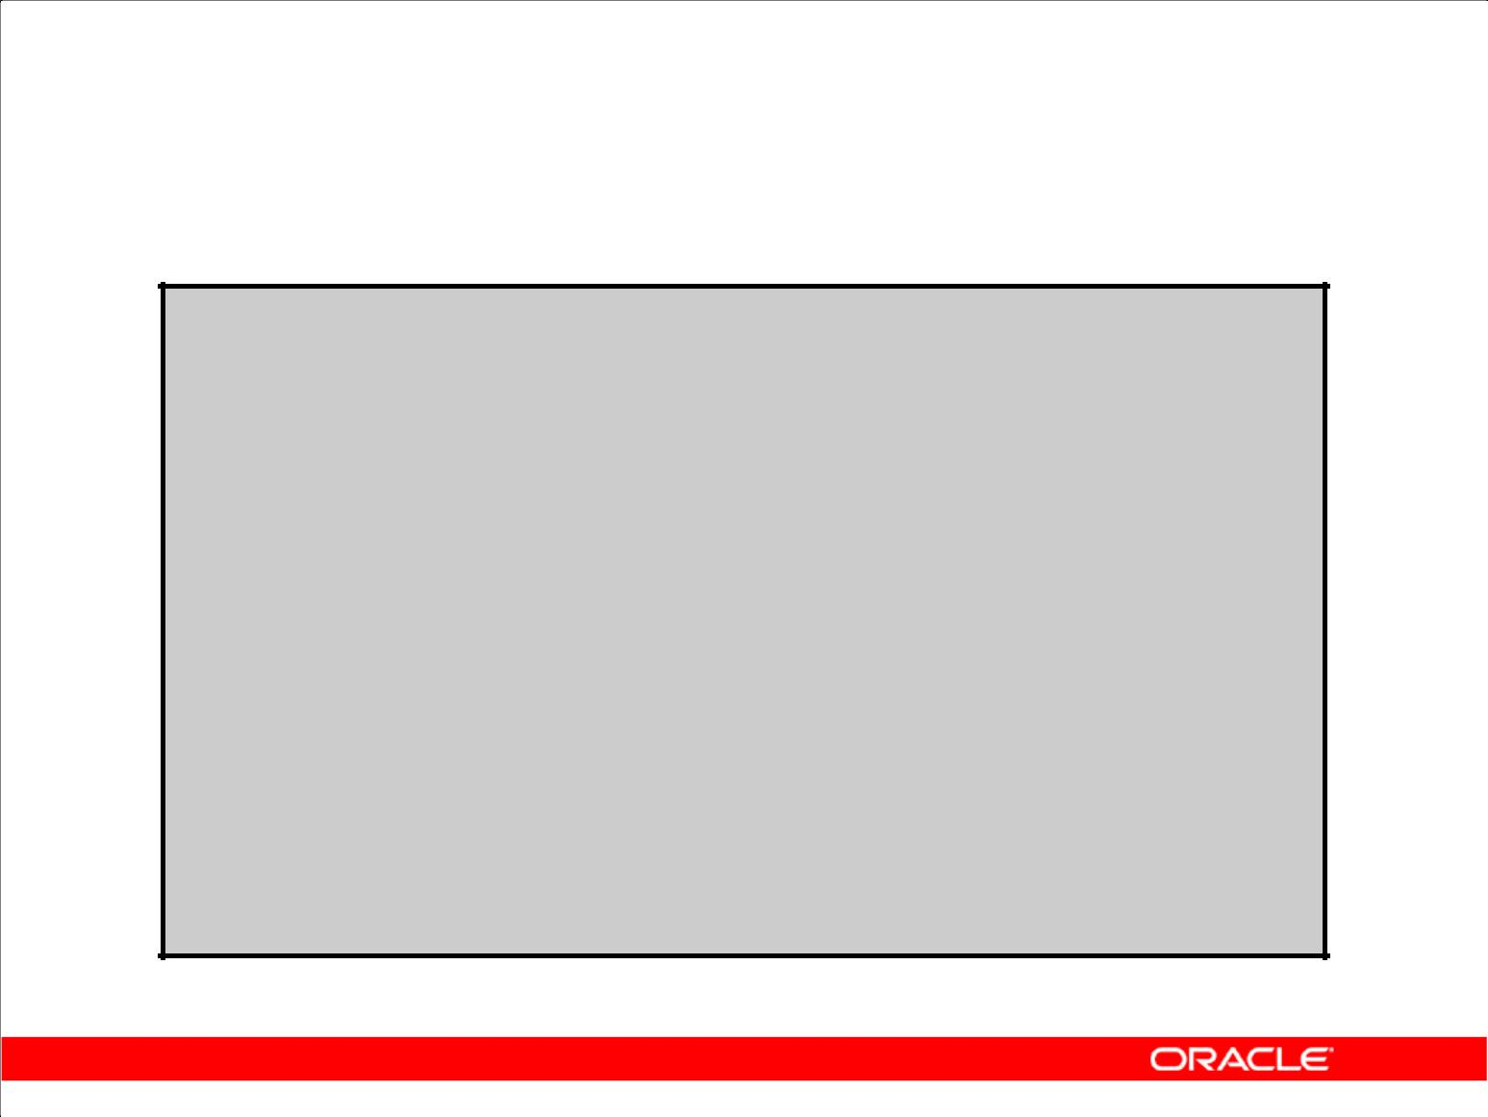**WITH Clause: Example**

|  |  |  |  |  |  |  |  |  |  |
| --- | --- | --- | --- | --- | --- | --- | --- | --- | --- |
|  | **WITH** |  |  |  |  |  |  |  |  |
|  | **dept_costs** | | | | **AS (** | | | | |
|  | **SELECT** | | | | **d.department_name, SUM(e.salary) AS dept_total** | | | | |
|  | **FROM** | | |  | **employees e JOIN departments d** | | | | |
|  | **ON** | | |  | **e.department_id = d.department_id** | | | | |
|  | **GROUP BY d.department_name),** | | | | | | | | |
|  | **avg_cost** | | | | **AS (** | | | | |
|  | **SELECT** | | | | **SUM(dept_total)/COUNT(*) AS dept_avg** | | | | |
|  | **FROM** | | |  | **dept_costs)** | | |  |  |
|  | **SELECT** | | | **\*** |  |  |  |  |  |
|  | **FROM** | |  | **dept_costs** | | |  | |  |
|  | **WHERE** | | | **dept_total >** | | | | | |
|  |  |  |  | **(SELECT dept_avg** | | | | | |
|  |  |  |  | **FROM** | | **avg_cost)** | | |  |

**ORDER BY department_name;**

Copyright © 2009, Oracle. All rights reserved.

**WITH Clause: Example (continued)**

The SQL code in the slide is an example of a situation in which you can improve performance and write SQL more simply by using the WITH clause. The query creates the query names DEPT_COSTS and AVG_COST and then uses them in the body of the main query. Internally, the WITH clause is

resolved either as an in-line view or a temporary table. The optimizer chooses the appropriate resolution depending on the cost or benefit of temporarily storing the results of the WITH clause.

The output generated by the SQL code in the slide is as follows:

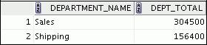

**WITH Clause Usage Notes**

1. It is used only with SELECT statements.
2. A query name is visible to all WITH element query blocks (including their subquery blocks) defined after it and the main query block itself (including its subquery blocks).
3. When the query name is the same as an existing table name, the parser searches from the inside out, and the query block name takes precedence over the table name.
4. The WITH clause can hold more than one query. Each query is then separated by a comma.

|  |
| --- |
| Oracle Internal & Oracle Academy Use Only |

**Oracle Database 10*g*: SQL Fundamentals II 6 - 24**

**Summary**

In this lesson, you should have learned that:

1. A multiple-column subquery returns more than one column
2. Multiple-column comparisons can be pairwise or nonpairwise
3. A multiple-column subquery can also be used in the FROM clause of a SELECT statement

Copyright © 2009, Oracle. All rights reserved.

**Summary**

You can use multiple-column subqueries to combine multiple WHERE conditions in a single WHERE clause. Column comparisons in a multiple-column subquery can be pairwise comparisons or nonpairwise comparisons.

You can use a subquery to define a table to be operated on by a containing query.

Scalar subqueries can be used in:

1. Condition and expression part of DECODE and CASE
2. All clauses of SELECT except GROUP BY
3. A SET clause and WHERE clause of the UPDATE statement

|  |
| --- |
| Oracle Internal & Oracle Academy Use Only |

**Oracle Database 10*g*: SQL Fundamentals II 6 - 25**

**Summary**

1. Correlated subqueries are useful whenever a subquery must return a different result for each candidate row
2. The EXISTS operator is a Boolean operator that tests the presence of a value
3. Correlated subqueries can be used with SELECT, UPDATE, and DELETE statements
4. You can use the WITH clause to use the same query block in a SELECT statement when it occurs more than once

Copyright © 2009, Oracle. All rights reserved.

**Summary (continued)**

The Oracle server performs a correlated subquery when the subquery references a column from a table referred to in the parent statement. A correlated subquery is evaluated once for each row processed by the parent statement. The parent statement can be a SELECT, UPDATE, or DELETE statement. Using the WITH clause, you can reuse the same query when it is costly to reevaluate the query block and it occurs more than once within a complex query.

|  |
| --- |
| Oracle Internal & Oracle Academy Use Only |

**Oracle Database 10*g*: SQL Fundamentals II 6 - 26**

**Practice 6: Overview**

This practice covers the following topics:

1. Creating multiple-column subqueries
2. Writing correlated subqueries
3. Using the EXISTS operator
4. Using scalar subqueries
5. Using the WITH clause

Copyright © 2009, Oracle. All rights reserved.

**Practice 6: Overview**

In this practice, you write multiple-column subqueries, and correlated and scalar subqueries. You also solve problems by using the WITH clause.

|  |
| --- |
| Oracle Internal & Oracle Academy Use Only |

**Oracle Database 10*g*: SQL Fundamentals II 6 - 27**

**Practice 6**

1. Write a query to display the last name, department number, and salary of any employee whose department number and salary both match the department number and salary of any employee who earns a commission.

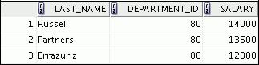

**…**



1. Display the last name, department name, and salary of any employee whose salary and commission match the salary and commission of any employee located in location ID 1700.

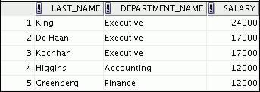

**…**

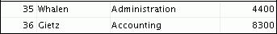

1. Create a query to display the last name, hire date, and salary for all employees who have the same salary and commission as Kochhar.

**Note:** Do not display Kochhar in the result set.

1. Create a query to display the employees who earn a salary that is higher than the salary of all the sales managers (JOB_ID = 'SA_MAN'). Sort the results on salary from the highest to the lowest.

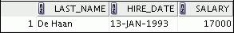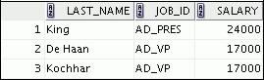

|  |
| --- |
| Oracle Internal & Oracle Academy Use Only |

**Oracle Database 10*g*: SQL Fundamentals II 6 - 28**

**Practice 6 (continued)**

1. Display the employee ID, last name, and department ID of those employees who live in cities whose name begins with *T*.
2. Write a query to find all employees who earn more than the average salary in their departments. Display the last name, salary, department ID, and the average salary for the department. Sort by average salary. Use aliases for the columns retrieved by the query as shown in the sample output.

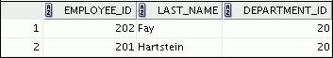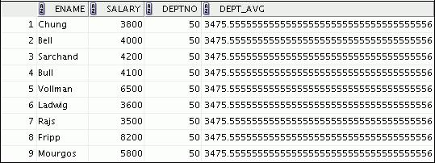

**…**

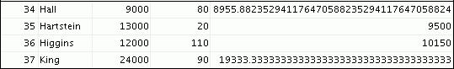

1. Find all employees who are not supervisors.

a. First do this using the NOT EXISTS operator.

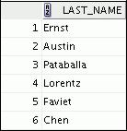

**…**

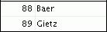

b. Can this be done by using the NOT IN operator? How, or why not?

|  |
| --- |
| Oracle Internal & Oracle Academy Use Only |

**Oracle Database 10*g*: SQL Fundamentals II 6 - 29**

**Practice 6 (continued)**

1. Write a query to display the last names of the employees who earn less than the average salary in their departments.

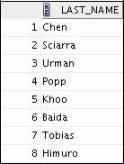

**…**

1. Write a query to display the last names of the employees who have one or more coworkers in their departments with later hire dates but higher salaries.

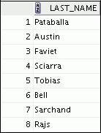

**…**

|  |
| --- |
| Oracle Internal & Oracle Academy Use Only |

**Oracle Database 10*g*: SQL Fundamentals II 6 - 30**

**Practice 6 (continued)**

1. Write a query to display the employee ID, last name, and department name of all employees. **Note:** Use a scalar subquery to retrieve the department name in theSELECTstatement.

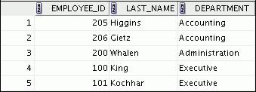

**…**

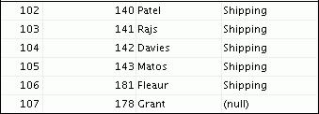

1. Write a query to display the department names of those departments whose total salary cost is above one-eighth (1/8) the total salary cost of the whole company. Use the WITH clause to write this query. Name the query SUMMARY.



|  |
| --- |
| Oracle Internal & Oracle Academy Use Only |

**Oracle Database 10*g*: SQL Fundamentals II 6 - 31**

Oracle Internal & Oracle Academy Use Only



**Hierarchical Retrieval**

Copyright © 2009, Oracle. All rights reserved.

|  |
| --- |
| Oracle Internal & Oracle Academy Use Only |

**Objectives**

After completing this lesson, you should be able to do the following:

1. Interpret the concept of a hierarchical query
2. Create a tree-structured report
3. Format hierarchical data
4. Exclude branches from the tree structure

Copyright © 2009, Oracle. All rights reserved.

**Objectives**

In this lesson, you learn how to use hierarchical queries to create tree-structured reports.

|  |
| --- |
| Oracle Internal & Oracle Academy Use Only |

**Oracle Database 10*g*: SQL Fundamentals II 7 - 2**

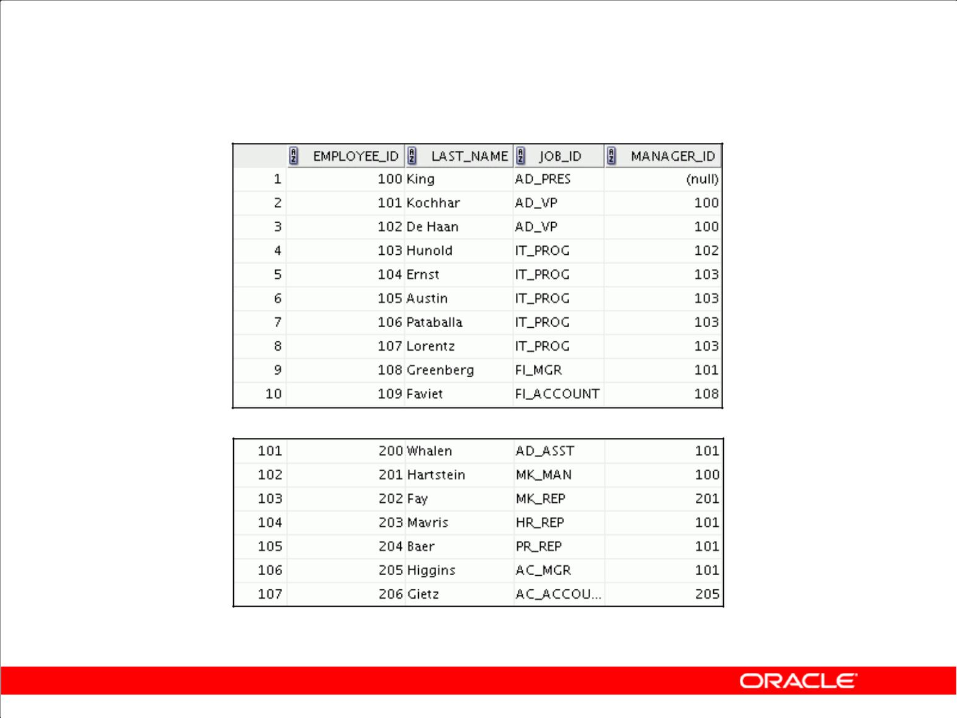**Sample Data from the EMPLOYEES Table**

**…**

Copyright © 2009, Oracle. All rights reserved.

**Sample Data from the EMPLOYEES Table**

Using hierarchical queries, you can retrieve data based on a natural hierarchical relationship between rows in a table. A relational database does not store records in a hierarchical way. However, where a hierarchical relationship exists between the rows of a single table, a process called *tree walking* enables the hierarchy to be constructed. A hierarchical query is a method of reporting, with the branches of a tree in a specific order.

Imagine a family tree with the eldest members of the family found close to the base or trunk of the tree and the youngest members representing branches of the tree. Branches can have their own branches, and so on.

A hierarchical query is possible when a relationship exists between rows in a table. For example, in the slide, you see that employees with the job IDs of AD_VP, ST_MAN, SA_MAN, and MK_MAN report directly to the president of the company. You know this because the MANAGER_ID column of these records contains the employee ID 100, which belongs to the president (AD_PRES).

**Note:** Hierarchical trees are used in various fields such as human genealogy (family trees), livestock(breeding purposes), corporate management (management hierarchies), manufacturing (product assembly), evolutionary research (species development), and scientific research.

|  |
| --- |
| Oracle Internal & Oracle Academy Use Only |

**Oracle Database 10*g*: SQL Fundamentals II 7 - 3**

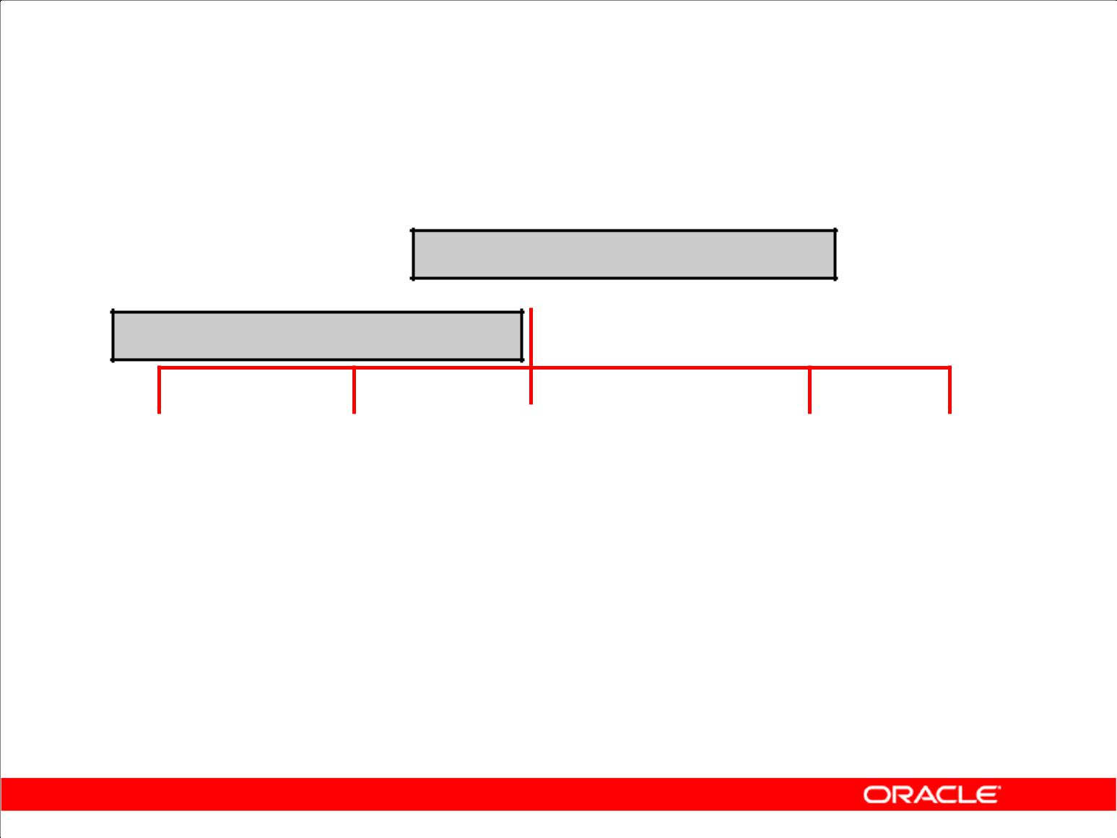**Natural Tree Structure**

**EMPLOYEE_ID = 100 (Parent)**

**King**

**MANAGER_ID = 100 (Child)**

**Kochhar** **De Haan** **Mourgos** **Zlotkey Hartstein**

|  |  |  |  |  |  |  |  |  |  |  |  |  |  |  |  |
| --- | --- | --- | --- | --- | --- | --- | --- | --- | --- | --- | --- | --- | --- | --- | --- |
|  |  |  |  |  |  |  |  |  |  |  |  |  |  |  |  |
|  |  |  |  |  |  |  |  |  |  |  |  |  |  |  |  |
|  |  |  |  |  |  |  |  |  |  |  |  |  |  |  |  |
| **Whalen Higgins Hunold Rajs Davies** | | | | | | | | | **Matos Vargas** | | | |  |  |  |
|  |  |  |  |  |  |  |  |  |  |  |  |  |  |  |  |
|  |  |  |  |  |  |  |  |  |  |  |  |  |  | **Fay** | |
|  |  |  |  |  |  |  |  |  |  |  |  |  |  |
|  |  |  |  |  |  |  | | |  |  |  |  |  |  |  |
|  |  | **Gietz Ernst Lorentz** | | | | | | |  | **Abel Taylor Grant** | | | | | |

Copyright © 2009, Oracle. All rights reserved.

**Natural Tree Structure**

The EMPLOYEES table has a tree structure representing the management reporting line. The

hierarchy can be created by looking at the relationship between equivalent values in the EMPLOYEE_ID and MANAGER_ID columns. This relationship can be exploited by joining the table to itself. The MANAGER_ID column contains the employee number of the employee’s manager.

The parent-child relationship of a tree structure enables you to control:

1. The direction in which the hierarchy is walked
2. The starting point inside the hierarchy

**Note:** The slide displays an inverted tree structure of the management hierarchy of the employees inthe EMPLOYEES table.

|  |
| --- |
| Oracle Internal & Oracle Academy Use Only |

**Oracle Database 10*g*: SQL Fundamentals II 7 - 4**

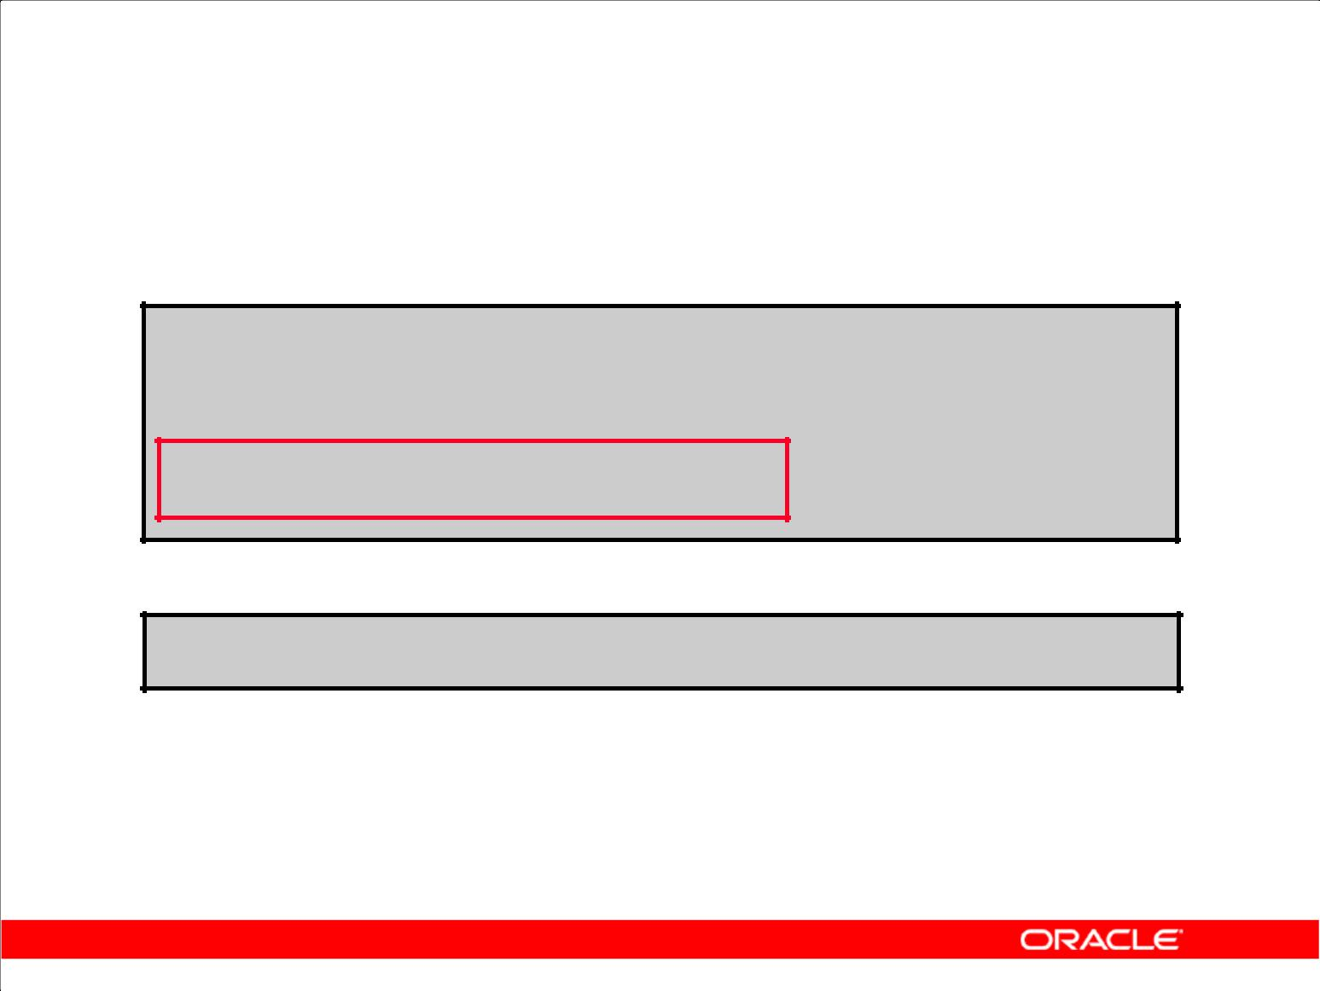**Hierarchical Queries**

**SELECT [LEVEL], *column*, *expr*...**

**FROM** ***table***

**[WHERE *condition(s)*]**

**[START WITH *condition(s)*]**

**[CONNECT BY PRIOR *condition(s)*] ;**

WHERE *condition*:

***expr comparison_operator expr***

Copyright © 2009, Oracle. All rights reserved.

**Keywords and Clauses**

Hierarchical queries can be identified by the presence of the CONNECT BY and START WITH clauses.

|  |  |
| --- | --- |
| In the syntax: | Is the standard SELECT clause |
| SELECT |
| LEVEL | For each row returned by a hierarchical query, the LEVEL |
| pseudocolumn returns 1 for a root row, 2 for a child of a root, and so on. | |
| FROM *table* | Specifies the table, view, or snapshot containing the columns. You can |
| select from only one table. | |
| WHERE | Restricts the rows returned by the query without affecting other rows of |
| the hierarchy | |
| *condition* | Is a comparison with expressions |

START WITH Specifies the root rows of the hierarchy (where to start). This clause is

required for a true hierarchical query.

CONNECT BY Specifies the columns in which the relationship between parent and child PRIOR rows exist. This clause is required for a hierarchical query.

The SELECT statement cannot contain a join or query from a view that contains a join.

|  |
| --- |
| Oracle Internal & Oracle Academy Use Only |

**Oracle Database 10*g*: SQL Fundamentals II 7 - 5**

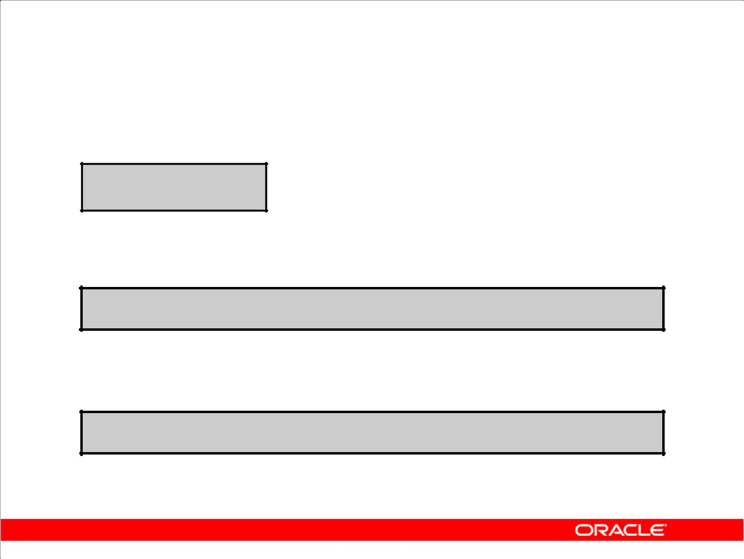**Walking the Tree**

**Starting Point**

1. Specifies the condition that must be met
2. Accepts any valid condition

**START WITH *column1* = *value***

Using the EMPLOYEES table, start with the employee whose last name is Kochhar.

**...START WITH *last_name* = 'Kochhar'**

Copyright © 2009, Oracle. All rights reserved.

**Walking the Tree**

The row or rows to be used as the root of the tree are determined by the START WITH clause. The START WITH clause can be used in conjunction with any valid condition.

**Examples**

Using the EMPLOYEES table, start with King, the president of the company.

... START WITH manager_id IS NULL

Using the EMPLOYEES table, start with employee Kochhar. A START WITH condition can contain a subquery.

... START WITH employee_id = (SELECT employee_id FROM employees

WHERE last_name = 'Kochhar')

If the START WITH clause is omitted, the tree walk is started with all the rows in the table as root rows. If a WHERE clause is used, the walk is started with all the rows that satisfy the WHERE condition. This no longer reflects a true hierarchy.

**Note:** TheCONNECT BY PRIORandSTART WITHclauses are not ANSI SQL standard.

|  |
| --- |
| Oracle Internal & Oracle Academy Use Only |

**Oracle Database 10*g*: SQL Fundamentals II 7 - 6**

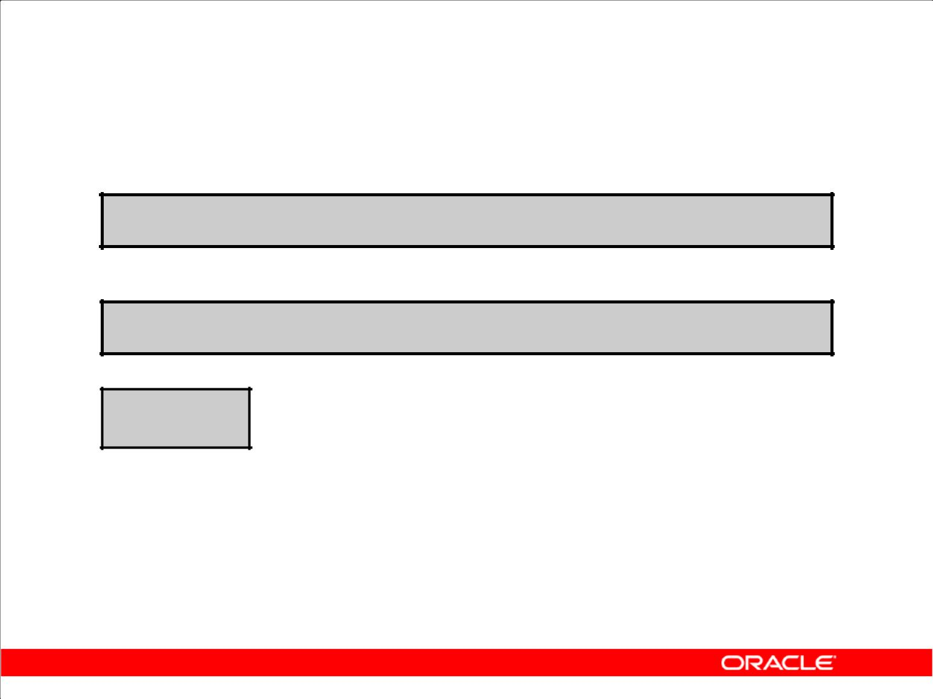**Walking the Tree**

**CONNECT BY PRIOR *column1* = *column2***

Walk from the top down, using the EMPLOYEES table.

**... CONNECT BY PRIOR employee_id = manager_id**

**Direction**

**Top down  Column1 = Parent Key**

**Column2 = Child Key**

**Bottom up  Column1 = Child Key**

**Column2 = Parent Key**

Copyright © 2009, Oracle. All rights reserved.

**Walking the Tree (continued)**

The direction of the query, whether it is from parent to child or from child to parent, is determined by the CONNECT BY PRIOR column placement. The PRIOR operator refers to the parent row. To find the child rows of a parent row, the Oracle server evaluates the PRIOR expression for the parent row

and the other expressions for each row in the table. Rows for which the condition is true are the child rows of the parent. The Oracle server always selects child rows by evaluating the CONNECT BY

condition with respect to a current parent row.

**Examples**

Walk from the top down using the EMPLOYEES table. Define a hierarchical relationship in which the

EMPLOYEE_ID value of the parent row is equal to the MANAGER_ID value of the child row:

... CONNECT BY PRIOR employee_id = manager_id

Walk from the bottom up using the EMPLOYEES table:

... CONNECT BY PRIOR manager_id = employee_id

The PRIOR operator does not necessarily need to be coded immediately following CONNECT BY. Thus, the following CONNECT BY PRIOR clause gives the same result as the one in the preceding example:

... CONNECT BY employee_id = PRIOR manager_id

**Note:** TheCONNECT BYclause cannot contain a subquery.

|  |
| --- |
| Oracle Internal & Oracle Academy Use Only |

**Oracle Database 10*g*: SQL Fundamentals II 7 - 7**

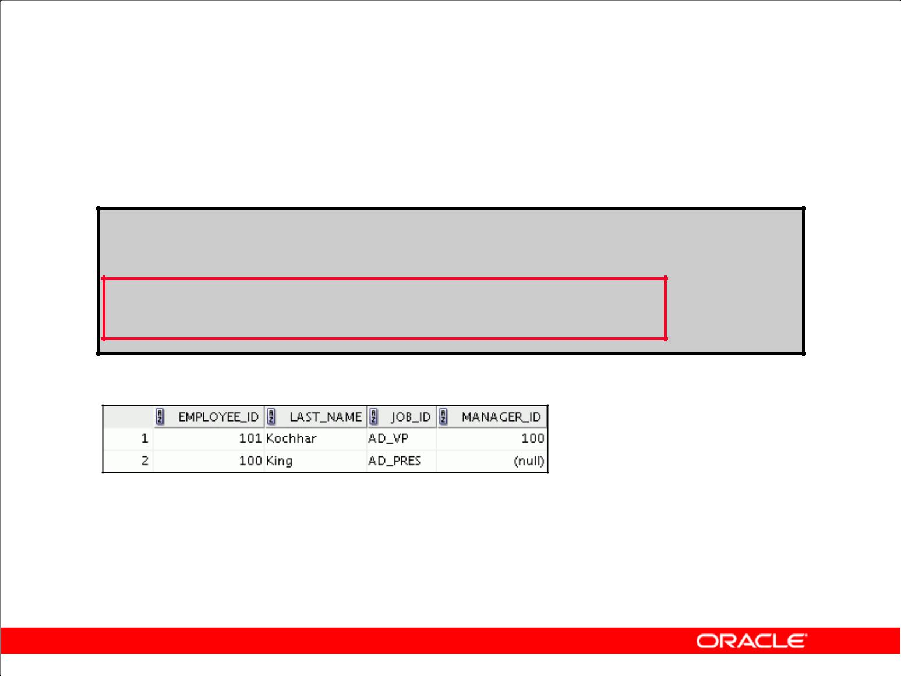**Walking the Tree: From the Bottom Up**

**SELECT employee_id, last_name, job_id, manager_id**

**FROM employees**

**START WITH** **employee_id = 101**

**CONNECT BY PRIOR manager_id = employee_id ;**

Copyright © 2009, Oracle. All rights reserved.

**Walking the Tree: From the Bottom Up**

The example in the slide displays a list of managers starting with the employee whose employee ID is 101.

**Example**

In the following example, EMPLOYEE_ID values are evaluated for the parent row and MANAGER_ID, and SALARY values are evaluated for the child rows. The PRIOR operator applies only to the EMPLOYEE_ID value.

... CONNECT BY PRIOR employee_id = manager_id AND salary > 15000;

To qualify as a child row, a row must have a MANAGER_ID value equal to the EMPLOYEE_ID value of the parent row and must have a SALARY value greater than $15,000.

|  |
| --- |
| Oracle Internal & Oracle Academy Use Only |

**Oracle Database 10*g*: SQL Fundamentals II 7 - 8**

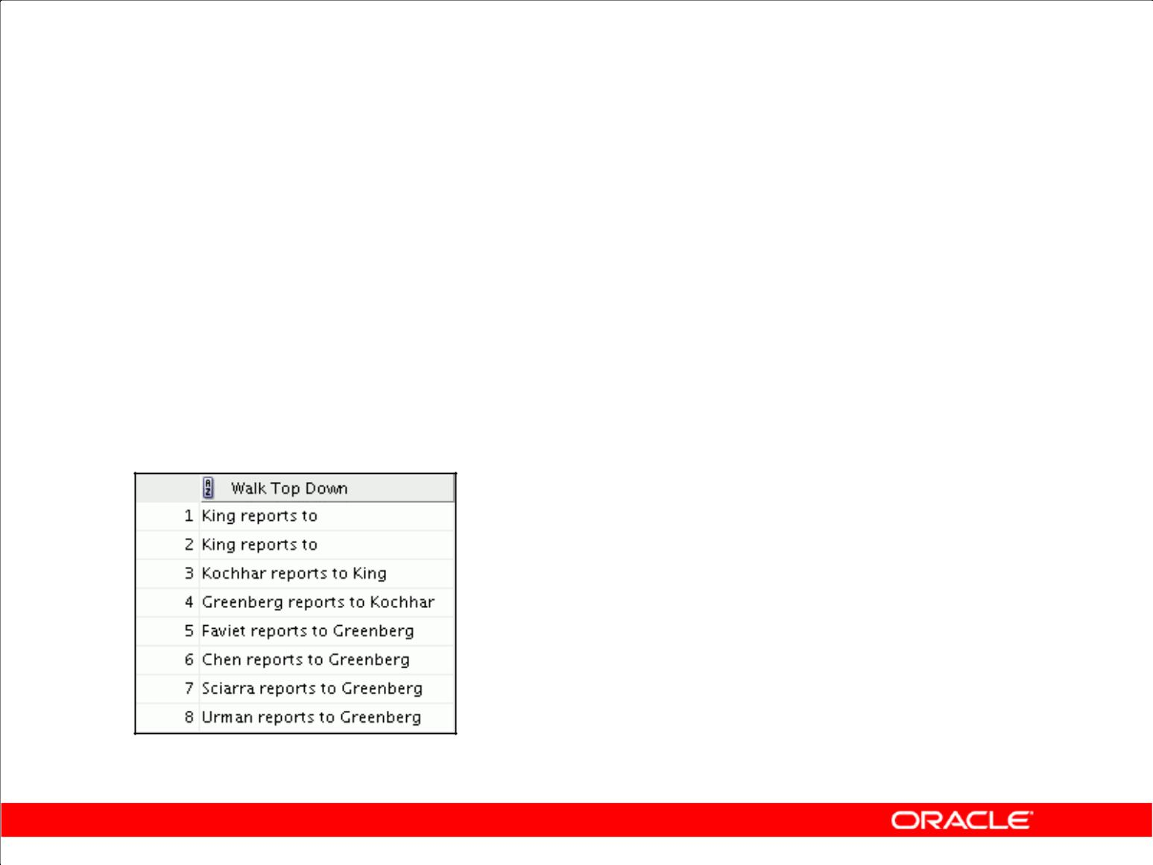**Walking the Tree: From the Top Down**

|  |  |  |  |
| --- | --- | --- | --- |
|  | **SELECT** | **last_name||' reports to '||** | |
|  | **PRIOR** | **last_name "Walk Top Down"** | |
|  | **FROM** | **employees** | |
|  | **START** | **WITH last_name = 'King'** |  |
|  | **CONNECT** | **BY PRIOR employee_id = manager_id** | **;** |
|  |  |  |  |

**…**

Copyright © 2009, Oracle. All rights reserved.

**Walking the Tree: From the Top Down**

Walking from the top down, display the names of the employees and their manager. Use employee King as the starting point. Print only one column.

|  |
| --- |
| Oracle Internal & Oracle Academy Use Only |

**Oracle Database 10*g*: SQL Fundamentals II 7 - 9**

**Ranking Rows with the LEVEL Pseudocolumn**

|  |  |  |  |  |  |  |  |  |  |  |  |  |  |  |  |  |  |  |  |
| --- | --- | --- | --- | --- | --- | --- | --- | --- | --- | --- | --- | --- | --- | --- | --- | --- | --- | --- | --- |
|  |  |  |  |  |  |  |  |  |  |  |  |  |  |  |  |  |  | **Level 1** |  |
|  |  |  |  |  |  |  |  | **King** | |  |  |  |  |  |  |  |  | **root/** |  |
|  |  |  |  |  |  |  |  |  |  |  |  |  |  |  |  |  |  | **parent** |  |
|  |  |  |  |  |  |  |  |  |  |  |  |  |  |  |  |  |  |  |
|  |  |  |  |  |  |  |  |  |  |  |  |  |  |  |  |  |  |  |  |
|  |  |  |  |  |  |  |  |  |  |  |  |  |  |  |  |  |  | **Level 2** |  |
|  | **Kochhar** | |  | **De Haan** | | | | **Mourgos** | |  |  |  | **Zlotkey Hartstein** | | | | | **parent/** |  |
|  |  |  |  |  |  |  |  |  |  |  |  |  |  |  |  |  |  | **child/leaf** |  |
|  |  |  |  |  |  |  |  |  |  |  |  |  |  |  |  |  |  |  |
|  |  |  |  |  |  |  |  |  |  |  |  |  |  |  |  |  |  |  |  |
|  |  |  |  |  |  |  |  |  |  |  |  |  |  |  |  |  |  |  |  |
|  |  |  |  |  |  |  |  |  |  |  |  |  |  |  |  |  |  | **Level 3** |  |
|  |  |  |  |  |  |  |  |  |  |  |  |  |  |  |  |  |  |  |
| **Whalen** | | | **Higgins Hunold Rajs** | | | | | **Davies** | | **Matos Vargas** | | | |  | **Fay** | | |  |
|  | **parent/** |  |
|  |  |  |  |  |  |  |  |  |  |  |  |  |  |  |  |  |  | **child/leaf** |  |
|  |  |  |  |  |  |  |  |  |  |  |  |  |  |  |  |  |  |  |  |
|  |  |  |  |  |  |  |  |  |  |  |  |  |  |  |  |  |  | **Level 4** |  |
|  |  | **Gietz Ernst Lorentz** | | | | | |  |  |  | **Abel Taylor** | | | | **Grant** | | |  |
|  |  |  |  |  | **leaf** |  |
|  |  |  |  |  |  |  |  |  |  |  |  |  |  |  |  |  |  |  |

Copyright © 2009, Oracle. All rights reserved.

**Ranking Rows with the LEVEL Pseudocolumn**

You can explicitly show the rank or level of a row in the hierarchy by using the LEVEL pseudocolumn. This will make your report more readable. The forks where one or more branches split away from a larger branch are called nodes, and the very end of a branch is called a leaf or leaf node. The diagram in the slide shows the nodes of the inverted tree with their LEVEL values. For example, employee Higgins is a parent and a child, whereas employee Davies is a child and a leaf.

**LEVEL Pseudocolumn**

|  |  |
| --- | --- |
| **Value** | **Level** |
| 1 | A root node |
| 2 | A child of a root node |
| 3 | A child of a child, and so on |

In the slide, King is the root or parent (LEVEL = 1). Kochhar, De Haan, Mourgos, Zlotkey, Hartstein, Higgins, and Hunold are children and also parents (LEVEL = 2). Whalen, Rajs, Davies, Matos, Vargas, Gietz, Ernst, Lorentz, Abel, Taylor, Grant, and Fay are children and leaves (LEVEL = 3 and LEVEL = 4).

**Note:** A*root node*is the highest node within an inverted tree. A*child node*is any nonroot node. Aparent node is any node that has children. A leaf node is any node without children. The number of levels returned by a hierarchical query may be limited by available user memory.

|  |
| --- |
| Oracle Internal & Oracle Academy Use Only |

**Oracle Database 10*g*: SQL Fundamentals II 7 - 10**

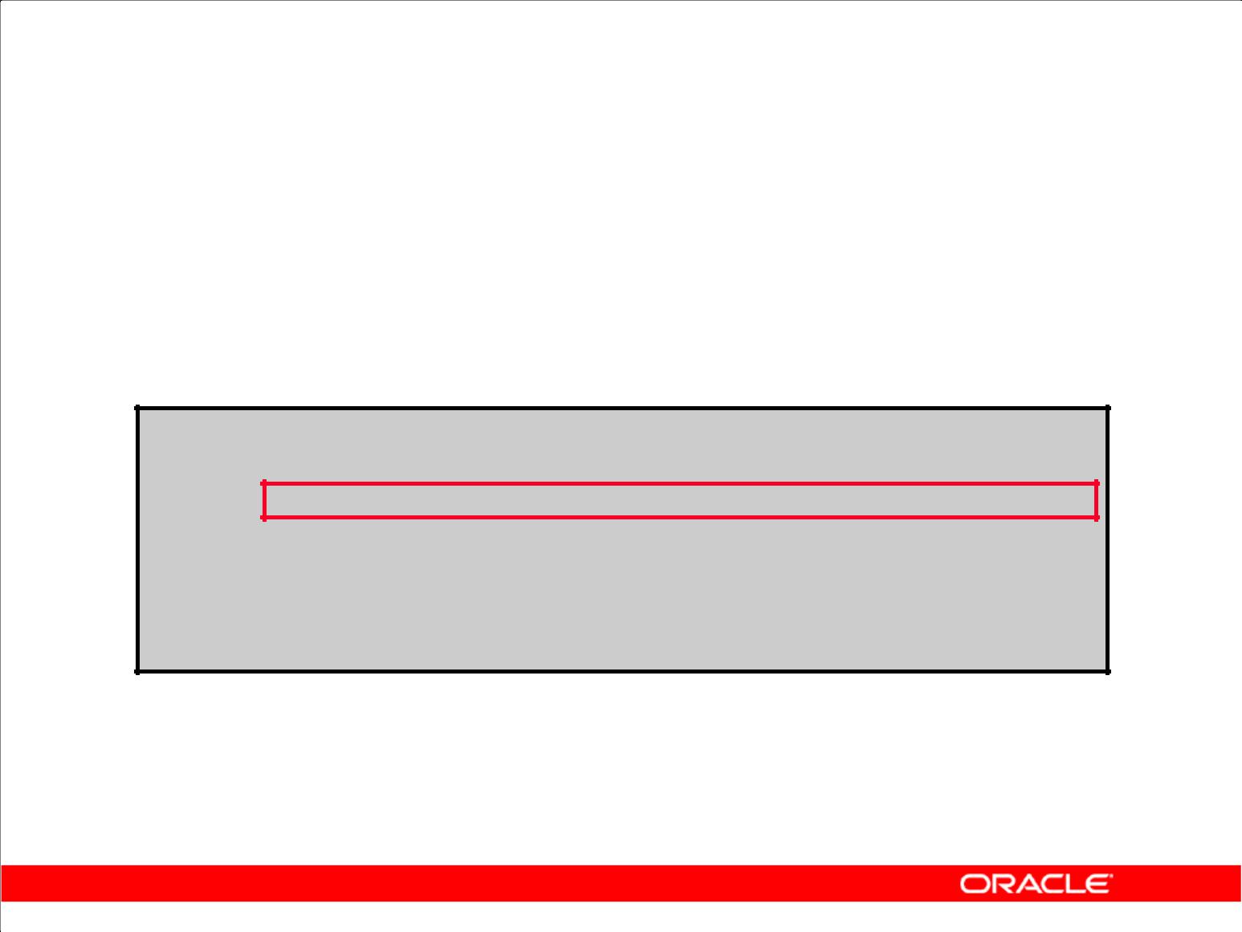**Formatting Hierarchical Reports Using LEVEL and LPAD**

Create a report displaying company management levels, beginning with the highest level and indenting each of the following levels.

**COLUMN org_chart FORMAT A12**

**SELECT LPAD(last_name, LENGTH(last_name)+(LEVEL*2)-2,'_')**

**AS org_chart**

**FROM** **employees**

**START WITH first_name='Steven' AND last_name='King' CONNECT BY PRIOR employee_id=manager_id**

Copyright © 2009, Oracle. All rights reserved.

**Formatting Hierarchical Reports Using LEVEL and LPAD**

The nodes in a tree are assigned level numbers from the root. Use the LPAD function in conjunction with the LEVEL pseudocolumn to display a hierarchical report as an indented tree.

In the example in the slide:

1. LPAD(*char1*,*n* [,*char2*]) returns *char1*, left-padded to length *n* with the sequence of characters in *char2*. The argument *n* is the total length of the return value as it is displayed on your terminal screen.
2. LPAD(last_name, LENGTH(last_name)+(LEVEL*2)-2,'_')defines the display format
3. *char1* is theLAST_NAME, *n* the total length of the return value, is length of theLAST_NAME+(LEVEL*2)-2, and *char2* is '_'.

That is, this tells SQL to take the LAST_NAME and left-pad it with the '_' character until the length of the resultant string is equal to the value determined by

LENGTH(last_name)+(LEVEL*2)-2.

For King, LEVEL = 1. Therefore, (2 * 1) – 2 = 2 – 2 = 0. So King does not get padded with any '_' character and is displayed in column 1.

For Kochhar, LEVEL = 2. Therefore, (2 * 2) – 2 = 4 – 2 = 2 . So Kochhar gets padded with 2 '_' characters and is displayed indented.

The rest of the records in the EMPLOYEES table are displayed similarly.

|  |
| --- |
| Oracle Internal & Oracle Academy Use Only |

**Oracle Database 10*g*: SQL Fundamentals II 7 - 11**

**Formatting Hierarchical Reports Using LEVEL and LPAD (continued)**

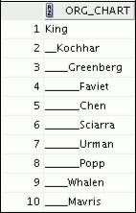

**…**

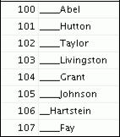

|  |
| --- |
| Oracle Internal & Oracle Academy Use Only |

**Oracle Database 10*g*: SQL Fundamentals II 7 - 12**

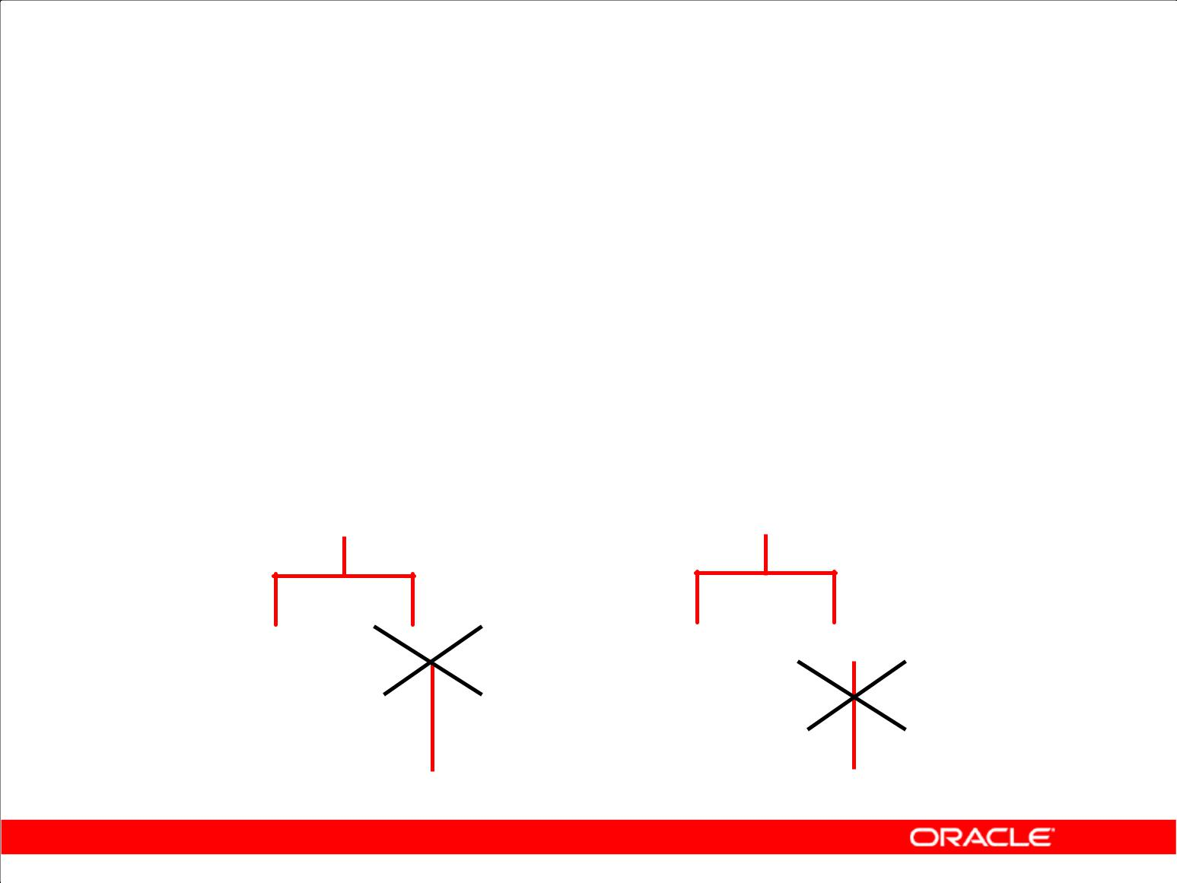**Pruning Branches**

**Use the WHERE clause** **Use the CONNECT BY clause**

**to eliminate a node.** **to eliminate a branch.**

**WHERE last_name != 'Higgins'CONNECT BY PRIOR**

**employee_id = manager_id**

**AND last_name != 'Higgins'**

**Kochhar** **Kochhar**

**Whalen** **Higgins** **Whalen** **Higgins**

**Gietz** **Gietz**

Copyright © 2009, Oracle. All rights reserved.

**Pruning Branches**

You can use the WHERE and CONNECT BY clauses to prune the tree (that is, to control which nodes or rows are displayed). The predicate you use acts as a Boolean condition.

**Examples**

Starting at the root, walk from the top down, and eliminate employee Higgins in the result, but process the child rows.

|  |  |  |
| --- | --- | --- |
| SELECT | department_id, employee_id,last_name, job_id, salary | |
| FROM | employees |  |
| WHERE | last_name | != 'Higgins' |
| START | WITH manager_id IS NULL | |
| CONNECT | BY PRIOR employee_id = manager_id; | |

Starting at the root, walk from the top down, and eliminate employee Higgins and all child rows.

SELECT department_id, employee_id,last_name, job_id, salary

FROM employees

START WITH manager_id IS NULL

CONNECT BY PRIOR employee_id = manager_id

AND last_name != 'Higgins';

|  |
| --- |
| Oracle Internal & Oracle Academy Use Only |

**Oracle Database 10*g*: SQL Fundamentals II 7 - 13**

**Summary**

In this lesson, you should have learned that:

1. You can use hierarchical queries to view a hierarchical relationship between rows in a table
2. You specify the direction and starting point of the query
3. You can eliminate nodes or branches by pruning

Copyright © 2009, Oracle. All rights reserved.

**Summary**

You can use hierarchical queries to retrieve data based on a natural hierarchical relationship between rows in a table. The LEVEL pseudocolumn counts how far down a hierarchical tree you have traveled. You can specify the direction of the query using the CONNECT BY PRIOR clause. You can specify the starting point using the START WITH clause. You can use the WHERE and CONNECT BY clauses to prune the tree branches.

|  |
| --- |
| Oracle Internal & Oracle Academy Use Only |

**Oracle Database 10*g*: SQL Fundamentals II 7 - 14**

**Practice 7: Overview**

This practice covers the following topics:

1. Distinguishing hierarchical queries from nonhierarchical queries
2. Walking through a tree
3. Producing an indented report by using the LEVEL pseudocolumn
4. Pruning the tree structure
5. Sorting the output

Copyright © 2009, Oracle. All rights reserved.

**Practice 7: Overview**

In this practice, you gain practical experience in producing hierarchical reports.

**Note:** Question 1 is a paper-based question.

|  |
| --- |
| Oracle Internal & Oracle Academy Use Only |

**Oracle Database 10*g*: SQL Fundamentals II 7 - 15**

**Practice 7**

1. Look at the following output examples. Are they the result of a hierarchical query? Explain why or why not.

**Exhibit 1:**

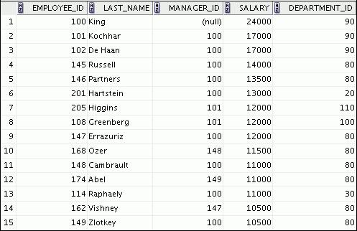

**…**

**Exhibit 2:**

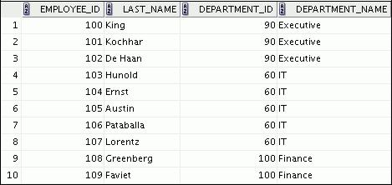

**…**

|  |
| --- |
| Oracle Internal & Oracle Academy Use Only |

**Oracle Database 10*g*: SQL Fundamentals II 7 - 16**

**Practice 7 (continued)**

**Exhibit 3:**

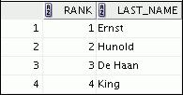

1. Produce a report that shows an organization chart for Mourgos’s department. Print the last names, salaries, and department IDs.

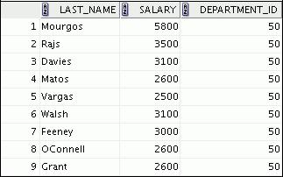

1. Create a report that shows the hierarchy of managers for the employee Lorentz. Display his immediate manager first.

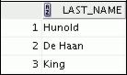

|  |
| --- |
| Oracle Internal & Oracle Academy Use Only |

**Oracle Database 10*g*: SQL Fundamentals II 7 - 17**

**Practice 7 (continued)**

1. Create an indented report that shows the management hierarchy starting from the employee whose LAST_NAME is Kochhar. Print the employee’s last name, manager ID, and department ID. Give alias names to the columns as shown in the sample output.

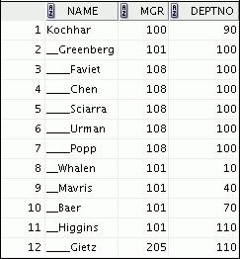

If you have time, complete the following exercise:

1. Produce a company organization chart that shows the management hierarchy. Start with the person at the top level, exclude all those with a job ID of IT_PROG, and exclude De Haan and those employees who report to De Haan.

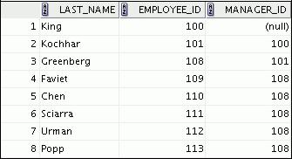

**…**

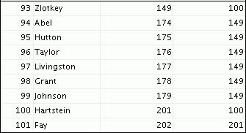

|  |
| --- |
| Oracle Internal & Oracle Academy Use Only |

**Oracle Database 10*g*: SQL Fundamentals II 7 - 18**



**Regular Expression Support**

Copyright © 2009, Oracle. All rights reserved.

|  |
| --- |
| Oracle Internal & Oracle Academy Use Only |

**Objectives**

After completing this lesson, you should be able to use regular expression support in SQL to search, match, and replace strings in terms of regular expressions.

Copyright © 2009, Oracle. All rights reserved.

**Objectives**

In this lesson, you learn to use the regular expression support feature that has been introduced in Oracle Database 10*g*.

|  |
| --- |
| Oracle Internal & Oracle Academy Use Only |

**Oracle Database 10*g*: SQL Fundamentals II 8 - 2**

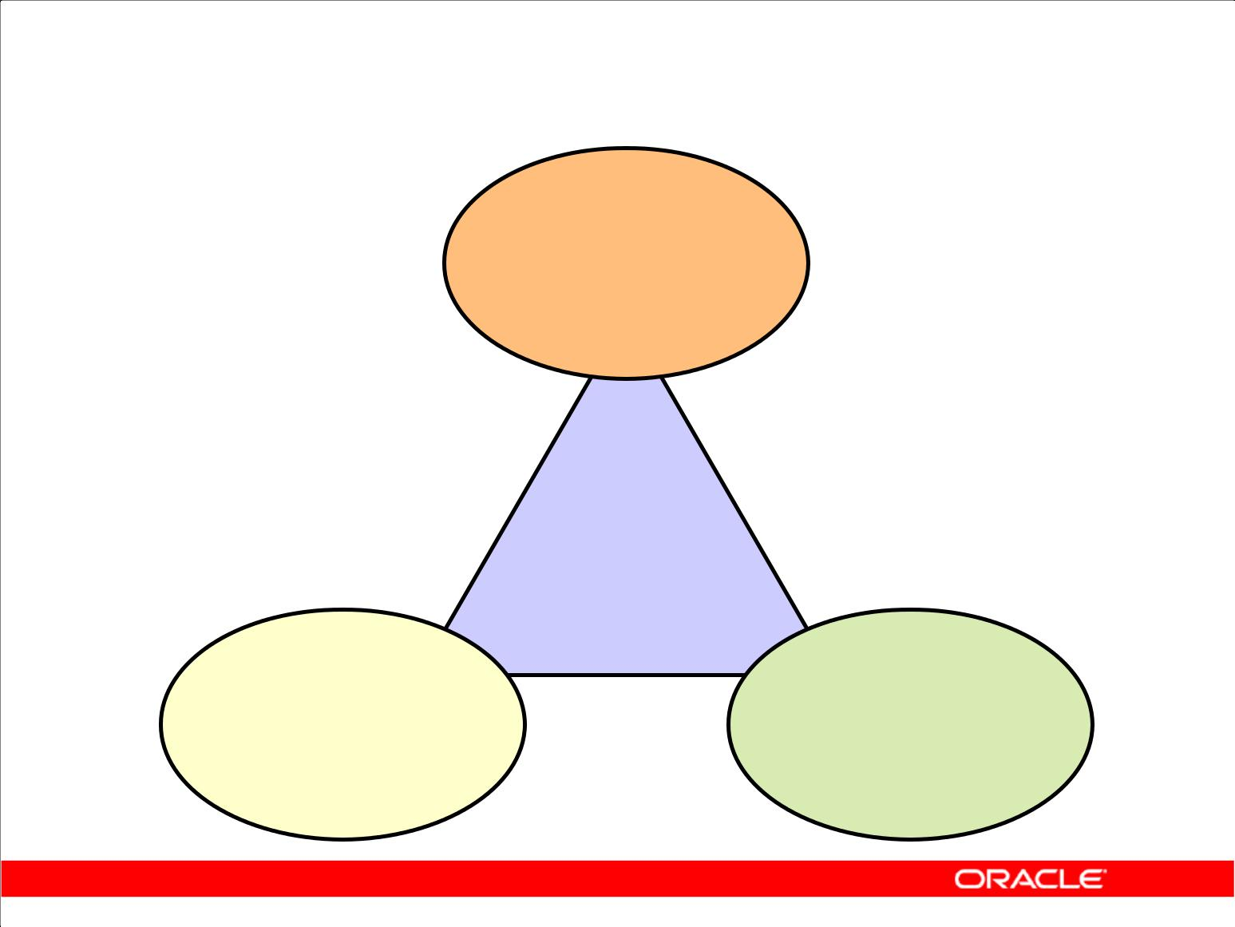**Regular Expression: Overview**

1. **multilingual regular expression support for SQL and PL/SQL string types**

|  |  |
| --- | --- |
|  | **ABC** |
| **A method of** | **Several new** |
| **describing both** |
| **simple and complex** | **functions to** |
| **patterns for** | **support regular** |
| **searching and** | **expressions** |
| **manipulating** |
|  |

Copyright © 2009, Oracle. All rights reserved.

**Regular Expression: Overview**

Oracle Database 10*g* introduces support for regular expressions. The implementation complies with the Portable Operating System for UNIX (POSIX) standard, controlled by the Institute of Electrical and Electronics Engineers (IEEE), for ASCII data matching semantics and syntax. Oracle’s multilingual capabilities extend the matching capabilities of the operators beyond the POSIX standard. Regular expressions are a method of describing both simple and complex patterns for searching and manipulating.

String manipulation and searching contribute to a large percentage of the logic within a Web-based application. Usage ranges from the simple (for example, find the word “San Francisco” in a specified text) to the complex (for example, extract all URLs from the text) to the more complex (for instance, find all words whose every second character is a vowel).

When coupled with native SQL, the use of regular expressions allows for very powerful search and manipulation operations on any data stored in an Oracle Database. You can use this feature to easily solve problems that would otherwise be very complex to program.

|  |
| --- |
| Oracle Internal & Oracle Academy Use Only |

**Oracle Database 10*g*: SQL Fundamentals II 8 - 3**

|  |  |  |  |
| --- | --- | --- | --- |
|  |  | **Meta Characters** | |
|  |  |  |  |
|  | **Symbol** | **Description** |  |
|  |  |  |  |
|  | * | Matches zero or more occurrences |  |
|  | | | Alteration operator for specifying alternative matches |  |
|  | ^/$ | Matches the start-of-line/end-of-line |  |
|  | [ ] | Bracket expression for a matching list matching any one of the expressions |  |
|  |  | represented in the list |  |
|  | {m} | Matches exactly *m* times |  |
|  | {m,n} | Matches at least *m* times but no more than *n* times |  |
|  | [: :] | Specifies a character class and matches any character in that class |  |
|  | \ | Can have 4 different meanings: 1. Stand for itself. 2. Quote the next |  |
|  |  | character. 3. Introduce an operator. 4. Do nothing. |  |
|  | + | Matches one or more occurrences |  |
|  | ? | Matches zero or one occurrence |  |
|  | . | Matches any character in the supported character set, except NULL |  |
|  | () | Grouping expression, treated as a single subexpression |  |
|  | [==] | Specifies equivalence classes |  |
|  | \n | Back-reference expression |  |
|  | [..] | Specifies one collation element, such as a multicharacter element |  |
|  |  | Copyright © 2009, Oracle. All rights reserved. | |



**Meta Characters**

Meta characters are special characters that have a special meaning, such as a wildcard character, a repeating character, a nonmatching character, or a range of characters. You can use several predefined meta character symbols in the pattern matching.

|  |
| --- |
| Oracle Internal & Oracle Academy Use Only |

**Oracle Database 10*g*: SQL Fundamentals II 8 - 4**

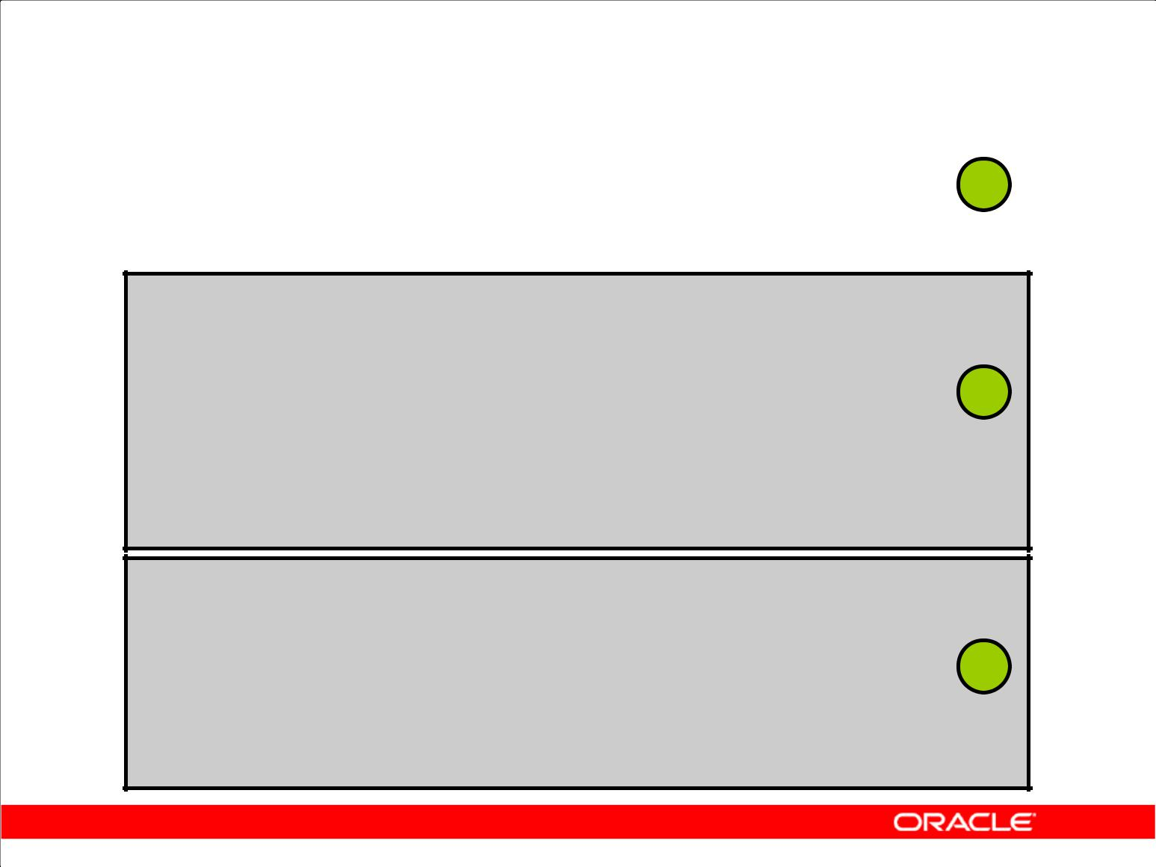**Using Meta Characters**

|  |  |  |  |
| --- | --- | --- | --- |
| **Problem: Find 'abc' within a string:** | | | **1** |
| **Solution:** | **'abc'** |  |
| **Matches:** | **abc** |  |  |
| **Does not match:** | **'def'** | |  |
|  |  |  |  |

**Problem: To find 'a' followed by any character, followed**

|  |  |  |  |
| --- | --- | --- | --- |
| **by 'c'** |  |  |  |
| **Meta Character: *any* character is defined by '.'** | | |  |
| **Solution:** | **'a.c'** |  | **2** |
| **Matches:** |  |  |
| **abc** |  |  |
| **Matches:** | **adc** | |  |
| **Matches:** | **alc** | |  |
| **Matches:** | **a&c** | |  |
| **Does not match:** | **abb** | |  |

**Problem: To find one or more occurrences of 'a'**

**Meta Character: Use'+' sign to match one or more of the previous characters**

|  |  |  |
| --- | --- | --- |
| **Solution:** | **'a+'** | **3** |
| **Matches:** | **a** |  |
| **Matches:** | **aa** |  |
| **Does not match:** | **bbb** |  |

Copyright © 2009, Oracle. All rights reserved.

**Using Meta Characters**

1. In the first example, a simple match is performed.
2. In the second example, the any character is defined as a '.'. This example searches for the character “a” followed by any character, followed by the character “c”.
3. The third example searches for one or more occurrences of the letter “a.” The “+” character is used here to indicate a match of one or more of the previous characters.

You can search for nonmatching character lists too. A nonmatching character list allows you to define a set of characters for which a match is invalid. For example, to find anything but the characters “a,” “b,” or “c,” you can define the “^” to indicate a nonmatch.

Expression: [^abc]

Matches: abcdef

Matches: ghi

Does not match: abc

To match any letter not between “a” and “i,” you can use:

Expression: [^a-i]

Matches: hijk

Matches: lmn

Does not match: abcdefghi

|  |
| --- |
| Oracle Internal & Oracle Academy Use Only |

**Oracle Database 10*g*: SQL Fundamentals II 8 - 5**

|  |  |  |  |  |  |
| --- | --- | --- | --- | --- | --- |
| **Using Meta Characters (continued)** | | |  |  |  |
|  |  |  |  | |  |
|  | **Meta Character** | **Operator Name** | **Description** | |  |
|  | **Syntax** |  |  |  |  |
|  |  |  |  | |  |
|  | **.** | Any Character – Dot | Match any character. | |  |
|  |  |  |  | |  |
|  | **+** | One or More – Plus | Match one or more occurrences of the | |  |
|  |  | Quantifier | preceding subexpression. | |  |
|  |  |  |  | |  |
|  | **?** | Zero or One – Question Mark | Match zero or one occurrence of the | |  |
|  |  | Quantifier | preceding subexpression. | |  |
|  |  |  |  | |  |
|  | **\*** | Zero or More – Star | Match zero or more occurrences of the | |  |
|  |  | Quantifier | preceding subexpression. | | Only |
|  |  |  |  |  |
|  | **{m}** | Interval – Exact Count | Match | |
|  |  |
|  | **{m,}** |  | • | exactly *m* occurrences | Use |
|  | **{m,n}** |  | • | at least *m* occurrences |
|  |  |  |
|  |  |  |  |
|  | **[…]** | Matching Character List | • | at least *m*, but not more than *n* | Academy |
|  | Match any character in list ... | |
|  |  |  |  | occurrences of the preceding |  |
|  |  |  |  | subexpression |  |
|  |  |  |  |  | &Oracle |
|  |  |  |  |  |
|  | **[^…]** | Non-Matching Character List | Match any character not in list ... | |
|  |  |
|  |  |  |  | |  |
|  | **|** | Or | 'a|b' matches character 'a' or 'b'. | | Internal |
|  |  |  |  | |
|  | **\n** | Back reference | Match the nth preceding subexpression, | |
|  | **(…)** | Subexpression or Grouping | Treat expression ... as a unit. | |  |
|  |  |  | where *n* is an integer from 1 to 9. | | Oracle |
|  |  |  |  |  |
|  | **\** | Escape Character | Treat the subsequent meta character in | |
|  |  |
|  |  |  | the expression as a literal. | |  |
|  |  |  |  | |  |
|  | **^** | Beginning of Line Anchor | Match the subsequent expression when it | |  |
|  |  |  | occurs at the beginning of a line. | |  |
|  |  |  |  | |  |
|  | **$** | End of Line Anchor | Match the preceding expression only | |  |
|  |  |  | when it occurs at the end of a line. | |  |
|  |  |  |  | |  |
|  | **[:class:]** | POSIX Character Class | Match any character belonging to the | |  |
|  |  |  | specified character *class*. | |  |
|  |  |  |  |  |  |

**Oracle Database 10*g*: SQL Fundamentals II 8 - 6**

**Regular Expression Functions**

|  |  |
| --- | --- |
| **Function Name** | **Description** |
|  |  |
| REGEXP_LIKE | Similar to the LIKE operator, but performs regular |
|  | expression matching instead of simple pattern |
|  | matching |
|  |  |
| REGEXP_REPLACE | Searches for a regular expression pattern and |
|  | replaces it with a replacement string |
| REGEXP_INSTR | Searches for a given string for a regular |
|  | expression pattern and returns the position where |
|  | the match is found |
| REGEXP_SUBSTR | Searches for a regular expression pattern within a |
|  | given string and returns the matched substring |

Copyright © 2009, Oracle. All rights reserved.

**Regular Expression Functions**

Oracle Database 10*g* provides a set of SQL functions that you can use to search and manipulate strings using regular expressions. You can use these functions on any data type that holds character data such as CHAR, NCHAR, CLOB, NCLOB, NVARCHAR2, and VARCHAR2. A regular expression must be enclosed or wrapped between single quotation marks. Doing so ensures that the entire expression is interpreted by the SQL function and can improve the readability of your code.

**REGEXP_LIKE:** This function searches a character column for a pattern. Use this function in theWHERE clause of a query to return rows matching the regular expression you specify.

**REGEXP_REPLACE:** This function searches for a pattern in a character column and replaces eachoccurrence of that pattern with the pattern you specify.

**REGEXP_INSTR:** This function searches a string for a given occurrence of a regular expressionpattern. You specify which occurrence you want to find and the start position to search from. This function returns an integer indicating the position in the string where the match is found.

**REGEXP_SUBSTR:** This function returns the actual substring matching the regular expressionpattern you specify.

|  |
| --- |
| Oracle Internal & Oracle Academy Use Only |

**Oracle Database 10*g*: SQL Fundamentals II 8 - 7**

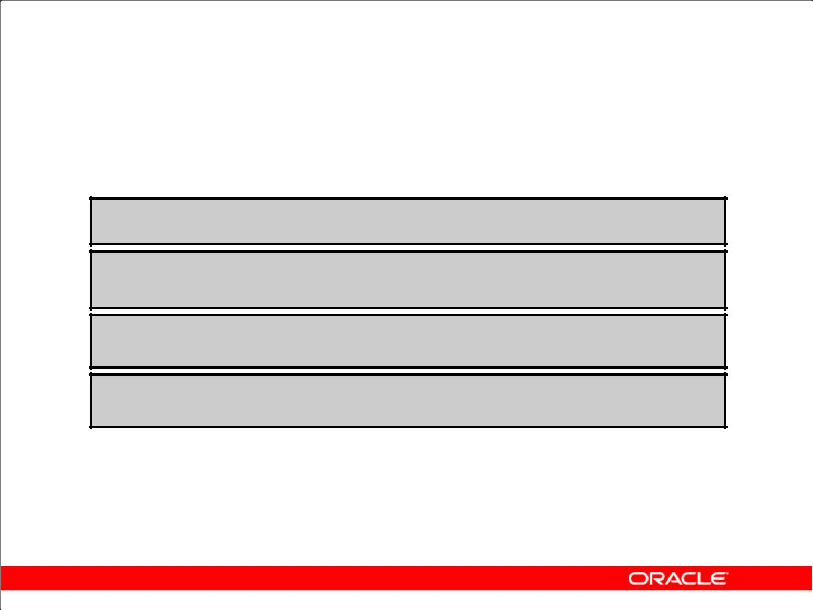**REGEXP Function Syntax**

**REGEXP_LIKE (srcstr, pattern [,match_option])**

**REGEXP_INSTR (srcstr, pattern [, position [, occurrence [, return_ option [, match_option]]]])**

**REGEXP_SUBSTR (srcstr, pattern [, position**

**[, occurrence [, match_option]]])**

**REGEXP_REPLACE(srcstr, pattern [,replacestr [, position [, occurrence [, match_option]]]])**

Copyright © 2009, Oracle. All rights reserved.

**REGEXP Function Syntax**

The following table contains descriptions of the terms shown in the syntax in the slide:

|  |  |
| --- | --- |
| srcstr | Search value |
|  |  |
| pattern | Regular expression |
|  |  |
| occurrence | Occurrence to search for |
|  |  |
| position | Search starting position |
|  |  |
| return_option | Start or end position of occurrence |
|  |  |
| replacestr | Character string replacing pattern |
|  |  |
| match_option | Option to change default matching; it can include one or |
|  | more of the following values: |
|  | “c” uses case-sensitive matching (default). |
|  | “i” uses non-case-sensitive matching. |
|  | “n” allows match-any-character operator. |
|  | “m” treats source string as multiple line. |
|  |  |

|  |
| --- |
| Oracle Internal & Oracle Academy Use Only |

**Oracle Database 10*g*: SQL Fundamentals II 8 - 8**

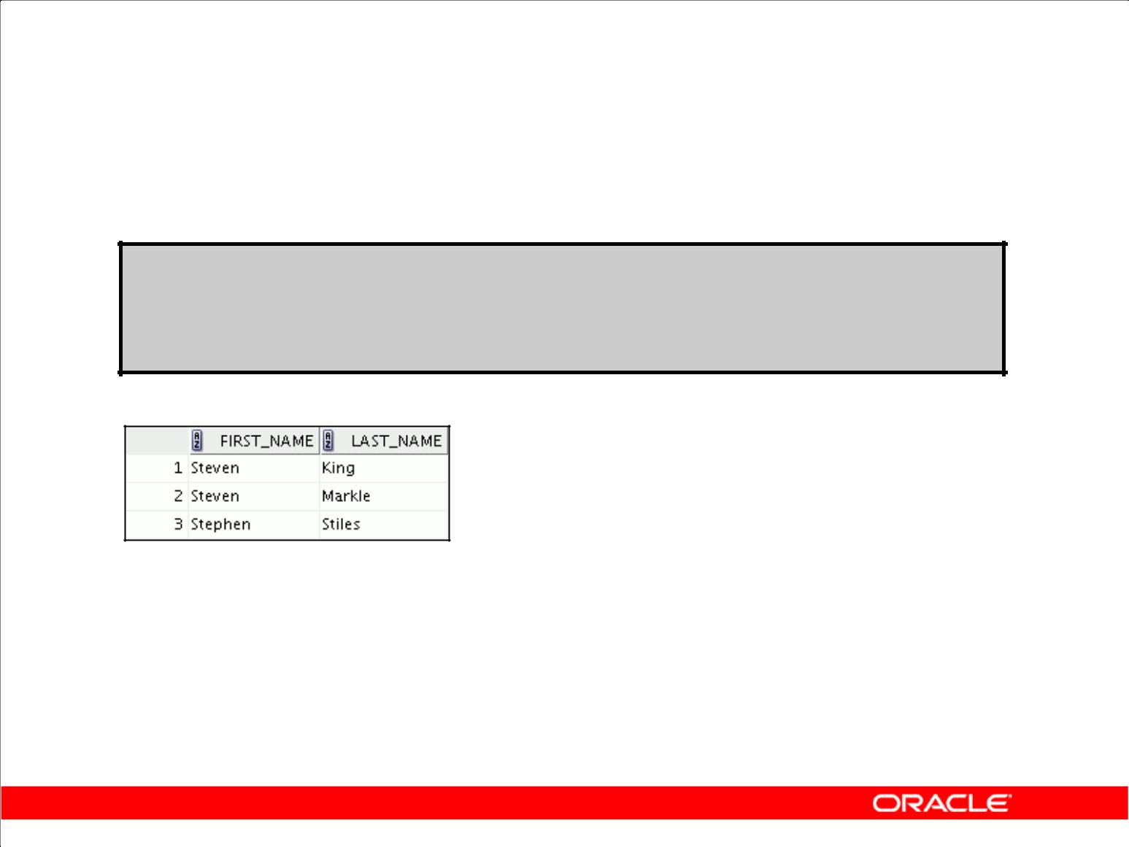**Performing Basic Searches**

**SELECT first_name, last_name**

**FROM employees**

**WHERE REGEXP_LIKE (first_name, '^Ste(v|ph)en$');**

Copyright © 2009, Oracle. All rights reserved.

**Example of REGEXP_LIKE**

In this query, against the EMPLOYEES table, all employees with first names containing either Steven or Stephen are displayed. In the expression used,

**'^Ste(v|ph)en$'** :

1. ^ indicates the beginning of the sentence
2. $ indicates the end of the sentence
3. | indicates either/or

|  |
| --- |
| Oracle Internal & Oracle Academy Use Only |

**Oracle Database 10*g*: SQL Fundamentals II 8 - 9**

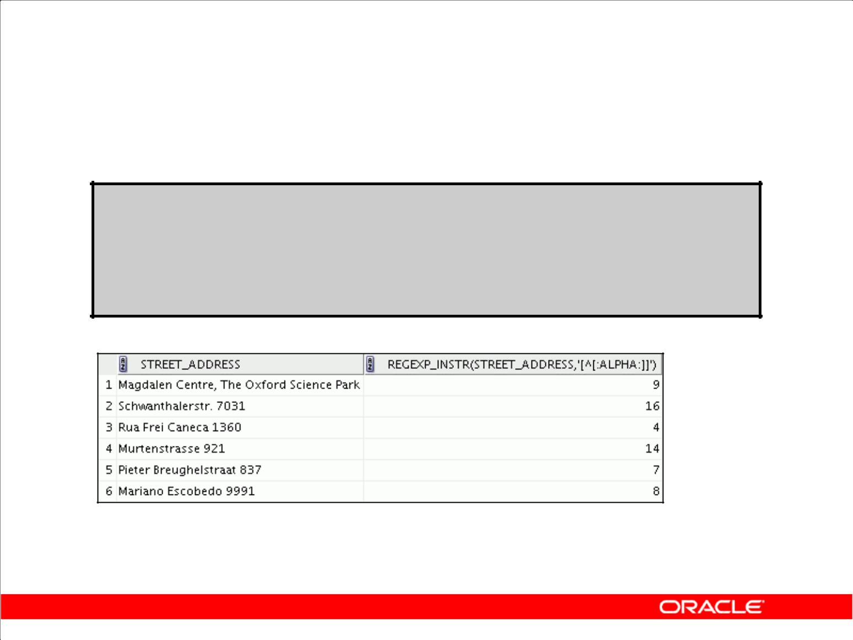**Checking the Presence of a Pattern**

**SELECT street_address,**

**REGEXP_INSTR(street_address,'[^[:alpha:]]')**

**FROM locations**

**WHERE**

**REGEXP_INSTR(street_address,'[^[:alpha:]]')> 1;**

Copyright © 2009, Oracle. All rights reserved.

**Checking the Presence of a Pattern**

In this example, the REGEXP_INSTR function is used to search the street address to find the location of the first nonalphabetic character, regardless of whether it is in uppercase or lowercase. The search is performed only on those addresses that do not start with a number. Note that [:<class>:] implies a character class and matches any character from within that class, and [:alpha:] matches with any alphabetic character. The results are displayed.

In the expression used in the query **'[^[:alpha:]]'**:

1. [ starts the expression
2. ^ indicates NOT
3. [:alpha:] indicates alpha character class
4. ] ends the expression

**Note:** The POSIX character class operator enables you to search for an expression within a characterlist that is a member of a specific POSIX character class. You can use this operator to search for specific formatting, such as uppercase characters, or you can search for special characters such as digits or punctuation characters. The full set of POSIX character classes is supported. Use the syntax [:*class*:] where *class* is the name of the POSIX character class to search for. The following regular expression searches for one or more consecutive uppercase characters: [[:upper:]]+ .

|  |
| --- |
| Oracle Internal & Oracle Academy Use Only |

**Oracle Database 10*g*: SQL Fundamentals II 8 - 10**

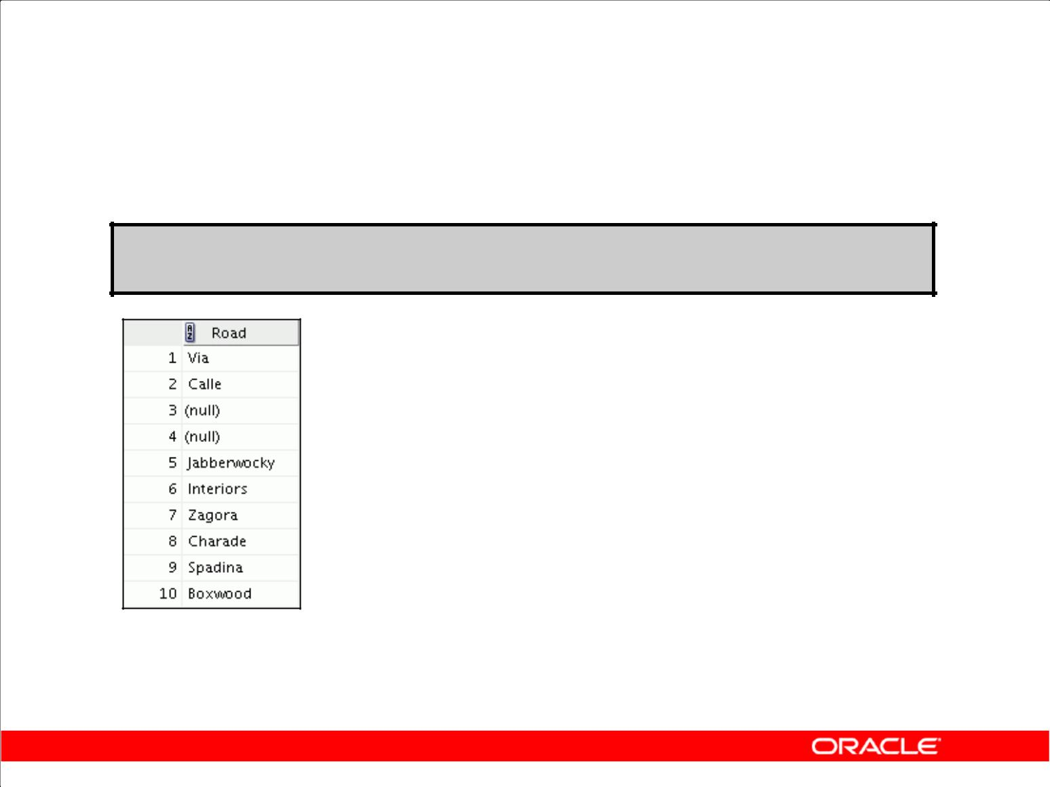**Example of Extracting Substrings**

**SELECT REGEXP_SUBSTR(street_address , ' [^ ]+ ')**

**"Road" FROM locations;**

**…**

Copyright © 2009, Oracle. All rights reserved.

**Example of Extracting a Substring**

In this example, the road names are extracted from the LOCATIONS table. To do this, the contents in the STREET_ADDRESS column that are before the first space are returned using the REGEXP_SUBSTR function. In the expression used in the query '[^ ]+ ':

1. [ starts the expression
2. ^ indicates NOT
3. indicates space
4. ] ends the expression
5. + indicates 1 or more
6. indicates space

|  |
| --- |
| Oracle Internal & Oracle Academy Use Only |

**Oracle Database 10*g*: SQL Fundamentals II 8 - 11**

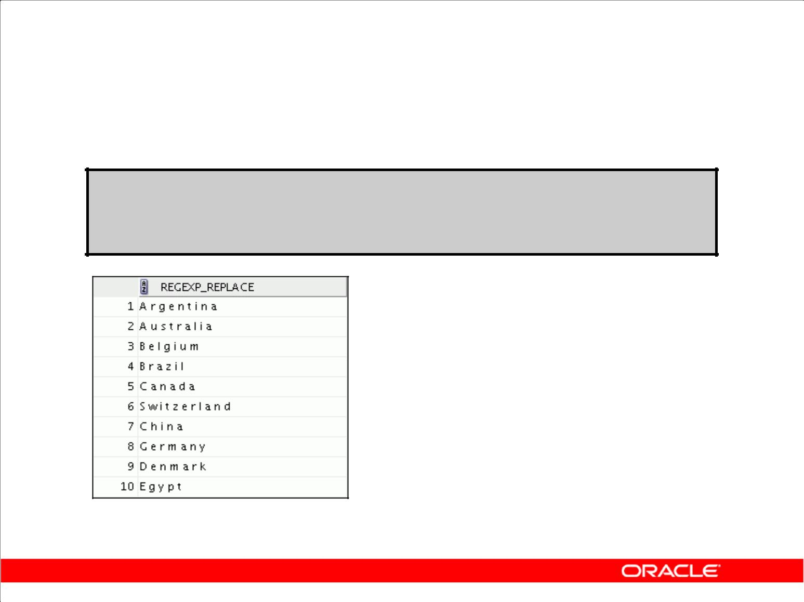**Replacing Patterns**

**SELECT REGEXP_REPLACE( country_name, '(.)', '\1 ') "REGEXP_REPLACE"**

**FROM countries;**

**…**

Copyright © 2009, Oracle. All rights reserved.

**Replacing Patterns**

This example examines COUNTRY_NAME. The Oracle Database reformats this pattern with a space after each non-null character in the string. The results are shown.

|  |
| --- |
| Oracle Internal & Oracle Academy Use Only |

**Oracle Database 10*g*: SQL Fundamentals II 8 - 12**

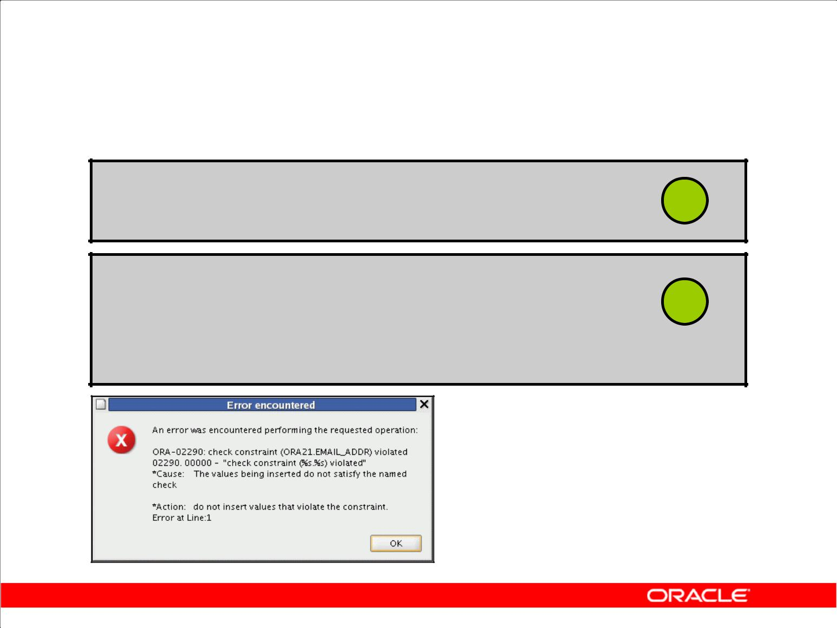**Regular Expressions and**

**Check Constraints**

**ALTER TABLE emp8**

**ADD CONSTRAINT email_addr** **1**

**CHECK(REGEXP_LIKE(email,'@'))NOVALIDATE ;**

**INSERT INTO emp8 VALUES**

**(500,'Christian','Patel', 2 'ChrisP2creme.com', 1234567890, '12-Jan-2004', 'HR_REP', 2000, null, 102, 40) ;**

Copyright © 2009, Oracle. All rights reserved.

**Regular Expressions and Check Constraints**

Regular expressions can also be used in check constraints. In this example, a check constraint is added on the EMAIL column of the EMPLOYEES table. This ensures that only strings containing an

“@” symbol are accepted. The constraint is tested. The check constraint is violated because the e-mail address does not contain the required symbol. The NOVALIDATE clause ensures that the

existing data is not checked.

|  |
| --- |
| Oracle Internal & Oracle Academy Use Only |

**Oracle Database 10*g*: SQL Fundamentals II 8 - 13**

**Summary**

In this lesson, you should have learned how to use regular expression support in SQL and PL/SQL to search, match, and replace strings in terms of regular expressions.

Copyright © 2009, Oracle. All rights reserved.

**Summary**

In this lesson, you have learned to use the regular expression support features that have been introduced in Oracle Database 10*g*.

|  |
| --- |
| Oracle Internal & Oracle Academy Use Only |

**Oracle Database 10*g*: SQL Fundamentals II 8 - 14**

**Practice 8: Overview**

This practice covers using regular expressions.

Copyright © 2009, Oracle. All rights reserved.

**Practice 8: Overview**

This practices covers searching and replacing data using regular expressions.

|  |
| --- |
| Oracle Internal & Oracle Academy Use Only |

**Oracle Database 10*g*: SQL Fundamentals II 8 - 15**

**Practice 8**

1. Write a query to search the EMPLOYEES table for all employees whose first names start with “Ne” or “Na.”
2. Create a query that removes the spaces in the STREET _ADDRESS column of the LOCATIONS table in the display.

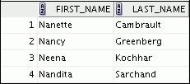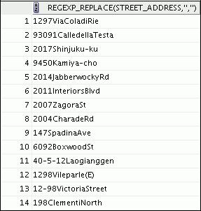

**…**

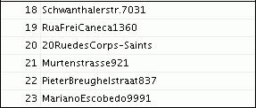

|  |
| --- |
| Oracle Internal & Oracle Academy Use Only |

**Oracle Database 10*g*: SQL Fundamentals II 8 - 16**

**Practice 8 (continued)**

1. Create a query that displays “St” replaced by “Street” in the STREET_ADDRESS column of the LOCATIONS table. Be careful that you do not affect any rows that already have “Street” in them. Display only those rows that are affected.

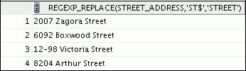

|  |
| --- |
| Oracle Internal & Oracle Academy Use Only |

**Oracle Database 10*g*: SQL Fundamentals II 8 - 17**

Oracle Internal & Oracle Academy Use Only

**_____________________**

**Appendix A:**

**Practice Solutions**

**_____________________**

|  |
| --- |
| Oracle Internal & Oracle Academy Use Only |

**Practice 1: Solutions**

To complete question 6 and the subsequent ones, you need to connect to the database using SQL Developer. To do so, double-click the SQL Developer icon on the desktop.

To create a new database connection in the Connections Navigator, right-click Connections. Select New Connection from the menu. The New/Select Database Connection dialog box appears.

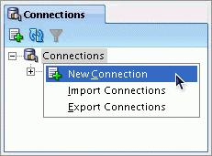

Create a database connection using the following information:

1. Connection Name: ora21
2. Username: ora21
3. Password: ora21
4. Hostname: localhost
5. Port: 1521
6. SID: ORCL
7. Ensure that you select the Save Password check box.

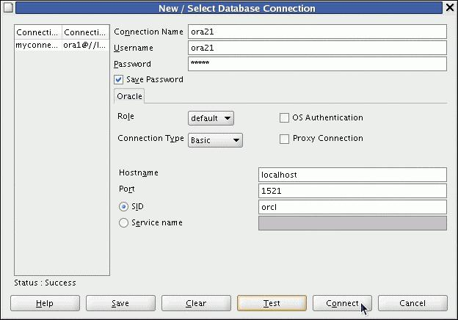

|  |
| --- |
| Oracle Internal & Oracle Academy Use Only |

**Practice 1: Solutions (continued)**

Create another database connection using the following information:

1. Connection Name: ora22
2. Username: ora22
3. Password: ora22
4. Hostname: localhost
5. Port: 1521
6. SID: ORCL
7. Ensure that you select the Save Password check box.

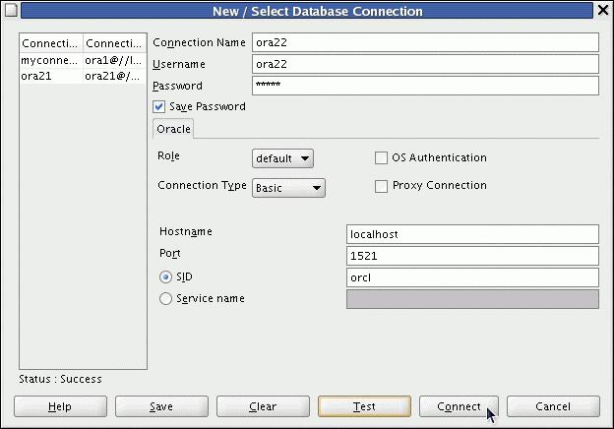

1. Which privilege should a user be given to log on to the Oracle server? Is this a system or an object privilege?

**The CREATE SESSION system privilege**

1. Which privilege should a user be given to create tables?

**The CREATE TABLE privilege**

1. If you create a table, who can pass along privileges to other users on your table?

**You can, or anyone that you have given those privileges to, by using the WITH GRANT OPTION**

1. You are the DBA. You are creating many users who require the same system privileges. What should you use to make your job easier?

**Create a role containing the system privileges and grant the role to the users.**

1. Which command would you use to change your password?

**The ALTER USER statement**

**Oracle Database 10*g*: SQL Fundamentals II A - 3**

|  |
| --- |
| Oracle Internal & Oracle Academy Use Only |

**Practice 1: Solutions (continued)**

6. Connect as user ora21. Query all the rows in your DEPARTMENTS table.

**SELECT \***

**FROM** **departments;**

1. Add a new row to your DEPARTMENTS table. Add Education as department number 500.

**INSERT INTO departments (department_id, department_name)**

**VALUES (500, 'Education');**

**COMMIT;**

1. Grant user ora22 access to your DEPARTMENTS table.

**GRANT SELECT ON departments TO ora22;**

1. Connect as user ora22. Query user ora21’s DEPARTMENTS table.

**SELECT \***

**FROM ora21.departments;**

1. Create a synonym for user ora21’s DEPARTMENTS table. Query all the rows in user ora21’s DEPARTMENTS table by using your synonym.

**CREATE SYNONYM new_dept**

**FOR ora21.DEPARTMENTS;**

**SELECT \***

**FROM new_dept;**

1. As user ora22, query the USER_TABLES data dictionary to see information about the tables that you own.

**SELECT table_name**

**FROM** **user_tables;**

|  |
| --- |
| Oracle Internal & Oracle Academy Use Only |

**Oracle Database 10*g*: SQL Fundamentals II A - 4**

**Practice 1: Solutions (continued)**

1. As user ora22, query the ALL_TABLES data dictionary view to see information about all the tables that you can access. Exclude the tables that you own.

**SELECT table_name, owner**

**FROM** **all_tables**

**WHERE** **owner <>'ORA22';**

13. Connect as user ora21 and revoke the SELECT privilege from user ora22.

**REVOKE SELECT ON departments**

**FROM ora22;**

1. Remove the row that you inserted into the DEPARTMENTS table in step 7 and save the changes.

**DELETE FROM** **departments**

**WHERE department_id = 500**

**/**

**COMMIT**

**/**

|  |
| --- |
| Oracle Internal & Oracle Academy Use Only |

**Oracle Database 10*g*: SQL Fundamentals II A - 5**

**Practice 2: Solutions**

1. Create the DEPT2 table based on the following table instance chart. Place the syntax in a script called lab_02_01.sql, and then execute the statement in the script to create the table. Confirm that the table is created.

|  |  |  |
| --- | --- | --- |
| **Column Name** | ID | NAME |
|  |  |  |
| **Key Type** |  |  |
|  |  |  |
| **Nulls/Unique** |  |  |
|  |  |  |
| **FK Table** |  |  |
|  |  |  |
| **FK Column** |  |  |
|  |  |  |
| **Data type** | NUMBER | VARCHAR2 |
|  |  |  |
| **Length** | 7 | 25 |
|  |  |  |

**CREATE TABLE dept2**

**(id NUMBER(7),**

**name VARCHAR2(25));**

**DESCRIBE dept2**

1. Populate the DEPT2 table with data from the DEPARTMENTS table. Include only the columns that you need.

**INSERT INTO dept2**

**SELECT** **department_id, department_name**

**FROM** **departments;**

1. Create the EMP2 table based on the following table instance chart. Place the syntax in a script called lab_02_03.sql, and then execute the statement in the script to create the table. Confirm that the table is created.

|  |  |
| --- | --- |
| **CREATE TABLE** | **emp2** |
| **(id** | **NUMBER(7),** |
| **last_name** | **VARCHAR2(25),** |
| **first_name** | **VARCHAR2(25),** |
| **dept_id** | **NUMBER(7));** |
| **DESCRIBE emp2** |  |
|  |  |

|  |
| --- |
| Oracle Internal & Oracle Academy Use Only |

**Practice 2: Solutions (continued)**

1. Modify the EMP2 table to allow for longer employee last names. Confirm your modification.

**ALTER TABLE emp2**

**MODIFY (last_name VARCHAR2(50));**

**DESCRIBE emp2**

1. Confirm that both the DEPT2 and EMP2 tables are stored in the data dictionary. (**Hint:**

USER_TABLES)

**SELECT table_name**

**FROM** **user_tables**

**WHERE** **table_name IN ('DEPT2', 'EMP2');**

1. Create the EMPLOYEES2 table based on the structure of the EMPLOYEES table. Include only the EMPLOYEE_ID, FIRST_NAME, LAST_NAME, SALARY, and

DEPARTMENT_ID columns. Name the columns in your new table ID, FIRST_NAME,

LAST_NAME, SALARY, and DEPT_ID, respectively.

**CREATE TABLE employees2 AS**

**SELECT** **employee_id id, first_name, last_name, salary,**

**department_id dept**_**id**

**FROM** **employees;**

1. Drop the EMP2 table.

**DROP TABLE emp2;**

1. Query the Recycle bin to see whether the table is present.

**SELECT original_name, operation, droptime FROM recyclebin;**

9. Undrop the EMP2 table.

**FLASHBACK TABLE emp2 TO BEFORE DROP; DESC emp2;**

**Oracle Database 10*g*: SQL Fundamentals II A - 7**

|  |
| --- |
| Oracle Internal & Oracle Academy Use Only |

**Practice 2: Solutions (continued)**

1. Drop the FIRST_NAME column from the EMPLOYEES2 table. Confirm your modification by checking the description of the table.

**ALTER TABLE employees2**

**DROP COLUMN first_name;**

**DESCRIBE employees2**

1. In the EMPLOYEES2 table, mark the DEPT_ID column as UNUSED. Confirm your modification by checking the description of the table.

**ALTER TABLE employees2**

**SET** **UNUSED (dept_id);**

**DESCRIBE employees2**

1. Drop all the UNUSED columns from the EMPLOYEES2 table. Confirm your modification by checking the description of the table.

**ALTER TABLE employees2**

**DROP UNUSED COLUMNS;**

**DESCRIBE employees2**

1. Add a table-level PRIMARY KEY constraint to the EMP2 table on the ID column. The constraint should be named at creation. Name the constraint my_emp_id_pk.

**ALTER TABLE** **emp2**

**ADD CONSTRAINT my_emp**_**id**_**pk PRIMARY KEY (id);**

1. Create a PRIMARY KEY constraint to the DEPT2 table using the ID column. The constraint should be named at creation. Name the constraint my_dept_id_pk.

**ALTER TABLE** **dept2**

**ADD CONSTRAINT my_dept_id_pk PRIMARY KEY(id);**

1. Add a foreign key reference on the EMP2 table that ensures that the employee is not assigned to a nonexistent department. Name the constraint my_emp_dept_id_fk.

**ALTER TABLE emp2**

**ADD CONSTRAINT my_emp_dept_id_fk**

**FOREIGN KEY (dept_id) REFERENCES dept2(id);**

|  |
| --- |
| Oracle Internal & Oracle Academy Use Only |

**Oracle Database 10*g*: SQL Fundamentals II A - 8**

**Practice 2: Solutions (continued)**

1. Confirm that the constraints were added by querying the USER_CONSTRAINTS view. Note the types and names of the constraints.

**SELECT constraint_name, constraint_type**

**FROM** **user**_**constraints**

**WHERE** **table**_**name IN ('EMP2', 'DEPT2');**

1. Display the object names and types from the USER_OBJECTS data dictionary view for the EMP2 and DEPT2 tables. Note that the new tables are created and a new index is created.

|  |  |  |
| --- | --- | --- |
| **SELECT** | **object_name, object_type** | |
| **FROM** | **user_objects** | |
| **WHERE** | **object_name** | **LIKE 'EMP%'** |
| **OR** | **object_name** | **LIKE 'DEPT%';** |
|  |  |  |

If you have the time, complete the following exercise:

1. Modify the EMP2 table. Add a COMMISSION column of the NUMBER data type, precision 2, and scale 2. Add a constraint to the COMMISSION column that ensures that a commission value is greater than zero.

**ALTER TABLE emp2**

**ADD commission NUMBER(2,2)**

**CONSTRAINT my_emp_comm_ck CHECK (commission > 0);**

19. Drop the EMP2 and DEPT2 tables so that they cannot be restored. Verify the Recycle Bin.

**DROP TABLE emp2 PURGE;**

**DROP TABLE dept2 PURGE;**

**SELECT original_name, operation, droptime FROM recyclebin;**

1. Create the DEPT_NAMED_INDEX table based on the following table instance chart. Name the index for the PRIMARY KEY column as DEPT_PK_IDX.

|  |  |  |
| --- | --- | --- |
| **Column Name** | Deptno | Dname |
|  |  |  |
| **Primary Key** | Yes |  |
|  |  |  |
| **Data Type** | Number | VARCHAR2 |
|  |  |  |
| **Length** | 4 | 30 |
|  |  |  |

**Oracle Database 10*g*: SQL Fundamentals II A - 9**

|  |
| --- |
| Oracle Internal & Oracle Academy Use Only |

**Practice 2: Solutions (continued)**

**CREATE TABLE DEPT_NAMED_INDEX**

**(deptno NUMBER(4)**

**PRIMARY KEY USING INDEX**

**(CREATE INDEX dept_pk_idx ON**

**DEPT_NAMED_INDEX(deptno)),**

**dname VARCHAR2(30));**

|  |
| --- |
| Oracle Internal & Oracle Academy Use Only |

**Oracle Database 10*g*: SQL Fundamentals II A - 10**

**Practice 3: Solutions**

1. Run the lab_03_01.sql script in the lab folder to create the SAL_HISTORY table.
2. Display the structure of the SAL_HISTORY table.

**DESC sal_history**

1. Run the lab_03_03.sql script in the lab folder to create the MGR_HISTORY table.
2. Display the structure of the MGR_HISTORY table.

**DESC mgr_history**

1. Run the lab_03_05.sql script in the lab folder to create the SPECIAL_SAL table.
2. Display the structure of the SPECIAL_SAL table.

**DESC special_sal**

1. a. Write a query to do the following:
   1. Retrieve the employee ID, hire date, salary, and manager ID of those employees whose employee ID is less than 125 from the EMPLOYEES table.
   2. If the salary is more than $20,000, insert the employee ID and salary into the

SPECIAL_SAL table.

* 1. Insert the employee ID, hire date, and salary into the SAL_HISTORY table.
  2. Insert the employee ID, manager ID, and salary into the MGR_HISTORY table.

**INSERT ALL**

**WHEN SAL > 20000 THEN**

**INTO** **special_sal VALUES (EMPID, SAL)**

**ELSE**

**INTO sal_history VALUES(EMPID,HIREDATE,SAL)**

**INTO mgr_history VALUES(EMPID,MGR,SAL)**

**SELECT employee_id EMPID, hire_date HIREDATE,**

|  |
| --- |
| Oracle Internal & Oracle Academy Use Only |

**Practice 3: Solutions (continued)**

**salary SAL, manager_id MGR**

**FROM employees**

**WHERE employee_id < 125;**

* 1. Display the records from the SPECIAL_SAL table.

**SELECT * FROM special_sal;**

* 1. Display the records from the SAL_HISTORY table.

**SELECT * FROM sal_history;**

* 1. Display the records from the MGR_HISTORY table.

**SELECT * FROM mgr_history;**

1. a. Run the lab_03_08a.sql script in the lab folder to create the

SALES_SOURCE_DATA table.

* 1. Run the lab_03_08b.sql script in the lab folder to insert records into the

SALES_SOURCE_DATA table.

* 1. Display the structure of the SALES_SOURCE_DATA table.

**DESC sales_source_data**

1. Display the records from the SALES_SOURCE_DATA table.

**SELECT * FROM SALES_SOURCE_DATA;**

1. Run the lab_03_08c.sql script in the lab folder to create the

SALES_INFO table.

1. Display the structure of the SALES_INFO table.

**DESC sales_info**

**Oracle Database 10*g*: SQL Fundamentals II A - 12**

|  |
| --- |
| Oracle Internal & Oracle Academy Use Only |

**Practice 3: Solutions (continued)**

1. Write a query to do the following:
   1. Retrieve the details of the employee ID, week ID, sales on Monday, sales on Tuesday, sales on Wednesday, sales on Thursday, and sales on Friday from the

SALES_SOURCE_DATA table.

* 1. Build a transformation such that each record retrieved from the

SALES_SOURCE_DATA table is converted into multiple records for the

SALES_INFO table.

**Hint:** Use a pivotingINSERTstatement.

|  |  |
| --- | --- |
| **INSERT** | **ALL** |
| **INTO** | **sales_info VALUES (employee_id, week_id, sales_MON)** |
| **INTO** | **sales_info VALUES (employee_id, week_id, sales_TUE)** |
| **INTO** | **sales_info VALUES (employee_id, week_id, sales_WED)** |
| **INTO** | **sales_info VALUES (employee_id, week_id,** |
|  | **sales_THUR)** |
| **INTO** | **sales_info VALUES (employee_id, week_id, sales_FRI)** |

**SELECT EMPLOYEE_ID, week_id, sales_MON, sales_TUE,**

**sales_WED, sales_THUR,sales_FRI FROM sales_source_data;**

h. Display the records from the SALES_INFO table.

**SELECT * FROM sales_info;**

1. You have the data of past employees stored in a flat file called emp.data. You want to store the names and email IDs of all past and present employees in a table. To do this, first create an external table called EMP_DATA using the emp.dat source file in the emp_dir directory. You can use the script in lab_03_09.sql to do this.

|  |
| --- |
| Oracle Internal & Oracle Academy Use Only |

**Oracle Database 10*g*: SQL Fundamentals II A - 13**

**Practice 3: Solutions (continued)**

**CREATE TABLE emp_data**

**(first_name** **VARCHAR2(20)**

**,last_name** **VARCHAR2(20)**

**, email** **VARCHAR2(30)**

**)**

**ORGANIZATION EXTERNAL**

**(**

**TYPE oracle_loader**

**DEFAULT DIRECTORY emp_dir**

**ACCESS PARAMETERS**

**(**

**RECORDS DELIMITED BY NEWLINE CHARACTERSET US7ASCII**

**NOBADFILE**

**NOLOGFILE**

**FIELDS**

**( first_name POSITION ( 1:20) CHAR**

**, last_name POSITION (22:41) CHAR**

**, email** **POSITION (43:72) CHAR )**

**)**

**LOCATION ('emp.dat') ) ;**

1. Next, run the lab_03_10.sql script to create the EMP_HIST table.
   1. Increase the size of the email column to 45.
   2. Merge the data in the EMP_DATA table that was created in step 9 with the data in the EMP_HIST table. Assume that the data in the external EMP_DATA table is the most up-to-date. If a row in the EMP_DATA table matches the EMP_HIST table, update the email column of the EMP_HIST table to match the EMP_DATA table row. If a row in the EMP_DATA table does not match, insert it into the EMP_HIST table. Rows are considered matching when the employee’s first and last names are identical.

**MERGE INTO EMP_HIST f USING EMP_DATA h**

**ON (f.first_name = h.first_name**

**AND f.last_name = h.last_name)**

**WHEN MATCHED THEN**

**UPDATE SET f.email = h.email**

**WHEN NOT MATCHED THEN**

**INSERT (f.first_name**

1. **f.last_name**
2. **f.email)**

**VALUES (h.first_name**

1. **h.last_name**
2. **h.email);**

|  |
| --- |
| Oracle Internal & Oracle Academy Use Only |

**Oracle Database 10*g*: SQL Fundamentals II A - 14**

**Practice 3: Solutions (continued)**

* 1. Retrieve the rows from EMP_HIST after the merge.

**SELECT * FROM emp_hist;**

1. Create the EMP3 table using the lab_03_11.sql script. In the EMP3 table, change the department for Kochhar to 60 and commit your change. Next, change the department for Kochhar to 50 and commit your change. Track the changes to Kochhar using the Row Versions feature.

**UPDATE emp3 SET department_id = 60**

**WHERE last_name = ‘Kochchar’;**

**COMMIT;**

**UPDATE emp3 SET department_id = 50**

**WHERE last_name = ‘Kochchar’;**

**COMMIT;**

**SELECT VERSIONS_STARTTIME "START_DATE",**

**VERSIONS_ENDTIME "END_DATE",** **DEPARTMENT_ID**

**FROM EMP3**

**VERSIONS BETWEEN SCN MINVALUE AND MAXVALUE**

**WHERE LAST_NAME ='Kochhar';**

|  |
| --- |
| Oracle Internal & Oracle Academy Use Only |

**Oracle Database 10*g*: SQL Fundamentals II A - 15**

**Practice 4: Solutions**

1. Write a query to display the following for those employees whose manager ID is less than 120:
   1. Manager ID
   2. Job ID and total salary for every job ID for employees who report to the same manager
   3. Total salary of those managers
   4. Total salary of those managers, irrespective of the job IDs

**SELECT manager_id,job_id,sum(salary)**

**FROM** **employees**

**WHERE manager_id < 120**

**GROUP BY ROLLUP(manager_id,job_id);**

1. Observe the output from question 1. Write a query using the GROUPING function to determine whether the NULL values in the columns corresponding to the GROUP BY expressions are caused by the ROLLUP operation.

**SELECT manager_id MGR ,job_id JOB, sum(salary),GROUPING(manager_id),GROUPING(job_id)**

**FROM employees**

**WHERE manager_id < 120**

**GROUP BY ROLLUP(manager_id,job_id);**

1. Write a query to display the following for those employees whose manager ID is less than 120:
   1. Manager ID
   2. Job and total salary for every job for employees who report to the same manager
   3. Total salary of those managers
   4. Cross-tabulation values to display the total salary for every job, irrespective of the manager
   5. Total salary irrespective of the job titles

**SELECT manager_id, job_id, sum(salary) FROM employees**

**WHERE manager_id < 120**

**GROUP BY CUBE(manager_id, job_id);**

|  |
| --- |
| Oracle Internal & Oracle Academy Use Only |

**Practice 4: Solutions (continued)**

1. Observe the output from question 3. Write a query using the GROUPING function to determine whether the NULL values in the columns corresponding to the GROUP BY expressions are caused by the CUBE operation.

**SELECT manager_id MGR ,job_id JOB, sum(salary),GROUPING(manager_id),GROUPING(job_id) FROM employees**

**WHERE manager_id < 120**

**GROUP BY CUBE(manager_id,job_id);**

1. Using GROUPING SETS, write a query to display the following groupings:
   1. department_id, manager_id, job_id
   2. department_id, job_id
   3. manager_id, job_id

The query should calculate the sum of the salaries for each of these groups.

**SELECT department_id, manager_id, job_id, SUM(salary)**

**FROM employees**

**GROUP BY**

**GROUPING SETS ((department_id, manager_id, job_id), (department_id, job_id),(manager_id,job_id));**

|  |
| --- |
| Oracle Internal & Oracle Academy Use Only |

**Oracle Database 10*g*: SQL Fundamentals II A - 17**

**Practice 5: Solutions**

1. Alter the session to set the NLS_DATE_FORMAT to DD-MON-YYYY HH24:MI:SS.

**ALTER SESSION SET NLS_DATE_FORMAT = 'DD-MON-YYYY HH24:MI:SS';**

1. a. Write queries to display the time zone offsets (TZ_OFFSET) for the following time zones:

*US/Pacific-New*

**SELECT TZ_OFFSET ('US/Pacific-New') from dual;**

*Singapore*

**SELECT TZ_OFFSET ('Singapore') from dual;**

*Egypt*

**SELECT TZ_OFFSET ('Egypt') from dual;**

1. Alter the session to set the TIME_ZONE parameter value to the time zone offset of US/Pacific-New.

**ALTER SESSION SET TIME_ZONE = '-7:00';**

1. Display the CURRENT_DATE, CURRENT_TIMESTAMP, and LOCALTIMESTAMP for this session.

**Note:** The output may be different based on the date when the command is executed.

**SELECT CURRENT_DATE, CURRENT_TIMESTAMP,**

**LOCALTIMESTAMP FROM DUAL;**

1. Alter the session to set the TIME_ZONE parameter value to the time zone offset of Singapore.

**ALTER SESSION SET TIME_ZONE = '+8:00';**

1. Display the CURRENT_DATE, CURRENT_TIMESTAMP, LOCALTIMESTAMP for this session.

**Note:** The output may be different based on the date when the command is executed.

**SELECT CURRENT_DATE, CURRENT_TIMESTAMP, LOCALTIMESTAMP FROM DUAL;**

|  |
| --- |
| Oracle Internal & Oracle Academy Use Only |

**Practice 5: Solutions (continued)**

**Note: Observe in the preceding practice that CURRENT_DATE,**

**CURRENT_TIMESTAMP, and LOCALTIMESTAMP are all sensitive to the session time zone.**

1. Write a query to display DBTIMEZONE and SESSIONTIMEZONE.

**SELECT DBTIMEZONE,SESSIONTIMEZONE**

**FROM DUAL;**

1. Write a query to extract YEAR from the HIRE_DATE column of the EMPLOYEES table for those employees who work in department 80.

**SELECT last_name, EXTRACT (YEAR FROM HIRE_DATE)**

**FROM employees**

**WHERE department_id = 80;**

1. Alter the session to set NLS_DATE_FORMAT to DD-MON-YYYY.

**ALTER SESSION SET NLS_DATE_FORMAT = 'DD-MON-YYYY';**

1. Examine and run the lab_05_06.sql script to create the SAMPLE_DATES table and populate it.
2. Select from the table and view the data.

**SELECT * FROM sample_dates;**

* 1. Change the data type of the DATE_COL column to TIMESTAMP. Select from the table to view the data.

**ALTER TABLE sample_dates MODIFY date_col TIMESTAMP; SELECT * FROM sample_dates;**

1. Try to change the data type of the DATE_COL column to TIMESTAMP WITH TIME ZONE. What happens?

**ALTER TABLE sample_dates MODIFY date_col TIMESTAMP WITH TIME ZONE;**

**You are unable to change the data type of the DATE_COL column because the Oracle server does not permit you to convert from TIMESTAMP to TIMESTAMP WITH TIMEZONE by using the ALTER statement.**

**Oracle Database 10*g*: SQL Fundamentals II A - 19**

|  |
| --- |
| Oracle Internal & Oracle Academy Use Only |

**Practice 5: Solutions (continued)**

1. Create a query to retrieve last names from the EMPLOYEES table and calculate the review status. If the year hired is 1998, display Needs Review for the review status; otherwise, display not this year! Name the review status column Review. Sort the results by the HIRE_DATE column.

**Hint:** Use aCASEexpression with theEXTRACTfunction to calculate the review status.

**SELECT e.last_name**

1. **(CASE extract(year from e.hire_date) WHEN 1998 THEN 'Needs Review'**

**ELSE 'not this year!'**

**END )** **AS "Review "**

**FROM employees e**

**ORDER BY e.hire_date;**

1. Create a query to print the last names and the number of years of service for each employee. If the employee has been employed for five or more years, print 5 years of service. If the employee has been employed for 10 or more years, print 10 years of service. If the employee has been employed for 15 or more years, print 15 years of service. If none of these conditions match, print maybe next year! Sort the results by the HIRE_DATE column. Use the EMPLOYEES table.

**Hint:** UseCASEexpressions andTO_YMINTERVAL.

**SELECT e.last_name, hire_date, sysdate,**

**(CASE**

**WHEN (sysdate -TO_YMINTERVAL('15-0'))>=**

**hire_date THEN** **'15 years of service'**

**WHEN (sysdate -TO_YMINTERVAL('10-0'))>= hire_date**

**THEN '10 years of service'**

**WHEN (sysdate - TO_YMINTERVAL('5-0'))>= hire_date**

**THEN '5 years of service'**

**ELSE 'maybe next year!'**

**END) AS "Awards"**

**FROM employees e;**

|  |
| --- |
| Oracle Internal & Oracle Academy Use Only |

**Oracle Database 10*g*: SQL Fundamentals II A - 20**

**Practice 6: Solutions**

1. Write a query to display the last name, department number, and salary of any employee whose department number and salary both match the department number and salary of any employee who earns a commission.

**SELECT last_name, department_id, salary**

**FROM employees**

**WHERE (salary, department_id) IN**

**(SELECT salary, department_id**

**FROM** **employees**

**WHERE** **commission_pct IS NOT NULL);**

1. Display the last name, department name, and salary of any employee whose salary and commission match the salary and commission of any employee located in location ID 1700.

|  |  |  |
| --- | --- | --- |
| **SELECT e.last_name,** | | **d.department_name, e.salary** |
| **FROM** | **employees e,** | **departments d** |
| **WHERE** | **e.department_id = d.department_id** | |
| **AND** | **(salary, NVL(commission_pct,0)) IN** | |
|  | **(SELECT** | **salary, NVL(commission_pct,0)** |
|  | **FROM** | **employees e, departments d** |
|  | **WHERE** | **e.department_id = d.department_id** |
|  | **AND** | **d.location_id = 1700);** |
|  |  |  |

1. Create a query to display the last name, hire date, and salary for all employees who have the same salary and commission as Kochhar.

**Note:** Do not display Kochhar in the result set.

**SELECT last_name, hire_date, salary FROM employees**

**WHERE (salary, NVL(commission_pct,0)) IN**

**(SELECT salary, NVL(commission_pct,0)**

**FROM** **employees**

**WHERE last_name = 'Kochhar')**

**AND last_name != 'Kochhar';**

|  |
| --- |
| Oracle Internal & Oracle Academy Use Only |

**Practice 6: Solutions (continued)**

1. Create a query to display the employees who earn a salary that is higher than the salary of all the sales managers (JOB_ID = 'SA_MAN'). Sort the results on salary from the highest to the lowest.

**SELECT last_name, job_id, salary**

**FROM employees**

**WHERE salary > ALL**

**(SELECT salary**

**FROM** **employees**

**WHERE job_id = 'SA_MAN')**

**ORDER BY salary DESC;**

1. Display the details of the employee ID, last name, and department ID of those employees who live in cities whose name begins with *T*.

**SELECT employee_id, last_name, department_id FROM employees**

**WHERE department_id IN (SELECT department_id**

**FROM departments**

**WHERE location_id IN**

**(SELECT** **location_id**

**FROM locations**

**WHERE city LIKE 'T%'));**

1. Write a query to find all the employees who earn more than the average salary in their departments. Display the last name, salary, department ID, and the average salary for the department. Sort by average salary. Use aliases for the columns retrieved by the query as shown in the sample output.

**SELECT e.last_name ename, e.salary salary,**

**e.department_id deptno, AVG(a.salary) dept_avg**

**FROM** **employees e, employees a**

**WHERE e.department_id = a.department_id**

**AND** **e.salary > (SELECT AVG(salary)**

**FROM employees**

**WHERE department_id = e.department_id ) GROUP BY e.last_name, e.salary, e.department_id ORDER BY AVG(a.salary);**

|  |
| --- |
| Oracle Internal & Oracle Academy Use Only |

**Oracle Database 10*g*: SQL Fundamentals II A - 22**

**Practice 6: Solutions (continued)**

1. Find all employees who are not supervisors.

a. First, do this by using the NOT EXISTS operator.

**SELECT outer.last_name**

**FROM** **employees outer**

**WHERE** **NOT EXISTS (SELECT 'X'**

**FROM employees inner**

**WHERE inner.manager_id =**

**outer.employee_id);**

b. Can this be done by using the NOT IN operator? How, or why not?

**SELECT outer.last_name**

**FROM** **employees outer**

**WHERE** **outer.employee_id**

**NOT IN (SELECT inner.manager_id**

**FROM** **employees inner);**

This alternative solution is not a good one. The subquery picks up a NULL value, so the entire query returns no rows. The reason is that all conditions that compare a NULL value result in NULL. Whenever NULL values are likely to be part of the value set, *do not* use NOT IN as a substitute for NOT EXISTS.

1. Write a query to display the last names of the employees who earn less than the average salary in their departments.

**SELECT last_name**

**FROM** **employees outer**

**WHERE outer.salary < (SELECT AVG(inner.salary)**

**FROM employees inner**

**WHERE inner.department_id**

**= outer.department_id);**

|  |
| --- |
| Oracle Internal & Oracle Academy Use Only |

**Oracle Database 10*g*: SQL Fundamentals II A - 23**

**Practice 6: Solutions (continued)**

1. Write a query to display the last names of the employees who have one or more coworkers in their departments with later hire dates but higher salaries.

**SELECT last_name**

**FROM** **employees outer**

**WHERE EXISTS (SELECT 'X'**

**FROM employees inner**

**WHERE inner.department_id =**

**outer.department_id**

**AND inner.hire_date > outer.hire_date AND inner.salary > outer.salary);**

1. Write a query to display the employee ID, last name, and department name of all employees.

**Note:** Use a scalar subquery to retrieve the department name in theSELECTstatement.

**SELECT employee_id, last_name,**

**(SELECT department_name**

**FROM departments d**

**WHERE** **e.department_id =**

**d.department_id ) department**

**FROM employees e**

**ORDER BY department;**

1. Write a query to display the department names of those departments whose total salary cost is above one-eighth (1/8) the total salary cost of the whole company. Use the WITH clause to write this query. Name the query SUMMARY.

**WITH**

**summary AS (**

**SELECT d.department_name, SUM(e.salary) AS dept_total FROM employees e, departments d**

**WHERE e.department_id = d.department_id GROUP BY d.department_name)**

**SELECT department_name, dept_total**

**FROM summary**

**WHERE dept_total > ( SELECT SUM(dept_total) * 1/8 FROM summary )**

**ORDER BY dept_total DESC;**

**Oracle Database 10*g*: SQL Fundamentals II A - 24**

|  |
| --- |
| Oracle Internal & Oracle Academy Use Only |

**Practice 7: Solutions**

1. Look at the following output examples. Are these outputs the result of a hierarchical query? Explain why or why not.

**Exhibit 1: This is not a hierarchical query; the report simply has a descending sort on SALARY.**

**Exhibit 2: This is not a hierarchical query; there are two tables involved.**

**Exhibit 3: Yes, this is most definitely a hierarchical query because it displays the tree structure representing the management reporting line from the EMPLOYEES table.**

1. Produce a report that shows an organization chart for Mourgos’s department. Print the last names, salaries, and department IDs.

**SELECT last_name, salary, department_id**

**FROM employees**

**START WITH last_name = 'Mourgos'**

**CONNECT BY PRIOR employee_id = manager_id;**

1. Create a report that shows the hierarchy of managers for employee Lorentz. Display his immediate manager first.

**SELECT last_name**

**FROM employees**

**WHERE last_name != 'Lorentz'**

**START WITH last_name = 'Lorentz'**

**CONNECT BY PRIOR manager_id = employee_id;**

1. Create an indented report that shows the management hierarchy starting from the employee whose LAST_NAME is Kochhar. Print the employee’s last name, manager ID, and department ID. Give alias names to the columns as shown in the sample output.

**COLUMN name FORMAT A20**

**SELECT LPAD(last_name, LENGTH(last_name)+(LEVEL*2)-2,'_')**

**name,manager_id mgr, department_id deptno FROM employees**

**START WITH last_name = 'Kochhar'**

**CONNECT BY PRIOR employee_id = manager_id**

**/**

**COLUMN name CLEAR**

|  |
| --- |
| Oracle Internal & Oracle Academy Use Only |

**Practice 7: Solutions (continued)**

If you have time, complete the following exercises:

1. Produce a company organization chart that shows the management hierarchy. Start with the person at the top level, exclude all people with a job ID of IT_PROG, and exclude De Haan and those employees who report to De Haan.

**SELECT last_name,employee_id, manager_id**

**FROM** **employees**

**WHERE job_id != 'IT_PROG'**

**START WITH manager_id IS NULL**

**CONNECT BY PRIOR employee_id = manager_id**

**AND last_name != 'De Haan';**

|  |
| --- |
| Oracle Internal & Oracle Academy Use Only |

**Oracle Database 10*g*: SQL Fundamentals II A - 26**

**Practice 8: Solutions**

1. Write a query to search the EMPLOYEES table for all employees whose first names start with “Ne” or “Na.”

**SELECT first_name, last_name**

**FROM employees**

**WHERE REGEXP_LIKE (first_name, '^N(e|a).');**

1. Create a query that removes the spaces in the STREET_ADDRESS column of the LOCATIONS table in the display.

**SELECT regexp_replace (street_address, ' ','')**

**FROM locations;**

1. Create a query that displays “St” replaced by “Street” in the STREET_ADDRESS column of the LOCATIONS table. Be careful that you do not affect any rows that already have “Street” in them. Display only those rows, which are affected.

**SELECT REGEXP_REPLACE (street_address, 'St$', 'Street') FROM locations**

**WHERE REGEXP_LIKE (street_address, 'St');**

|  |
| --- |
| Oracle Internal & Oracle Academy Use Only |

Oracle Internal & Oracle Academy Use Only

**_____________________**

**Appendix B:**

**Table Descriptions**

**and Data**

**_____________________**

|  |
| --- |
| Oracle Internal & Oracle Academy Use Only |

**ENTITY RELATIONSHIP DIAGRAM**

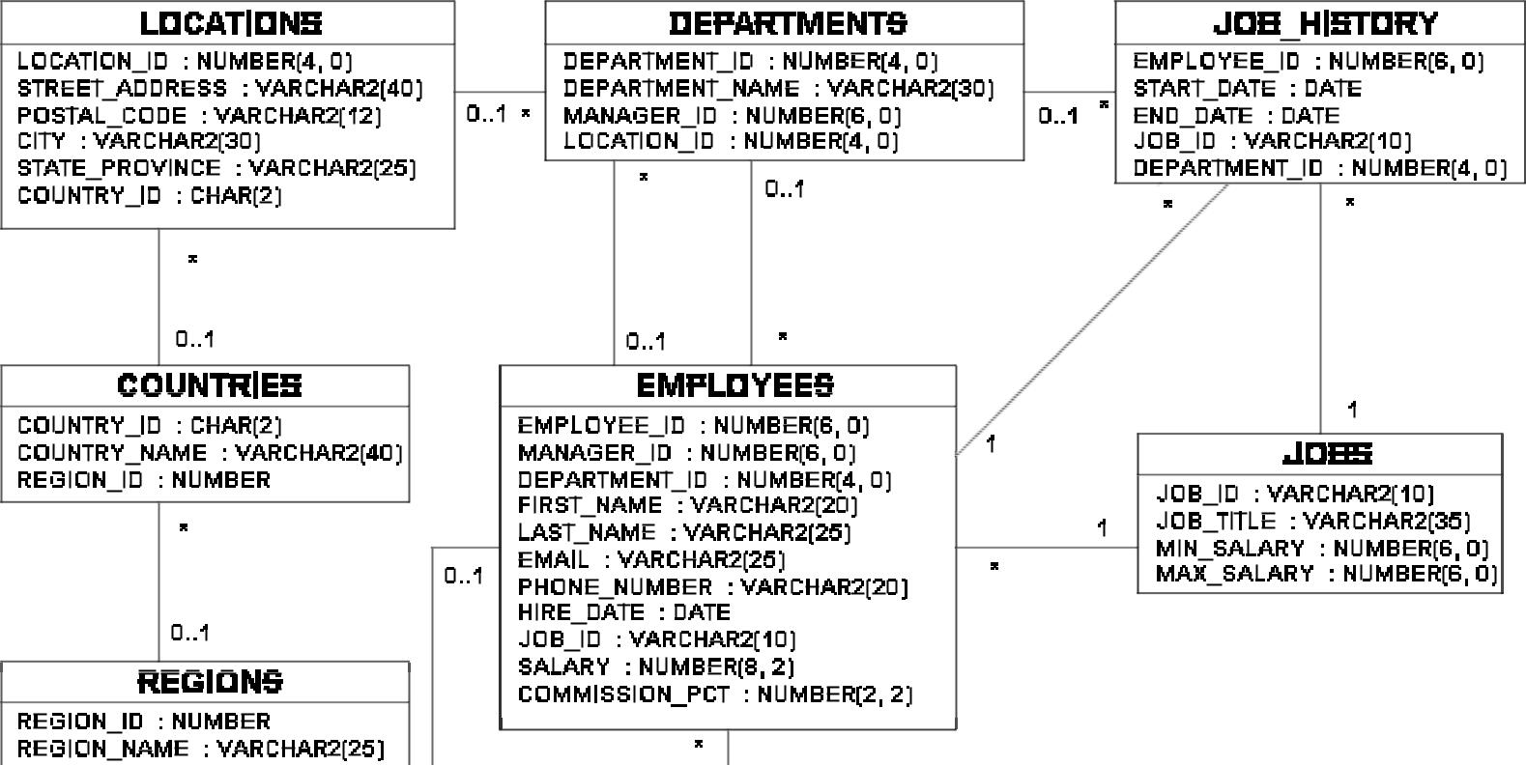

|  |
| --- |
| Oracle Internal & Oracle Academy Use Only |



**Oracle Database 10*g*: SQL Fundamentals II B - 2**

**Tables in the Schema**

SELECT * FROM tab;

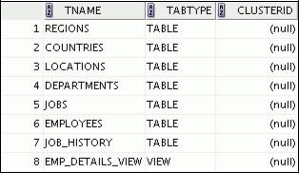

|  |
| --- |
| Oracle Internal & Oracle Academy Use Only |

**Oracle Database 10*g*: SQL Fundamentals II B - 3**

**REGIONS Table**

DESCRIBE regions

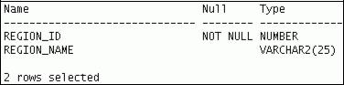

SELECT * FROM regions;

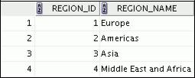

|  |
| --- |
| Oracle Internal & Oracle Academy Use Only |

**Oracle Database 10*g*: SQL Fundamentals II B - 4**

**COUNTRIES Table**

DESCRIBE countries

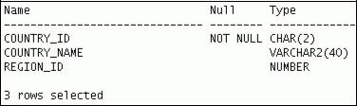

SELECT * FROM countries;

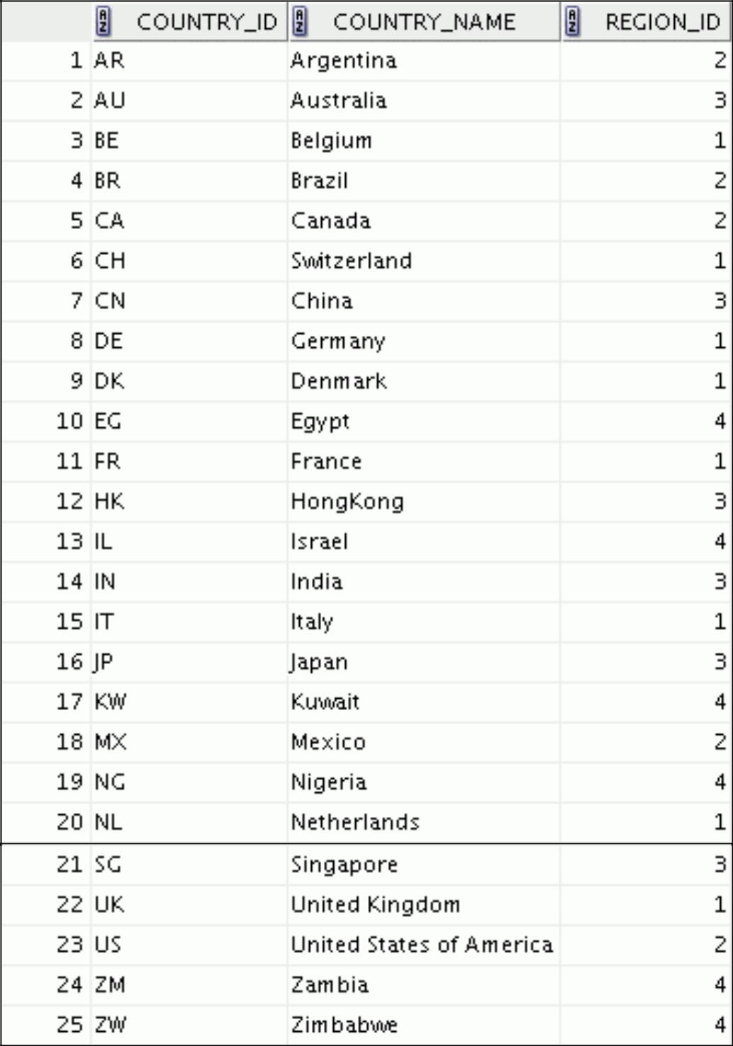

|  |
| --- |
| Oracle Internal & Oracle Academy Use Only |

**Oracle Database 10*g*: SQL Fundamentals II B - 5**

**LOCATIONS Table**

DESCRIBE locations;

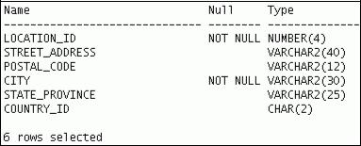

SELECT * FROM locations;

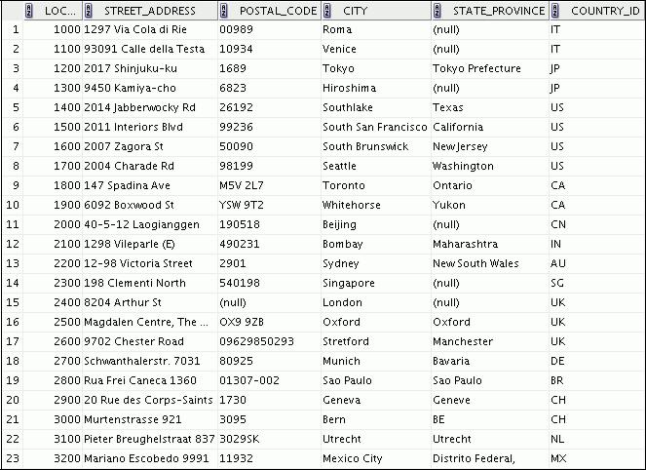

|  |
| --- |
| Oracle Internal & Oracle Academy Use Only |

**Oracle Database 10*g*: SQL Fundamentals II B - 6**

**DEPARTMENTS Table**

DESCRIBE departments

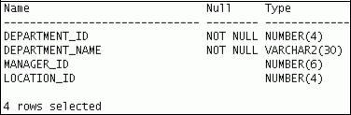

SELECT * FROM departments;

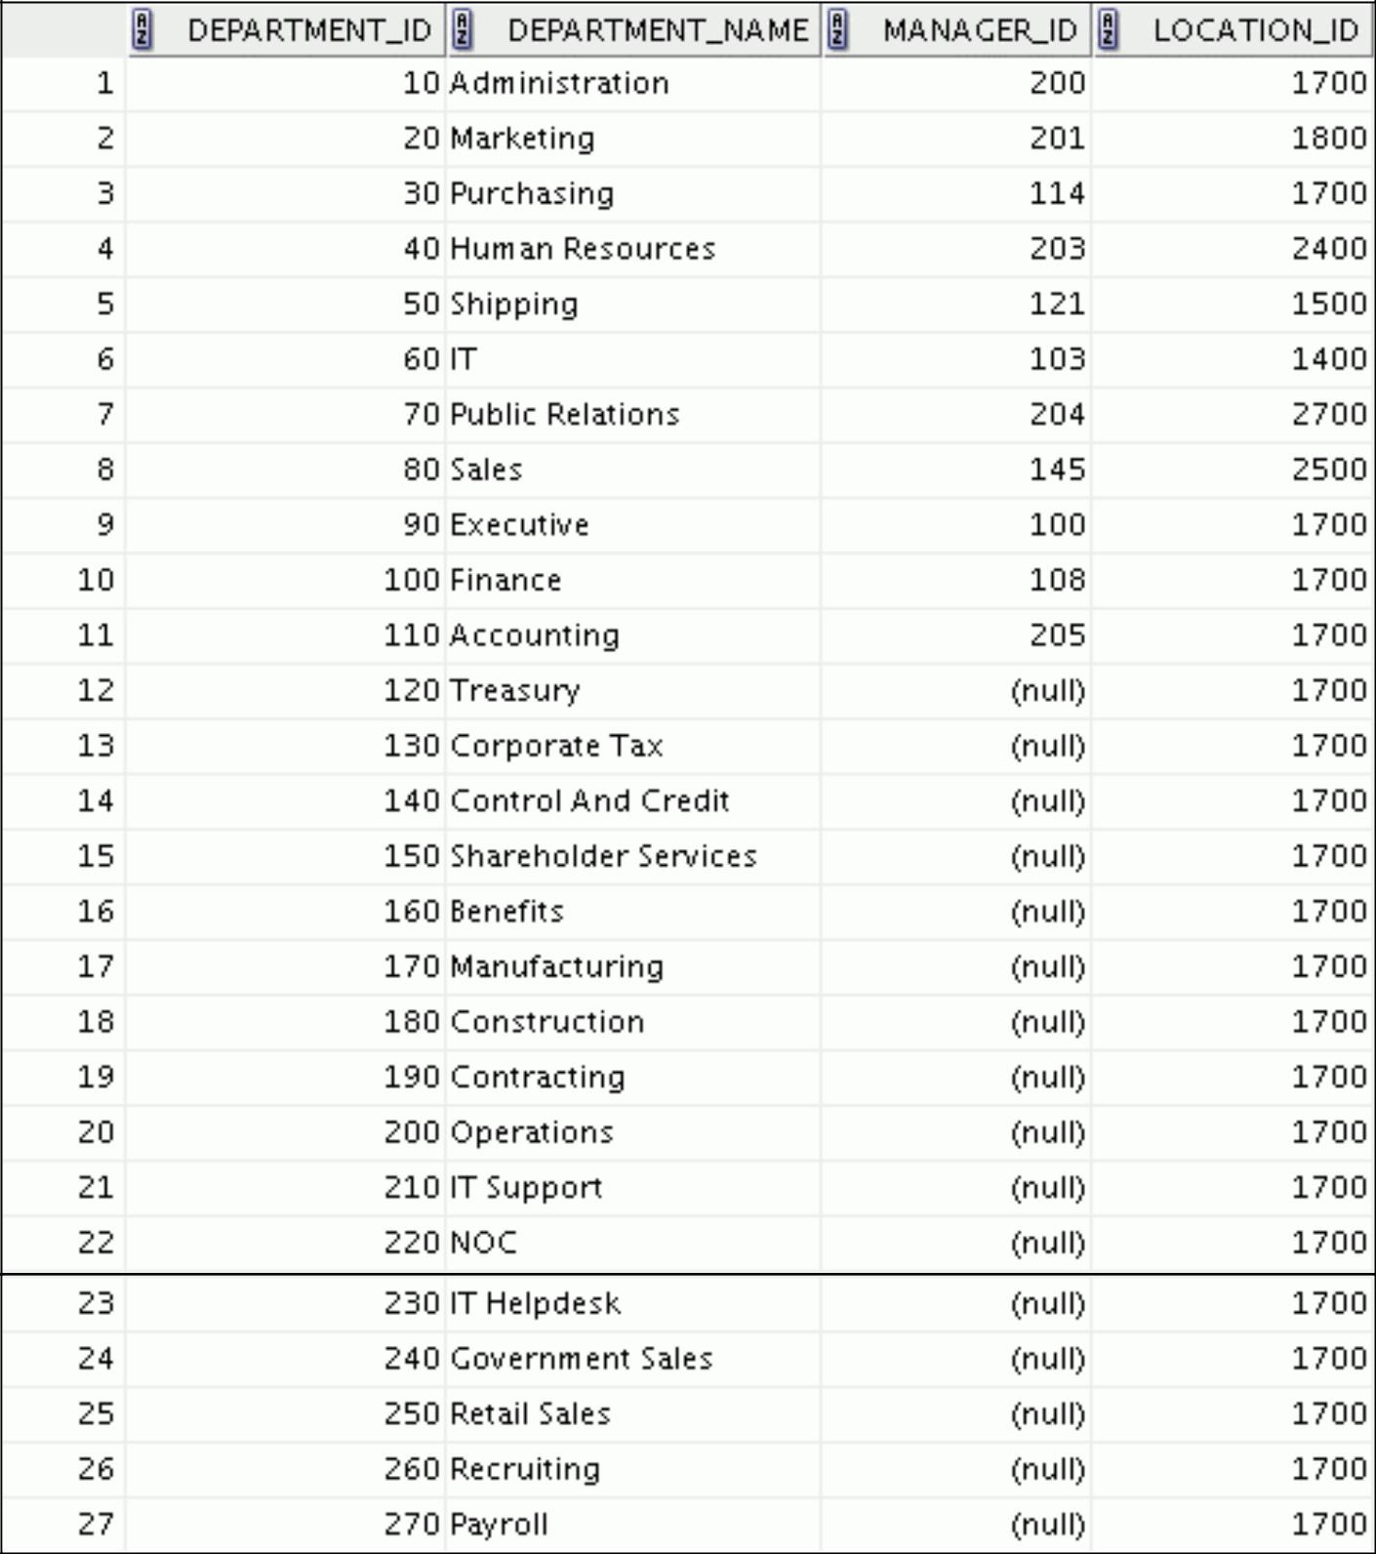

|  |
| --- |
| Oracle Internal & Oracle Academy Use Only |

**Oracle Database 10*g*: SQL Fundamentals II B - 7**

**JOBS Table**

DESCRIBE jobs

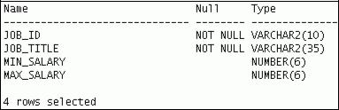

SELECT * FROM jobs;

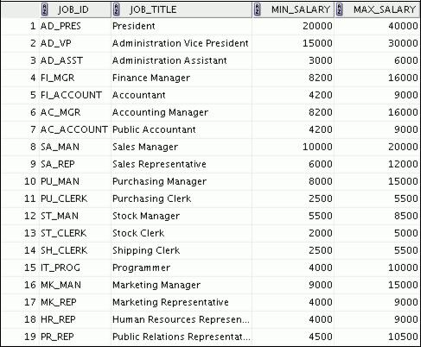

|  |
| --- |
| Oracle Internal & Oracle Academy Use Only |

**Oracle Database 10*g*: SQL Fundamentals II B - 8**

**EMPLOYEES Table**

DESCRIBE employees

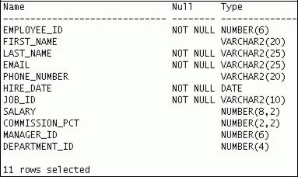

The headings for the EMPLOYEE_ID, FIRST_NAME, LAST_NAME, SALARY, COMMISSION_PCT, MANAGER_ID, and DEPARTMENT_ID columns are set as ID, FNAME, LNAME, SAL, COMM, MGRID, and DEPTID respectively in the following screenshots to fit the table values across the page.

SELECT * FROM employees;

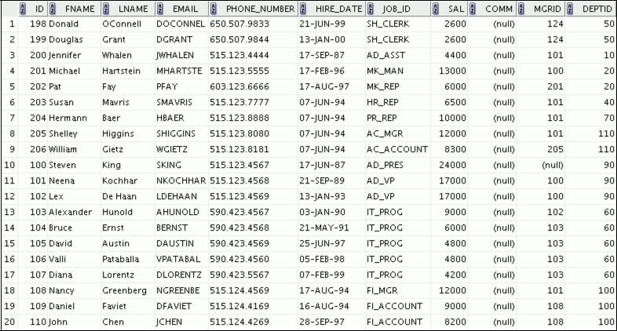

|  |
| --- |
| Oracle Internal & Oracle Academy Use Only |

**Oracle Database 10*g*: SQL Fundamentals II B - 9**

**EMPLOYEES Table (continued)**

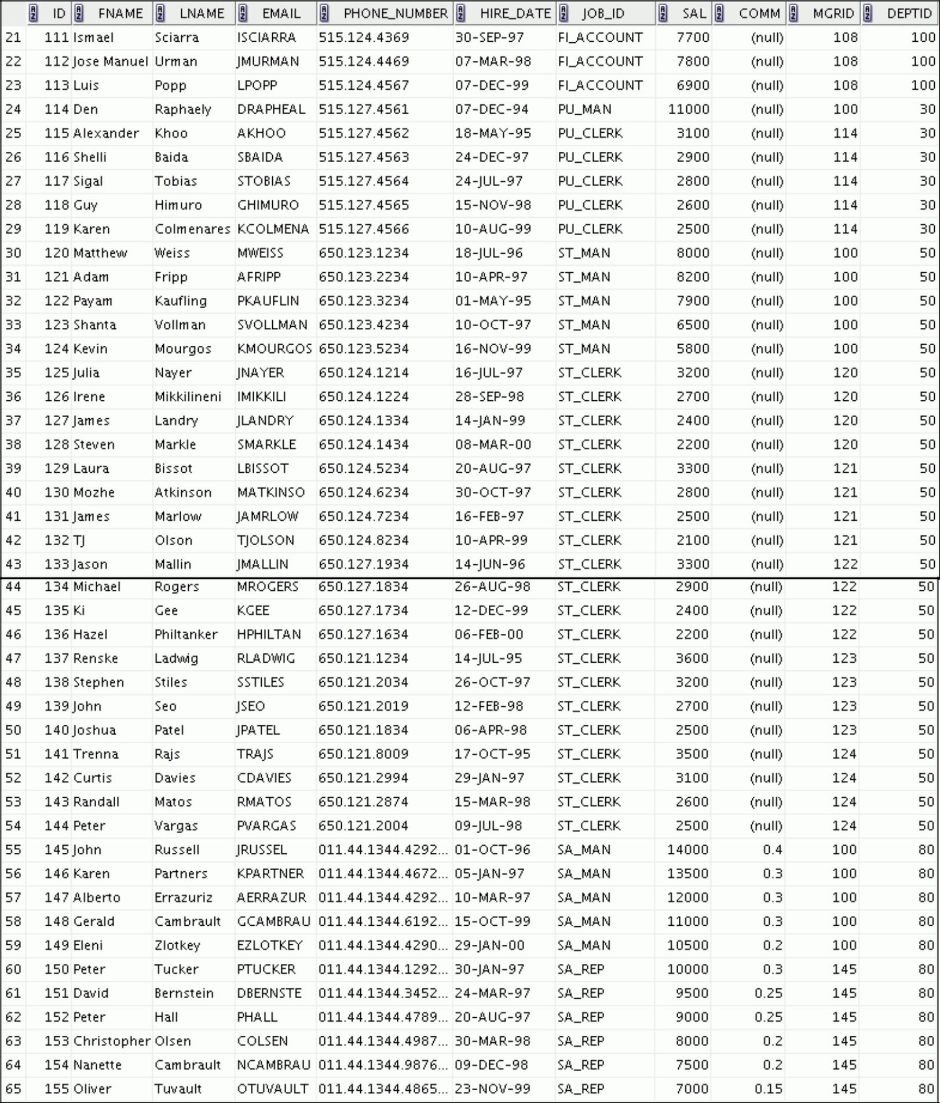

|  |
| --- |
| Oracle Internal & Oracle Academy Use Only |

**Oracle Database 10*g*: SQL Fundamentals II B - 10**

**EMPLOYEES Table (continued)**

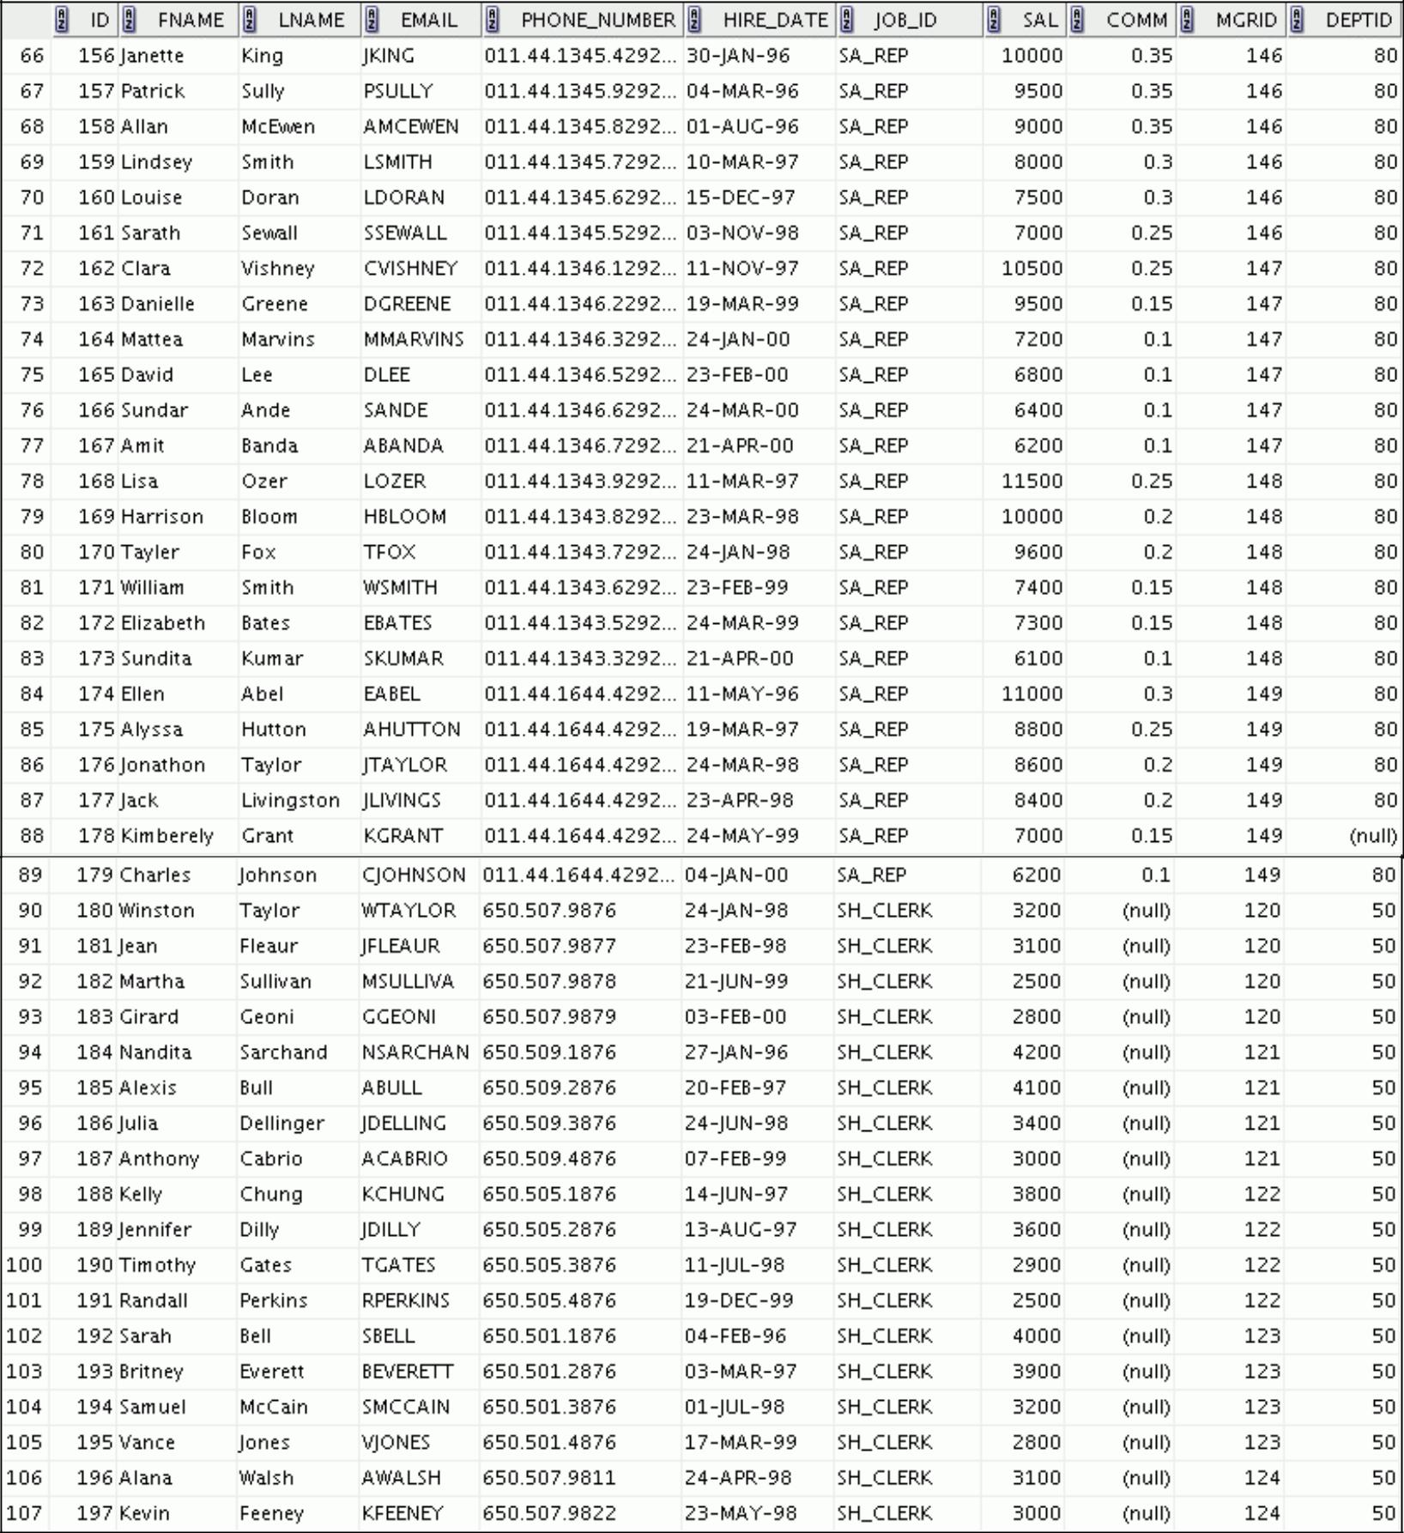

|  |
| --- |
| Oracle Internal & Oracle Academy Use Only |

**Oracle Database 10*g*: SQL Fundamentals II B - 11**

**JOB_HISTORY Table**

DESCRIBE job_history

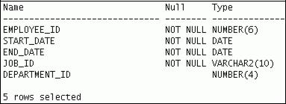

SELECT * FROM job_history; Only

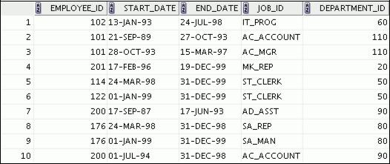

|  |
| --- |
| Oracle Internal & Oracle Academy Use |

**Oracle Database 10*g*: SQL Fundamentals II B - 12**



**Writing Advanced Scripts**

Copyright © 2009, Oracle. All rights reserved.

|  |
| --- |
| Oracle Internal & Oracle Academy Use Only |

**Objectives**

After completing this appendix, you should be able to do the following:

1. Describe the type of problems that are solved by using SQL to generate SQL
2. Write a script that generates a script of DROP TABLE statements
3. Write a script that generates a script of INSERT INTO statements

Copyright © 2009, Oracle. All rights reserved.

**Objectives**

In this appendix, you learn how to write a SQL script to generates a SQL script.

|  |
| --- |
| Oracle Internal & Oracle Academy Use Only |

**Oracle Database 10*g*: SQL Fundamentals II C - 2**

**Using SQL to Generate SQL**

1. SQL can be used to generate scripts in SQL.
2. The data dictionary:

– Is a collection of tables and views that contain database information

– Is created and maintained by the Oracle server

**SQL** **Data dictionary**

**SQL script**

Copyright © 2009, Oracle. All rights reserved.

**Using SQL to Generate SQL**

SQL can be a powerful tool to generate other SQL statements. In most cases, this involves writing a script file. You can use SQL from SQL to:

1. Avoid repetitive coding
2. Access information from the data dictionary
3. Drop or re-create database objects
4. Generate dynamic predicates that contain run-time parameters

The examples used in this lesson involve selecting information from the data dictionary. The data dictionary is a collection of tables and views that contain information about the database. This collection is created and maintained by the Oracle server. All data dictionary tables are owned by the SYS user. Information stored in the data dictionary includes names of Oracle server users, privileges granted to users, database object names, table constraints, and audit information. There are four categories of data dictionary views. Each category has a distinct prefix that reflects its intended use.

|  |  |
| --- | --- |
| **Prefix** | **Description** |
|  |  |
| USER_ | Contains details of objects owned by the user |
|  |  |
| ALL_ | Contains details of objects to which the user has been granted access rights, in addition to |
|  | objects owned by the user |
| DBA_ | Contains details of users with DBA privileges to access any object in the database |
|  |  |
| V$_ | Stores information about database server performance and locking; available only to the DBA |
|  |  |

|  |
| --- |
| Oracle Internal & Oracle Academy Use Only |

**Oracle Database 10*g*: SQL Fundamentals II C - 3**

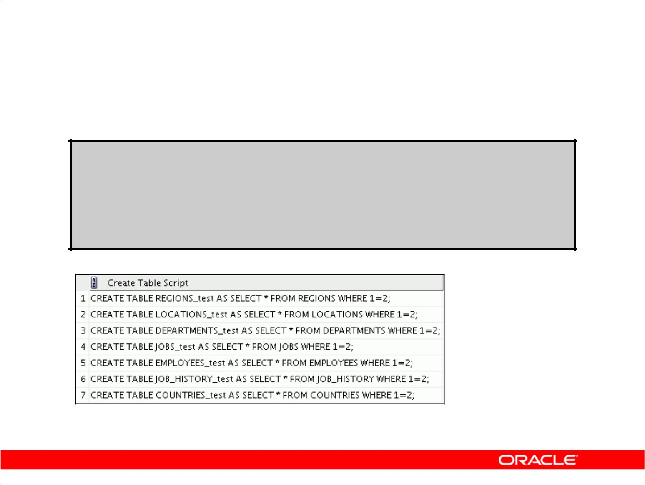**Creating a Basic Script**

**SELECT 'CREATE TABLE ' || table_name || '_test ' || 'AS SELECT * FROM '**

1. **table_name ||' WHERE 1=2;' AS "Create Table Script"**

**FROM user_tables;**

Copyright © 2009, Oracle. All rights reserved.

**A Basic Script**

The example in the slide produces a report with CREATE TABLE statements from every table you own. Each CREATE TABLE statement produced in the report includes the syntax to create a table using the table name with a suffix of _test and having only the structure of the corresponding existing table. The old table name is obtained from the TABLE_NAME column of the data dictionary view USER_TABLES.

The next step is to enhance the report to automate the process.

**Note:** You can query the data dictionary tables to view various database objects that you own. Thedata dictionary views frequently used include:

1. USER_TABLES: Displays description of the user’s own tables
2. USER_OBJECTS: Displays all the objects owned by the user
3. USER_TAB_PRIVS_MADE: Displays all grants on objects owned by the user
4. USER_COL_PRIVS_MADE: Displays all grants on columns of objects owned by the user

|  |
| --- |
| Oracle Internal & Oracle Academy Use Only |

**Oracle Database 10*g*: SQL Fundamentals II C - 4**

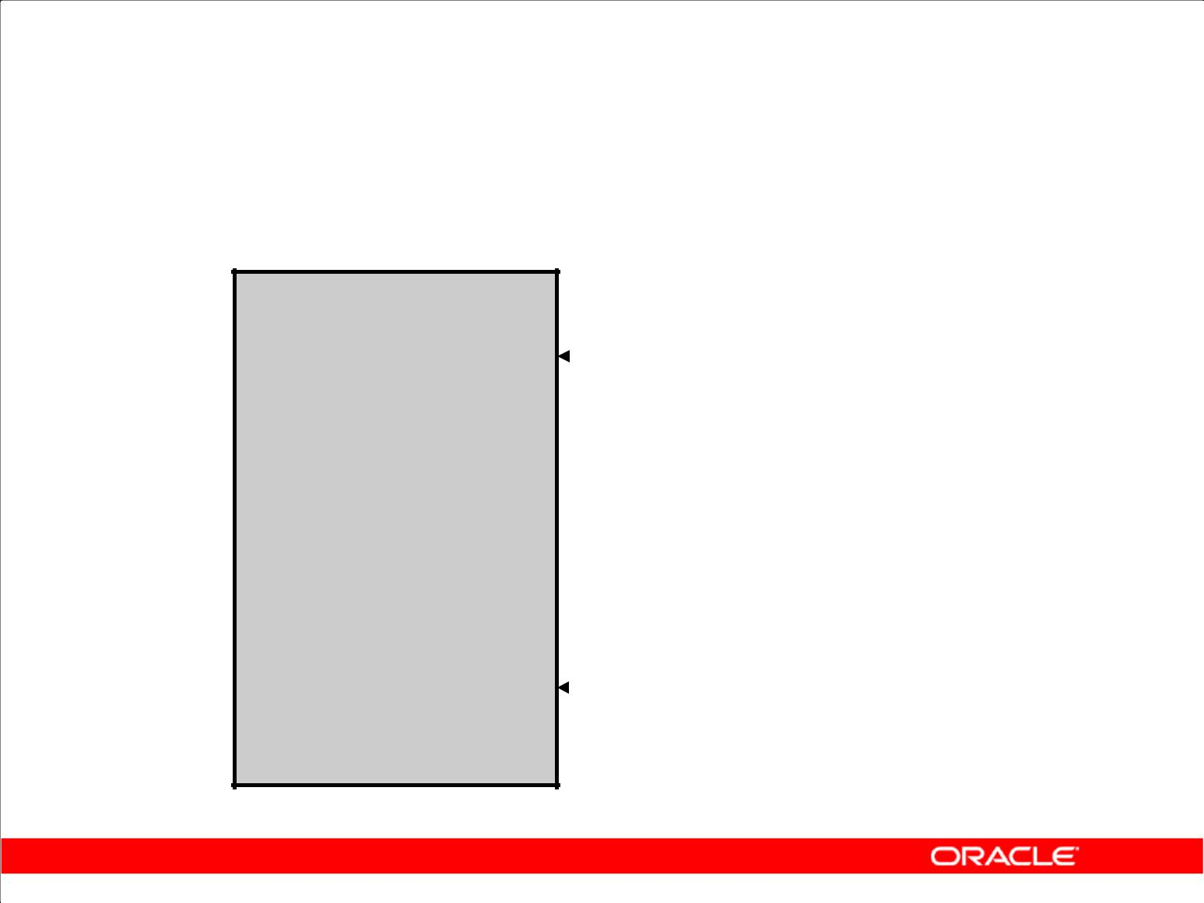**Controlling the Environment**

|  |  |  |  |  |
| --- | --- | --- | --- | --- |
| **SET ECHO OFF** | |  |  |  |
| **SET** | **FEEDBACK OFF** | |  | **Set system variables** |
| **SET** | **PAGESIZE** | **0** |  | **to appropriate values.** |

|  |  |  |  |
| --- | --- | --- | --- |
| **SQL STATEMENT** | |  |  |
| **SET FEEDBACK ON** | |  | **Set system variables** |
| **SET** | **PAGESIZE 24** |  |
| **SET** | **ECHO ON** |  | **back to the default** |
|  |  |  | **value.** |

Copyright © 2009, Oracle. All rights reserved.

**Controlling the Environment**

To execute the SQL statements that are generated, you must capture them in a file that can then be run. You must also plan to clean up the output that is generated and make sure that you suppress elements such as headings, feedback messages, top titles, and so on. In SQL Developer, you can save these statements to a script.

**Note:** Some of the SQL*Plus statements are not supported by SQL Worksheet. For the complete listof SQL*Plus statements that are supported, and not supported by SQL Worksheet, refer to the topic titled *SQL*Plus Statements Supported and Not Supported in SQL Worksheet* in the SQL Developer online Help

|  |
| --- |
| Oracle Internal & Oracle Academy Use Only |

**Oracle Database 10*g*: SQL Fundamentals II C - 5**

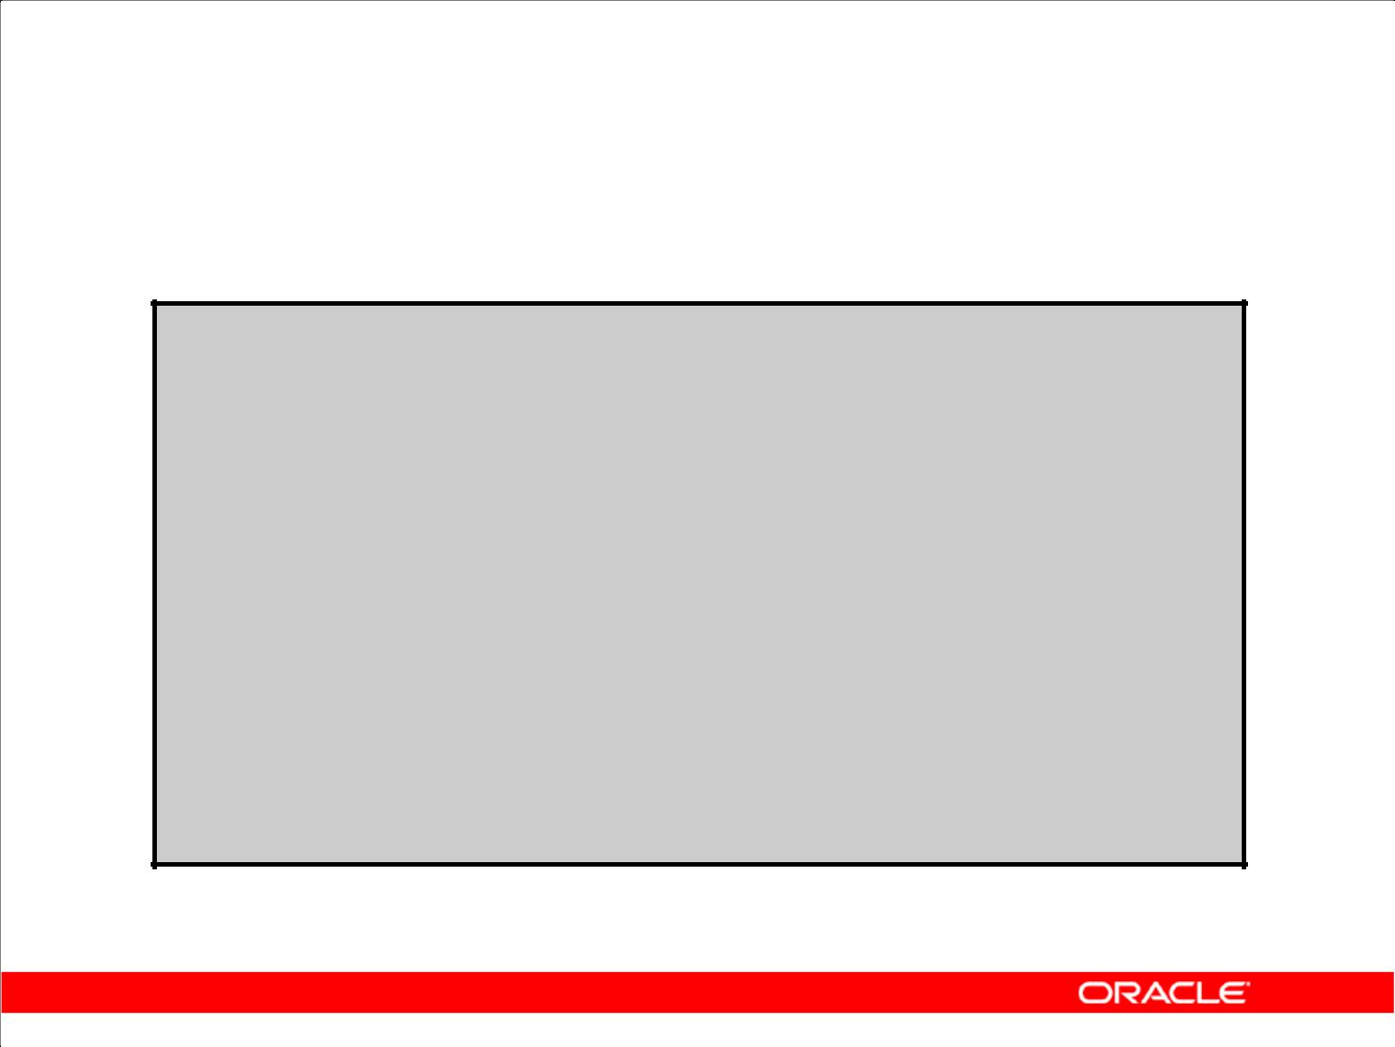**The Complete Picture**

**SET ECHO OFF**

**SET FEEDBACK OFF**

**SET PAGESIZE 0**

**SELECT 'DROP TABLE ' || object_name || ';'**

**FROM** **user_objects**

**WHERE object_type = 'TABLE'**

**/**

**SET FEEDBACK ON**

**SET PAGESIZE 24**

**SET ECHO ON**

Copyright © 2009, Oracle. All rights reserved.

**The Complete Picture**

The output of the command in the slide is saved into a file called dropem.sql in SQL Developer.

To save the output into a file in SQL Developer, you use the Save File option under the Script Output pane. The dropem.sql file contains the following data. This file can now be started from SQL

Developer by locating the script file, loading it, and executing it.

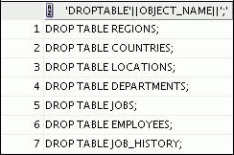

|  |
| --- |
| Oracle Internal & Oracle Academy Use Only |

**Oracle Database 10*g*: SQL Fundamentals II C - 6**

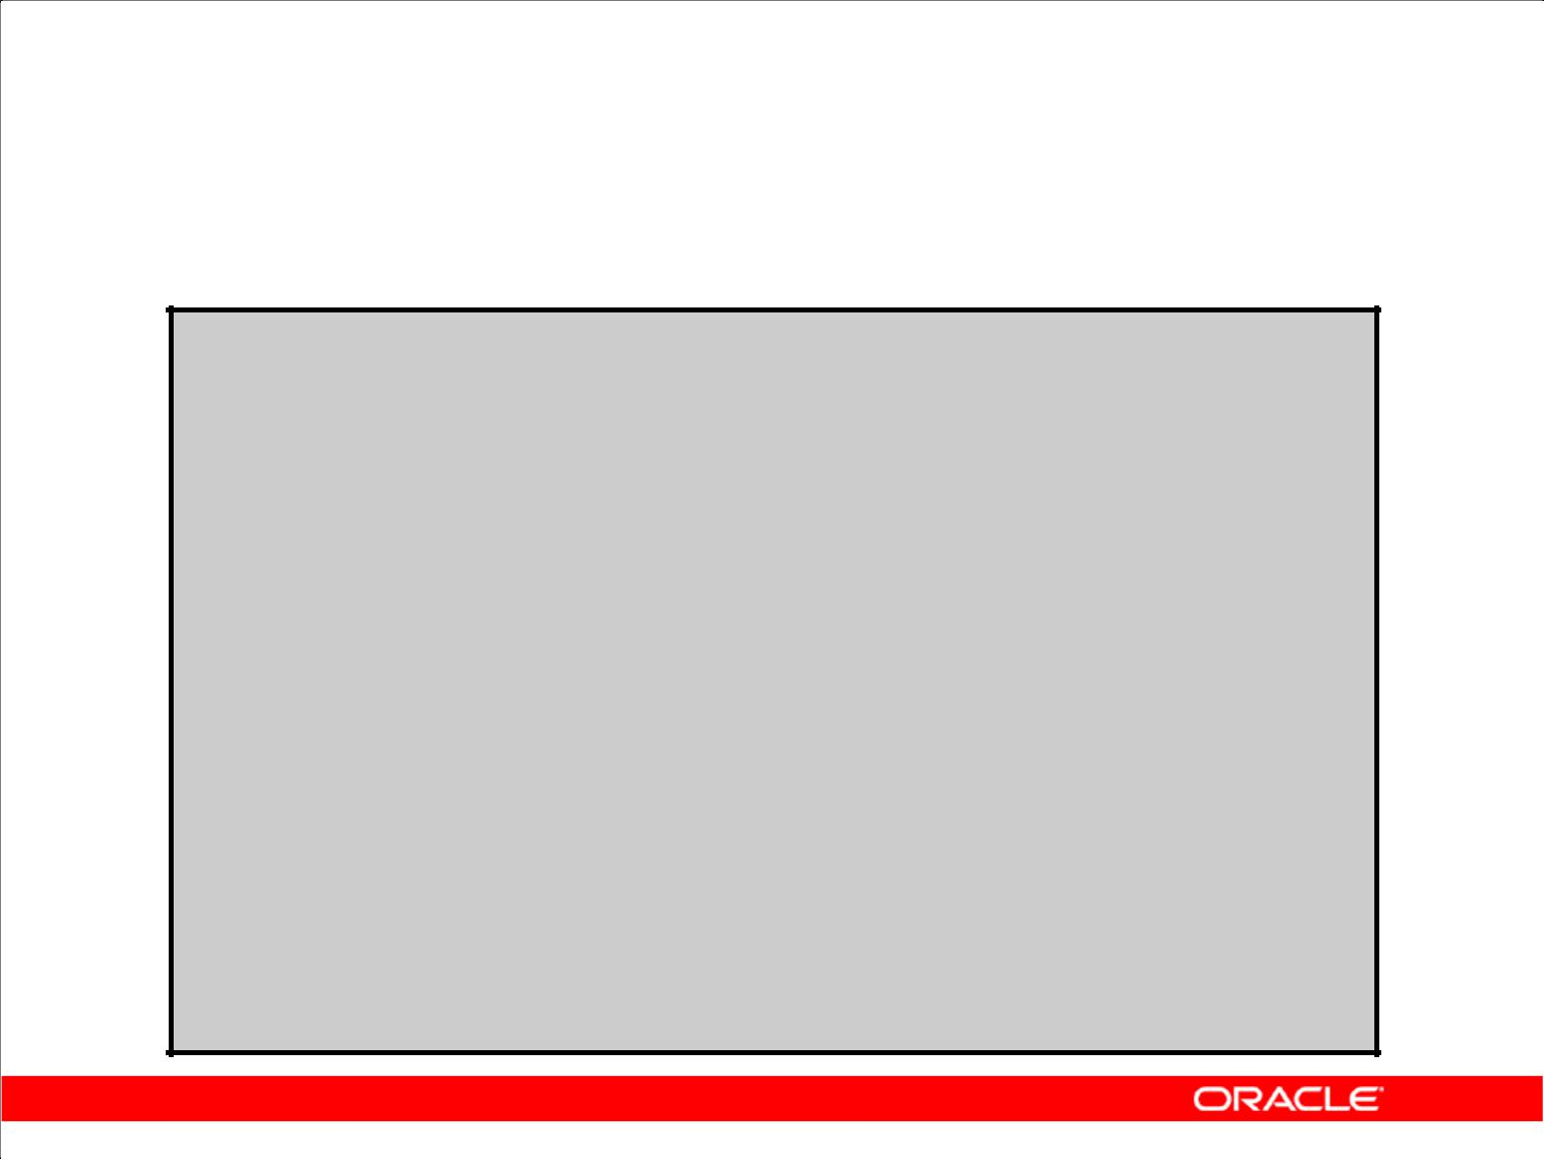**Dumping the Contents of a Table to a File**

**SET HEADING OFF ECHO OFF FEEDBACK OFF SET PAGESIZE 0**

**SELECT**

**'INSERT INTO departments_test VALUES**

**(' || department_id || ', ''' || department_name ||**

**''', ''' || location_id || ''');'**

**AS "Insert Statements Script"**

**FROM departments**

**/**

**SET PAGESIZE 24**

**SET HEADING ON ECHO ON FEEDBACK ON**

Copyright © 2009, Oracle. All rights reserved.

**Dumping Table Contents to a File**

Sometimes, it is useful to have the values for the rows of a table in a text file in the format of an INSERT INTO VALUES statement. This script can be run to populate the table in case the table has

been dropped accidentally.

The example in the slide produces INSERT statements for the DEPARTMENTS_TEST table, captured in the data.sql file using the output option in SQL Developer.

The contents of the data.sql script file are as follows:

|  |  |
| --- | --- |
| INSERT | INTO departments_test VALUES |
| (10, | 'Administration', 1700); |
| INSERT | INTO departments_test VALUES |
| (20, | 'Marketing', 1800); |
| INSERT | INTO departments_test VALUES |
| (50, | 'Shipping', 1500); |
| INSERT | INTO departments_test VALUES |
| (60, | 'IT', 1400); |
| ... |  |

|  |
| --- |
| Oracle Internal & Oracle Academy Use Only |

**Oracle Database 10*g*: SQL Fundamentals II C - 7**

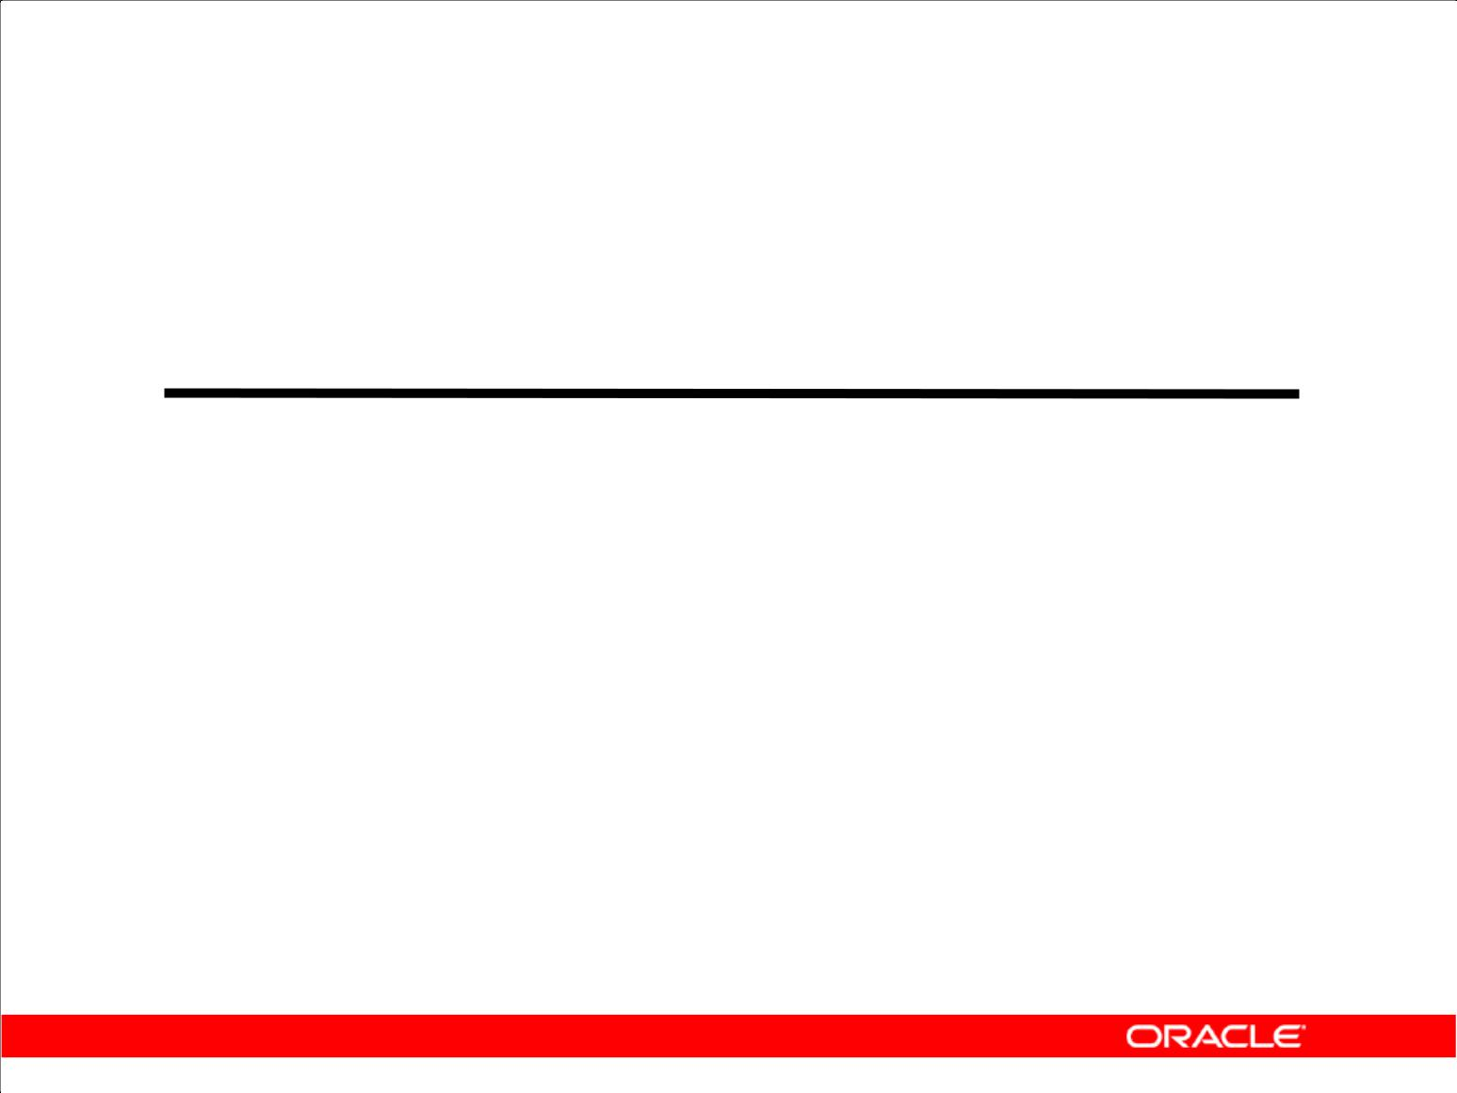**Dumping the Contents of a Table to a File**

|  |  |
| --- | --- |
| **Source** | **Result** |
| **'''X'''** | **'X'** |
| **''''** | **'** |
| **''''||department_name||''''** | **'Administration'** |
| **''', '''** | **','** |
| **''');'** | **');** |
|  |  |

Copyright © 2009, Oracle. All rights reserved.

**Dumping Table Contents to a File (continued)**

You may have noticed the large number of single quotation marks in the previous slide. A set of four single quotation marks produces one single quotation mark in the final statement. Also remember that character and date values must be surrounded by quotation marks.

Within a string, to display one single quotation mark, you need to prefix it with another single quotation mark. For example, in the fifth example in the slide, the surrounding quotation marks are for the entire string. The second quotation mark acts as a prefix to display the third quotation mark. Thus, the result is one single quotation mark followed by the parenthesis, followed by the semicolon.

|  |
| --- |
| Oracle Internal & Oracle Academy Use Only |

**Oracle Database 10*g*: SQL Fundamentals II C - 8**

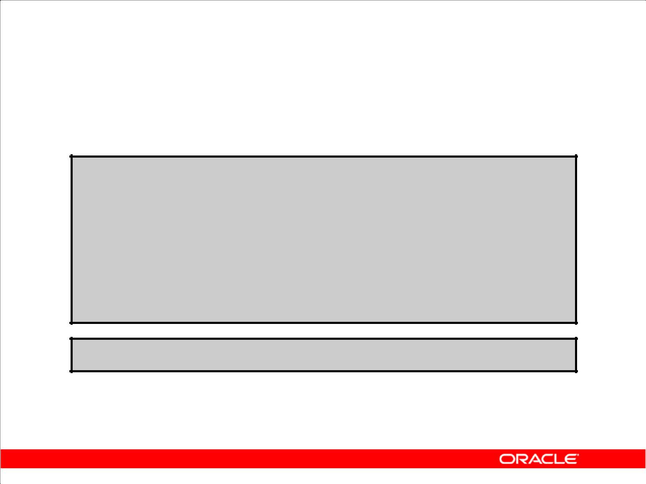**Generating a Dynamic Predicate**

**COLUMN my_col NEW_VALUE dyn_where_clause**

**SELECT DECODE('&&deptno', null,**

**DECODE ('&&hiredate', null, ' ',**

**'WHERE hire_date=TO_DATE('''||'&&hiredate'',''DD-MON-YYYY'')'), DECODE ('&&hiredate', null,**

**'WHERE department_id = ' || '&&deptno',**

**'WHERE department_id = ' || '&&deptno' ||**

1. **AND hire_date = TO_DATE('''||'&&hiredate'',''DD-MON-YYYY'')')) AS my_col FROM dual;**

**SELECT last_name FROM employees &dyn_where_clause;**

Copyright © 2009, Oracle. All rights reserved.

**Generating a Dynamic Predicate**

The example in the slide generates a SELECT statement that retrieves data of all employees in a department who were hired on a specific day. The script generates the WHERE clause dynamically.

**Note:** After the user variable is in place, you must use theUNDEFINEcommand to delete it.

The first SELECT statement prompts you to enter the department number. If you do not enter any department number, the department number is treated as null by the DECODE function, and the user

is then prompted for the hire date. If you do not enter any hire date, the hire date is treated as null by the DECODE function and the dynamic WHERE clause that is generated is also a null, which causes the second SELECT statement to retrieve all rows from the EMPLOYEES table.

**Note:** TheNEW_V[ALUE]variable specifies a variable to hold a column value. You can referencethe variable in TTITLE commands. Use NEW_VALUE to display column values or the date in the top title. You must include the column in a BREAK command with the SKIP PAGE action. The variable name cannot contain a pound sign (#). NEW_VALUE is useful for master/detail reports in which there is a new master record for each page.

|  |
| --- |
| Oracle Internal & Oracle Academy Use Only |

**Oracle Database 10*g*: SQL Fundamentals II C - 9**

**Generating a Dynamic Predicate (continued)**

**Note:** Here, the hire date must be entered in theDD-MON-YYYYformat.

The SELECT statement in the slide can be interpreted as follows:

IF (*<<deptno>>* is not entered) THEN

IF (*<<hiredate>>* is not entered) THEN return empty string

ELSE

return the string ‘WHERE hire_date = TO_DATE('<<*hiredate>>*', 'DD-MON-YYYY')’

ELSE

IF (*<<hiredate>>* is not entered) THEN

return the string ‘WHERE department_id = <<*deptno>>*

*entered*'

ELSE

return the string ‘WHERE department_id = <<*deptno>>*

*entered*

AND hire_date =

TO_DATE(' <<*hiredate>>*', 'DD-MON-YYYY')’ END IF

The returned string becomes the value of the DYN_WHERE_CLAUSE variable, which will be used in the second SELECT statement.

**Note:** Use SQL*Plus for these examples.

When the first example in the slide is executed, the user is prompted for the values for DEPTNO and

HIREDATE:



The following value for MY_COL is generated:



When the second example in the slide is executed, the following output is generated:

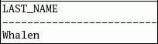

|  |
| --- |
| Oracle Internal & Oracle Academy Use Only |

**Oracle Database 10*g*: SQL Fundamentals II C - 10**

**Summary**

In this appendix, you should have learned that:

1. You can write a SQL script to generate another SQL script
2. Script files often use the data dictionary
3. You can capture the output in a file

Copyright © 2009, Oracle. All rights reserved.

**Summary**

SQL can be used to generate SQL scripts. These scripts can be used to avoid repetitive coding, drop or re-create objects, get help from the data dictionary, and generate dynamic predicates that contain run-time parameters.

|  |
| --- |
| Oracle Internal & Oracle Academy Use Only |

**Oracle Database 10*g*: SQL Fundamentals II C - 11**

Oracle Internal & Oracle Academy Use Only



**Oracle Architectural Components**

Copyright © 2009, Oracle. All rights reserved.

|  |
| --- |
| Oracle Internal & Oracle Academy Use Only |

**Objectives**

After completing this appendix, you should be able to do the following:

1. Describe the Oracle server architecture and its main components
2. List the structures involved in connecting a user to an Oracle instance
3. List the stages in processing:

– Queries

– Data manipulation language (DML) statements

– Commits

Copyright © 2009, Oracle. All rights reserved.

**Objectives**

This appendix introduces the Oracle server architecture by describing the files, processes, and memory structures involved in establishing a database connection and executing a SQL command.

|  |
| --- |
| Oracle Internal & Oracle Academy Use Only |

**Oracle Database 10*g*: SQL Fundamentals II D - 2**

**Oracle Database Architecture: Overview**

The Oracle Database consists of two main components:

1. The database or the physical structures
2. The instance or the memory structures

Copyright © 2009, Oracle. All rights reserved.

**Oracle Database Architecture: Overview**

The Oracle Database consists of two main components—the instance and the database itself.

1. The database consists of physical files such as:
   1. The control file where the database configuration is stored
   2. The redo log files that have information required for database recovery
   3. The data files where all data is stored
   4. The parameter file, which contains the parameters that control the size and properties of an instance
   5. The password file, which contains the superuser or SYSDBA password
2. The instance consists of the System Global Area (SGA) and the server processes that perform tasks within the database.

|  |
| --- |
| Oracle Internal & Oracle Academy Use Only |

**Oracle Database 10*g*: SQL Fundamentals II D - 3**

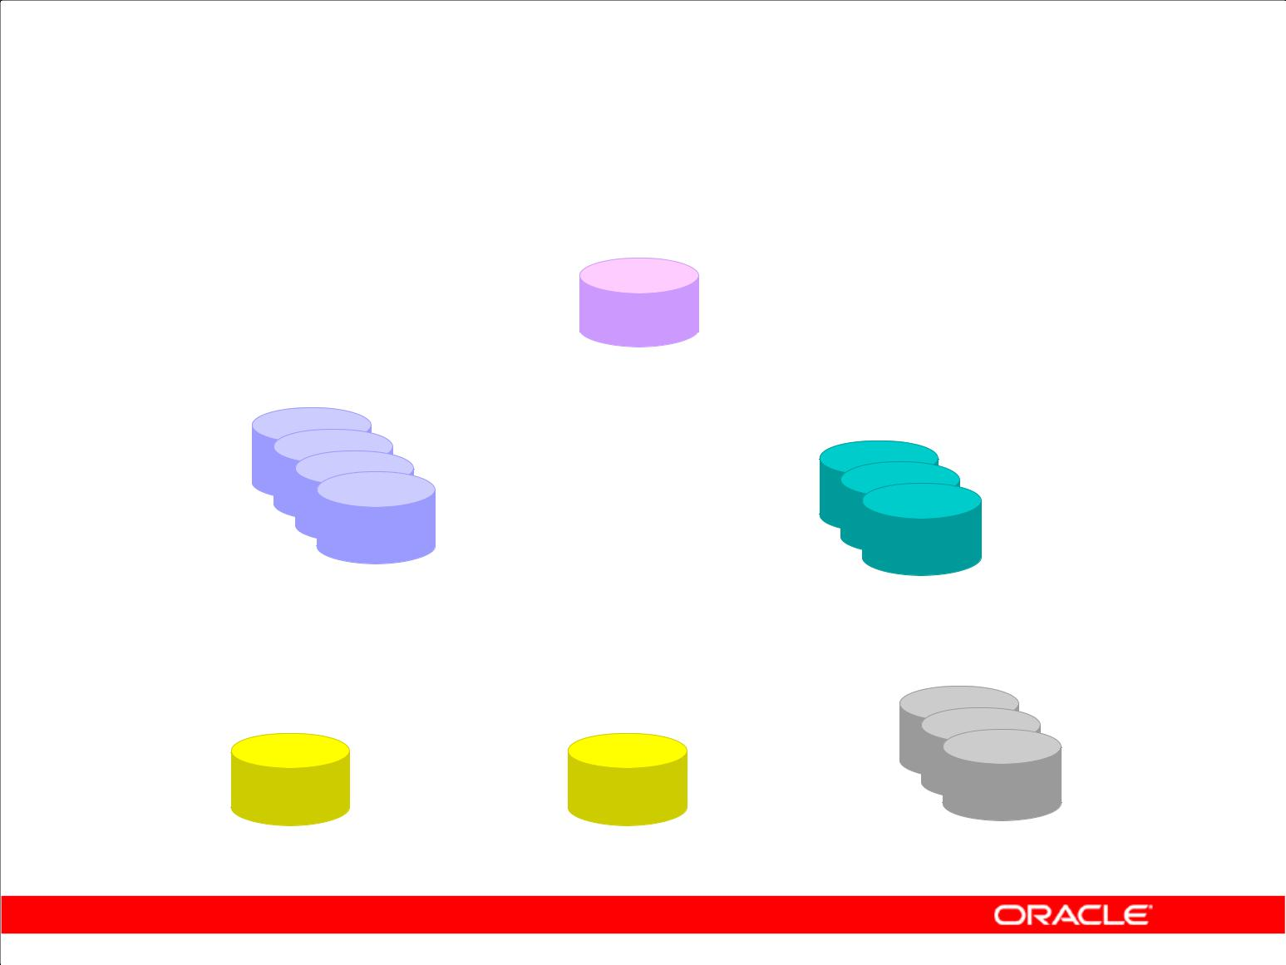**Database Physical Architecture**

**Control files**

Data files Online redo log files

Parameter file Password file Archive log files

Copyright © 2009, Oracle. All rights reserved.

**Database Physical Architecture**

The files that make up an Oracle Database are organized into the following:

1. **Control files:** These files contain data about the database itself, called the metadata. These filesare critical to the database. Without them, you cannot open the data files to access the data within the database.
2. **Data files:** These files contain the data of the database.
3. **Online redo log files:** These files allow for instance recovery of the database. If the databasewere to crash and not lose any data files, the instance will be able to recover the database with the information in these files.

There are other files that are not officially part of the database but are important to the successful running of the database. These are:

1. **Parameter file:** The parameter file is used to define how the instance will be configured when itstarts up.
2. **Password file:** This file allows users to connect remotely to the database and performadministrative tasks.
3. **Archive log files:** These files contain an ongoing history of the redo generated by the instance.These files allow for database recovery. By using these files and a backup of the database, it is possible to recover a lost data file.

|  |
| --- |
| Oracle Internal & Oracle Academy Use Only |

**Oracle Database 10*g*: SQL Fundamentals II D - 4**

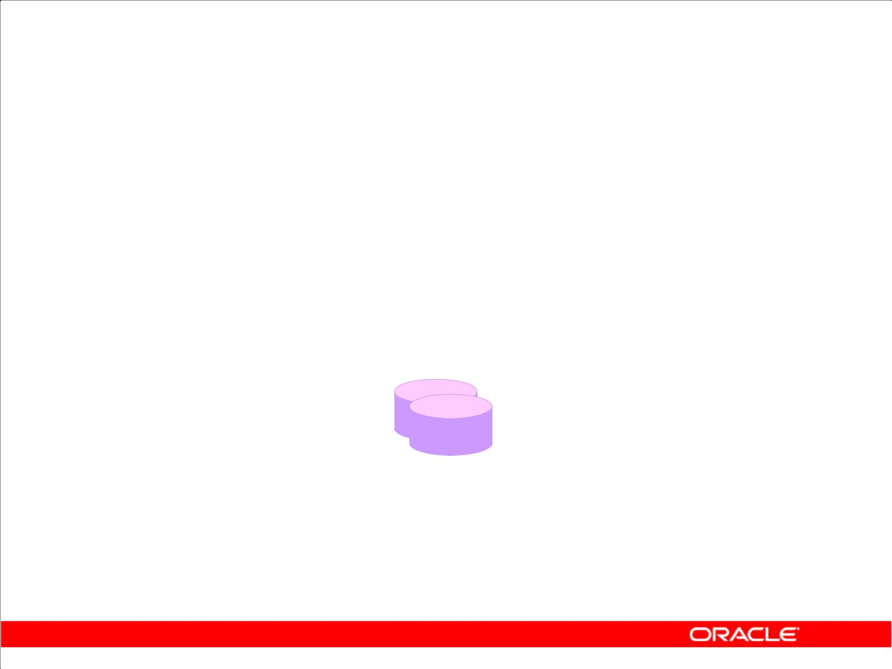**Control Files**

1. Contain physical database structure information
2. Should be multiplexed to protect against loss
3. Are read at mount stage

**Control files**

Copyright © 2009, Oracle. All rights reserved.

**Control Files**

When you start the instance and mount the database, the control file is read. The entries in the control file specify the physical files that constitute the database.

When you add additional files to your database, the control file is automatically updated.

The location of the control files is specified in an initialization parameter.

To protect against failure of the database due to the loss of the control file, you should multiplex the control file on at least three different physical devices. By specifying multiple files through the initialization parameter, you enable the Oracle Database server to maintain multiple copies of the control file.

|  |
| --- |
| Oracle Internal & Oracle Academy Use Only |

**Oracle Database 10*g*: SQL Fundamentals II D - 5**

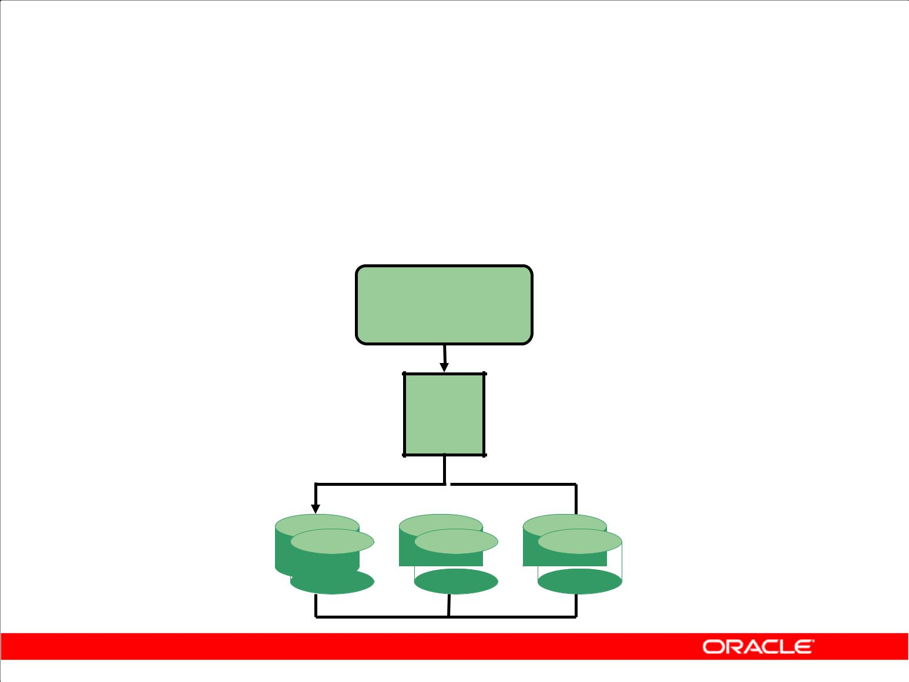**Redo Log Files**

1. Record changes to the database
2. Should be multiplexed to protect against loss

**Redo log**

**buffer**

**Log**

**Writer**

**LGWR**

**Group 1 Group 2  Group 3**

Copyright © 2009, Oracle. All rights reserved.

**Redo Log Files**

Redo log files are used to record changes to the database as a result of transactions and internal Oracle Database server actions. They protect the database from loss of integrity due to system failures caused by power outages, disk failures, and so on. Redo log files should be multiplexed to ensure that the information stored in them is not lost in the event of a disk failure.

The redo log consists of groups of redo log files. A group consists of a redo log file and its multiplexed copies. Each identical copy is said to be a member of that group and each group is identified by a number. The log writer (LGWR) process writes redo records from the redo log buffer to a redo log group until the file is filled or a log switch operation is requested. Then it switches and writes to the files in the next group. The redo log groups are used in a circular fashion.

|  |
| --- |
| Oracle Internal & Oracle Academy Use Only |

**Oracle Database 10*g*: SQL Fundamentals II D - 6**

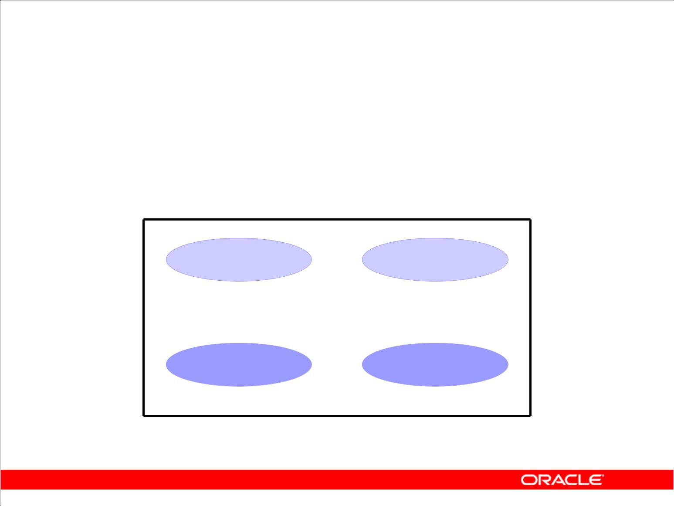**Tablespaces and Data Files**

1. Tablespaces consist of one or more data files.
2. Data files belong to only one tablespace.

|  |  |  |
| --- | --- | --- |
| **Data file 1** |  | **Data file 2** |
|  |  |  |

**USERS tablespace**

Copyright © 2009, Oracle. All rights reserved.

**Tablespaces and Data Files**

A database is divided into logical storage units called tablespaces, which can be used to group related logical structures. Each database is logically divided into one or more tablespaces. One or more data files are explicitly created for each tablespace to physically store the data of all logical structures in a tablespace.

**Note:** You can also createbigfiletablespaces, which are tablespaces with a single, but very large(up to 4-G blocks) data file. Traditional smallfile tablespaces (which are the default) can contain multiple data files, but the files cannot be as large. For more information about bigfile tablespaces, refer to the *Database Administrator’s Guide*.

|  |
| --- |
| Oracle Internal & Oracle Academy Use Only |

**Oracle Database 10*g*: SQL Fundamentals II D - 7**

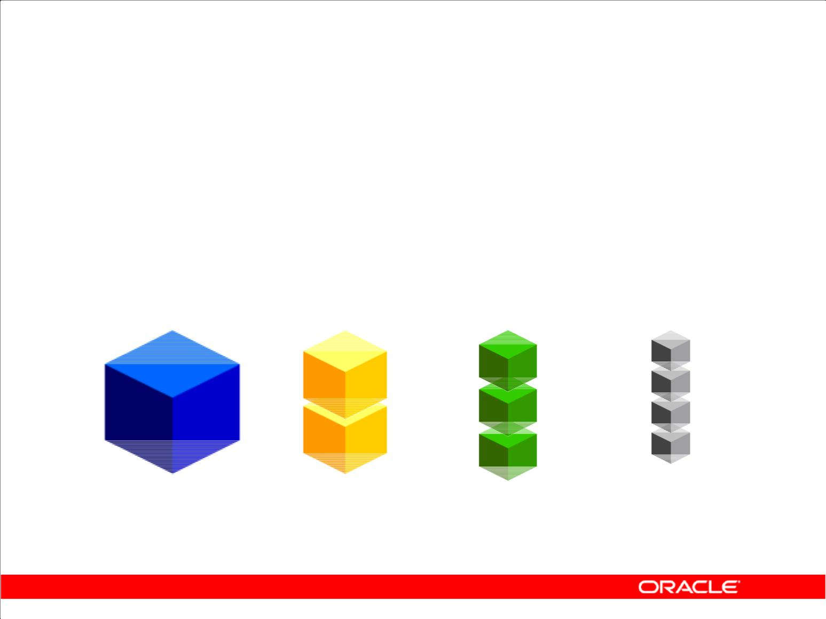**Segments, Extents, and Blocks**

1. Segments exist within a tablespace.
2. Segments consist of a collection of extents.
3. Extents are a collection of data blocks.
4. Data blocks are mapped to OS blocks.

**Segment** **Extents** **Data** **OS**

**blocks** **blocks**

Copyright © 2009, Oracle. All rights reserved.

**Segments, Extents, and Blocks**

Database objects such as tables and indexes are stored in tablespaces as segments. Each segment contains one or more extents. An extent consists of contiguous data blocks, which means that each extent can exist only in one data file. Data blocks are the smallest unit of I/O in the database.

When the database requests a set of data blocks from the operating system (OS), the OS maps this to the actual OS block on the storage device. Because of this, you need not be aware of the physical address of any of the data in your database. This also means that a data file can be striped and or mirrored on several disks.

The size of the data block can be set at database creation time. The default size of 8 K is adequate for most databases. If your database supports a data warehouse application that has large tables and indexes, then a larger block may be beneficial. If your database supports a transactional application where reads and write are very random, then specifying a smaller block size may be beneficial. The maximum block size is dependent on your OS. The minimum block size is 2 K and should rarely (if ever) be used.

You can have tablespaces with different block sizes. Generally, this should be used only to support transportable tablespaces. For details, refer to the *Database Administrator’s Guide*.

|  |
| --- |
| Oracle Internal & Oracle Academy Use Only |

**Oracle Database 10*g*: SQL Fundamentals II D - 8**

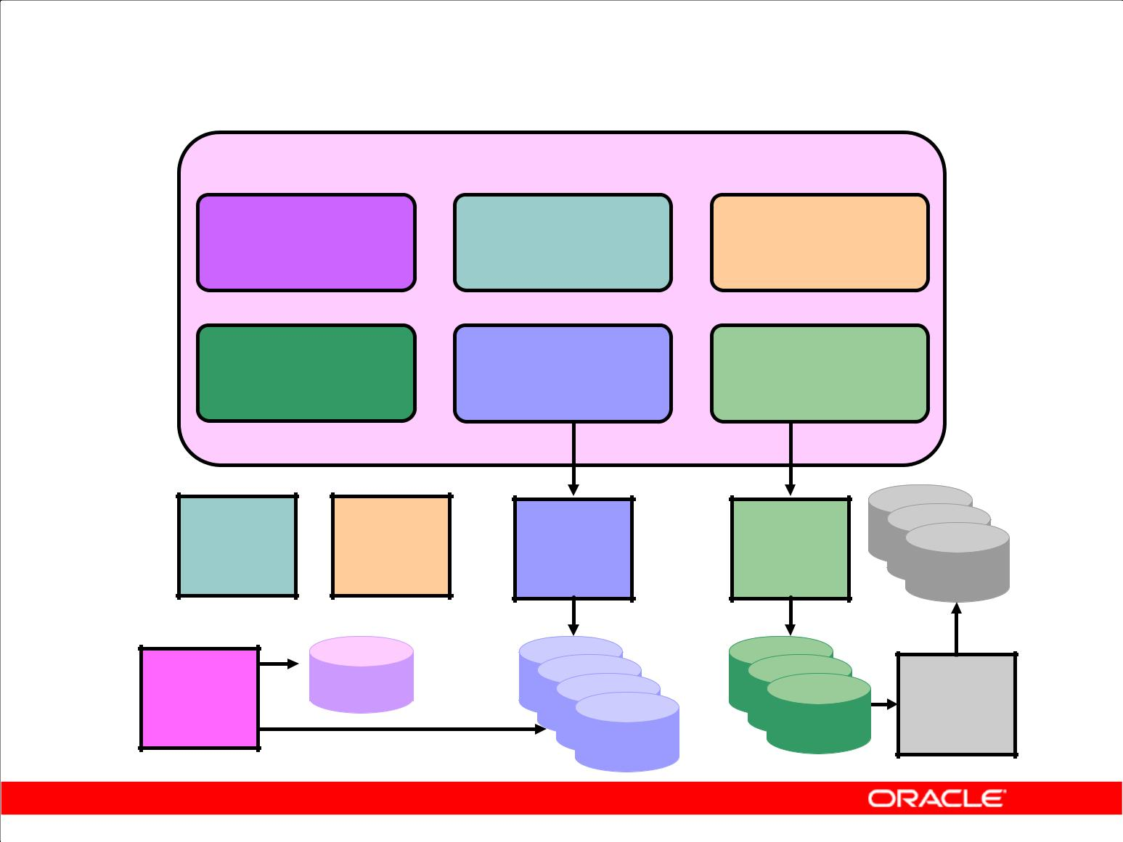**Oracle Instance Management**

**SGA**

**Shared pool** **Streams pool** **Large pool**

|  |  |  |
| --- | --- | --- |
| **Java pool** | **Database** | **Redo log** |
| **buffer cache** | **buffer** |
|  |

|  |  |  |  |
| --- | --- | --- | --- |
| **System** | **Process** | **Database** | **Log** |
| **monitor** | **monitor** | **writer** | **writer** |
| **SMON** | **PMON** | **DBW0** | **LGWR** |
| **Check** |  |  | **Archiver** |
| **point** |  |  |
|  |  | **ARC0** |
| **CKPT** |  |  |
|  |  |  |

Copyright © 2009, Oracle. All rights reserved.

**Oracle Instance Management**

An Oracle Database server consists of an Oracle Database and an Oracle instance. An Oracle instance consists of memory buffers known as the System Global Area (SGA) and background processes.

The instance is idle (nonexistent) until it is started. When the instance is started, an initialization parameter file is read and the instance is configured accordingly.

After the instance is started and the database is opened, users can access the database.

|  |
| --- |
| Oracle Internal & Oracle Academy Use Only |

**Oracle Database 10*g*: SQL Fundamentals II D - 9**

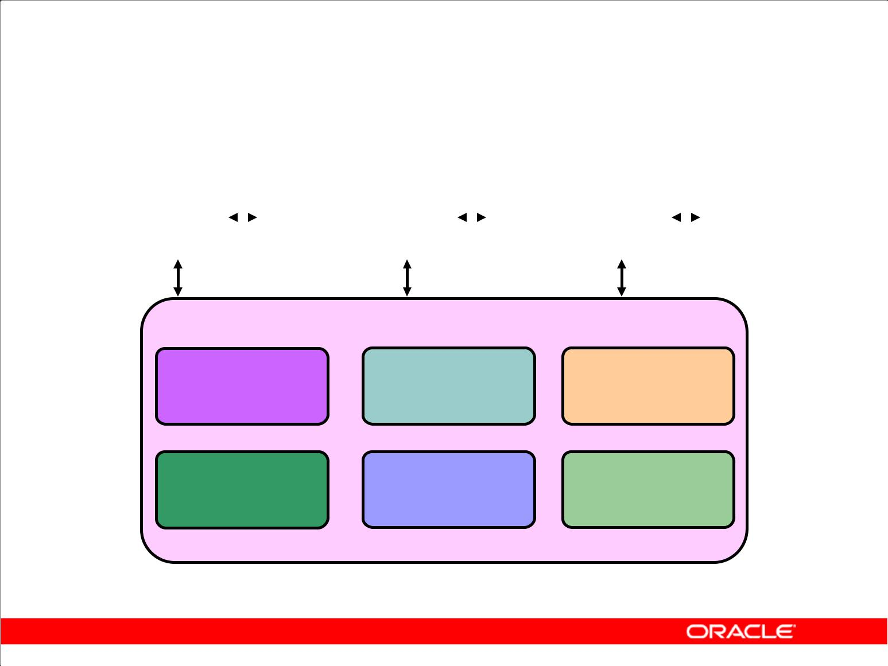**Oracle Memory Structures**

|  |  |  |  |  |  |  |  |  |  |  |  |  |  |  |  |  |
| --- | --- | --- | --- | --- | --- | --- | --- | --- | --- | --- | --- | --- | --- | --- | --- | --- |
| **Server** |  |  |  |  |  | **Server** |  |  |  |  |  | **Back-** |  |  |  |  |
|  |  |  | **PGA** |  |  |  | **PGA** |  |  |  | **PGA** |
| **process** |  |  |  |  | **process** |  |  |  |  | **ground** |  |  |  |
|  |  |  |  |  |  |  |  |  |  |  |
| **1** |  |  |  |  |  | **2** |  |  |  |  |  | **process** |  |  |  |  |
|  |  |  |  |  |  |  |  |  |  |  |  |

**SGA**

**Shared pool** **Streams pool** **Large pool**

|  |  |  |
| --- | --- | --- |
| **Java pool** | **Database** | **Redo log** |
| **buffer cache** | **buffer** |
|  |

Copyright © 2009, Oracle. All rights reserved.

**Oracle Memory Structures**

The basic memory structures associated with an Oracle instance include:

1. **System Global Area (SGA):** Shared by all server and background processes
2. **Program Global Area (PGA):** Private to each server and background process; there is onePGA for each process

The System Global Area (SGA) is a shared memory area that contains data and control information for the instance.

The SGA consists of the following data structures:

1. **Database buffer cache:** Caches blocks of data retrieved from the database
2. **Redo log buffer:** Caches redo information (used for instance recovery) until it can be written tothe physical redo log files stored on disk
3. **Shared pool:** Caches various constructs that can be shared among users
4. **Large pool:** Is an optional area used for buffering large I/O requests
5. **Java pool:** Is used for all session-specific Java code and data within the Java Virtual Machine(JVM)
6. **Streams pool:** Is used by Oracle Streams

When you start the instance by using Enterprise Manager or SQL*Plus, the memory allocated for the SGA is displayed.

|  |
| --- |
| Oracle Internal & Oracle Academy Use Only |

**Oracle Database 10*g*: SQL Fundamentals II D - 10**

**Oracle Memory Structures (continued)**

With the dynamic SGA infrastructure, the size of the database buffer cache, the shared pool, the large pool, the Java pool, and the Streams pool can be changed without shutting down the instance.

The preconfigured database has been pretuned with adequate settings for the memory parameters. However, as your database usage expands, you may find it necessary to alter the settings of the memory parameters.

Oracle provides alerts and advisors to identify memory-sizing problems and to help you determine appropriate values for memory parameters.

A Program Global Area (PGA) is a memory region that contains data and control information for each server process. A server process services a client’s requests. Each server process has its own private PGA area that is created when the server process is started. Access to it is exclusive to that server process, and is read and written only by the Oracle code acting on behalf of it.

The amount of PGA memory used and its content depends on whether the instance is configured in shared server mode. Generally, the PGA contains the following:

1. **Private SQL area:** Contains data such as bind information and run-time memory structures.Each session that issues a SQL statement has a private SQL area.
2. **Session memory:** Is memory allocated to hold session variables and other information related tothe session

|  |
| --- |
| Oracle Internal & Oracle Academy Use Only |

**Oracle Database 10*g*: SQL Fundamentals II D - 11**

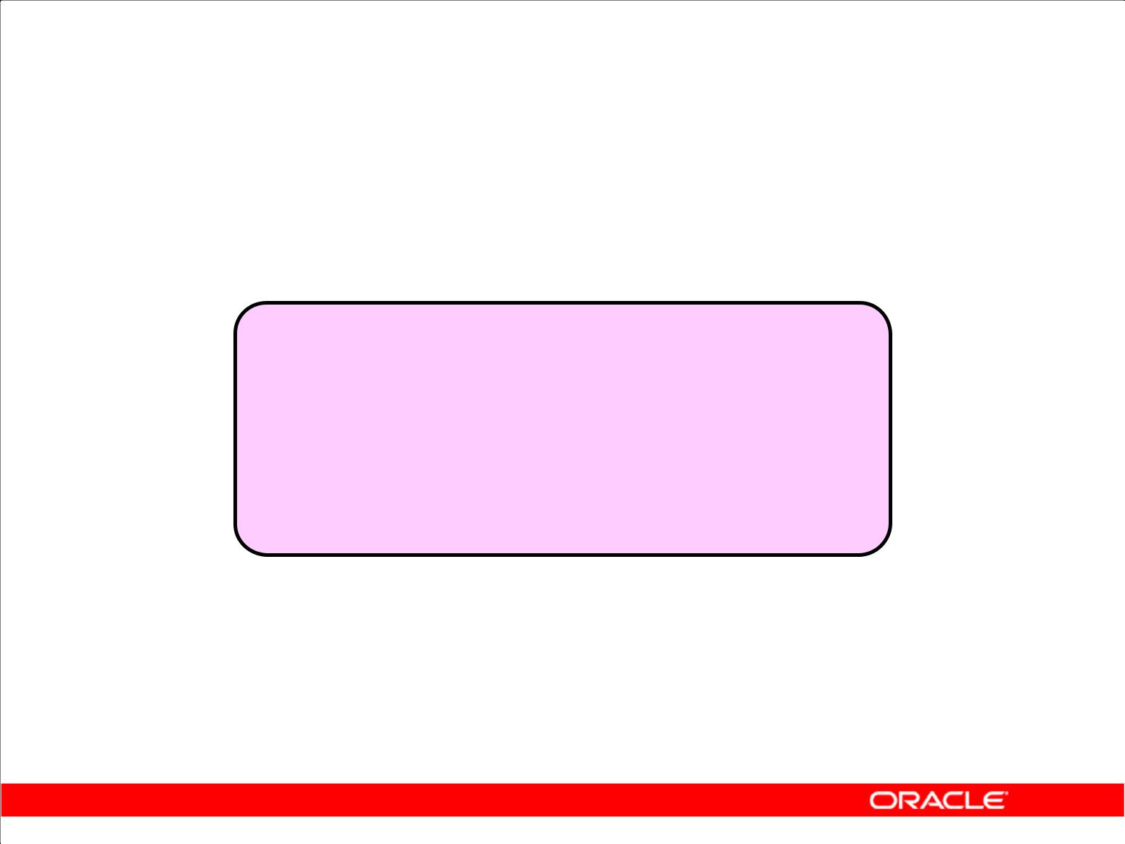**Oracle Processes**

|  |  |  |  |  |  |  |
| --- | --- | --- | --- | --- | --- | --- |
| **Server** |  | **Server** |  | **Server** |  | **Server** |
| **process** |  | **process** |  | **process** |  | **process** |
|  |  |  |  |  |  |  |

**System Global Area**

**(SGA)**

|  |  |  |  |  |  |  |  |  |  |  |
| --- | --- | --- | --- | --- | --- | --- | --- | --- | --- | --- |
| **System** |  | **Process** |  | **Database** |  | **Check** |  | **Log** |  | **Archiver** |
| **monitor** |  | **monitor** |  | **writer** |  | **point** |  | **writer** |  |
|  |  |  |  |  | **ARC0** |
| **SMON** |  | **PMON** |  | **DBW0** |  | **CKPT** |  | **LGWR** |  |
|  |  |  |  |  |  |
|  |  |  |  |  |  |  |  |  |  |  |

**Background processes**

Copyright © 2009, Oracle. All rights reserved.

**Oracle Processes**

When you invoke an application program or an Oracle tool such as Enterprise Manager, the Oracle server creates a server process to execute commands issued by the application.

Oracle also creates a set of background processes for an instance that interact with each other and with the operating system to manage the memory structures, asynchronously perform I/O to write data to disk, and do general housekeeping.

Which background processes are present depends upon the features that are being used in the database. The most common background processes are the following:

1. **System monitor (SMON):** Performs crash recovery when the instance is started following afailure
2. **Process monitor (PMON):** Performs process cleanup when a user process fails
3. **Database writer (DBW*n*):** Writes modified blocks from the database buffer cache to the files ondisk
4. **Checkpoint (CKPT):** SignalsDBW*n*at checkpoints and updates all the data files and control filesof the database to indicate the most recent checkpoint
5. **Log writer (LGWR):** Writes redo log entries to disk
6. **Archiver (ARC*n*):** Copies the redo log files to archival storage when the log files are full or alog switch occurs

|  |
| --- |
| Oracle Internal & Oracle Academy Use Only |

**Oracle Database 10*g*: SQL Fundamentals II D - 12**

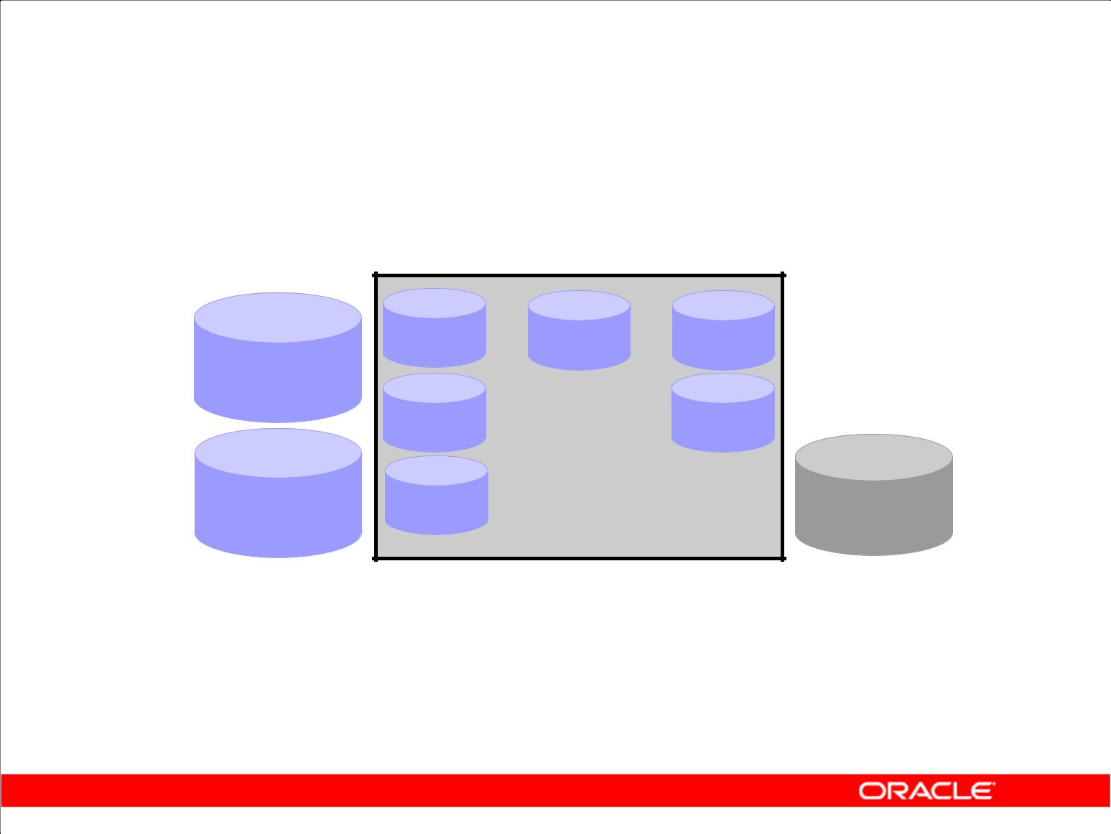**Other Key Physical Structures**

**Parameter**

**file**

|  |  |  |
| --- | --- | --- |
| **Password** | **Database** | **Archived** |
| **file** | **log files** |

Copyright © 2009, Oracle. All rights reserved.

**Other Key Files**

The Oracle server also uses other files that are not part of the database:

1. The parameter file defines the characteristics of an Oracle instance. For example, it contains parameters that size some of the memory structures in the SGA.
2. The password file authenticates which users are permitted to start up and shut down an Oracle instance.
3. Archived redo log files are offline copies of the redo log files that may be necessary for recovery from media failures.

|  |
| --- |
| Oracle Internal & Oracle Academy Use Only |

**Oracle Database 10*g*: SQL Fundamentals II D - 13**

**Processing a SQL Statement**

1. Connect to an instance using:

– The user process

– The server process

1. The Oracle server components that are used depend on the type of SQL statement:

– Queries return rows.

– Data manipulation language (DML) statements log changes.

– Commit ensures transaction recovery.

1. Some Oracle server components do not participate in SQL statement processing.

Copyright © 2009, Oracle. All rights reserved.

**Components Used to Process SQL**

Not all the components of an Oracle instance are used to process SQL statements. The user and server processes are used to connect a user to an Oracle instance. These processes are not part of the Oracle instance, but are required to process a SQL statement.

Some of the background processes, SGA structures, and database files are used to process SQL statements. Depending on the type of SQL statement, different components are used:

1. Queries require additional processing to return rows to the user.
2. Data manipulation language (DML) statements require additional processing to log the changes made to the data.
3. Commit processing ensures that the modified data in a transaction can be recovered.

Some required background processes do not directly participate in processing a SQL statement, but are used to improve performance and to recover the database.

The optional background process, ARC0, is used to ensure that a production database can be recovered.

|  |
| --- |
| Oracle Internal & Oracle Academy Use Only |

**Oracle Database 10*g*: SQL Fundamentals II D - 14**

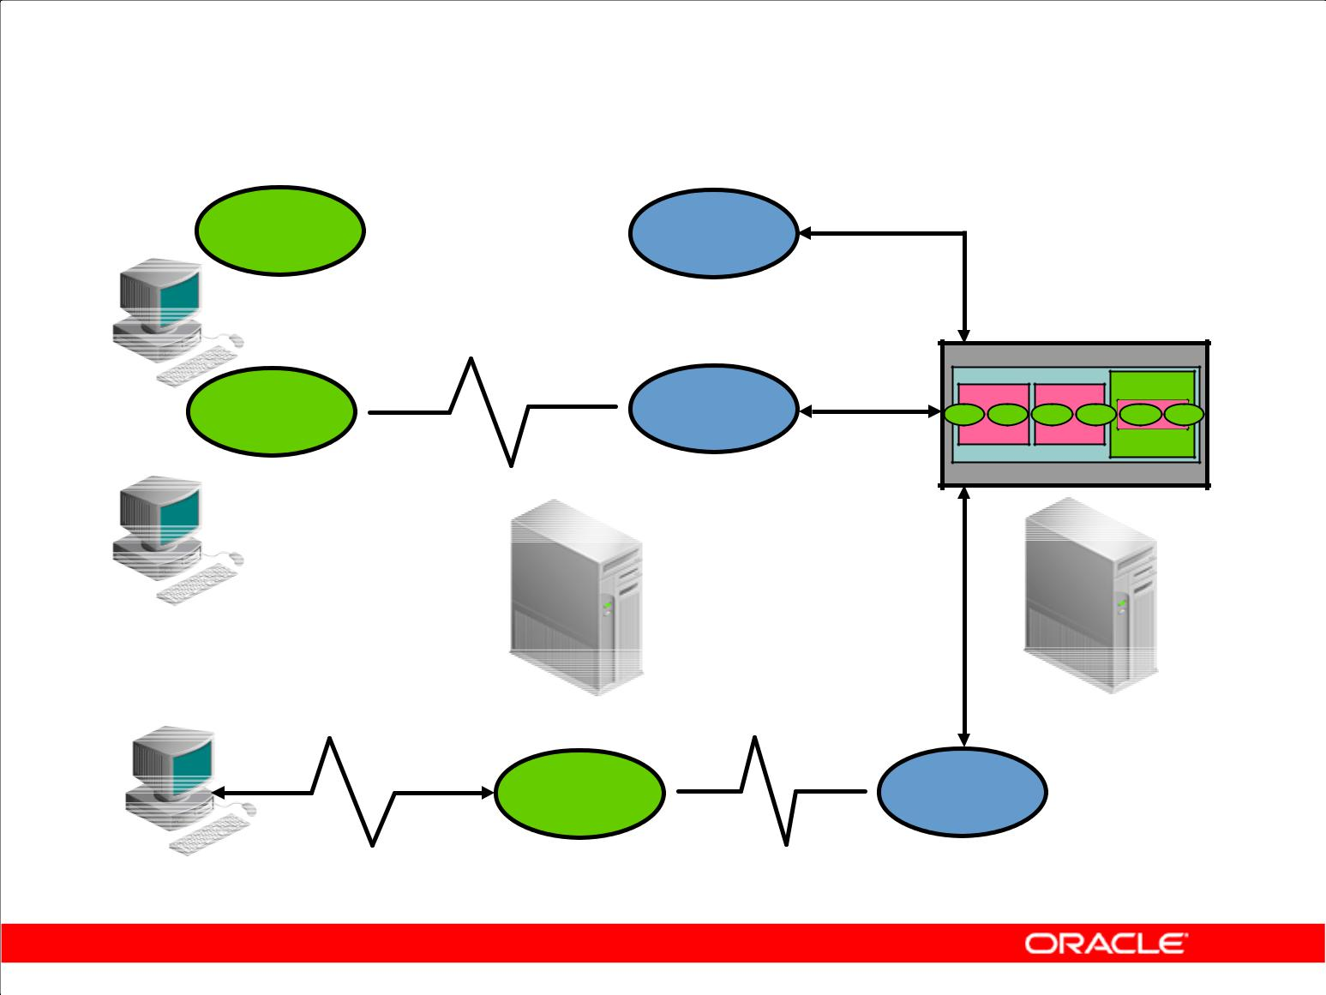**Connecting to an Instance**

**User**  **Server**

**Oracle server**

**User**  **Server**

**Client**

**Application server** **Server**

**User**  **Server**

**Browser**

Copyright © 2009, Oracle. All rights reserved.

**Processes Used to Connect to an Instance**

Before users can submit SQL statements to the Oracle server, they must connect to an instance.

The user starts a tool such as SQL Developer or runs an application developed using a tool such as Oracle Forms. This application or tool is executed in a *user process*.

In the most basic configuration, when a user logs on to the Oracle server, a process is created on the computer running the Oracle server. This process is called a server process. The server process communicates with the Oracle instance on behalf of the user process that runs on the client. The server process executes SQL statements on behalf of the user.

**Connection**

A connection is a communication pathway between a user process and an Oracle server. A database user can connect to an Oracle server in one of three ways:

1. The user logs on to the operating system running the Oracle instance and starts an application or tool that accesses the database on that system. The communication pathway is established using the interprocess communication mechanisms available on the host operating system.

|  |
| --- |
| Oracle Internal & Oracle Academy Use Only |

**Oracle Database 10*g*: SQL Fundamentals II D - 15**

**Processes Used to Connect to an Instance (continued)**

**Connection (continued)**

1. The user starts the application or tool on a local computer and connects over a network to the computer running the Oracle instance. In this configuration, called client/server, network software is used to communicate between the user and the Oracle server.
2. In a three-tiered connection, the user’s computer communicates over the network to an application or a network server, which is connected through a network to the machine running the Oracle instance. For example, the user runs a browser on a network computer to use an application residing on an NT server that retrieves data from an Oracle Database running on a UNIX host.

**Sessions**

A session is a specific connection of a user to an Oracle server. The session starts when the user is validated by the Oracle server, and it ends when the user logs out or when there is an abnormal termination. For a given database user, many concurrent sessions are possible if the user logs on from many tools, applications, or terminals at the same time. Except for some specialized database administration tools, starting a database session requires that the Oracle server be available for use.

**Note:** The type of connection explained here, where there is a one-to-one correspondence between auser and server process, is called a *dedicated server connection*.

|  |
| --- |
| Oracle Internal & Oracle Academy Use Only |

**Oracle Database 10*g*: SQL Fundamentals II D - 16**

**Processing a Query**

1. Parse:

– Search for identical statement.

– Check syntax, object names, and privileges.

– Lock objects used during parse.

– Create and store execution plan.

1. Execute: Identify rows selected.
2. Fetch: Return rows to user process.

Copyright © 2009, Oracle. All rights reserved.

**Query Processing Steps**

Queries are different from other types of SQL statements because, if successful, they return data as results. Whereas other statements simply return success or failure, a query can return one row or thousands of rows.

There are three main stages in the processing of a query:

1. Parse
2. Execute
3. Fetch

During the *parse* stage, the SQL statement is passed from the user process to the server process, and a parsed representation of the SQL statement is loaded into a shared SQL area.

During parse, the server process performs the following functions:

1. Searches for an existing copy of the SQL statement in the shared pool
2. Validates the SQL statement by checking its syntax
3. Performs data dictionary lookups to validate table and column definitions

The execute fetch executes the statement using the best optimizer approach and the fetch retrieves the rows back to the user.

|  |
| --- |
| Oracle Internal & Oracle Academy Use Only |

**Oracle Database 10*g*: SQL Fundamentals II D - 17**

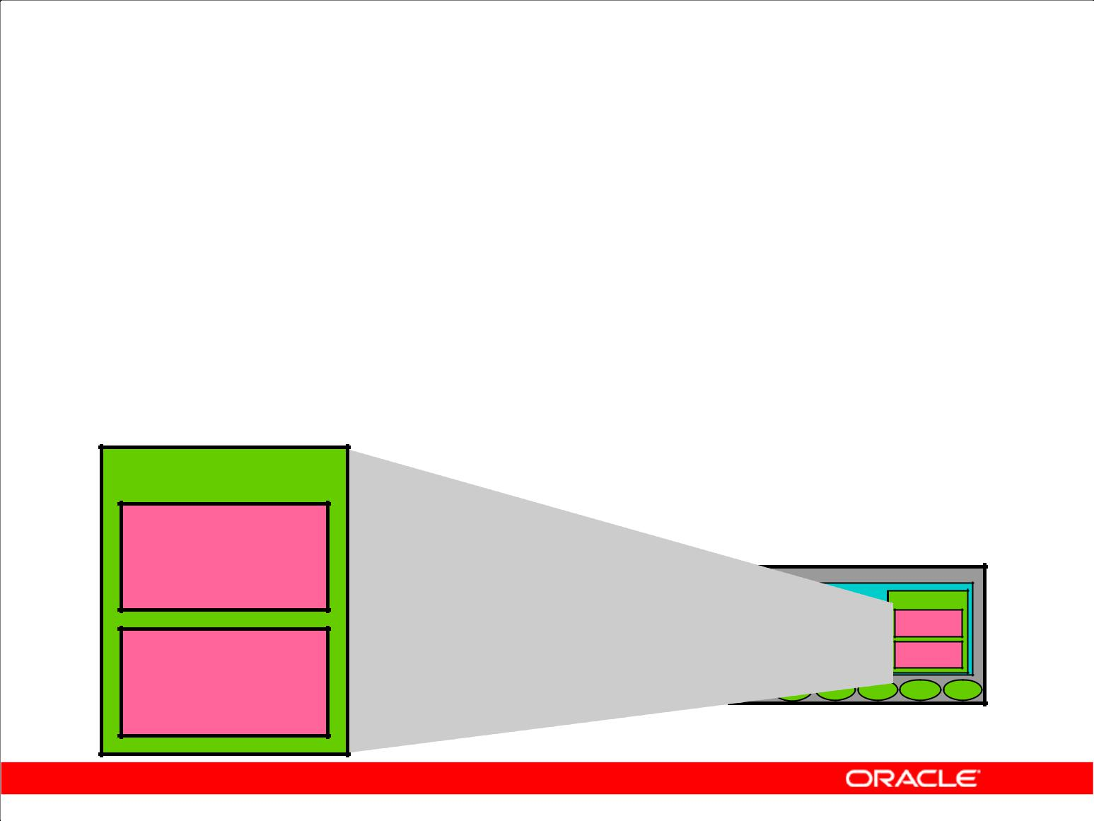**Shared Pool**

1. The library cache contains the SQL statement text, parsed code, and execution plan.
2. The data dictionary cache contains table, column, and other object definitions and privileges.
3. The shared pool is sized by SHARED_POOL_SIZE.

**Shared pool**

**Library**

**cache**

**Data dictionary**

**cache**

Copyright © 2009, Oracle. All rights reserved.

**Shared Pool Components**

During the parse stage, the server process uses the area in the SGA known as the shared pool to compile the SQL statement. The shared pool has two primary components:

1. Library cache
2. Data dictionary cache

**Library Cache**

The library cache stores information about the most recently used SQL statements in a memory structure called a shared SQL area. The shared SQL area contains:

1. The text of the SQL statement
2. The parse tree, which is a compiled version of the statement
3. The execution plan, with steps to be taken when executing the statement

The optimizer is the function in the Oracle server that determines the optimal execution plan.

If a SQL statement is reexecuted and a shared SQL area already contains the execution plan for the statement, then the server process does not need to parse the statement. The library cache improves the performance of applications that reuse SQL statements by reducing parse time and memory requirements. If the SQL statement is not reused, it is eventually aged out of the library cache.

|  |
| --- |
| Oracle Internal & Oracle Academy Use Only |

**Oracle Database 10*g*: SQL Fundamentals II D - 18**

**Shared Pool Components (continued)**

**Data Dictionary Cache**

The data dictionary cache, also known as the dictionary cache or row cache, is a collection of the most recently used definitions in the database. It includes information about database files, tables, indexes, columns, users, privileges, and other database objects.

During the parse phase, the server process looks for the information in the dictionary cache to resolve the object names specified in the SQL statement and to validate the access privileges. If necessary, the server process initiates the loading of this information from the data files.

**Sizing the Shared Pool**

The size of the shared pool is specified by the SHARED_ POOL_SIZE initialization parameter.

|  |
| --- |
| Oracle Internal & Oracle Academy Use Only |

**Oracle Database 10*g*: SQL Fundamentals II D - 19**

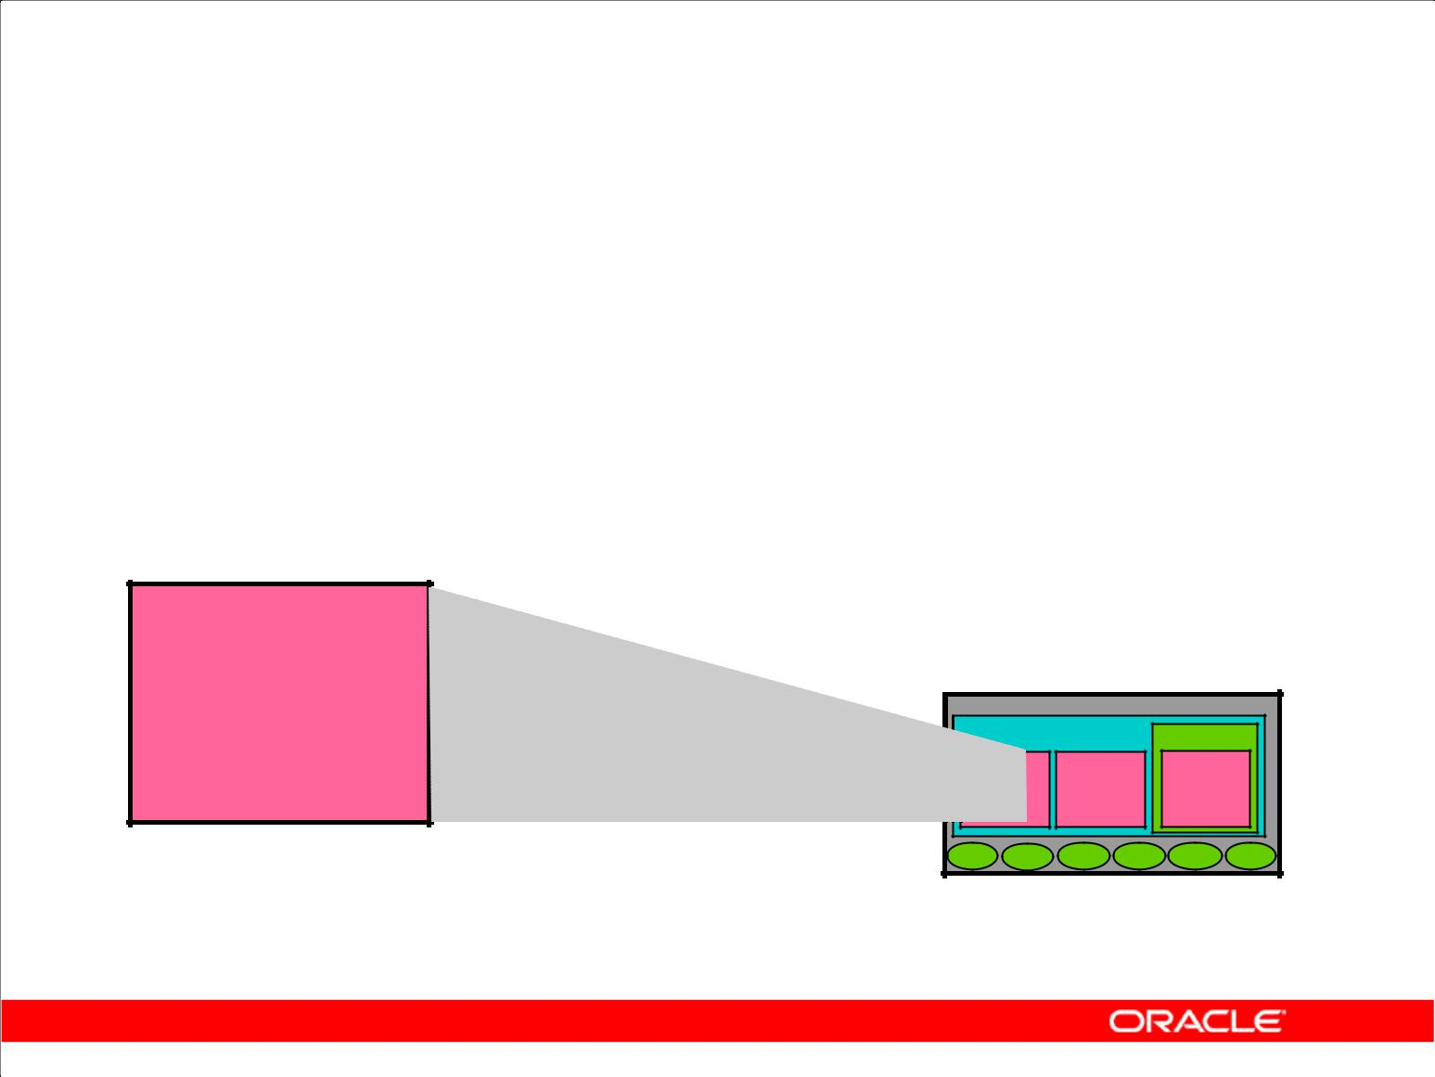**Database Buffer Cache**

1. It stores the most recently used blocks.
2. The size of a buffer is based on DB_BLOCK_SIZE.
3. The number of buffers is defined by DB_BLOCK_BUFFERS.

**Database buffer**

**cache**

Copyright © 2009, Oracle. All rights reserved.

**Functions of the Database Buffer Cache**

When a query is processed, the server process looks in the database buffer cache for any blocks it needs. If the block is not found in the database buffer cache, the server process reads the block from the data file and places a copy in the buffer cache. Because subsequent requests for the same block may find the block in memory, the requests may not require physical reads. The Oracle server uses a least recently used algorithm to age out buffers that have not been accessed recently to make room for new blocks in the buffer cache.

**Sizing the Database Buffer Cache**

The size of each buffer in the buffer cache is equal to the size of an Oracle block, and it is specified by the DB_BLOCK_SIZE parameter. The number of buffers is equal to the value of the

DB_BLOCK_BUFFERS parameter.

|  |
| --- |
| Oracle Internal & Oracle Academy Use Only |

**Oracle Database 10*g*: SQL Fundamentals II D - 20**

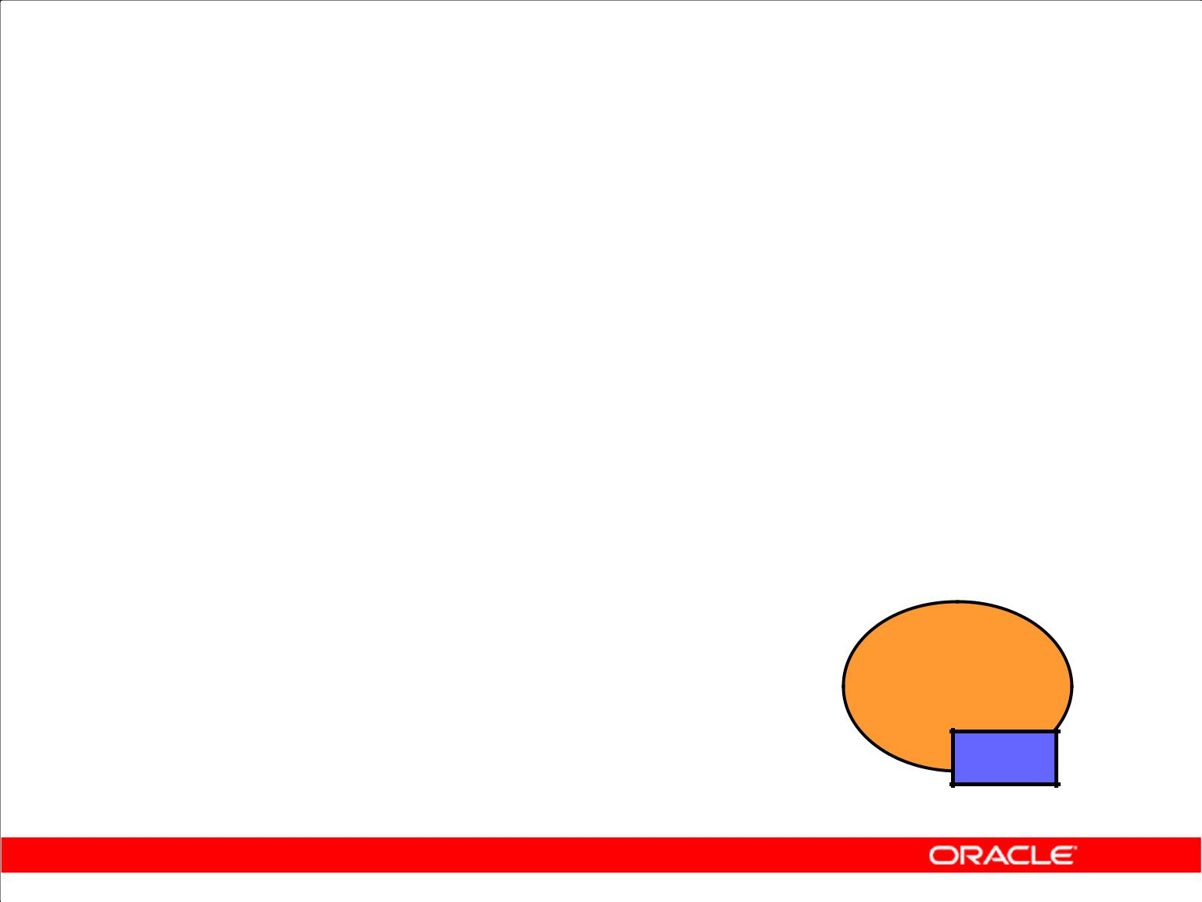**Program Global Area (PGA)**

1. Is not shared
2. Is writable only by the server process
3. Contains:

– Sort area

– Session information

– Cursor state

– Stack space

**Server**

**process**

**PGA**

Copyright © 2009, Oracle. All rights reserved.

**Program Global Area: Components**

A Program Global Area (PGA) is a memory region that contains data and control information for a server process. It is a nonshared memory created by Oracle when a server process is started. Access to it is exclusive to that server process, and is read and written only by the Oracle server code acting on behalf of it. The PGA memory allocated by each server process attached to an Oracle instance is referred to as the aggregated PGA memory allocated by the instance.

In a dedicated server configuration, the PGA of the server includes the following components:

1. **Sort area:** Is used for any sorts that may be required to process the SQL statement
2. **Session information:** Includes user privileges and performance statistics for the session
3. **Cursor state:** Indicates the stage in the processing of the SQL statements that are currently usedby the session
4. **Stack space:** Contains other session variables

The PGA is allocated when a process is created and deallocated when the process is terminated.

|  |
| --- |
| Oracle Internal & Oracle Academy Use Only |

**Oracle Database 10*g*: SQL Fundamentals II D - 21**

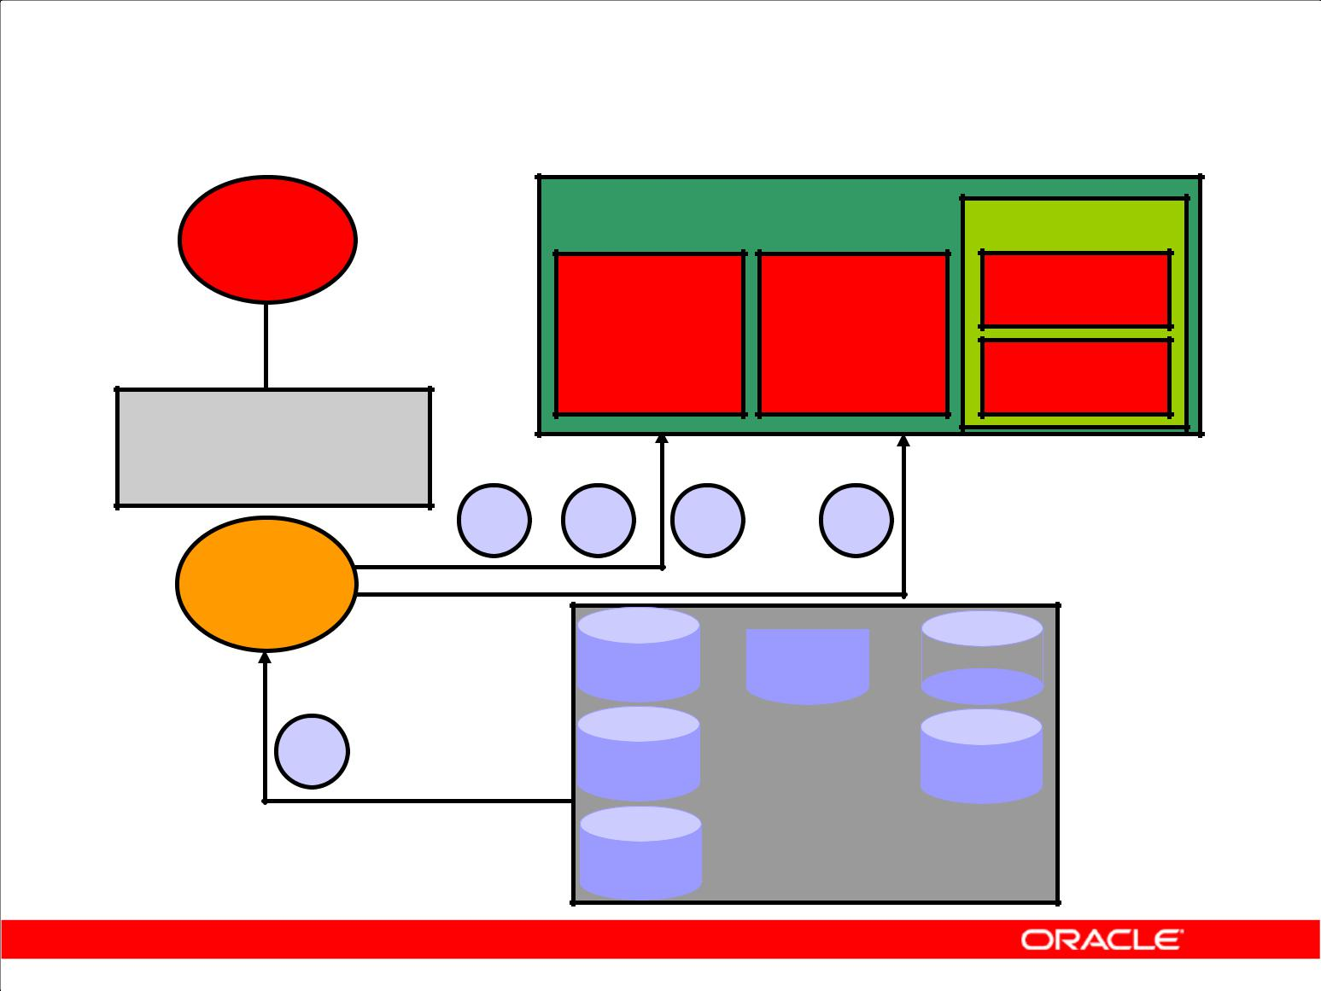**Processing a DML Statement**

|  |  |  |  |  |
| --- | --- | --- | --- | --- |
| **User** | **SGA** |  |  | **Shared pool** |
| **process** | **Database** | |  |  |
|  | **Redo log** | |
|  | **buffer** | |
|  | **buffer** |  |
|  | **cache** | |  |
|  |  |  |
| **UPDATE** |  |  |  |  |
| **employees ...** |  |  |  |  |
| **4** | **1** | **2** | **3** |  |
| **Server** |  |  |  |  |
| **process** | **Data** |  | **Control** | **Redo** |
|  |  |
|  | **files** |  | **files** | **log files** |

**1**

**Database**

Copyright © 2009, Oracle. All rights reserved.

**DML Processing Steps**

A data manipulation language (DML) statement requires only two phases of processing:

1. Parse is the same as the parse phase used for processing a query.
2. Execute requires additional processing to make data changes.

**DML Execute Phase**

To execute a DML statement:

1. If the data and rollback blocks are not already in the buffer cache, the server process reads them from the data files into the buffer cache.
2. The server process places locks on the rows that are to be modified.
3. In the redo log buffer, the server process records the changes to be made to the rollback and data blocks.
4. The rollback block changes record the values of the data before it is modified. The rollback block is used to store the “before image” of the data, so that the DML statements can be rolled back if necessary.
5. The data block changes record the new values of the data.

|  |
| --- |
| Oracle Internal & Oracle Academy Use Only |

**Oracle Database 10*g*: SQL Fundamentals II D - 22**

**DML Processing Steps (continued)**

**DML Execute Phase (continued)**

The server process records the “before image” to the rollback block and updates the data block. Both of these changes are done in the database buffer cache. Any changed blocks in the buffer cache are marked as dirty buffers (that is, buffers that are not the same as the corresponding blocks on the disk).

The processing of a DELETE or INSERT command uses similar steps. The “before image” for a DELETE contains the column values in the deleted row, and the “before image” of an INSERT contains the row location information.

Because the changes made to the blocks are only recorded in memory structures and are not written immediately to disk, a computer failure that causes the loss of the SGA can also lose these changes.

|  |
| --- |
| Oracle Internal & Oracle Academy Use Only |

**Oracle Database 10*g*: SQL Fundamentals II D - 23**

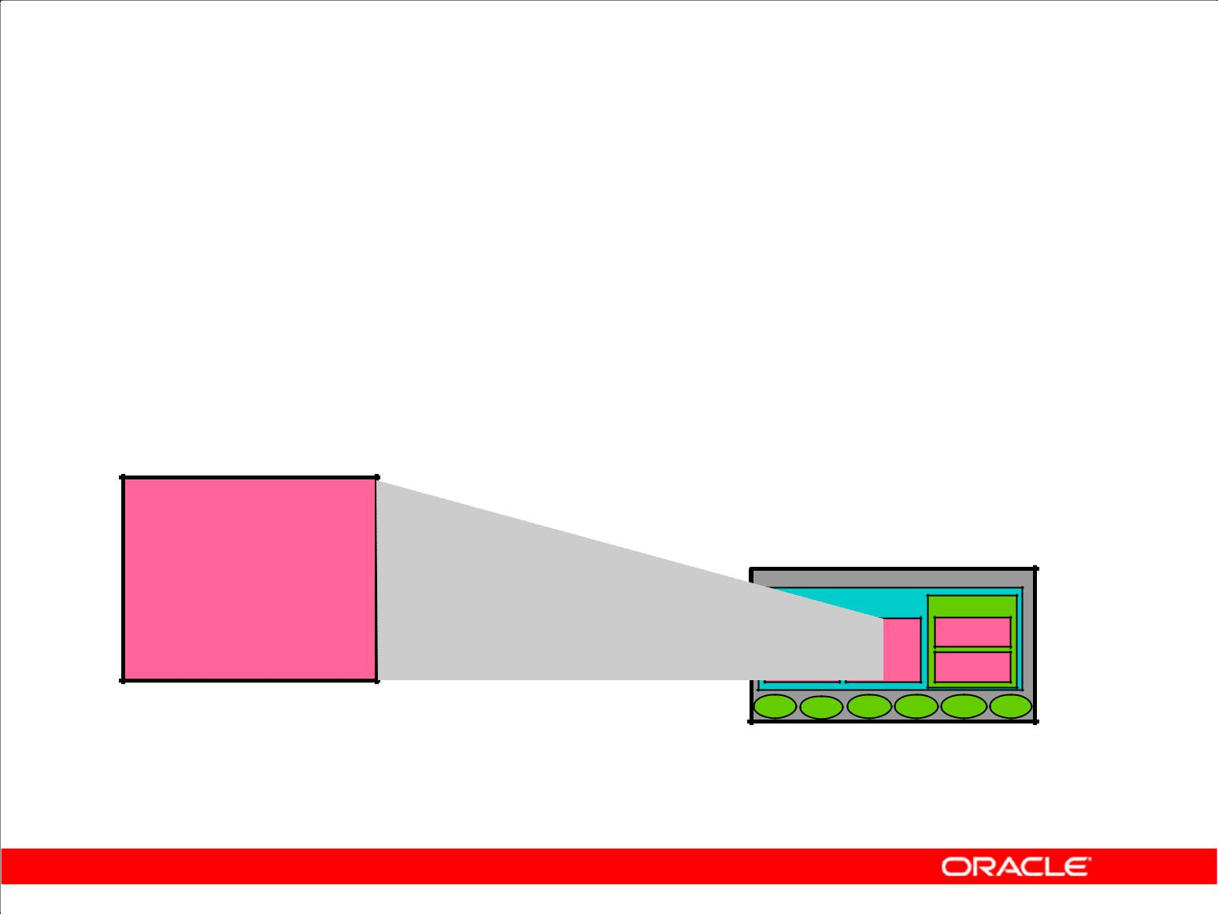**Redo Log Buffer**

1. Has its size defined by LOG_BUFFER
2. Records changes made through the instance
3. Is used sequentially
4. Is a circular buffer

**Database buffer**

**cache**

Copyright © 2009, Oracle. All rights reserved.

**Redo Log Buffer: Characteristics**

The server process records most of the changes made to data file blocks in the redo log buffer, which is a part of the SGA. The redo log buffer has the following characteristics:

1. Its size in bytes is defined by the LOG_BUFFER parameter.
2. It records the block that is changed, the location of the change, and the new value in a redo entry. A redo entry makes no distinction between the type of block that is changed; it only records which bytes are changed in the block.
3. The redo log buffer is used sequentially, and changes made by one transaction may be interleaved with changes made by other transactions.
4. It is a circular buffer that is reused after it is filled, but only after all the old redo entries are recorded in the redo log files.

|  |
| --- |
| Oracle Internal & Oracle Academy Use Only |

**Oracle Database 10*g*: SQL Fundamentals II D - 24**

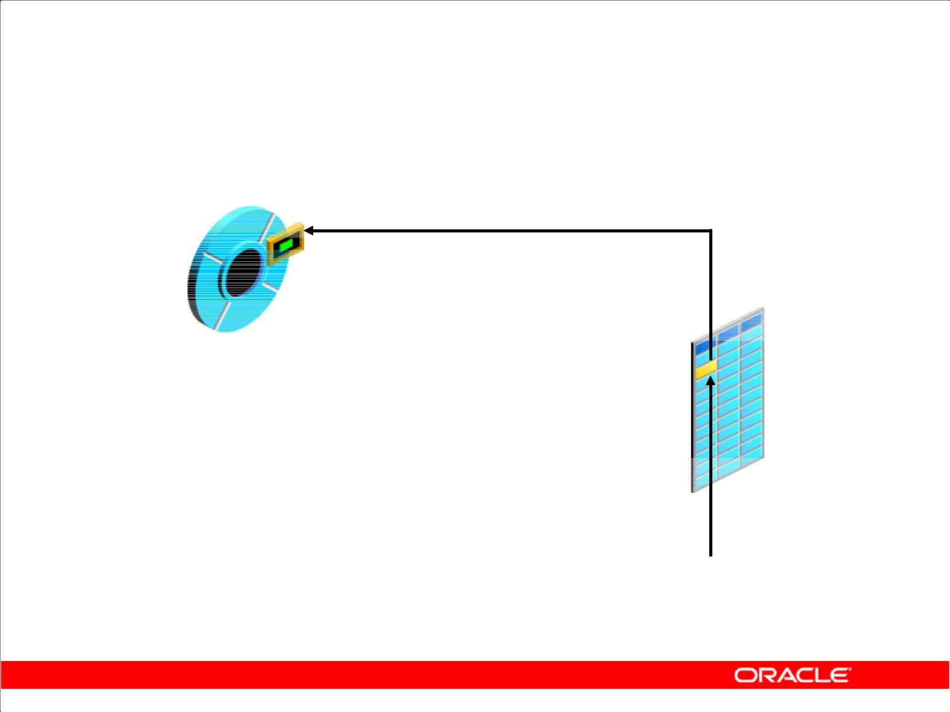**Rollback Segment**

**Old image**

**Rollback segment**

**New image**

**Table**

**DML statement**

Copyright © 2009, Oracle. All rights reserved.

**Rollback Segment**

Before making a change, the server process saves the old data value in a rollback segment. This “before image” is used to:

1. Undo the changes if the transaction is rolled back
2. Provide read consistency by ensuring that other transactions do not see uncommitted changes made by the DML statement
3. Recover the database to a consistent state in case of failures

Rollback segments, such as tables and indexes, exist in data files, and rollback blocks are brought into the database buffer cache as required. Rollback segments are created by the DBA.

Changes to rollback segments are recorded in the redo log buffer.

|  |
| --- |
| Oracle Internal & Oracle Academy Use Only |

**Oracle Database 10*g*: SQL Fundamentals II D - 25**

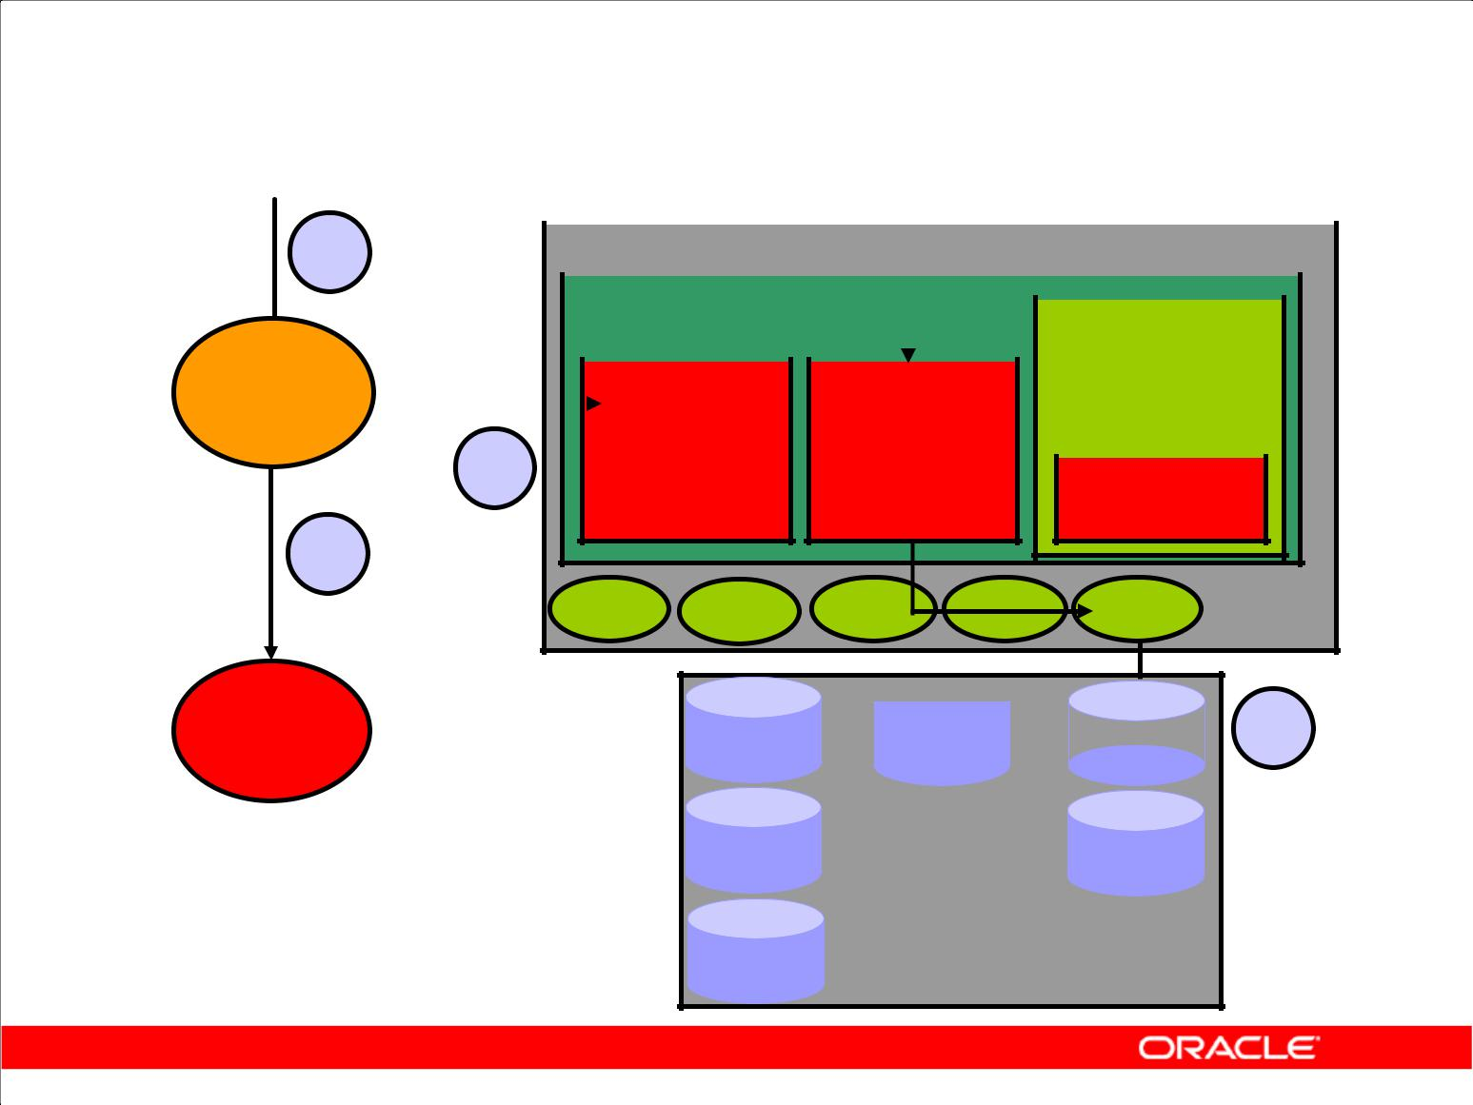**COMMIT Processing**

|  |  |  |  |  |  |  |  |  |  |  |  |  |  |  |  |  |
| --- | --- | --- | --- | --- | --- | --- | --- | --- | --- | --- | --- | --- | --- | --- | --- | --- |
|  |  | **1** |  |  |  |  |  |  |  |  |  |  |  |  |  |  |
|  |  |  |  | **Instance** | | | |  |  |  |  |  |  |  |  |
|  |  |  |  |  |  | **SGA** | | |  |  |  |  |  |  |  | |
| **Server** | | | |  |  |  |  |  | **Shared pool** | | | | |
|  |  |  |  |  |  |  |  |  |  |  |  |  |
|  |  |  | **Database** | |  |  |  |  |  |  |  |  |
| **process** | | |  |  |  |  | **Redo log** | | | |  |  |  |  |
|  |  |  |  |  |  |  |  |
| **4** | | | |  |  |  | **buffer** | |  |  | | |
|  |  |  | **buffer** | | | |  |  | | |
|  |  |  |
|  |  |  |  |  |  |  | **cache** | |  |  |  |  |  |  |  |  |

**3**

**LGWR **

|  |  |  |  |  |
| --- | --- | --- | --- | --- |
| **User** | **Data** | **Control** | **Redo** | **2** |
| **process** | **files** | **files** | **log files** |

**Database**

Copyright © 2009, Oracle. All rights reserved.

**Fast COMMIT**

The Oracle server uses a fast COMMIT mechanism that guarantees that the committed changes can be recovered in case of instance failure.

**System Change Number**

Whenever a transaction commits, the Oracle server assigns a commit system change number (SCN) to the transaction. The SCN is monotonically incremented and is unique within the database. It is used by the Oracle server as an internal time stamp to synchronize data and to provide read consistency when data is retrieved from the data files. Using the SCN enables the Oracle server to perform consistency checks without depending on the date and time of the operating system.

**Steps in Processing COMMITs**

When a COMMIT is issued, the following steps are performed:

1. The server process places a commit record, along with the SCN, in the redo log buffer.
2. LGWR performs a contiguous write of all the redo log buffer entries up to and including

the commit record to the redo log files. After this point, the Oracle server can guarantee that the changes will not be lost even if there is an instance failure.

|  |
| --- |
| Oracle Internal & Oracle Academy Use Only |

**Oracle Database 10*g*: SQL Fundamentals II D - 26**

**Fast COMMIT (continued)**

**Steps in Processing COMMITs (continued)**

1. The user is informed that the COMMIT is complete.
2. The server process records information to indicate that the transaction is complete and that resource locks can be released.

Flushing of the dirty buffers to the data file is performed independently by DBW0 and can occur either before or after the commit.

**Advantages of the Fast COMMIT**

The fast COMMIT mechanism ensures data recovery by writing changes to the redo log buffer instead of the data files. It has the following advantages:

1. Sequential writes to the log files are faster than writing to different blocks in the data file.
2. Only the minimal information that is necessary to record changes is written to the log files; writing to the data files would require whole blocks of data to be written.
3. If multiple transactions request to commit at the same time, the instance piggybacks redo log records into a single write.
4. Unless the redo log buffer is particularly full, only one synchronous write is required per transaction. If piggybacking occurs, there can be less than one synchronous write per transaction.
5. Because the redo log buffer may be flushed before the COMMIT, the size of the transaction does not affect the amount of time needed for an actual COMMIT operation.

**Note:** Rolling back a transaction does not triggerLGWRto write to disk. The Oracle server alwaysrolls back uncommitted changes when recovering from failures. If there is a failure after a rollback, before the rollback entries are recorded on disk, the absence of a commit record is sufficient to ensure that the changes made by the transaction are rolled back.

|  |
| --- |
| Oracle Internal & Oracle Academy Use Only |

**Oracle Database 10*g*: SQL Fundamentals II D - 27**

**Summary**

In this appendix, you should have learned how to:

1. Identify database files: data files, control files, and online redo logs
2. Describe SGA memory structures: DB buffer cache, shared SQL pool, and redo log buffer
3. Explain primary background processes:

DBW0, LGWR, CKPT, PMON, SMON, and ARC0

1. List SQL processing steps: parse, execute, and fetch

Copyright © 2009, Oracle. All rights reserved.

**Summary**

**Oracle Database Files**

The Oracle Database includes the following files:

1. **Control files:** Contain information required to verify the integrity of the database, including thenames of the other files in the database (The control files are usually mirrored.)
2. **Data files:** Contain the data in the database, including tables, indexes, rollback segments, andtemporary segments
3. **Online redo logs:** Contain the changes made to the data files (Online redo logs are used forrecovery and are usually mirrored.)

Other files commonly used with the database include:

1. **Parameter file:** Defines the characteristics of an Oracle instance
2. **Password file:** Authenticates privileged database users
3. **Archived redo logs:** Are backups of the online redo logs

|  |
| --- |
| Oracle Internal & Oracle Academy Use Only |

**Oracle Database 10*g*: SQL Fundamentals II D - 28**

**Summary (continued)**

**SGA Memory Structures**

The System Global Area (SGA) has three primary structures:

1. **Shared pool:** Stores the most recently executed SQL statements and the most recently used datafrom the data dictionary
2. **Database buffer cache:** Stores the most recently used data
3. **Redo log buffer:** Records changes made to the database using the instance

**Background Processes**

A production Oracle instance includes the following processes:

1. **Database writer (DBW0):** Writes changed data to the data files
2. **Log writer (LGWR):** Records changes to the data files in the online redo log files
3. **System monitor (SMON):** Checks for consistency and initiates recovery of the database whenthe database is opened
4. **Process monitor (PMON):** Cleans up the resources if one of the processes fails
5. **Checkpoint process (CKPT):** Updates the database status information after a checkpoint
6. **Archiver (ARC0):** Backs up the online redo log to ensure recovery after a media failure (Thisprocess is optional, but is usually included in a production instance.)

Depending on its configuration, the instance may also include other processes.

**SQL Statement Processing Steps**

The steps used to process a SQL statement include:

1. **Parse:** Compiles the SQL statement
2. **Execute:** Identifies selected rows or applies DML changes to the data
3. **Fetch:** Returns the rows queried by aSELECTstatement

|  |
| --- |
| Oracle Internal & Oracle Academy Use Only |

**Oracle Database 10*g*: SQL Fundamentals II D - 29**

Oracle Internal & Oracle Academy Use Only



**Using SQL Developer**

Copyright © 2009, Oracle. All rights reserved.

|  |
| --- |
| Oracle Internal & Oracle Academy Use Only |

**Objectives**

After completing this appendix, you should be able to do the following:

1. List the key features of Oracle SQL Developer
2. Install Oracle SQL Developer
3. Identify menu items of Oracle SQL Developer
4. Create a database connection
5. Manage database objects
6. Use SQL Worksheet
7. Execute SQL statements and SQL scripts
8. Create and save reports

Copyright © 2009, Oracle. All rights reserved.

**Objectives**

In this appendix, you are introduced to the graphical tool SQL Developer. You learn how to use SQL Developer for your database development tasks. You learn how to use SQL Worksheet to execute SQL statements and SQL scripts.

|  |
| --- |
| Oracle Internal & Oracle Academy Use Only |

**Oracle Database 10*g*: SQL Fundamentals II E - 2**

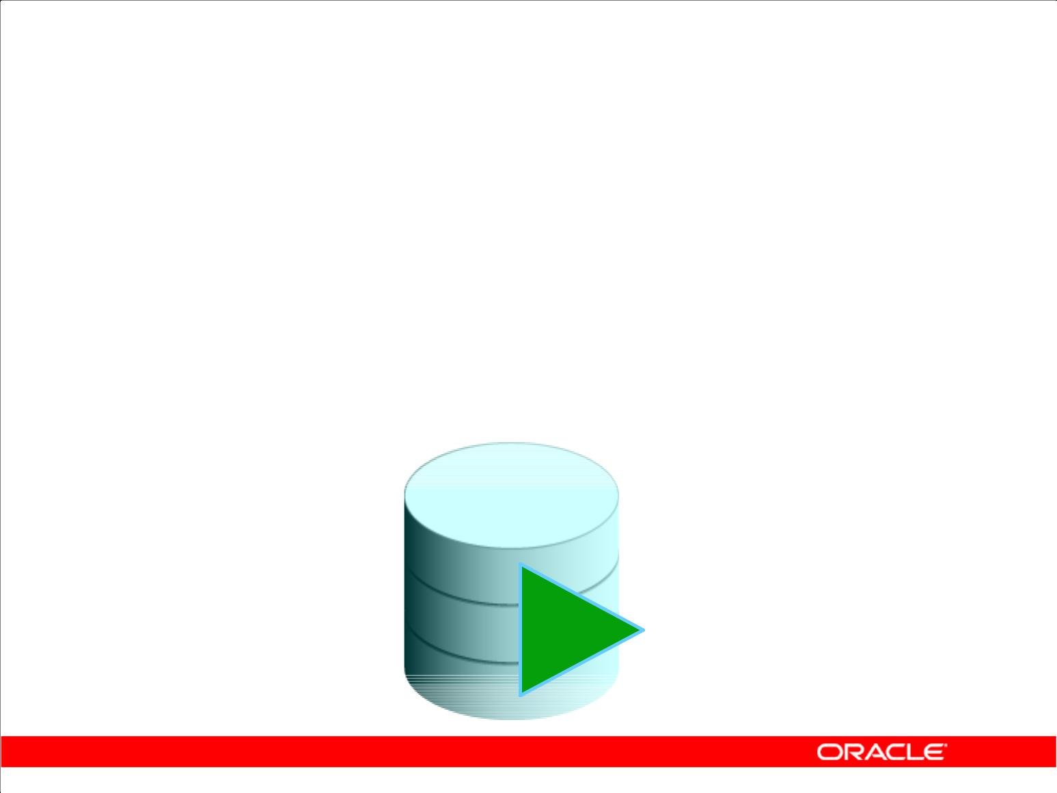**What Is Oracle SQL Developer?**

1. Oracle SQL Developer is a free graphical tool that enhances productivity and simplifies database development tasks.
2. You can connect to any target Oracle Database schema using standard Oracle Database authentication.

Copyright © 2009, Oracle. All rights reserved.

**What Is Oracle SQL Developer?**

Oracle SQL Developer is a free graphical tool designed to improve your productivity and simplify the development of everyday database tasks. With just a few clicks, you can easily create and debug stored procedures, test SQL statements, and view optimizer plans.

SQL Developer, the visual tool for database development, simplifies the following tasks:

1. Browsing and managing database objects
2. Executing SQL statements and scripts
3. Editing and debugging PL/SQL statements
4. Creating reports

You can connect to any target Oracle Database schema using standard Oracle Database authentication. When connected, you can perform operations on objects in the database.

|  |
| --- |
| Oracle Internal & Oracle Academy Use Only |

**Oracle Database 10*g*: SQL Fundamentals II E - 3**

**Key Features**

1. Developed in Java
2. Supports Windows, Linux, and Mac OS X platforms
3. Default connectivity by using the JDBC Thin driver
4. Does not require an installer
5. Connects to any Oracle Database version 9.2.0.1 and later
6. Bundled with JRE 1.5

Copyright © 2009, Oracle. All rights reserved.

**Key Features of SQL Developer**

Oracle SQL Developer is developed in Java, leveraging the Oracle JDeveloper IDE. The tool runs on the Windows, Linux, and Mac OS X platforms. You can install SQL Developer on the Database Server and connect remotely from your desktop, thus avoiding client server network traffic.

Default connectivity to the database is through the JDBC Thin driver; so, no Oracle Home is required. SQL Developer does not require an installer and you need to just unzip the downloaded file.

With SQL Developer, users can connect to Oracle Database 9.2.0.1 and later versions, and all Oracle Database editions including Express Edition. SQL Developer is bundled with JRE 1.5, with an additional tools.jar to support Windows clients. Non-Windows clients need only JDK 1.5.

|  |
| --- |
| Oracle Internal & Oracle Academy Use Only |

**Oracle Database 10*g*: SQL Fundamentals II E - 4**

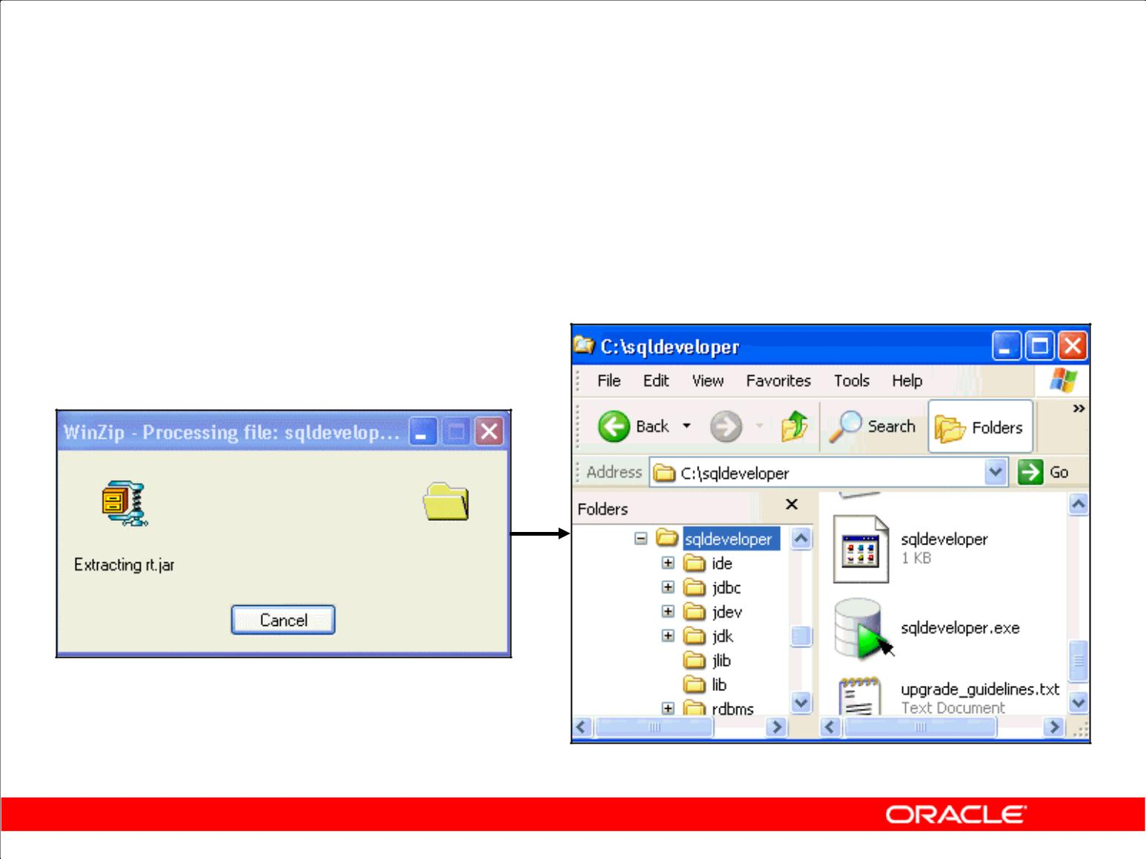**Installing SQL Developer**

Download the Oracle SQL Developer kit and unzip it into any directory on your machine.

Copyright © 2009, Oracle. All rights reserved.

**Installing SQL Developer**

Oracle SQL Developer does not require an installer. To install SQL Developer, you need an unzip tool.

To install SQL Developer, perform the following steps:

1. Create a folder as <local drive>:\SQL Developer.
2. Download the SQL Developer kit from http://www.oracle.com/technology/software/products/sql/index.html.
3. Unzip the downloaded SQL Developer kit into the folder created in step 1.

To start SQL Developer, go to <local drive>:\SQL Developer, and double-click sqldeveloper.exe.

|  |
| --- |
| Oracle Internal & Oracle Academy Use Only |

**Oracle Database 10*g*: SQL Fundamentals II E - 5**

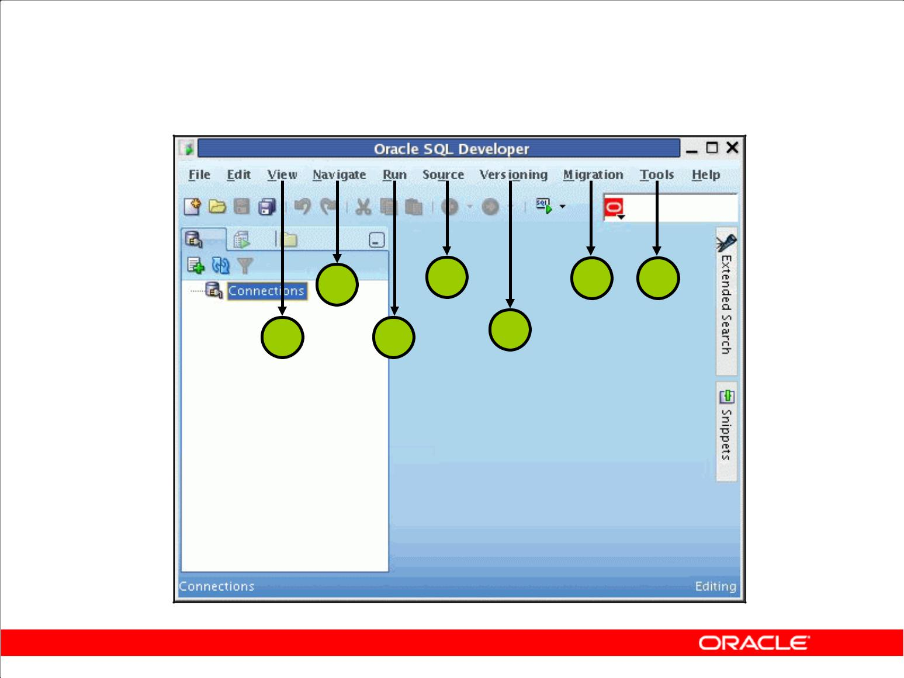**Menus for SQL Developer**

|  |  |  |  |
| --- | --- | --- | --- |
| **2** | **4** | **6** | **7** |

**1** **3** **5**

Copyright © 2009, Oracle. All rights reserved.

**Menus for SQL Developer**

SQL Developer has two main navigation tabs.

1. **Connections Navigator:** By using this tab, you can browse database objects and users to whichyou have access.
2. **Reporting Tab:** By using this tab, you can run predefined reports or create and add your ownreports.

SQL Developer uses the left side for navigation to find and select objects, and the right side to display information about selected objects. You can customize many aspects of the appearance and behavior of SQL Developer by setting preferences. The menus at the top contain standard entries, plus entries for features specific to SQL Developer.

1. **View:** Contains options that affect what is displayed in the SQL Developer interface
2. **Navigate:** Contains options for navigating to panes and for the execution of subprograms
3. **Run:** Contains the Run File and Execution Profile options that are relevant when a function orprocedure is selected
4. **Source:** Contains options for use when editing functions and procedures
5. **Versioning:** Enables you to work with the files placed under source code control
6. **Migration:** Enables you to migrate from another database, such as Microsoft SQL Server andMicrosoft Access, to an Oracle Database
7. **Tools:** Invokes SQL Worksheet, Preferences, and any added External Tools

|  |
| --- |
| Oracle Internal & Oracle Academy Use Only |

**Oracle Database 10*g*: SQL Fundamentals II E - 6**

**Creating a Database Connection**

1. You must have at least one database connection to use SQL Developer.
2. You can create and test connections:

– For multiple databases

– For multiple schemas

1. SQL Developer automatically imports any connections defined in the tnsnames.ora file on your system.
2. You can export connections to an XML file.
3. Each additional database connection created is listed in the connections navigator hierarchy.

Copyright © 2009, Oracle. All rights reserved.

**Creating a Database Connection**

A connection is a SQL Developer object that specifies the necessary information for connecting to a specific database as a specific user of that database. To use SQL Developer, you must have at least one database connection which may be existing, created, or imported.

You can create and test connections for multiple databases and for multiple schemas.

By default, the tnsnames.ora file is located in the $ORACLE_HOME/network/admin directory. But, it can also be in the directory specified by the TNS_ADMIN environment variable or

registry value. When you start SQL Developer and display the database connections dialog box, SQL Developer automatically imports any connections defined in the tnsnames.ora file on your

system.

**Note:** On Windows systems, if thetnsnames.orafile exists but its connections are not beingused by SQL Developer, define TNS_ADMIN as a system environment variable.

You can export connections to an XML file so that you can reuse it later.

You can create additional connections to connect to the same database but as different users, or to connect to different databases. Each database connection is listed in the Connections navigator hierarchy.

|  |
| --- |
| Oracle Internal & Oracle Academy Use Only |

**Oracle Database 10*g*: SQL Fundamentals II E - 7**

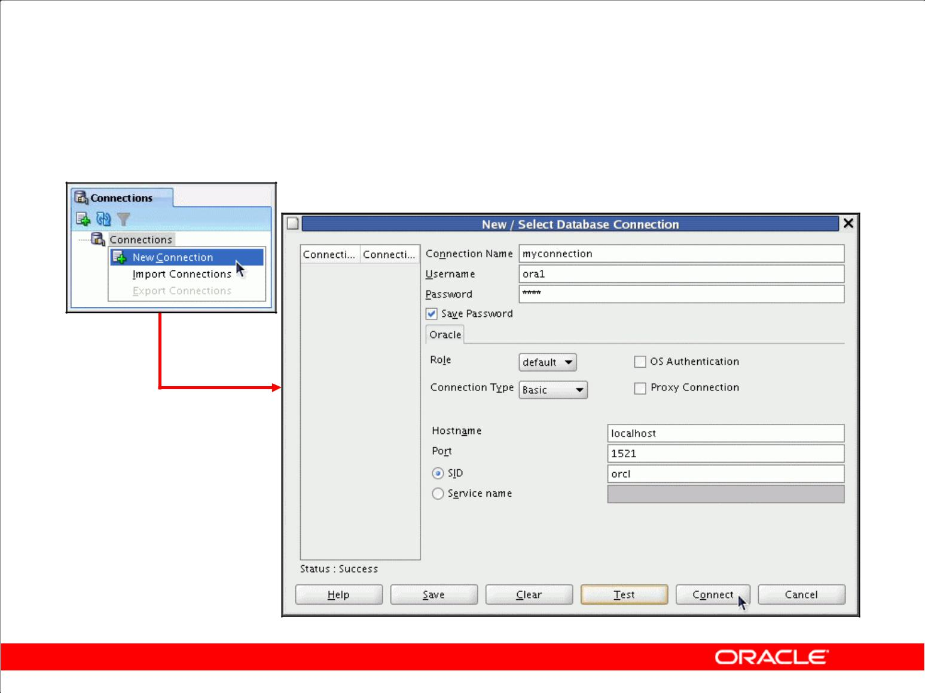**Creating a Database Connection**

Copyright © 2009, Oracle. All rights reserved.

**Creating a Database Connection (continued)**

To create a database connection, perform the following steps:

1. Double-click <*your_path*>\sqldeveloper\sqldeveloper.exe.
2. On the **Connections** tabbed page, right-click **Connections** and select **New Connection**.
3. Enter the connection name, username, password, host name, port number, and SID for the database you want to connect.
4. Click **Test** to make sure that the connection has been set correctly.
5. Click **Connect**.

Note: If you select the **Save Password** check box, the password is saved to an XML file. So, after you close the SQL Developer connection and open it again, you will not be prompted for the password.

|  |
| --- |
| Oracle Internal & Oracle Academy Use Only |

**Oracle Database 10*g*: SQL Fundamentals II E - 8**

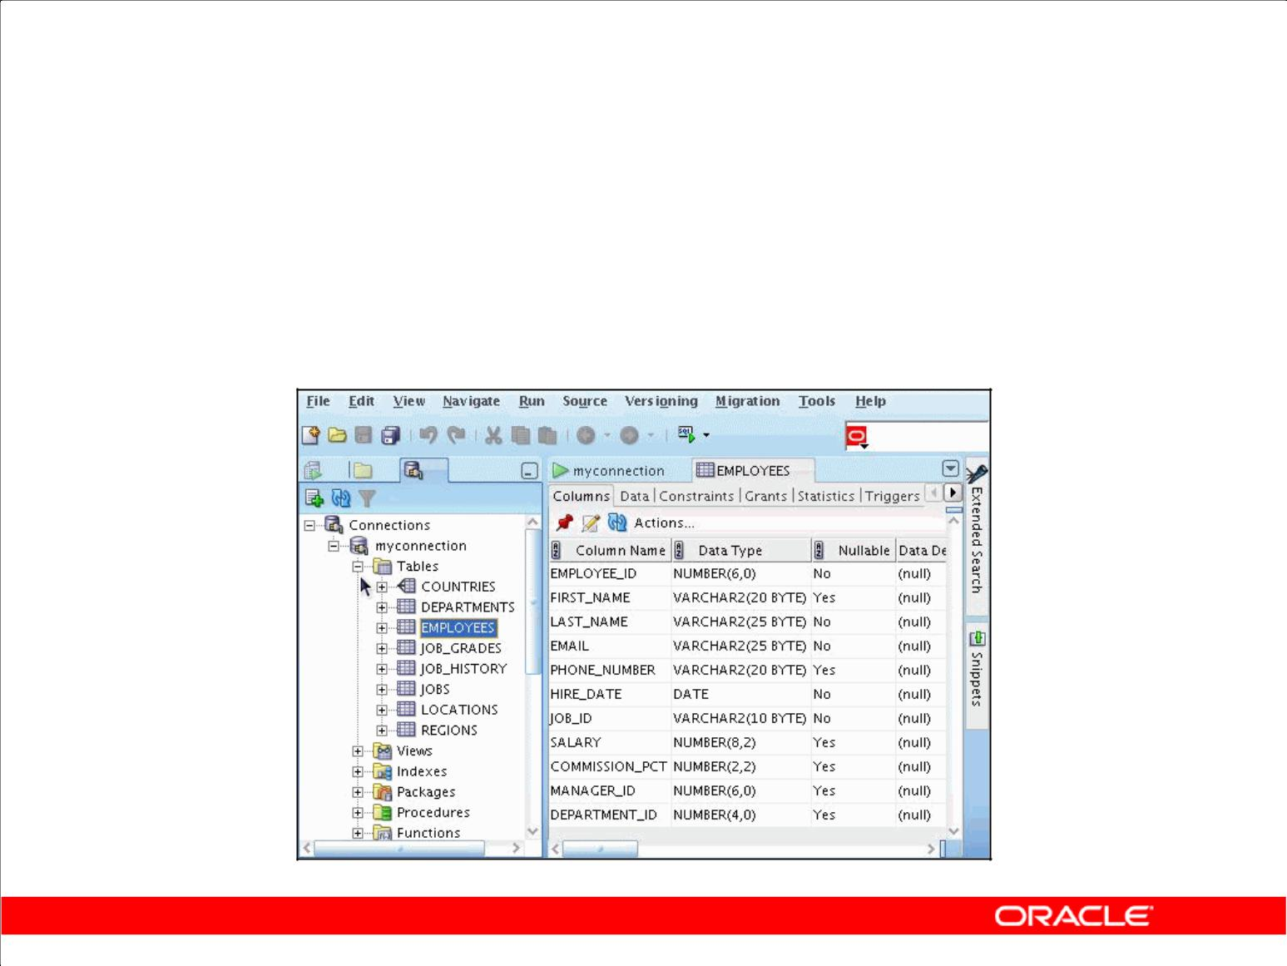**Browsing Database Objects**

Use the Database Navigator to:

1. Browse through many objects in a database schema
2. Perform a quick review of the definitions of objects

Copyright © 2009, Oracle. All rights reserved.

**Browsing Database Objects**

After you create a database connection, you can use the Database Navigator to browse through many objects in a database schema including Tables, Views, Indexes, Packages, Procedures, Triggers, Types, and so on.

SQL Developer uses the left side for navigation to find and select objects, and the right side to display information about the selected objects. You can customize many aspects of the appearance of SQL Developer by setting preferences.

You can see the definition of the objects broken into tabs of information that is pulled out of the data dictionary. For example, if you select a table in the Navigator, the details about columns, constraints, grants, statistics, triggers and more are all displayed in an easy-to-read tabbed page.

If you want to see the definition of the EMPLOYEES table as shown on the slide, perform the following steps:

1. Expand the connection node in the Connections Navigator.
2. Expand **Tables**.
3. Double-click **EMPLOYEES**.

Using the Data tab, you can enter new rows, update data, and commit these changes to the database.

|  |
| --- |
| Oracle Internal & Oracle Academy Use Only |

**Oracle Database 10*g*: SQL Fundamentals II E - 9**

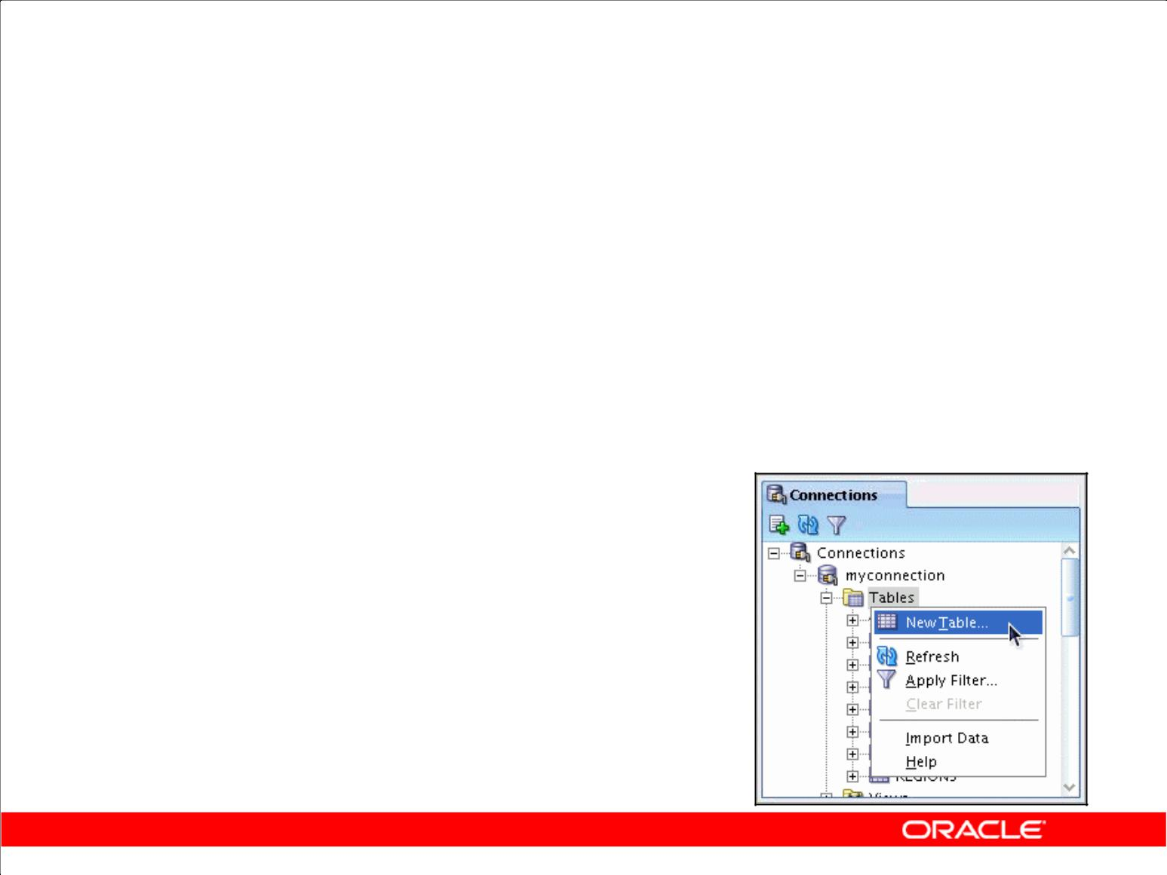**Creating a Schema Object**

1. SQL Developer supports the creation of any schema object by:

– Executing a SQL statement in SQL Worksheet

– Using the context menu

1. Edit the objects by using an edit dialog box or one of many context-sensitive menus.
2. View the DDL for adjustments such as creating a new object or editing an existing schema object.

Copyright © 2009, Oracle. All rights reserved.

**Creating a Schema Object**

SQL Developer supports the creation of any schema object by executing a SQL statement in SQL Worksheet. Alternatively, you can create objects using the context menus. Once created, you can edit the objects using an edit dialog or one of many context-sensitive menus.

As new objects are created or existing objects are edited, the DDL for those adjustments is available for review. An Export DDL option is available if you want to create the full DDL for one or more objects in the schema.

The slide shows creating a table using the context menu. To open a dialog box for creating a new table, right-click **Tables** and select **New Table**. The dialog boxes for creating and editing database objects have multiple tabs, each reflecting a logical grouping of properties for that type of object.

|  |
| --- |
| Oracle Internal & Oracle Academy Use Only |

**Oracle Database 10*g*: SQL Fundamentals II E - 10**

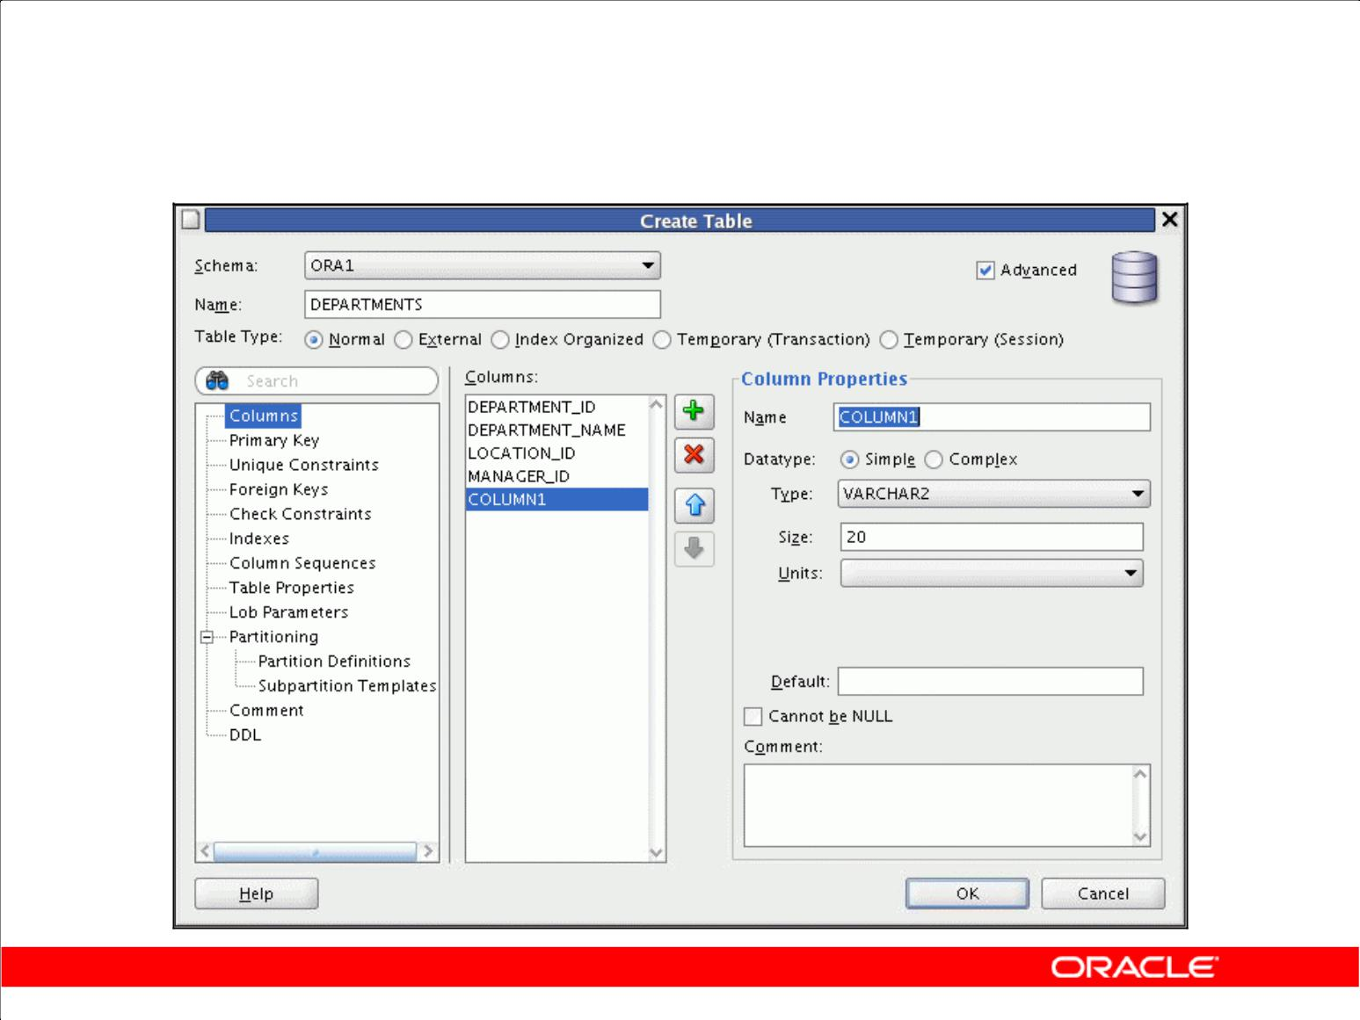**Creating a New Table: Example**

Copyright © 2009, Oracle. All rights reserved.

**Creating a New Table: Example**

In the Create Table dialog box, if you do not select the **Advanced** check box, you can create a table quickly by specifying columns and some frequently used features.

If you select the **Advanced** check box, the Create Table dialog box changes to one with multiple tabs, in which you can specify an extended set of features while creating the table.

The example in the slide shows creating the DEPENDENT table by selecting the **Advanced** check box.

To create a new table, perform the following steps:

1. In the Connections Navigator, right-click **Tables**.
2. Select **New Table**.
3. In the Create Table dialog box, select **Advanced**.
4. Specify column information.
5. Click **OK**.

Although it is not required, you should also specify a primary key by selecting Primary Key in the dialog box. Sometimes, you may want to edit the table that you have created. To edit a table, right-click the table in the Connections Navigator and select **Edit**.

|  |
| --- |
| Oracle Internal & Oracle Academy Use Only |

**Oracle Database 10*g*: SQL Fundamentals II E - 11**

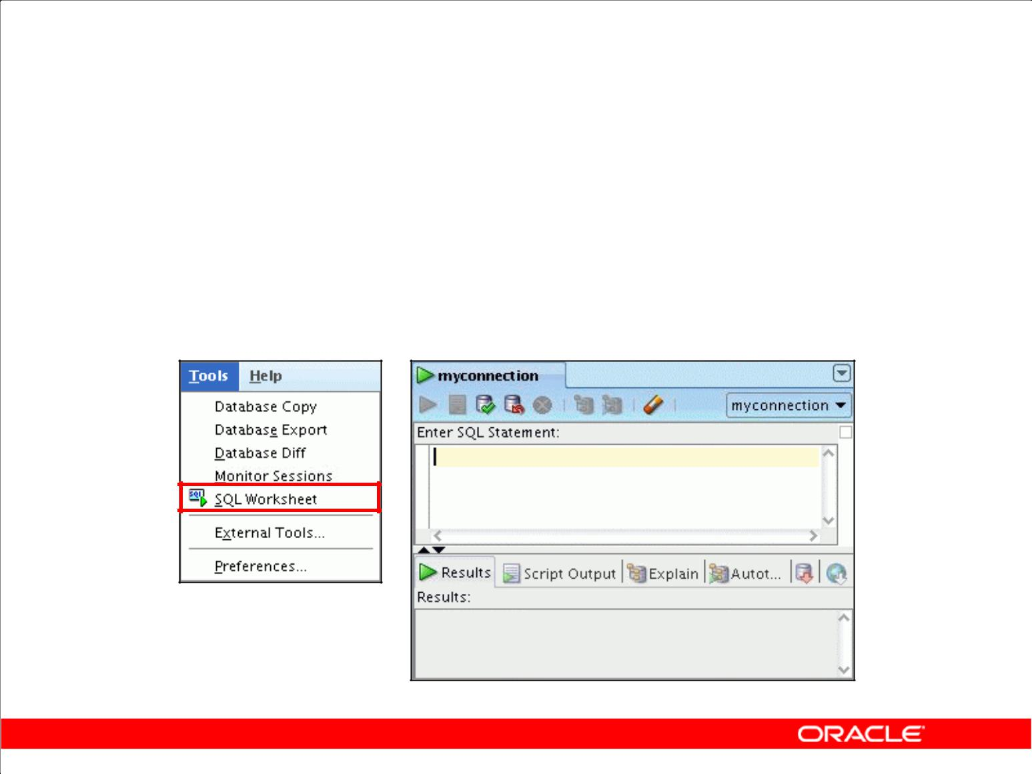**Using SQL Worksheet**

1. Use SQL Worksheet to enter and execute SQL, PL/SQL, and SQL *Plus statements.
2. Specify any actions that can be processed by the database connection associated with the worksheet.

Copyright © 2009, Oracle. All rights reserved.

**Using SQL Worksheet**

When you connect to a database, a SQL Worksheet window for that connection is automatically opened. You can use SQL Worksheet to enter and execute SQL, PL/SQL, and SQL*Plus statements. The SQL Worksheet supports SQL*Plus statements to a certain extent. SQL*Plus statements that are not supported by the SQL Worksheet are ignored and not passed to the database.

You can specify any actions that can be processed by the database connection associated with the worksheet, such as:

1. Creating a table
2. Inserting data
3. Creating and editing a trigger
4. Selecting data from a table
5. Saving the selected data to a file

You can display a SQL worksheet by using any of the following two options:

1. Select **Tools > SQL Worksheet**.
2. Click the **Open SQL Worksheet** icon.

|  |
| --- |
| Oracle Internal & Oracle Academy Use Only |

**Oracle Database 10*g*: SQL Fundamentals II E - 12**

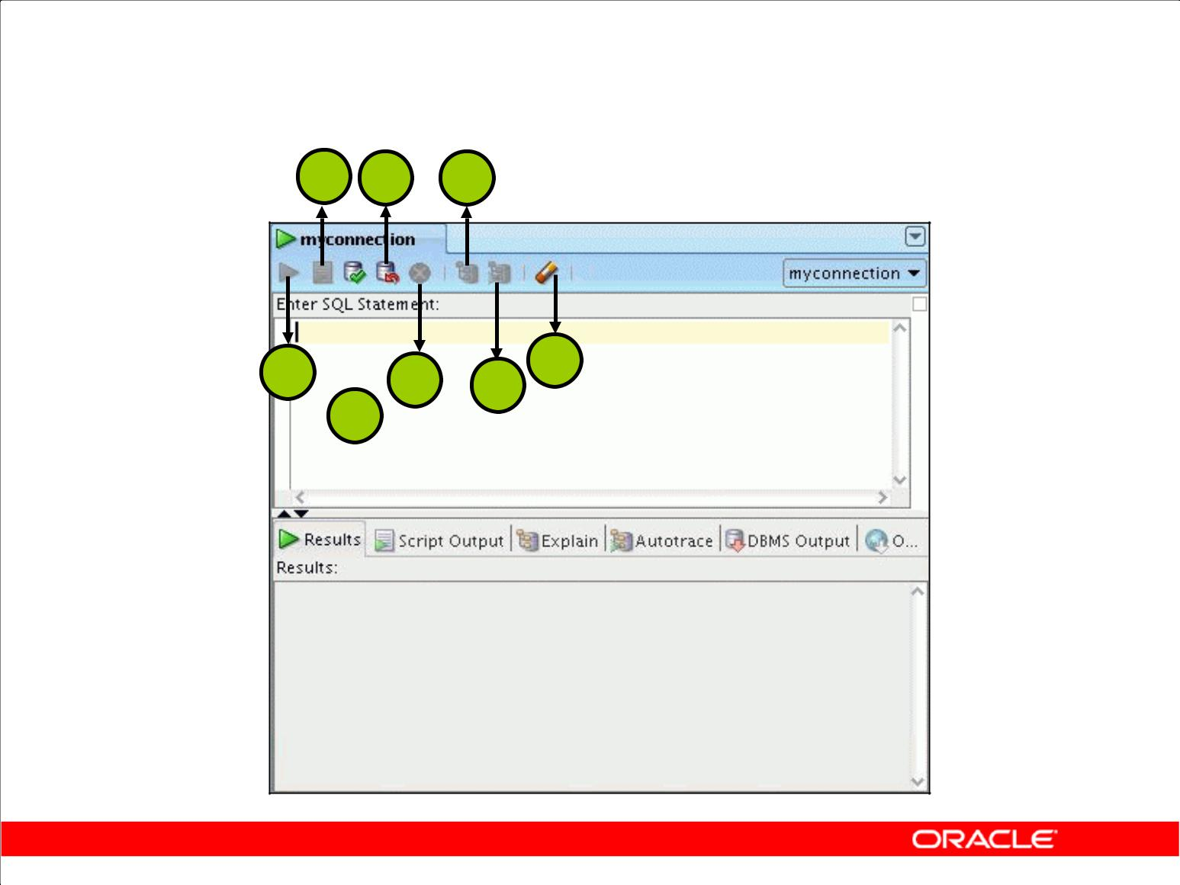**Using SQL Worksheet**

**2 4** **6**

**1**  **5 7** **8**

**3**

Copyright © 2009, Oracle. All rights reserved.

**Using SQL Worksheet (continued)**

You may want to use shortcut keys or icons to perform certain tasks such as executing a SQL statement, running a script, and viewing the history of SQL statements that you have executed. You can use the SQL Worksheet toolbar that contains icons to perform the following tasks:

1. **Execute Statement:** Executes the statement at the cursor in the Enter SQL Statement box. Youcan use bind variables in the SQL statements but not substitution variables.
2. **Run Script:** Executes all statements in the Enter SQL Statement box by using the ScriptRunner. You can use substitution variables in the SQL statements but not bind variables.
3. **Commit:** Writes any changes to the database, and ends the transaction
4. **Rollback:** Discards any changes to the database, without writing them to the database, and endsthe transaction
5. **Cancel:** Stops the execution of any statements currently being executed
6. **Execute Explain Plan:** Generates the execution plan, which you can see by clicking the Explaintab
7. **Autotrace:** Generates trace information for the statement, which you can see by clicking theAutotrace tab
8. **Clear:** Erases the statement or statements in the Enter SQL Statement box

|  |
| --- |
| Oracle Internal & Oracle Academy Use Only |

**Oracle Database 10*g*: SQL Fundamentals II E - 13**

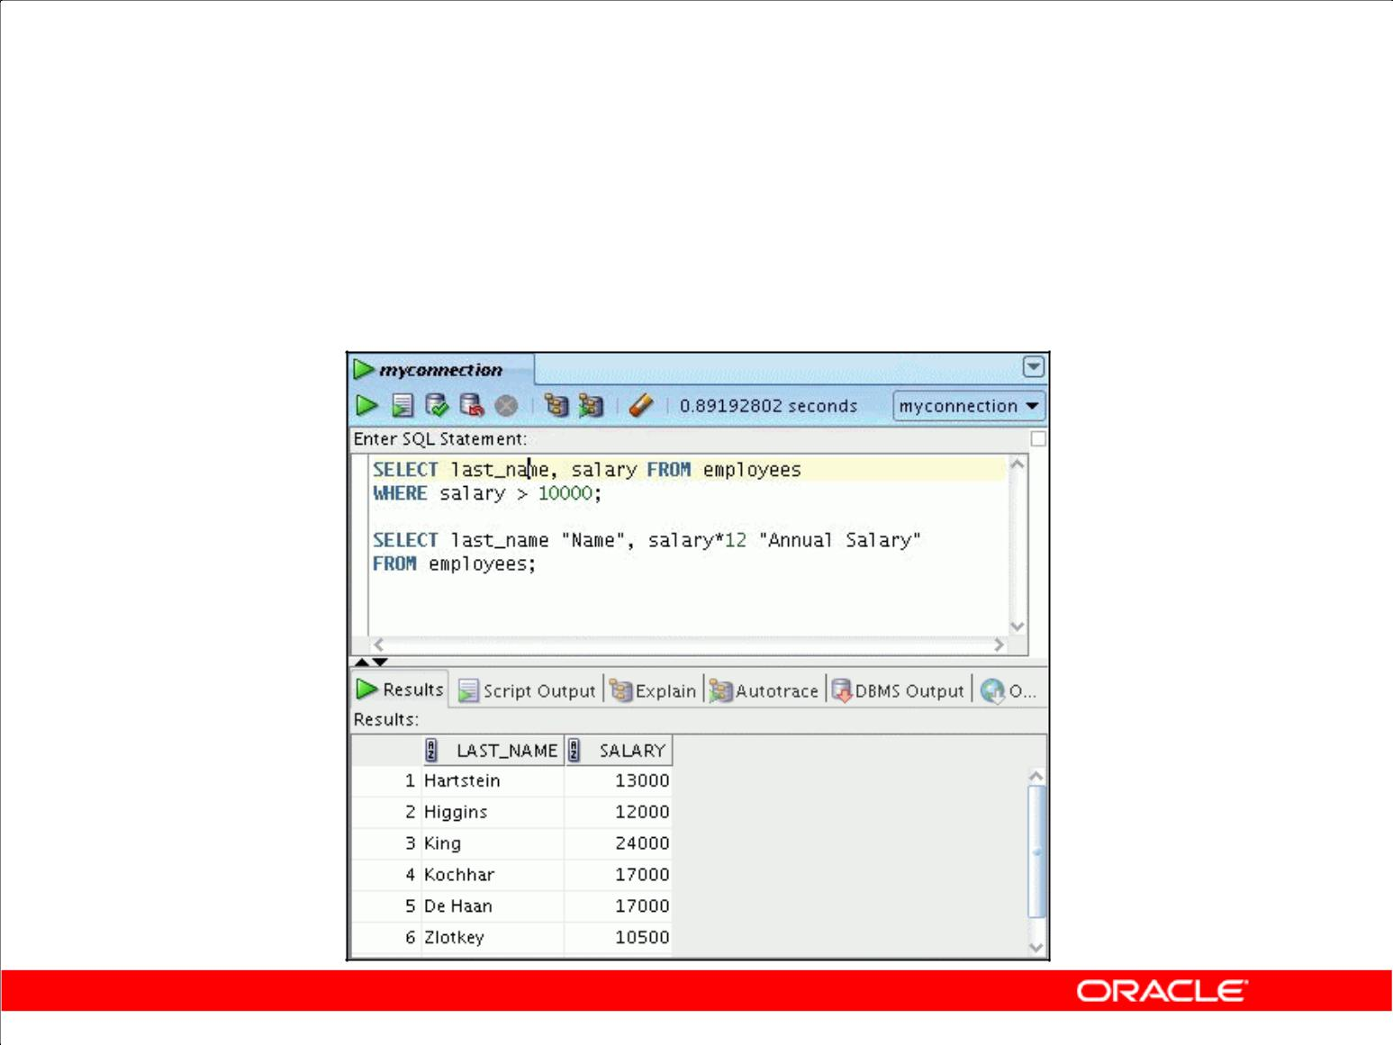**Executing SQL Statements**

Use the Enter SQL Statement box to enter single or multiple SQL statements.

Copyright © 2009, Oracle. All rights reserved.

**Executing SQL Statements**

In SQL Worksheet, you can use the Enter SQL Statement box to enter a single or multiple SQL statements. For a single statement, the semicolon at the end is optional.

When you type in the statement, the SQL keywords are automatically highlighted. To execute a SQL statement, ensure that your cursor is within the statement and click the **Execute Statement** icon. Alternatively, you can press the **F9** key.

To execute multiple SQL statements and see the results, click the **Run Script** icon. Alternatively, you can press the **F5** key.

In the example in the slide, as there are multiple SQL statements, the first statement is terminated with a semicolon. The cursor is in the first statement and, therefore, when the statement is executed, results corresponding to the first statement are displayed in the Results box.

|  |
| --- |
| Oracle Internal & Oracle Academy Use Only |

**Oracle Database 10*g*: SQL Fundamentals II E - 14**

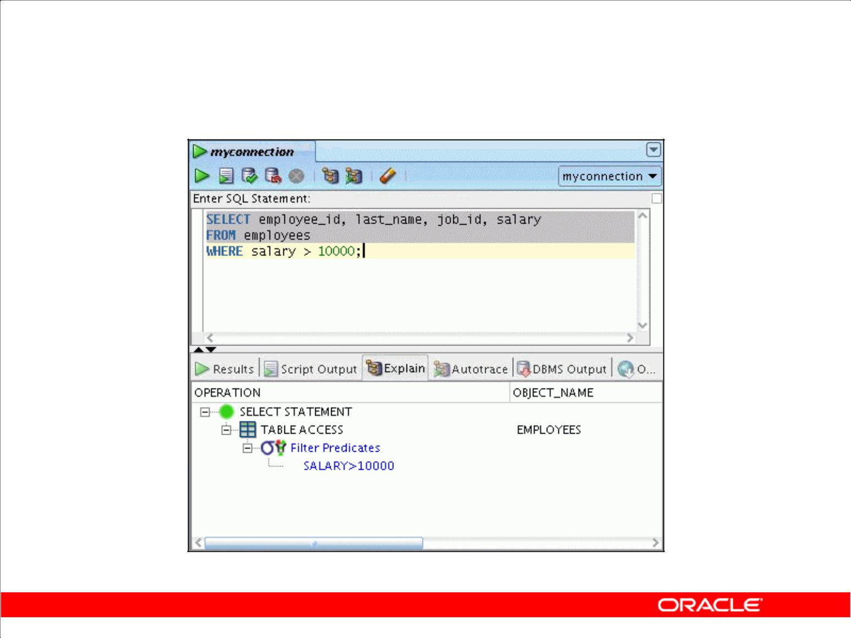**Viewing the Execution Plan**

Copyright © 2009, Oracle. All rights reserved.

**Viewing the Execution Plan**

You can execute a SQL script and view the execution plan. To execute a SQL script file, perform the following steps:

1. From the **File** menu, Select **Open**.
2. In the Open dialog box, double-click the **.sql** file.
3. Click the **Run Script** icon.

When you double-click the .sql file, the SQL statements are loaded into the Enter SQL Statement box. You can execute the script or each line individually. The results are displayed in the Script Output area.

The example in the slide shows the execution plan. The Execute Explain Plan icon generates the execution plan. An execution plan is the sequence of operations that are performed to execute the statement. You can see the execution plan by clicking the **Explain** tab.

|  |
| --- |
| Oracle Internal & Oracle Academy Use Only |

**Oracle Database 10*g*: SQL Fundamentals II E - 15**

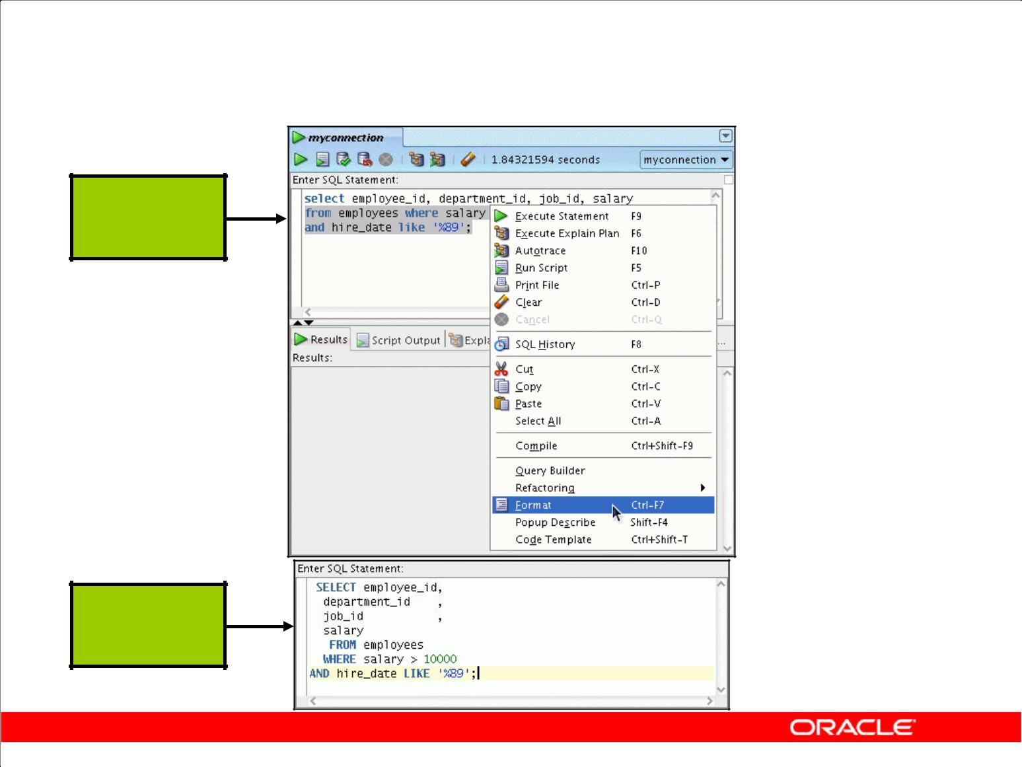**Formatting the SQL Code**

**Before**

**Formatting**

**After**

**Formatting**

Copyright © 2009, Oracle. All rights reserved.

**Formatting the SQL Code**

You may want to beautify the indentation, spacing, capitalization, and line separation of the SQL code. SQL Developer has the feature of formatting the SQL code.

To format the SQL code, right-click in the statement area, and select **Format**.

In the example in the slide, before formatting, the SQL code has the keywords not capitalized and the statement not properly indented. After formatting, the SQL code is beautified with the keywords capitalized and the statement properly indented.

|  |
| --- |
| Oracle Internal & Oracle Academy Use Only |

**Oracle Database 10*g*: SQL Fundamentals II E - 16**

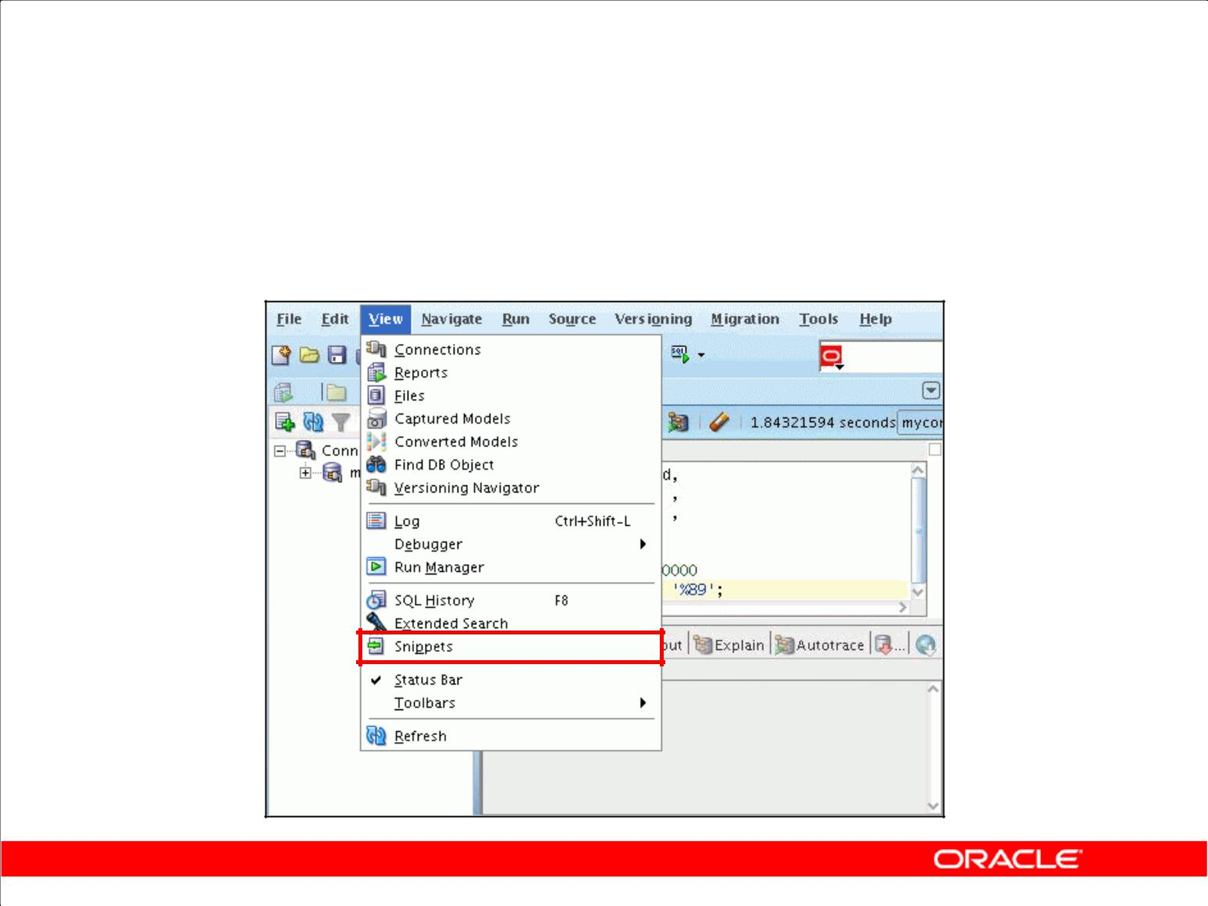**Using Snippets**

Snippets are code fragments that may be just syntax or examples.

Copyright © 2009, Oracle. All rights reserved.

**Using Snippets**

You may want to use certain code fragments when you are using the SQL Worksheet or creating or editing a PL/SQL function or procedure. SQL Developer has the feature called Snippets. Snippets are code fragments, such as SQL functions, Optimizer hints, and miscellaneous PL/SQL programming techniques. You can drag and drop snippets into the editor window.

To display Snippets, select **View > Snippets**.

The Snippets window is displayed on the right side. You can use the drop-down list to select a group. A Snippets button is placed in the right window margin, so that you can display the Snippets window if it becomes hidden.

|  |
| --- |
| Oracle Internal & Oracle Academy Use Only |

**Oracle Database 10*g*: SQL Fundamentals II E - 17**

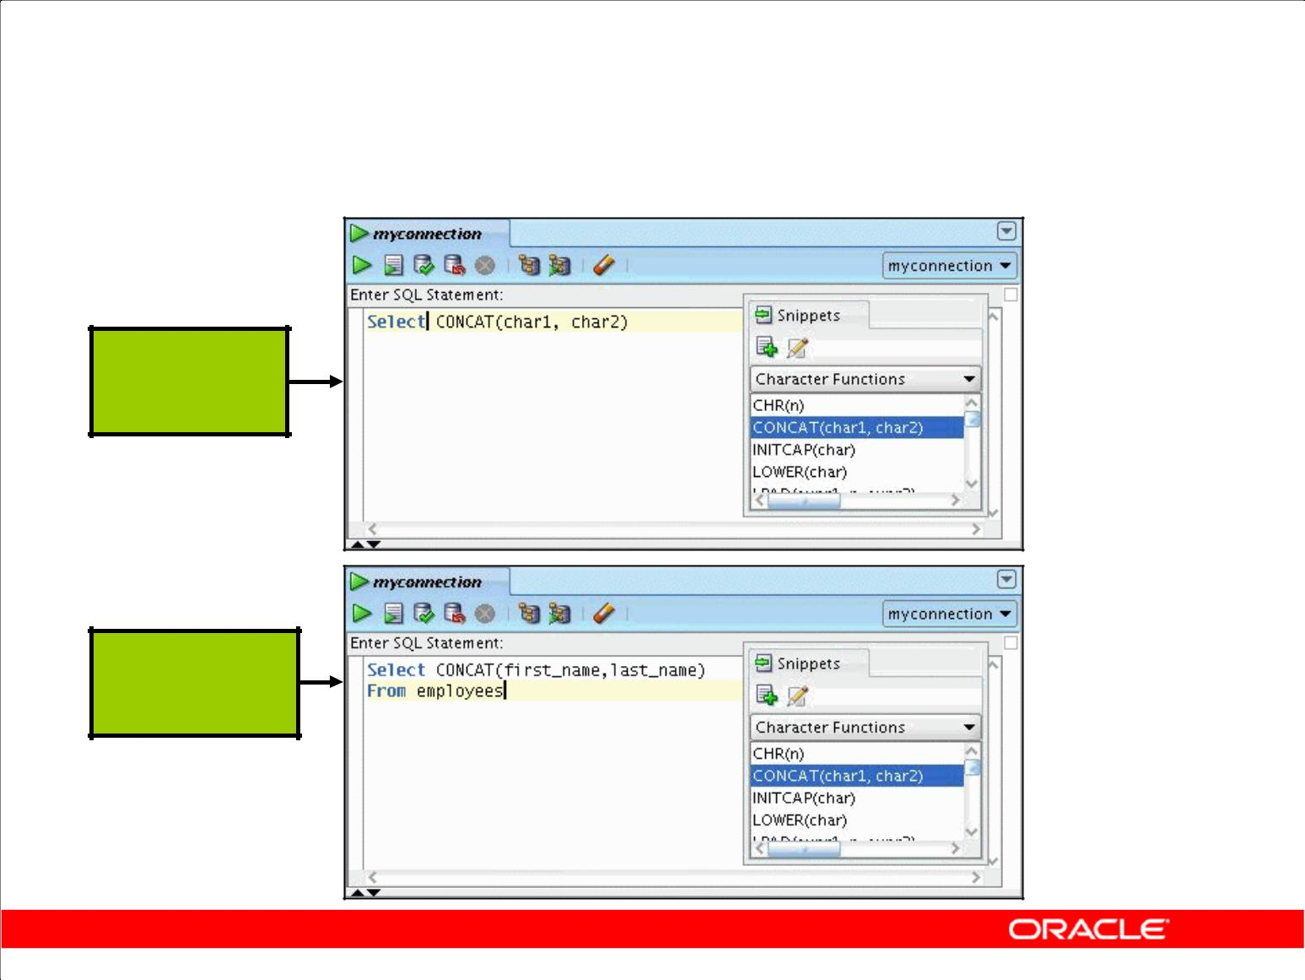**Using Snippets: Example**

**Inserting a**

**snippet**

**Editing the**

**snippet**

Copyright © 2009, Oracle. All rights reserved.

**Using Snippets: Example**

To insert a snippet into your code in SQL Worksheet or in a PL/SQL function or procedure, drag the snippet from the Snippets window and drop it into the desired place in your code. Then, you can edit the syntax so that the SQL function is valid in the current context. To see a brief description of a SQL function in a tool tip, place the cursor over the function name.

The example in the slide shows that CONCAT(char1, char2)is dragged from the Character Functions group in the Snippets window. Then, the CONCAT function syntax is edited and the rest of the statement is added such as in the following:

SELECT CONCAT(first_name, last_name)

FROM employees;

|  |
| --- |
| Oracle Internal & Oracle Academy Use Only |

**Oracle Database 10*g*: SQL Fundamentals II E - 18**

**Using SQL*Plus**

1. SQL Worksheet does not support all SQL*Plus statements.
2. SQL*Plus statements that are not supported by SQL Worksheet are:

– append

– archive

– attribute

– break

– change

– clear

Copyright © 2009, Oracle. All rights reserved.

**Using SQL*Plus**

SQL Worksheet supports some SQL*Plus statements. SQL*Plus statements must be interpreted by the SQL Worksheet before being passed to the database; any SQL*Plus statements that are not supported by the SQL Worksheet are ignored and not passed to the database. For example, some of the SQL*Plus statements that are not supported by SQL Worksheet are listed in the slide. For the complete list of SQL*Plus statements that are supported and not supported by SQL Worksheet, refer to SQL Developer online Help.

|  |
| --- |
| Oracle Internal & Oracle Academy Use Only |

**Oracle Database 10*g*: SQL Fundamentals II E - 19**

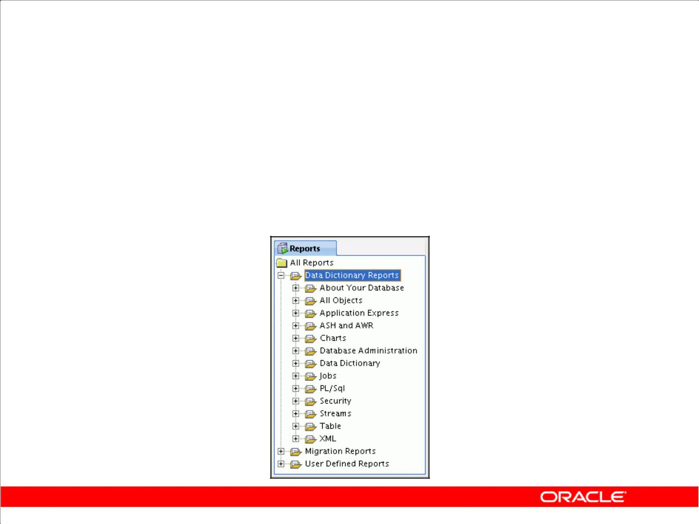**Database Reporting**

1. SQL Developer provides you with a number of predefined reports about your database and objects.
2. The reports are organized into categories.
3. You can create your own customized reports too.

Copyright © 2009, Oracle. All rights reserved.

**Database Reporting**

SQL Developer provides many reports about the database and its objects. These reports are grouped into the following categories:

1. About Your Database reports
2. Object reports
3. Application Express reports
4. Charts
5. Database Administration reports
6. Data Dictionary reports
7. Jobs reports
8. PL/SQL reports
9. Security reports
10. Streams reports
11. Table reports
12. XML reports

To display a report, click the Reports tabbed page and then select the report type. You can also create your own user-defined reports.

|  |
| --- |
| Oracle Internal & Oracle Academy Use Only |

**Oracle Database 10*g*: SQL Fundamentals II E - 20**

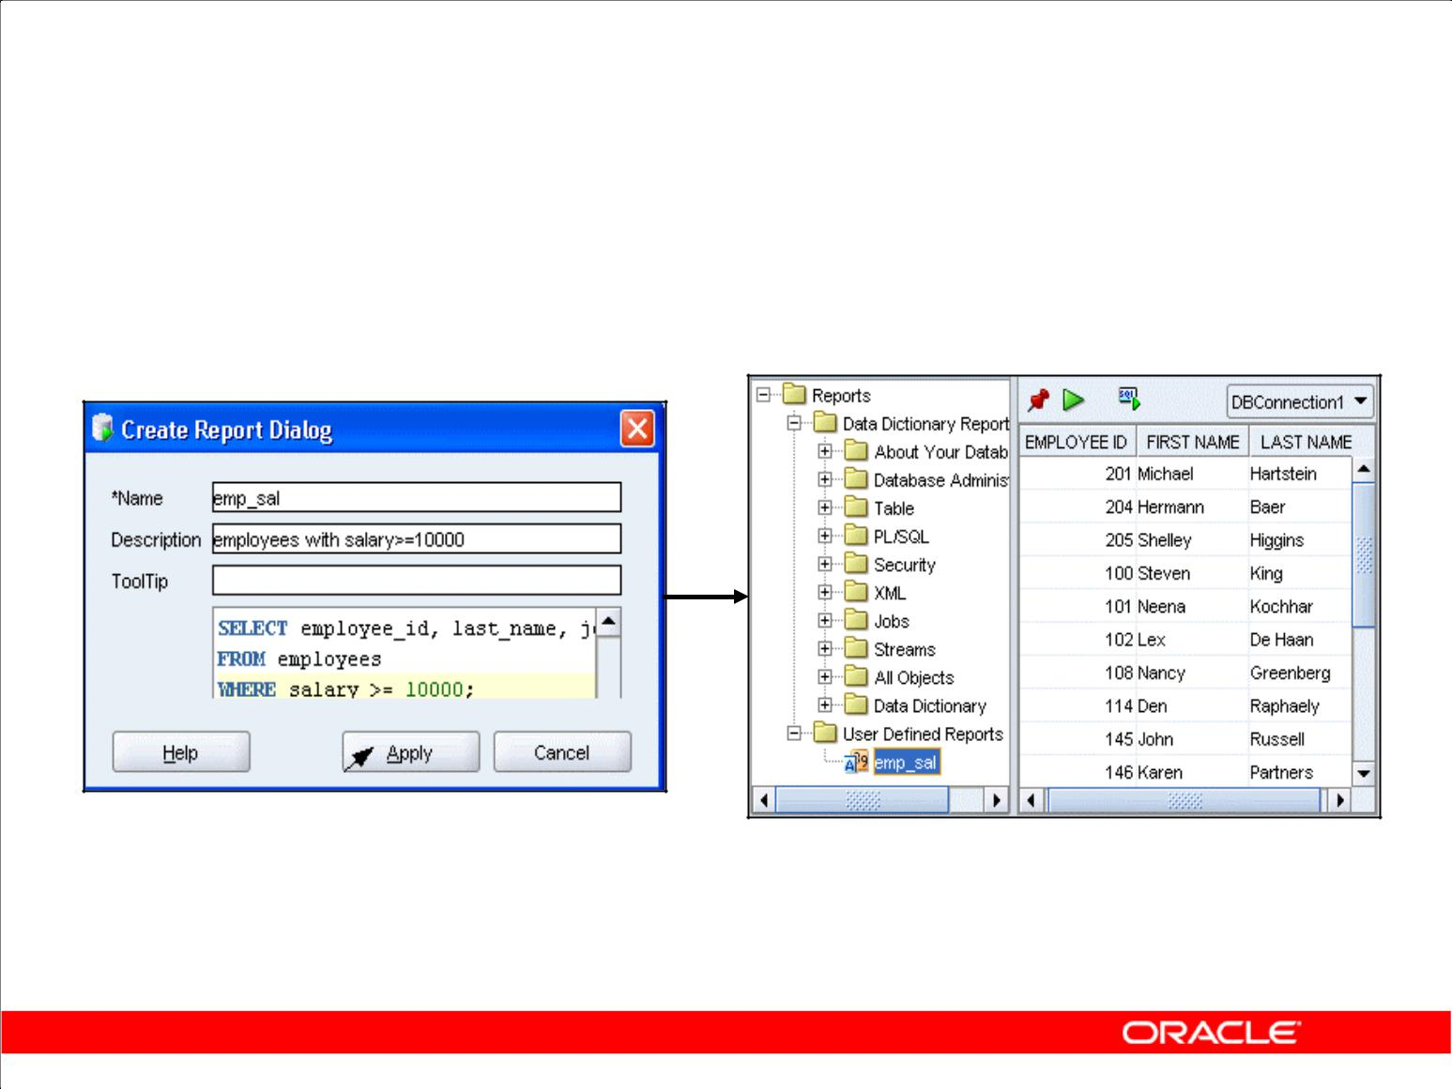**Creating a User-Defined Report**

Create and save user-defined reports for repeated use.

Copyright © 2009, Oracle. All rights reserved.

**Creating a User-Defined Report**

User-defined reports are any reports that are created by SQL Developer users. To create a user-defined report, perform the following steps:

1. Right-click the **User Defined Reports** node under Reports, and select **Add Report**.
2. In the Create Report Dialog box, specify the report name and the SQL query to retrieve information for the report. Then, click **Apply**.

In the example in the slide, the report name is specified as emp_sal. An optional description is provided indicating that the report contains details of employees with salary >= 10000. The complete SQL statement for retrieving the information to be displayed in the user-defined report is specified in the SQL box. You can also include an optional tool tip to be displayed when the cursor stays briefly over the report name in the Reports navigator display.

You can organize user-defined reports in folders, and you can create a hierarchy of folders and subfolders. To create a folder for user-defined reports, right-click the User Defined Reports node or any folder name under that node and select Add Folder.

Information about user-defined reports, including any folders for these reports, is stored in a file named UserReports.xml under the directory for user-specific information.

|  |
| --- |
| Oracle Internal & Oracle Academy Use Only |

**Oracle Database 10*g*: SQL Fundamentals II E - 21**

**Summary**

In this appendix, you should have learned how to use SQL Developer to do the following:

1. Browse, create, and edit database objects
2. Execute SQL statements and scripts in SQL Worksheet
3. Create and save custom reports

Copyright © 2009, Oracle. All rights reserved.

**Summary**

SQL Developer is a free graphical tool to simplify database development tasks. Using SQL Developer, you can browse, create, and edit database objects. You can use SQL Worksheet to run SQL statements and scripts. SQL Developer enables you to create and save your own special set of reports for repeated use.

|  |
| --- |
| Oracle Internal & Oracle Academy Use Only |

**Oracle Database 10*g*: SQL Fundamentals II E - 22**



|  |
| --- |
| **Index** |

Oracle Internal & Oracle Academy Use Only

**Note:** A bolded number or letter refers to an entire lesson or appendix.

**A**

Access Parameter 2-31, 2-32, 2-34, 2-35

Adding a column 2-5, 6-18

ALL INSERT 3-2, 3-16, 3-18, 3-21, 3-35

ALTER 1-11, 1-12, 1-14, 1-19, 2-2-16, 2-18, 2-19, 2-22, 2-37, 2-38, 3-15,

3-27, 4-14, 5-4, 5-6-9, 5-13, 5-17, 5-36, 5-37, 6-16, 6-18, 8-13

ALTER SESSION 2-13, 5-4, 5-6, 5-7, 5-8, 5-9, 5-17

ALTER TABLE 2-3-16, 2-18, 2-19, 2-22, 2-37, 2-38, 5-13, 6-18, 8-13 ALTER USER 1-11, 1-19

**C**

Cascading Constraints 2-18, 2-19

Check Constraints 6-7, 8-13

Child Node 7-10

Composite Column 4-17, 4-18, 4-19, 4-20, 4-23

Concatenated Grouping 4-21, 4-22, 4-23

Conditional INSERT 3-2, 3-16, 3-17, 3-18, 3-19, 3-20, 3-21, 3-22, 3-23, 3-35

CONNECT BY 6-7, 7-5, 7-6, 7-7, 7-8, 7-9, 7-11, 7-13, 7-14 CONNECT BY PRIOR 7-5, 7-6, 7-7, 7-8, 7-9, 7-11, 7-13, 7-14

Constraint 1-17, 2-2, 2-7, 2-10-22-24, 2-27, 2-37, 2-38, 2-41, 2-42, 6-7, 8-13 Correlated Subquery 6-9, 6-10-13, 6-17, 6-18, 6-20, 6-21, 6-26 Correlated Subquery To Update Row 6-17, 6-18

Correlated Update 6-17, 6-18, 6-19

Correlation 6-13

Create Database 5-9

Create Index 2-2, 2-20, 2-21, 2-22, 2-23, 2-37, 2-38 Cross-Tabular Reports 4-9 Cross-Tabulation Rows 4-6

Cross-Tabulation Values 4-2, 4-9, 4-23, 4-26

CUBE i-4, 4-2, 4-6, 4-7, 4-9, 4-10, 4-11, 4-13, 4-14, 4-17, 4-18, 4-19, 4-21, 4-22, 4-23, 4-24, 4-27

CURRENT_DATE 5-2, 5-5, 5-6, 5-15, 5-34, 5-35, 5-36

CURRENT_TIMESTAMP 5-2, 5-5, 5-7, 5-8, 5-17, 5-34, 5-35, 5-36

**Oracle Database 10*g*: SQL Fundamentals II Index-2**

|  |
| --- |
| Oracle Internal & Oracle Academy Use Only |

**D**

Datetime i-4, 5-2, 5-5, 5-10-12, 5-18, 5-19, 5-21-23, 5-25, 5-28, 5-30, 5-32-35

Datetime Function i-4, 5-2, 5-34, 5-35

Daylight Saving 5-3, 5-28, 5-32, 5-33

DBTIMEZONE 5-2, 5-4, 5-9, 5-26, 5-34, 5-36

DEFAULT DIRECTORY 2-31, 2-32, 2-34

Deferring Constraints 2-13

Disabling Constraints 2-15

DROP TABLE 2-25, 2-27

Dropping a column 2-7, 2-8

**E**

Enabling Constraints 2-16

Execution Plan 4-16, 4-20

EXIST 1-16, 2-2, 2-3, 2-6, 2-10, 2-11, 2-16, 2-22, 2-31, 2-32, 2-41, 3-4, 3-12, 3-15, 3-27, 3-28, 3-30, 3-31, 3-34, 5-32, 6-2, 6-14, 6-15, 6-16, 6-20, 6-21, 6-24, 6-26, 6-27, 6-29, 7-3, 7-5, 8-13

External Table i-4, 2-2, 2-28, 2-29, 2-30, 2-31, 2-32, 2-33, 2-34, 2-35, 2-36, 2-37, 2-38, 3-39

EXTRACT 2-31, 3-14, 4-7, 5-2, 5-25, 5-34, 5-35, 5-37, 5-38, 8-3, 8-11

**F**

FIRST INSERT 3-2, 3-16, 3-22, 3-23, 3-35

FLASHBACK TABLE 2-25, 2-26, 2-27, 3-31

Flashback Version Query 3-31, 3-32, 3-33

FROM_TZ 5-2, 5-28, 5-34

|  |
| --- |
| Oracle Internal & Oracle Academy Use Only |

**Oracle Database 10*g*: SQL Fundamentals II Index-3**

**G**

Greenwich Mean Time 5-3, 5-6, 5-14

GROUP BY 3-7, 3-23, 4-3-25, 4-27, 6-7, 6-20, 6-24, 6-25 GROUP BY ROLLUP 4-8, 4-12, 4-17, 4-18, 4-19

GROUPING i-4, **4**

GROUPING SET i-4, **4**

**H**

HAVING 2-22, 3-5, 4-3, 4-5, 4-7, 4-9, 4-11, 6-20 Hierarchical Queries i-4, 7-2, 7-3, 7-5, 7-14, 7-15

**I**

Inner Query 6-8, 6-10, 6-12, 6-14, 6-15

INSERT i-4, 1-12, 1-15, 1-18, 1-23, 2-6, 2-30, 2-35, **3**, 5-15, 5-17, 5-22, 5-24, 6-19, 8-13

INTERVAL 3-34, 5-2, 5-18, 5-19, 5-20, 5-21, 5-22, 5-23, 5-24, 5-25, 5-30, 5-31, 5-32, 5-34, 5-39

INTERVAL DAY TO SECOND 5-20, 5-22, 5-23, 5-24, 5-31 INTERVAL YEAR TO MONTH 5-20, 5-21, 5-22, 5-30, 5-31

**L**

LEVEL 1-2, 1-3, 1-4, 1-5, 1-6, 2-41, 4-2, 4-8, 4-11, 4-17, 7-5, 7-10, 7-11, 7-12, 7-14, 7-15, 7-18

LOCALTIMESTAMP 5-2, 5-5, 5-8, 5-34, 5-35, 5-36 LPAD 7-11, 7-12

**M**

MERGE i-4, 3-2, 3-27, 3-28, 3-29, 3-30, 3-35, 3-36, 3-39

Meta Characters 8-4, 8-5, 8-6

Modifying a column 2-6

Multiple-Column Subqueries 6-2, 6-3, 6-7, 6-25, 6-27

|  |
| --- |
| Oracle Internal & Oracle Academy Use Only |

**Oracle Database 10*g*: SQL Fundamentals II Index-4**

**N**

NLS_Date_Language 5-29

Nonpairwise Comparisons 6-4, 6-25

NOT EXIST 1-16, 5-32, 6-2, 6-14, 6-16, 6-29

NOT IN 3-11, 6-16, 6-29

**O**

ON DELETE CASCADE 2-12

ORACLE_LOADER 2-28, 2-32, 2-34, 2-35

ORDER BY 2-23, 4-3, 4-4, 4-5, 4-7, 4-9, 4-11, 6-8, 6-9, 6-24

ORGANIZATION EXTERNAL 2-29, 2-31, 2-32, 2-34 Outer Query 3-7, 6-8, 6-10, 6-12, 6-13, 6-14

**P**

Pairwise Comparisons 6-4, 6-25

Parent-Child Relationship 7-4

PIVOTING 3-2, 3-16, 3-24, 3-25, 3-26, 3-35, 3-39

Prune The Tree 7-13, 7-14

Pseudocolumn 7-5, 7-10, 7-11, 7-14, 7-15

Purge 2-25, 2-27

**R**

Ranking Rows 7-10

REGEXP_INSTR 8-7, 8-8, 8-10

REGEXP_LIKE 8-7, 8-8, 8-9, 8-13

REGEXP_REPLACE 8-7, 8-8, 8-12

REGEXP_SUBSTR 8-7, 8-8, 8-11

Regular Expression Support 8-1, 8-2, 8-3, 8-14

Reject Limit 2-31, 2-32, 2-33, 2-34, 2-35

Replacing Patterns 8-12

ROLLUP i-4, 4-2, 4-6, 4-7, 4-8, 4-9, 4-10, 4-11, 4-12, 4-13, 4-14, 4-17, 4-18, 4-19, 4-21, 4-22, 4-23, 4-24, 4-25

Root Node 7-10

Row Versions 3-36, 3-40

|  |
| --- |
| Oracle Internal & Oracle Academy Use Only |

**Oracle Database 10*g*: SQL Fundamentals II Index-5**

**S**

Scalar Subquery 6-7, 6-9, 6-31

SESSIONTIMEZONE 5-2, 5-6, 5-7, 5-9, 5-26, 5-34, 5-36 SET TIME_ZONE 5-4, 5-6, 5-7, 5-8, 5-9, 5-17

SET UNUSED 2-8

SQL Developer 1-11, 1-21

START WITH 7-5, 7-6, 7-11, 7-14, 7-18, 8-10, 8-16 Subquery 3-4, 3-5, 3-6, 3-7, 3-8, 3-10, 3-11, 3-14, 3-17,

3-28, 6-2, 6-3, 6-5, 6-6, 6-7, 6-9, 6-10, 6-11, 6-12, 6-13,

6-14, 6-17, 6-18, 6-20, 6-21, 6-22, 6-24, 6-25, 6-26, 6-31, 7-6,

7-7

Superaggregate Rows 4-6, 4-8, 4-9

**T**

Time Zone 5-1, 5-3, 5-4, 5-5, 5-6, 5-7, 5-8, 5-9, 5-10,

5-11, 5-13, 5-14, 5-15, 5-16, 5-17, 5-25, 5-26, 5-27, 5-28, 5-29,

5-32, 5-33, 5-35, 5-36, 5-37

TIMESTAMP 2-26, 3-32, 5-2, 5-5, 5-7, 5-8, 5-10, 5-11, 5-12,

5-13, 5-14, 5-15, 5-16, 5-17, 5-28, 5-29, 5-34, 5-35, 5-36, 5-37 TIMESTAMP WITH LOCAL TIMEZONE 5-16, 5-17

TIMESTAMP WITH TIME ZONE 5-5, 5-7, 5-8, 5-10, 5-13, 5-14, 5-15,

5-16, 5-28, 5-29, 5-37

TO_DSINTERVAL 5-2, 5-31

TO_YMINTERVAL 5-2, 5-30, 5-31, 5-34, 5-39

Tracking Changes 3-2, 3-31, 3-35

Tree-Structured Report 7-2

TZ_OFFSET 5-2, 5-26, 5-27, 5-34, 5-36

**U**

Unconditional INSERT ALL 3-19

UNION 4-2, 4-7, 4-10, 4-13, 4-14, 4-16, 4-17, 4-18, 4-20, 4-23, 5-32 UNION ALL 4-2, 4-7, 4-10, 4-13, 4-14, 4-16, 4-17, 4-18, 4-20, 4-23

|  |
| --- |
| Oracle Internal & Oracle Academy Use Only |

**Oracle Database 10*g*: SQL Fundamentals II Index-6**

**V**

V$TIMEZONE_NAME 5-27, 5-28

VERSIONS BETWEEN 3-32, 3-34

**W**

Walking the Tree 7-6, 7-7, 7-8, 7-9

WITH Clause 6-2, 6-22, 6-23, 6-24, 6-26, 6-27, 6-31, 7-5, 7-6, 7-14

|  |
| --- |
| Oracle Internal & Oracle Academy Use Only |

**Oracle Database 10*g*: SQL Fundamentals II Index-7**

Oracle Internal & Oracle Academy Use Only